Simulating Loyalty Journeys with Emarsys: Closing the Loop, Opening New Chapters

"You don’t need production access to demonstrate value. You just need architecture, imagination, and real-time response."

Over the past few posts, I’ve shared pieces of a journey: from exploring SAP Emarsys’ loyalty architecture to crafting a hands-on prototype that simulates real-time external event triggers, personalization output, and audit insights — all powered by SAP CAP + Node.js.  
  
Today, that journey comes full circle.

# The Final Demo — in Action

## ✅ Step 1 – Choose Your Trigger Source

Select from SAP Commerce Cloud, Corevist B2B, S/4HANA, Salesforce, Oracle, and more.

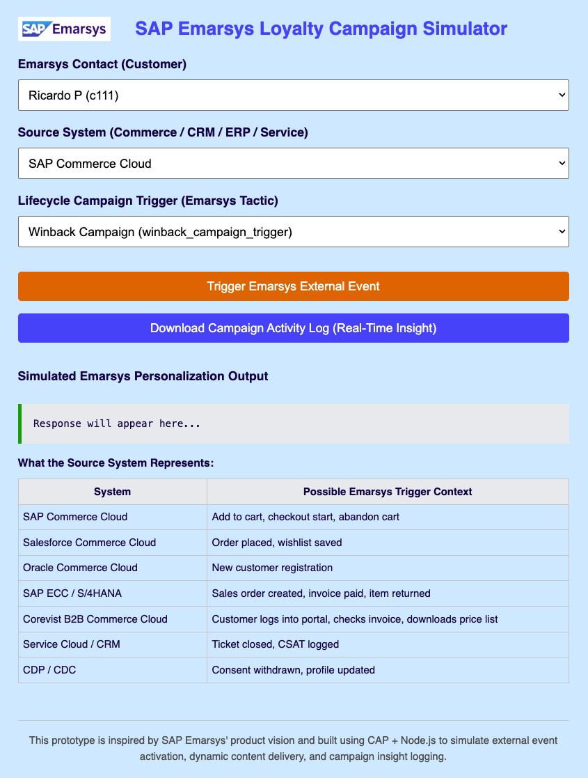

## ✅ Step 2 – Trigger an Emarsys Tactic

Simulate the external event call using CAP’s service logic.

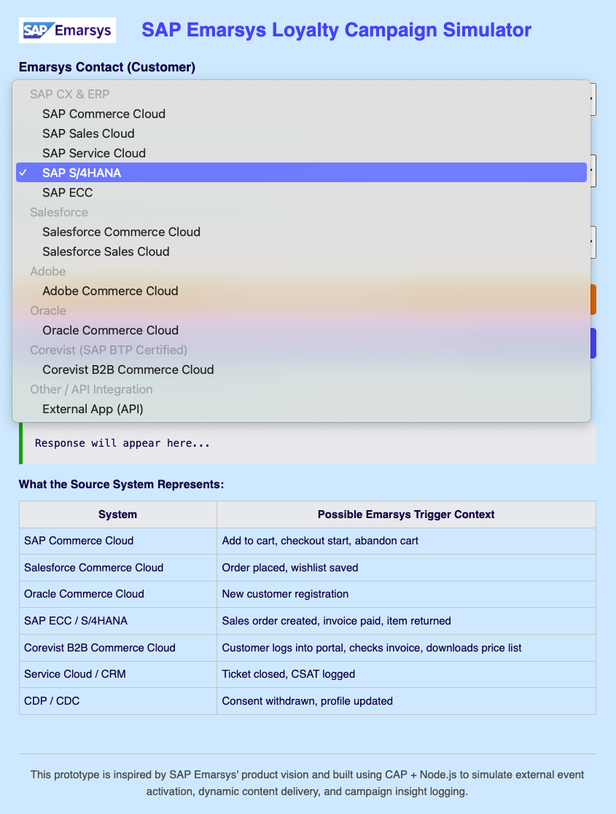

## ✅ Step 3 – Preview the Personalized Output

Dynamic content renders in real-time, just like Emarsys would.

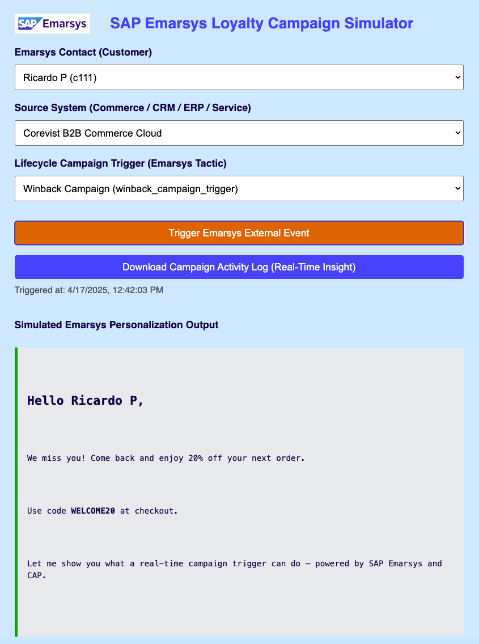

# Architecture Behind the Scenes

- Frontend in HTML, enhanced with CAP OData v4  
- Backend powered by cds, SQLite, Node.js  
- Real-time audit logging, CSV export, and system source injection

# Why This Matters

You don’t need production credentials to run a strategy workshop.  
  
You just need to show that you understand:  
- How Emarsys fits into the bigger SAP CX picture  
- How campaigns are orchestrated using external triggers  
- How integration works across commerce, CRM, and ERP

# What’s Coming Next

This post concludes my Emarsys showcase, but the broader narrative continues.  
  
Next, I’ll explore how these ideas extend into:  
- SAP BTP – architecture patterns, CAP extensions, event-driven flows  
- AWS – low-cost serverless infrastructure and customer data orchestration  
- Corevist – B2B commerce strategies for manufacturers and distributors  
- SAP S/4HANA – where ERP and loyalty finally meet

# Final Thought

If you’re thinking about loyalty architecture, composable CX, or real-time campaign strategy — I’m ready to help, prototype, or facilitate the conversation.  
  
📩 DM me if you want a walkthrough of this demo — or the next one.