ISSUES
- Area use: the plot have the coloured areas under the lines that make part of the target invisible and make think that the areas has some meaning, when it’s not.
- Line use: the use of a line chart convey the idea of the same thing changing over time, or space, so a technically continuous variable not a categorical one.
- Background lines/value on graph: the background lines seem unnecessary if I put the exact value over any peak, so over any data. I need to choose one or the other, booth are redundant
- Type of chart: because I think the idea is to compare actual and target revenue a line plot is not the best option. A bar or a bullet plot may be more suitable for this goal. Also a global comparison may be good to add for a better general comprehension

CHARTS
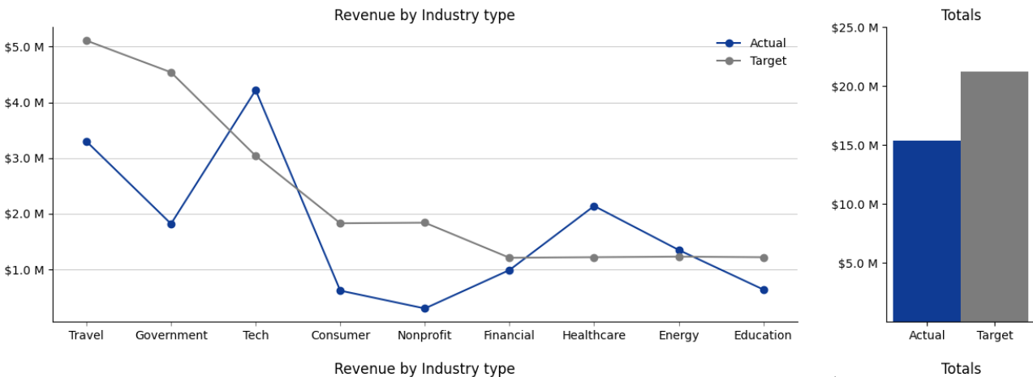
So I would propose 3 different improved charts. One that maintain the lines, and one with bars.

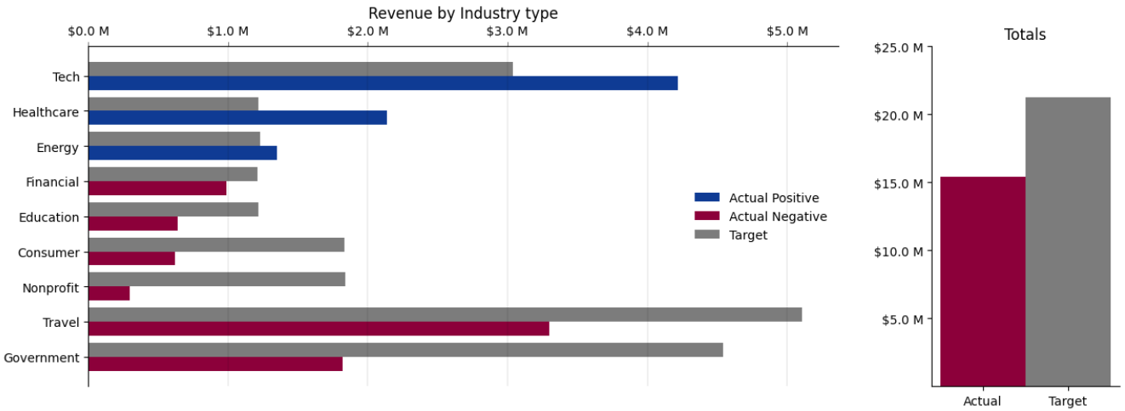
A bar plot that give us a very good idea of best and worst industry sectors.

And then a bullet plot that’s more compact and elegant if we are more interested how every single industry type are doing
