Elisabetta  Pietrostefani  University of Liverpool | Francisco  Rowe  University of Liverpool
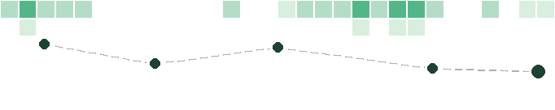 | 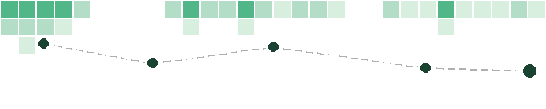
Martina  Pardy  University of Liverpool | Matt  Mason  University of Liverpool
 | 
Andrea  Nasuto  University of Liverpool | Shaonlee  Patranabis  University of Liverpool
 | 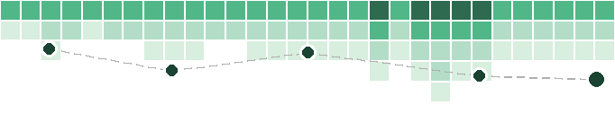
Hong  Tran-Jones  IOM DTM | Prithvi  Hirani  IOM DTM
 | 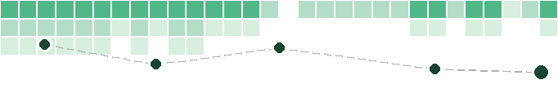
Nando  Lewis  IOM | Kate  Hodkinson  OCHA
 | 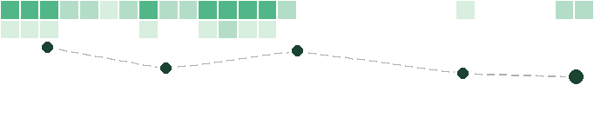

Lisa Lim Ah  Ken  IOM Climate Action | Fawad  Qureshi  Snowflake
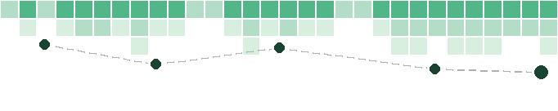 | 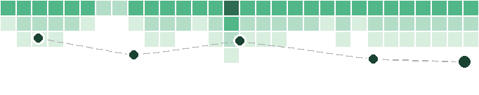
Becky  Oconnor  Snowflake | Meg  McGrath  Snowflake
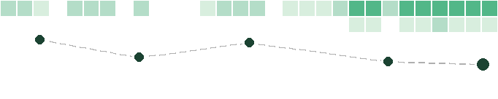 | 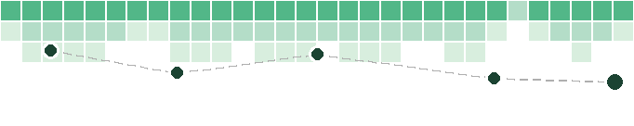
Andrea  Aparicio  University College London | Édith  Darin  University of Oxford
 | 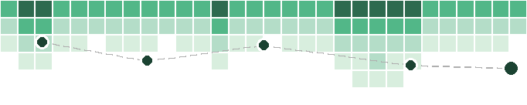
Ana Varela  Varela  London School of Economics | Nannan  Wei  London School of Economics
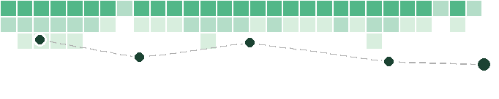 | 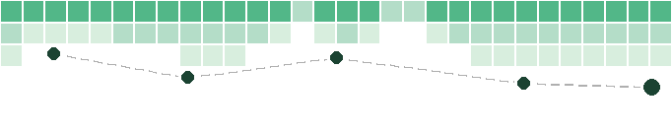
Ming  Tang  London School of Economics | Anna  Zanchetta  Alan Turing Institute
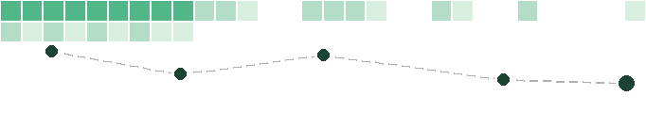 | 

Yijing  Li  King's College London | Zara  Shabrina  King's College London
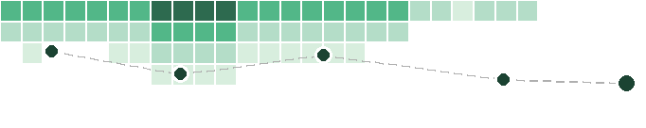 | 
Tosin  Orenaike  IOM DTM | Fahad  Naveed  IOM Pakistan
 | 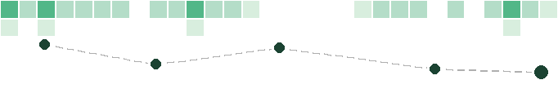
Heidy  Posada  IOM Colombia | Ruzi  Kahonde  FCDO
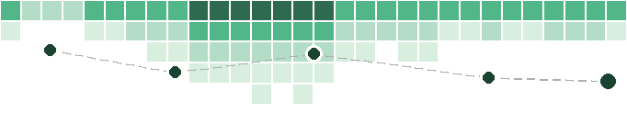 | 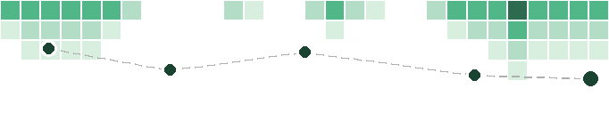
Mouad  Khoubbane  IOM | Yassine  Kerkeni  IOM
 | 
Stuart  Campo  IOM | Elena  Gentili  Banca d'Italia
 | 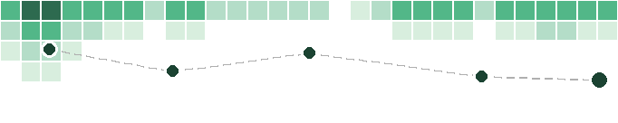

Linus  Bengtsson  Flowminder | Martin  Hendrick  EPFL
 | 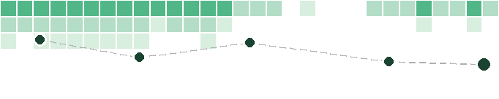
Sebastian  Langer  FCDO | Jin  Rui  King's College London
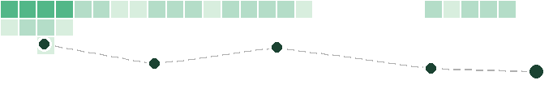 | 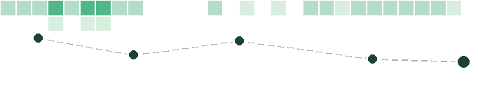
Lawrence  Hawker  University of Bristol | Caroline  Jawo  University of Liverpool
 | 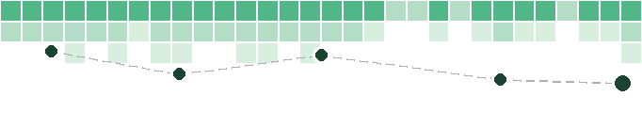
Munazza  Usmani  Newcastle University | Charis  Entwistle  MHCLG
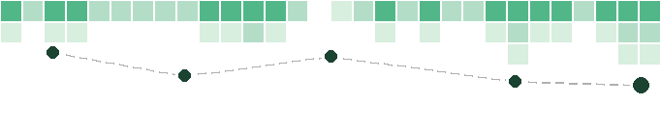 | 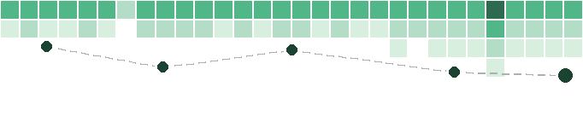
Jiaming  Yu  King's College London | Paul  Blanchard  World Bank
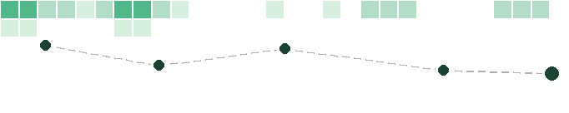 | 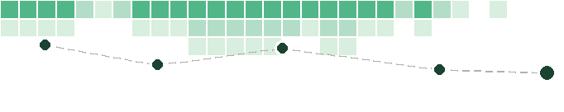

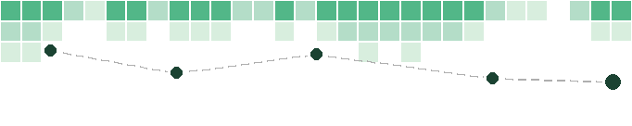 | 
 | 
 | 
 | 
 | 

