**How to compare two documents in Total Commander?**

1. **Make sure both documents have “.txt” extension.**
2. **Open Total Commander.**

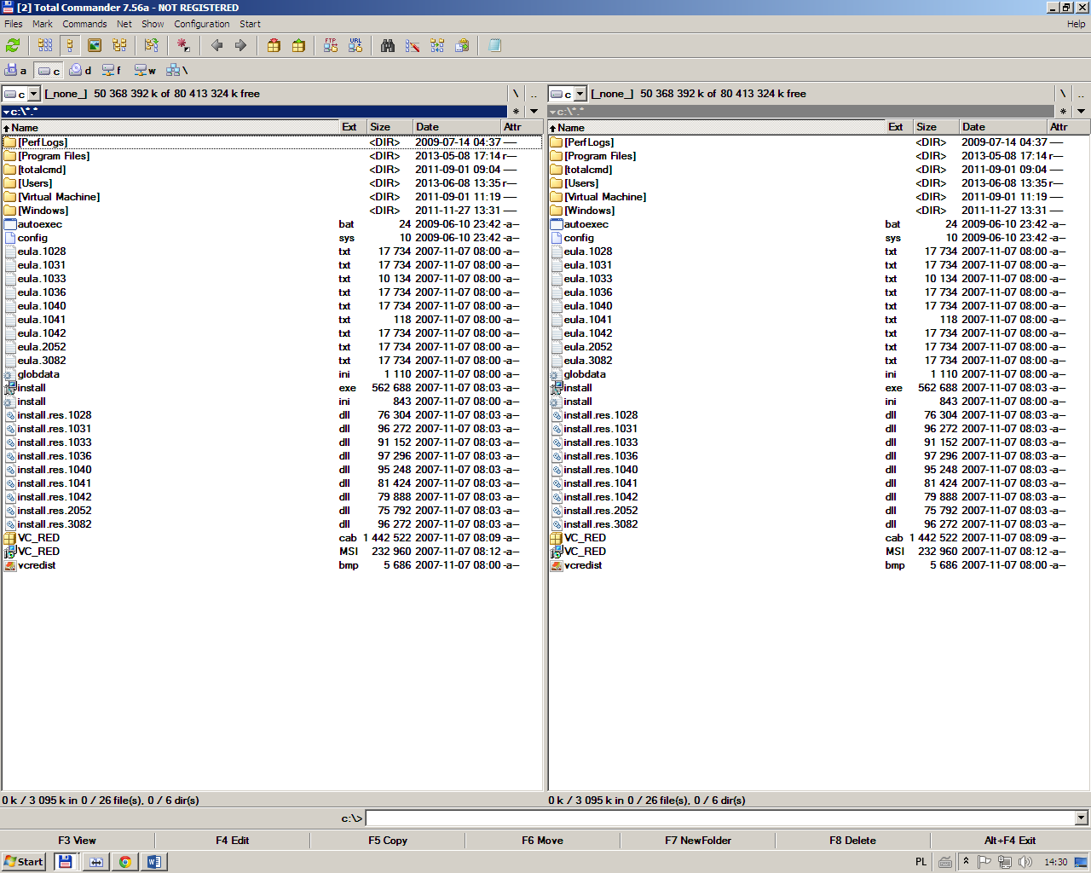

1. Choose “Files” from options and then “Compare by content”.

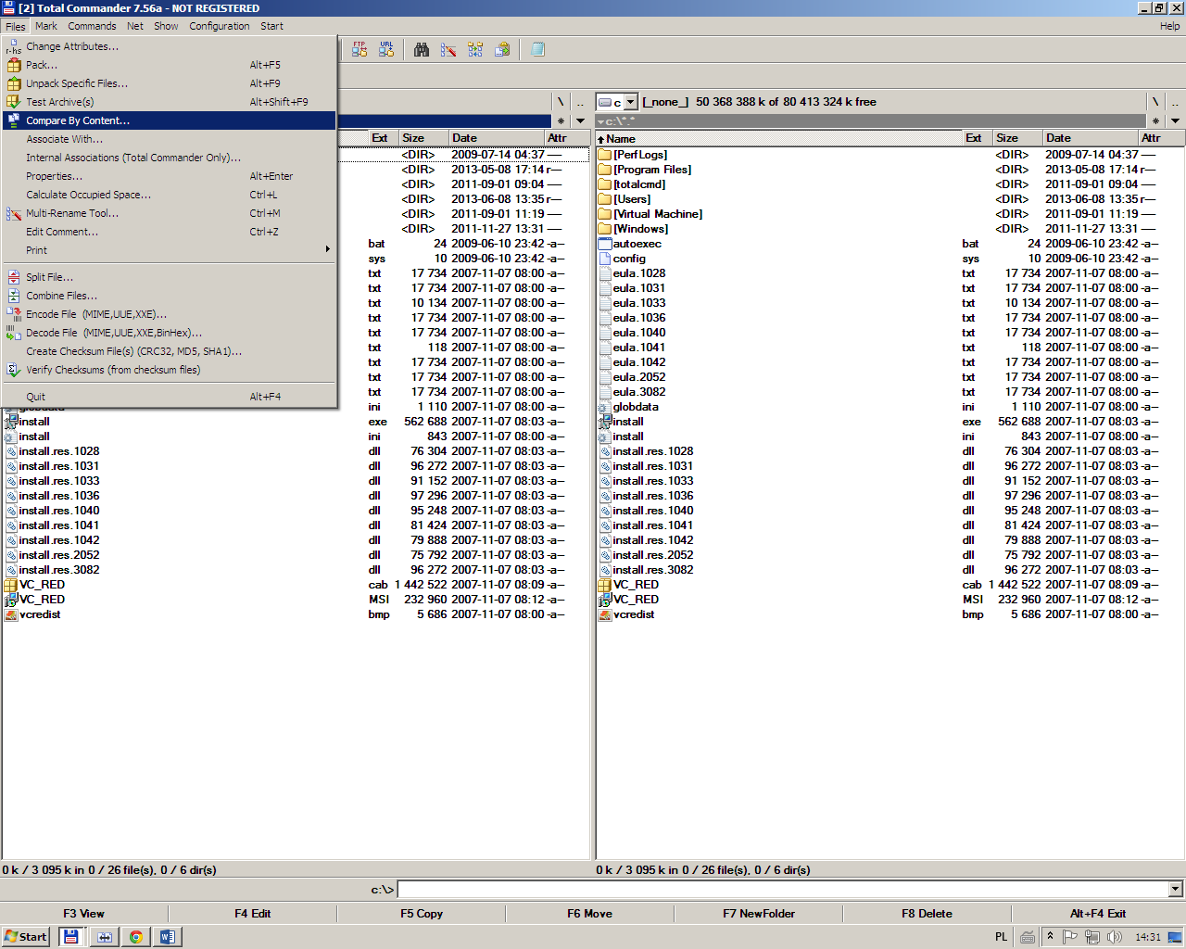

1. Choose two files you want to compare.

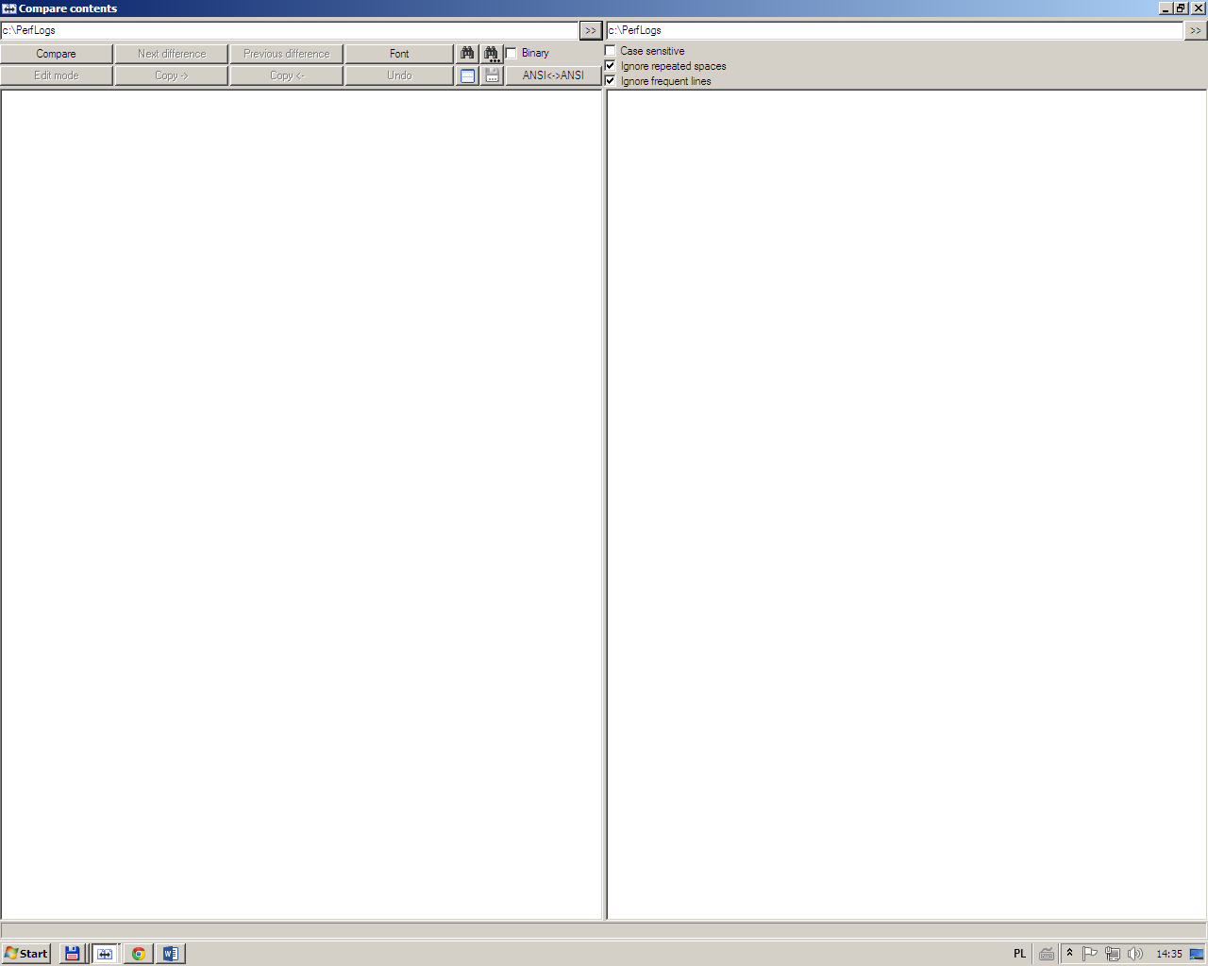

1. Choose option “compare”.