|  |  |
| --- | --- |
| **Project – External Document** |  |
| COMP6144  Web Programming |
| Odd Semester Year 2020/2021 |

* Project Title

IDEA Furniture website

* Introduction

In this project, we are required to build a simple e-commerce website called IDEA Furniture which sells furniture. For backend, we used Laravel 7.* as our framework. For authentication, we used Laravel’s build in authentication utilizing the laravel/ui package (version 2.4) to make it simpler and cleaner. We also made seeders and migrations so all tester has to do is to migrate, seed, and link the storage to test the website. For UI design, we opt to make a simple UI with white and pastel red color. When doing important actions (performing CRUD, checkout, etc) there is a confirmation dialog just in case any misclicks occur, to confirm the user’s actions. Proper feedback is also displayed (success and error messages) after doing certain actions to make sure the user is engaged with the website. We’ve also included icons from font awesome to make the UI more appealing for the user.

Link for the project :

* Notes
* The database name is “ideafurnituredb”
* Please perform migration and seeding with php artisan migrate:fresh –seed
* Please create storage link with php artisan storage:link
* We have also included an image file, please copy the images to the storage/app/public/images before viewing the website, as performing CRUD operations will also change the storage system.
* About the file system:
  + All product type images are stored in thumbnail/ folder
  + Product type images when stored are named in this format: timestamp_productTypeName.ext
  + All product images are stored in a folder named after its product type
  + Product type images when stored are named in this format: timestamp_productName.ext
* Since not specified in the question, all users who registers through the register page in the website will be automatically be registered as ‘member’ role. To add admin user(s), manual insert through SQL queries or from the UserSeeder is required.
* Report / Documentation

1. LOGIN

This is the login page. Page can be accessed by guess only. Error message will be shown if credentials don’t match the database. User can check the remember me checkbox, for the remember me functionality, where the website will remember the user for 12 hours using cookies. This means as long as the user does not log out in the 12 hours period, the website will be in the logged in state. When the user logs out, the cookie will be removed.

Note: We have added two user, user ‘admin@admin’ with password ‘admin1234’ for admin and user ‘member@member’ with password ‘member1234’ for member.

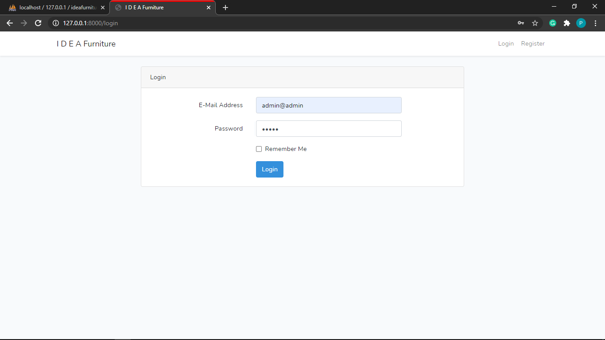

1. REGISTER

This is register page. This page can only be accessed by guest. If inputted credential does not match the requirements, it will display error message under it. User who registers from here will be automatically added as member and will be logged in to the website.

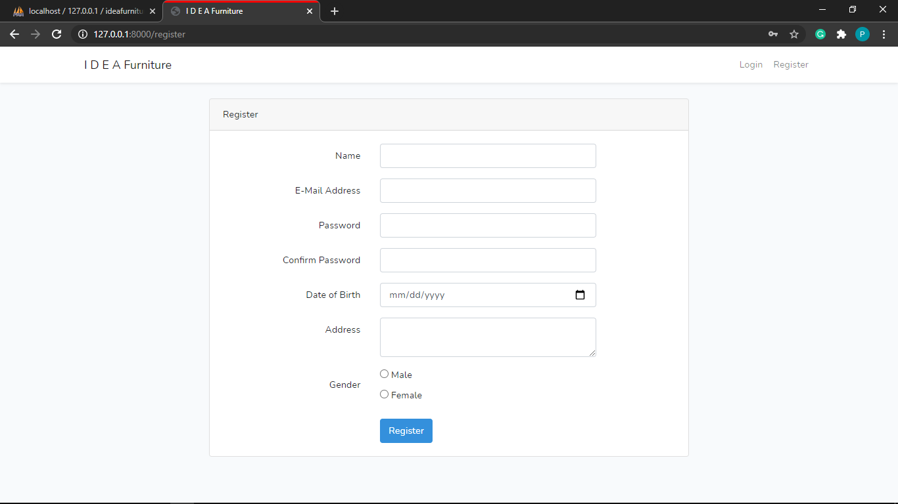

1. HOME

This is the home page where all product type available will be shown.

* 1. For Guest and Member users

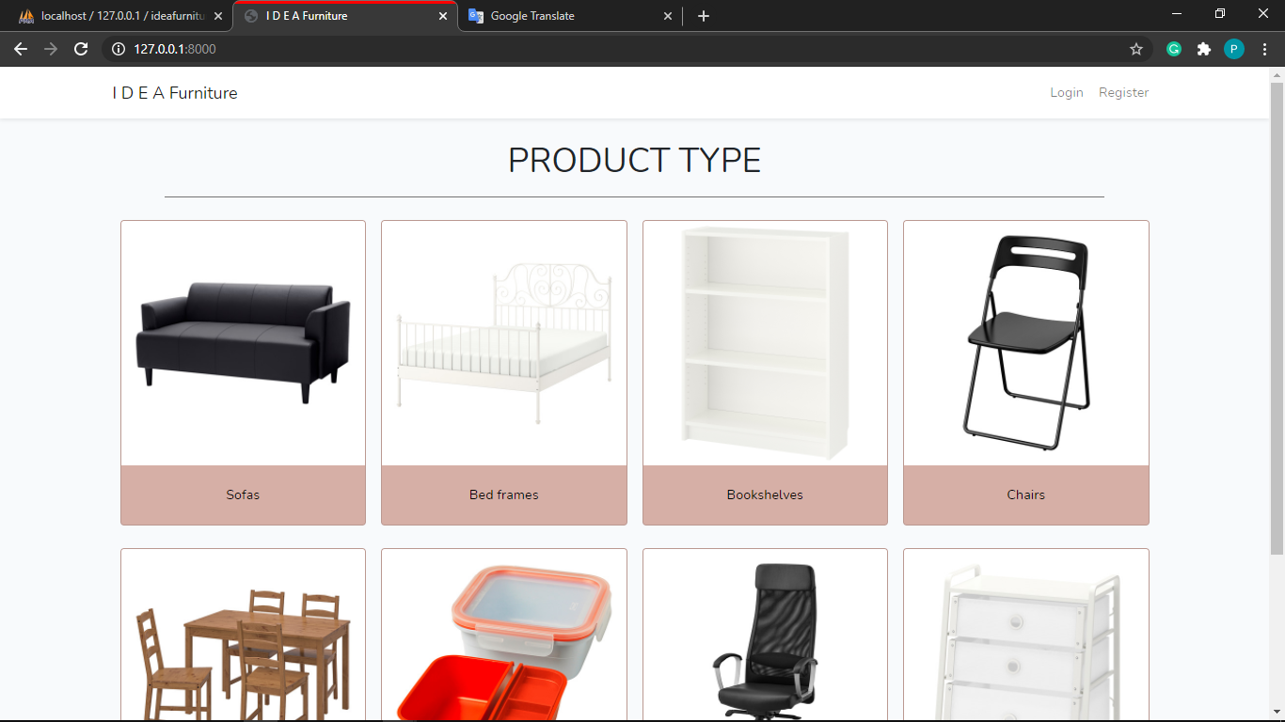

* 1. For Admin

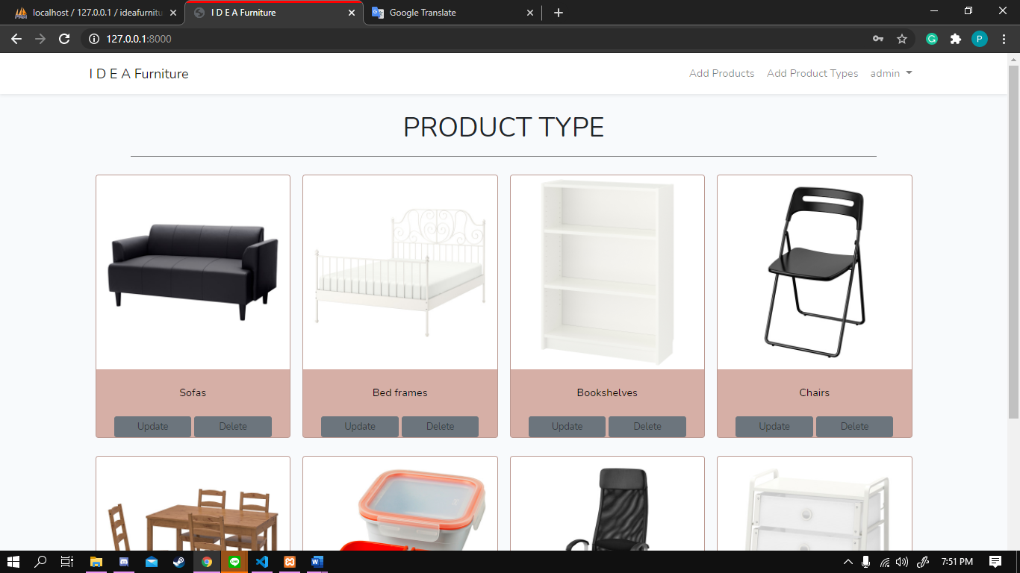

*There is update and delete button under the product type for admin users, to update/delete the product type.*

1. VIEW PRODUCT

This is view product page. After clicking the image or the name of the product type, user will be directed to this page, where they can see all the products in the product type. Products are only shown 10 at a time (pagination links at the bottom of the page).

* 1. For Guest and Member users

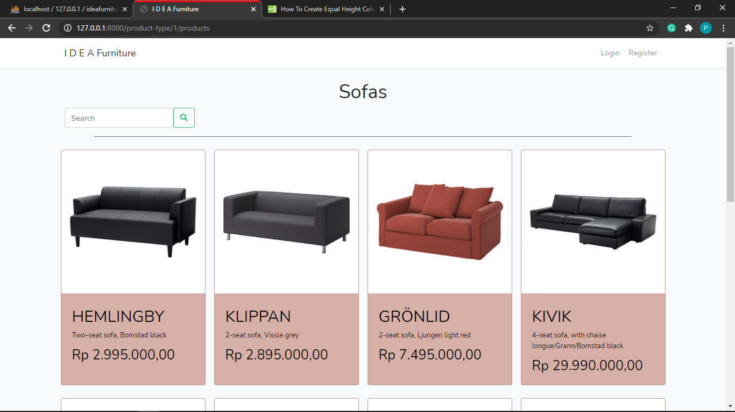

* 1. For Admin

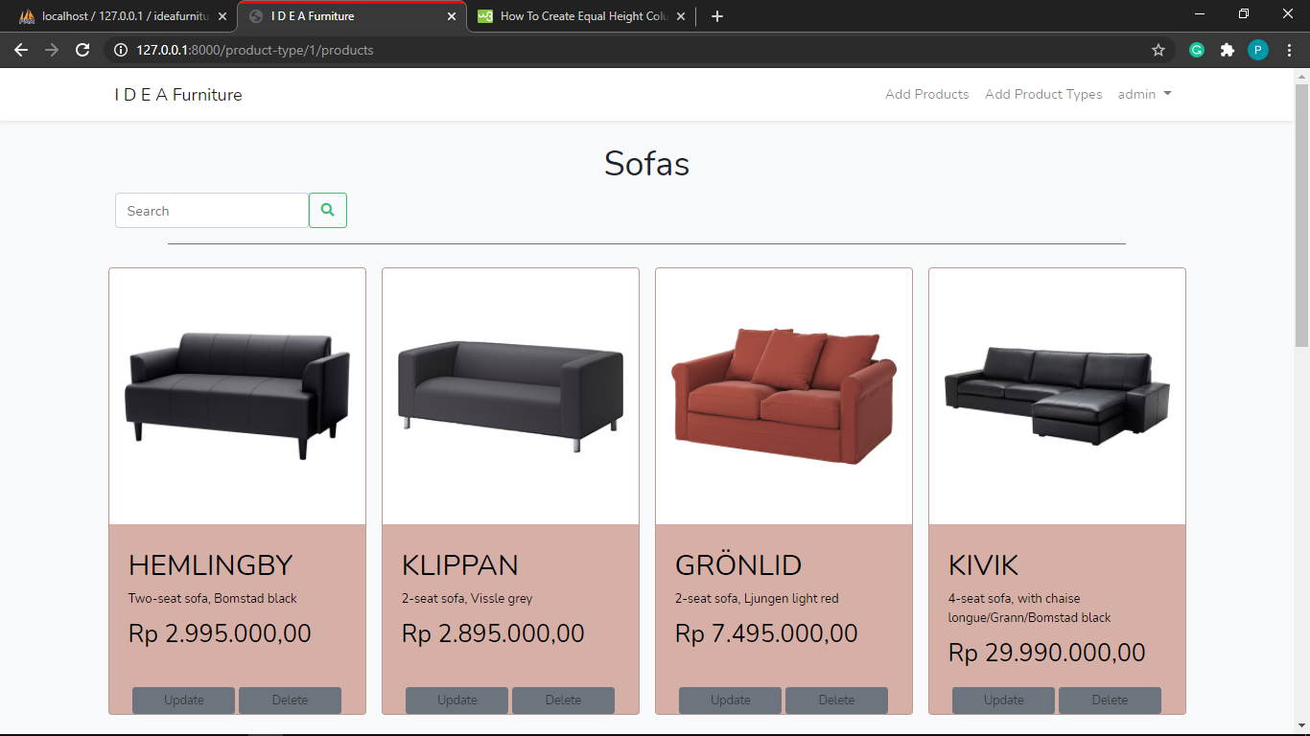

*There is update and delete button under the product for admin users, to update/delete the product.*

If there is no product available, this will be shown:

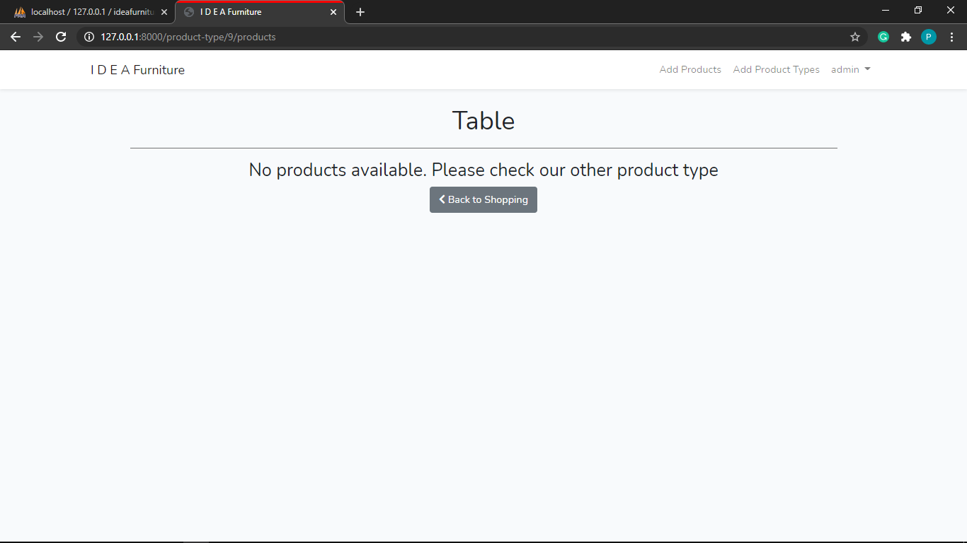

1. VIEW PRODUCT DETAILS

This is the product details page. After clicking the image/name of the product, user will be directed to this page. Member have an additional form which can be used to add the product to cart, while guest and admin does not have this form in view. After member click add to cart, a success message will be displayed if the quantity suffice (below stock, not zero, not null).

* 1. For Member

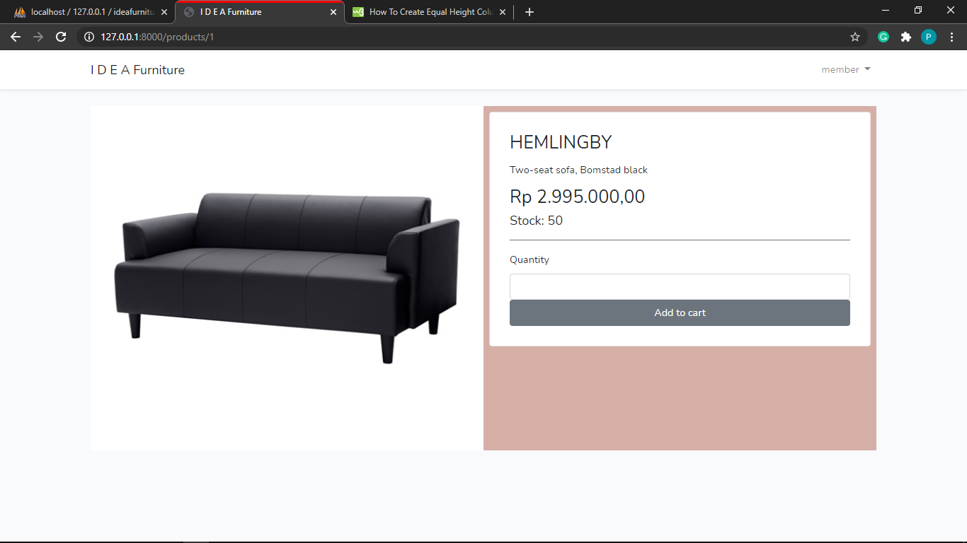

*Additional form to add item to cart for member users*

* 1. For Guest and Admin

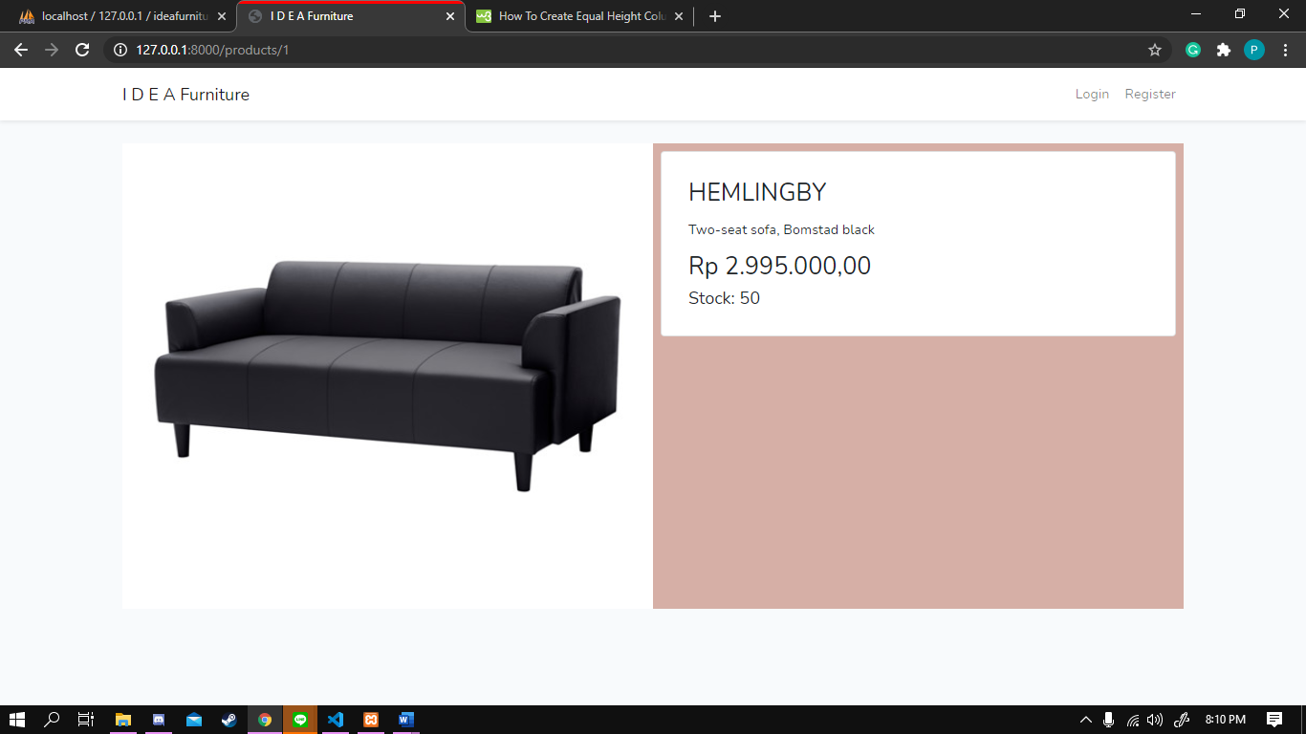

1. ADD PRODUCT

This is the add product page. Only admin can access this page. After admin inputted data, a success message will appear if the data matches all the requirements.

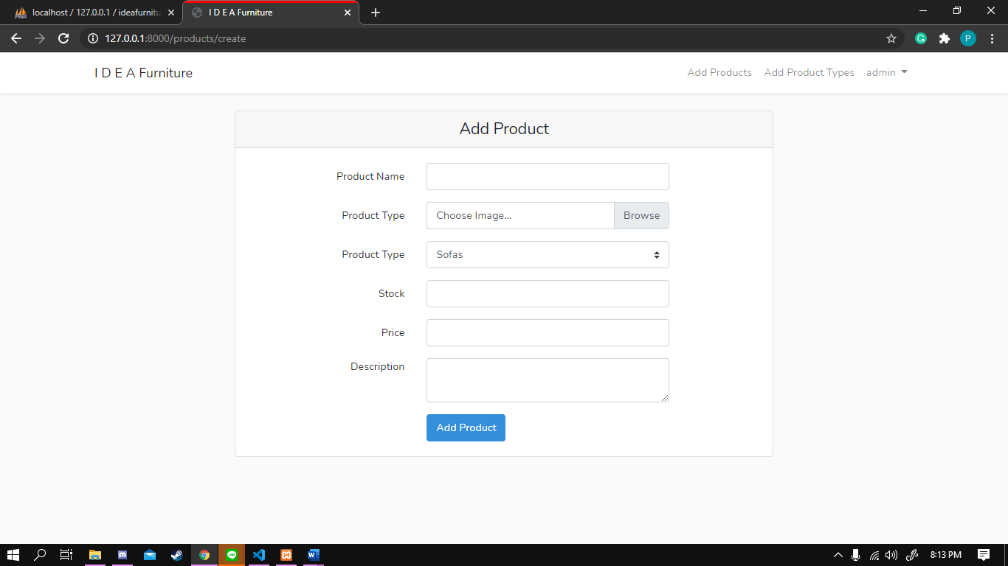

* 1. Success

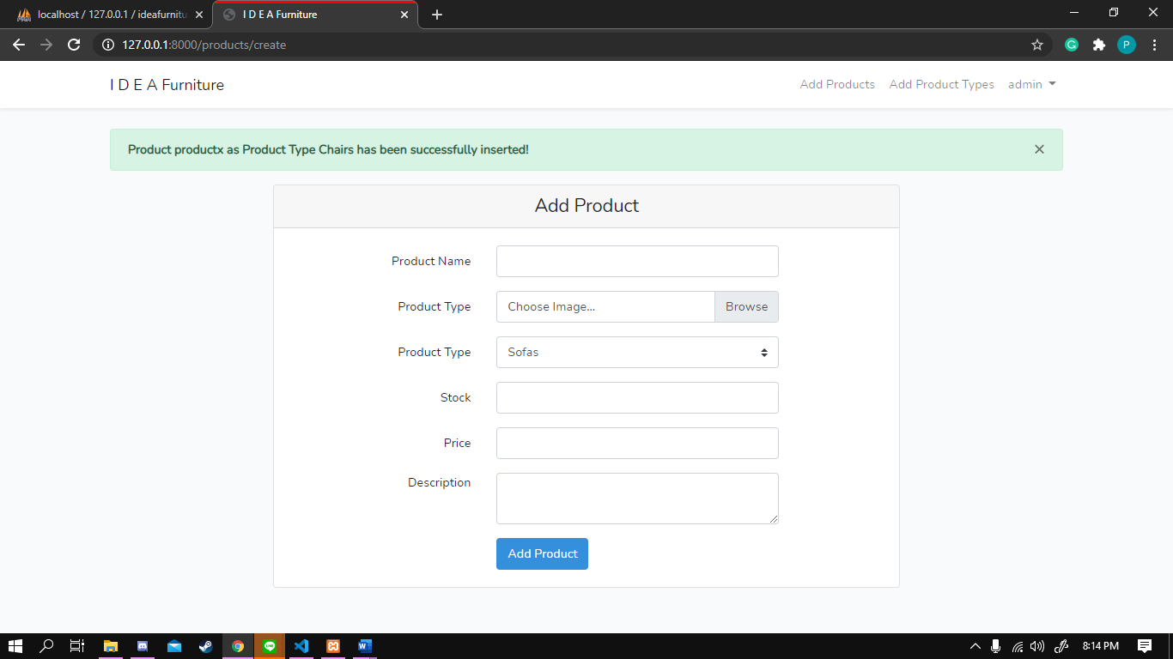

* 1. Error example (name too short)

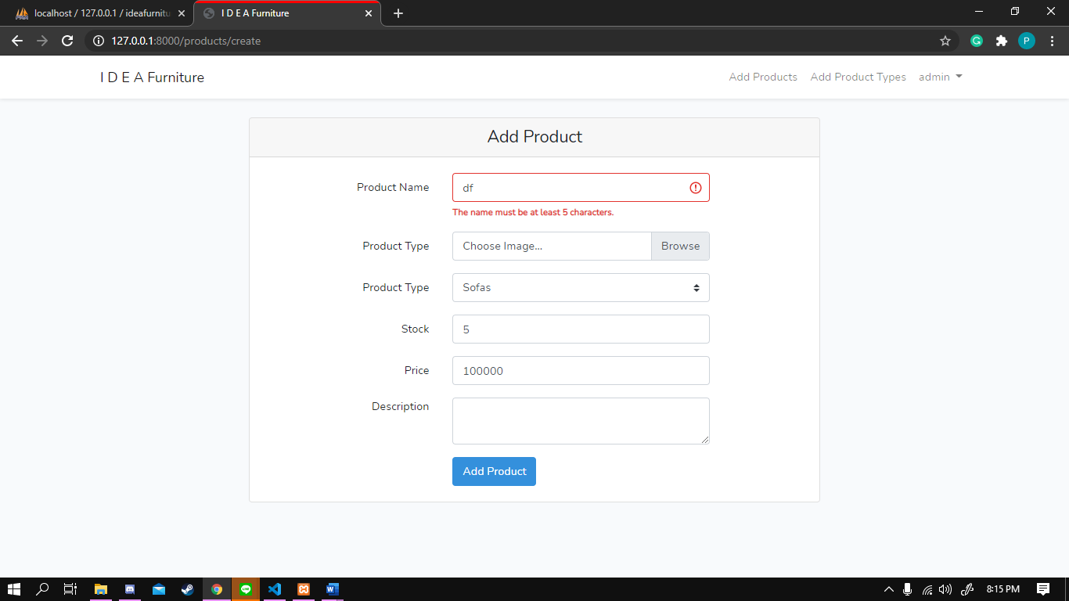

NOTE: We added an image called noideayet.jpg. If admin doesn’t add any image to new product, noideayet will be used instead as a replacement instead. The noideayet.jpg is stored at the the thumbnail/ folder

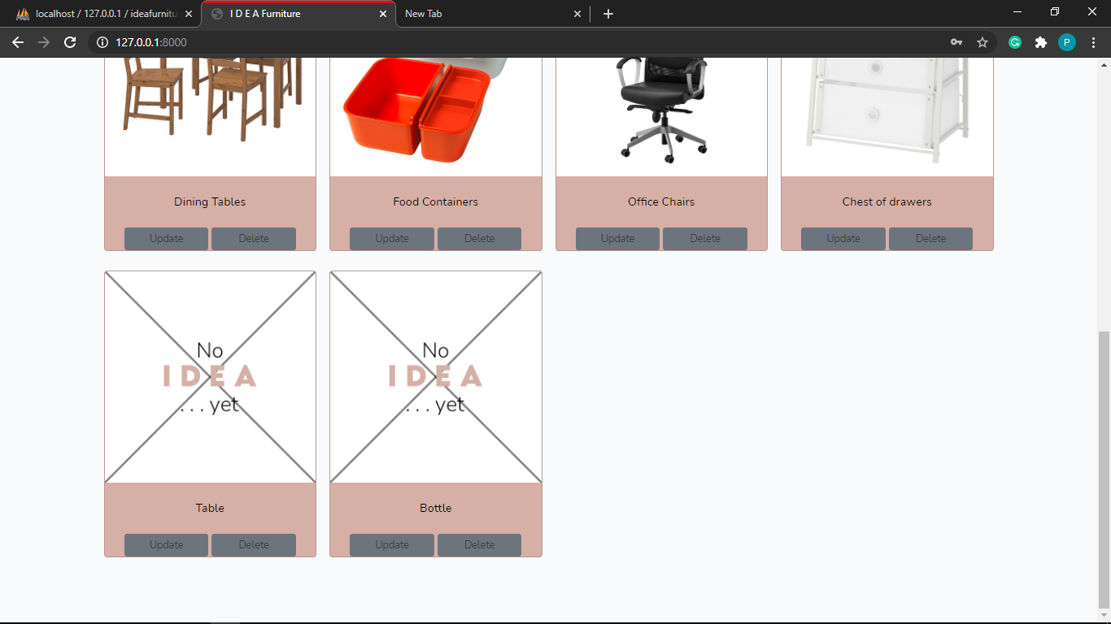

1. UPDATE PRODUCT

This is the update product page. Old data of the product will be added automatically to the input bar. Admin can choose to delete current image (making the product type image become the “no idea yet” image), or include a new image.

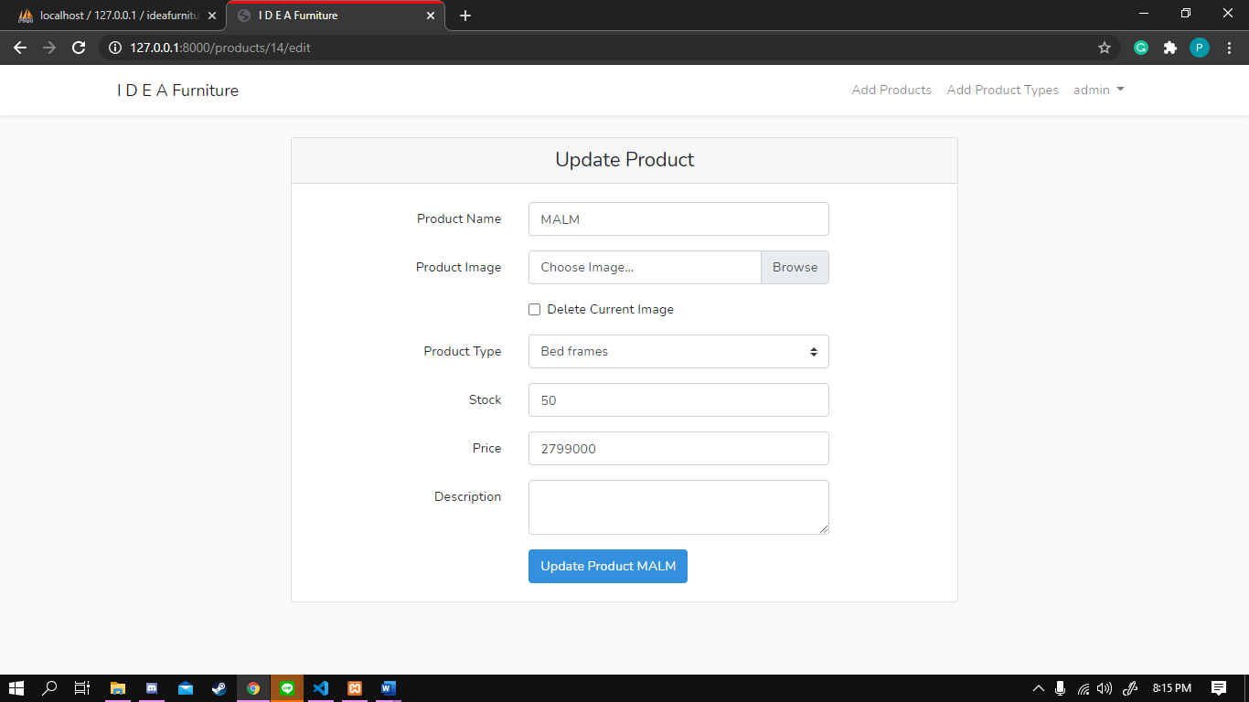

* 1. Success

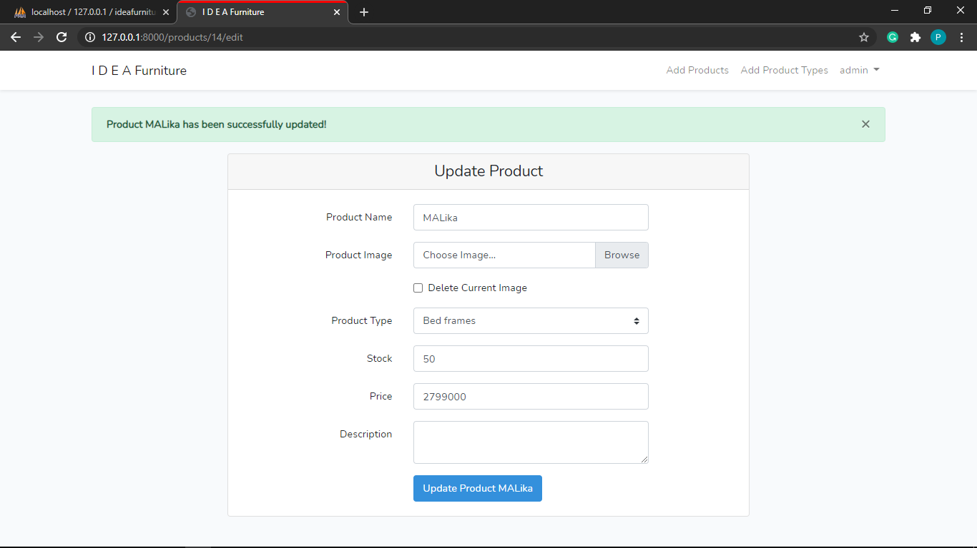

1. ADD PRODUCT TYPE

This is the add product type page. Only admin can access this page. Success message will be displayed above if the addition is a success.

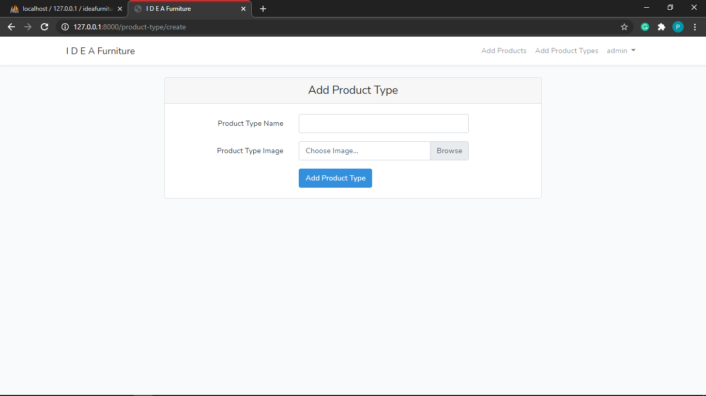

* 1. Success

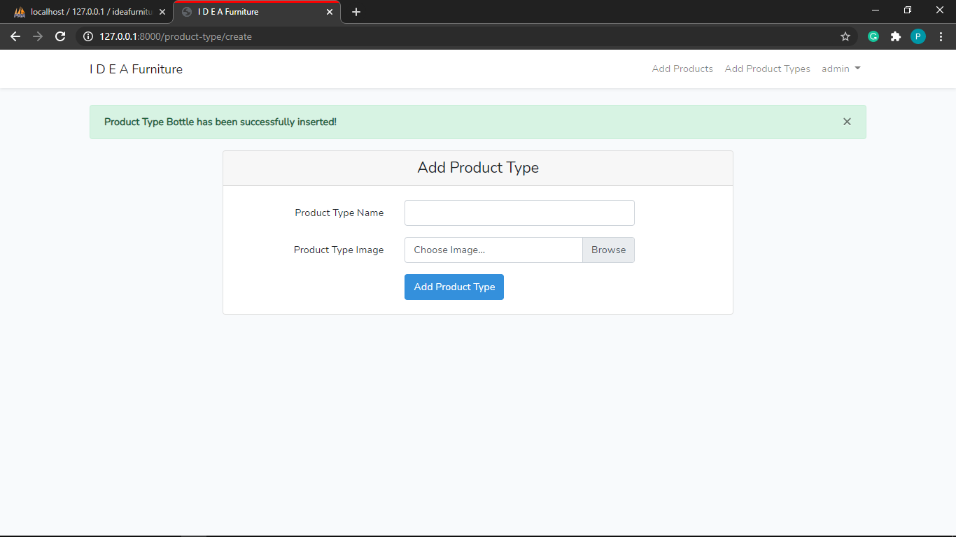

NOTE: Same as products, we added an image called noideayet.jpg. If admin doesn’t add any image to new product type, noideayet will be used instead as a replacement instead.

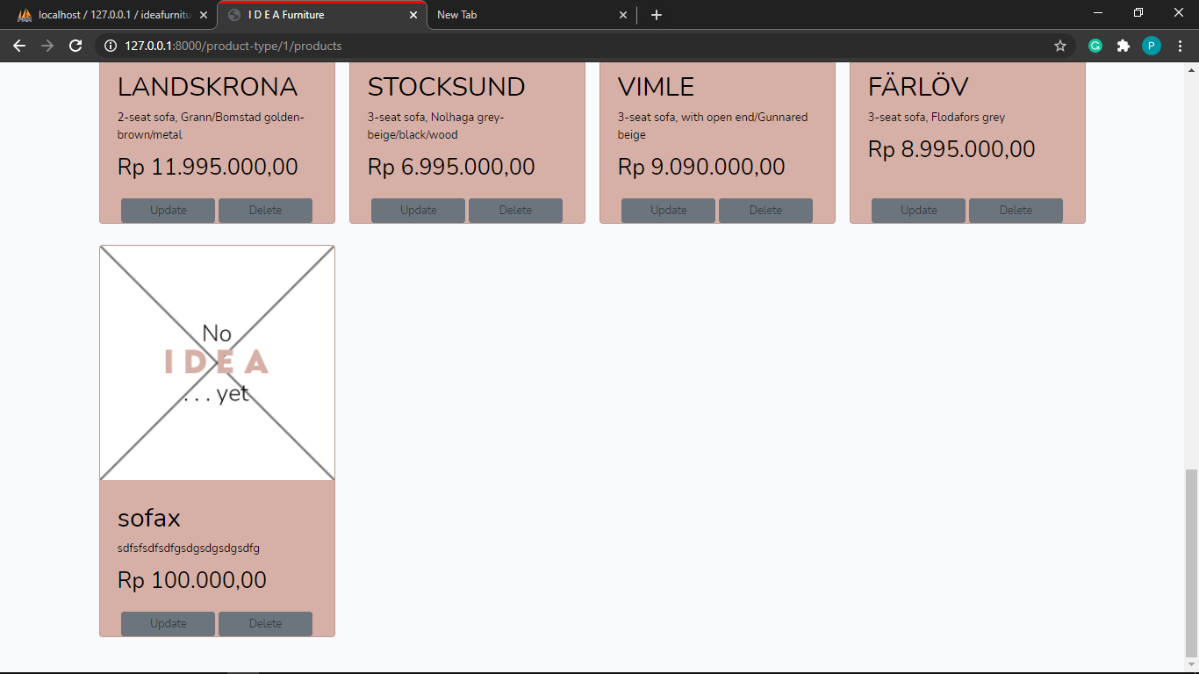

1. UPDATE PRODUCT TYPE

This is the update product type page. Only admin can access this page. Admin can choose to delete current image (making the product type image become the “no idea yet” image), or include a new image.

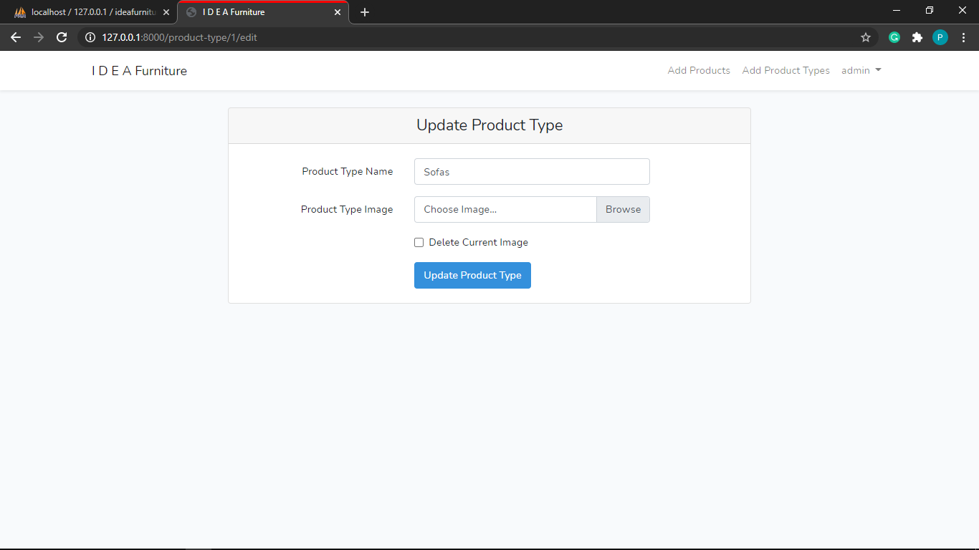

* 1. Success

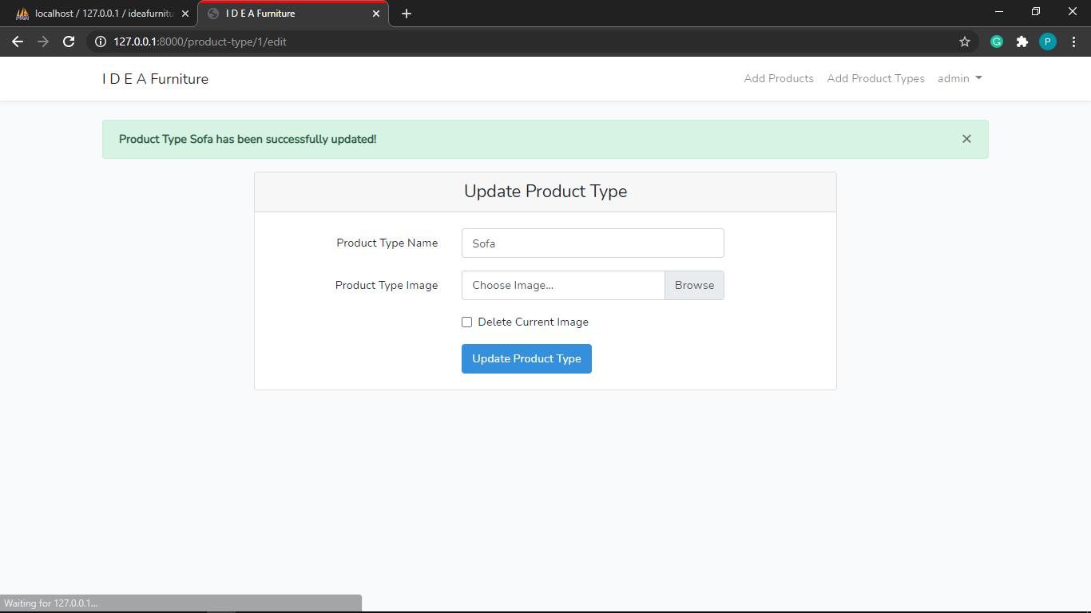

1. EDIT PROFILE

This is edit profile page. Only member can access it. Current user data will be automatically filled.

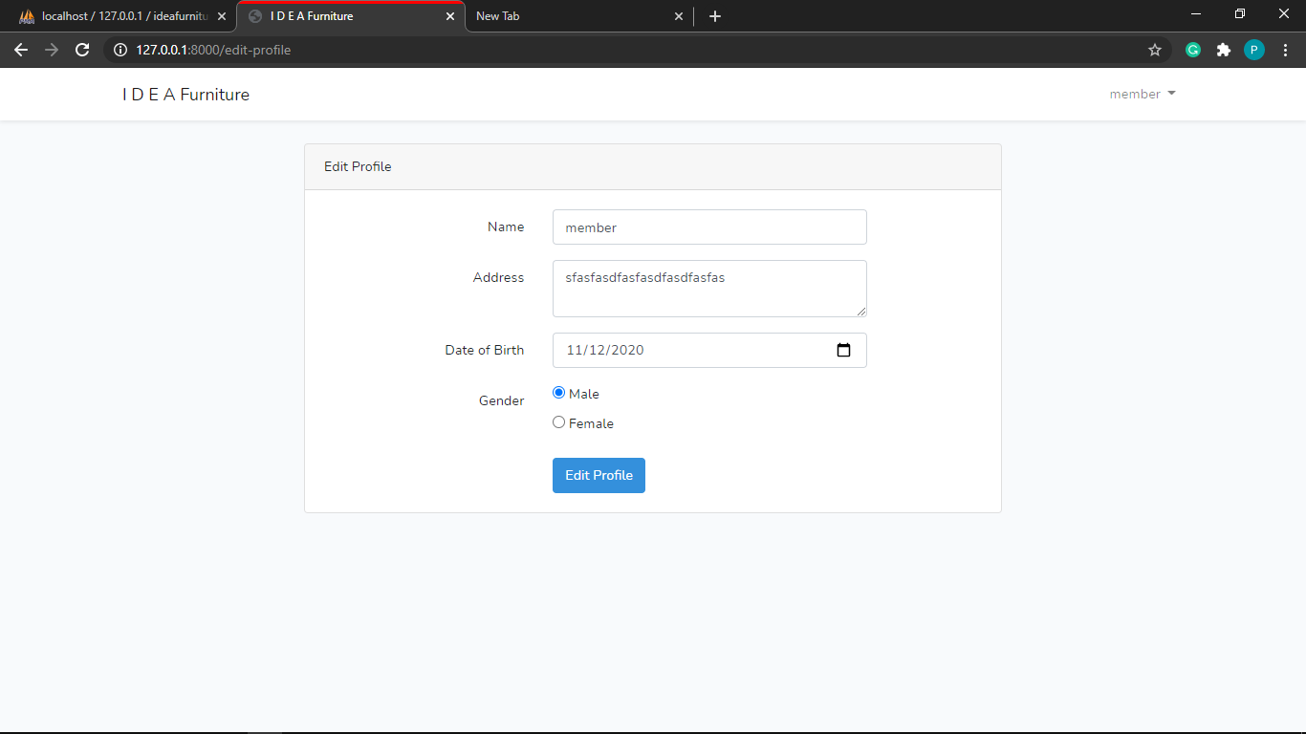

* 1. Success

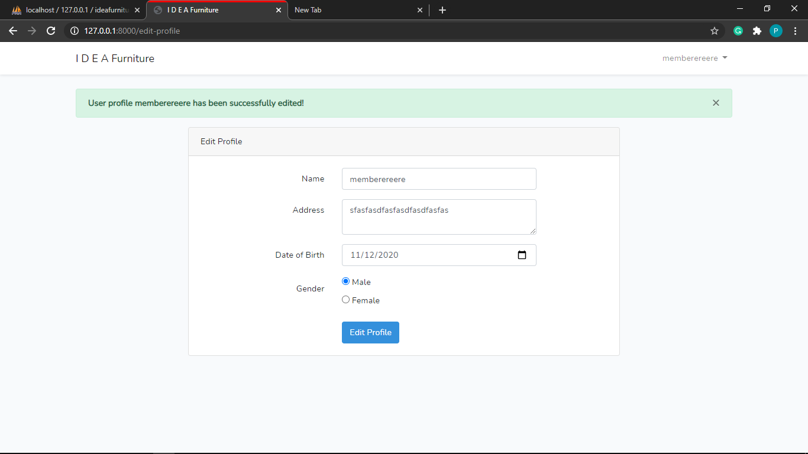

1. TRANSACTION HISTORY

This is the transaction history page. Only member can access it.

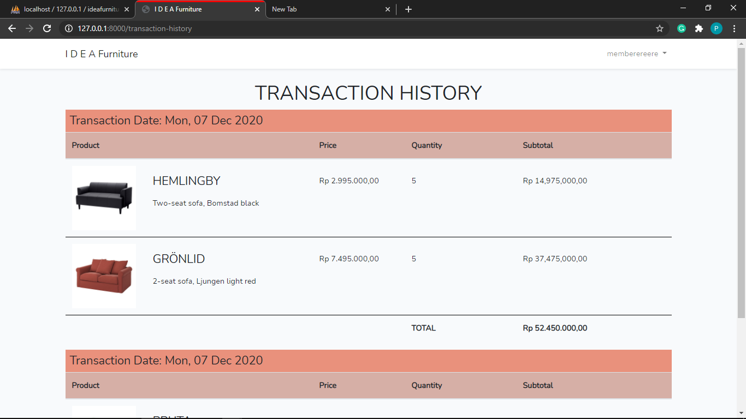

If there is no transaction history, this will be shown:

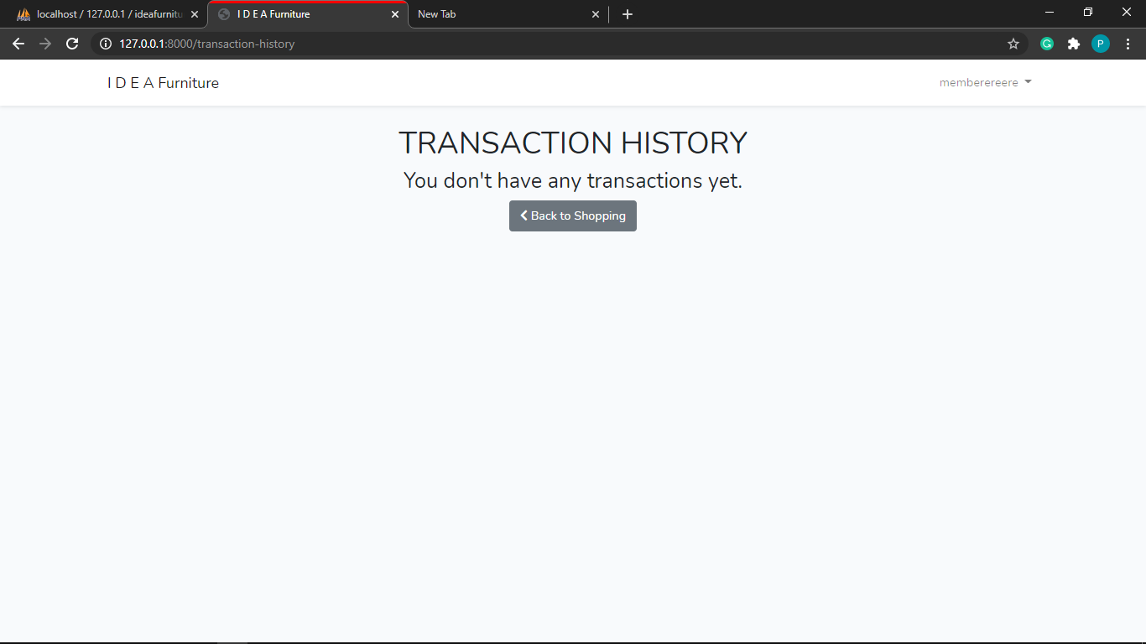

1. SHOPPING CART

This is the shopping cart page. Only member can access it. We have added a remove all item button so that user can easily delete all item.

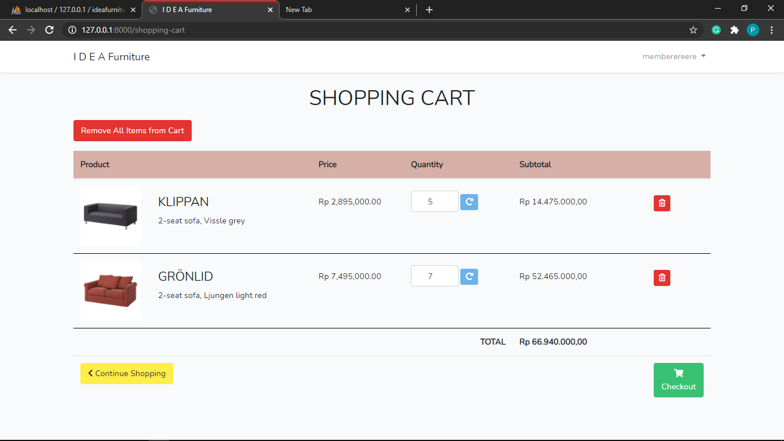

If there is no item, this will be shown:

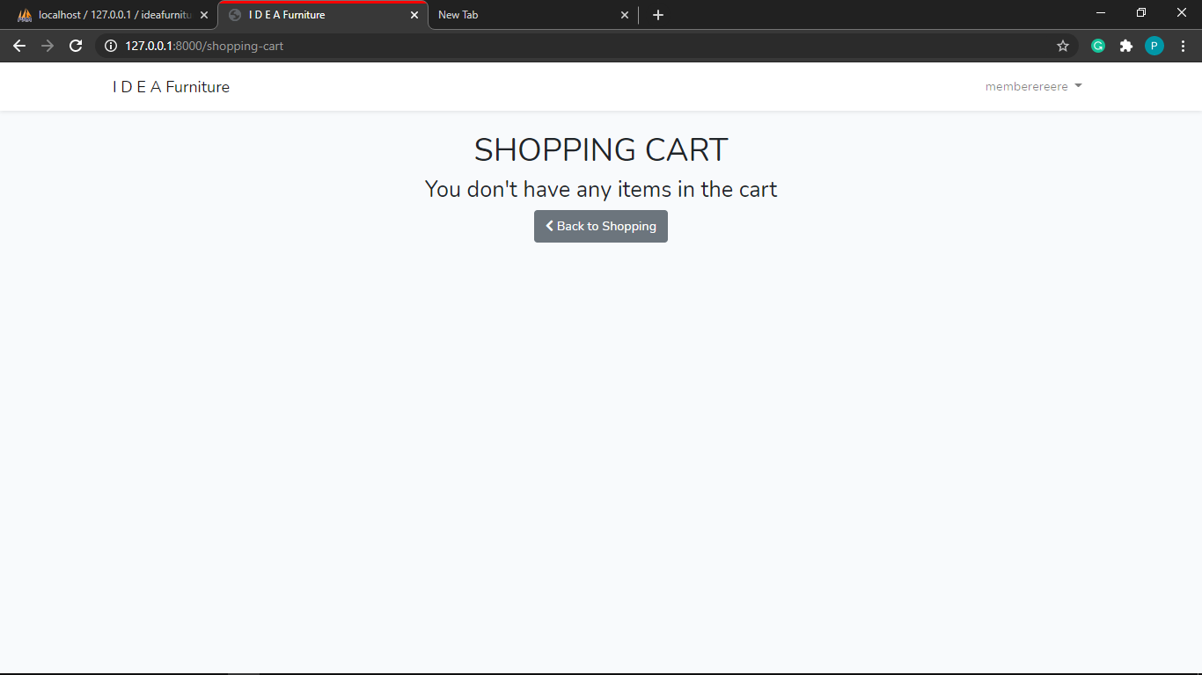

* Reference
* Products name, price, description, and image from: https://www.ikea.co.id/en/
* Group Member
* 2201752552 - Jason Andersen Winfrey
* 2201741025 - Pietter Haizel