Web Programming Final Term Test

Pietter Haizel

2201741025

Wonderful Journey Documentation

The website is based on the screen shot and the description of the problem. Some of the orientation and the design might not make sense, but I am just making the best of what I think based on the information I have.

Link for the file: https://github.com/pietter567/Wonderful-Journey

* Home page as guest

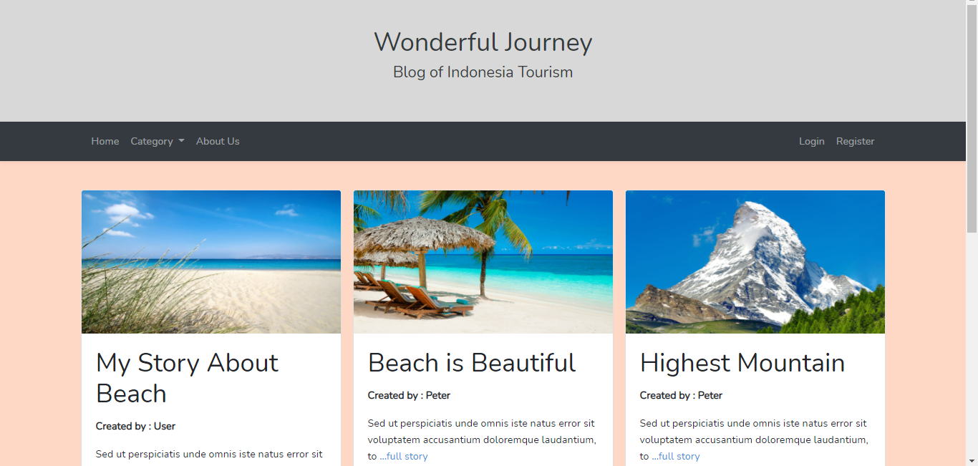

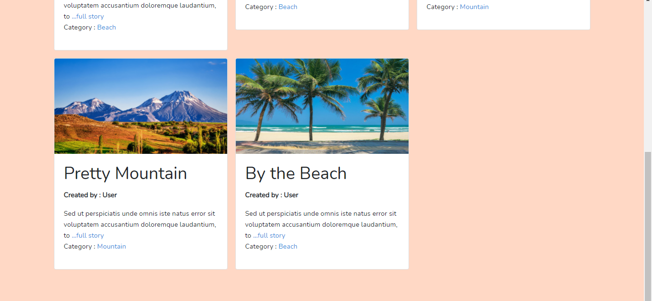

* Category, can be accessed by clicking navbar (guest) or by the article’s category (logged user)

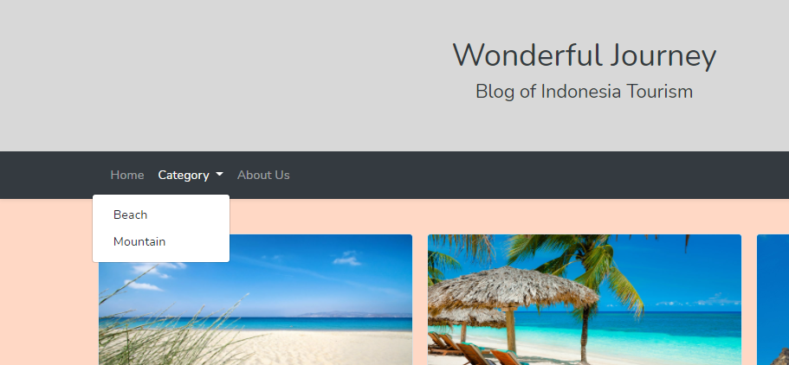

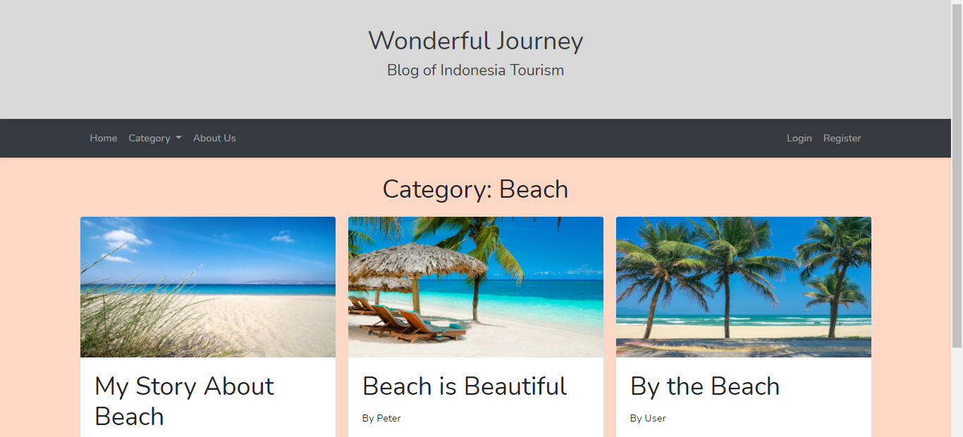

* Article post (can be accessed by anyone by clicking either the picture of the article or the ‘full story button’)

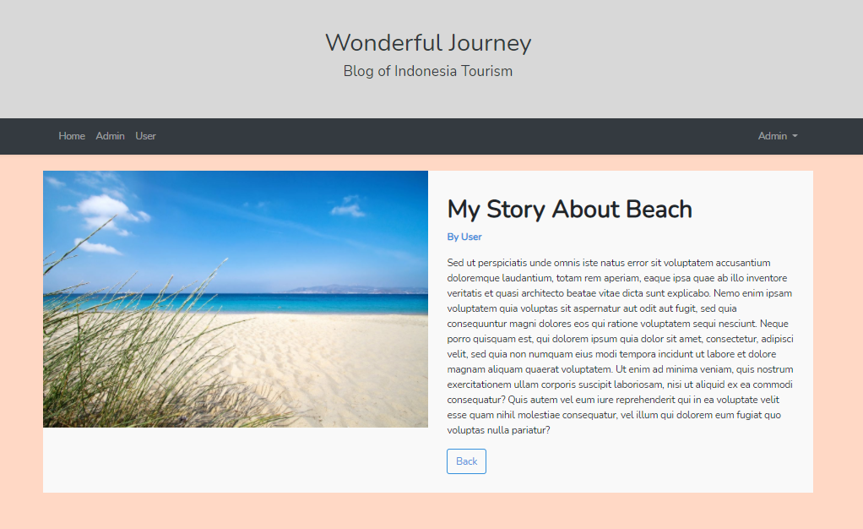

* About us, can be accessed by everyone (directly by link for logged user or by navbar for guest).

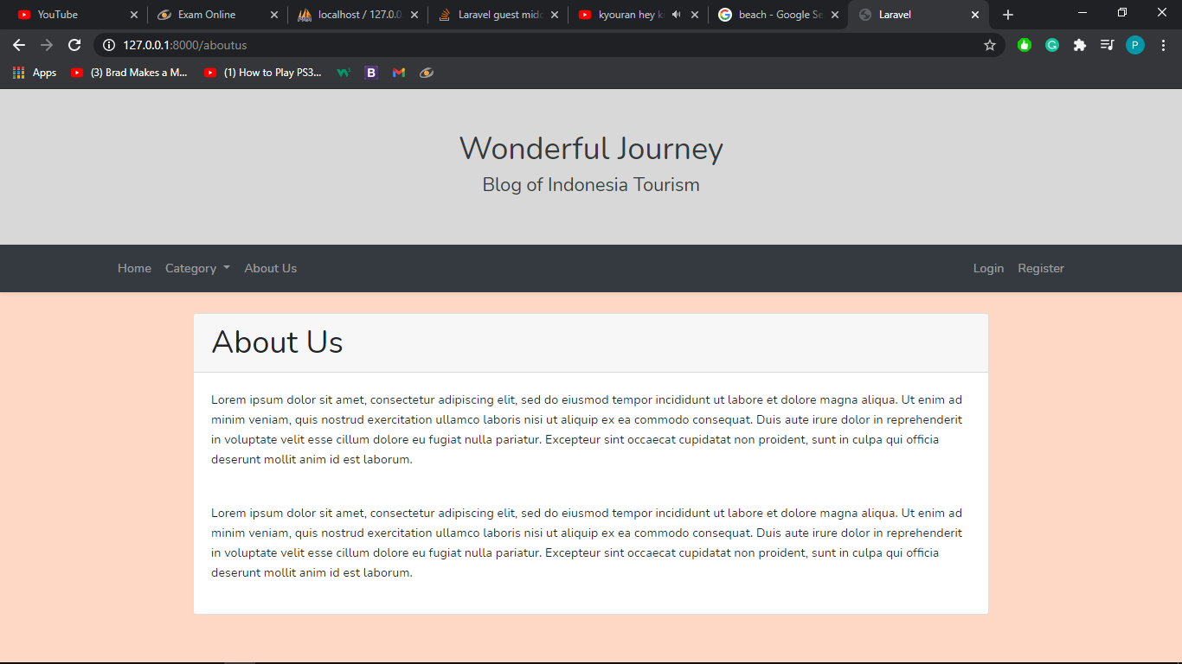

* Register (zoomed out to see all the box, can only accessed by guest)

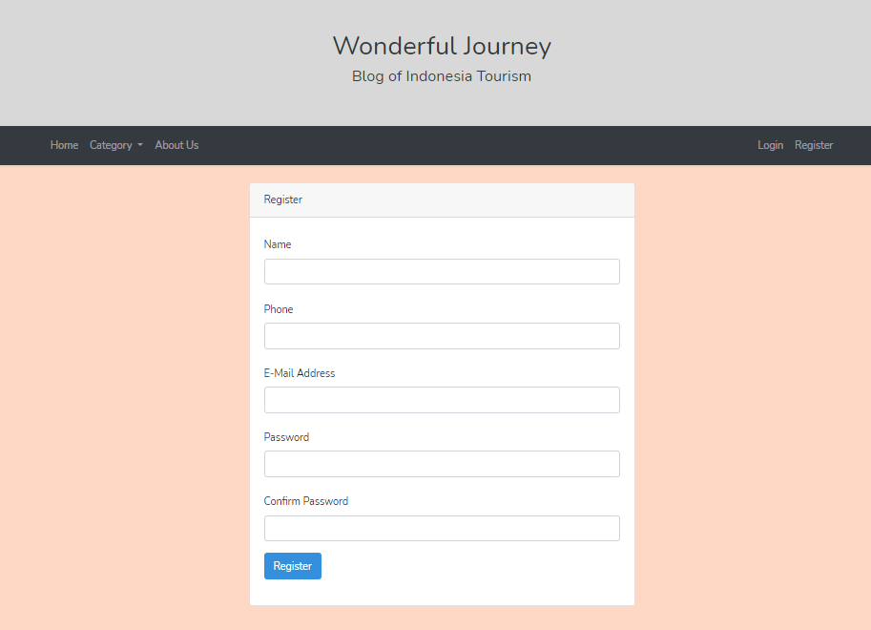

* Login (can only be accessed by guest)

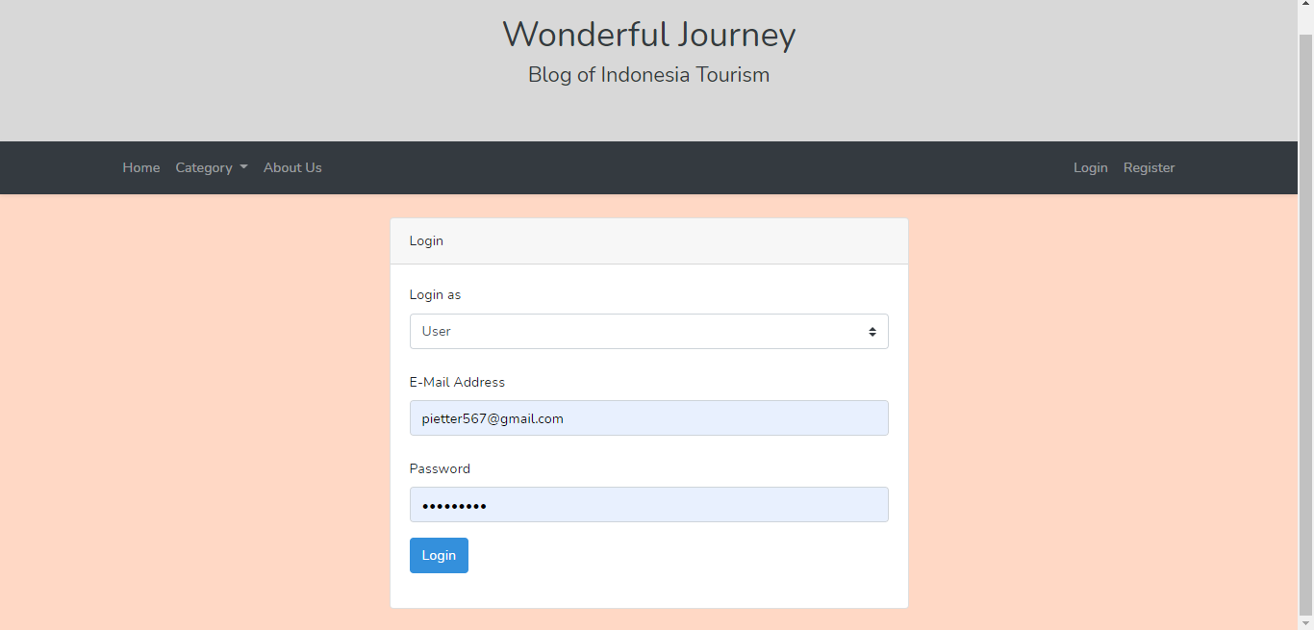

* Greeting message (can only be accessed by logged user, either admin or user, will be shown after successful login/register. Will show the user’s name after welcome)

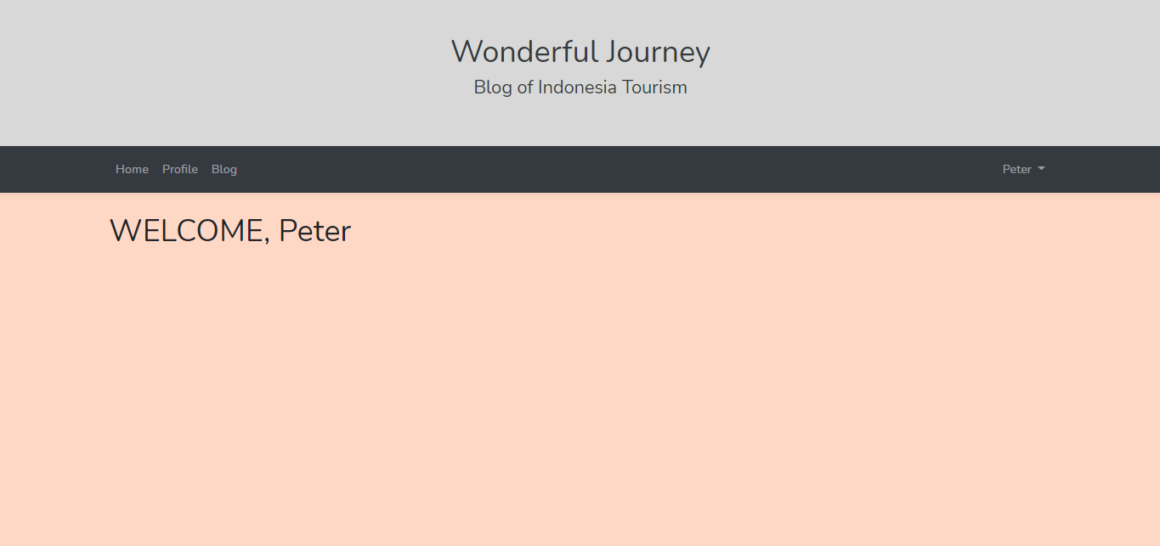

* Profile (can only be accessed by user in the navbar ‘profile’. Can be changed by changing the data inside the box and pressing update)

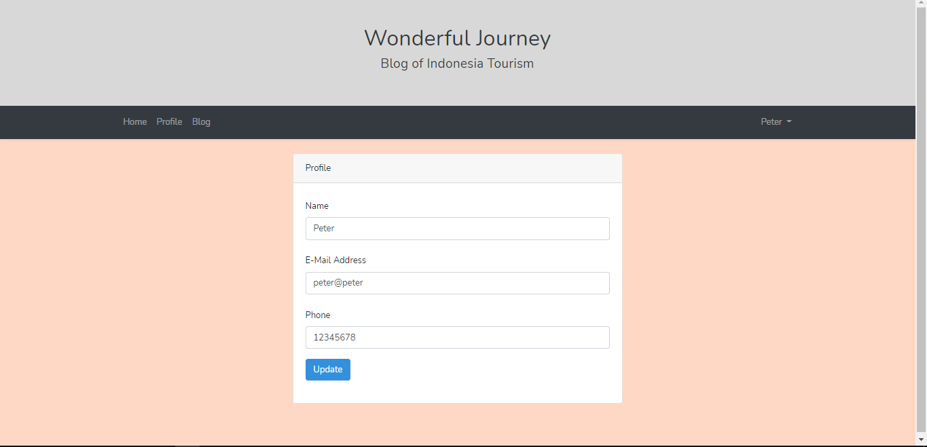

* Blog List (can only be accessed by user in the navbar ‘blog’. User can delete their blog here)

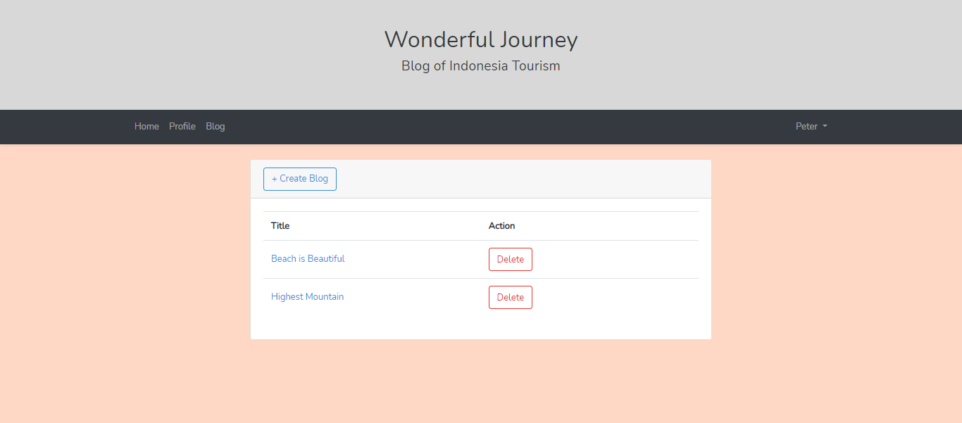

* Create blog (can only be accessed by user by clicking the create blog button in blog list)

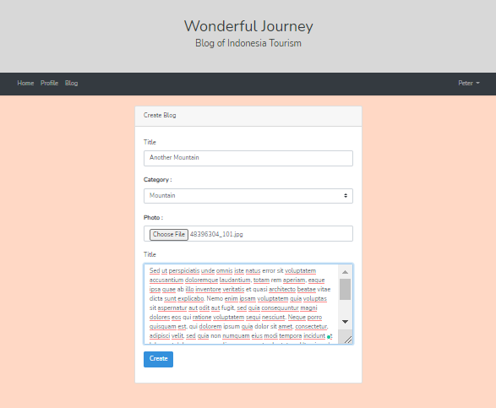 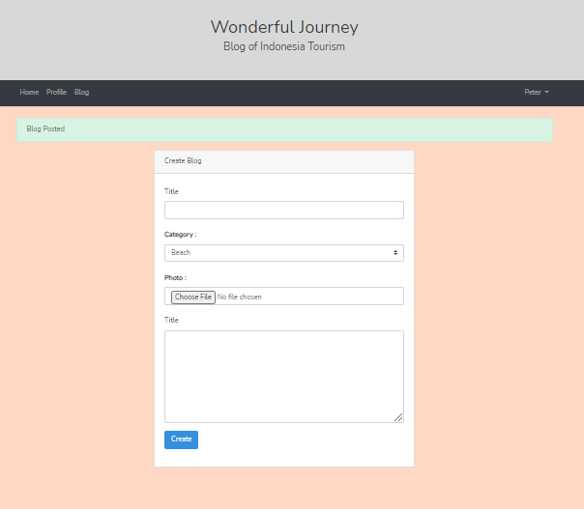

* Admin’s menu (Navbar is different, additionally article will have delete button so admin can delete user’s article there)

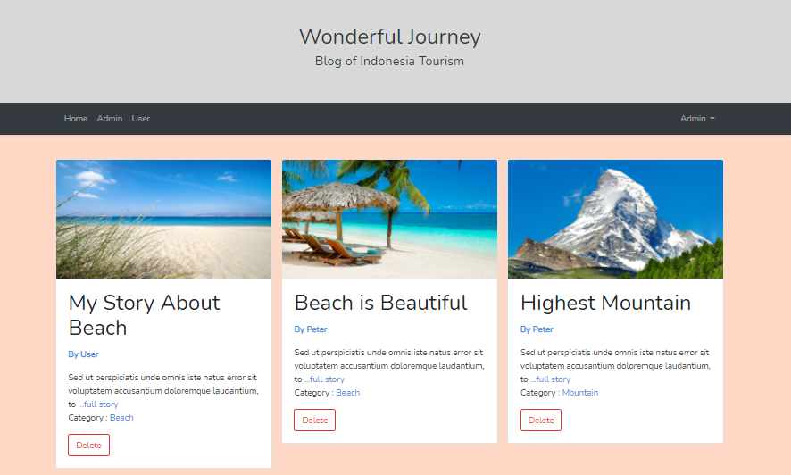

* Admin’s profile (can be accessed by clicking ‘Admin’ in the navbar. There is no update button as admin’s profile changes will have to be done by seeding)

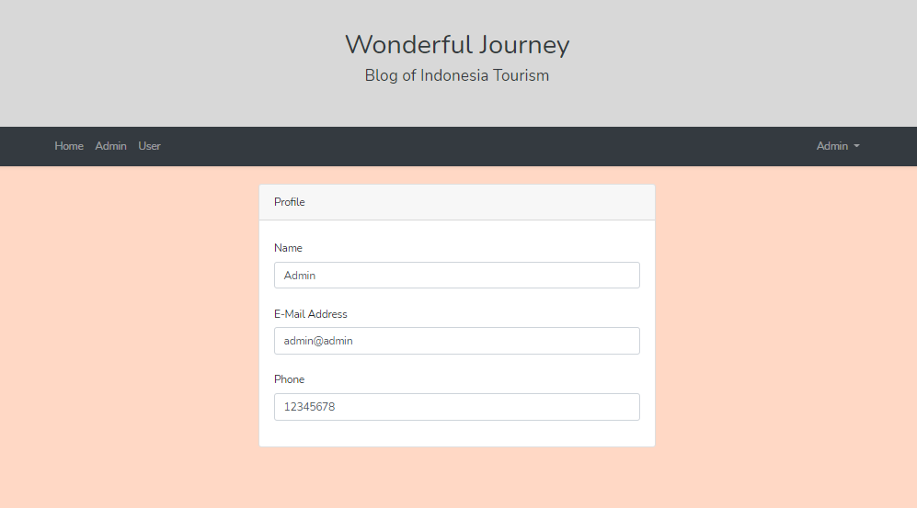

* User’s List (can be accessed only by admin in the ‘User’ navbar. It will list all user and admin can delete them. Deleting user will delete all existing article made by user)

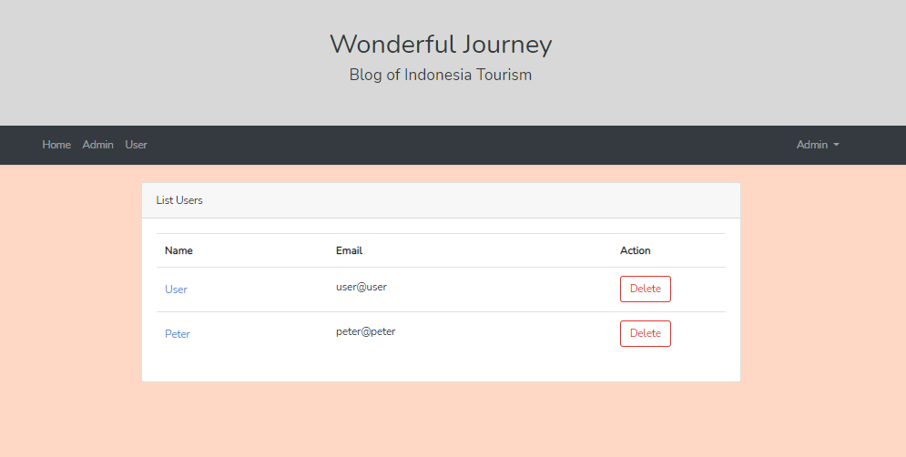

* User Detail (can only be accessed by admin by clicking the name of the user in the User List, will show a detailed information of user)

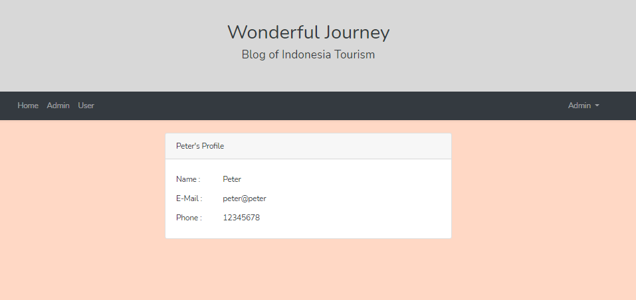

* Logout (can be accessed by logged user, will log out the user)

