Robert Ross

Professor Collette Caton

UWRT-150.42

3 December 2015

What’s the big deal about Magic: the Gathering?

Magic: The Gathering is a trading card game created by Richard Garfield. Its first expansion, Alpha, came out in 1993. It eventually came under control of Wizards of the Coast and is headed by Mark Rosewater. It is typically sold in Booster Packs. A Booster pack contains 11 Commons, 3 uncommon, and a Rare or Mythic Rare Typically, this is how stores will sell cards to customers. So, outside of supplemental products such as commander releases and other expansions, this is the only way to acquire cards through Wizard’s. There’s a very large secondary market for the game, and this is how most people end up acquiring their cards. While it is expensive, it’s a lot cheaper than trying to get the cards you know threw packs. With these cards there are many ways to play. There are multiple formats: Draft, Standard, Modern, Legacy, and Commander are the main popular choices. To draft you assemble into a pod of 8, each with 3 booster packs, and you each open a card and pass the pack and you repeat until all the packs are empty. Form the cards you assembled you build a 40 card deck. This is an example of a sealed format, one where you don’t show up with cards to play but you get them during the event. A constructed 60-card format such as Standard, Modern, Legacy, and Vintage, is one where you show up to the event with a deck that is no less than 60 cards and its accompanied by a sideboard that is no more than 15. Within both the sideboard and deck, you can have a card no more than 4 times in it, unless it is a basic land. You must also adhere to what cards are legal in the format (so fit the restrictions and ban list of the format). Commander is a common constructed multiplayer format, in which usually four people sit down with a 100 singleton card deck, that is, no card can appear more than once in the deck (except for basic lands). There are even more ways to play and that is only scratching the surface. I believe these are some of the key factors of what makes Magic to be a very popular game almost 23 years later. One thing that Richard Garfield said in many of his interviews is that he expected it to be popular, but not as popular as it became. So I aim to answer the question: “Why did it become, and why is it still, so popular?”

One of the reasons I believe Magic to be very popular is it allows many people of very different minds to play and enjoy themselves in certain ways, both in and out of the game. The game has so many aspects to it, such as deck building, collecting, grinding out wins at some grand prix, and social aspects, that it allows everyone to specifically enjoy one part about it. Wizard’s has developed a set of psychiatric profiles to help them develop cards to help target specific player types they believe to be part of the player base.

From the article writing by Mark Rosewater, on one spectrum you have three player types: The Johnny, The Timmy, and The Spike. The Timmy is the player who loves big creatures with big effects. He likes to destroy his opponent with big, unstoppable creatures and/or effects. Winning isn’t necessarily his priority. The next player type on this spectrum is the Johnny. This player type likes to have his own style. While he might not win a lot with his own decks that he didn’t find online, if he wins a few times he will be happy. Lastly, they had the tournament player, or as they call him: the spike. This player like to grand grind prix’s, ptqs, and even the pro tour, which are all big and highly competitive magic events. They only want to win. These different player types help define a lot of why people play magic.

The game is set up in a way in which it allows people who are looking for completely different things to get those out of the game. Friday Night Magic (Hosted weekly by game stores) is a mismatch of all players. It’s competitive enough that it allows a spike to practice, but casual enough that the Timmy’s and Johnny’s who aren’t spikes can get some wins. These events is where you will see the biggest mishmash of different payer types. When you attend a grand prix main event, you’ll usually encounter a spike or a Johnny/Timmy with some aspects of a spike. This is one of the big things that made Magic popular. Friday Night Magic is at the level where both casual and competitive players can show up and have a good time. This allows people who don’t have friends who play the game to go out and enjoy it. Not to mention the vast amount of formats available for different people to play and enjoy while using the same base rules and cards.

Another scale Wizards uses is being a Vorthos or a Melvin. A Vorthos looks at specific cards with flavor. Meaning, a Vorthos likes cards that are filled with flavor. Flavor, in this context, doesn’t refer to the taste of a card, but rather how close it is to something that actually happened in the story. For example, the card Feldon of the Third Path (Card 1.1).

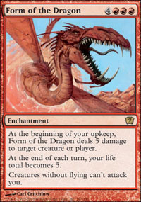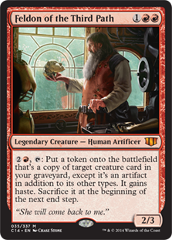

Card 1.2

Card 1.1

In the story, Feldon was a character who lost his wife during a war. He spent his remaining time trying to bring back his wife as a machine (The idea behind bringing back a card from the graveyard, except it is an artifact in addition to its other types). When he finally did it, he decided it wasn’t right nor was it the same, so he dismantled the artifact (Sacrifice it at the next end step). This card is felt by many to be an epitome of flavor.

There’s another meaning to flavor in magic as well. Not in that a card relates directly to the story but has effects that fit to the card. This type of flavor can almost be thought of a simulation of something that happens in the world (or fantasy world). Take for example, the card Form of the Dragon (Card 1.2). This flavor behind this card is that it turns you into a dragon. Becoming the form of the dragon. The first ability is akin to breathing fire, dealing damage every turn to your opponent. The ability that happens at your end step is because dragons don’t have a lot of health but can be very resilient. Finally, the last ability is because dragons fly creatures without flying won’t be able to hit you.

Now what about a Melvin? A Melvin looks at cards and enjoys cards with mechanics that go well together. A good example of this is the card Liliana Vess:

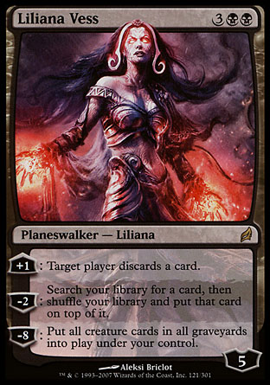

This card has mechanics that really interact well with each other. One ability puts creatures into the graveyard in the form of people discarding cards and the other returns them to the battlefield.

What does this all have to do with why people play the game though? This shows the vast amount of types of people who can enjoy the game. Somone who likes to build decks that revolve around flavorful combos can build that deck. The game is set up so someone who just wants to win can do that too. Wizard’s designs cards on their own so different player types can come in and enjoy the game, while intermingling with other player types. Each person’s personality is abstracted from them in how they play and what cards they play. There’s even more reasons outside of the cards themselves as to why people play and enjoy magic.

I did a survey over at the magic subreddit on why people play magic, what their enjoyment of the game stems from, and how they got into the game. One of the questions is what aspects of magic they enjoy:

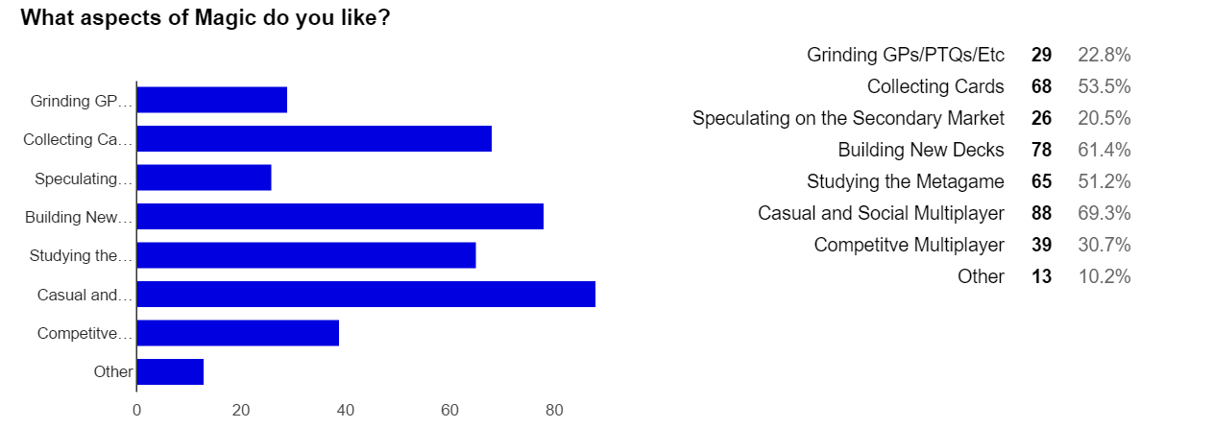

Figure 1.3

The survey was out of 127 responses. A couple answers can be combined, as they usually go hand in hand. For example, Grinding GPs and Studying the Metgame are usually hand in hand as those are things spikes typically do.

One of the interesting things is the large amount of people who enjoy casual and social multiplayer. It goes hand-in-hand with one of the largest responses to the option question ‘Why did you start playing magic?’ Most people stated that they were introduced by their friends in some way.

This also leads into things that people enjoy about that game outside of playing the game, as Stefan Johansson stated there are three levels: The collecting level, the deckbuilding level, and the match level. Talking about the different player types touched on the Match level and a bit of the deck building level. What things from this study fall into the collecting and deckbuilding levels though? Obviously, collecting cards and building new decks are both part of their respective level, but studying the metagame can go into deckbuilding as it influences how you build a deck, and speculating on the secondary market can fall into collecting cards, before showing how these make the game popular, I’ll define them.

Collecting cards is just that, it’s collecting different cards. Some people will do this by collecting as many of a specific card as they can, others will collect all of the cards from a single set, or maybe someone just collects cards with pretty artwork. There’s a lot that goes in to collecting and why people do it. The fact of the matter is however, that it is a part of human nature. Magic provides collectors with a perfect emulation of real collecting. Cards on their own are not inherently ‘rare’ (outside of a few), they are artificially made rare. It’s very easy to go to a shop and find a specific card you need. It’s much harder to find that cards just scouring what people have for trade or hoping you get it out of a booster pack. This happens a lot when people go to build new decks, they might not get the cards they want for it through trading, they might have to order it online or through a store.

People also play because of deckbuilding. Tying back to the profiles wizard’s uses, you have the ‘Johnny’ player type. This is a subgroup of magic that Wizards feels if large enough to warrant how they design cards. One of the defining features of the Johnny is a passion for building decks, rather than ‘netdecking’ (or taking a deck off the internet). Since Wizards identifies a large segment of its players to be Johnnies and in turn deck builders, it’s obviously a large pull to the game. I see why too. With the many different formats and ways to play magic, deck building can be an outlet for self-expression. You can play in so many different ways, if you want to kill your opponent as fast as possible you can build an aggressive deck, or if you want to control what your opponent can do you can play a control deck. Formats like commander allow you to build decks around a specific card, and play certain cards that would otherwise be unplayable. This ability to keep building decks allows a player to keep fresh and not feel like magic is getting stale for them if collecting cards or going to grand prixs is for them.

I feel one of the reason’s magic is the fact that all three of its levels are strong. While that increases the playability and drawing people of all types into the game. How does the game stay popular after so many years? Not only do they print new sets every year with fresh new cards and mechanics. Wizards tries to keep the game balanced and fair.

What is meant by balance? It’s the idea that every strength of an ability you can do has a drawback, so it’s balance is checked. Sweetster and Wyeth mention the idea of ‘control’ in their game flow model. When an unfair and unbalanced card is used, the opponent of the card feels like they don’t have control. When a player doesn’t have control they lose enjoyment according to Sweetser and Wyeth. If a person is not enjoying the game, why would they keep playing?

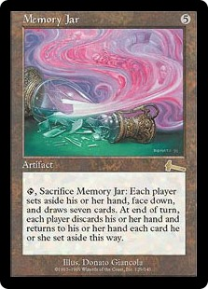

One of the most infamous unbalanced cards is Memory Jar. You don’t even need to understand the game to understand why this card is unfair. In magic, card advantage is everything. It’s the idea that being able to use more cards than your opponents should result in you having the advantage and having an easier time winning, just because you have more options available. Memory Jar provides pure card advantage. When you use it, each person sets aside their current hand of cards and draws a new seven, at the end of the turn, each player discards their hand and retakes the hand they set aside. In magic, almost everything you do is done during your turn. That’s where the problem lies. The person who used the card gets to draw a fresh hands of cards they can use, whereas the other player(s) draw a hand of (most-likely) unusable cards.

This card is the only one to ever receive and “Emergency ban”. Normally, when cards are banned they are done so at regular intervals throughout the year (It’s done when a new set is released). However, Memory Jar was banned outside of the regular ban cycle as it was very degenerate. It made it easy for decks focused around a combination of cards to assemble that combination. If this wasn’t banned that quickly, or if it was never banned Magic might not still be around today. I know this, because a time happened where there was such a powerful decks, it made attendance of events hit an

all-time low because people just were not having fun.

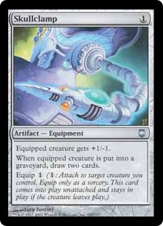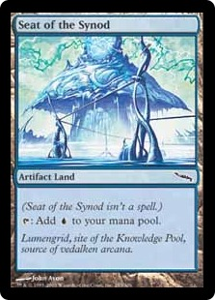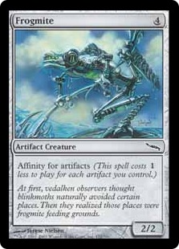

Above are some of the cards in the “Affinity” deck from Mirrodin’s standard environment. Of the ones shown, Skullclamp and Seat of the Synod were eventually banned. However, they were banned at a regular interval and not an emergency banning. Wizards created this mechanics Affinity, that is not inherently unbalanced. It was a way to reward you for playing other artifacts by making the spell cost less for each artifact in play. So on its own it’s not anything unfair. It is when you build your deck around the mechanic and Wizard’s also released 6 lands that counted as artifacts. This deck was so fast and powerful no other deck could stop it unless it was specifically designed to beat it. This wasn’t fun for a lot of players. When the format exists of three main decks, two of which run hate cards for the third one, it doesn’t allow the Johnnies and Deck builders their freedom and they get alienated from the game. If Wizards didn’t ban these cards I don’t think Magic would be nearly as popular today as it is now.

There’s a lot of reasons why people play magic and enjoy it. I think having a company whose job it is to keep the game balanced certainly helps to keep it popular. Other companies don’t keep their games balanced and in the end it hurts. For example, Yu-gi-oh. It’s parent company Konami will print a very unbalanced card, wait for the price to go up on it (it has a similar model to how magic cards are sold), then they reprint it to cash out on it, and then a few months later they ban it. It’s the reason I won’t play the game outside of a casual setting again. I think keeping the game balanced but always implementing fresh ideas allows the game to thrive and have old players stay while bringing in their friends, and other new players.

Works Cited

Forsythe, Aaron. "The Power Behind Affinity." Weblog post. *Daily MTG*. N.p., 04 Mar. 2005. Web. 12 Dec. 2015.

Ham, Ethan. "Rarity and Power: Balance in Collectible Object Games." *Game Studies*. N.p., n.d. Web. 12 Dec. 2015. <http://gamestudies.org/1001/articles/ham?utm_source=twitterfeed&utm_medium=twitter>.

Johansson, Stefan J. "What Makes Online Collectible Card Games Fun to Play?" *Breaking New Ground: Innovation in Games, Play, Practice and Theory. Proceedings of DiGRA* (2009): n. pag. Web. <http://www.digra.org/wp-content/uploads/digital-library/09287.37268.pdf>.

Rosewater, Mark. "Making Magic: Melvin and Vorthos." *: Daily MTG : Magic: The Gathering*. N.p., 07 May 2007. Web. 12 Dec. 2015.

Rosewater, Mark. "Making Magic: Melvin and Vorthos." *: Daily MTG : Magic: The Gathering*. N.p., 07 May 2007. Web. 12 Dec. 2015.

Rosewater, Mark. "Making Magic: Timmy, Johnny, and Spike." *: Daily MTG : Magic: The Gathering*. N.p., n.d. Web. 12 Dec. 2015.

Rosewater, Mark. "Making Magic: Timmy, Johnny, and Spike Revisited." *Timmy, Johnny, and Spike Revisited : Daily MTG : Magic: The Gathering*. N.p., 26 Mar. 2006. Web. 12 Dec. 2015.

Sonam Adinolf, Selen Turkay, Teachers College, Columbia University. *Collection, Creation and Community: A Discussion on Collectible Card Games* (n.d.): n. pag. Web.