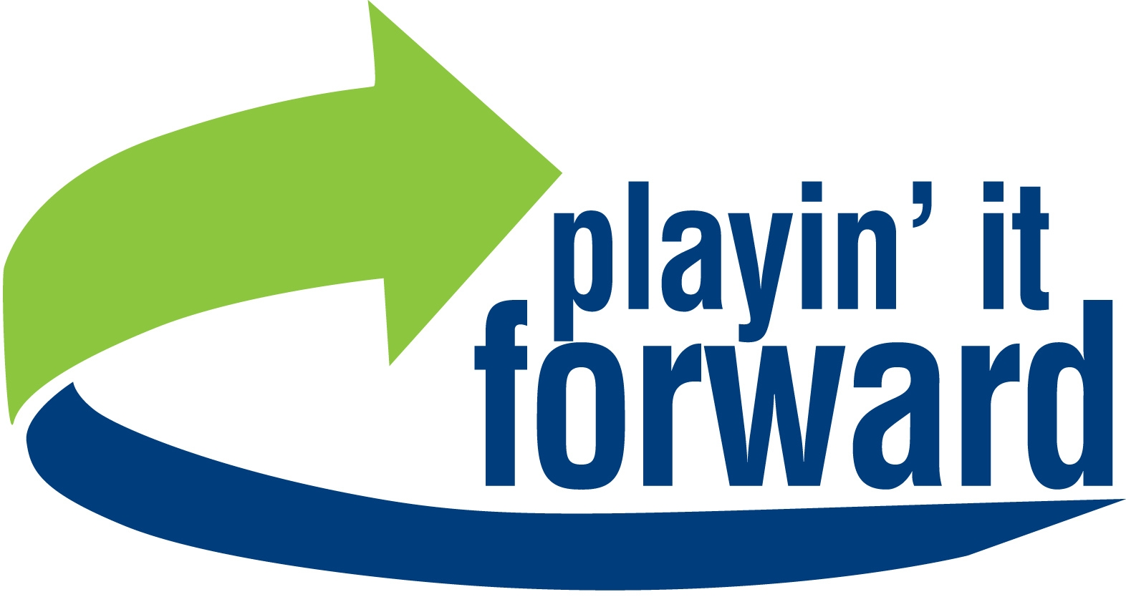 We Want You!! 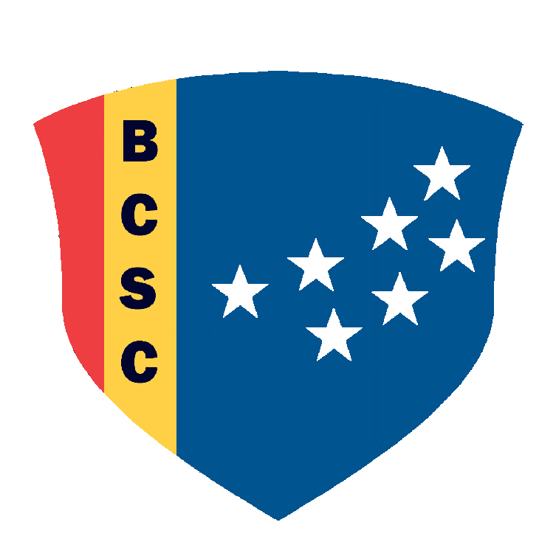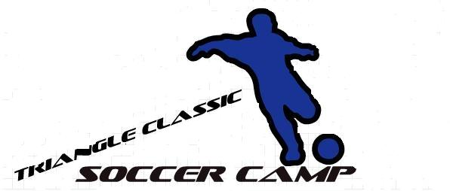

In order to offer our youth participants the best sport experience possible we recognize that community support is essential. Please consider the following Advertising Sponsorship proposal when making advertising budget decisions this season. We are a 501 c 3 organization and all donations are tax deductible!!
**All Sponsorship Partners will be recognized on Sponsor Recognition Night and will appear on back of training T-shirts
Community Partner | Flier Representation | $150-$199
Charter Partner | Community Partner + Website Logo Hyperlink | $200-$399
Bronze Partner | Charter Partner + Picture Plaque | $500
Silver Partner | Bronze Partner + Logo Representation on Warmups | $750
Gold Partner | Silver Partner + Patch on Game Shorts and jersey location: A | $1000
Other Opportunities
Jersey Sponsor | Corporate Logo representation on each Jersey | $price$ depends upon location; see back of this page. (per team) | Mark Location and indicate front or back:
Referee Sponsor | Corporate Logo representation on Referee Jersey | $250 per jersey
Match Sponsor | Game Ball Presentation Prior to game + Semi-permanent POS | $400 per match
Ball Sponsor | Game Ball Presentation prior to game | $200 per match
Plate Match Sponsor | Plate Trophy with Sponsor Name | $500 per match

Please place a “check” mark next to the sponsorship package or packages (in the right column) that you would like to participate in and circle the logo at the top of the page for the sport you would like your sponsorship to support. Please make all checks payable to Playin’ It Forward Sports, Inc. and remit to:

Playin’ It Forward Sports, Inc.
c/o Matthew Weeden
8311 Brier Creek Parkway, Suite 105-452
Raleigh, NC 27617

