

西南林业大学
大数据与智能工程学院
实践(实习)报告

课程名称 《数据库原理与应用》
专业班级 计算机科学与技术2022级（2）班
学 号 20220451013
学生姓名 陈丽群
指导教师 鲁 宁

2024年6月18日

《数据库原理与应用》上机作业

第13次
- 上机题目
学生成绩管理系统开发
- 上机目的
1. 掌握JAVA，Python或C#操作 MySQL的方法（我用的是C#）
2. 会灵活应用 Python和MySQL解决实际问题
- 上机内容
- 以自己建立的学生成绩管理数据库，利用 C#语言开发前端应用程序，实现学生基本信息（StudInfo）、班级基本信息（ClassInfo）、课程基本信息（CourseInfo）、学生成绩信息（StudScoreInfo）的添加、删除、修改功能。
- 利用 C#语言建立学生成绩查询功能，实现输入学号或姓名查询学生的成绩。
- 利用C#语言实现学生成绩的统计功能，即输入学号或姓名查询各学生的平均分、总分、最高分、最低分、课程门数。
- 实现页面展示
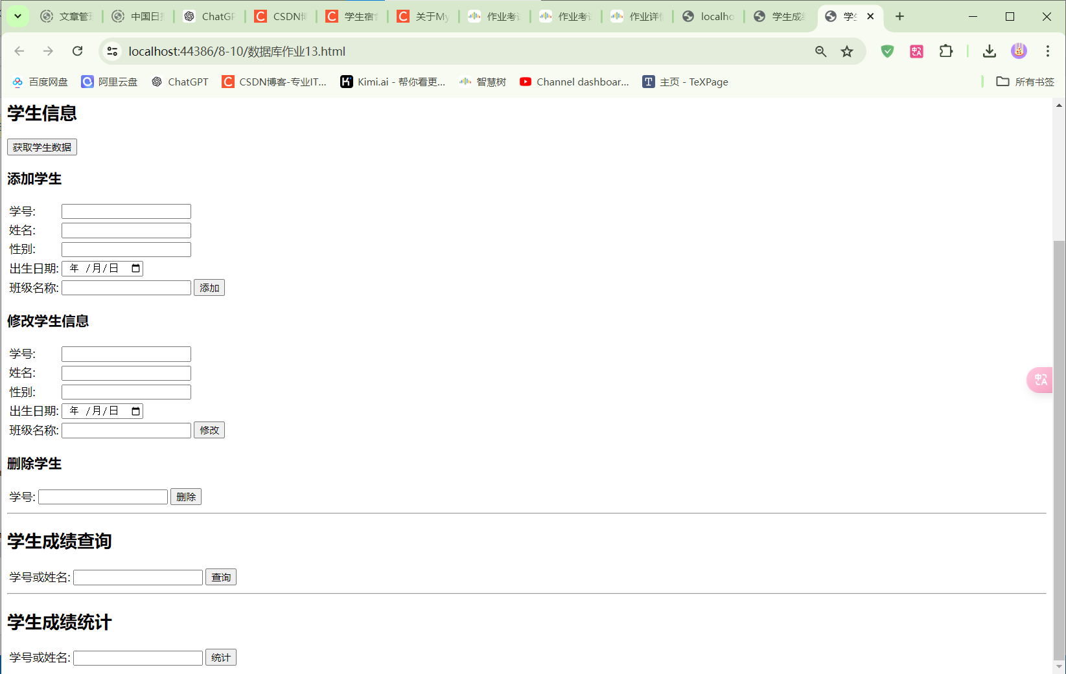
- 前端代码
- <!DOCTYPE html>
- <html>
- <head>
- <meta charset="utf-8" />
- <title>学生成绩管理系统</title>
- <script src="https://code.jquery.com/jquery-3.7.1.js"
- integrity="sha256-eKhayi8LEQwp4NKxN+CfCh+3qOVUtJn3QNZ0TciWLP4="
- crossorigin="anonymous"></script>
- <script>
- $(document).ready(function () {
- $("#bnt1").click(function () {
- var username = $("#username").val();
- var password = $("#mm").val();
- $.ajax({
- type: "POST",
- url: "data.asmx/Lo",
- data: JSON.stringify({ Name: username, psw: password }),
- contentType: "application/json; charset=utf-8",
- dataType: "json",
- success: function (response) {
- $("#errorInfo").text(response.d);
- }
- });
- });

- $("#getstudent").click(function () {
- $.ajax({
- type: "POST",
- url: "data.asmx/UersIsValid",
- contentType: "application/json; charset=utf-8",
- dataType: "json",
- success: function (response) {
- var output = "<table border='1'><tr><th>学号</th><th>姓名</th><th>性别</th><th>出生日期</th><th>班级</th></tr>";
- $.each(response.d, function (i, item) {
- output += "<tr><td>" + item.StudNo + "</td><td>" + item.StudName + "</td><td>" + item.StudSex + "</td><td>" + item.BirthDate + "</td><td>" + item.ClassName + "</td></tr>";
- });
- output += "</table>";
- $("#out").html(output);
- }
- });
- });

- $("#addbnt").click(function () {
- var studno = $("#studno").val();
- var studname = $("#studname").val();
- var studsex = $("#studsex").val();
- var birthdate = $("#birthdate").val();
- var classname = $("#classname").val();
- $.ajax({
- type: "POST",
- url: "data.asmx/Addstudent",
- data: JSON.stringify({ studno: studno, studname: studname, studsex: studsex, birthdate: birthdate, classname: classname }),
- contentType: "application/json; charset=utf-8",
- dataType: "json",
- success: function (response) {
- $("#output").text(response.d);
- }
- });
- });

- $("#changebnt").click(function () {
- var studno = $("#studno").val();
- var studname = $("#studname").val();
- var studsex = $("#studsex").val();
- var birthdate = $("#birthdate").val();
- var classname = $("#classname").val();
- $.ajax({
- type: "POST",
- url: "data.asmx/updataUser",
- data: JSON.stringify({ studno: studno, studname: studname, studsex: studsex, birthdate: birthdate, classname: classname }),
- contentType: "application/json; charset=utf-8",
- dataType: "json",
- success: function (response) {
- $("#output").text(response.d);
- }
- });
- });

- $("#deletabnt").click(function () {
- var studno = $("#delstudno").val();
- $.ajax({
- type: "POST",
- url: "data.asmx/DelateStudent",
- data: JSON.stringify({ studno: studno }),
- contentType: "application/json; charset=utf-8",
- dataType: "json",
- success: function (response) {
- $("#outputd").text(response.d);
- }
- });
- });

- $("#searchbnt").click(function () {
- var query = $("#searchquery").val();
- $.ajax({
- type: "POST",
- url: "data.asmx/QueryStudent",
- data: JSON.stringify({ query: query }),
- contentType: "application/json; charset=utf-8",
- dataType: "json",
- success: function (response) {
- var output = "<table border='1'><tr><th>学号</th><th>姓名</th><th>性别</th><th>出生日期</th><th>班级</th></tr>";
- $.each(response.d, function (i, item) {
- output += "<tr><td>" + item.StudNo + "</td><td>" + item.StudName + "</td><td>" + item.StudSex + "</td><td>" + item.BirthDate + "</td><td>" + item.ClassName + "</td></tr>";
- });
- output += "</table>";
- $("#outputsearch").html(output);
- }
- });
- });

- $("#statsbnt").click(function () {
- var query = $("#statsquery").val();
- $.ajax({
- type: "POST",
- url: "data.asmx/StatsStudent",
- data: JSON.stringify({ query: query }),
- contentType: "application/json; charset=utf-8",
- dataType: "json",
- success: function (response) {
- var output = "<table border='1'><tr><th>学号</th><th>平均分</th><th>总分</th><th>最高分</th><th>最低分</th><th>课程门数</th></tr>";
- $.each(response.d, function (i, item) {
- output += "<tr><td>" + item.StudNo + "</td><td>" + item.AvgScore + "</td><td>" + item.TotalScore + "</td><td>" + item.MaxScore + "</td><td>" + item.MinScore + "</td><td>" + item.CourseCount + "</td></tr>";
- });
- output += "</table>";
- $("#outputstats").html(output);
- }
- });
- });
- });
- </script>
- </head>
- <body>
- <h1>学生成绩管理系统</h1>
- <div>
- <h2>登录</h2>
- <table>
- <tr>
- <td>用户名</td>
- <td><input id="username" /></td>
- <td id="errorInfo"></td>
- </tr>
- <tr>
- <td>密码</td>
- <td><input id="mm" type="password" /></td>
- </tr>
- <tr><td><input id="bnt1" type="button" value="登录" /></td></tr>
- </table>
- </div>
- <hr />
- <div>
- <h2>学生信息</h2>
- <button id="getstudent">获取学生数据</button>
- <div id="out"></div>
- <h3>添加学生</h3>
- <table>
- <tr>
- <td>学号:</td>
- <td><input id="studno" /></td>
- </tr>
- <tr>
- <td>姓名:</td>
- <td><input id="studname" /></td>
- </tr>
- <tr>
- <td>性别:</td>
- <td><input id="studsex" /></td>
- </tr>
- <tr>
- <td>出生日期:</td>
- <td><input id="birthdate" type="date" /></td>
- </tr>
- <tr>
- <td>班级名称:</td>
- <td><input id="classname" /></td>
- <td><button id="addbnt">添加</button></td>
- </tr>
- </table>
- <h3>修改学生信息</h3>
- <table>
- <tr>
- <td>学号:</td>
- <td><input id="studno" /></td>
- </tr>
- <tr>
- <td>姓名:</td>
- <td><input id="studname" /></td>
- </tr>
- <tr>
- <td>性别:</td>
- <td><input id="studsex" /></td>
- </tr>
- <tr>
- <td>出生日期:</td>
- <td><input id="birthdate" type="date" /></td>
- </tr>
- <tr>
- <td>班级名称:</td>
- <td><input id="classname" /></td>
- <td><button id="changebnt">修改</button></td>
- </tr>
- </table>
- <div id="output"></div>
- <h3>删除学生</h3>
- <table>
- <tr>
- <td>学号:</td>
- <td><input id="delstudno" /></td>
- <td><button id="deletabnt">删除</button></td>
- </tr>
- </table>
- <div id="outputd"></div>
- </div>
- <hr />
- <div>
- <h2>学生成绩查询</h2>
- <table>
- <tr>
- <td>学号或姓名:</td>
- <td><input id="searchquery" /></td>
- <td><button id="searchbnt">查询</button></td>
- </tr>
- </table>
- <div id="outputsearch"></div>
- </div>
- <hr />
- <div>
- <h2>学生成绩统计</h2>
- <table>
- <tr>
- <td>学号或姓名:</td>
- <td><input id="statsquery" /></td>
- <td><button id="statsbnt">统计</button></td>
- </tr>
- </table>
- <div id="outputstats"></div>
- </div>
- </body>
- </html>

- 后端代码
- using System;
- using System.Collections.Generic;
- using System.Linq;
- using System.Web;
- using System.Web.Services;
- using MySql.Data.MySqlClient;

- namespace data
- {
- public partial class data : System.Web.UI.Page
- {
- private static string connectionString = "server=your_server_address;user=your_username;password=your_password;database=20220451013_clq;";

- [WebMethod]
- public static string Lo(string Name, string psw)
- {
- try
- {
- using (MySqlConnection conn = new MySqlConnection(connectionString))
- {
- conn.Open();
- string query = "SELECT Password FROM UserInfo WHERE UserName = @Name";
- MySqlCommand cmd = new MySqlCommand(query, conn);
- cmd.Parameters.AddWithValue("@Name", Name);
- var result = cmd.ExecuteScalar();
- if (result != null)
- {
- if (result.ToString() == psw)
- {
- return "true";
- }
- else
- {
- return "密码错误";
- }
- }
- else
- {
- return "用户不存在！";
- }
- }
- }
- catch (Exception ex)
- {
- return "登录失败：" + ex.Message;
- }
- }

- [WebMethod]
- public static List<Student> UersIsValid()
- {
- List<Student> students = new List<Student>();
- using (MySqlConnection conn = new MySqlConnection(connectionString))
- {
- conn.Open();
- string query = "SELECT * FROM StudInfo";
- MySqlCommand cmd = new MySqlCommand(query, conn);
- MySqlDataReader reader = cmd.ExecuteReader();
- while (reader.Read())
- {
- students.Add(new Student
- {
- StudNo = reader["StudNo"].ToString(),
- StudName = reader["StudName"].ToString(),
- StudSex = reader["StudSex"].ToString(),
- BirthDate = reader["BirthDate"].ToString(),
- ClassName = reader["ClassName"].ToString()
- });
- }
- }
- return students;
- }

- [WebMethod]
- public static int Addstudent(string studno, string studname, string studsex, string birthdate, string classname)
- {
- using (MySqlConnection conn = new MySqlConnection(connectionString))
- {
- conn.Open();
- string query = "INSERT INTO StudInfo (StudNo, StudName, StudSex, BirthDate, ClassName) VALUES (@studno, @studname, @studsex, @birthdate, @classname)";
- MySqlCommand cmd = new MySqlCommand(query, conn);
- cmd.Parameters.AddWithValue("@studno", studno);
- cmd.Parameters.AddWithValue("@studname", studname);
- cmd.Parameters.AddWithValue("@studsex", studsex);
- cmd.Parameters.AddWithValue("@birthdate", birthdate);
- cmd.Parameters.AddWithValue("@classname", classname);
- return cmd.ExecuteNonQuery();
- }
- }

- [WebMethod]
- public static int updataUser(string studno, string studname, string studsex, string birthdate, string classname)
- {
- using (MySqlConnection conn = new MySqlConnection(connectionString))
- {
- conn.Open();
- string query = "UPDATE StudInfo SET StudName = @studname, StudSex = @studsex, BirthDate = @birthdate, ClassName = @classname WHERE StudNo = @studno";
- MySqlCommand cmd = new MySqlCommand(query, conn);
- cmd.Parameters.AddWithValue("@studno", studno);
- cmd.Parameters.AddWithValue("@studname", studname);
- cmd.Parameters.AddWithValue("@studsex", studsex);
- cmd.Parameters.AddWithValue("@birthdate", birthdate);
- cmd.Parameters.AddWithValue("@classname", classname);
- return cmd.ExecuteNonQuery();
- }
- }

- [WebMethod]
- public static string DelateStudent(string studno)
- {
- try
- {
- using (MySqlConnection conn = new MySqlConnection(connectionString))
- {
- conn.Open();
- string query = "DELETE FROM StudInfo WHERE StudNo = @studno";
- MySqlCommand cmd = new MySqlCommand(query, conn);
- cmd.Parameters.AddWithValue("@studno", studno);
- int rowsAffected = cmd.ExecuteNonQuery();
- return rowsAffected > 0 ? "删除成功，影响行数：" + rowsAffected : "学生不存在";
- }
- }
- catch (Exception ex)
- {
- return "删除失败：" + ex.Message;
- }
- }

- [WebMethod]
- public static List<Student> QueryStudent(string query)
- {
- List<Student> students = new List<Student>();
- using (MySqlConnection conn = new MySqlConnection(connectionString))
- {
- conn.Open();
- string sql = "SELECT * FROM StudInfo WHERE StudNo LIKE @query OR StudName LIKE @query";
- MySqlCommand cmd = new MySqlCommand(sql, conn);
- cmd.Parameters.AddWithValue("@query", "%" + query + "%");
- MySqlDataReader reader = cmd.ExecuteReader();
- while (reader.Read())
- {
- students.Add(new Student
- {
- StudNo = reader["StudNo"].ToString(),
- StudName = reader["StudName"].ToString(),
- StudSex = reader["StudSex"].ToString(),
- BirthDate = reader["BirthDate"].ToString(),
- ClassName = reader["ClassName"].ToString()
- });
- }
- }
- return students;
- }

- [WebMethod]
- public static List<StudentStats> StatsStudent(string query)
- {
- List<StudentStats> stats = new List<StudentStats>();
- using (MySqlConnection conn = new MySqlConnection(connectionString))
- {
- conn.Open();
- string sql = @"SELECT
- StudNo,
- AVG(StudScore) AS AvgScore,
- SUM(StudScore) AS TotalScore,
- MAX(StudScore) AS MaxScore,
- MIN(StudScore) AS MinScore,
- COUNT(CourseID) AS CourseCount
- FROM StudScoreInfo
- WHERE StudNo LIKE @query OR StudNo IN (SELECT StudNo FROM StudInfo WHERE StudName LIKE @query)
- GROUP BY StudNo";
- MySqlCommand cmd = new MySqlCommand(sql, conn);
- cmd.Parameters.AddWithValue("@query", "%" + query + "%");
- MySqlDataReader reader = cmd.ExecuteReader();
- while (reader.Read())
- {
- stats.Add(new StudentStats
- {
- StudNo = reader["StudNo"].ToString(),
- AvgScore = Convert.ToDouble(reader["AvgScore"]),
- TotalScore = Convert.ToDouble(reader["TotalScore"]),
- MaxScore = Convert.ToDouble(reader["MaxScore"]),
- MinScore = Convert.ToDouble(reader["MinScore"]),
- CourseCount = Convert.ToInt32(reader["CourseCount"])
- });
- }
- }
- return stats;
- }

- public class Student
- {
- public string StudNo { get; set; }
- public string StudName { get; set; }
- public string StudSex { get; set; }
- public string BirthDate { get; set; }
- public string ClassName { get; set; }
- }

- public class StudentStats
- {
- public string StudNo { get; set; }
- public double AvgScore { get; set; }
- public double TotalScore { get; set; }
- public double MaxScore { get; set; }
- public double MinScore { get; set; }
- public int CourseCount { get; set; }
- }
- }
- }

