M.S. in Applied Data Science Portfolio
La Monte Henry Piggy Yarroll
2026-02-25
Table of Contents

1 M.S. in Applied Data Science Portfolio

1.1 La Monte Henry Piggy Yarroll, orcid.org/0009-0006-3073-6352
Syracuse University School of Information Studies
March 2026

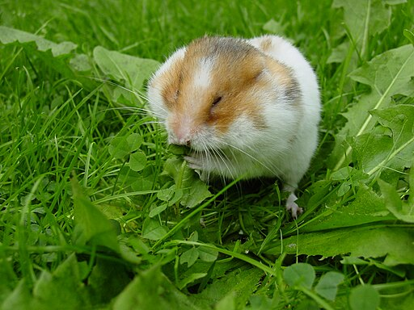 Peter Maas, CC BY-SA 2.5 https://creativecommons.org/licenses/by-sa/2.5, via Wikimedia Commons

2 The Data Hamster
I am a data hamster. I hoard data whenever I can. I have a complete record of almost every meal for the last several years. I have email archives going back to 1989. I’ve scanned hundreds of public domain books for Project Gutenberg. I have a large collection of open access and public domain mycological literature.
Information is data imbued with meaning. Information in a useful form is knowledge. I document here my effort to convert much of my data to knowledge. The Syracuse University iSchool Masters in Applied Data Science gave me the opportunity to explore much of my lifetime data hoard.
The recent explosion in Large Language Models enabled several parts of my Synoptic Key of Life Project (SKOL). I started this project in 2019 to understand the scattered mycological literature through machine learning, with little concept of how to implement the full stack, but with confidence that the technology would soon be available.
I developed a deeper understanding of traditional machine learning methods which allowed me to create actionable insights from my food and blood glucose records. I invented a metric which captures the glycemic impact of the meals that I personally eat, without having to rely on fasting measurements or careful weighing of foods.
Almost everyone has experienced some mangling of their name. I was able to recruit a group of fellow students to explore the problem of really recording names in a way that is personally and culturaly aware. We implemented these ideas in a SQL database as a component of a Customer Relationship Manager.
I enrolled in the MS in Applied Data Science program specifically to acquire the skills to turn my data into knowledge.

2.1 Program Learning Goals
This portfolio demonstrates achievement of the six program learning goals through five course projects spanning database design, text mining, deep learning, natural language processing, and big data management. The table below summarizes the goals; subsequent sections show how each project addresses them.
# | Learning Goal | Shorthand
G1 | Collect, store, and access data by identifying and leveraging applicable technologies | Data technologies
G2 | Create actionable insight across a range of contexts (e.g. societal, business, political), using data and the full data science life cycle | Actionable insight
G3 | Apply visualization and predictive models to help generate actionable insight | Visualization & models
G4 | Use programming languages such as R and Python to support the generation of actionable insight | Programming
G5 | Communicate insights gained via visualization and analytics to a broad range of audiences (including project sponsors and technical team leads) | Communication
G6 | Apply ethics in the development, use and evaluation of data and predictive models (e.g., fairness, bias, transparency, privacy) | Ethics

2.2 Name Navigator (IST 659: Data Administration Concepts and Database Management)
“Name Navigator” Database Application, Spring 2024. (La Monte H. P. Yarroll et al. 2024).

2.2.1 Project Summary
The Name Navigator is a database application that represents human personal names in a culturally aware way, suitable for use in a Customer Relationship Management (CRM) system. Naming conventions vary world-wide; assumptions based on Western English-speaking culture often result in insensitive mangling of names. The system provides locale-specific views of names for different applications: formal address, informal conversation, legal documents, and pronunciation guidance.
The database supports multiple locales (English/US and Georgian/Georgia in the initial implementation), Unicode and IPA pronunciation for each name particle, gender identity and pronoun preferences, the concept of “dead names” (names no longer used by an individual), and an override mechanism for contacts who prefer not to provide detailed name components.

2.2.2 Learning Goals Addressed
We built this project built upon an ethical observation: people’s names really matter (G6 Ethics). I recruited a team that shared my vision and we implemented a solid CRM component (G2 Actionable Insight), in SQL and T-SQL (G4 *programming languages).
The system supports dead names (old names that should no longer be used such “maiden names”), collects gender identity and preferred pronouns, and provides an override mechanism in case we failed to account for a particular naming convention (G6 Ethics).
The project centered around collecting, storing and accessing (G1) name information.
We practiced communicating data relationships via standard modeling diagrams (G5 Communication) and mockups (with Balsamiq).
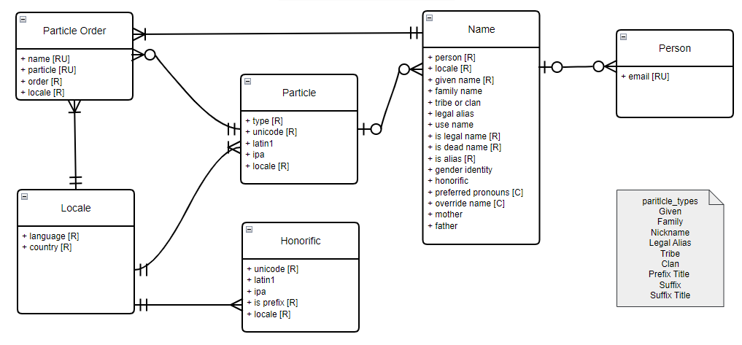 Conceptual Model for Name Navigator
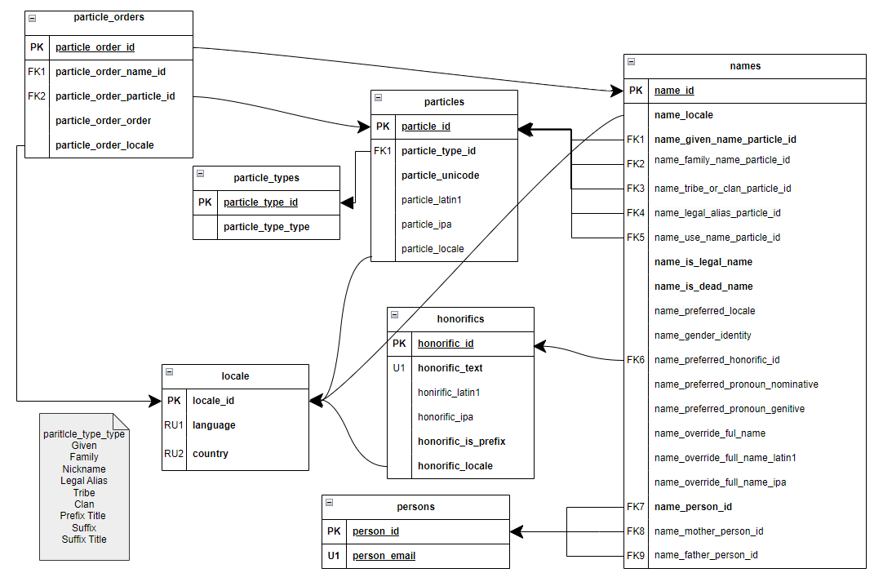 Logical Model for Name Navigator
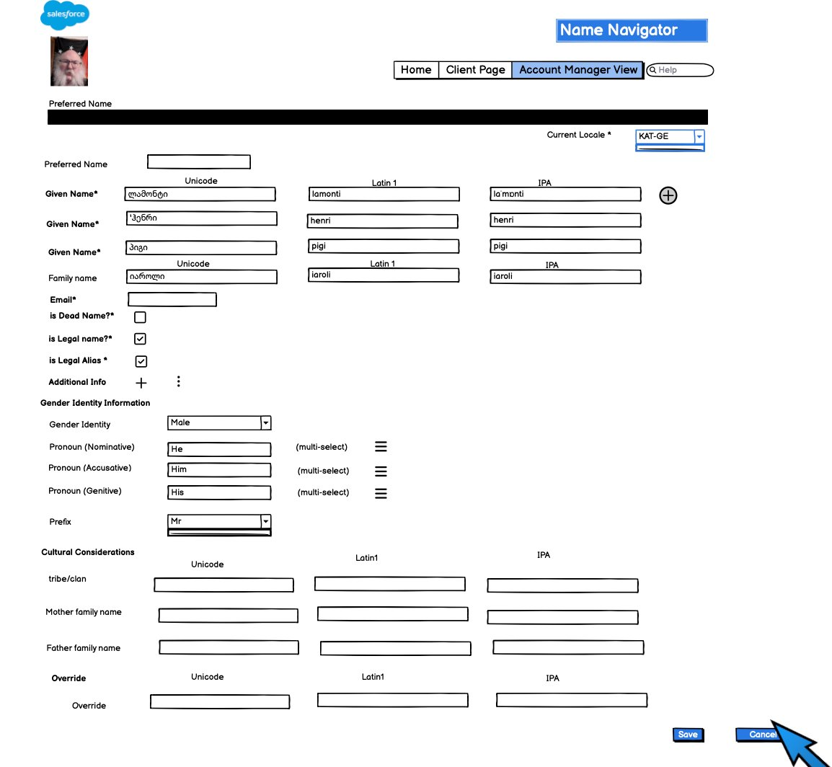 Balsamiq Mockup for Name Navigator

2.3 Glycemic Increment (IST 736: Text Mining)
“Glycemic Increment: Individualized Medicine for Diabetics,” Fall 2025. (Yarroll 2026b).

2.3.1 Project Summary
This project introduced Glycemic Increment (G+), a novel metric for estimating the blood sugar consequences of specific foods and composite meals. Unlike population-level metrics based on fasting conditions, such as Glycemic Index and Glycemic Load, G+ uses an individual patient’s own Continuous Glucose Monitor (CGM) data paired with their meal logs to build a personalized linear regression model. The coefficient for each food directly approximates that food’s effect on the patient’s blood sugar based on the portions they actually eat.
The dataset comprises two years of CGM readings (every 5 minutes) and free-form food logs. We evaluated nine models across three meal types (regular, extended, unpreceded), two vectorizers (Binary CountVectorizer, QuantifierVectorizer), and two tokenizers (ngrams, full-format parser).

2.3.2 Learning Goals Addressed
This project is an example of Individualized Medicine (G2 Actionable Insight) that leverages combined glycemic data and food logs.
An important part of Data Science is the process of data cleaning (G1 collect). The Glycemic Increment project involved convertiing loosely structured food logs (csv format) into structured records that we could feed into machine learning models. We applied several different methods to extract the metric in mg*hours/dl.
We created several custom tozenizers and vectorizers in Python (G4 Programming). The QuantifierVectorizer is a novel contribution that preserves quantity information from the food logs.
Here is the whole project in 3 charts (G3 Visualization & models) (G5 Communication):
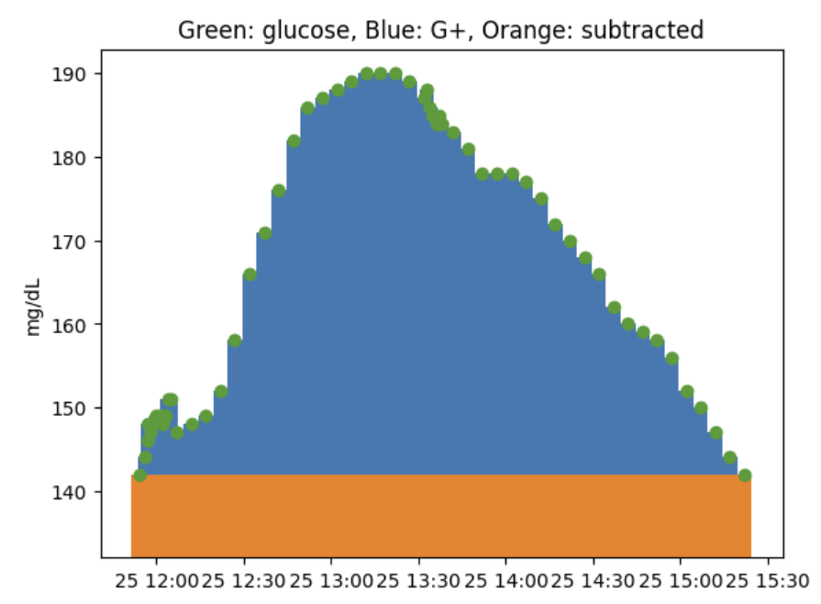 Glycemic Increment Illustrated
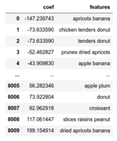 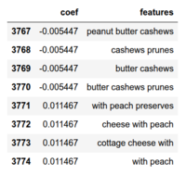 Trigrams with G+, max and min
The final project is formatted as an IEEE-format TeX document, suitable for many professional journals (G5 Communication).
Our key insight: “While not perfect, these models are useful for predicting the effects of specific meals on blood sugar.” The food coefficients validated expectations—konjac noodles (GI=0) showed minimal effect; foods always eaten with rice showed confounded high values.

2.4 Synopitc Key of Life
I managed to recruit fellow students in several classes to work on different aspects of my Synoptic Key of Life Project. This is an effort to understand the open access and public domain taxonomic literature in mycology. This tool guides an amateur through the process of creating a technical description of a collection of fungi.
Here is how the various classes map onto the architecture:
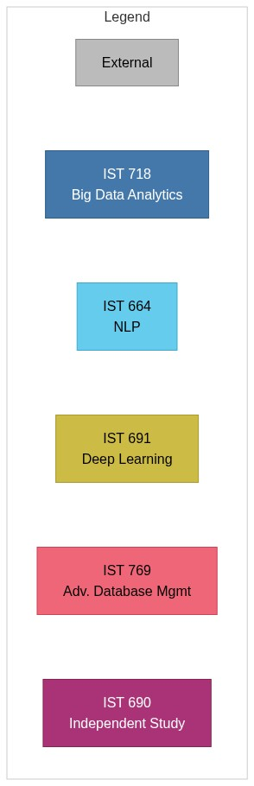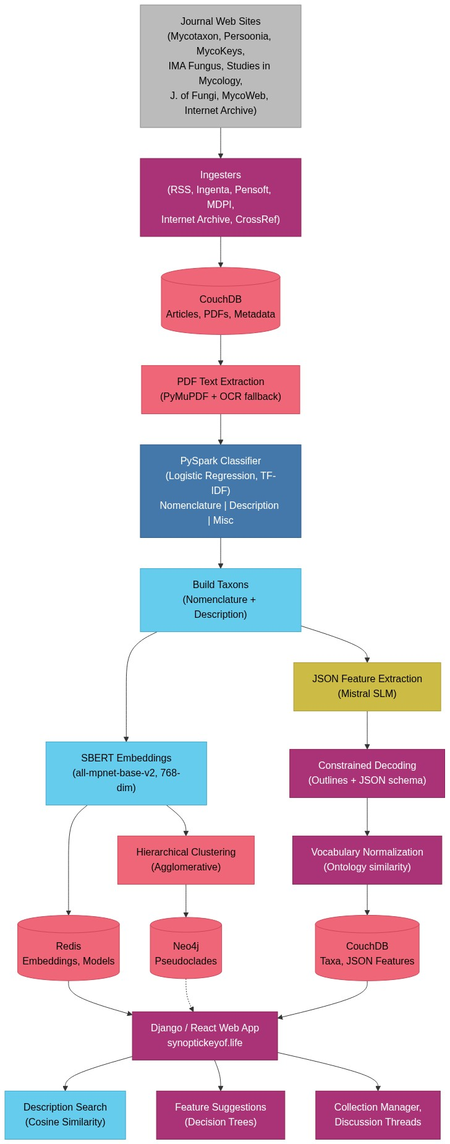

2.5 Synoptic Key of Life II (IST 718: Big Data Analytics)
“Synoptic Key of Life II”, Spring 2025. (Caspers et al. 2025).

2.5.1 Project Summary
This project builds a PySpark pipeline to evaluate machine learning algorithms to classify nomenclature and description blocks in mycological journal articles. The articles were hand-annotated with (Yang et al. 2018).

2.5.2 Learning Goals Addressed
This project was my first foray in my Master’s program into Mycology (G2 insight accross contexts). We built an assortment of classification models and evaluated them for the task at hand (G3 predictive models). PySpark is an important library for parallel Python work (G1 Data technologies, G4 programming).

2.6 Feature Extraction for Fungal Taxonomy (IST 691: Deep Learning)
“Synoptic Key of Life: Feature Extraction for Fungal Taxonomy,” Spring 2025. (Yarroll et al. 2025).

2.6.1 Project Summary
This project applies large and small language models to extract structured feature information from unstructured mycological species descriptions. The goal is to transform prose descriptions like “Mycelium on the substrate is medium orange-brown, septate, 3–4 μm diam.” into nested JSON structures with features, subfeatures, and values—data suitable for building synoptic key menus.
{
'mycelium': {
'color': 'medium orange-brown',
'septation': 'septate',
'diameter': '3–4 μm',
}
}
The work builds on the SKOL project’s existing classification pipeline and annotation corpus. The team evaluated ChatGPT 4.0, Llama 3.3 70B, Gemma3 (27B and 12B), and Mistral 7B (Jiang et al. 2023), ultimately fine-tuning Mistral 7B Instruct using 16 hand-built training examples. Results were evaluated using Jaccard distance between generated and ground-truth feature/value sets.

2.6.2 Learning Goals Addressed
We used labeled OCR (G1 Data Technologies) page scans from three mycological journals (Mycologia, Mycotaxon, Persoonia) labeled with the PySpark classification pipeline built in IST 718. We used Hugging Face transformers for fine-tuining and ollama for local model serving (G4 Programming in Python). The fine-tuning dataset proved too small to be genuinely useful, but we learned the technique well enough to apply it (G3 Predictive Models).
The extracted JSON from this project was eventually (IST 690 Spring 2026) used to build menus for suggesting features for a collection, (G2 Actionable Insight).
The final paper is an IEEE-format conference paper with abstract, structured sections, figures, and references (G5 Communication). I presented this work at MASMC 2025 (Mid Atlantic Mycology Conference) as a poster for a non-technical mycology audience.

2.7 Mycology Literature Search (IST 664: Natural Language Processing)
“Mycology Literature Search,” Fall 2024. (La Monte Henry Piggy Yarroll et al. 2024).

2.7.1 Project Summary
This project created a semantic search system for mycological journal articles using sentence transformer text embedding. The team extended two pre-existing applications: SKOL (Synoptic Key of Life), which classifies and annotates article content, and MycoSearch (forked from Dr. Draft’s SOTA Literature Search), which embeds and searches the processed content.
Users input specimen descriptions (e.g., “pileus campanulate, lamellae yellow rust-brown”) and receive ranked matches from the literature based on semantic similarity—not keyword matching.
The key contribution is the Taxon class—a custom data structure that encapsulates nomenclature, descriptions, and metadata for each species. Taxon objects are embedded via SBERT (all-mpnet-base-v2), (Reimers and Gurevych 2019) into a 768-dimensional vector space, enabling cosine similarity search where a user’s specimen description is matched against the embedded literature.

2.7.2 Learning Goals Addressed
The SBERT embeddings (G1 Data Technologies) produced by Dr. Draft’s MycoSearch are the core capability of https://synopitickeyof.life/skol (G2 Actionable Insight). This enables researchers and amateurs to find relevant species descriptions without knowing exact taxonomic terminology.
In order to figure out how to associate Nomenclature blocks with Description blocks, we looked at plots which looked at the distances in paragraphs between Nomenclature blocks and adjacent Description blocks (G3 Visualization).
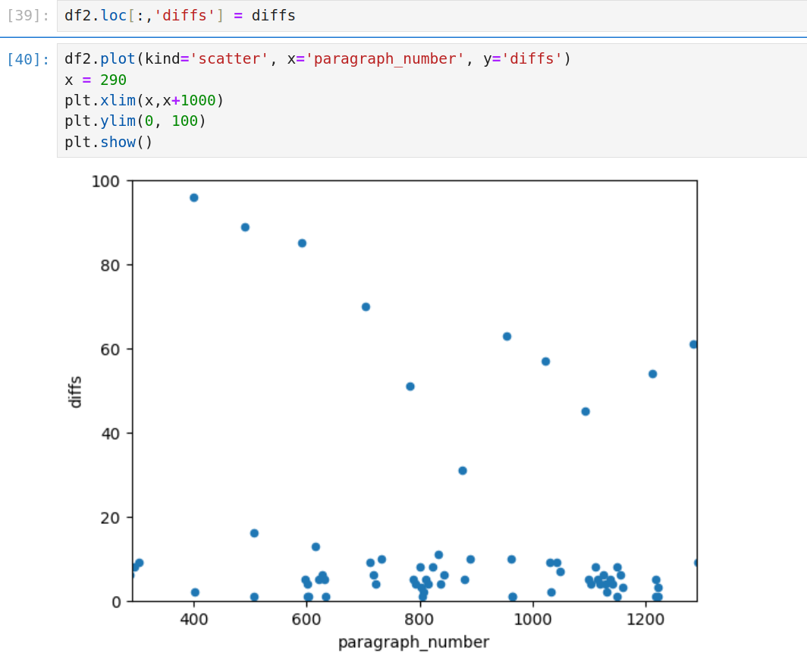 The upper dots represent the distances between species descriptions within an article, indicating how far the search progresses between potential matches. The lower dots highlight species descriptions closely associated with species names. Larger distances between descriptions suggest a lower likelihood of relevance to the search criteria. Typically, the search extends up to 5–6 paragraphs before stopping, with increasing distances between descriptions signaling diminishing relevance to the query.
Technologies used for this project include sentence transformers (SBERT), scikit-learn, pandas, and matplotlib (G4 Programming).

2.8 SKOL IV: All the Data (IST 769: Advanced Database Management)
“SKOL IV: All the Data,” Fall 2025. (Yarroll 2025).

2.8.1 Project Summary
This project implements the complete SKOL data pipeline from ingestion through search, bringing together all previous course work into a near-production system. The Jupyter notebook orchestrates web scraping (with robots.txt compliance), PDF text extraction and OCR, text classification, Taxon object construction, SBERT embedding, LLM-based JSON feature extraction, and hierarchical clustering—all backed by CouchDB (Anderson et al. 2009), for document storage, Redis (Redis Ltd. 2025) for caching models and embeddings, PySpark (Faria 2024) for distributed processing, and Neo4j (Neo4j 2024) for graph-based exploration of taxonomic clusters.
The system ingests articles from multiple sources (e.g. Mycotaxon (Pennycook 1974--Present) and Studies in Mycology (Crous 1972--Present) via Ingenta Connect RSS feeds, Persoonia (P. W. Crous 1959-Present), historical works from the MycoWeb (Wood and Stevens 2025) archives), and processes them through the full pipeline.
Agglomerative hierarchical clustering produces “pseudoclades”, grouping taxa with similar descriptions, revealing biological relationships inferred purely from textual similarity.

2.8.2 Learning Goals Addressed
This project is an intermediate state between the technology components defiend in earlier classes and the production web site produced in IST 690. This is where I chose the production data storage technologies for SKOL (G1 Data Technologies):
- CouchDB: Document store for taxa records, article metadata, PDF attachments, and JSON structures. CouchDB’s native JSON support is ideal for the nested feature structures.
- Redis: In-memory cache for SBERT embeddings and trained classifier models, with configurable expiration.
- PySpark: Distributed processing for classification and text extraction at scale.
- Neo4j: Graph database for hierarchical clustering of taxa based on embedding similarity.
- Web scraping with robots.txt compliance (urllib.robotparser).
- RSS feed ingestion (feedparser) for ongoing article collection.
- PDF text extraction (PyMuPDF/fitz) with OCR fallback.
- Bibtex parsing for citation metadata.
- Parquet files for intermediate data.
In addition to the classification, embedding, and SLM models developed in earlier classes, I built a graph database with Agglomerative Clustering for taxonomic grouping, visualized as dendrograms in Neo4j (G3 models).
I used an assortment of additional Python infrastucture: PyMuPDF (PDF extraction), feedparser (RSS), bibtexparser (G4 programming).
In IST 769 we were asked to present our work as a Jupyter notebook (G5 Communication), as this is one of the work products that professional Data Scientists deliver. The Jupyter notebook is a concrete piece of reproducible research.
Given the focus of IST 769 on no-SQL databases and the large amount of code I produced with Claude Code, I structured the notebook to hide the non-storage components and show only the interactions with no-SQL databases. One critical skill is to present the information that your audience seeks and a minium of adiaphora.
G6 — Ethics:

2.9 Synoptic Key of Life Website (IST 690 Independent Study)
“Building the Synoptic Key of Life website,” Spring 2026. (Yarroll 2026a) under Dr. Gregory Block
The independent study brought together all the pieces of the Synoptic Key of Life and deployed the https://synoptickeyof.life/skol web site.
Detailed work items completed for IST 690 can be found at The SKOL Trello.

2.9.1 Project Hightlights
I used Claude Code to extract functionality from the various ipython notebooks into standalone programs that could be run from cron jobs (G2 Actionable insight).
The programs have a unified CLI with a set of standard arguments such as --ignore-existing, --dry-run, --verbosity=n, etc.
With Claude Code, I built a Django/React & REST web site the provides all the data products as usable interfaces.
I improved the translation of taxa descriptions to JSON by introducing constrained decoding with a suitable schema, and vocabulary normalization based on semantic similarity (G1 Data technologies). I explored the use of automated ontologies (, but found that the existing ontologies are too sparse for this application.
I tackled all the things that most application web sites need: accounts (lots of OAuth), domain email configuration (these days a lot more than an MX record), CI/CD automatic deployment, backups, daily reports, static credentials, encryption, etc…

2.9.2 Learning Goals Addressed
This brings the full data science lifecycle to completion: * Problem Definition: Enable semantic search over taxonomic literature * Data Collection: Web scraping, RSS feeds, OCR * Data Preparation: Classification, Taxon construction * Modeling: SBERT embeddings, LLM feature extraction, clustering * Evaluation: Classifier accuracy, search result quality * Deployment: synoptickeyof.life * Monitoring: Logging and ongoing ingestion of new publications.
The article ingesters are well-behaved web scrapers. They respect robots.txt, and HTTP flow control control packets such as 429 errors. They are rate-limited by default and back off if a web site generates 403 permission errors (G6 Ethics).

2.10 7. Synthesis and Reflection

2.10.1 Range of Contexts
I’ve created actionabile insights (G2) across a range of contexts: * Business: IST 659 Name Navigator for CRM cultural awareness * Individualized medicine: IST 736 Glycemic Increment for diabetic nutrition * Mycology/scientific research: IST 718, IST 691, IST 664, IST 769, IST 690 — the SKOL project.

2.10.2 Transparency and Reproducibility
It is essential that scientific endeavors be transparent and reproducible (G6 ethics). All of the code for these projects is available via my GitHub page: https://github.com/piggyatbaqaqi/ under permissive licenses.
The data all have careful provenance tracking and are limited to open access, and public domain works.
All of my papers include bibliographies citing the works I built upon. I’ve carefully documented the use of Claude Code for IST 769 and IST 690, a choice that might be controversial.

2.10.3 Integrated Learning Through SKOL
IST 718 → IST 664 → IST 691 → IST 769 → IST 690 form a progression: NLP foundations, deep learning for feature extraction, and production data architecture. Each course contributed essential components to the deployed system at https://synoptickeyof.life.

2.10.4 Strengths and Challenges
I feel that I have developed the skills I originally imagined I’d need to to bring SKOL to life. I learned about and practiced Natural Language Processing, Machine Learning models, and Large Language Models, along with an assortment of modern Python systems, such as CouchDB, Redis, PySpark, Django, and React.
I have leveraged my domain expertise in mycology.
I have turned much of my personal data collection into useful knowledge.
While we were able to go through the motions of LLM fine-tuning, we were not able to get the benefits.
Scaling to the full corpus of open access & public domain mycological literature continues to be a challenge. E.g. I’ve found that the production hardware can not calculate a new SBERT embedding and respond to search queries at the same time.
There are data quality issues with the current system. The training suite covers a narrow range of years. It does not generalize well to older and newer literature. The classifier is only of limited use for languages-other-than-English (LOTE). I need to produce more manual and semi-manual training sets.
I have found that the current system does successfully return matching descriptions in LOTE, but these are of limited use to users who do not read these languages. There are a number of open source translation models available.

2.10.5 Lifelong Learning Plan
I plan to continue work on SKOL and hope to recruit more participants into the project, both developers and users.
I am actively seeking a day job in which I can use these Data Science skills on a daily basis.

Portfolio prepared for IST 782 — Applied Data Science Portfolio Syracuse University School of Information Studies Spring 2026

References
Anderson, J. Chris, Jan Lehnardt, and Noah Slater. 2009. CouchDB: The Definitive Guide. O’Reilly Media.
Caspers, David, Christopher Murphy, and La Monte Henry Piggy Yarroll. 2025. Synoptic Key of Life II. IST 718 Final Project. Syracuse University School of Information Studies. https://github.com/piggyatbaqaqi/skol/blob/main/IST718/IST718_Final_Report_FINAL.docx.
Crous, Pedro W. 1972--Present. “Studies in Mycology.” In Studies in Mycology. Westerdijk Fungal Biodiversity Institute. https://www.studiesinmycology.org/.
Faria, Pedro Duarte. 2024. Introduction to Pyspark. Belo Horizonte. https://pedropark99.github.io/Introd-pyspark/.
Jiang, Albert Q, Alexandre Sablayrolles, Arthur Mensch, et al. 2023. “Mistral 7B.” arXiv Preprint arXiv:2310.06825.
Neo4j, Inc. 2024. Neo4j – the World’s Leading Graph Database. https://neo4j.com/product/neo4j-graph-database/.
P. W. Crous, Prof. dr. 1959-Present. “Persoonia - Molecular Phylogeny and Evolution of Fungi.” In Persoonia. Westerdijk Fungal Biodiversity Institute. https://www.persoonia.org/.
Pennycook, Shaun R. 1974--Present. “Mycotaxon: An International Journal Designed to Expedite Publication of Research on Taxonomy & Nomenclature of Fungi & Lichens.” In Mycotaxon. Mycotaxon, Ltd. http://www.mycotaxon.com.
Redis Ltd. 2025. Redis. https://redis.io/.
Reimers, Nils, and Iryna Gurevych. 2019. “Sentence-BERT: Sentence Embeddings Using Siamese BERT-Networks.” Proceedings of the 2019 Conference on Empirical Methods in Natural Language Processing, November. http://arxiv.org/abs/1908.10084.
Wood, Michael, and Fred Stevens. 2025. MykoWeb: A Bibliography of Mushrooms & Other Fungi. https://www.mykoweb.com/biblio/bibliography.html.
Yang, Jie, Yue Zhang, Linwei Li, and Xingxuan Li. 2018. YEDDA: A Lightweight Collaborative Text Span Annotation Tool. http://aclweb.org/anthology/P18-4006.
Yarroll, La Monte H. P., Oluwaseyi Durosinmi-Etti, Patrick Le, and Christopher A. Murphy. 2024. Name Navigator Database Application. IST 659 Final Project. Syracuse University School of Information Studies. https://github.com/piggyatbaqaqi/names/blob/main/final_project/Naming_report.pdf.
Yarroll, La Monte Henry Piggy. 2025. SKOL IV: All the Data. IST 769 Final Project. Syracuse University School of Information Studies. https://github.com/piggyatbaqaqi/skol/blob/main/IST769/IST769%20Final%20Project%20Proposal_%20Synoptic%20Key%20of%20Life%20Pipelines.odt.
Yarroll, La Monte Henry Piggy. 2026a. Building the Synoptic Key of Life Website. IST 690 Independent Study. Syracuse University School of Information Studies. https://github.com/piggyatbaqaqi/skol/blob/main/IST690/Synoptic%20Key%20of%20Life%20website_%20An%20Independent%20Study.md.
Yarroll, La Monte Henry Piggy. 2026b. M.s. In Applied Data Science Portfolio. IST 782 Portfolio. Syracuse University School of Information Studies. https://github.com/piggyatbaqaqi/skol/blob/main/IST782/portfolio2.md.
Yarroll, La Monte Henry Piggy, J. J. Balasi, Christopher Murphy, and Shintaro Osuga. 2024. Mycology Literature Search. IST 664 Final Project. Syracuse University School of Information Studies. https://github.com/piggyatbaqaqi/skol/blob/main/IST664/IST664_Team3_Balasi_Murphy_Osuga_Yarroll.docx.
Yarroll, La Monte Henry Piggy, Padmaja Kurumaddali, and Peter Le. 2025. Synoptic Key of Life: Feature Extraction for Fungal Taxonomy. IST 691 Final Project. Syracuse University School of Information Studies. https://github.com/piggyatbaqaqi/skol/blob/main/IST691/IST691_final_project_paper.docx.

