- The following time line demo basically gives out a quick view on how the logic works on a small segment of time.
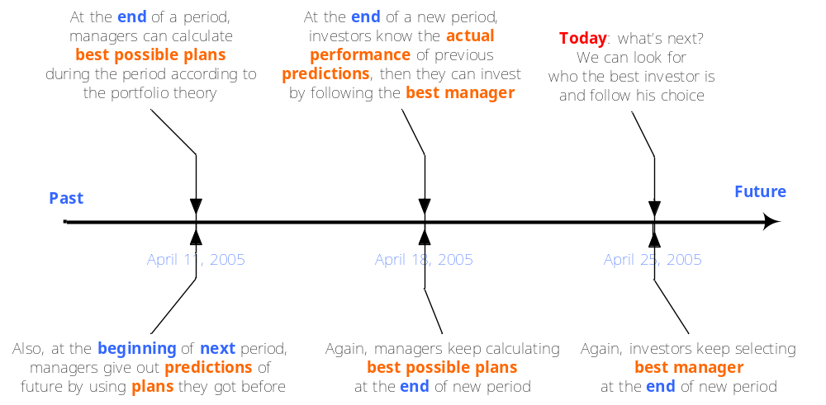
- 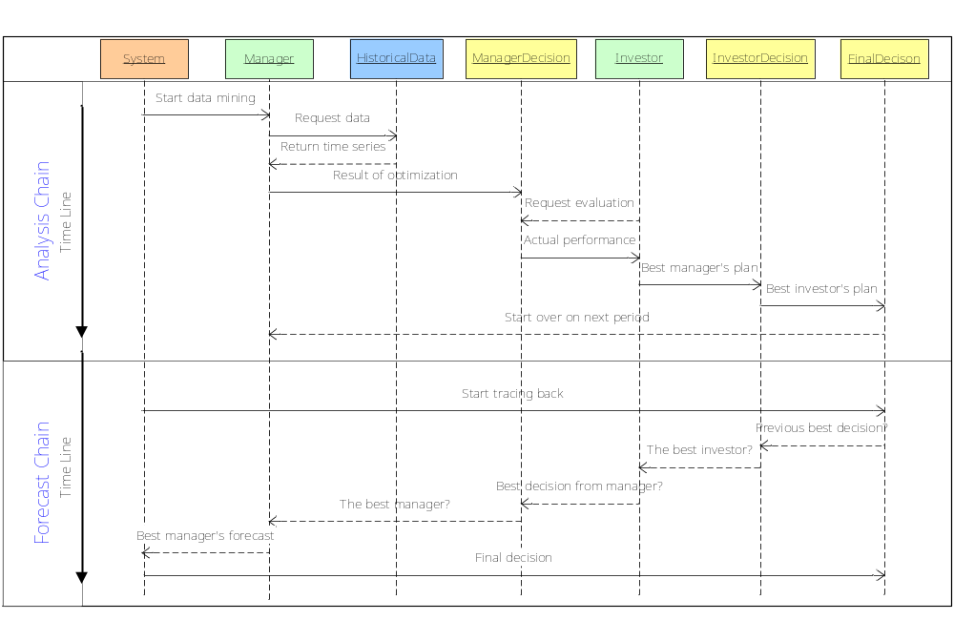The complete logic flow includes two parts: analysis chain and forecast chain. The former is used to data-mine all the historical data, while the latter is used to trace back to historical decisions the system generated in order to give out a suggestion for future.
- ERD is as followed. The core UML class diagram is quite similar to this ERD, since I’m currently focusing on data access layer design which means now I write only the getter/setter for each class without touch on any specific methods of business logic.

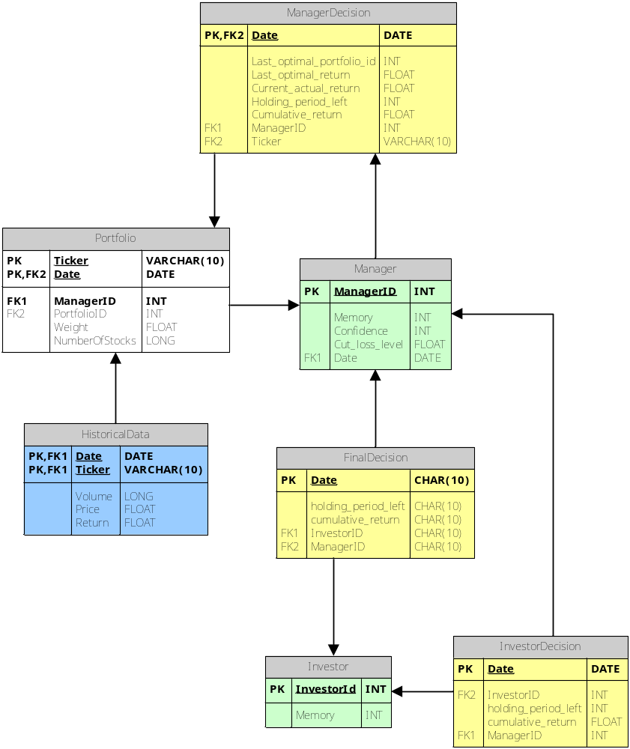

I decide to leave out the abstract concept of “investor group” to make design simple now. Since it does enhance the final forecasting performance, I will implement it later.

