一个样条插值的应用题
（彻底弄清样条插值）

1. PostScript(手写字母)是每个字母仅用了几个点用样条构造出来的。如
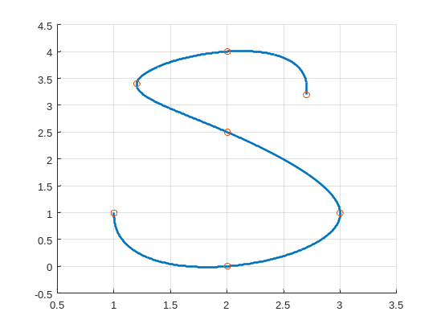
用以下7个点数据得到（图中的圆点所示）：
t  x  y | 0 1 2 3 4 5 6  1 2 3 2 1.2 2 2.7  1 0 1 2.5 3.4 4 3.2
请编程实现这样的字母。（注：插值得到足够多的点后，画图可以使用Matlab）

解:仅凭这7个点写不出这个S字符。必须添加加密点，可以通过插值（因为有光滑要求，所以用样条插值）实现。为了通过插值得到更多的点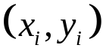，根据给定的插值节点，需要求出如下2个的插值函数：
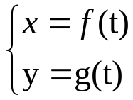

1）求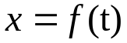的三次自然样条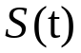（书上的边界条件二，即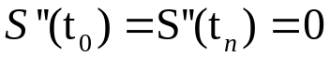）。
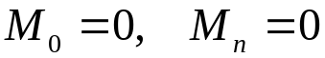，解下面方程组求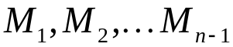：
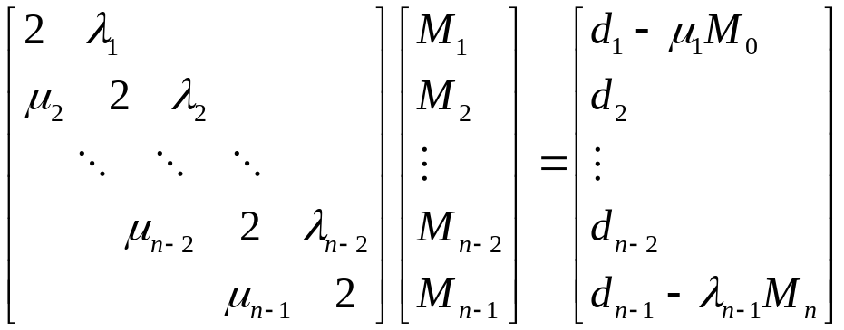
其中
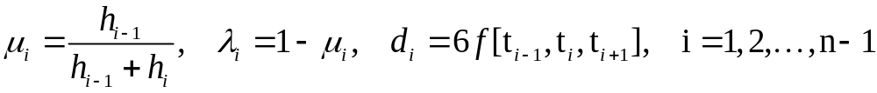
最后可得到
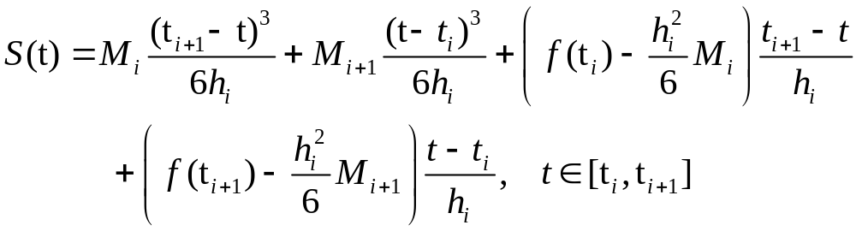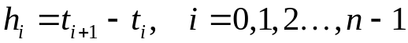。

2）求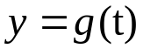的三次自然样条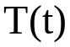（书上的边界条件二，即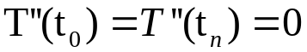）。
同1）

3）对于本例的手工计算：
对于的三次自然样条的求解如下：
t 0 1 2 3 4 5 6
x 1 2 3 2 1.2 2 2.7
即n=6,
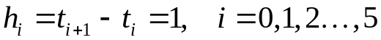
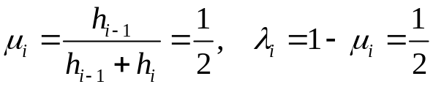
构造差商表计算
i ti xi=f(ti) f[t_{i-1},t_{i}] f[t_{i-1},t_{i},t_{i+1}]
0 0 1
1 1 2 1
2 2 3 1 0
3 3 2 -1 -1
4 4 1.2 -0.8 0.1
5 5 2 0.8 0.8
6 6 2.7 0.7 -0.05
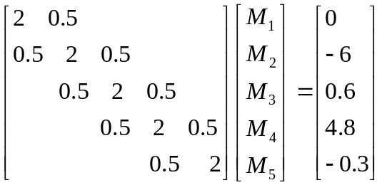
解得M1=0.834615，M2=-3.338462，M3=0.519231，M4=2.461538，M5=-0.765385
则
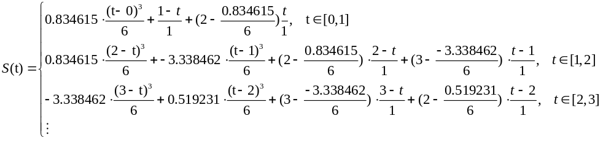对于的三次自然样条的求解同上理
t 0 1 2 3 4 5 6
y 1 0 1 2.5 3.4 4 3.2
构造差商表计算
i ti yi=g(ti) g[t_{i-1},t_{i}] g[t_{i-1},t_{i},t_{i+1}]
0 0 1
1 1 0 -1
2 2 1 1 1
3 3 2.5 1.5 0.25
4 4 3.4 0.9 -0.3
5 5 4 0.6 -0.15
6 6 3.2 -0.8 -0.7

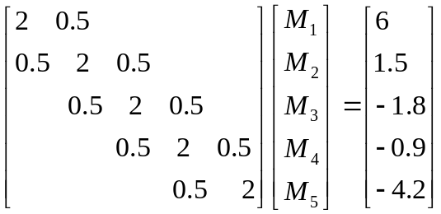

解得M1=2.929231，M2=0.283077，M3=-1.061538，M4=0.363077，M5=-2.190769
则
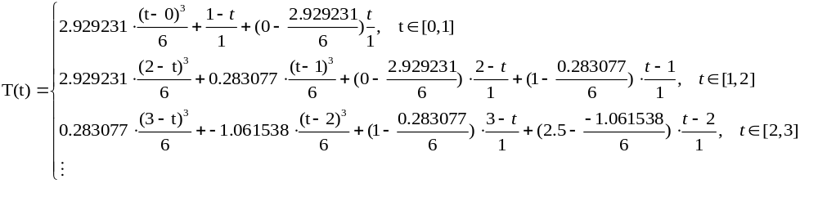 要取得足够多的点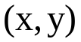，即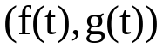，只要加密足够多的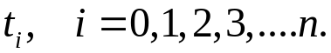 使得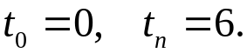 由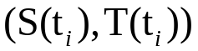取得构成字符的点。

4）计算机编程实现：

//文件名SPLINE.C
//自然样条条件的三次样条插值
#include <stdlib.h>
#include <stdio.h>
void spline(int n,double x[],double y[],double dy[],double ddy[],
int m,double t[],double z[],double dz[],double ddz[])
{
int j,k;
double h, *a, *b, *c;
void trid(int,double [],double [],double [],double []);
a = (double *)malloc(n*sizeof(double));
b = (double *)malloc(n*sizeof(double));
c = (double *)malloc(n*sizeof(double));
a[0] = 0; b[0] = 1; c[0] = 0; ddy[0] = 0;
ddy[1] = (y[2]-y[1])/(x[2]-x[1])-(y[1]-y[0])/(x[1]-x[0]);
ddy[1] = 6*ddy[1]/(x[2]-x[0]);
for (k=1; k<n-1; k++) //构造三对角方程组
{
a[k] = (x[k]-x[k-1])/(x[k+1]-x[k-1]);
b[k] = 2;
c[k] = 1 - a[k];
ddy[k] = (y[k+1]-y[k])/(x[k+1]-x[k])-(y[k]-y[k-1])/(x[k]-x[k-1]);
ddy[k] = 6*ddy[k]/(x[k+1]-x[k-1]);
}
a[n-1] = 0; b[n-1] = 1; c[n-1] = 0; ddy[n-1] = 0;
trid(n, a, b, c, ddy); //求解三对角方程组计算结点处的二阶导数值
for (k=1; k<n; k++) //计算结点处的一阶导数值
{
h = x[k]-x[k-1];
dy[k] = h*ddy[k]/2 + (y[k]-y[k-1])/h - h*(ddy[k]-ddy[k-1])/6;
}
h = x[1]-x[0];
dy[0] = -h*ddy[0]/2 + (y[1]-y[0])/h - h*(ddy[1]-ddy[0])/6;
for (j=0;j<=m-1;j++) //计算插值点处的函数值、一阶导数值和二阶导数值
{
if (t[j]>=x[n-1]) k=n-1;
else
{
k=1;
while (t[j]>x[k]) k=k+1;
}
h = x[k] - x[k-1];
z[j] = ddy[k-1]*(x[k]-t[j])*(x[k]-t[j])*(x[k]-t[j])/(6*h);
z[j] = z[j]+ddy[k]*(t[j]-x[k-1])*(t[j]-x[k-1])*(t[j]-x[k-1])/(6*h);
z[j] = z[j]+(y[k-1]-ddy[k-1]*h*h/6)*(x[k]-t[j])/h;
z[j] = z[j]+(y[k]-ddy[k]*h*h/6)*(t[j]-x[k-1])/h;
dz[j] = -ddy[k-1]*(x[k]-t[j])*(x[k]-t[j])/(2*h);
dz[j] = dz[j]+ddy[k]*(t[j]-x[k-1])*(t[j]-x[k-1])/(2*h);
dz[j] = dz[j]+(y[k]-y[k-1])/h - (ddy[k]-ddy[k-1])*h/6;
ddz[j] = ddy[k-1]*(x[k]-t[j])/h + ddy[k]*(t[j]-x[k-1])/h;
}
free(a); free(b); free(c);
return;
}

//“追赶”法求解三对角方程组
void trid(int n,double a[],double b[],double c[],double d[])
{
int k;
for (k=0;k<=n-2;k++)
{
c[k] = c[k]/b[k];
d[k] = d[k]/b[k];
b[k+1] = b[k+1] - a[k+1]*c[k];
d[k+1] = d[k+1] - a[k+1]*d[k];
}
d[n-1]=d[n-1]/b[n-1];
for (k=n-2;k>=0;k--) d[k]=d[k]-c[k]*d[k+1];
return;
}

void main()
{
int i;
double dy[7],ddy[7],z[601],dz[601],ddz[601];
double x[7]={0,1,2,3,4,5,6};
double y[7]={1,0,1,2.5,3.4,4,3.2};//用于求y=g(t)的样条插值函数T(t)
// y[7]={1,2,3,2,1.2,2,2.7}用于求x=f(t)的样条插值函数S(t)
double t[601];

FILE *fp;
fp=fopen("J:\\2019教学(上)\\计算方法\\教学过程设计\\splineEX\\Debug\\result.txt","a");//参数a表示追加写入

t[0]=0;
for(i=1;i<601;i++)
t[i]=t[i-1]+0.01;
spline(7,x,y,dy,ddy,601,t,z,dz,ddz);
printf(
" x(i) y(i) dy(i) ddy(i)\n");
for (i=0;i<=7;i++)
printf("%14f%14f%14f%14f\n",x[i],y[i],dy[i],ddy[i]);
printf("\n");

printf(
" t(i) z(i) dz(i) ddz(i)\n");
for (i=0;i<=600;i++)
{printf("%14f%14f%14f%14f\n",t[i],z[i],dz[i],ddz[i]);

fprintf(fp,"%f,",z[i]);
}

fclose(fp);
return;
}

5)用MATLAB显示：
t取步长为0.01，t=0:.01:600; 由上面的程序运行2次获得S[601]=z[601]和T[601]=z[601]如下：
S[601]=[ 1.000000,1.008609,1.017219,1.025831,1.034445,1.043062,1.051684,1.060311,1.068943,1.077582,1.086229,1.094884,1.103548,1.112222,1.120907,1.129604,1.138313,1.147036,1.155773,1.164525,1.173292,1.182077,1.190879,1.199699,1.208538,1.217398,1.226278,1.235180,1.244105,1.253053,1.262025,1.271022,1.280045,1.289095,1.298172,1.307278,1.316413,1.325578,1.334774,1.344001,1.353262,1.362555,1.371883,1.381246,1.390644,1.400080,1.409553,1.419064,1.428614,1.438205,1.447837,1.457510,1.467226,1.476985,1.486788,1.496637,1.506531,1.516472,1.526461,1.536498,1.546585,1.556721,1.566908,1.577148,1.587439,1.597784,1.608184,1.618638,1.629149,1.639716,1.650340,1.661024,1.671766,1.682568,1.693432,1.704357,1.715345,1.726396,1.737511,1.748692,1.759938,1.771252,1.782633,1.794082,1.805600,1.817189,1.828849,1.840580,1.852384,1.864262,1.876213,1.888240,1.900343,1.912523,1.924780,1.937116,1.949531,1.962026,1.974602,1.987260,2.000000,2.012823,2.025725,2.038703,2.051751,2.064867,2.078044,2.091281,2.104571,2.117912,2.131298,2.144726,2.158192,2.171691,2.185219,2.198773,2.212347,2.225938,2.239541,2.253153,2.266769,2.280385,2.293997,2.307600,2.321191,2.334766,2.348319,2.361847,2.375346,2.388812,2.402240,2.415627,2.428967,2.442258,2.455494,2.468672,2.481787,2.494836,2.507813,2.520715,2.533538,2.546278,2.558930,2.571490,2.583954,2.596319,2.608578,2.620729,2.632768,2.644690,2.656490,2.668166,2.679712,2.691125,2.702399,2.713532,2.724519,2.735356,2.746038,2.756562,2.766923,2.777117,2.787140,2.796988,2.806656,2.816141,2.825437,2.834542,2.843451,2.852160,2.860663,2.868959,2.877041,2.884907,2.892551,2.899970,2.907159,2.914115,2.920833,2.927309,2.933538,2.939518,2.945242,2.950708,2.955911,2.960847,2.965512,2.969901,2.974011,2.977837,2.981375,2.984621,2.987570,2.990220,2.992564,2.994600,2.996322,2.997728,2.998812,2.999571,3.000000,3.000097,2.999863,2.999304,2.998422,2.997221,2.995707,2.993881,2.991749,2.989313,2.986579,2.983549,2.980228,2.976619,2.972727,2.968555,2.964106,2.959386,2.954397,2.949144,2.943631,2.937861,2.931837,2.925565,2.919048,2.912290,2.905294,2.898064,2.890605,2.882920,2.875013,2.866888,2.858549,2.849999,2.841243,2.832284,2.823127,2.813774,2.804230,2.794499,2.784585,2.774491,2.764221,2.753779,2.743170,2.732396,2.721463,2.710372,2.699130,2.687738,2.676202,2.664525,2.652710,2.640763,2.628686,2.616483,2.604159,2.591717,2.579161,2.566495,2.553723,2.540848,2.527875,2.514807,2.501649,2.488403,2.475074,2.461666,2.448183,2.434628,2.421006,2.407319,2.393573,2.379771,2.365916,2.352013,2.338066,2.324078,2.310053,2.295995,2.281908,2.267795,2.253662,2.239511,2.225346,2.211171,2.196991,2.182808,2.168627,2.154452,2.140287,2.126134,2.111999,2.097885,2.083796,2.069735,2.055708,2.041716,2.027765,2.013859,2.000000,1.986193,1.972440,1.958742,1.945103,1.931523,1.918005,1.904550,1.891161,1.877839,1.864587,1.851406,1.838298,1.825265,1.812310,1.799434,1.786639,1.773927,1.761299,1.748759,1.736308,1.723947,1.711679,1.699506,1.687429,1.675451,1.663573,1.651798,1.640127,1.628562,1.617106,1.605760,1.594526,1.583406,1.572402,1.561516,1.550750,1.540105,1.529585,1.519190,1.508923,1.498786,1.488780,1.478907,1.469170,1.459571,1.450111,1.440792,1.431616,1.422585,1.413702,1.404967,1.396384,1.387953,1.379678,1.371559,1.363599,1.355799,1.348163,1.340690,1.333385,1.326247,1.319281,1.312486,1.305866,1.299422,1.293156,1.287070,1.281167,1.275447,1.269913,1.264568,1.259412,1.254447,1.249677,1.245102,1.240725,1.236547,1.232571,1.228798,1.225231,1.221871,1.218720,1.215780,1.213054,1.210542,1.208248,1.206172,1.204318,1.202686,1.201279,1.200099,1.199147,1.198426,1.197938,1.197684,1.197666,1.197887,1.198349,1.199052,1.200000,1.201193,1.202629,1.204305,1.206217,1.208362,1.210738,1.213340,1.216166,1.219212,1.222475,1.225952,1.229640,1.233535,1.237634,1.241935,1.246433,1.251126,1.256010,1.261082,1.266338,1.271777,1.277394,1.283186,1.289150,1.295282,1.301581,1.308041,1.314660,1.321436,1.328363,1.335441,1.342664,1.350030,1.357536,1.365178,1.372954,1.380859,1.388891,1.397047,1.405323,1.413716,1.422223,1.430841,1.439566,1.448395,1.457325,1.466353,1.475475,1.484689,1.493990,1.503377,1.512845,1.522391,1.532013,1.541706,1.551468,1.561296,1.571185,1.581134,1.591138,1.601195,1.611302,1.621454,1.631649,1.641884,1.652156,1.662460,1.672795,1.683156,1.693540,1.703945,1.714367,1.724803,1.735249,1.745703,1.756161,1.766620,1.777076,1.787527,1.797969,1.808399,1.818814,1.829211,1.839585,1.849935,1.860257,1.870547,1.880803,1.891021,1.901198,1.911331,1.921416,1.931450,1.941431,1.951354,1.961217,1.971016,1.980749,1.990411,2.000000,2.009513,2.018951,2.028313,2.037601,2.046816,2.055958,2.065028,2.074026,2.082955,2.091813,2.100603,2.109325,2.117979,2.126567,2.135089,2.143546,2.151939,2.160268,2.168534,2.176738,2.184882,2.192964,2.200987,2.208951,2.216857,2.224705,2.232497,2.240233,2.247914,2.255540,2.263113,2.270633,2.278101,2.285518,2.292884,2.300201,2.307468,2.314688,2.321859,2.328985,2.336064,2.343098,2.350088,2.357034,2.363937,2.370798,2.377618,2.384397,2.391136,2.397837,2.404499,2.411123,2.417711,2.424263,2.430780,2.437262,2.443710,2.450126,2.456509,2.462862,2.469183,2.475475,2.481737,2.487971,2.494178,2.500358,2.506512,2.512640,2.518745,2.524825,2.530882,2.536918,2.542931,2.548925,2.554898,2.560852,2.566788,2.572706,2.578607,2.584492,2.590362,2.596218,2.602059,2.607888,2.613704,2.619509,2.625303,2.631087,2.636862,2.642629,2.648388,2.654140,2.659886,2.665626,2.671362,2.677094,2.682823,2.688550,2.694276,2.700000,]

T[601]=[ 1.000000,0.985118,0.970240,0.955367,0.940503,0.925651,0.910813,0.895993,0.881194,0.866417,0.851668,0.836947,0.822259,0.807606,0.792991,0.778417,0.763887,0.749404,0.734970,0.720590,0.706265,0.691998,0.677793,0.663653,0.649580,0.635577,0.621647,0.607794,0.594020,0.580327,0.566720,0.553201,0.539772,0.526437,0.513199,0.500060,0.487024,0.474093,0.461271,0.448560,0.435963,0.423483,0.411124,0.398888,0.386777,0.374795,0.362946,0.351231,0.339653,0.328216,0.316923,0.305776,0.294779,0.283934,0.273244,0.262712,0.252342,0.242135,0.232096,0.222226,0.212529,0.203008,0.193666,0.184505,0.175529,0.166740,0.158142,0.149737,0.141528,0.133518,0.125711,0.118108,0.110714,0.103530,0.096561,0.089808,0.083274,0.076964,0.070879,0.065022,0.059397,0.054006,0.048852,0.043939,0.039269,0.034845,0.030669,0.026746,0.023078,0.019667,0.016517,0.013631,0.011011,0.008660,0.006583,0.004780,0.003256,0.002013,0.001054,0.000382,0.000000,-0.000090,0.000111,0.000599,0.001372,0.002427,0.003762,0.005374,0.007261,0.009419,0.011846,0.014540,0.017498,0.020716,0.024194,0.027927,0.031913,0.036150,0.040635,0.045366,0.050338,0.055551,0.061002,0.066687,0.072604,0.078750,0.085123,0.091721,0.098539,0.105577,0.112831,0.120298,0.127976,0.135863,0.143955,0.152250,0.160745,0.169438,0.178326,0.187407,0.196677,0.206134,0.215776,0.225599,0.235602,0.245781,0.256134,0.266658,0.277350,0.288209,0.299231,0.310413,0.321754,0.333249,0.344898,0.356696,0.368642,0.380733,0.392965,0.405337,0.417846,0.430489,0.443264,0.456167,0.469197,0.482350,0.495624,0.509017,0.522525,0.536146,0.549877,0.563716,0.577660,0.591707,0.605853,0.620096,0.634434,0.648864,0.663382,0.677988,0.692677,0.707447,0.722296,0.737221,0.752220,0.767288,0.782425,0.797628,0.812893,0.828218,0.843600,0.859037,0.874527,0.890065,0.905651,0.921281,0.936952,0.952662,0.968409,0.984189,1.000000,1.015840,1.031706,1.047598,1.063515,1.079454,1.095415,1.111396,1.127396,1.143414,1.159448,1.175496,1.191559,1.207633,1.223718,1.239813,1.255916,1.272025,1.288140,1.304260,1.320382,1.336505,1.352628,1.368750,1.384870,1.400986,1.417096,1.433199,1.449295,1.465381,1.481457,1.497520,1.513571,1.529606,1.545626,1.561627,1.577611,1.593574,1.609516,1.625434,1.641329,1.657199,1.673041,1.688855,1.704640,1.720394,1.736116,1.751804,1.767457,1.783074,1.798654,1.814194,1.829695,1.845153,1.860569,1.875941,1.891266,1.906545,1.921776,1.936956,1.952086,1.967164,1.982187,1.997156,2.012068,2.026922,2.041718,2.056453,2.071126,2.085736,2.100282,2.114761,2.129174,2.143518,2.157792,2.171995,2.186126,2.200182,2.214164,2.228068,2.241895,2.255643,2.269310,2.282895,2.296397,2.309814,2.323145,2.336389,2.349544,2.362609,2.375583,2.388464,2.401251,2.413943,2.426538,2.439034,2.451432,2.463728,2.475923,2.488014,2.500000,2.511880,2.523656,2.535329,2.546899,2.558369,2.569741,2.581014,2.592191,2.603274,2.614263,2.625160,2.635967,2.646685,2.657315,2.667859,2.678318,2.688694,2.698988,2.709201,2.719335,2.729392,2.739372,2.749278,2.759110,2.768870,2.778560,2.788180,2.797733,2.807220,2.816642,2.826000,2.835296,2.844532,2.853709,2.862827,2.871890,2.880898,2.889852,2.898754,2.907606,2.916409,2.925163,2.933872,2.942535,2.951156,2.959734,2.968271,2.976769,2.985230,2.993654,3.002043,3.010399,3.018722,3.027015,3.035279,3.043515,3.051725,3.059909,3.068070,3.076209,3.084328,3.092427,3.100508,3.108573,3.116622,3.124659,3.132683,3.140696,3.148701,3.156697,3.164687,3.172672,3.180653,3.188632,3.196611,3.204590,3.212571,3.220556,3.228545,3.236542,3.244545,3.252559,3.260583,3.268618,3.276668,3.284732,3.292813,3.300912,3.309029,3.317168,3.325328,3.333512,3.341721,3.349956,3.358219,3.366511,3.374834,3.383189,3.391577,3.400000,3.408459,3.416951,3.425475,3.434027,3.442606,3.451208,3.459831,3.468472,3.477129,3.485800,3.494481,3.503171,3.511866,3.520565,3.529263,3.537960,3.546653,3.555338,3.564014,3.572677,3.581326,3.589957,3.598568,3.607157,3.615721,3.624258,3.632764,3.641238,3.649676,3.658077,3.666437,3.674755,3.683027,3.691251,3.699425,3.707546,3.715611,3.723617,3.731563,3.739446,3.747263,3.755012,3.762689,3.770293,3.777821,3.785271,3.792639,3.799923,3.807121,3.814231,3.821249,3.828173,3.835000,3.841729,3.848356,3.854879,3.861295,3.867601,3.873796,3.879877,3.885841,3.891685,3.897407,3.903005,3.908475,3.913816,3.919024,3.924098,3.929034,3.933831,3.938485,3.942994,3.947355,3.951566,3.955625,3.959528,3.963274,3.966859,3.970282,3.973538,3.976627,3.979546,3.982291,3.984861,3.987252,3.989463,3.991490,3.993331,3.994984,3.996446,3.997715,3.998787,3.999661,4.000333,4.000802,4.001064,4.001118,4.000960,4.000588,4.000000,3.999193,3.998170,3.996932,3.995481,3.993820,3.991951,3.989876,3.987597,3.985117,3.982437,3.979560,3.976488,3.973224,3.969768,3.966125,3.962295,3.958281,3.954085,3.949710,3.945157,3.940429,3.935528,3.930456,3.925215,3.919808,3.914236,3.908503,3.902609,3.896558,3.890351,3.883991,3.877479,3.870819,3.864012,3.857060,3.849966,3.842732,3.835359,3.827851,3.820209,3.812436,3.804533,3.796504,3.788349,3.780072,3.771675,3.763159,3.754527,3.745781,3.736923,3.727956,3.718881,3.709702,3.700419,3.691035,3.681553,3.671975,3.662302,3.652538,3.642683,3.632741,3.622713,3.612603,3.602411,3.592140,3.581793,3.571371,3.560877,3.550312,3.539680,3.528982,3.518221,3.507398,3.496516,3.485577,3.474583,3.463537,3.452440,3.441295,3.430105,3.418870,3.407594,3.396278,3.384925,3.373537,3.362116,3.350664,3.339184,3.327678,3.316148,3.304595,3.293023,3.281434,3.269829,3.258211,3.246582,3.234944,3.223300,3.211651,3.200000]

plot(S,T',"LineWidth",2),grid on
