Study Guide to Accompany

Operating Systems Concepts essentials Second Edition by Silberschatz, Galvin and Gagne

By Andrew DeNicola, BU ECE Class of 2012
Figures Copyright © John Wiley & Sons 2012

Ch.1 – Introduction

- An OS is a program that acts as an intermediary between a user of a computer and the computer hardware
- Goals: Execute user programs, make the comp. system easy to use, utilize hardware efficiently
- Computer system: Hardware ↔ OS ↔ Applications ↔ Users (↔ = 'uses')
- OS is:
  - Resource allocator: decides between conflicting requests for efficient and fair resource use
  - Control program: controls execution of programs to prevent errors and improper use of computer
- Kernel: the one program running at all times on the computer
- Bootstrap program: loaded at power-up or reboot
  - Stored in ROM or EPROM (known as firmware), Initializes all aspects of system, loads OS kernel and starts execution
- I/O and CPU can execute concurrently
- Device controllers inform CPU that it is finished w/ operation by causing an interrupt
  - Interrupt transfers control to the interrupt service routine generally, through the interrupt vector, which contains the addresses of all the service routines
  - Incoming interrupts are disabled while another interrupt is being processed
  - Trap is a software generated interrupt caused by error or user request
  - OS determines which type of interrupt has occurred by polling or the vectored interrupt system
- System call: request to the operating system to allow user to wait for I/O completion
- Device-status table: contains entry for each I/O device indicating its type, address, and state
  - OS indexes into the I/O device table to determine device status and to modify the table entry to include interrupt
- Storage structure:
  - Main memory – random access, volatile
  - Secondary storage – extension of main memory That provides large non-volatile storage
  - Disk – divided into tracks which are subdivided into sectors. Disk controller determines logical interaction between the device and the computer.
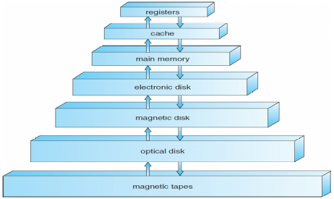
- Caching – copying information into faster storage system
- Multiprocessor Systems: Increased throughput, economy of
scale, increased reliability
  - Can be asymmetric or symmetric
  - Clustered systems – Linked multiprocessor systems
- Multiprogramming – Provides efficiency via job scheduling
  - When OS has to wait (ex: for I/O), switches to another job
- Timesharing – CPU switches jobs so frequently that each user
can interact with each job while it is running (interactive computing)
- Dual-mode operation allows OS to protect itself and other system components – User mode and kernel mode
  - Some instructions are only executable in kernel mode, these are privileged
- Single-threaded processes have one program counter, multi-threaded processes have one PC per thread
- Protection – mechanism for controlling access of processes or users to resources defined by the OS
- Security – defense of a system against attacks
- User IDs (UID), one per user, and Group IDs, determine which users and groups of users have which privileges

Ch.2 – OS Structures

- User Interface (UI) – Can be Command-Line (CLI) or Graphics User Interface (GUI) or Batch
  - These allow for the user to interact with the system services via system calls (typically written in C/C++)
- Other system services that a helpful to the user include: program execution, I/O operations, file-system manipulation, communications, and error detection
- Services that exist to ensure efficient OS operation are: resource allocation, accounting, protection and security
- Most system calls are accessed by Application Program Interface (API) such as Win32, POSIX, Java
- Usually there is a number associated with each system call
  - System call interface maintains a table indexed according to these numbers
- Parameters may need to be passed to the OS during a system call, may be done by:
  - Passing in registers, address of parameter stored in a block, pushed onto the stack by the program and popped off by the OS
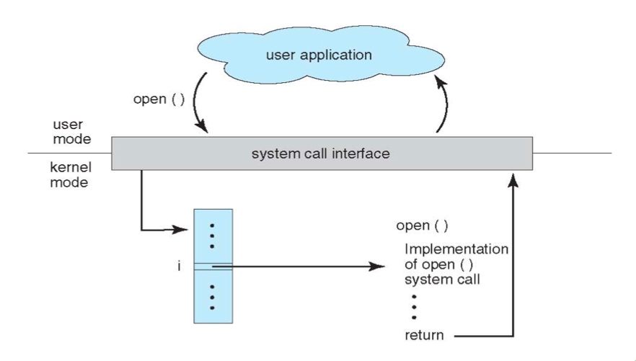
  - Block and stack methods do not limit the number or length of parameters being passed
- Process control system calls include: end, abort, load, execute, create/terminate process, wait, allocate/free memory
- File management system calls include: create/delete file, open/close file, read, write, get/set attributes
- Device management system calls: request/release device, read, write, logically attach/detach devices
- Information maintenance system calls: get/set time, get/set system data, get/set process/file/device attributes
- Communications system calls: create/delete communication connection, send/receive, transfer status information
- OS Layered approach:
  - The operating system is divided into a number of layers (levels), each built on top of lower layers. The bottom layer (layer 0), is the hardware; the highest (layer N) is the user interface
  - With modularity, layers are selected such that each uses functions (operations) and services of only lower-level layers
- Virtual machine: uses layered approach, treats hardware and the OS kernel as though they were all hardware.
  - Host creates the illusion that a process has its own processor and own virtual memory
  - Each guest provided with a 'virtual' copy of the underlying computer
- Application failures can generate core dump file capturing memory of the process
- Operating system failure can generate crash dump file containing kernel memory

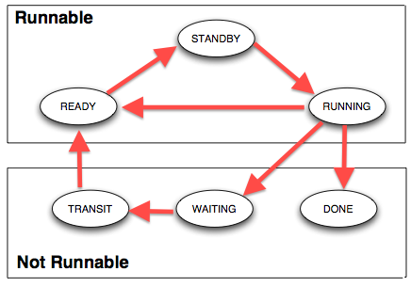
Ch.3 – Processes

- Process contains a program counter, stack, and data section.
  - Text section: program code itself
  - Stack: temporary data (function parameters, return addresses, local variables)
  - Data section: global variables
  - Heap: contains memory dynamically allocated during run-time
- Process Control Block (PCB): contains information associated with each process: process state, PC, CPU registers, scheduling information, accounting information, I/O status information
- Types of processes:
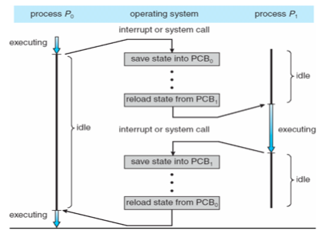
  - I/O Bound: spends more time doing I/O than computations, many short CPU bursts
  - CPU Bound: spends more time doing computations, few very long CPU bursts
- When CPU switches to another process, the system must save the state of the old process (to PCB) and load the saved state (from PCB) for the new process via a context switch
  - Time of a context switch is dependent on hardware
- Parent processes create children processes (form a tree)
  - PID allows for process management
  - Parents and children can share all/some/none resources
  - Parents can execute concurrently with children or wait until children terminate
  - fork() system call creates new process
    - exec() system call used after a fork to replace the processes' memory space with a new program
- Cooperating processes need interprocess communication (IPC): shared memory or message passing
- Message passing may be blocking or non-blocking
  - Blocking is considered synchronous
    - Blocking send has the sender block until the message is received
    - Blocking receive has the receiver block until a message is available
  - Non-blocking is considered asynchronous
    - Non-blocking send has the sender send the message and continue
    - Non-blocking receive has the receiver receive a valid message or null

Ch.4 – Threads

- Threads are fundamental unit of CPU utilization that forms the basis of multi-threaded computer systems
- Process creation is heavy-weight while thread creation is light-weight
  - Can simplify code and increase efficiency
- Kernels are generally multi-threaded
- Multi-threading models include: Many-to-One, One-to-One, Many-to-Many
  - Many-to-One: Many user-level threads mapped to single kernel thread
  - One-to-One: Each user-level thread maps to kernel thread
  - Many-to-Many: Many user-level threads mapped to many kernel threads
- Thread library provides programmer with API for creating and managing threads
- Issues include: thread cancellation, signal handling (synchronous/asynchronous), handling thread-specific data, and scheduler activations.
  - Cancellation:
    - Asynchronous cancellation terminates the target thread immediately
    - Deferred cancellation allows the target thread to periodically check if it should be canceled
  - Signal handler processes signals generated by a particular event, delivered to a process, handled
  - Scheduler activations provide upcalls – a communication mechanism from the kernel to the thread library.
    - Allows application to maintain the correct number of kernel threads
Ch.5 – Process Synchronization

- Race Condition: several processes access and manipulate the same data concurrently, outcome depends on which order each access takes place.
- Each process has critical section of code, where it is manipulating data
  - To solve critical section problem each process must ask permission to enter critical section in entry section, follow critical section with exit section and then execute the remainder section
  - Especially difficult to solve this problem in preemptive kernels
- Peterson's Solution: solution for two processes
  - Two processes share two variables: int turn and Boolean flag[2]
  - turn: whose turn it is to enter the critical section
  - flag: indication of whether or not a process is ready to enter critical section
    - flag[i] = true indicates that process P_{i} is ready
  - Algorithm for process P_{i}:
do {
flag[i] = TRUE;
turn = j;
while (flag[j] && turn == j)
critical section
flag[i] = FALSE;
remainder section
} while (TRUE);
- Modern machines provide atomic hardware instructions: Atomic = non-interruptable
- Solution using Locks:
do {
acquire lock
critical section
release lock
remainder section
} while (TRUE);
- Solution using Test-And-Set: Shared boolean variable lock, initialized to FALSE
boolean TestAndSet (boolean *target){
boolean rv = *target;
*target = TRUE;"
return rv:
}
do {
while ( TestAndSet (&lock ))
; // do nothing
// critical section
lock = FALSE;
// remainder section
} while (TRUE);

- Solution using Swap: Shared bool variable lock initialized to FALSE; Each process has local bool variable key
void Swap (boolean *a, boolean *b){
boolean temp = *a;
*a = *b;
*b = temp:
}
do {
key = TRUE;
while ( key == TRUE)
Swap (&lock, &key );
// critical section
lock = FALSE;
// remainder section
} while (TRUE);

- Semaphore: Synchronization tool that does not require busy waiting
  - Standard operations: wait() and signal() ← these are the only operations that can access semaphore S
  - Can have counting (unrestricted range) and binary (0 or 1) semaphores
- Deadlock: Two or more processes are waiting indefinitely for an event that can be caused by only one of the waiting processes (most OSes do not prevent or deal with deadlocks)
  - Can cause starvation and priority inversion (lower priority process holds lock needed by higher-priority process)
Ch.5 – Process Synchronization (Continued)

- Other synchronization problems include Bounded-Buffer Problem and Readers-Writers Problem
- Monitor is a high-level abstraction that provides a convenient and effective mechanism for process synchronization
  - Only one process may be active within the monitor at a time
  - Can utilize condition variables to suspend a resume processes (ex: condition x, y;)
    - x.wait() – a process that invokes the operation is suspended until x.signal()
    - x.signal() – resumes one of processes (if any) that invoked x.wait()
  - Can be implemented with semaphores

Ch.6 – CPU Scheduling

- Process execution consists of a cycle of CPU execution and I/O wait
- CPU scheduling decisions take place when a process:
  - Switches from running to waiting (nonpreemptive)
  - Switches from running to ready (preemptive)
  - Switches from waiting to ready (preemptive)
  - Terminates (nonpreemptive)
- The dispatcher module gives control of the CPU to the process selected by the short-term scheduler
  - Dispatch latency- the time it takes for the dispatcher to stop one process and start another
- Scheduling algorithms are chosen based on optimization criteria (ex: throughput, turnaround time, etc.)
  - FCFS, SJF, Shortest-Remaining-Time-First (preemptive SJF), Round Robin, Priority
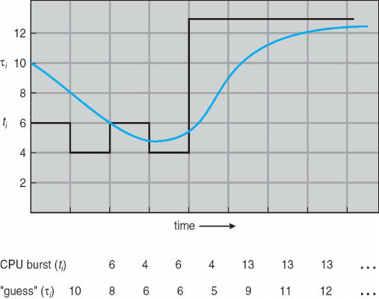
- Determining length of next CPU burst: Exponential Averaging:
  - t_{n} = actual length of n^{th} CPU burst
  - τ_{n+1} = predicted value for the next CPU burst
  - α, 0 ≤ α ≤ 1 (commonly α set to 1/2)
  - Define: τ_{n+1} = α*t_{n} + (1-α)τ_{n}
- Priority Scheduling can result in starvation, which can be solved by aging a process (as time progresses, increase the priority)
- In Round Robin, small time quantums can result in large amounts of context switches
  - Time quantum should be chosen so that 80% of processes have shorter burst times that the time quantum
- Multilevel Queues and Multilevel Feedback Queues have multiple process queues that have different priority levels
  - In the Feedback queue, priority is not fixed → Processes can be promoted and demoted to different queues
  - Feedback queues can have different scheduling algorithms at different levels
- Multiprocessor Scheduling is done in several different ways:
  - Asymmetric multiprocessing: only one processor accesses system data structures → no need to data share
  - Symmetric multiprocessing: each processor is self-scheduling (currently the most common method)
  - Processor affinity: a process running on one processor is more likely to continue to run on the same processor (so that the processor's memory still contains data specific to that specific process)
- Little's Formula can help determine average wait time per process in any scheduling algorithm:
  - n = λ x W
  - n = avg queue length; W = avg waiting time in queue; λ = average arrival rate into queue
- Simulations are programmed models of a computer system with variable clocks
  - Used to gather statistics indicating algorithm performance
  - Running simulations is more accurate than queuing models (like Little's Law)
  - Although more accurate, high cost and high risk

Ch.7 – Main Memory

- Cache sits between main memory and CPU registers
- Base and limit registers define logical address space usable by a process
- Compiled code addresses bind to relocatable addresses
  - Can happen at three different stages
    - Compile time: If memory location known a priori, absolute code can be generated
    - Load time: Must generate relocatable code if memory location not known at compile time
    - Execution time: Binding delayed until run time if the process can be moved during its execution
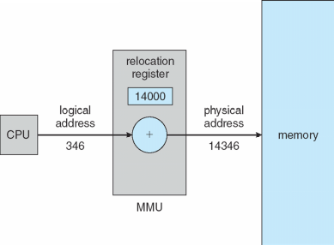
- Memory-Management Unit (MMU) device that maps virtual to physical address
- Simple scheme uses a relocation register which just adds a base value to address
- Swapping allows total physical memory space of processes to exceed physical memory
  - Def: process swapped out temporarily to backing store then brought back in for continued execution
- Backing store: fast disk large enough to accommodate copes of all memory images
- Roll out, roll in: swapping variant for priority-based scheduling.
  - Lower priority process swapped out so that higher priority process can be loaded
- Solutions to Dynamic Storage-Allocation Problem:
  - First-fit: allocate the first hole that is big enough
  - Best-fit: allocate the smallest hole that is big enough (must search entire list) → smallest leftover hole
  - Worst-fit: allocate the largest hole (search entire list) → largest leftover hole
- External Fragmentation: total memory space exists to satisfy request, but is not contiguous
  - Reduced by compaction: relocate free memory to be together in one block
    - Only possible if relocation is dynamic
- Internal Fragmentation: allocated memory may be slightly larger than requested memory
- Physical memory divided into fixed-sized frames: size is power of 2, between 512 bytes and 16 MB
- Logical memory divided into same sized blocks: pages
- Page table used to translate logical to physical addresses
  - Page number (p): used as an index into a page table
  - Page offset (d): combined with base address to define the physical memory address
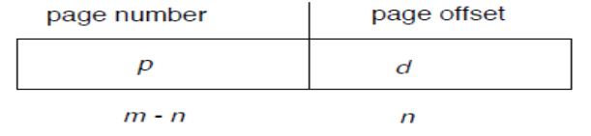
- Free-frame list is maintained to keep track of which frames can be allocated
For given logical address space 2^{m} and page size 2^{n}
Ch.7 – Main Memory (Continued)

- Transition Look-aside Buffer (TLB) is a CPU cache that memory management hardware uses to improve virtual address translation speed
  - Typically small – 64 to 1024 entries
  - On TLB miss, value loaded to TLB for faster access next time
  - TLB is associative – searched in parallel
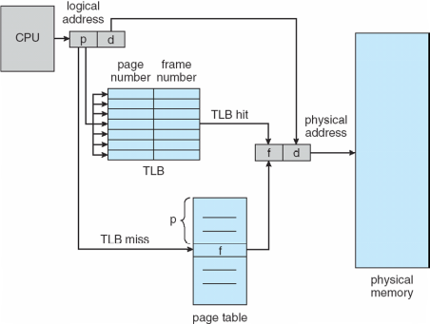Paging with TLB
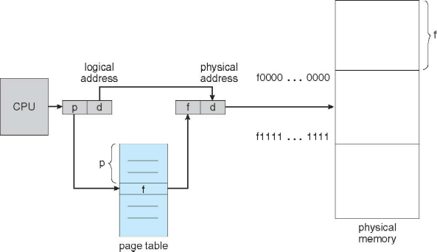Paging without TLB

- Effective Access Time: EAT = (1 + ε) α + (2 + ε)(1 – α)
  - ε = time unit, α = hit ratio
- Valid and invalid bits can be used to protect memory
  - “Valid” if the associated page is in the process' logical address space, so it is a legal page
- Can have multilevel page tables (paged page tables)
- Hashed Page Tables: virtual page number hashed into page table
  - Page table has chain of elements hashing to the same location
  - Each element has (1) virtual page number, (2) value of mapped page frame, (3) a pointer to the next element
  - Search through the chain for virtual page number
- Segment table – maps two-dimensional physical addresses
  - Entries protected with valid bits and r/w/x privileges

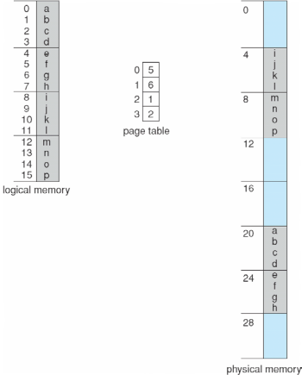Page table example
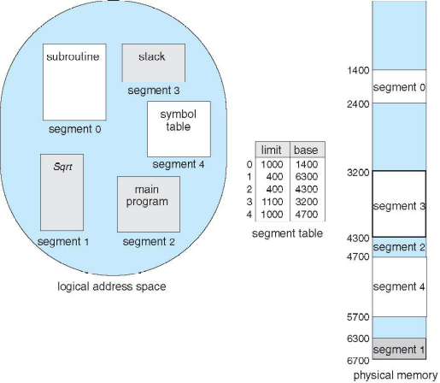Segmentation example

Ch.8 – Virtual Memory

- Virtual memory: separation of user logical memory and physical memory
  - Only part of program needs to be in memory for execution → logical address space > physical address space
  - Allows address spaces to be shared by multiple processes → less swapping
  - Allows pages to be shared during fork(), speeding process creation
- Page fault results from the first time there is a reference to a specific page → traps the OS
  - Must decide to abort if the reference is invalid, or if the desired page is just not in memory yet
    - If the latter: get empty frame, swap page into frame, reset tables to indicate page now in memory, set validation bit, restart instruction that caused the page fault
  - If an instruction accesses multiple pages near each other → less “pain” because of locality of reference
- Demand Paging only brings a page into memory when it is needed → less I/O and memory needed
  - Lazy swapper – never swaps a page into memory unless page will be needed
  - Could result in a lot of page-faults
  - Performance: EAT = [(1-p)*memory access + p*(page fault overhead + swap page out + swap page in + restart overhead)]; where Page Fault Rate 0 ″ p ″ 1
    - if p = 0, no page faults; if p = 1, every reference is a fault
  - Can optimize demand paging by loading entire process image to swap space at process load time
- Pure Demand Paging: process starts with no pages in memory
- Copy-on-Write (COW) allows both parent and child processes to initially share the same pages in memory
  - If either process modifies a shared page, only then is the page copied
- Modify (dirty) bit can be used to reduce overhead of page transfers → only modified pages written to disk
- When a page is replaced, write to disk if it has been marked dirty and swap in desired page
- Pages can be replaced using different algorithms: FIFO, LRU (below)
  - Stack can be used to record the most recent page references (LRU is a “stack” algorithm)
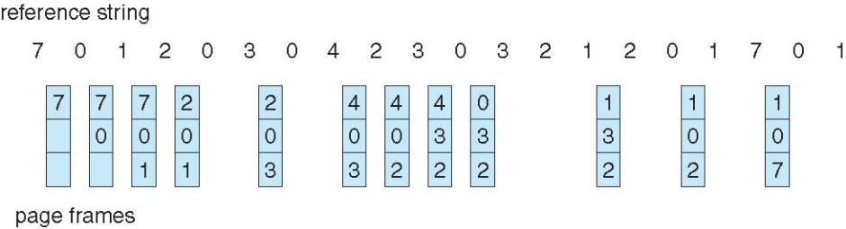
  - Second chance algorithm uses a reference bit
    - If 1, decrement and leave in memory
    - If 0, replace next page
- Fixed page allocation: Proportional allocation – Allocate according to size of process
  - s_{i} = size of process P_{i}, S = Σs_{i}, m = total number of frames, a_{i} – allocation for P_{i}
  - a_{i} = (s_{i}/S)*m
- Global replacement: process selects a replacement frame from set of all frames
  - One process can take frame from another
  - Process execution time can vary greatly
  - Greater throughput
- Local replacement: each process selects from only its own set of allocated frames
  - More consistent performance
  - Possible under-utilization of memory

Ch.8 – Virtual Memory (Continued)

- Page-fault rate is very high if a process does not have “enough” pages
  - Thrashing: a process is busy swapping pages in and out → minimal work is actually being performed
- Memory-mapped file I/O allows file I/O to be treated as routine memory access by mapping a disk block to a page in memory
- I/O Interlock: Pages must sometimes be locked into memory

Ch.9 – Mass-Storage Systems

- Magnetic disks provide bulk of secondary storage – rotate at 60 to 250 times per second
  - Transfer rate: rate at which data flows between drive and computer
  - Positioning time (random-access time) is time to move disk arm to desired cylinder (seek time) and time for desired sector to rotate under the disk head (rotational latency)
  - Head crash: disk head making contact with disk surface
- Drive attached to computer's I/O bus – EIDE, ATA, SATA, USB, etc.
  - Host controller uses bus to talk to disk controller
- Access latency = Average access time = average seek time + average latency (fast ~5ms, slow ~14.5ms)
- Average I/O time = avg. access time + (amount to transfer / transfer rate) + controller overhead
  - Ex: to transfer a 4KB block on a 7200 RPM disk with a 5ms average seek time, 1Gb/sec transfer rate with a .1ms controller overhead = 5ms + 4.17ms + 4KB / 1Gb/sec + 0.1ms = 9.27ms + .12ms = 9.39ms
- Disk drives addressed as 1-dimensional arrays of logical blocks
  - 1-dimensional array is mapped into the sectors of the disk sequentially
- Host-attached storage accessed through I/O ports talking to I/O buses
  - Storage area network (SAN): many hosts attach to many storage units, common in large storage environments
    - Storage made available via LUN masking from specific arrays to specific servers
- Network attached storage (NAS): storage made available over a network rather than local connection
- In disk scheduling, want to minimize seek time; Seek time is proportional to seek distance
- Bandwidth is (total number of bytes transferred) / (total time between first request and completion of last transfer)
- Sources of disk I/O requests: OS, system processes, user processes
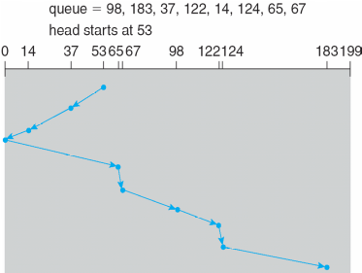SCAN
  - OS maintains queue of requests, per disk or device
- Several algorithms exist to schedule the servicing of disk I/O requests
  - FCFS, SSTF (shortest seek time first), SCAN, CSCAN, LOOK, CLOOK
    - SCAN/elevator: arm starts at one end and moves towards other end servicing requests as it goes, then reverses direction
    - CSCAN: instead of reversing direction, immediately goes back to beginning
    - LOOK/CLOOK: Arm only goes as far as the last request in each directions, then reverses immediately
- Low level/physical formatting: dividing a disk into sectors that the disk controller can read and write – usually 512 bytes of data
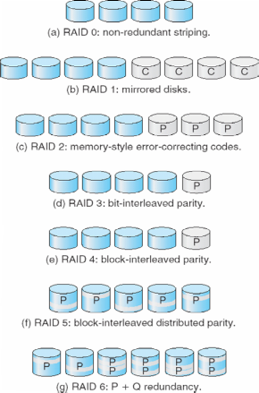
- Partition: divide disk into one or more groups of cylinders, each treated as logical disk
- Logical formatting: “making a file system”
- Increase efficiency by grouping blocks into clusters - Disk I/O is performed on blocks
  - Boot block initializes system - bootstrap loader stored in boot block
- Swap-space: virtual memory uses disk space as an extension of main memory
  - Kernel uses swap maps to track swap space use
- RAID: Multiple disk drives provide reliability via redundancy – increases mean time to failure
  - Disk striping uses group of disks as one storage unit
  - Mirroring/shadowing (RAID 1) – keeps duplicate of each disk
  - Striped mirrors (RAID 1+0) or mirrored striped (RAID 0+1) provides high performance/reliability
  - Block interleaved parity (RAID 4, 5, 6) uses much less redundancy
- Solaris ZFS adds checksums of all data and metadata – detect if object is the right one and whether it changed
- Tertiary storage is usually built using removable media – can be WORM or Read-only, handled like fixed disks
- Fixed disk usually more reliable than removable disk or tape drive
- Main memory is much more expensive than disk storage

Ch.10 – File-System Interface
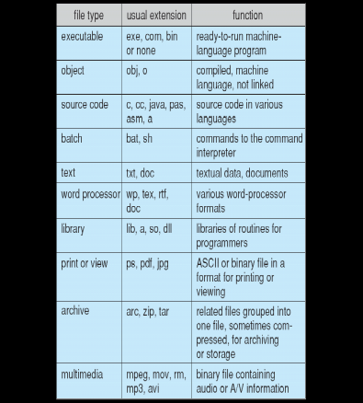
- File – Uniform logical view of information storage (no matter the medium)
  - Mapped onto physical devices (usually nonvolatile)
  - Smallest allotment of nameable storage
  - Types: Data (numeric, character, binary), Program, Free form, Structured
  - Structure decided by OS and/or program/programmer
- Attributes:
  - Name: Only info in human-readable form
  - Identifier: Unique tag, identifies file within the file system
  - Type, Size
  - Location: pointer to file location
  - Time, date, user identification
- File is an abstract data type
- Operations: create, write, read, reposition within file, delete, truncate
- Global table maintained containing process-independent open file information: open-file table
  - Per-process open file table contains pertinent info, plus pointer to entry in global open file table
- Open file locking: mediates access to a file (shared or exclusive)
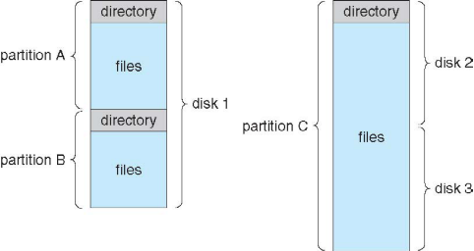File-System Organization
  - Mandatory – access denied depending on locks held and requested
  - Advisory – process can find status of locks and decide what to do
- File type can indicate internal file structure
- Access Methods: Sequential access, direct access
  - Sequential Access: tape model of a file
  - Direct Access: random access, relative access
- Disk can be subdivided into partitions; disks or partitions can be RAID protected against failure.
  - Can be used raw without a file-system or formatted with a file system
  - Partitions also knows as minidisks, slices
- Volume contains file system: also tracks file system's info in device directory or volume table of contents
- File system can be general or special-purpose. Some special purpose FS:
  - tmpfs – temporary file system in volatile memory
  - objfs – virtual file system that gives debuggers access to kernel symbols
  - ctfs – virtual file system that maintains info to manage which processes start when system boots
  - lofs – loop back file system allows one file system to be accessed in place of another
  - procfs – virtual file system that presents information on all processes as a file system
- Directory is similar to symbol table – translating file names into their directory entries
  - Should be efficient, convenient to users, logical grouping
  - Tree structured is most popular – allows for grouping
  - Commands for manipulating: remove – rm<file-name> ; make new sub directory - mkdir<dir-name>
- Current directory: default location for activities – can also specify a path to perform activities in
- Acyclic-graph directories adds ability to directly share directories between users
  - Acyclic can be guaranteed by: only allowing shared files, not shared sub directories; garbage collection; mechanism to check whether new links are OK
- File system must be mounted before it can be accessed – kernel data structure keeps track of mount points
- In a file sharing system User IDs and Group IDs help identify a user's permissions
- Client-server allows multiple clients to mount remote file systems from servers – NFS (UNIX), CIFS (Windows)
- Consistency semantics specify how multiple users are to access a shared file simultaneously – similar to synchronization algorithms from Ch.7
  - One way of protection is Controlled Access: when file created, determine r/w/x access for users/groups
Ch.11 – File System Implementation
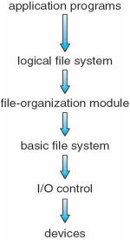
- File system resides on secondary storage – disks; file system is organized into layers →
- File control block: storage structure consisting of information about a file (exist per-file)
- Device driver: controls the physical device; manage I/O devices
- File organization module: understands files, logical addresses, and physical blocks
  - Translates logical block number to physical block number
  - Manages free space, disk allocation
- Logical file system: manages metadata information – maintains file control blocks
- Boot control block: contains info needed by system to boot OS from volume
- Volume control block: contains volume details; ex: total # blocks, # free blocks, block size, free block pointers
- Root partition: contains OS; mounted at boot time
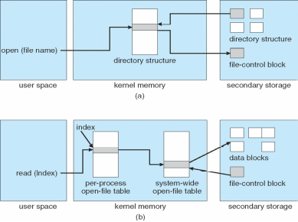(a) open() (b) read()
- For all partitions, system is consistency checked at mount time
  - Check metadata for correctness – only allow mount to occur if so
- Virtual file systems provide object-oriented way of implementing file systems
- Directories can be implemented as Linear Lists or Hash Tables
  - Linear list of file names with pointer to data blocks – simple but slow
  - Hash table – linear list with hash data structure – decreased search time
    - Good if entries are fixed size
    - Collisions can occur in hash tables when two file names hash to same location
- Contiguous allocation: each file occupies set of contiguous blocks
  - Simple, best performance in most cases; problem – finding space for file, external fragmentation
  - Extent based file systems are modified contiguous allocation schemes – extent is allocated for file allocation
- Linked Allocation: each file is a linked list of blocks – no external fragmentation
  - Locating a block can take many I/Os and disk seeks
- Indexed Allocation: each file has its own index block(s) of pointers to its data blocks
  - Need index table; can be random access; dynamic access without external fragmentation but has overhead
- Best methods: linked good for sequential, not random; contiguous good for sequential and random
- File system maintains free-space list to track available blocks/clusters
- Bit vector or bit map (n blocks): block number calculation → (#bits/word)*(# 0-value words)+(offset for 1st bit)

  - Example: block size = 4KB = 212 bytes
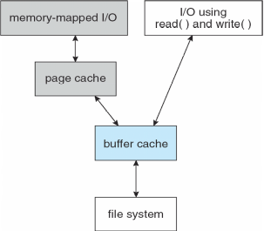
disk size = 240 bytes (1 terabyte)
n = 240/212 = 228 bits (or 256 MB)
if clusters of 4 blocks -> 64MB of memory

- Space maps (used in ZFS) divide device space into metaslab units and manages metaslabs
  - Each metaslab has associated space map
- Buffer cache – separate section of main memory for frequently used blocks
- Synchronous writes sometimes requested by apps or needed by OS – no buffering

  - Asynchronous writes are more common, buffer-able, faster
- Free-behind and read-ahead techniques to optimize sequential access
- Page cache caches pages rather than disk blocks using virtual memory techniques and addresses
  - Memory mapped I/O uses page cache while routine I/O through file system uses buffer (disk) cache
- Unified buffer cache: uses same page cache to cache both memory-mapped pages and ordinary file system I/O to avoid double caching

Ch.12 – I/O Systems

- Device drivers encapsulate device details – present uniform device access interface to I/O subsystem
- Port: connection point for device
- Bus: daisy chain or shared direct access
- Controller (host adapter): electronics that operate port, bus, device – sometimes integrated
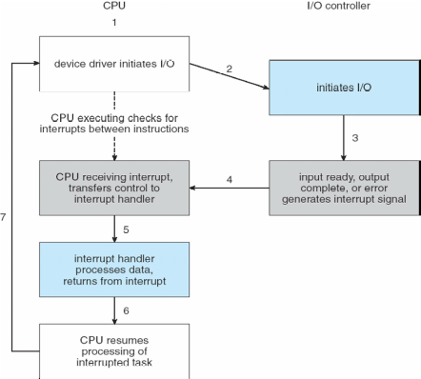
  - Contains processor, microcode, private memory, bus controller
- Memory-mapped I/O: device data and command registers mapped to processor address space
  - Especially for large address spaces (graphics)
- Polling for each byte of data – busy-wait for I/O from device
  - Reasonable for fast devices, inefficient for slow ones
  - Can happen in 3 instruction cycles
- CPU interrupt-request line is triggered by I/O devices – interrupt handler receives interrupts
  - Handler is maskable to ignore or delay some interrupts
  - Interrupt vector dispatches interrupt to correct handler – based on priority; some nonmaskable
  - Interrupt chaining occurs if there is more than one device at the same interrupt number
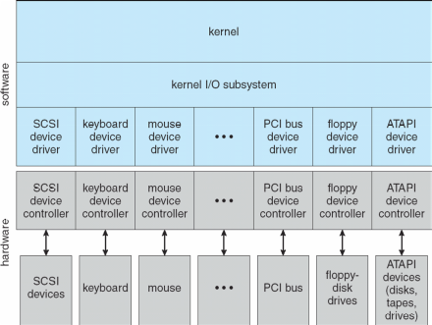
  - Interrupt mechanism is also used for exceptions
- Direct memory access is used to avoid programmed I/O for large data movement
  - Requires DMA controller
  - Bypasses CPU to transfer data directly between I/O device and memory
- Device driver layer hides differences among I/O controllers from kernel
- Devices vary in many dimensions: character stream/block, sequential/random access, synchronous/asynchronous, sharable/dedicated, speed, rw/ro/wo
- Block devices include disk drives: Raw I/O, Direct I/OU
  - Commands include read, write, seek
- Character devices include keyboards, mice, serial ports
  - Commands include get(), put()
- Network devices also have their own interface; UNIX and Windows NT/9x/2000 include socket interface
  - Approaches include pipes, FIFOs, streams, queues, mailboxes
- Programmable interval timer: used for timings, periodic interrupts
- Blocking I/O: process suspended until I/O completed – easy to use and understand, not always best method
- Nonblocking I/O: I/O call returns as much as available – implemented via multi-threading, returns quickly
- Asynchronous: process runs while I/O executes – difficult to use, process signaled upon I/O completion
- Spooling: hold output for a device – if device can only serve one request at a time (ex: printer)
- Device Reservation: provides exclusive access to a device – must be careful of deadlock
- Kernel keeps state info for I/O components, including open file tables, network connections, character device states
  - Complex data structures track buffers, memory allocation, “dirty” blocks
- STREAM: full-duplex communication channel between user-level process and device in UNIX
  - Each module contains read queue and write queue
  - Message passing used to communicate between queues – Flow control option to indicate available or busy
  - Asynchronous internally, synchronous where user process communicates with stream head
- I/O is a major factor in system performance – demand on CPU, context switching, data copying, network traffic

Ch.13 – Protection

- Principle of least privilege: programs, users, systems should be given just enough privileges to perform their tasks
- Access-right = <obj-name, rights-set> w/ rights-set is subset of all valid operations performable on the object
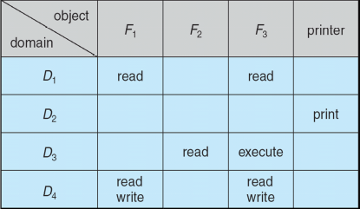
  - Domain: set of access-rights
    - UNIX system consists of 2 domains: user, supervisor
    - MULTICS domain implementation (domain rings) – if j<i → D_{i} ⊆ D_{j}
- Access matrix: rows represent domains, columns represent objects
  - Access(i,j) is the set of operations that a process executing in Domain_{i} can invoke on Object_{j}
  - Can be expanded to dynamic protection
- Access matrix design separates mechanism from policy
  - Mechanism: OS provides access-matrix and rules – ensures matrix is only manipulated by authorized users
  - Policy: User dictates policy – who can access what object and in what mode
- Solaris 10 uses role-based access control (RBAC) to implement least privilege
- Revocation of access rights
  - Access list: delete access rights from access list – simple, immediate
  - Capability list: required to locate capability in system before capability can be revoked – reacquisition, back-pointers, indirection, keys
- Language-Based Protection: allows high-level description of policies for the allocation and use of resources
  - Can provide software for protection enforcement when hardware-supported checking is unavailable

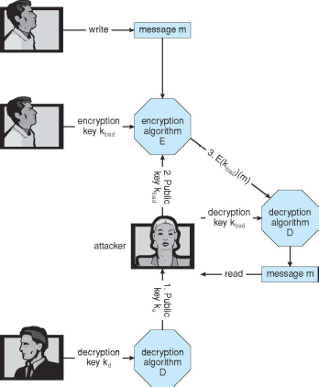Man-in-the-middle attack - Asymmetric Cryptography
Ch.14 – Security
- System secure when resources used and accessed as intended under all circumstances
- Attacks can be accidental or malicious
  - Easier to protect against accidental than malicious misuse
- Security violation categories:
  - Breach of confidentiality – unauthorized reading of data
  - Breach of integrity – unauthorized modification of data
  - Breach of availability – unauthorized destruction of data
  - Theft of service – unauthorized use of resources
  - Denial of service – prevention of legitimate use
- Methods of violation:
  - Masquerading – pretending to be an authorized user
  - Man-in-the-middle – intruder sits in data flow, masquerading as sender to receiver and vice versa
  - Session hijacking – intercept and already established session to bypass authentication
- Effective security must occur at four levels: physical, human, operating system, network
- Program threats: trojan horse (spyware, pop-up, etc.), trap door, logic bomb, stack and buffer overflow
- Viruses: code fragment embedded in legitimate program; self-replicating
  - Specific to CPU architecture, OS, applications
  - Virus dropper: inserts virus onto the system
- Windows is the target for most attacks – most common, everyone is administrator
- Worms: use spawn mechanism – standalone program
- Port scanning: automated attempt to connect to a range of ports on one or a range of IP addresses
  - Frequently launched from zombie systems to decrease traceability
- Denial of service: overload targeted computer preventing it from doing useful work
- Cryptography: means to constrain potential senders and/or receivers – based on keys
  - Allows for confirmation of source, receipt by specified destination, trust relationship
- Encryption: [K of keys], [M of messages], [C of ciphertexts], function E:K to encrypt, function D:K to decrypt
  - Can have symmetric and asymmetric (distributes public encryption key, holds private decipher key) encryption
    - Asymmetric is much more compute intensive – not used for bulk data transaction
    - Keys can be stored on a key ring
- Authentication: constraining a set of potential senders of a message
  - Helps to prove that the message is unmodified
  - Hash functions are basis of authentication
    - Creates small, fixed-size block of data (message digest, hash value)
- Symmetric encryption used in message-authentication code (MAC)
- Authenticators produced from authentication algorithm are digital signatures
- Authentication requires fewer computations than encryption methods
- Digital Certificates: proof of who or what owns a public key
- Defense in depth: most common security theory – multiple layers of security
- Can attempt to detect intrusion:
  - Signature-based: detect “bad patterns”
  - Anomaly detection: spots differences from normal behavior
    - Both can report false positives or false negatives
  - Auditing, accounting, and logging specific system or network activity

Ch.14 – Security (Continued)

- Firewall: placed between trusted and untrusted hosts
  - Limits network access between the two domains
  - Can be tunneled or spoofed
- Personal firewall is software layer on given host
  - Can monitor/limit traffic to/from host
- Application proxy firewall: Understands application protocol and can control them
- System-call firewall: Monitors all important system calls and apply rules and restrictions to them
