**Web Design and Development**

**CA 2**

**Report**

**Group Members:**

Sarah Mattimoe  *x00131475*

Sean McLoughlin *x00130298*

Kevin O'Keeffe  *x00128259*

Anthony Pigott *x00119297*

Brief overview of the project

When we were given our CA 2 brief, the first thing we did was get into groups. Our group consists of Sean, Kevin, Anthony and Sarah. We then had to come up with a topic for our website. There was much debate over what type of website we could build to showcase all of the appropriate features of a basic website. After much debate, we eventually decided on a fictional clothing store's website which would sell t-shirts, hooded sweatshirts and tracksuits for both male and females. We decided to call the website called 'SKAS', an amalgamation of all the first letters of each of our names.

In order to design the website, we first did some research regarding the design of a website of this type. There are many, many online clothing stores so we decided to look at the features of a selection of them in order to gain some inspiration for our own website. Based on our research, we decided upon a prototype concept which is user friendly and easy to maintain and update. The design of our website originated from a template on the w3Schools website, which was attached to bootstrap. The template was initially set up as an online store. The design focus was two rows, which incorporated the product image, product header and price of the product. The template offered us a starting point for the 'SKAS' website.

We then drew up a rough sketch of a storyboard showing how different pages on the website would look. We decided that the website should be relatively simple, with mostly black and grey navigation bar, footer, background colors, etc.. We felt that this would make the photos of the products stand out much more and give the website a pop of color.

The navigation bar is denoted by four sub headings; 'Home', 'Products', 'About' and 'Contact Us' on the left-hand side and two sub headings; 'Account' and 'Cart' on the right-hand side. This makes it easy to navigate and to access relevant information. We kept the number of sub headings to a minimum, as we felt it increased the websites overall appeal. This also meant it was more manageable code and content wise.

The site was developed using play framework, which allows you to make your website dynamic. It also allows you to add server side functionality which means that you can add, update and delete products on your website, at your own discretion. The website incorporated a variety of different languages such as HTML, CSS and BOOTSTRAP which allows web developers to make designing a website a lot easier.

The Layout

The sites layout was based on a simple design with a navigation bar on the top, footer based at the bottom and content placed in between both. For the products page we went with a 3x3 design to show of the products to give the user a simple display as so not overload their screen with to many products all at once and slowing down their internet. Each row contains three pictures with the product name and price above/below. The box model was used to display the content of the product page as it allowed us to use padding and margin to display our content visually neater.

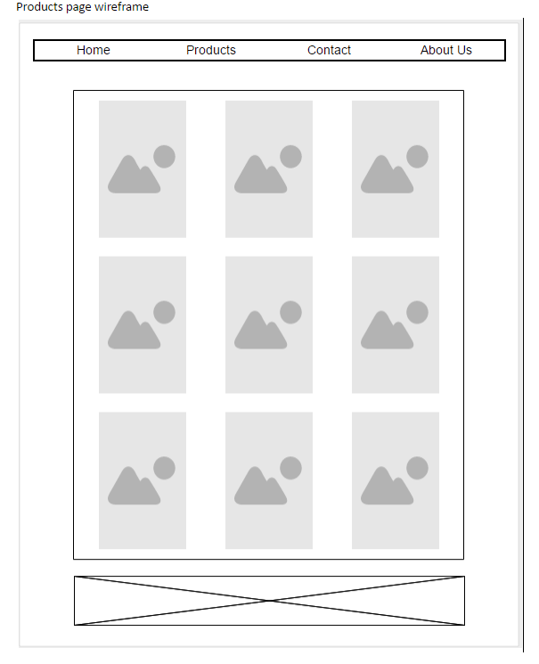

**The above image shows the initial template which has been modified based around based on the needs of each of page**

For the home page we decided to take the first row and implement this as our favourites products of the week. This highlighted the main products of the website. The carousal is above the NAV BAR which is set to display a select few of the images from the website. The homepage is kept to a minimum as it mean as a general overview and allows the user to get a sense of what the website has to offer.

The template was put into the @main folders which allows for it to imported into every view you create within play framework thus eliminating the need to code the template every time you create a new view within framework. Throughout the project we called the main to help us replicating the template and editing it based on the needs of each view. This meant for us while we were editing the template code its original version was not tampered with in any way as you are essentially cloning the main into each of the views you have made.

**Hierarchal site Structure**:

This can also be known as hierarchal site navigation which is able to traverse a Website by its hierarchical structure. Also called "Web navigation," the menus replicate the site's structure and allow the user to go down multiple levels to select a page. Below is our Hierarchal site Structure:   
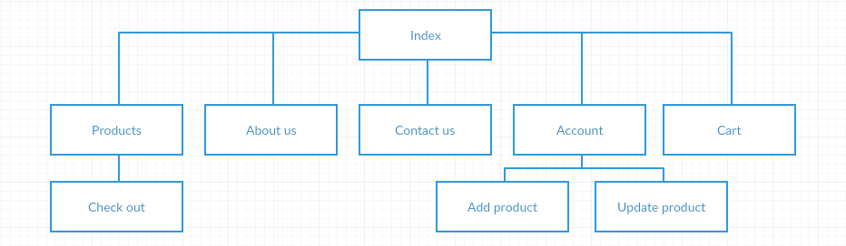

Team Role Overview

Team member Sean decided to design and implement the sign in and sign up elements of the site. This allows the admins to login and update the site and allows the customer to create an account. Once an account has been created, the customer will be able to shop online and keep record of their purchases. Sean also added a footer which contains a link to our Twitter and Facebook page to encourage members to follow us for regular updates, competitions and polls regarding the business of the shop.

Anthony designed several of the websites pages, including the home, product and about page. When Anthony was designing the homepage he decided to implement a bootstrap carousel made up of two images and three of our featured products from our site. The design features many elements from the initial design from out layout. I choose a color scheme which gave it a modern feel and also provides some color to the page. For the about us page the company history and aims were established to give the users an overview of why the website was established and the aims of the site as well as the products for which we can sell.

Kevin created the 'Contact Us' page. On this page he created a form to input your personal details and also there is a comment section where customers can send their comments and suggestions. The design is linear, so it follows first name, last name, e-mail, etc. and ends with the comment box. This in turn will enable us to gear the site and products more to the users specifications and needs in the foreseeable future should any situation arise from a users point of view

Sarah Helped with initial design the website by drawing up a rough template of what the site would look like as well as a hierarchical layout to show how the information will be accessed by the user. Saw was also in charge of overseeing that the report was drawn up in such a way that so the ideas of the website be conveyed into the report. Sarah also helped in developing some of the html and ccs for the pages which lighted the workload.

**Server side/Play Framework**

Once the static design was completed we began to implement it into the Play Framework, this would allow the site to respond dynamically depending on multiple factors such as type of user, whether the user was logged in and stock levels. The Play Framework would also allow easy management of the database to add, update and delete products and form management such as the adding and deleting of products as well as the contact us form.

**Roles**

Following the labs, Anthony done the models, create, update and delete methods / pages, database design and Sean done database design and login methods / pages and authorization methods.

Future Plans

If we had planned time better we would have added more functionality such as the admin and manager being able to see customer feedback and delete it when it has been dealt with or noted. An order class for customers to see previous orders. Individual product pages with more images (if we could figure it out) and more a more detailed description. Decreasing stock when a product has been bought. Price and brand filters on the product page, reorganized the file structure like it was suggested to do in the image upload, we would have also implemented this image upload function. We also planned to fix the design from some inconsistencies and have it look more professional and cleaner than it currently does.