程序设计（C与C++）实验报告

实验名称 | 第四章实验2
学 院 | 计算机科学与工程学院 | 专业班级 | 17信息安全
姓 名 | 蒋程 | 学 号 | 2017060201009
任课教师 | 卢光辉 | 实验时间 | 2017 年 05 月 19 日
成绩 |  | 说明

- 实验内容
封魔录的第二阶段
- 实验需求
生成20*70的地图，四周全部是委屈，右边围墙中间有一个出口，四个角附近各有一个建筑物，各个建筑下面有一个特殊人物。地图中间有一个烟囱。
- 设计过程
1、实现地图的绘
2、实现地图上面单位的绘制
3、实现人物移动功能
4、添加触碰障碍物的逻辑
3.1 伪代码
Maps.c文件：
/**
*此文件用于编写与地图有关的函数，方便Main调用
*/
char DISPLAYED_MAPS[2][20][70]
char BACKGROUND_MAPS[2][20][70]

def initUtils()
initUtils_1()
initUtils_2()

def initData()
initData_1()
initData_2()

def init_BG_map()
for k:2
for i:20
for j:70
BACKGROUND_MAPS[k][i][j] = 'x'
For i:19
For j:68
BACKGROUND_MAPS[k][i][j] = ' '

def initMap()
for k:2
for i:20
for j:70
DISPLAYED_MAPS[k][i][j] = '#'
for i:19
for j:69
DISPLAYED_MAPS[k][i][j] = ' '

def printTitle(int currentMap)
if currentMap == 0
printTitle_1()
else if currentMap == 1
printTitle_2

def initData_1()
for i = 3:4
for j = 7:16
BACKGROUND_MAPS[0][i][j] = 'x'
BACKGROUND_MAPS[0][5][10] = '@'
BACKGROUND_MAPS[0][5][11] = '@'
for i = 13:15
for j = 7:16
BACKGROUND_MAPS[0][i][j] = 'x'
BACKGROUND_MAPS[0][5][10] = '$'
BACKGROUND_MAPS[0][5][11] = '$'
for i = 3:4
for j = 55:64
BACKGROUND_MAPS[0][i][j] = 'x'
BACKGROUND_MAPS[0][5][10] = '!'
BACKGROUND_MAPS[0][5][11] = '!'
for i = 13:15
for j = 55:64
BACKGROUND_MAPS[0][i][j] = 'x'
BACKGROUND_MAPS[0][5][10] = '&'
BACKGROUND_MAPS[0][5][11] = '&'
for i= 7:12
for j = 31:37
BACKGROUND_MAPS[0][i][j] = 'x'
BACKGROUND_MAPS[0][9][68] = ' '
BACKGROUND_MAPS[0][9][69] = '1'

def initUtils_1()
for i=3:5
for j= 8:16
DISPLAYED_MAPS[0][i][j] = '#'
DISPLAYED_MAPS[0][5][11] = '@'

for i=13:15
for j= 8:16
DISPLAYED_MAPS[0][i][j] = '#'
DISPLAYED_MAPS[0][15][11] = '$'
for i=3:5
for j= 56:64
DISPLAYED_MAPS[0][i][j] = '#'
DISPLAYED_MAPS[0][5][59] = '!'
for i=13:15
for j= 56:64
DISPLAYED_MAPS[0][i][j] = '#'
DISPLAYED_MAPS[0][15][59] = ' &'
for i=8:11
for j= 33:36
DISPLAYED_MAPS[0][i][j] = '#'
DISPLAYED_MAPS[0][9][34] = ' '
DISPLAYED_MAPS[0][9][69] = ' '

def initData_2()
BACKGROUND_MAPS[1][9][0] = '0'
BACKGROUND_MAPS[1][9][1] = ' '

def initUtils_2()
DISPLAYED_MAPS[1][9][0] = ' '

def printTitle_1()
print("游戏难度:"+ difficulties[difficulty])
printBlank(20)
print("桃源村\n")

main.c文件

int currentMap

def initGame()
init_BG_Map()
initMap()
initPlayer()
initUtils()
initData()
currentMap = 0;

system("cls")
plotScreen()
gotoXY(34, 15)
print("☆")
gotoXY(0, 22)

print("不会吧，怎么一个NPC都没有")
Sleep(100)
cleanRow()

print("还是去找一找吧")
Sleep(100)
cleanRow()

MainLoop()

def plotScreen()
system("cls")
printTitle(currentMap)
for k:20
for i:70
print(DISPLAYED_MAPS[currentMap][k][i])
print(“\n”)

def gotoXY(int x int y)
COORD pos = (SHORT) (x), (SHORT) (y)
HANDLE hOut = GetStdHandle(STD_OUTPUT_HANDLE)
SetConsoleCursorPosition(hOut, pos)

def moveToXY(int old_x, int old_y, int new_x, int new_y)
gotoXY(old_x + 1, old_y)
print("\b ")
gotoXY(new_x, new_y)
print("☆")
Player.x = new_x
Player.y = new_y

def cleanRow()
for i:70
print(“\b”)
for j:70
print(“ ”)
for k:70
print(“\b”)
print(“\n”)

def printBlank(int count)
for i:count
print(“ ”)

def initPlayer()
Player.x = 34
Player.y = 15

def mainLoop()
while true
ch = getch
if ch == KEY_UP
checkData(Player.x, Player.y, Player.x, Player.y - 1)
else if ch == KEY_DOWN
checkData(Player.x, Player.y, Player.x, Player.y + 1)
else if ch == KEY_LEFT
checkData(Player.x, Player.y, Player.x - 1, Player.y)
else if ch == KEY_RIGHT
checkData(Player.x, Player.y, Player.x + 1, Player.y)

def checkData(int old_x, int old_y, int new_x, int new_y)
if (BACKGROUND_MAPS[currentMap][new_y - 1][new_x] == ' ')
moveToXY(old_x, old_y, new_x, new_y)
else if BACKGROUND_MAPS[currentMap][new_y - 1][new_x] == 'x'
//todo
else if BACKGROUND_MAPS[currentMap][new_y - 1][new_x] == '@'
//todo
else if BACKGROUND_MAPS[currentMap][new_y - 1][new_x] == '$'
//todo
else if BACKGROUND_MAPS[currentMap][new_y - 1][new_x] == '!'
//todo
else if BACKGROUND_MAPS[currentMap][new_y - 1][new_x] == '&
//todo
else if BACKGROUND_MAPS[currentMap][new_y - 1][new_x] == '1 currentMap = 1;
plotScreen()
moveToXY(old_x + 1, old_y, 1, old_y)
else if BACKGROUND_MAPS[currentMap][new_y - 1][new_x] == '0'
currentMap = 0
plotScreen()
moveToXY(old_x + 1, old_y, 68, old_y)

3.2 流程图
见附件

- 测试
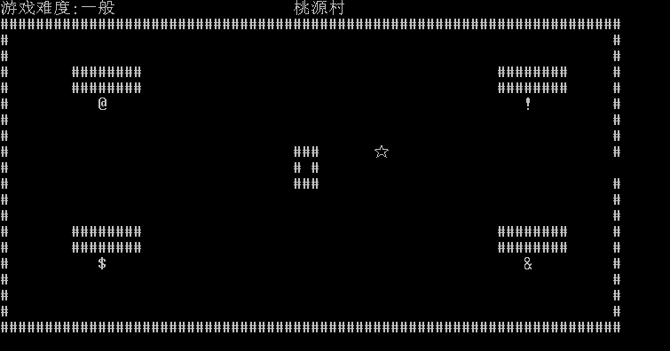

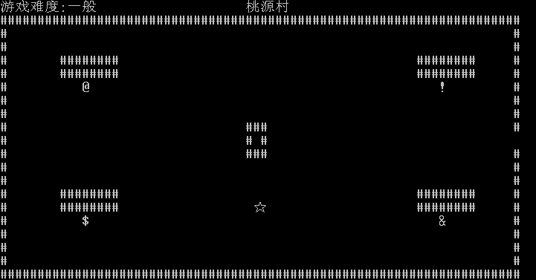

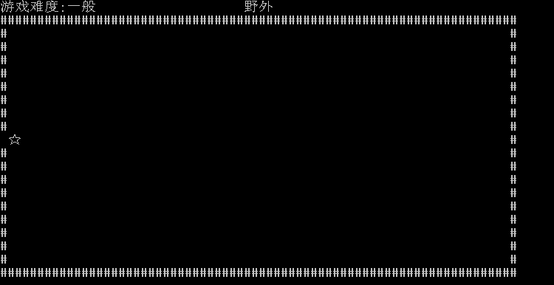

- 其它

