**搭建学生管理系统**

1. **建立数据库**

**mysql –u root –p 连接数据库服务器，用户名是root**

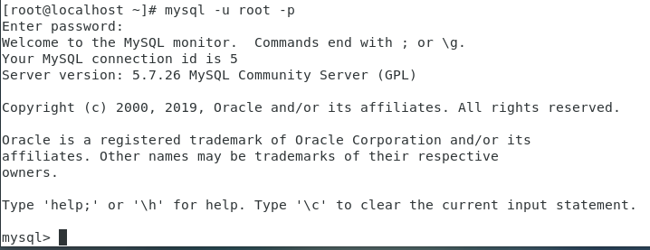

**CREATE DATABASE student_system 创建名字为student_system的数据库**



**Show databases; 查询数据库是否创建成功**

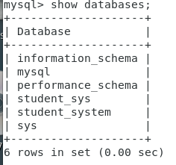

1. **USE student_system; 进入该数据库**



**根据需求建立《学生信息表》**

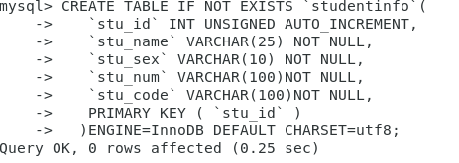

**《学生成绩表》**

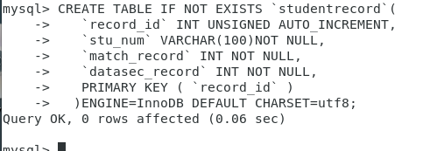

**查询表是否创建成功：**

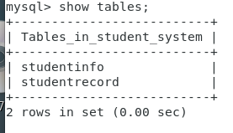

1. **学生信息插入数据**

**单条数据输入：**

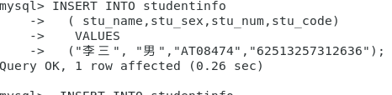

**多条数据输入：**

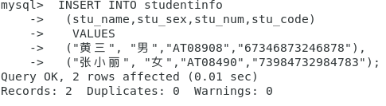

**查询studentinfo的数据：SELECT * FROM studentinfo;**

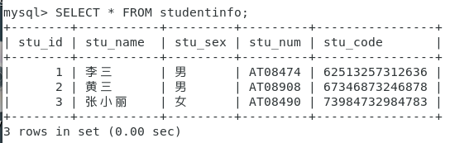

**查询数据条数：SELECT COUNT(*) FROM studentinfo;**

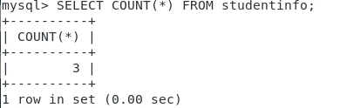

**查询部分信息：SELECT stu_id,stu_name,stu_code FROM studentinfo;**

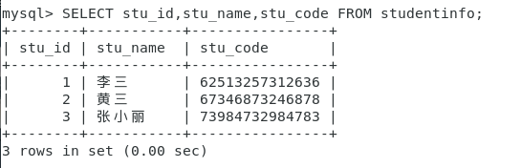

**显示条数查询：SELECT * FROM studentinfo LIMIT 0,100;**

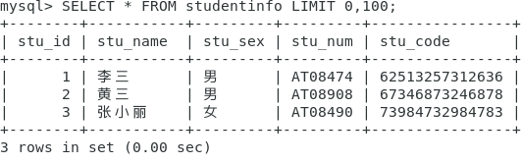

1. **学生成绩输入**

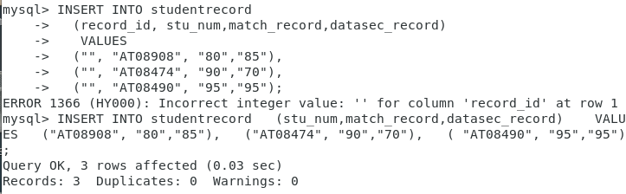

**联合查询：**

**SELECT stu_id,stu_name,stu_sex,stu_num,stu_code**

**FROM studentinfo**

**UNION**

**SELECT ALL FROM studentrecord;**

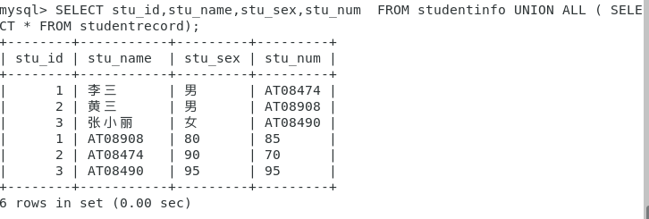

**可以选择任意相同数量的列进行联合查询**

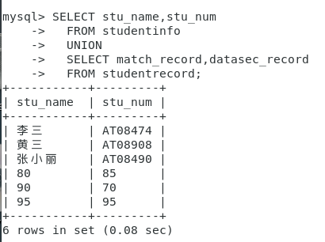

**带条件查询**

**SELECT * FROM studentinfo LIMIT 0,100;**

**SELECT \***

**FROM studentinfo**

**WHERE stu_name = "黄三";**

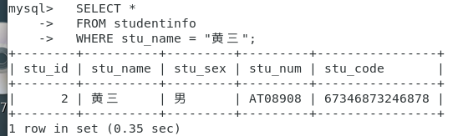

**模糊查询 LIKE**

**SELECT * FROM studentinfo LIMIT 0,100;**

**SELECT \***

**FROM studentinfo**

**WHERE stu_name LIKE "黄%";**

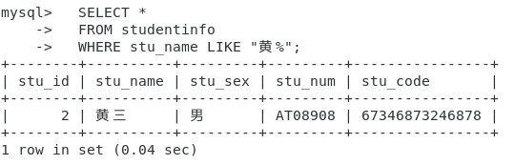

**排序 ORDER BY**

**SELECT field1, field2,...fieldN table_name1, table_name2...**

**ORDER BY field1 [ASC [DESC][默认 ASC]], [field2...] [ASC [DESC][默认 ASC]]**

**SELECT stu_num,match_record,datasec_record**

**FROM studentrecord**

**WHERE match_record >= 90**

**ORDER BY match_record;**

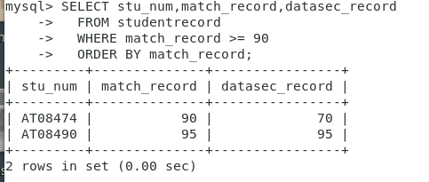

**分组 GROUP BY：**

**SELECT match_record,COUNT(*) datasec_record**

**FROM studentrecord**

**GROUP BY match_record;**

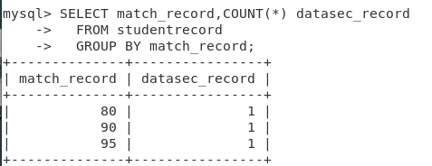

**删除数据**

**DELETE FROM studentinfo WHERE stu_name = "黄三";**



**更新数据**

**UPDATE table_name SET field1=new-value1, field2=new-value2 [WHERE Clause]**

**UPDATE studentinfo**

**SET stu_name="李四"**

**WHERE stu_name = "李三";**

