Summary

Format: FPS online death matches

Summary: A FPS shooter that you play online with other users. No AI. Matches are timed Deathmatch/Team Deathmatch. Users go around killing each other and destroying buildings. If someone is in the building, damage will be done to them. Graphics will be simple/low poly count.

Features:
Lobby/Server List
Destructible Environment
Customized Characters
Builds for hiding and destroying

Details:
Simple Graphics
Buildings made of blocks w/physics and destructible
Individual body part health

Requirements:
Individuals host the game and show them on the server/lobby.

Components:
-Weapons
Melee
Guns
Explosives
-Characters pieces (each piece can be injured and customized)
Head
Body
Arms
Legs
-Buildings (Destructible)
1 and 2 story
-Scores
Kills, deaths, damage done to people, damage received.

Main Menu Options

-Create Character
-Battles ~ Join and Create
-Settings
-Exit

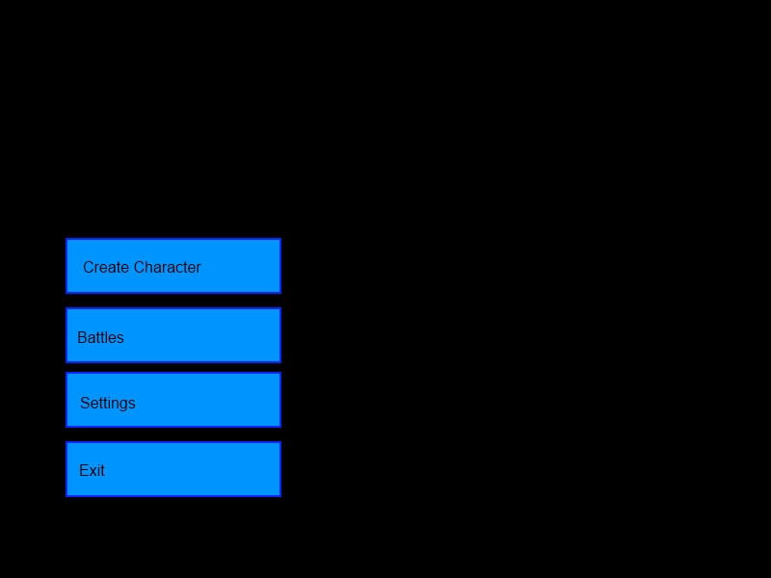

Battle Screen – Join

-Search Field
-Game Type (Drop down)
-Game List (LAN and Internet list)

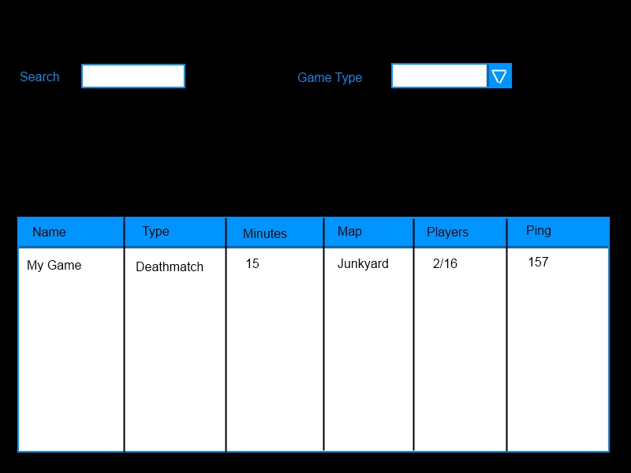

Battle Screen – Create

-Create ~ LAN or Internet
-Set # of players, map, game time, game mode, game name, password(optional)

Game Modes – Deathmatch or Team Deathmatch
Game Time – 5, 10, 15 or 20 minutes.
Number of Players - Up to 16.
Game Name – How it will be seen by people viewing the lobby.
Password – optional

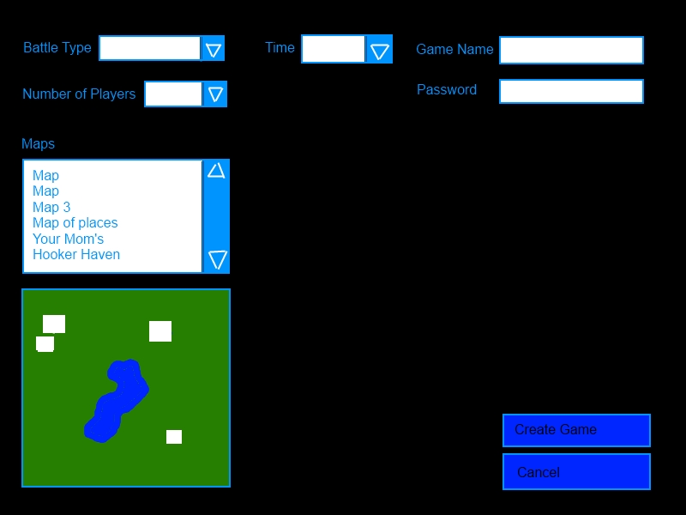

Settings Screen

-Video
-Sound
-Character (Set your default character) (also store user name here)
-Heads Up Display (HUD)

Create Character Screen

-Body Attributes
Head, body, arms, legs. User can specify colors for each part during creation and specify different shaped pieces. The possibility of extra add ons for characters is also a possibility.

Lobby Screen

-Displays the game information (mode, number of players, etc)
-Displays the users
-Displays the map for the specified game
-Chat Room

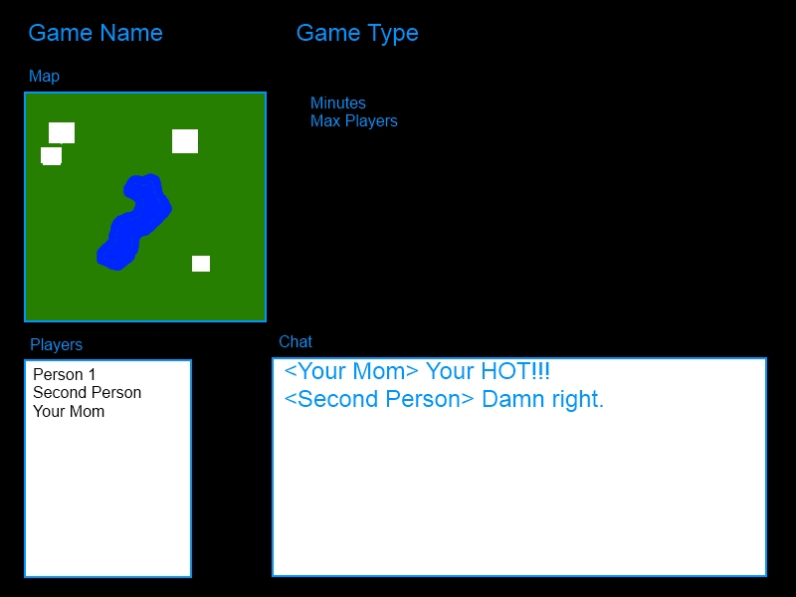

Gameplay

-Field of play is surrounded by walls to limit the size of fight area.
-Destructible buildings
-First person shooter
-Weapons are scattered through field of play. People start with a single revolver.
-Ammo and health are scattered through field of play
-Players can take damage to individual body parts and still fight till dead (optional feature)
-Damage caused by being in or around building that is destroyed

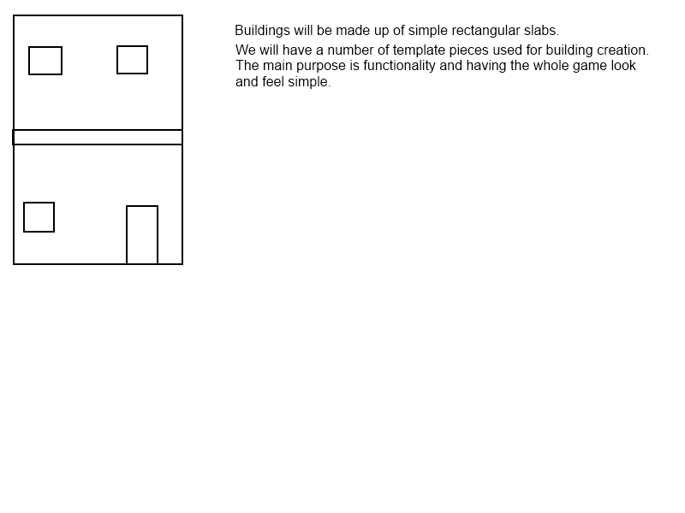
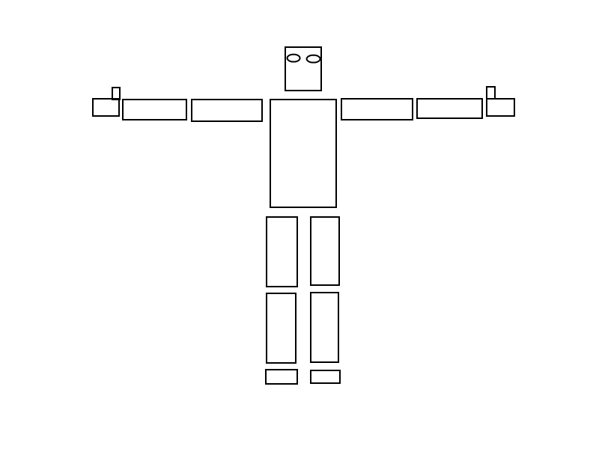
End of Match

Shows Scores
-Kills, deaths, damage done to players, damage received,........
-Broken down by player

