Introduction
MaxAir PCBs are available for both Sensors and Relay Controllers, these PCBs have jumper pins available for configuration of the 'Node ID' and other parameters.

Sensor Ver 2.12
Sensor PCB Ver 2.12 has a total of 10 Jumpers, labelled J1 to J10.
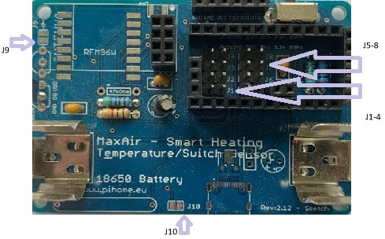
Jumpers J1 to J4 are used to set the Node ID value, where J1 and J2 are used in combination to set the tens part of the Node ID and jumpers J3 and J4 the units part.
Jumpers J1 and J2 |  | Jumpers J3 and J4
Jumpers | Node ID | Jumpers | Node ID
None | 2x | None | x0
J1 | 3x | J3 | x1
J2 | 4x | J4 | X2
J1 and J2 | 5x | J3 and J4 | x3
Hence no jumpers installed will result in a Node ID of 20 and all jumpers installed will result in a Node ID of 53.
Jumpers J5 to J8 usage:
Jumper | Usage
J5 | COMPARE_TEMP (No Jumper = 1, Jumper = 0, Jumpers ignored if myCompareTemp not initialised to 0 in sketch).
J6 | COMPARE_BVOLT (No Jumper = 0, Jumper = 1, Jumpers ignored if myCompareBvolt not initialised to 0 in sketch)
J7 | NOT USED
J8 | NOT USED
There are also two solder jumper pads, J9 and J10, usage is:
Jumper | Usage
J9 | MAX_ATTACHED_DS18B20 (No Jumper = 1, Jumper = 2)
J10 | ENABLE REED SWITCH (No Jumper = disabled)

Relay Controller Ver 1.0
The relay controller PCB has a total of three jumpers, labelled J1, J2 and J3.
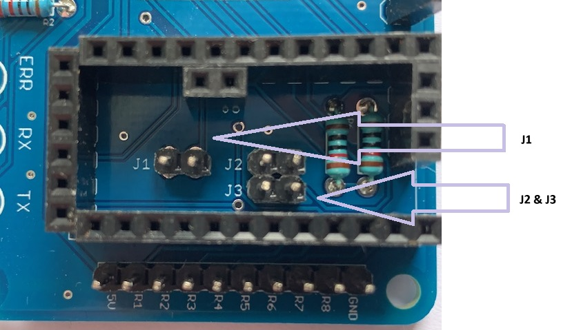
Jumper J1 is used to select the relay ON trigger state eg. if the relay requires a LOW logic level to turn ON then a jumper should be placed across the J1 pins. Jumpers J2 and J3 are used to select the Node ID, usage is:

Jumpers J1 | Jumpers J2 and J3
Used to select the relay trigger level.  Jumper – Negative Trigger  NO Jumper – Positive Trigger | Jumpers | Node ID
 | None | 100
 | J2 | 101
 | J3 | 102
 | J3 and J4 | 103

