MaxAir provides an ‘Holidays’ option, which allows the definition of a schedule which will override the ‘normal’ schedules between a set start date/time and an end date/time.

Holidays mode is configured by clicking on the ‘Holidays’ button on the ‘Home/One Touch’ screen.

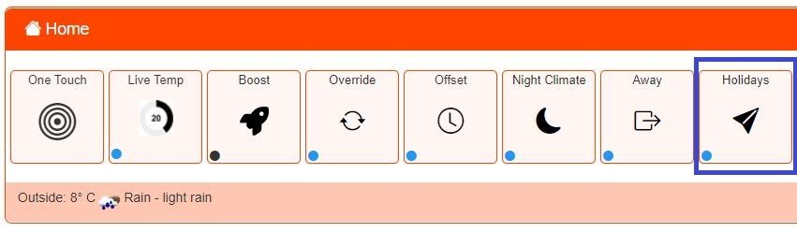If no Holiday schedules have been configured the status indicator will be black, if a Holiday schedule is present, but not currently active the indicator will be blue and will change to red when the schedule is running.

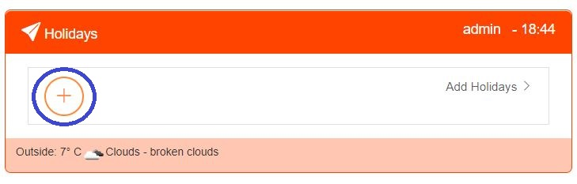

Click on the + icon to create a new ‘Holiday Period’.

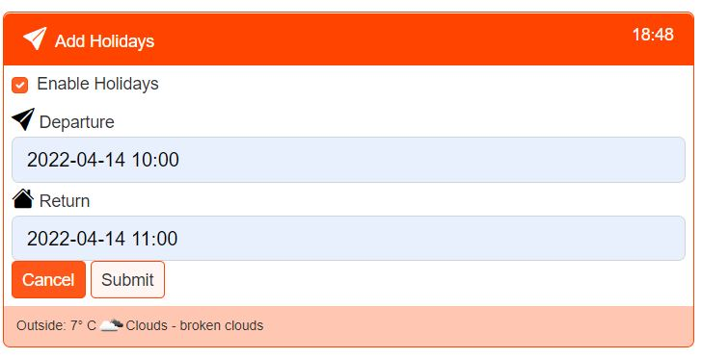

Enable and set the Depart and Return Date/Time values, then click on the ‘Submit’ button.

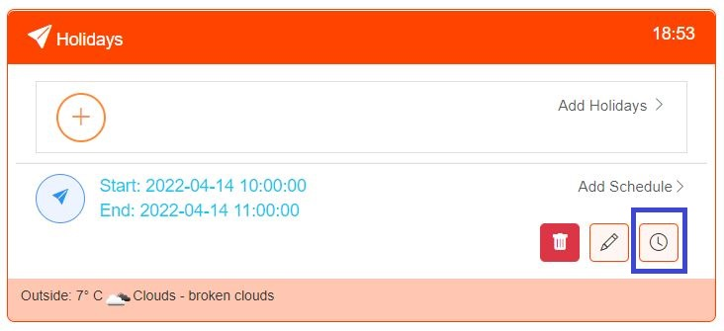

Click on the Timer icon to create a schedule in the usual Manner.

