MaxAir can both send and receive information using the MQTT protocol.

**Message Queueing Telemetry Transfer**, or [MQTT](https://mqtt.org/), is a lightweight IP-based messaging protocol designed for communication between sensors, controllers, and other devices. It’s designed to support equipment that may not always be online, like automated devices built with microcontrollers. MQTT server programs are called **brokers**. A broker keeps track of messages from clients, and allows any client to query the last message sent by another client.

Messages are organized into **topics**. Typically, a topic represents a device, with each sub-topic representing its characteristics. For example, a weather station might have the main topic “station” with subtopics “temperature”, “humidity”, “air quality”, and so forth. The weather station itself would send messages to each of the subtopics, and a web client might subscribe to those topics to graph them onscreen over time.

Clients either publish new messages to topics, or subscribe to topics, and the broker notifies them when new messages arrive. For this reason, MQTT is known as a **Publish & Subscribe**, or **PubSub** system.

The MaxAir Gateway script /**var/www/gateway.py** together with the Python library **paho-mqtt** are used to send and receive MQTT data.

MaxAir will require access to a Mosquitto Broker, which can exist on the same device hosting MaxAir or on a separate device.

MaxAir will require an account on the Mosquitto Brocker which it can access.

## Example Configuration

* The Mosquitto Broker will be installed on the same device which is hosting MaxAir.
* A sensor device will be employed which uses a DS18B20 1-wire temperature sensor, interfaced to a WeMos D1 Mini microcontroller, running the Tasmota software package.
* A Sonoff Basic Module running the Tasmota software package will be configured as a relay.

### Installing Mosquitto

* From the linux command line execute ‘***apt-get install mosquitto mosquitto-clients***’
* From the linux command line execute ‘***systemctl enable mosquitto***’
* From the linux command line execute ‘mosquitto_passwd -c /etc/mosquitto/credentials admin’
* Enter the password ’***pihome***’ and confirm
* Create and edit a new file from the linux command line by executing the command **‘nano /etc/mosquitto/conf.d/maxair.conf’**
* Add the following 3 lines and save the file
  + per_listener_settings true
  + allow_anonymous false
  + password_file /etc/mosquitto/credentials
* If not already available then install paho-mqtt using the command ‘***pip3 install paho-mqtt***’

### Configure the Tasmota DS18B20 D1 Mini Sensor

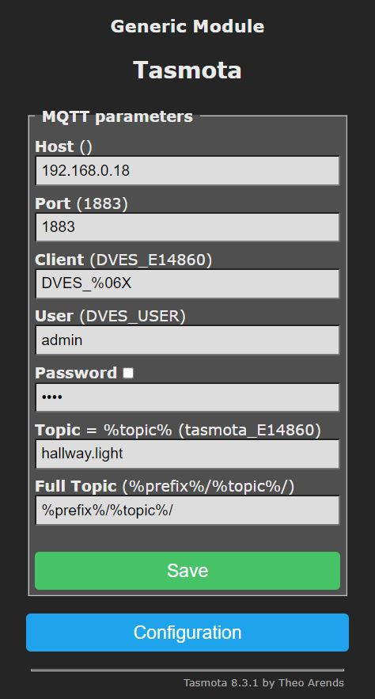Connect to the Tasmota device using its IP address and configure the MQTT parameters. For this example the MQTT Broker has an IP address of 192.168.0.18 and the Topic, Full Topic settings are as shown.

At this point the Tasmota DS18B20 should be sending temperature data to the Mosquitto Broker.

### Configure the Sonoff Basic Module as a Switch Device

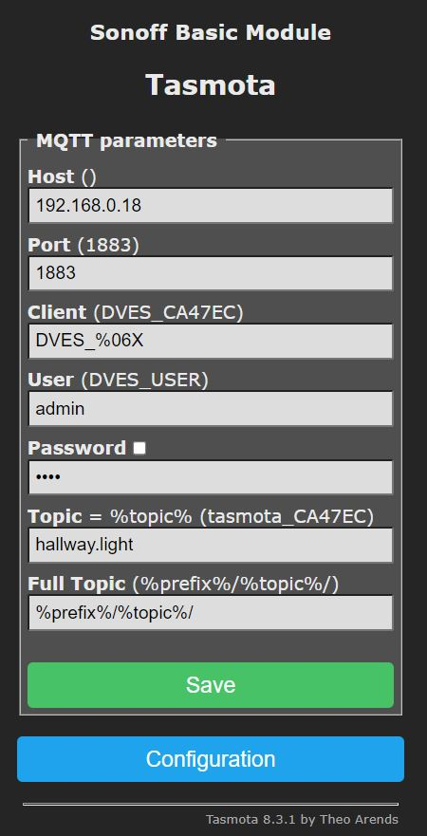Connect to the Sonoff device using its IP address and configure the MQTT parameters. For this example the MQTT Broker has an IP address of 192.168.0.18 and the Topic, Full Topic settings are as shown (and are exactly the same as for the previous Sensor example).

At this point it is possible for the Sonoff switch state to be set using an MQTT message.

### Configure MaxAir to Communicate Using MQTT

#### Create an MQTT Connection

From Settings/System Configuration/MQTT select ‘Add’

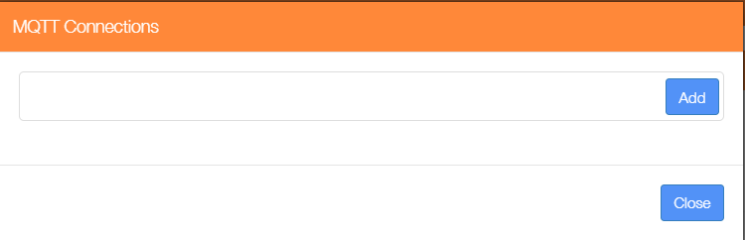

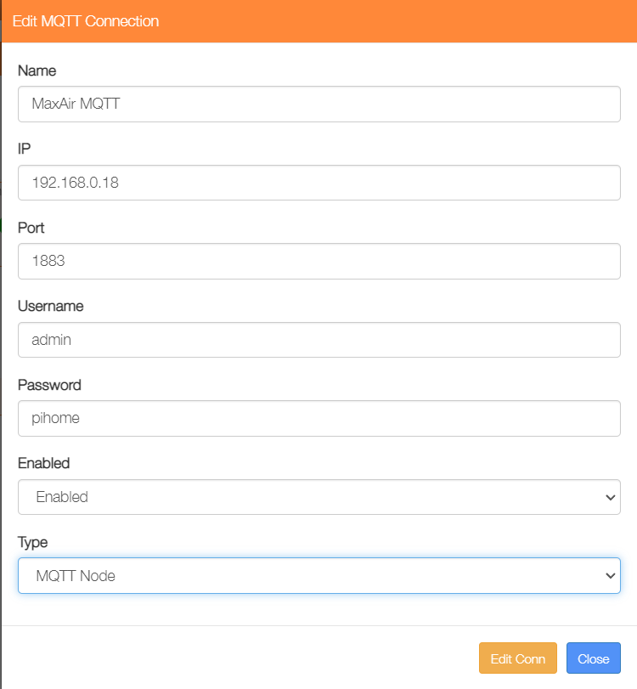The example shows is using the Mosquitto Broker IP address of 192.168.0.18, with a default Port number of 1883, the Username and Password were as setup when configuring the broker, the connection is Enabled and the Type is selected as ‘MQTT Node’.

#### Create MQTT Type Nodes for Both a Sensor and a Controller

From Settings/Node and Zone Configuration/Nodes Add Node. For the example case a Node ID of 31 has been chosen and the Node Name selected as ‘MQTT Sensor’.

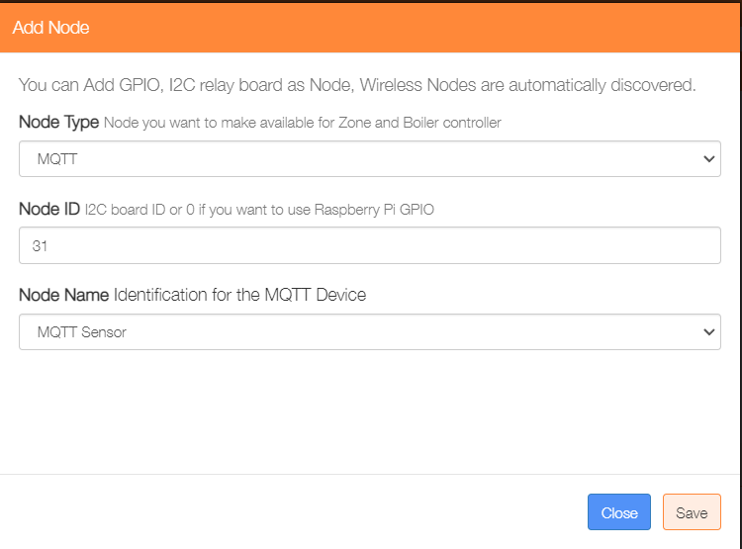

Click on ‘Save’ to store the new node in the nodes table.

Add a second node for the MQTT Controller device, for this example a Node ID of 32 is used.

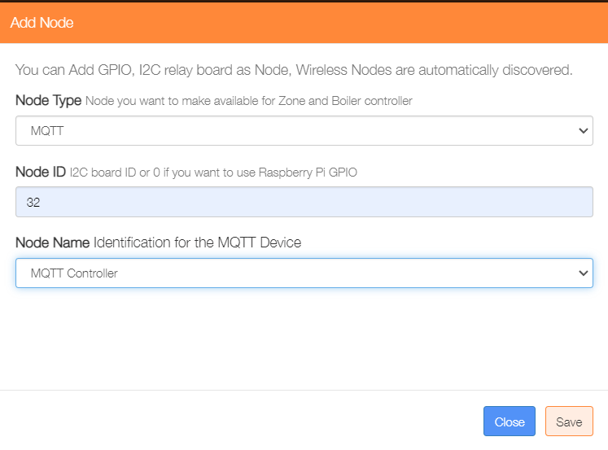

#### Create MQTT Devices

From Settings/Node and Zone Configuration/MQTT Devices select Add MQTT Device

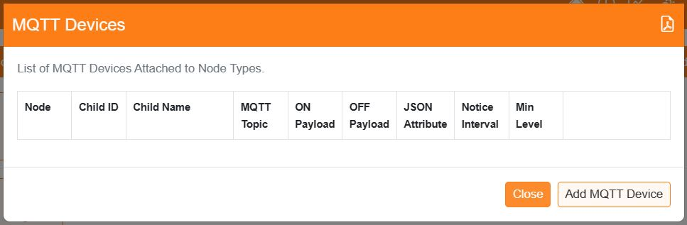

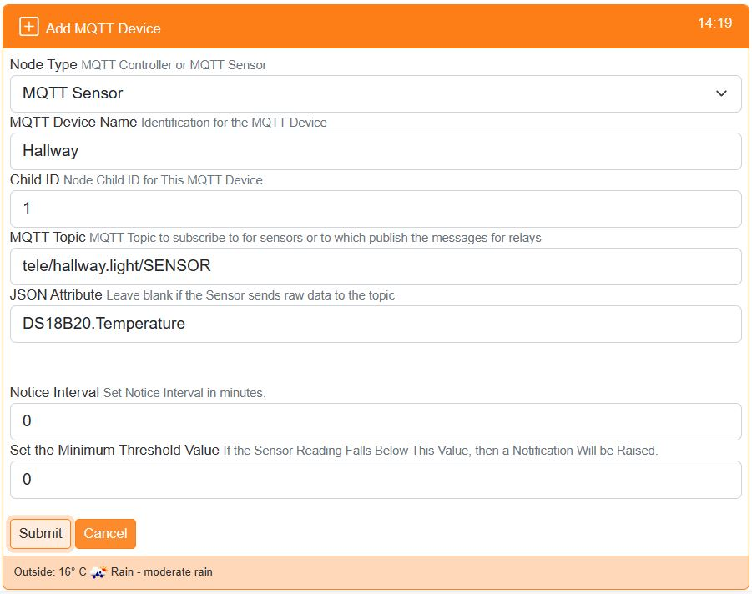The example shows that the Node Type has been selected as ‘MQTT Sensor’, its Device Name is ‘Hallway’, its Child ID has been set as 2, the MQTT Topic has been set as ‘tele/hallway.light/SENSOR’ and the JSON Attribute is set to ‘DS18B20.Temperature. The ‘Notice Interval’ can be set so that the Home Screen will display warnings if the sensor does not report within the set period. The ‘Minimum Value’ can be set for battery powered sensors, so that a notification is generated if the value falls below the setting.

Add a second MQTT device for the controller. The example shows that the Node Type has been selected as ‘MQTT Controller’, its Device Name is ‘Hallway Lamp’, its Child ID has been set as 1, the MQTT Topic has been set as ‘cmnd/hallway.light/POWER’, the ON Message is set as ‘ON’ and the OFF Message is set as ‘OFF’.

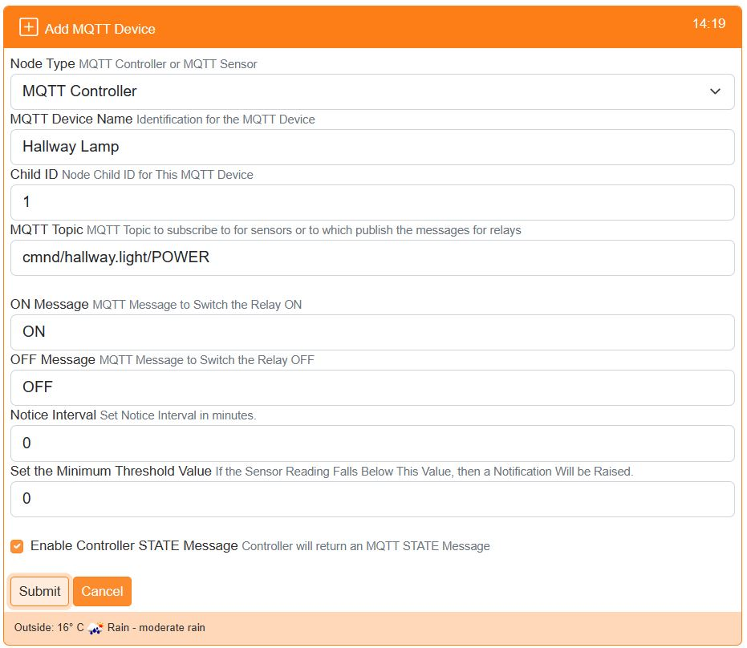Optionally if ‘Enable Controller STATE Message’ is ticked, then an addition ‘MQTT Sensor’ topic will be created to capture ON/OFF state messages generated by the MQTT controller. These are used to synchronize the MaxAir state to any changes caused by external agents e.g HomeAssistant. As for Sensors, both the ‘Notice Interval’ and ‘Minimum Threshold Values’ can be set to generate notification (if ‘Enable Controller STATE Message’ is NOT ticked, then these inputs are hidden).

Finally add a Sensor and Relay device to MaxAir using the GUI menus under Settings/Node and Zone Configuration, using the Node IDs and Child IDs configured above.

In order to use the MQTT Controller device it will need to be added to a Zone, so that an entry is added the the messages_out queue.

The MQTT devices should now be active. Correct operation can be verified by running the Gateway Script in console mode, from the command line enter

‘**pkill -f gateway.py && python3 /var/www/cron/gateway.py**’

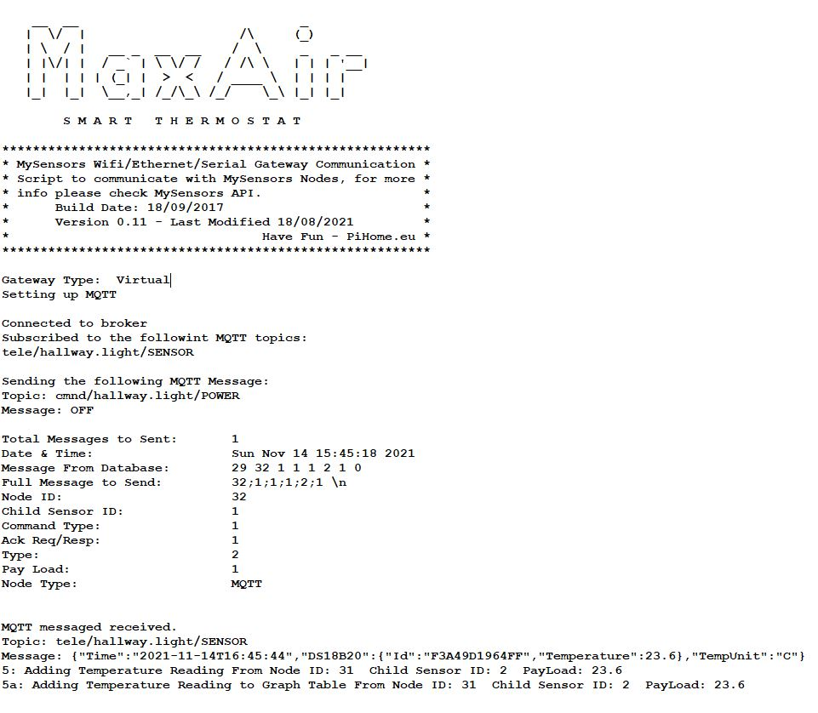Monitor the output for a few minutes

A connection to the MQTT Broker was established together with a subscription to the MQTT Sensor topic. Data was sent to the MQTT Controller device to set its initial state, and after a few minutes data was received from the MQTT Sensor device

An entry for the node will be added to the messages_in table, which will contain the returned temperature.

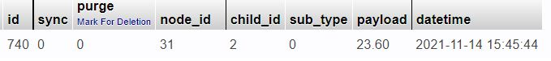

The messages_out table will have an entry for the Node ID allocated to the MQTT Controller.

