# MaxAir Zone Setup – Multiple Sensors

MaxAir supports zones with multiple sensors, where the ‘control temperature’ is derived from the average readings reported by all ‘active’ sensors.

From the Zone Add/Edit dialogue sensors can be added or deleted using the plus, minus buttons

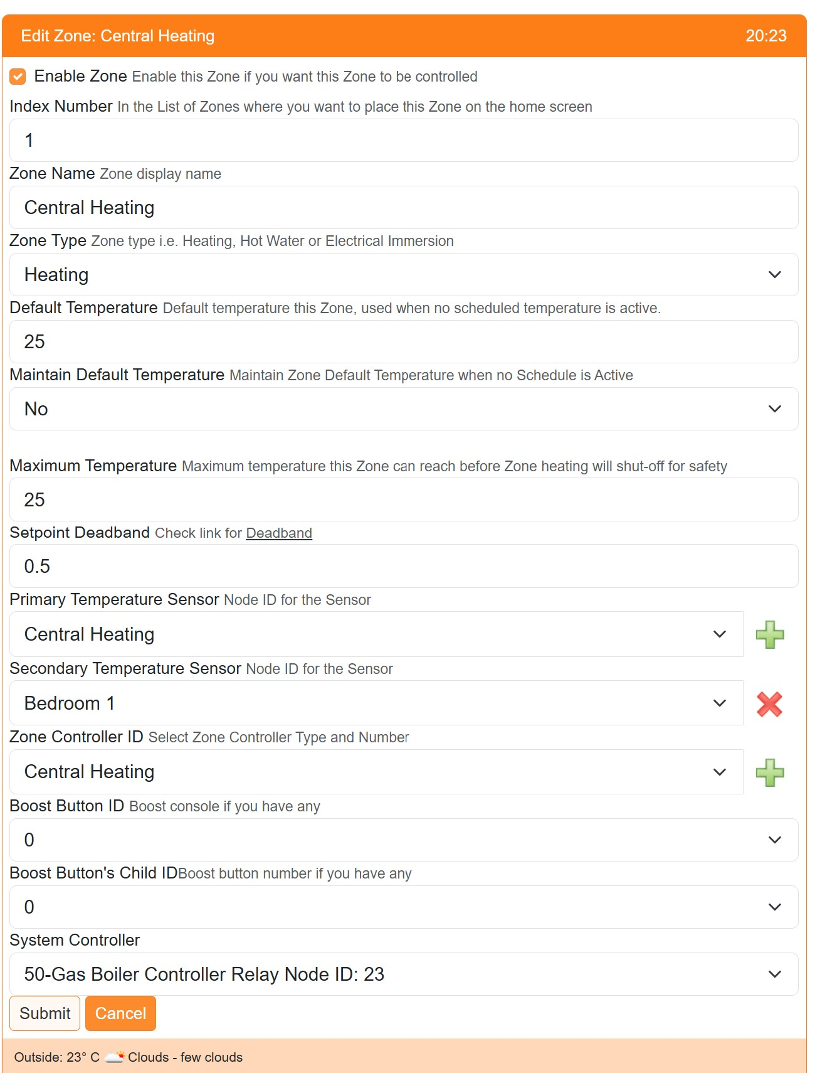

Note: It is possible to attach both multiple Sensors and Zone Controllers.

## Zone Control

### Single Sensor

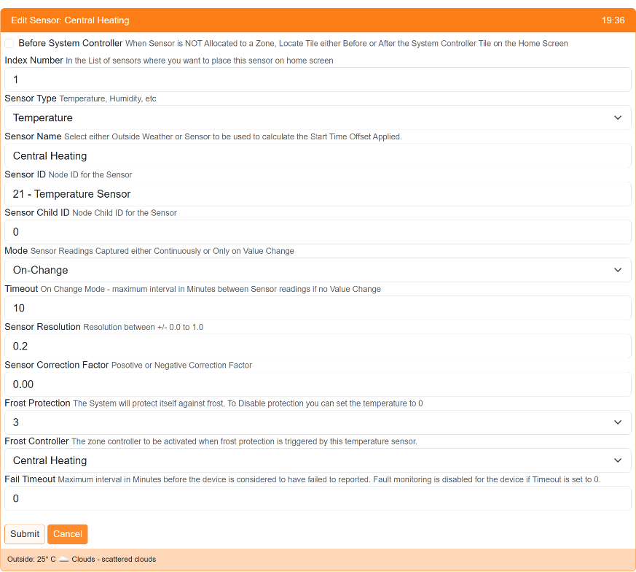

If a single sensor is attached to the zone, then zone control will be achieved using the parameters allocated to that sensor e.g.

Frost Control will use the *Frost Protection* and *Frost Controller* parameters allocated.

Sensor Timeout will be configured using the *Fail Timeout* parameter. If this is set to 0 then the Zone will remain active even if the sensor never reports, otherwise the Zone will be suspended if the Sensor does not report within the *Fail Timeout* interval.

### Multiple Sensors

Note: when adding a ‘Secondary Sensor’ from the Zone Add/Edit dialogue, only thos sensors with a *Fail Timout* setting which is not 0, will be available for selection. This is in order that the average reading can be calculated effectively.

#### Control Temperature

The Zone control temperature will be the average calculated from the individual sensor readings. If a ‘Fail Timeout’ has been set for a sensor and it fails to report within this period, then it will be removed from the average calculation. The Zone will be suspended if all attached sensors, which have a none zero ‘Fail Timeout’ fail to report. Only the *Primary Sensor* can have a *Fail Timeout* of 0, if this is the case then the Zone will NOT be suspended if ALL the attached sensors fail to report and the last reading reported by the *Primary Sensor* will be used as the control temperature.

#### Frost Control

Frost Control will be achieved by using the individual sensor settings and reported temperature. Hence different trigger temperatures could be used for each sensor, if desired. If the Zone has multiple Zone Controllers attached then each sensor could be linked to different Zone Controllers.

#### Zone Status Popup

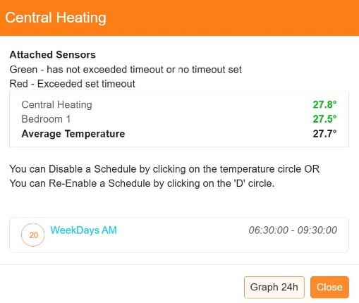The Zone Status popup will show a list of the attached sensor, with the current temperature shown in green if the sensor has reported within its *Fail Timeout* period, or else it will be displayed in red.

If multiple sensors are attached, then the Average Temperature will be displayed.

#### Zone Graphs

In the case of multiple sensors, the calculated Average Temperature will be used for the graph displays.

Note: When multiple sensors are configured, the calculated average temperature is added to the database ‘messages_in’ table. This will occur on-change of else every 10 minutes, the table entry id will be of the form ‘zavg_*zone_id*’.

#### Zone Settings Popup

Selecting the Zone menu item from the Settings/Node and Zone Configuration menu will display the a list of currently configured zones, including any allocation of multiple sensors.

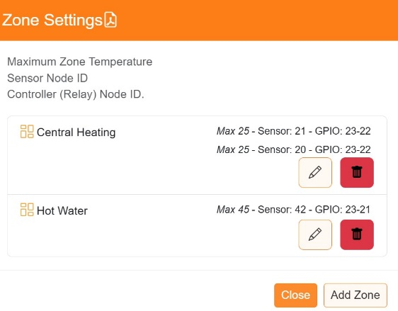Note: This dialogue can be used to Add/Delete/Edit the zone configurations.