## Introduction

MaxAir supports three levels of access to the system, ‘Level 0’, this is the special ‘admin’ account with full access to the system, including the ability to create additional user accounts. Only one ‘admin’ ‘Level 0’ account can exist on the system.

User accounts created with Level 1 access have the ability to configure system features through the various Settings menus. User accounts created with Level 2 access have no ability to configure the system and as such this is a display only configuration.

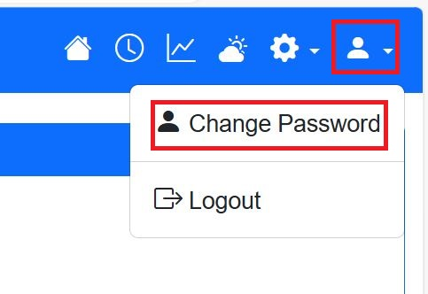

An initial ‘admin’ is installed at system setup, the details, including the password, can be changed by clicking on the toolbar ‘Person’ icon and selecting ‘Change Password’.

The ‘Change Password’ screen allows a new password to be entered, confirmed and saved.

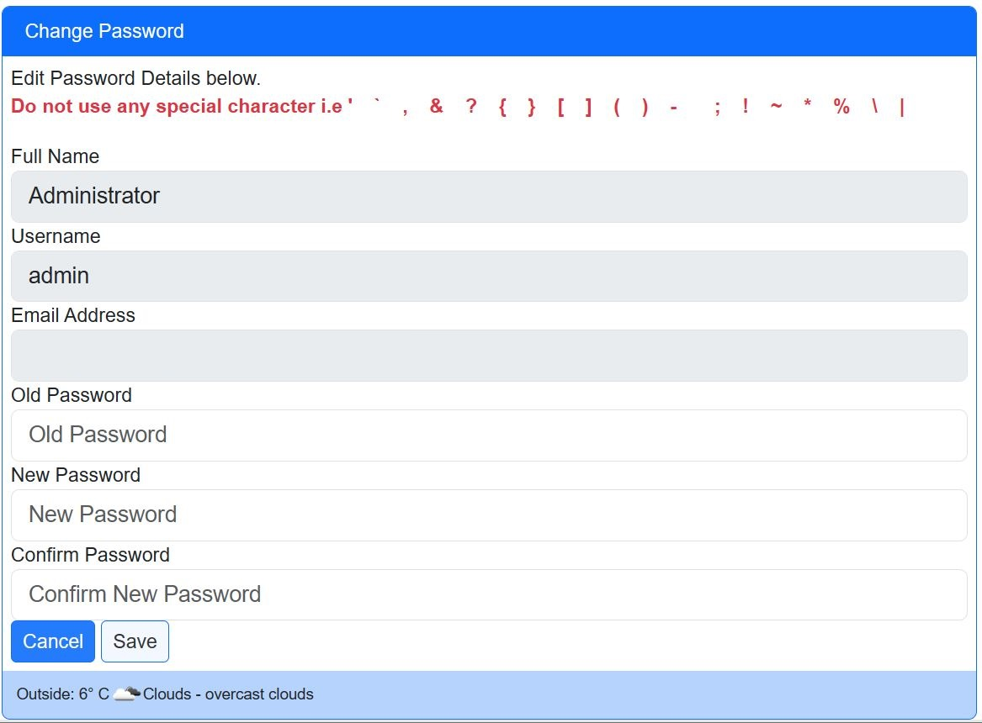

New user accounts can be added and edited by the ‘admin’ account using the ‘Settings/System Maintenance/User Accounts’ option.

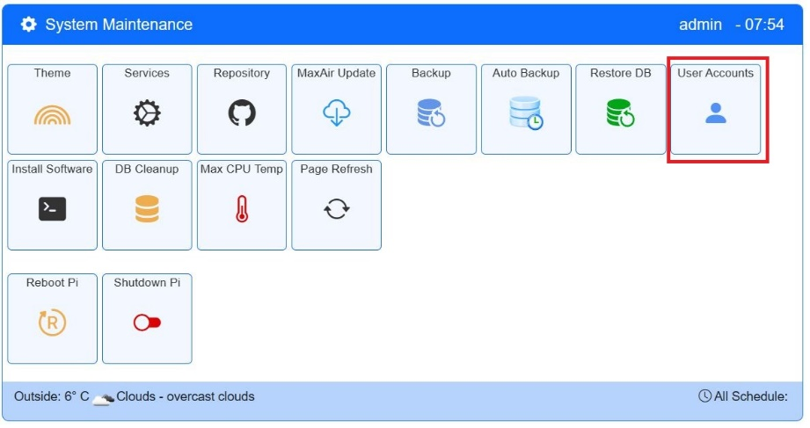

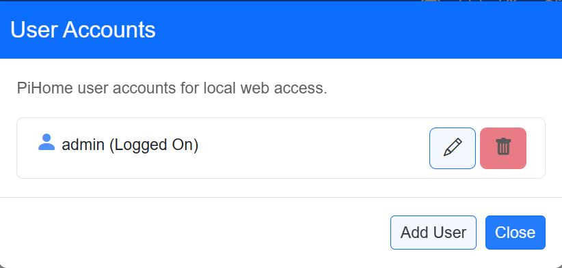

Selecting this option allows the editing of existing accounts, the deletion of existing account (Note: the ‘admin’ and the logged-on accounts cannot be deleted).

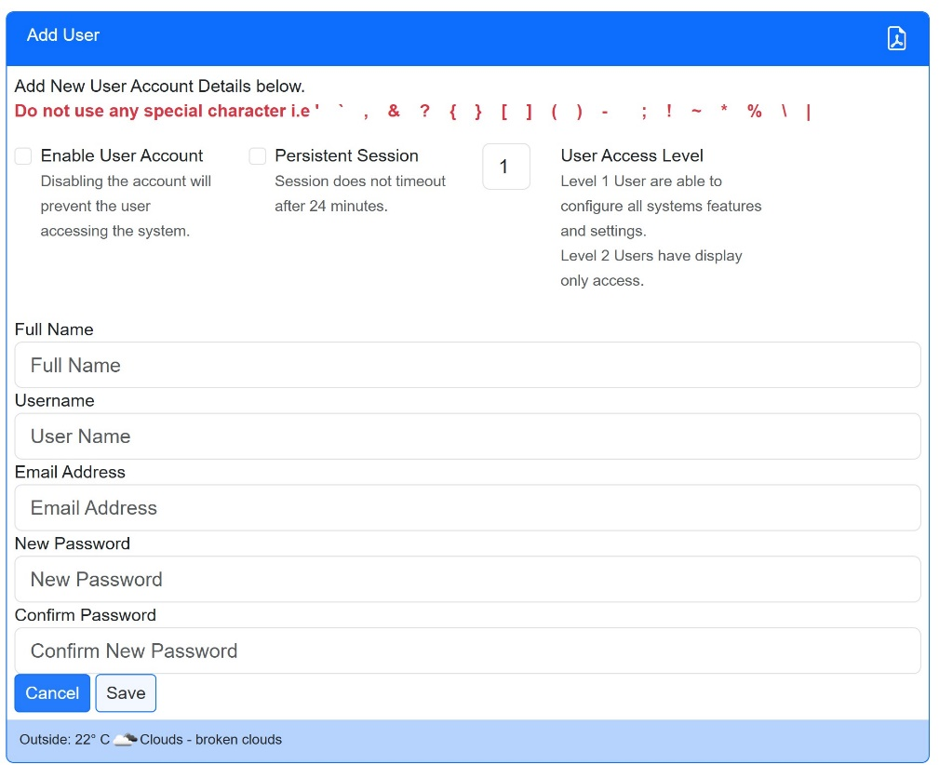

The format of the screen is the same for both editing an existing user or adding a new user.

Note: When editing the ‘admin’ account, the ‘User Access Level’ option will not be displayed, this is because this account has ‘special’ Level 0 access.

Enter the relevant user details and click on ‘Enable User Account’ to activate the account. Note: the account Access Level can be selected as either 1 or 2 and/or the user session made to not timeout by clicking on ‘Persistent session. Click on ‘Save’ to either add the new account or save the changes to an existing account.

## Level 0 ‘admin’ Account

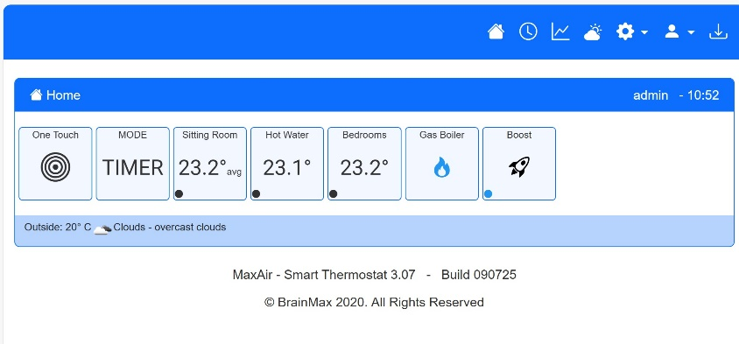

When logged-on as the ‘admin’ user the ‘Settings’ option is displayed on the top right toolbar and the ‘One Touch’ and ‘Mode’ buttons are visible on the Home screen display.

## Level 1 Accounts

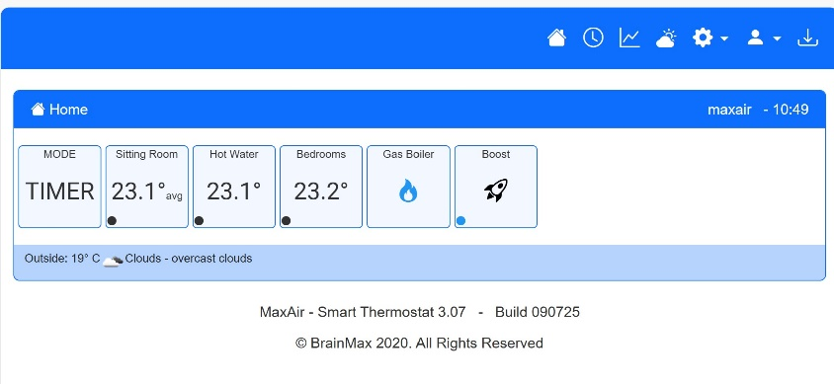

When logged-on as a Level 1 user the ‘Settings’ option is displayed on the top right toolbar and the ‘One Touch’ button is removed from the Home screen display.

## Level 2 Accounts

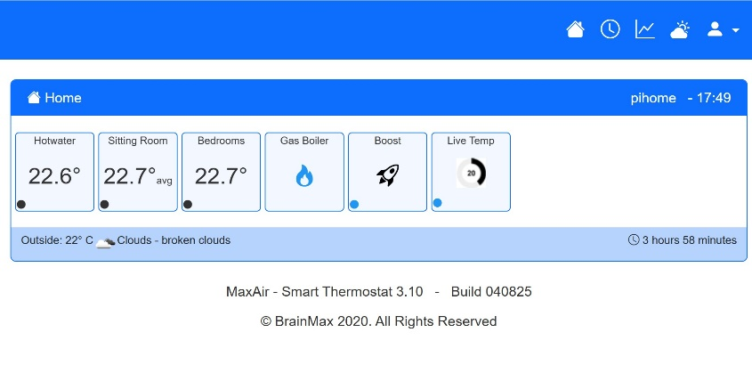

When logged-on as a Level 2 user the ‘Settings’ option is not displayed on the top right toolbar, also the ‘One Touch’ and ‘Mode’ buttons are removed from the Home screen display.

Both the ‘admin’ and Level 1 users can determine which additional tiles are displayed, in the above example the ‘Boost’ and ‘Live Temp’ tiles have been selected for display.

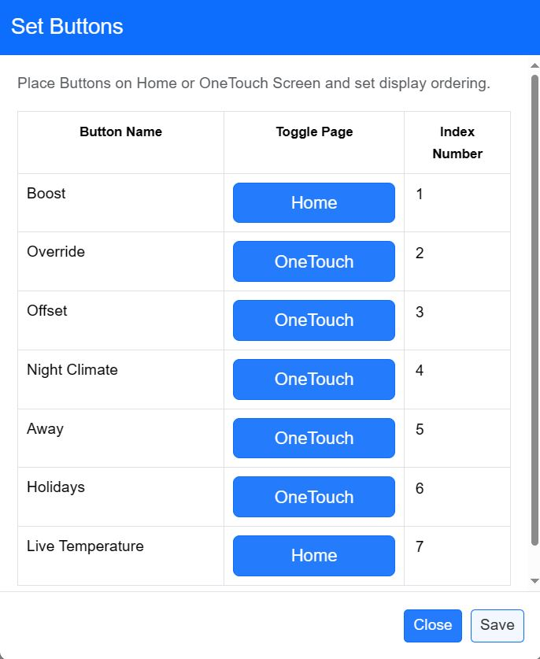

What to display is configured by an ‘admin’ account. To determine which function tiles to display (ie. Boost, Override, Night Climate, Away, Holidays, Live Temp, Add Theme, Add relay, Add Sensor, Add MQTT Dev and Add Zone), use the ‘Settings/System Configuration/Set Buttons’ option to allocate required tiles to the Home screen, rather than the One Touch screen.

In this example only the ‘Boost’ and ‘Live Temperature’ tiles are allocated to the Home screen and so will still be displayed for Level 1 and Level 2 type users.

Sensors can be hidden on the Home screen using two different methods. The first is by setting the sensor to ‘Not Show’ in the sensor configuration. Use the ‘Settings/Device Configuration/Sensors’ option and de-select ‘Show’ for the sensor you do not wish to display and then click the ‘Save’ button. Note: this will not display the sensor for all users, including ‘administrators’.

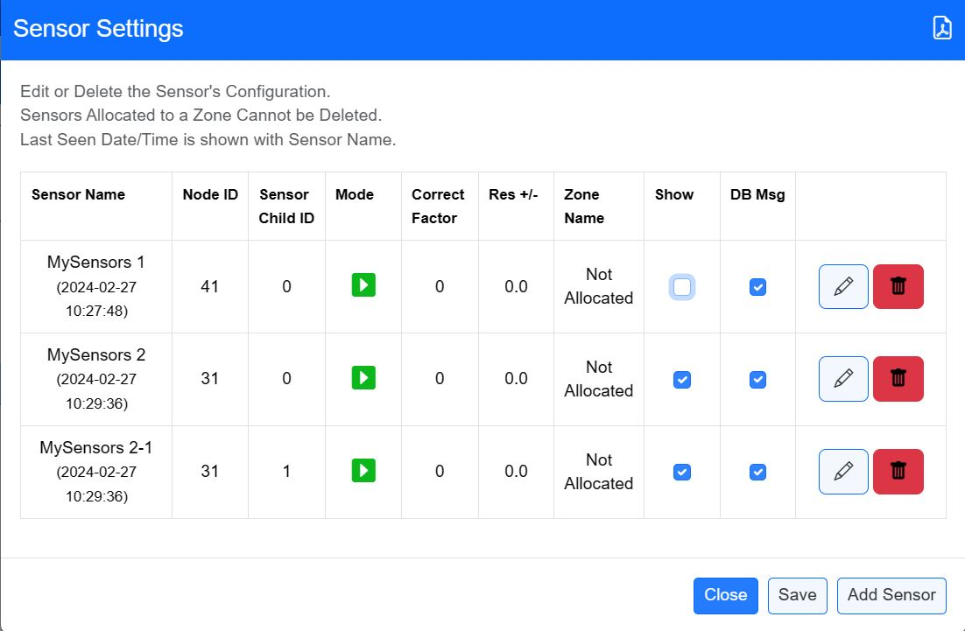

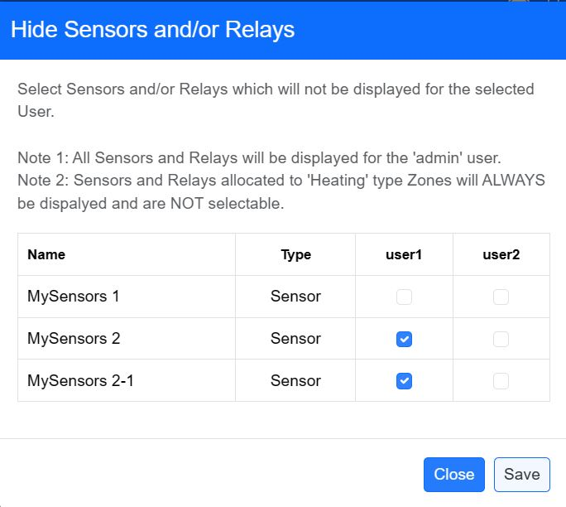

The second method hides both sensors and relays on a user-by-user basis. Use the ‘Settings/Device Configuration/Hide Sen/Rel’ option. In this example ‘Sensor 1’ will be displayed for ‘user1’ and all sensors will be hidden for ‘user2’.