The current copy of the MaxAir software code is held in the GitHub Repository - <https://github.com/pihome-shc/PiHomeHVAC.git>. Any updates to the MaxAir code will be reflected in this repository.

MaxAir executes a script each day at mid-night, this script compares each software code module on the controller executing MaxAir against the corresponding software code modules in the Repository. If there are any discrepancies then copies of the updated files will be downloaded to directories ‘/var/www/code_updates’ and ‘/var/www/database_updates’, update icons will be displayed on the toolbar, both code and database update icons may be displayed:

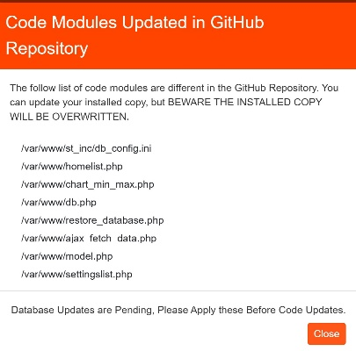

Clicking on the ‘Update’ icon will display a list of any software code modules files which require updating:

If there are pending database updates, then there will be prompt to ensure that the database updates are installed before the code updates.

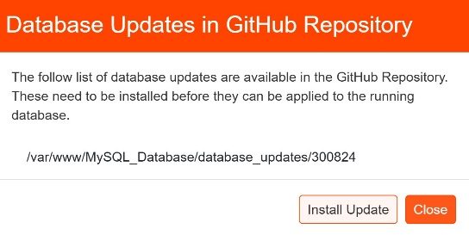

If available clicking on the database icon will display a list of any database updates to install:

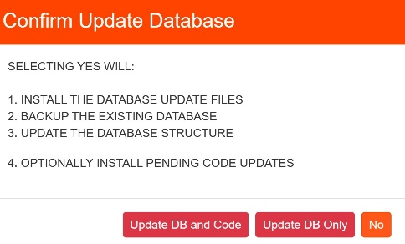

Clicking on the ‘Install Update’ button will popup a confirmation dialoge.

Only the database updates can be installed or both the database and any code updates can be installed.

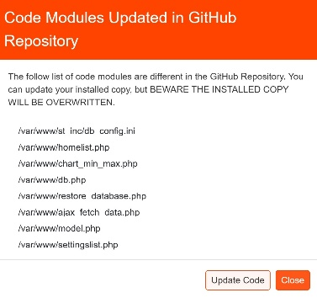Once any pending database update have been installed, then outstanding code updates can be applied:

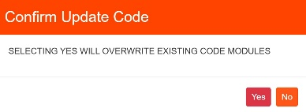Clicking on the ‘Update Code’ button will display a confirmation dialogue

Selecting ‘Yes’ will overwrite the existing software code modules with the corresponding updated file held in the directory ‘/var/www/code_updates’. The copies in ‘/var/www/code_updates’ will then be deleted, removing the ‘Update’ icon from the toolbar.

## Displaying the MaxAir Code Version Status

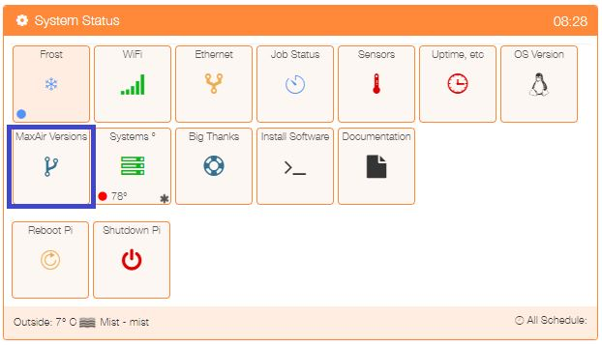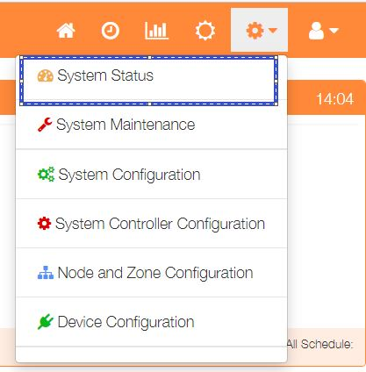Select ‘System Status’ from the Settings dropdown list, then click the ‘MaxAir Versions’ button.

.

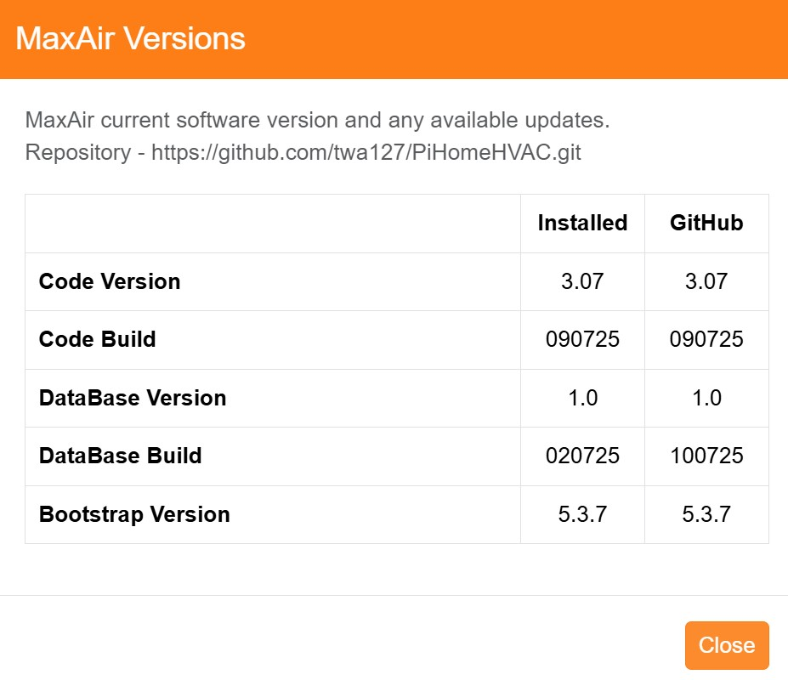The current and Repository versions will be displayed.

## Force a check for Updates

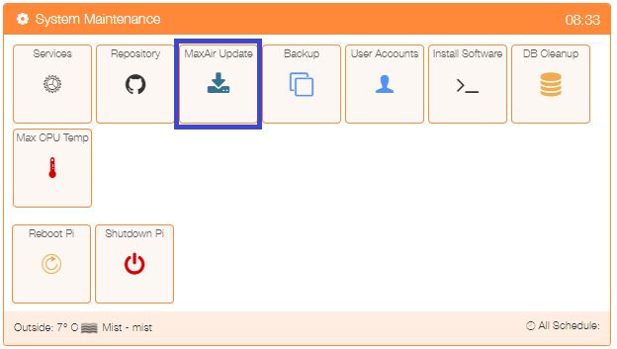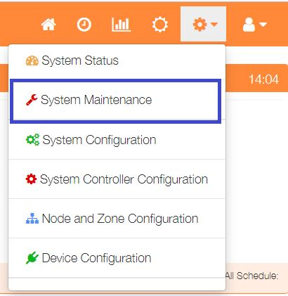 Select ‘System Maintenance’ from the Settings dropdown list, then click the ‘MaxAir Update’ button.

A dialogue will be displayed, if the ‘Check for Updates’ button is clicked, then the script to compare each software code module on the controller executing MaxAir against the corresponding software code modules in the Repository will be executed as a background task. This could take 2 to 3 minutes to complete execution, if there are any discrepancies then copies of the updated files will be stored in directory ‘/var/www/code_updates’ and the ‘Update’ icon will be displayed on the toolbar.

