ROBO LASER GATE
LASER TIMING GATE
Measure every run. View results instantly over Wi‑Fi.
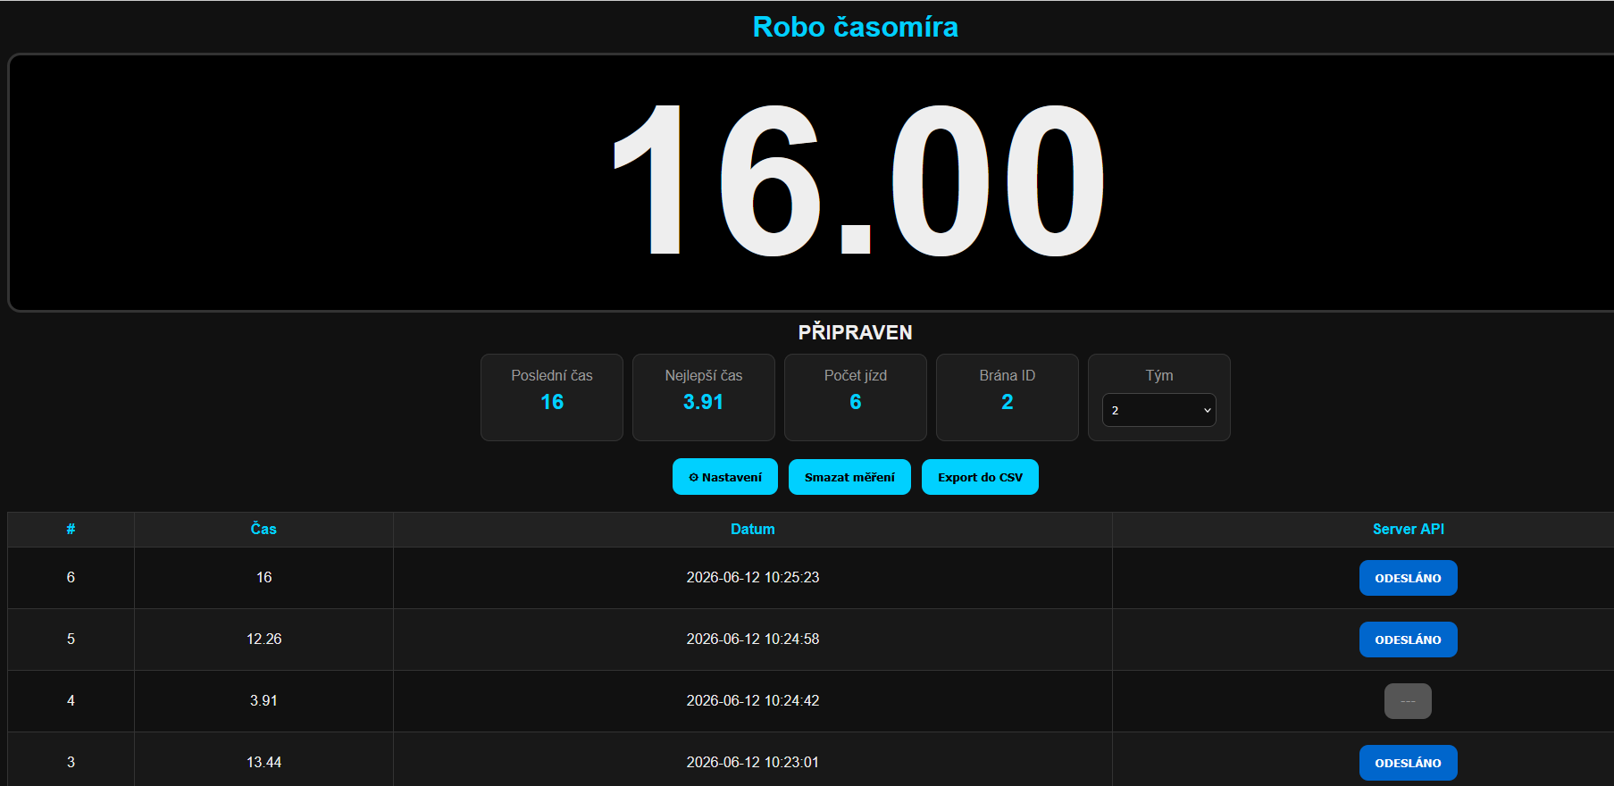

HOW IT WORKS
An interrupted laser beam starts the timer. The next interruption stops the clock and stores the result. A Raspberry Pi handles both timing and a web dashboard accessible from a phone, tablet or computer.
KEY FEATURES
WI‑FI STA / AP  Connect to an existing network or create a hotspot | LIVE TIMER  Live timer, last run and personal best
5 000  Stored runs; latest 50 shown in the dashboard | CSV + API  CSV export and remote server uploads
SETUP  Debounce, minimum lap time and sensor polarity | SIGNAL  Buzzer and status LED

OPEN-SOURCE PROJECT  Documentation, source code and build resources.  github.com/pihrt-com/robo_laser_gate | 
For robotics competitions, test tracks and educational projects • ROBO competition

