Curriculum Vitae
Name  peacecop kalmer: | Contacts  Physical address  Instituudi tee 3-27  Harku  76902 Harku  Harjumaa  Estonia  Baltics  Europe  Email address  pandeero@gmail.com  Phone number  +372 5620 4556

Nationality
Estonian

Date of start of independent breathing
8th of April 1978

Languages
ekk (C2), deu (C1), eng (B2), swe (B2), rus (B2), fra (A1)

Common education & qualifications
22.10.2024 Tartu Ülikool
Õppimist toetav õpetamine (6 h = 0,25 EAP)
21.10.2024 Tartu Ülikool
Aktiivõppemeetodid õppimisprotsessis (6 h = 0,25 EAP)
2024 Eesti Keele Instituut
Tööalane täienduskoolitus Haridustöötajate keeleõppe aruteluseminar (4 h)
Since 2021 TALLINN UNIVERSITY, Tallinn
“Integreeritud loodusteadused”, BSc
25.04.2023-20.05.2024 Tallinna Ülikool, Tallinn
“Õppimist toetav hindamine” (26 h)
9.03.2021-27.03.2021 Tartu Ülikool
Joint Classroom: "Kultuuridevahelise suhtlemise koolitus toetamaks õpetaja oskust õpetada mitmekultuurilises klassiruumis" (20 tundi (0,75 EAP))
2014 EESTI MAAÜLIKOOL, Tartu
information day “Cooperative Activities: Cooperative Law and Legislation”
2013 Juhatuse Kompetentsikeskus, Tallinn
course about leading people (16 h)
2011-2012 Ettevõtluse Arendamise Sihtasutus (Enterprise Estonia)
mentoring program für NGO-s
2011
Employment Contracts Act e-Handbook
since 2011 OÜ TOMEKIT, Harku
Chairman of the Board, Developer
Responsibilities included: leading the company, developing web software, doing internet marketing, teaching. Result: internet marketing for a customer, two web sites, continuous development for two customers, continuous tennis trainings at different facilities, “With Ten Steps Ready To Play at the End of the Lesson” during Tallinn Autumn Student Days 2011.
Nov 2010 Täiskasvanute koolitus vabahariduslikes koolituskeskustes (Adult education in non-formal education training centers), Tallinn
Public performance (16 h)
Oct 2010 InterAct Projektid & Koolitus OÜ, Kirke Maar
NGO Leaders Development Program: project management (16 * 45 min) & finance management (16 * 45 min)
2010 BDA Consulting OÜ
Basic training for non - profit organizations (18 * 45 min)
2007 Tallinna Tehnikaülikool (Tallinn University of Technology), Tallinn
Course (2 CP) „Strategical Leading of Sustainable Entrepreneurship“ (A)
since 2003 Tallinna Tehnikaülikool, Tallinn
shindo and latin american dance courses - initiator, project manager and assistant
2003-2006 Tallinna Tehnikaülikool, Tallinn
M.Sc. (tehnikateaduste magistri kraad) Computer Science
Master’s thesis: „Estimation of the Size of a New Software Project With Function Point Analysis on the Basis of „Sports Portal of Tallinn University of Technology““ (A)
aug 2008 Studentenwerk Schleswig-Holstein, Kiel
training
1996 – 2002 Tallinna Tehnikaülikool (Tallinn Technical University), Tallinn, Estonia
BA (majandusteaduste bakalaureuse kraad) Business Administration & Informatics Bachelor work: „Music Industry in Today's Economy“ (5)
2001 Kulturni Cirkus, Namest nad Oslavou, Czech Republic
International Summer Academy: Intuitive Written, Bookbinding (fist own book)
2000 Universität Trier, Germany Exchange Month
Summer Course "Germany in New Millennium – Decampment and Retrospect" including: High Level German (good)
2000 MitOst e.V., Rzeszów, Poland
Seminar “Who Else But We Will Communicate Inter Culturally?”
1998 Golden NeoLife Diamite International
selling the products and schooling about them
1999 Jugendbegegnungsstätte Kreisau, Kreisau, Poland
Seminar “Europe XXL Journalistic Writing”
1999 Tallinn, Estonia
Learning Traffic and Driving (driving license of category B)
1996 Tallinn, Estonia
German Olympiad (fourth place)
1993-1996 Tallinna 37. Keskkool, Tallinn, Estonia
Higher Grades include: Native Language (5), Mathematics (5), German (5), Chemistry (5), and Music Study (5)
1993-1996 Mathematical School by University of Tartu, Tartu, Estonia
correspondent study includes: Mathematics (4)
1992-1993 Tallinna Toompea Kaarli Kogudus (Estonian Evangelical Lutheran Church Charles XI Parish)
camp school
1985-1996 Tallinna 37. Keskkool, Tallinn, Estonia
Grade include: Music (5)

Path to a software developer
1998: HTML, ECMAScript, CSS, Visual BASIC, VBA, Access, Windows 95
2000: ASP, Windows NT, Windows 98, Solaris, Visual Source Safe
Mar 2000 - Dec 2002 Index Net AS, Tallinn
software tester
Responsibilities included: programming and testing. Result: "BoxShop", "Äripäev"
Sep - Dec 2000 Interaktive Service der Integrierten Systeme Multimedia Net GmbH, Düsseldorf
trainee in accounting and supervision
Responsibilities included: fixing cellular invoice data. Result: many types of SQL queries, successful grey-hat hacking.
Apr 2001 - Dec 2002 TietoEnator Eesti AS, Tallinn
IT tech support
Responsibilities included: systems consultant. Result: "TEE Library", various offers and analyzes
2002– 2003 Universität Basel (University of Basel), Basel, Switzerland
Advanced Training: Computer Science
2004: Java, Sybase, Windows XP, Windows ME, Windows 2000, Sodipodi, Inkscape, Eclipse
Jan 2004 - Jan 2005 Mindware Solutions OÜ, Tallinn
Programmer
Responsibilities included: Getting to know programming, ASE base backup and mapping. Result: Several modules in "EPS", "Instructions for transporting the ASE base from one environment to another "
2004 Tata Infotech, India
Certificate Course of Web Application Development using Java Technologies (6 weeks)
2005: start of using XML, TomCat, Postgre SQL, CVS, PHP
May 2005 - Dec 2006 FM Services OÜ, Tallinn
programmer
Responsibilities included: developments for CiTY24 gateways and their databases documentation. Result: developments in Java
Dec 2006 - Jul 2007 Finestmedia OÜ, Tallinn
tech support
Responsibilities included: providing technical support for "City24" real estate gates, their database documentation, small Java and XML developments. Result: small developments and supporting documents
2007: start of using Apache, MySQL, Windows 7, Windows Vista, Ubuntu, Subversion, The Gimp, Scribus
Jun 07 – Sep 08 Postimees Online OÜ, Tallinn
Programmer
Responsibilities included: development of and customer support to different inner and outer online media projects. Result: www.elukiri.ee, elu24.ee, foorum.elu24.ee, Postimees.ee, ilmajaam.ee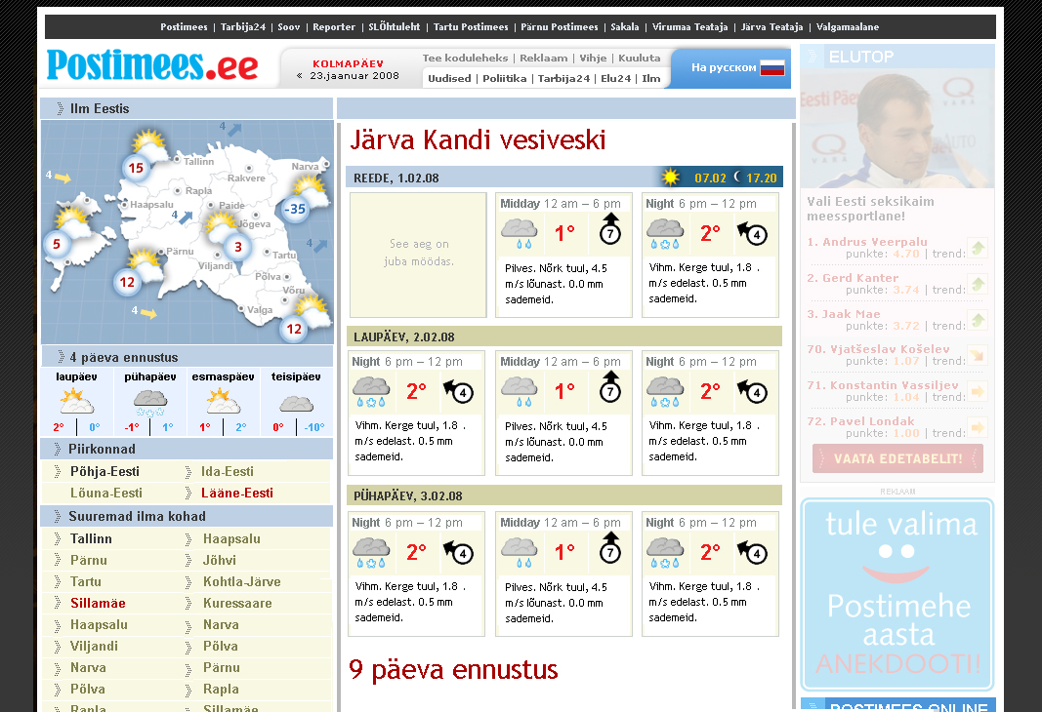
Aug 08 – Oct 08 freelancer, Tallinn
Programmer
Responsibilities included: development of “Kataloog”, a web site for direct marketing. Result: the administration side.
Jan 09 – Jun 09 Proekspert AS, Tallinn
Java Programmer
Responsibilities included: development of a issue management system based on JIRA for Skype, review of a PHP CMS. Result: some JIRA developments and the review.
Aug 09 – Dec 09 Iizi Kindlustusmaakler AS, Tallinn
Programmer and Systems Analyst
Responsibilities included: development of the insurance broker system for both inside and outside users, maintained mostly at iizi.net. Result: many tasks including the plan to start using SVN.
Jan 10 freelancer, Harku
Designer
Responsibilities included: creating a logo for Metsahindamise OÜ. Result: the logo.
development of epood.ee, price calculator
2013 Analytics Academy
course “Digital Analytics Fundamentals”
2014 Analytics Acacemy
course “Google Analytics Platform Principles”
2015: JSON, nginx, mariadb, hg
development of a system for mapping the knowledge and skills
2018: REST, Blender
Nora movie
2018: git
other accomplishments: development of tennis ranking and statistics system; leading comp sci clubs in Harku, Harjujärve, Muraste
Oct 2019 to May 2021 comp sci club in Peetri Lasteaed-Põhikool
2024-2025 infotehnoloogia õpetaja Gaia Hariduse Seltsis
FrontAccounting: reporting bugs
Shotcut: reporting bugs
ONLYOFFICE DocumentServer: reporting bug.

Path to a teacher of math and sci
since Mar 10 Tegusad Õpilased & Tudengid, Harku
Chairman of the Board
Responsibilities included: developing a system for exchange of discount opportunities, teachings, leading comp sci clubs. Result: The system for discount opportunities was discontinued. I’ve lead comp sci clubs in Muraste, Harku, Harkujärve, Peetri and virtually. I’ve taught math one-to-one and in small groups.
2014-2016 alleged OÜ PÄRNU TEHNIKAHARIDUSKESKUS, Pärnu, Pärnu, Estonia
teacher
Responsibilities included: teaching web-based technologies, basics of programming, software development process, lead into agile software development, basics of creating web apps, testing software systems, programming, basics of distributed apps, legalisation of information technology, basics of documenting, basics of database systems, planning and programming databases, basics of object-oriented programming, web programming and markup languages in ekk.
2014 HARIDUSE INFOTEHNOLOOGIA SIHTASUTUS, Tiia Niggulis
marking models (0.46 EAP / 12 * 45 min)
2014 HARIDUSE INFOTEHNOLOOGIA SIHTASUTUS, Siret Lahemaa
creating of manuals (0.92 EAP / 24 * 45 min)
Mar 2016 educationonair.withgoogle.com
Assessing 21st century skills in a project-based environment (30 min)
2016-2017 alleged TALLINNA POLÜTEHNIKUM, Tallinn
teacher
Responsibilities included: teaching web design, multimedium, web development, basics of programming and programming of serverside web applications in ekk.
2016 - 2018 alleged AS AUDENTES, Tallinn, Harju
IT teacher
Responsibilities included: teaching Computer Science and Theory Of Knowledge in eng.
Side-result: software for creating mappings of knowledge and skills.
2016 Hariduse Infotehnoloogia Sihtasutus
ICT autumn conference 2016 - Digitally active school (0.2 EAP / 5.3 * 45 min)
Oct - Nov 2016 International Baccalaureate Organization
Computer Science (Cat.1) Diploma Programme (>= 16 h)
2017 executive training institute malta, valerie zimmat
Content- and language-integrated learning (CLIL) - Methodology & Information and communications technology Tools for Teachers working with CLIL (42 h)
Jan - Mar 2018 MTÜ MONDO MAAILMAKOOL
ADVANCED COURSE FOR UNESCO SCHOOLS THROUGH DIGITAL EDUCATION (60 * 45 min)
2018 Ida-Virumaa Kutsehariduskeskus, Jõhvi
teaching basics of distributed applications
2018 - 2019 Tallinna Kunstigümnaasium, Tallinn
teaching math at gymnasium level, basics of programming and leading project days in comp sci
Oct 2019 Hariduse Infotehnoloogia Sihtasutus, Tallinn, IRI NEEM, KAJA KOMISSAROV, ERIKAPAADIMEISTER
Independent study in everyday study organization
since 2019
teaching math to individuals and in small groups from the grade five to the university level
2019 Hariduse Infotehnoloogia Sihtasutus (Information Technology Foundation for Education), Tartu, LAINE ALUOJA, Mari Tõnisson
eTwinning schooling for beginners (.46 EAP / 12 * 45 min)
2019-2021 Peetri Lasteaed-Põhikool
teaching math for seven-graders, offering aid in math to individuals and learners in small groups, leading comp sci clubs
Oct - Nov 2019 TALLINNA ÕPETAJATE MAJA, Reet Laur
Enesekindel õpetaja: oskuslik suhetes ja inspireeriv klassitunnis (12 h)
2019 www.code.org
Pre-reader express course
2020 Hariduse Infotehnoloogia Sihtasutus
Tööalane täienduskoolitus Digivõti: Õppija digipädevuse toetamine aineõpetajale: matemaatika (39 h)
Mar-May 2023 MTÜ Edu Valem
leading science club
Aug-Dec 2023 Kohila Gümnaasium
teaching physics at the high school level with the load of 0.667
2023-2024 MTÜ Edu Valem
teaching physics and chemistry at the high school level on lesson basis
Mar-Apr 2024 TARTU ÜLIKOOL
continuing education program “Laste ja noorte kliimateadlikkuse kujundamine” (1 EAP)
Apr-Jun 2024, Aug 2024-Jun 2025 Mittetulundusühing Haridus- ja Kultuuriselts Tuulemaa
teaching physics and chemistry at the high school level
Jun 2024 Eesti Füüsika Selts, Orissaare, Saaremaa, Estonia
Füüsikaõpetajate suvelaager 2024 (five days)
Jun-Jul 2024 CERN, Geneva, Switzerland
International High School Teacher Programme (70 h of lectures, visits to research facilities, hands-on workshops, as well as Q&A and discussion sessions, 10 h activity in a particular study group and every participant took part in presenting their final study group report in English)
Aug 2024 Füüsikaõpetajate võrgustik, Kauksi puhkeküla, Ida-Virumaa, Estonia
Füüsikaõpetajate suvekool 2024 (two days)
Responsibilities included: in addition to participating in lectures, visits and workshops, holding a presentation about my experiences from the High school Teachers’ Summer program 2024 at CERN
Oct 2024 NARVA PÄHKLIMÄE KOOL, Narva, Ida-Virumaa, Estonia
Nordplus PROJECT TOWARDS REAL MATHS (4 h)
2024-2025 Narva Täiskasvanute Kool, Narva, Ida-Virumaa, Estonia
õpetaja
created instructions: development environment: instructions; programming: instructions to write a basic program in eight programming languages; Preprocessed Hypertext (PHP): instructions as slides and text document, tasks, building an application programming interface; Structured Query Language: instructions for managing relational databases based on mariadb; MP: instructions of how to use PHP and mariadb together
teaching one-to-one: math, physics, chemistry

Path to a tennis coach
2003 - 2006 Tallinna Tehnikaülikool, Tallinn
tennis competitions - arranger
several tennis competitions
Eesti Akadeemiline Spordiliit, Kääriku
Student Summer Games: leading tennis
2013 Eesti Tennise Liit, Haapsalu
Seminar for Estonian tennis coaches: development of player; overview of international schoolings; competition systems of Estonian and international tournaments, rankings; general physical preparation in tennis; ethical problems of young player; new certification system (15 h)
2012 “Ajujaht”
half-finalist in the entrepreneurship competition with the idea “Virtual personal tennis coach”
2012 Eesti Tennise Liit (Estonian Tennis Federation), Tallinn
Extra schooling for coaches by Mark Tennant: skills to develop on red, orange and green court and when to move between them, effective training with a large group, relations to parents, competing as a part of the training, competitions and planning them for under 11, the club program fur under-11-s (16 h)
2012 Eesti Tennise Liit, Tallinn
Extra schooling for coaches by Rolf Bühler and Hrvoje Zmajic: physical training integrated with the tennis training, the factors of the physical training, the factors of the coordination, coaching a large group (18 h)
2011 Eesti Tennise Liit
schooling for coaches for the second level (30 h)
2011 Eesti Tennise Liit, Pärnu
Extra schooling for coaches (6 h)
2011 Tallinna Ülikooli Terviseteaduste ja Spordi Instituut (Faculty of Health Sciences and Sports)
coaches level II sports theory theory course (4 EAP / 50 h)
2011 Eesti Olümpiakomitee (Estonian Olympic Committee)
professional certificate for being a tennis coach at the first level
2010 Eesti Tennise Liit
coaches first course (30 h)
2010 Tallinna Ülikooli Terviseteaduste ja Spordi Instituut (Faculty of Health Sciences and Sports)
coaches level I sports theory theory course (2 EAP / 30 h)
since Aug 08 MTÜ Eesti Kõrgkoolitennise Liit, Harku, Harjumaa, Estonia
Chairman of the Board
Responsibilities included: taking care of tennis activities of students and workers of establishments of higher education, maintaining the union's site at tennis24.ee, mapping Harku’s tennis. Result: Estonian Student Championships, developments for tennis24.ee, competitions and maps of Harku’s tennis.

