**DESIGN AND IMPLEMENTATION OF COMPUTERIZED HOSTEL**

**ALLOCATION MANAGEMENT SYSTEM**

PROJECT REPORT

Submitted by

**OMOPARIOLA KAYODE EZEKIEL AND TIRIMISIYU MONSURU OLA**

**NCSF/13/032 AND NCSF/13/068**

IN PARTIAL FULFILLMENT OF THE REQUIREMENTS FOR THE DEGREE

OF

**NATIONAL DIPLOMA DEGREE (ND)**

IN

THE DEPARTMENT OF COMPUTER SCIENCE

SCHOOL OF PURE AND APPLIED SCIENCE

OGUN STATE INSTITUTE OF TECHNOLOGY

IGBESA

AUGUST 2015

**CERTIFICATION**

This project work was written, arranged and compiled by OMOPARIOLA KAYODE EZEKIEL AND TIRIMISIYU MONSURU OLA with the matric number NCSF/13/032 AND NCSF/13/068 under the supervision of Mr Jimoh Q.O. of computer science Department in partial fulfillment of the registration for the award of ND in Computer Science.

________________ _________________

Supervisor Date

MRS JIMOH Q.O.

_________________ _________________

MRS R.A OLADEJO Date

HOD

**DEDICATION**

This project is dedicated to Almighty God, The alpha and Omega, The Beginning and the End, the owner of our Life who made it possible for Me to be favored, start the ND program me and complete it successfully. You alone had been my Strength and Hope. Thank You My Heavenly Father. You are a Wonderful God, glory be to your holy name in heaven(Hallelujah).

**ABSTRACT**

“HOSTEL ALLOCATION MANAGEMENT SYSTEM” is software developed for managing various activities in the hostel. For the past few years the number of educational institutions is increasing rapidly. Thereby the number of hostels is also increasing for the accommodation of the students studying in this institution. And hence there is a lot of strain on the person who are running the hostel and software’s are not usually used in this context. This particular project deals with the problems on managing a hostel and avoids the problems which occur when carried manually. Identification of the drawbacks of the existing system leads to the designing of computerized system that will be compatible to the existing system with the system which is more user friendly and more GUI oriented. We can improve the efficiency of the system, thus overcome the drawbacks of the existing system

**TABLE OF CONTENTS**

CHAPTER 1

1.0 INTRODUCTION

1.1 BACKGROUND OF THE STUDY

1.2 STATEMENT OF THE PROBLEMS

1.3 PROJECT OBJECTIVES

1.4 SIGNIFICANT OF THE STUDY

1.5 SCOPE OF THE STUDY

1.6 LIMITATION OF THE STUDY

CHAPTER 2

2.0 LITERATURE REVIEW

2.1 HOSTEL ALLOCATION MANAGEMENT SYSTEM

2.2. SYSTEM DEVELOPMENT

2.2.1 HOSTEL MODULE

CHAPTER 3

3.0 METHODOLOGY

3.1 SYSTEM ANALYSIS

3.2FEASIBILITY STUDY

3.3 REQUIREMENT ANALYSIS AND SPECIFICATION

CHAPTER 4

4.0. SYSTEM TESTING AND IMPLEMENTATION

4.1. SYSTEM TESTING

4.2. SYSTEM SPECIFICATION HW/SW

4.2.1. HARDWARE REQUIREMENT

4.3. RESULT OF THE RESEARCH WOR

4.4. USER’S MANUAL

CHAPTER 5

5.0. SUMMARY

5.1. CONCLUSION

5.2. RECOMMENDATION

REFERENCES

APPENDIX

**CHAPTER ONE**

**1.0 INTRODUCTION**

1.1 BACKGROUND OF THE STUDY

**Hostel**: A hostel is essentially a form of accommodation that offers reasonably priced, shared accommodation to travelers in either private or dormitory rooms.

**A management information system (MIS):** is a system that provides information needed to manage organizations effectively. In 1912, in Altena Castle in Germany, Richard Schirrmann created the first permanent *Jugendherberge* or "Youth Hostel". These first Youth Hostels were an exponent of the ideology of the German Youth Movement to let poor city youngsters breathe fresh air outdoors. The youths were supposed to manage the hostel themselves as much as possible, doing chores to keep the costs down and build character as well as being physically active outdoors. Because of this, many Youth Hostels closed during the middle part of the day.

There are several differences between hostels and hotels, including:

1. Hostels tend to be budget-oriented; rates are considerably lower, and many hostels have programs to share books, DVDs and other items.
2. For those who prefer an informal environment, hostels do not usually have the same level of formality as hotels.
3. For those who prefer to socialize with their fellow guests, hostels usually have more common areas and opportunities to socialize. The dormitory aspect of hostels also increases the social factor.

**1.2** **STATEMENT OF THE PROBLEM**

The growing number of students in higher institutions all over the world has posed a lot of accommodation problem on the part of students and school management. Students at the beginning of each session waste half of the semester looking for accommodation. The few hostels that exist in the universities are not properly managed. Statistics of the number of rooms required to match the growing number of students are far fetched. Most often, students pay for hostel fee and end up not getting one due to lack of bed space. Hostel administrators cannot give accurate information of the occupancy of a particular room. These and many more form the statement of the problem that necessitated this research work.

1.3 OBJECTIVES OF THE STUDY

The project is designed to help in the management of hostel allocation in the university. The main objective of the new system includes:

1. Design and develop a central database system that would serve as hostel database, which will contain information on all the available rooms in the hostels.
2. Design a computer – driven hostel allocation system for allocating hostel rooms to students.
3. To generate reports on hostel occupancy

1.4 SIGNIFICANCE OF THE STUDY

The new system designed for computer driven student’s hostel allocation will among other things:

1. Facilitate timely allocation of hostel rooms to students
2. Check the hostel occupancy at any time for information management
3. Enable management to plan on improving hostel living condition.
4. Have first hand information on the statistics of students in the hostel.

**1.5 SCOPE OF THE STUDY**

The research work will cover among other things:

1. Hostel allocation
2. Hostel rooms registration
3. Student reports.

The research will be carried out using OGUN STATE COLLEGE OF HEALTH TECHNOLOGY , Ijebu, Ogun State

**1.6 LIMITATIONS**

Some of the constraints encountered during this project design include the following:

1. **Financial Constraints:** The design was achieved but not without some financial involvements. One had to pay for the computer time. Also the typing and planning of the work has its own financial involvements.
2. **High programming Technique:** The programming aspect of this project posed a lot of problematic bugs that took us some days to solve. Problems such database connections using VB and MS Access database posed a lot of challenges.
3. **Few Literature Sources:** The topic though seems to be a common term; it is not a popular topic to surf from the Internet. It had fewer literature sources.

**CHAPTER 2**

**2.0. LITERATURE REVIEW**

**2.1. Hostel Allocation Management System**

As the topic mentions above "Hostel Management System" is software that is developed to help in managing various activities in the hostel. As is well-known, the education institutions are rapidly increasing for the past few years. Therefore, it leads to mushrooming of hostels for the accommodation of the students study in these institutions. And hence there is the appearance of Hostel Allocation Management System which helps with dealing the problem of managing hostel and avoid the problem when do it manually. (Muhammed Shaheer .K.A, Muhammed Shiras.A, Vinod Raj. R, Prasobh.G.V, April, 2009) Hostel Allocation management by manual way is tedious process, since it involves work load and time consumption. In this system, we can easily manage the hostel details, room details, student records, easy way of room allocation and hostel attendance. Thus, there are a lot of repetition can be easily evaded which has reduced the data redundancy. (M. Deepika, A. Chitra, 2010).

**Functional Feature:**

1. Creation of Building and Block information.
2. Provision of various room types (Single / Twin/Single with Air-con Room/Twin with Air-con Room).
3. Room allotment to the student.
4. Monitoring Visitors and Guest register.
5. Transfer of rooms.
6. Room evacuation. (Hostel System, 2006)

**The features of Administrator**

In computer based hostel allocation management system one of the primary factors to be considered is the administrators. The administrator function includes:

1. Allot different students to the different hostels.

2. Vacate the students for the hostels.

3. Edit the details of the students & modify the student records.

1) **Allotment of the hostels**

The officer must checks the certified application forms of the students obtained and verify it with the student database. If the students are found eligible then they are allotted to the hostel.

2) **Vacating the room**

As the student's course is over they will vacate their rooms. So it is required for the administrator to remove their records from the database tables. This part includes the option for the room vacation and the deletion of the particular record from the database.

3) **Edit the details of students and modify the student records**

As the new student moves into hostel, the officer needs to edit the details of students and modifies the student records to make sure the data is updated.(Muhammed , 2009).

We can improve the efficiency of the system, thus overcome the drawbacks, these drawbacks are;

1. Less human error
2. Strength and strain of manual labor can be reduced
3. Reduce data redundancy
4. High security
5. Data consistency
6. Easy to handle
7. Easy data updating
8. Easy record keeping
9. Backup data can be easily generated (Hostel Management System, 2009)

**2.3 System Development**

The Accommodation Office currently uses the system which is called Computer Based Hostel Allocation Management System. This software helps officers who work in accommodation office in managing various kinds of activities in the hostels. Hostel Allocation Management System (HMS) is one of the modules of the Total Campus Management System (TCMS).

**2.3.1 Hostel Module**

Hostel management module has features of efficiently and effectively managing the entire residential facility in the institute. It has reducing the staff & paper works and improved workflows. This hostel module will keep the updated records of students, lodging, transfer room and other facilities.

Hostel Management System has helped the accommodation office in saving the human resource as compared to the previous system (Room Master). All the edited information or updated information will show in the HMS immediately. HMS has provides the best service to the accommodation office in managing daily workflows.

Through the implementation of Hostel Allocation Management System, it has replacing manual system where it able the staff to complete the work more efficient and effectively. The system has helped in managing any problem occurring within the hostel accommodation and avoiding any problem when keying in the detail manually.

Room vacancy details.Therefore, through the usage of this system, they can easily manage the room details, student records, allocation of room and hostel attendances. Besides, repetition can be easily avoided. It also has reduced that data redundancy and any inconsistency of data. The accommodation office uses Hostel Allocation Management System to key in all the details of the students who are staying in the hostels. This system is mainly used to do room bookings,. Reports in regard to the room allocation, room availability, student transfer and evacuation are provided too.

**2.3.2 System Functions:**

Hostel Allocation Management System (HMS) has several functions which enable the staffs from accommodation office such as allocate students to the different hostels, reserve the room for the students, control status of rental payment and edit the details of the students & modify the student records.

**1. Allocating students to the hostels**

The officers must check the details in an application form of the students and verify it from database to match the application of students. Therefore, when the students are eligible then they are allocated to the hostel. The officers will also allocate the room according the requirements of the students as there are different types of rooms are available.

**2. Vacating the room**

As the students have completed their course In School, they will be graduated and vacate their rooms.

When the students vacate their room, the officer needs to check whether the room facilities have

missing or broken down. If all facilities are completed, accommodation office will return the deposits to the students. Thus, the officers in accommodation office will have to remove the particular student details and records from the student database. This is to ensure there will not be the problem exists when the existing residents' records coincide with previous residents.

**3. Editing the details of the student and modifying the students records**

As there are new students move into the hostels, they need to register themselves as a residents of the hostels. The officers need to key in the details of the new students who want to move in into the hostels. Therefore, the officers have to edit the details of the students and modify the student records to ensure the data is updated.

**4. Maintenance**

Maintenance of the Hostel Allocation Management System (HMS) will only do when the system facing the problem. The systems no need to have a check annually or quarterly. According to the officer of the Accommodation Office Azlinda Binti Alias, she says the system is not facing any serious problem until now.

Regardless to the update, the system will have update when the Hostel Allocation Management System (HMS) doesn't meet the requirement of the Total Campus Management System (TCMS). In this point,

Information System Office (INSO) & Information Technology Centre (INTC) which is from the INTI International University departments will handle this update. The staff of the Accommodation Office only is the end user of the system. They don’t know about the technical problem of the system. The entire problem will pass to INSO & INTC to handle.

**6. Problem that Hostel Allocation Management System (HMS) having & Future Plan**

There is a problem that Hostel Management System (HMS) is having. From the interview, we know that when the Total Campus Management System (TCMS) is giving a huge amount of staff is using, HMS will be affected. Example like, when the TCMS is jamming because of many people is using its, HMS can't send or received the information from the TCMS. The staffs have to wait the TCMS recover only they can do their works.

Future plan of the Accommodation Office is to create an E-service for the residents of the hostel. The E-services will provide residents an on-line booking room functions. Residents do not need like before do their room booking manually. But due to some problem they are considering, the panning is still waiting to approve. The problem they are considering have many, one of them is they are considering that now a day resident's computer skill is very good. They finding a good security for the E-services to provide the system will be hack by the residents.

**SYSTEM UTILITY**

**HISTORY NATURE OF BUSINESS**

Ogun State College Of Health Technology , Ijebu, Ogun State owned 200 room ultra-modern hostel (each room is self-contained) facility situated at Ijebu, Ogun State  
The Hostel is equipped with modern facilities and equipment geared towards providing comfort and adequate security for the Hostel’s tenants. These and many other features make the facility a Hostel of choice.

**CHAPTER 3**

**3.0 RESEARCH METHODOLOGY**

**3.1 SYSTEM ANALYSIS AND DESIGN**

**EXISTING SYSTEM**

The existing system is manual based and need lot of efforts and consume enough time. In the existing system we can allocate room for student with the use of keeping filling a form and filling them . It may lead to corruptions in the allocation process as well as lost of file or file damage.

**DISADVANTAGES:**

1. More human power
2. More strength and strain of manual labour needed
3. Repetition of same procedure.
4. Low security.
5. Data redundancy.
6. Difficulty to handle.
7. Difficulty to update data.
8. Record keeping is difficult.
9. Backup data can be easily generated.

**PROPOSED SYSYTEM**

The proposed system is having many advantages over the existing system. It require less overhead and very efficient. The proposed system deals with allotment process efficiently

**3.2 FEASIBILITY STUDY**

**TECHNICAL FEASIBILITY**

The technical feasibility in the proposed system deals with the technology used in the system. It deals with the hardware and software used in the system whether they are of latest technology or not. It happens that after a system is prepared a new technology arises and the user wants the system based on that technology. This system use windows platform, Visual Basic (VB) as front end technology and MS Acces as backend technology. Thus DESIGN AND IMPLEMENTATION OF HOSTEL ALLOCATION MANAGEMENT SYSTEM is technically feasible.

**ECONOMICAL FEASIBILITY**

Economic analysis is the most frequently used method for evaluating the effectiveness of a new system. More commonly known as cost/benefit analysis. Visual Basic (VB) and MS Access database easily available and user friendly

**OPERATIONAL FEASIBILITY**

The project has been developed in such a way that it becomes very easy even for a person with little computer knowledge to operate it. This software is very user friendly and does not require any technical person to operate .Thus the project is even operationally feasible.

* 1. **REQUIREMENT ANALYSIS AND SPECIFICATION**

**REQUIREMENT DEFINATION**

System design is concerned with the design of the proposed system based on the investigation and requirement made. This involves the processing algorithms and data structure; system design is not same as implementation. It is strongly influences by the programming language used to implement the proposed system.

**INPUT DESIGN**

Input design data for this research work are all the data, which are collected manually from OGUN STATE COLLEGE OF HEALTH TECHNOLOGY HOSTEL, and the data will be design into input table as shown below.

1. Login table
2. Student Info
3. School
4. Room Allocation
5. **TABLE NAME:** Login table.

**KEY FIELD:** User name.

**PURPOSE:** This table shows the administrator (username) access to the student records.

|  |  |  |  |
| --- | --- | --- | --- |
| **S/N** | **FIELD NAME** | **DATA TYPE** | **FIELD SIZE** |
| 1. | Username | Text | 06 |
| 2. | Password | Text | 08 |

1. **TABLE NAME:** StudentInfo.

**KEY FIELD:** Id.

**PURPOSE:** This table shows the student information.

|  |  |  |  |
| --- | --- | --- | --- |
| **S.N** | **FIELD NAME** | **DATA TYPE** | **FIELD SIZE** |
| 1. | Id | AutoNumber | Long Integer |
| 2. | Matric Number | Text | 50 |
| 3. | Last name | Text | 25 |
| 4. | First Name | Text | 25 |
| 5. | Sex | Text | 25 |
| 6. | School | Text | 20 |
| 7. | Department | Date | 20 |
| 8 | Level | Text | 20 |
| 9 | Allocated | Yes/No | 20 |
| 10 | Course of Study | Text | 20 |
| 11 | Next of kin address | Text | 50 |
| 12 | Name of Sponsor | Text | 25 |
| 13 | Sponsor’s Address | Memo | 50 |
| 14 | Next of kin | Text | 50 |
| 15 | Receipt No. | Text | 11 |
| 16  17 | Special  CGP | Yes/No  Number | 10  4 |

1. **TABLE NAME:** School.

**KEY FIELD:**

**PURPOSE:** This table shows the student information.

|  |  |  |  |
| --- | --- | --- | --- |
| **S/N** | **FIELD NAME** | **DATA TYPE** | **FIELD SIZE** |
| 1. | Schools | Text | 50 |

1. **TABLE NAME:** Room allocation.

**KEY FIELD:** RoomId

**PURPOSE:** This table shows the Allocated rooms.

|  |  |  |  |
| --- | --- | --- | --- |
| **S/N** | **FIELD NAME** | **DATA TYPE** | **FIELD SIZE** |
| 1. | Id | Integer | 06 |
| 2 | RoomId | Text | 06 |
| 3 | MatricNo. | Text | 10 |
| 4 | HostelName | Text | 50 |

**OUTPUT DESIGN**

The output design of their project work will be the result of all the processed information which are carried out by the creation of a graphical user interface (which is known as forms in visual basic 6.0. programming language) it is this procedure information that the computer would out as hard copy or display on screen.

Stated below are sample of the output to be used in the proposed system of this project.

1. All allocated room
2. All un allocated rooms
3. Fully allocated room
4. Partially allocated room
5. Fully allocated rooms
6. Hostel
7. Student list by department
8. Student list by department(male)
9. Student list by department(female)
10. Student (special case )
11. Non HNDII student

**PRGRAM FLOWCHART**

Start

Enter User name & Password

NO

Is the data correct?

YES

Main menu

Stop

Is the data correct?

Management

Allocation

Report

# CHAPTER FOUR

# SYSTEM TESTING AND IMPLEMENTATION

This chapter describes the installation of the new system, the software and the hardware that would be needed to be installed for proper implementation.

## SYSTEM TESTING

This is the test conducted on a computer integrated system to evaluate the system’s compliance with it specified requirements. The proposed system has been tested with real life data and information each program module has been tested with appropriate data to ensure it work as expected, the system testing with appropriate data to ensure it work as expected. The system testing determines how the entire system as a whole can be relied upon.

## SYSTEM SPECIFICATION HW/SW

These are tools that are necessary for the workability of the proposed system: these tools are divided into two specifically

1. Hardware requirement
2. Software requirement.
   * 1. **HARDWARE REQUIREMENT**

The hardware components needed for the proposed system are

1. A CPU (central processing unit)
2. Pentium iv mother board and above
3. 513mb RAM and above
4. 40GB Hard Disk and above
5. 15 inches VDU
6. Laser jet printer
7. UPS (uninterrupted power supply)
8. Optical mouse
9. Enhanced keyboard
   1. **RESULT OF THE RESEARCH WOR**

The proposed software of the project work would contain the following:

1. Login Page
2. Student Registration Page
3. Student Record Page
4. Create hostel Page
5. Hostel Management Page

**THE LOGIN PAGE:** The login page is the page that only the authorized user can access in order to view the content of the program

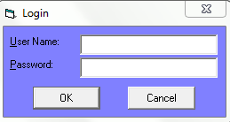

**STUDENT REGISTRATION PAGE:** Displays the form to register a new student

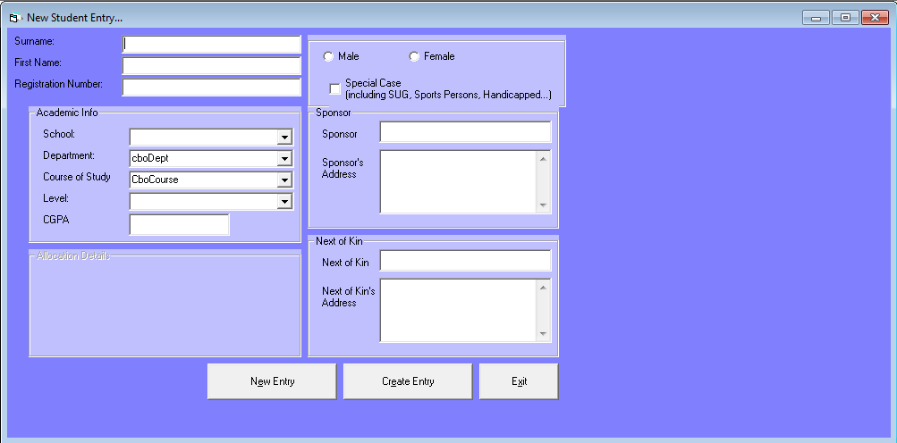

**STUDENT RECORD PAGE:** This page displays the record of registered student

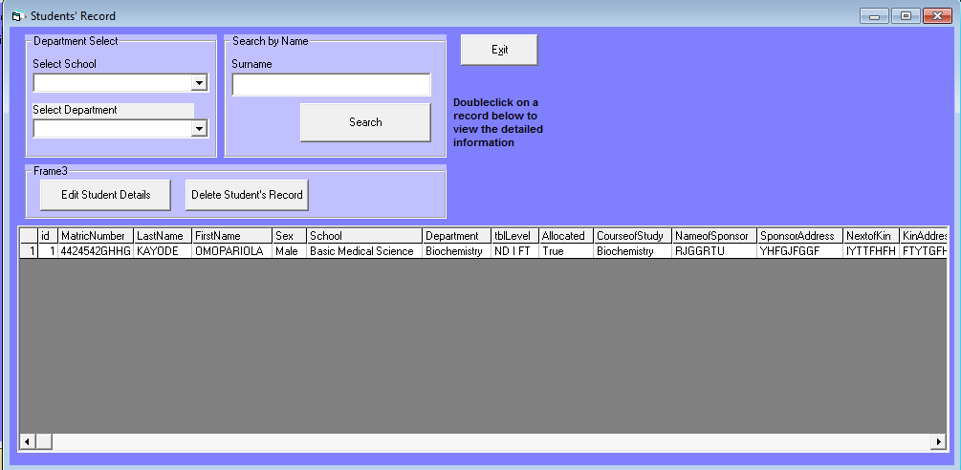

**CREATE HOSTEL PAGE:** This form displays the page to create a new hostel

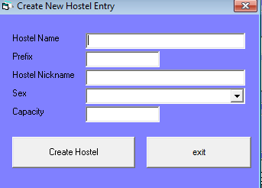

**HOSTEL MANAGEMENT PAGE:** This page displays the available rooms in the hostel

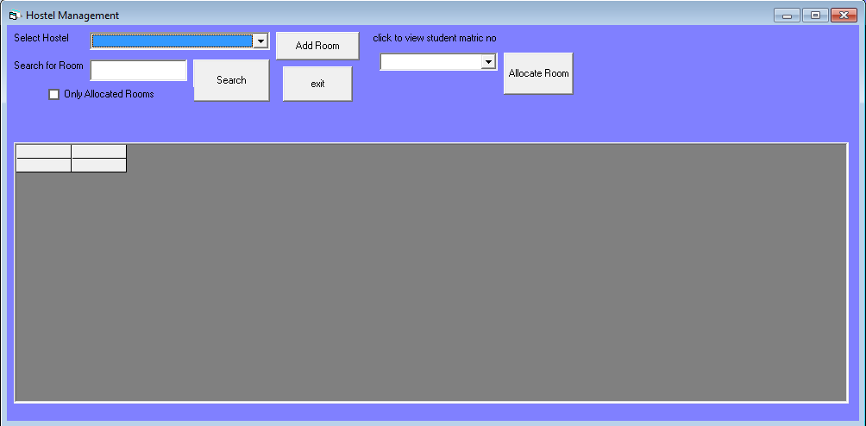

## USER’S MANUAL

This user manual would be a guide to the person operating the proposed system for the first time.

1. Power the system

2. Allow the system to boot.

3. Open the CD drive of the CPU and put the software.

4. Close the CD drive.

5. Click on the state button on the task bar.

6. Select my computer option from the menu

7. Right click on the cd drive icon and select open.

8. Select the Microsoft access icon from option and copy it.

9. Check on the start button on the disk bar again.

10. Open the local disk drive C and paste the icon.

11. Then check for Hostel Allocation – Shortcut

12. Copy the Hostel Allocation – Shortcut to desktop then lunch

13. Type in the correct password and login.

# CHAPTER FIVE

**SUMMARY, CONCLUSION AND RECOMMENDATION**

* 1. **SUMMARY**

It is required that OGUN STATE COLLEGE OF HEALTH TECHNOLOGY HOSTEL to change over from manual system to an automated system with the aids of collected data and research work done. A new system is designed and developed with the aid of visual basic 6.0 programming language and Microsoft access.

## CONCLUSION

With the new proposed system the staff of OGUN STATE COLLEGE OF HEALTH TECHNOLOGY HOSTEL should be enlighten with seminars in other to train them on how to fully understand the implementation of the new proposed system.

In the course of this project, I came to the understanding that Hostel allocation management of so many hostel are still processed manually until now.

However, this is a stepping stone for upcoming programmers in extending the trend of Hostel allocation management.

## RECOMMENDATION

This involves the act of suggesting the user of the new proposed system. This system has been fully designed and developed, in such a way that it should be recommended for full utilization of its resources.

**REFERENCES**

Alkon W.F (2007). Sets Sights Far Up the Ladder ," New York Times,

Austine J.J (2006)."Hostel management, definition . HostelManagement.com. p. 12.

Allen Salkin (2012). In Hostel Basement, Newcomer

Arthur Frommer Online (2009). The eruption of low cost, private hostels

James A.O (2005). List of Hostel Chains - Hostel Wiki

Johnson A.I (2003). Define: Hostel - what is a hostel? | Hostel Management

Laboy, Suzette (2009). "South Beach becoming backpacker hot spot" . Associated Press

McGrath,Ginny(2008)."Whatever happened to Youth Hostels?”LondonTimes Online. retrived from http://www.hihostels.com/web/about.en.htm

Mark T.J.et.al (2009). .Australia.comInternational Backpacker Snapshot Destination NSW

Ojo A.I (2015). Guideline to a successful project work and seminal presentation

Peter K.O (2010). Hostelling International Selling Hotel Room

Reulecke J.S. et.al (2009)"Hostel horror or safety? Separating fact from fiction".

Wiki(2014). Limitation of web based hostel management system

**APPENDIX**

**LOGIN FORM**

Dim rsLogin As New Recordsetn

Private Sub cmdCancel_Click()

'set the global var to false

'to denote a failed login

LoginSucceeded = False

Unload Me

End Sub

Private Sub cmdOK_Click()

'check for correct password

sSQL = "select * from users where username = '" & txtUserName & "'"

Set rsLogin = cn.Execute(sSQL)

If rsLogin.EOF And rsLogin.BOF Then

MsgBox "Invalid Username, try again!", , "Login"

txtUserName.SetFocus

SendKeys "{Home}+{End}"

Exit Sub

End If

If rsLogin.Fields("password") <> txtPassword Then

MsgBox "Invalid Password, try again!", , "Login"

txtPassword.SetFocus

SendKeys "{Home}+{End}"

Exit Sub

End If

'password correct

frmMain.Show

Unload Me

End Sub

Private Sub Form_Unload(Cancel As Integer)

Unload frmSplash

End Sub

**MAIN FORM**

Private Sub Command1_Click()

frmStudReg.Show

End Sub

Private Sub Command2_Click()

frmStudRec.Show

End Sub

Private Sub Command3_Click()

frmAddHostel.Show

End Sub

Private Sub Command4_Click()

frmHostelMgt.Show

End Sub

Private Sub Command6_Click()

DataReport5.Show

End Sub

Private Sub MDIForm_Load()

End Sub

Private Sub mnuAbout_Click()

frmAbout.Show 1

End Sub

Private Sub mnuAllocate_Click()

MsgBox "Automatic Allocation wiating for Supervisor Recommendation!", vbInformation

End Sub

Private Sub mnuCascade_Click()

Me.Arrange vbCascade

End Sub

Private Sub mnuCreateHostel_Click()

frmAddHostel.Show

End Sub

Private Sub mnuDocumentation_Click()

frmBrowser.Show

End Sub

Private Sub mnuExit_Click()

Unload Me

End Sub

Private Sub mnuRptHostels_Click()

frmRptHostel.Show

End Sub

Private Sub mnuHostelMgt_Click()

frmHostelMgt.Show

End Sub

Private Sub mnuMgtStudent_Click()

frmStudRec.Show

End Sub

Private Sub mnuNonHND2_Click()

DataReport9.Show

End Sub

Private Sub mnuReg_Click()

frmStudReg.Show

End Sub

Private Sub mnuRptAllUn_Click()

DataEnvironment1.Command4_Grouping

DataReport2.Show

End Sub

Private Sub mnuRptFully_Click()

DataEnvironment1.Command5_Grouping

DataReport3.Show

End Sub

Private Sub mnuRptHos_Click()

frmRptHostel.Show

End Sub

Private Sub mnuRptPartial_Click()

DataEnvironment1.Command3_Grouping

DataReport1.Show

End Sub

Private Sub mnuRptStudDept_Click()

DataReport6.Show

End Sub

Private Sub mnuRptStudDeptF_Click()

DataReport7.Show

End Sub

Private Sub mnuRptStudDeptM_Click()

DataReport10.Show

End Sub

Private Sub mnuRptStudSpc_Click()

DataReport8.Show

End Sub

Private Sub mnuRptViewAll_Click()

DataEnvironment1.Command7_Grouping

DataReport4.Show

End Sub

**FORM ADD HOSTEL**

Dim sSQL As String

Private Sub Command1_Click()

On Error GoTo ErrorHandler

cn.BeginTrans

sSQL = "insert into hostelname(HostelName, HostelNickname, Sex, Prefix, Capacity, CapacityUsed) values ('" & txtHostelName & "','" & txtNickname & "','" & cboSex & "','" & txtPrefix & "', " & CInt(txtCapacity) & ", 0)"

cn.Execute sSQL

MsgBox "Hostel " & txtHostelName & " created.", vbInformation

cn.CommitTrans

Exit Sub

ErrorHandler:

cn.RollbackTrans

MsgBox "Hostel " & txtHostelName & " not created.", vbInformation

End Sub

Private Sub Command2_Click()

Unload Me

End Sub

Private Sub Form_Load()

With cboSex

.Clear

.AddItem "Female"

.AddItem "Male"

.AddItem "Mixed"

End With

End Sub

Private Sub txtHostelName_Change()

txtPrefix = Left$(txtHostelName, 1)

Command1.Caption = "Create Hostel '" & txtHostelName & "'"

End Sub

**FORM ADD ROOM**

Dim rsHostel As New Recordset

Private Sub cboHostels_Click()

sSQL = "select sex from hostelname where hostelname = '" & cboHostels & "'"

Set rsHostel = cn.Execute(sSQL)

If LCase$(rsHostel.Fields(0)) = "male" Then

txtRoomSex.Clear

txtRoomSex.AddItem "Male"

ElseIf LCase$(rsHostel.Fields(0)) = "female" Then

txtRoomSex.Clear

txtRoomSex.AddItem "Female"

Else

txtRoomSex.Clear

txtRoomSex.AddItem "Male"

txtRoomSex.AddItem "Female"

End If

End Sub

'dim

Private Sub cmdCancel_Click()

Create_Room

Unload Me

End Sub

Private Sub cmdCreateRoom_Click()

Create_Room

Clear_Fields

End Sub

Private Sub Command1_Click()

Unload Me

End Sub

Private Sub Form_Load()

txtRoomSex.Clear

txtRoomSex.AddItem "Male"

txtRoomSex.AddItem "Female"

sSQL = "select * from HostelName"

Set rsHostel = cn.Execute(sSQL)

rsHostel.MoveFirst

cboHostels.Clear

Do While Not rsHostel.EOF

cboHostels.AddItem rsHostel.Fields(1)

rsHostel.MoveNext

Loop

End Sub

Sub Create_Room()

Dim intCapacity As Integer

Dim strRoomNumber, strSex As String

strRoomNumber = Me.txtRoomNumber

intCapacity = CInt(txtRoomCapacity)

strSex = Me.txtRoomSex

If strRoomNumber = "" Then

MsgBox "please enter an entry for the room number"

Exit Sub

End If

If intCapacity = 0 Then

MsgBox "please enter an entry for the room capacity"

Exit Sub

End If

If strSex = "" Then

MsgBox "please enter an entry for the room sex"

Exit Sub

End If

mess = MsgBox("create room entry - number:" & strRoomNumber & " capacity:" & intCapacity & " members sex:" & strSex & " - in hostel:" & cboHostels.Text & "?", vbYesNo)

If mess = vbNo Then

Exit Sub

End If

sSQL = "select capacity from hostelname where hostelname = '" & cboHostels.Text & "'"

Set rshotel = cn.Execute(sSQL)

'insert room record

sSQL = "insert into Hostels(RoomID, HostelName, RoomNumber, Capacity, Allocated, Sex) values ('" & Left$(cboHostels.Text, 1) & "-" & strRoomNumber & "','" & cboHostels.Text & "','" & strRoomNumber & "'," & intCapacity & ",0,'" & strSex & "')"

cn.Execute sSQL

sSQL = "select * from HostelName where HostelName='" & cboHostels & "'"

Set rsHostel = cn.Execute(sSQL)

Cap = CInt(rsHostel.Fields("capacity"))

'update hostel parent record - total capacity

sSQL = "update hostelname set capacity = " & Cap + CInt(intCapacity) & " where HostelName = '" & cboHostels & "'"

cn.Execute sSQL

End Sub

Sub Clear_Fields()

Me.txtRoomCapacity = ""

Me.txtRoomNumber = ""

Me.txtRoomSex = ""

End Sub

**FORM HOSTEL MANAGEMENT**

Dim sSQL As String

Dim rs As New Recordset

Dim rsStud1 As New Recordset

Private Sub cboHostel_Click()

loadRS

End Sub

Private Sub cboStud_Click()

sSQL = "select MatricNumber, LastName, Firstname, Sex, DepartMent from StudentInfo where MatricNumber = '" & cboStud.Text & "'"

Set rs = cn.Execute(sSQL)

Label4 = ""

Label4 = Label4 & "Matric Number: " & rs.Fields("MatricNumber") & vbCrLf

Label4 = Label4 & "(" & rs.Fields("LastName") & ", " & rs.Fields("Firstname") & ")" & vbCrLf

Label4 = Label4 & "Sex: " & rs.Fields("Sex") & vbCrLf

Label4 = Label4 & rs.Fields("Department")

End Sub

Private Sub Check1_Click()

loadRS

End Sub

Private Sub cmdAlloc_Click()

Dim strStud As String

Dim intAlloc As Integer

If cboStud.Text = "" Then

MsgBox "Select a student's matric number first!", vbExclamation

Exit Sub

End If

If grd.Row < 0 Then

MsgBox "Please select a room to allocate!", vbCritical

Exit Sub

End If

strStud = cboStud.Text

sSQL = "select Allocated, Sex from Studentinfo where MatricNumber = '" & strStud & "'"

Set rsStud1 = cn.Execute(sSQL)

If rsStud1.BOF And rsStud1.EOF Then

MsgBox "sorry, no student like that..."

Exit Sub

End If

If rsStud1.Fields("Allocated") = True Then

MsgBox "Student already allocated to a room.", vbCritical

Exit Sub

Else

'check students sex

If LCase$(grd.TextMatrix(grd.Row, 7)) <> LCase$(rsStud1.Fields("Sex")) Then

MsgBox "Wrong Sex Allocation... Check Student's Sex", vbCritical

Exit Sub

End If

'do the allocation here

intAlloc = CInt(grd.TextMatrix(grd.Row, 6))

intCapacity = CInt(grd.TextMatrix(grd.Row, 5))

If intAlloc = intCapacity Then

MsgBox "Sorry, room full!", vbCritical

Exit Sub

End If

intAlloc = CInt(grd.TextMatrix(grd.Row, 6)) + 1

'insert to room allocation table

sSQL = "insert into RoomAllocation(RoomId, MatricNo) values ('" & grd.TextMatrix(grd.Row, 2) & "','" & strStud & "')"

cn.Execute sSQL

'indicate in student table that student is allocated

sSQL = "update StudentInfo set Allocated = " & True & " where MatricNumber = '" & strStud & "'"

cn.Execute sSQL

'update current status of room allocation

sSQL = "update Hostels set Allocated = " & intAlloc & " where RoomId = '" & grd.TextMatrix(grd.Row, 2) & "'"

cn.Execute sSQL

loadRS

loadUnAllocated

End If

End Sub

Private Sub Command1_Click()

Load frmAddRoom

frmAddRoom.cboHostels.Text = cboHostel.Text

frmAddRoom.Show

loadRS

End Sub

Private Sub Command2_Click()

loadRS

End Sub

Private Sub Command3_Click()

Unload Me

End Sub

Private Sub Form_Activate()

loadRS

End Sub

Private Sub Form_Load()

sSQL = "select hostelname from hostelname"

Set rs = cn.Execute(sSQL)

With cboHostel

.Clear

Do While Not rs.EOF

.AddItem rs.Fields(0)

rs.MoveNext

Loop

End With

loadUnAllocated

End Sub

Private Sub Form_Resize()

With grd

.Height = ScaleHeight - .Top - 300

.Width = ScaleWidth - 300

End With

End Sub

Public Sub grd_dblClick()

'MsgBox grd.TextMatrix(grd.Row, 2)

Dim rs1 As New Recordset

sSQL = "select id,RoomId,MatricNo from RoomAllocation where RoomID = '" & grd.TextMatrix(grd.Row, 2) & "'"

Set rs1 = cn.Execute(sSQL)

If rs1.EOF And rs1.BOF Then

MsgBox "No Allocation for Room ", vbCritical

Exit Sub

End If

Load frmRoomDetails

With frmRoomDetails

LoadRecordsetIntoGrid rs1, .grd

.Show

End With

End Sub

Private Sub txtRoomSearch_Change()

loadRS

End Sub

Public Sub loadRS()

If cboHostel.Text = "" Then Exit Sub

sSQL = "select * from hostels where hostelname = '" & cboHostel.Text & "'"

If txtRoomSearch <> "" Then

sSQL = sSQL & " and RoomNumber like '" & txtRoomSearch.Text & "%'"

End If

If Check1.Value = vbChecked Then

sSQL = sSQL & " and allocated > 0"

End If

loadRS1:

Set rs = cn.Execute(sSQL)

If rs.EOF And rs.BOF Then

MsgBox "Room Information not found", vbCritical

sSQL = "select * from hostels where hostelname = '" & cboHostel.Text & "'"

'GoTo loadRS1

Else

LoadRecordsetIntoGrid rs, grd

End If

loadUnAllocated

End Sub

Sub loadUnAllocated()

'On Error Resume Next

cboStud.Clear

sSQL = "select MatricNumber from StudentInfo where Allocated = " & False

Set rs = cn.Execute(sSQL)

Do While Not rs.EOF

cboStud.AddItem rs.Fields(0)

rs.MoveNext

Loop

End Sub