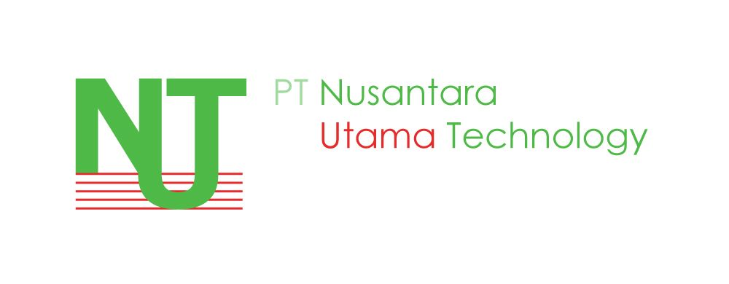

Dear Sir/ Madam,

I, Derry Adrian Saleh hereby acknowledge receipt of 1 unit of laptop/ netbook (Model: ASPIRE V3-471G-52454G75Ma Brand: ACER, S/no: NXRZ2SM0022170AA4F7600) on 10 Januari 2013.

It is also hereby confirm that this unit of laptop is belongs to PT Nusantara Utama Technology and will be returned whenever necessary. I will responsible for any charges due to any lost subject to certain circumstances.

Thank you.

Signature : …………………………….
Name : …………………………….
NRIC No. : …………………………….
Date : …………………………….

