**Results**

**Sentinel 2**

**Mapping**

We observe a quite uniform Shannon diversity map (Map 1), with some lowspot of diversity, in the upper left corner for instance. The principal component choice made to compute the spectral species clustering have a noticeable impact on the resulting Shannon index estimates (S1). The plant diversity from the three field work sites can be best estimate using the principal component 1,2,7 and 8 as well as 20 clusters in the K-mean analysis. With these parameters, we manage to get the same relationship between sites observed for real species richness. The spectral species diversity is however always severely underestimate.

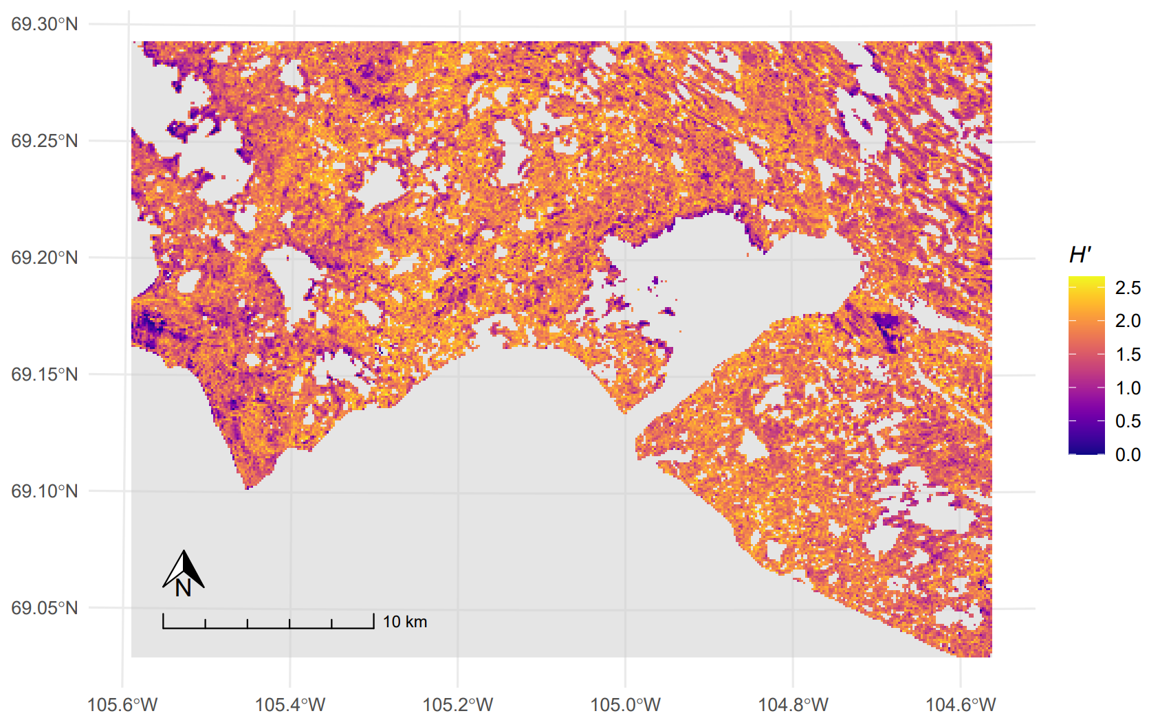

Map 1: Map of Shannon index computed based on the spectral species richness and distribution over 100 meters resolution. Spectral species are determined via a k-mean clustering of pixels of a Sentinel-2 satellite image, after dimensionality reduction of the later.

**Modelling**

At 100 meters resolution, our models suggest a positive relationship between small scale (2-10m) topography variation and the detection of the spectral diversity, as the model coefficient for the standard deviation of the slope is above one (Table 1). However, we find a negative effect of the standard deviation of elevation on the Shannon diversity estimates. Both effects size become smaller when computed at a bigger resolution, up to having no significant effect at one kilometre grain size. An analysis of the semivariance between pixels of the 100 meters resolution map of standard deviation of elevation confirmed the presence of some autocorrelation between neighbouring pixels (S1). This autocorrelation is well accounted for in the model random term, as the range define by the model match the range given by the variograme analysis.

Table 1: Mean and standard deviation of model coefficients for the standard deviation of elevation or slope taken over 100, 200, 300, 500 or 1000 meters square. The coefficients come from independent models of the form Shannon index ~ 1 + σ(x) + random spatial autocorrelation term + ε, computed under a gamma distribution family with a log-link function.

|  |  |  |  |  |  |  |  |  |  |  |  |  |
| --- | --- | --- | --- | --- | --- | --- | --- | --- | --- | --- | --- | --- |
| Resolution | **100m** | | **200m** | | **300m** | | **500m** | | | **1000m** | | |
|  | mean | σ | mean | σ | mean | σ | | mean | σ | | mean | σ |
| σ(elevation) | 0.995 | 0.001 | 0.995 | 0.001 | 0.997 | 0.001 | | 0.999 | 0.001 | | 0.998 | 0.001 |
| σ(slope) | 1.049 | 0.001 | 1.027 | 0.002 | 1.017 | 0.002 | | 1.014 | 0.003 | | 1.00 | 0.004 |

**Supplementary**

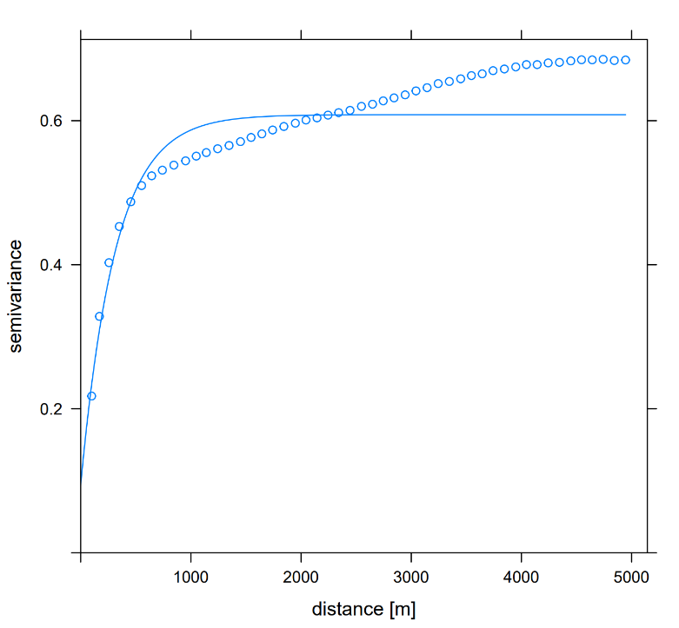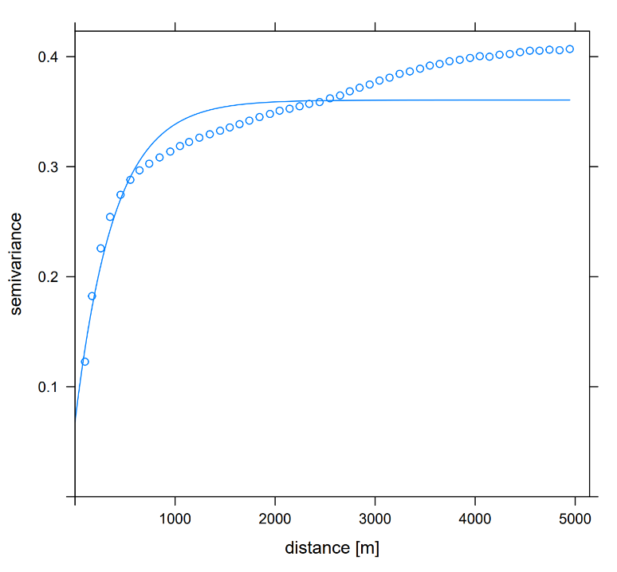

Range : **386.54**

**A**

**B**

Supplementary figure 1: Semivariogram of (A) the standard deviation of elevation data points and (B) the standard deviation of slope points from the 100 meter resolution map. The semivariogram is computed with an interval distance of 100 meters, corresponding to one pixel.

Range : **314.05**

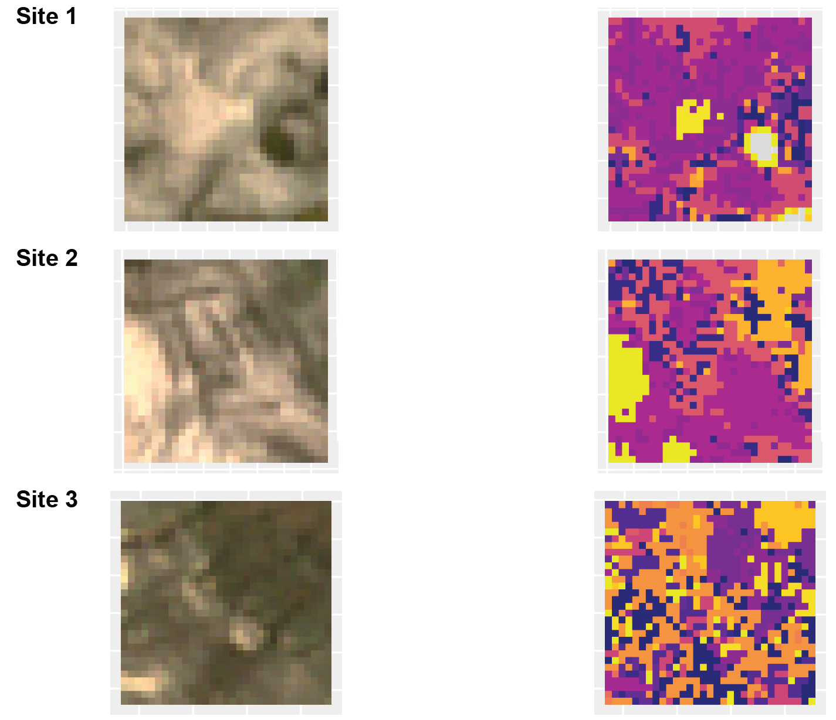

**Spectral richness: 7.15**

**Spectral Shannon index: 1.53**

**True richness: 29**

**Spectral richness: 7.15**

**Spectral Shannon index: 1.79**

**True richness: 29**

**Spectral richness: 10.20**

**Spectral Shannon index: 2.03**

**True richness: 36**

**True colour map**

**Spectral species map**



Supplementary figure xxx: Field work site diversity computed from spectral species map produced with principal component 1, 2, 7 and 8. Left: true colour map from field work sites view from Sentinel 2 satellite. Middle: Illustration os the assignment of the 20 spectral species for one of the 20 iterations. Each colour correspond to a spectral species. Right: Spectral richness, computed as the number of spectral species present in the field work site area, spectral Shannon index, computed with the spectral richness and the abundance of each spectral species in the field work site area and true richness, computed by a cumulative addition of the species presence record in each 18 plots in each site.

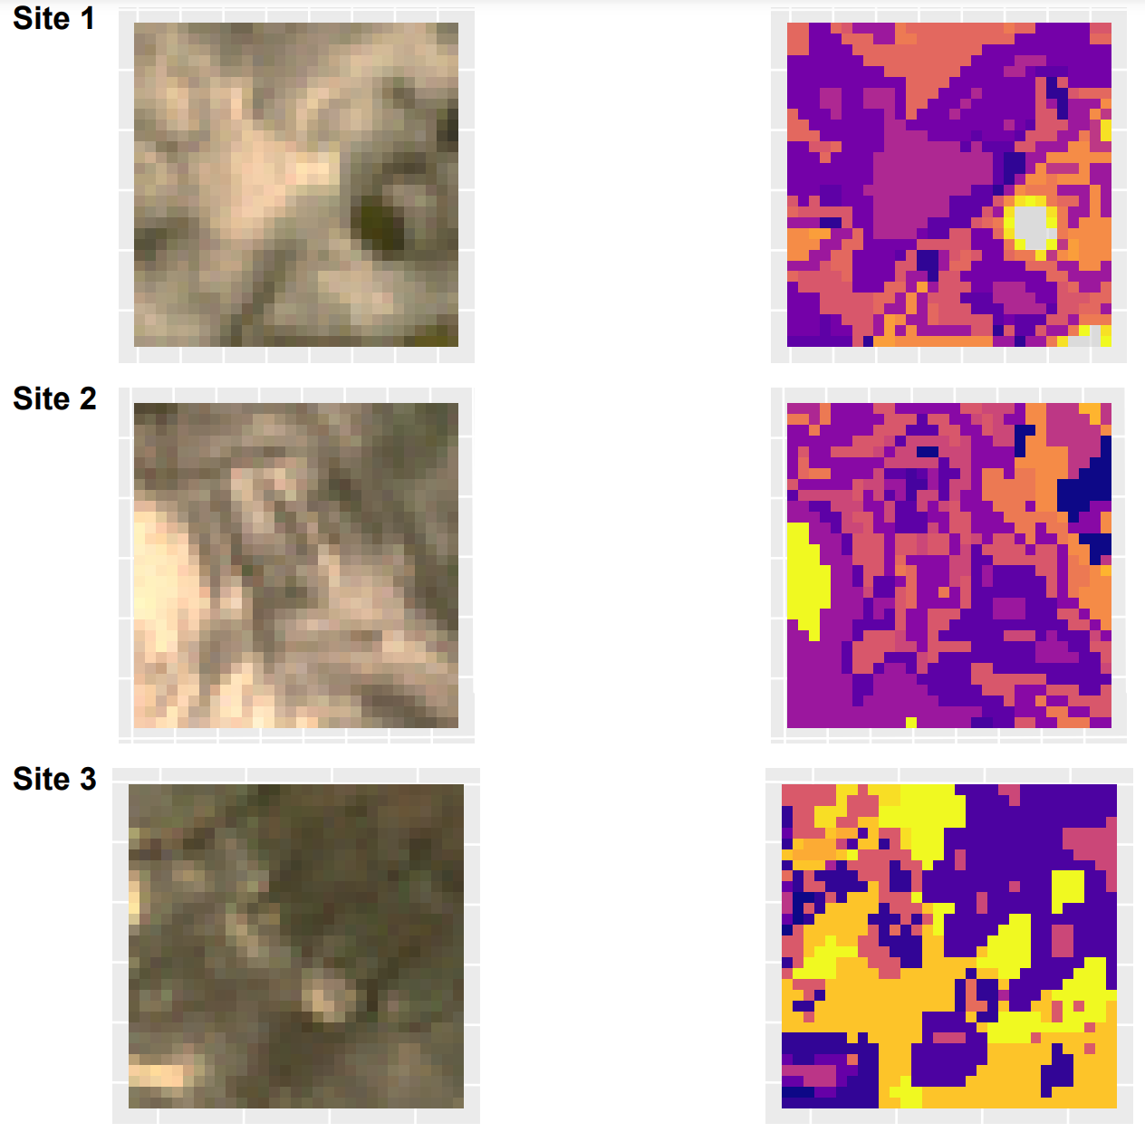

**True colour map**

**Spectral species map**

**Spectral richness: 8.55**

**Spectral Shannon index: 1.95**

**True richness: 29**

**Spectral richness: 10.50**

**Spectral Shannon index: 2.11**

**True richness: 29**

**Spectral richness: 6.9**

**Spectral Shannon index: 1.70**

**True richness: 36**



Supplementary figure xxx: Field work site diversity computed from spectral species map produced with principal component 1, 2, cumulatively explaining 94.5% of the variance. Left: true colour map from field work sites view from Sentinel 2 satellite. Middle: Illustration of the assignment of the 20 spectral species for one of the 20 iterations. Each colour correspond to a spectral species. Right: Spectral richness, computed as the number of spectral species present in the field work site area, spectral Shannon index, computed with the spectral richness and the abundance of each spectral species in the field work site area and true richness, computed by a cumulative addition of the species presence record in each 18 plots in each site.

**Questions**

* How to present the results of the effect of the PC on the spectral species map and computation of the spectral species richness? Does it need the RGB map map and illustrative spectral sp map?
  + If yes, it is problematic not to have the latitude-longitude numbers? And the colour scale for the spectral species?
* It is ok to state in the coefficient table that the coefficient comes from independent models or would it be better to make two tables?