PROJECT DOCUMENTATION

Automating Employee Data

Using Import Sets & Dot Walking in ServiceNow
Skills: Import Sets, Dot Walking, Dictionary Override

Submitted By

E428A8DB8084B4B8C664F81706E2792A PARTHIBAN K

EDE33BA381506E4AC024804BCBE5151C PRAVEEN P

0F76FC128465C4887C14ED9C83766406 RAJA D

CF6B31C9D01A90AB8074C6BA324E3EDS RAJKUMAR K

Abstract
This project demonstrates how employee data can be automatically imported into ServiceNow using Import Sets and Transform Maps.
The system then uses Dot Walking to display related employee details such as department and manager information directly in Incident forms.
Additionally, Dictionary Override is used to modify the default priority value specifically for the Incident table.
This automation improves efficiency, ensures data accuracy, and enables faster incident handling within the organization.

Introduction
ServiceNow is a cloud‑based platform widely used for IT service management. Organizations often need to import employee data
from external systems and use that information within different modules such as Incident Management. Manual data entry can lead to errors
and inefficiencies. Therefore, automating the import of employee data and linking it with incidents helps organizations manage incidents
faster and more effectively. This project explains how to import employee records, display manager details using dot walking, and customize
field behavior using dictionary override.

Problem Statement
Your organization wants to regularly import a list of new employees with their details such as Name, Email, Department,
Manager, and Manager Email from an external system. When an Incident is assigned to an employee, the manager’s email of that employee’s
department should automatically appear on the Incident form. Also, the Priority field on the Incident should have a different default value
than other child tables of the Task table since incidents often require urgent attention.

Objective
• Automate the import of employee data.
• Display department and manager details in the Incident form.
• Set a custom default priority value for the Incident table.
• Improve data accuracy and incident resolution efficiency.

Tools and Skills Used
• ServiceNow Platform
• Import Sets
• Transform Maps
• Dot Walking
• Dictionary Override

Procedure
Milestone 1: Import Data from Data Source
1. Create an Excel or Google Sheet with fields: Name, Email, Department, Manager, Manager Email.
2. Save and download the file in .xlsx or .csv format.
3. In ServiceNow, navigate to System Import Sets → Load Data.
4. Create an import table and upload the file.
5. Create a Transform Map to map fields from the import table to the User (sys_user) table.
6. Use Mapping Assist to match fields.
7. Run Transform to insert the records into the target table.

Milestone 2: Dot Walking
1. Open the Incident form.
2. Configure the form layout.
3. Add fields such as Assigned to.Department, Assigned to.Email, and Assigned to.Manager.
4. When an incident is assigned to a user, these details automatically appear.

Milestone 3: Dictionary Override
1. Open the Incident table (extended from Task).
2. Locate the Priority field.
3. Create a Dictionary Override.
4. Override the default value and set it to 3 (Moderate).
5. Verify the new default value in the Incident form.

Screenshots
Screenshot 1: Employee Data Sheet in Excel
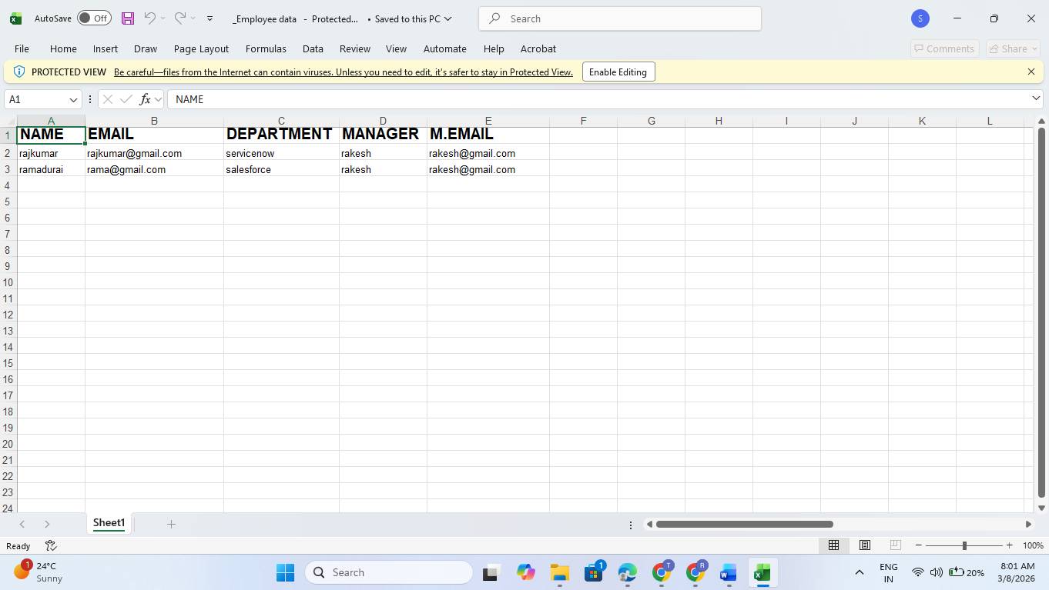
Screenshot 2: Loading Data in ServiceNow Import Sets 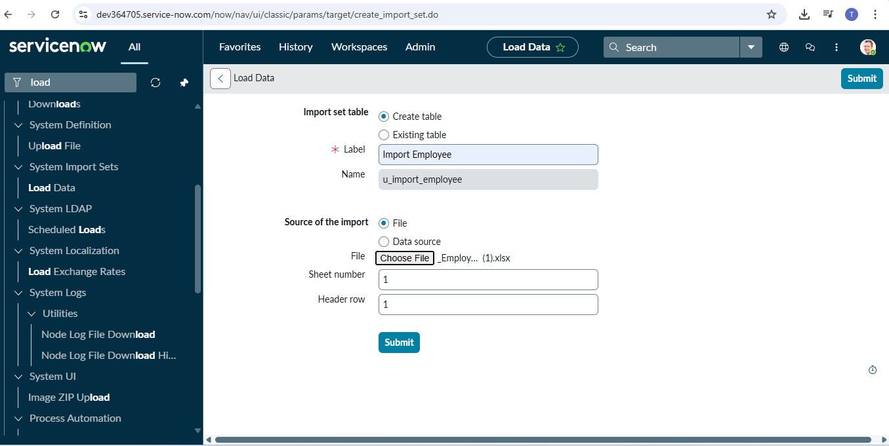

Screenshot 3: Transform Map Configuration
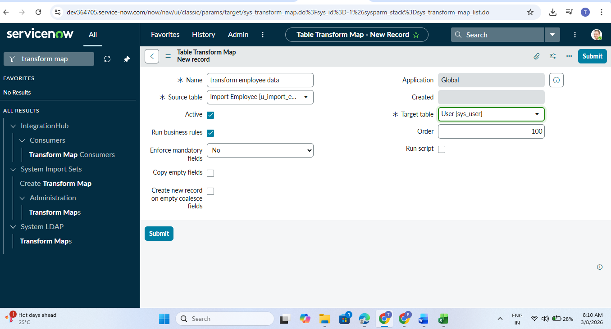

Screenshot 4: Dot Walking Fields in Incident Form Layout
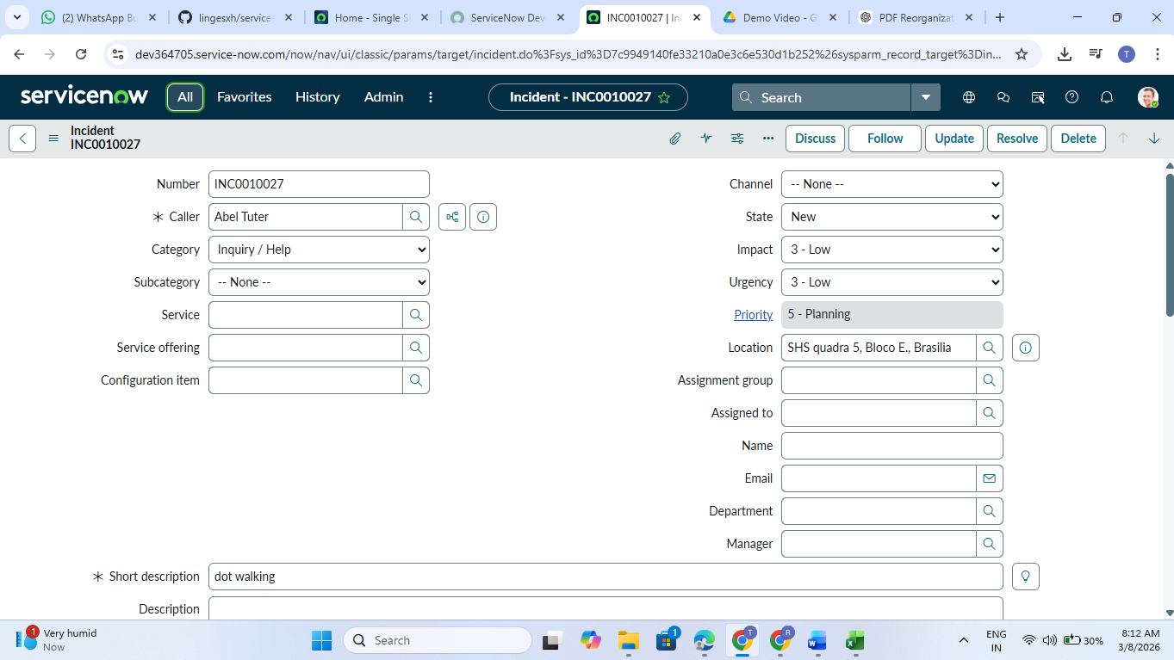

Screenshot 5: Dictionary Override for Priority Field
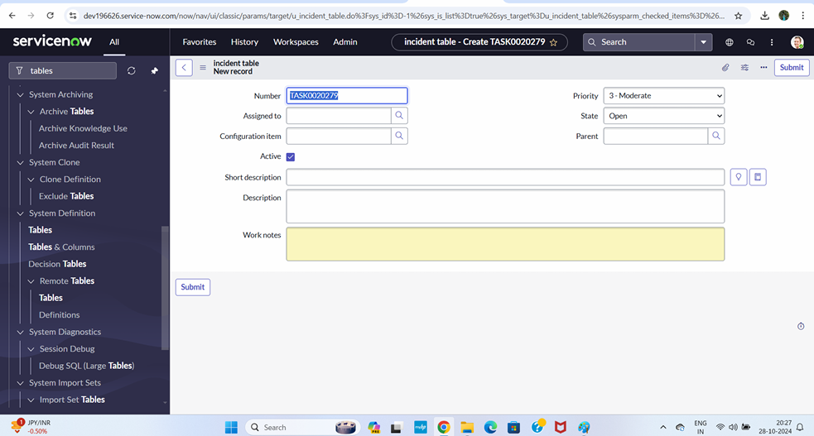

Conclusion
This project successfully demonstrates how to automate employee data import in ServiceNow. By using Import Sets and Transform Maps,
employee records can be efficiently imported into the system. Dot Walking helps retrieve related information without opening multiple records,
and Dictionary Override allows customization of field values for specific tables. Overall, these features enhance efficiency and improve
incident management processes.

