RFP pathways report

Hilaire et al. (2022)

Table of Contents

This report is generated automatically from the R-Markdown file rfp_report_doc_final.Rmd.

# World

v_region <- "World"

## Primary energy production

section_variables <- c("Energy Supply|Production|Oil", "Energy Supply|Production|Gas", "Energy Supply|Production|Coal", "Energy Supply|Production|Biomass")

### GCAM

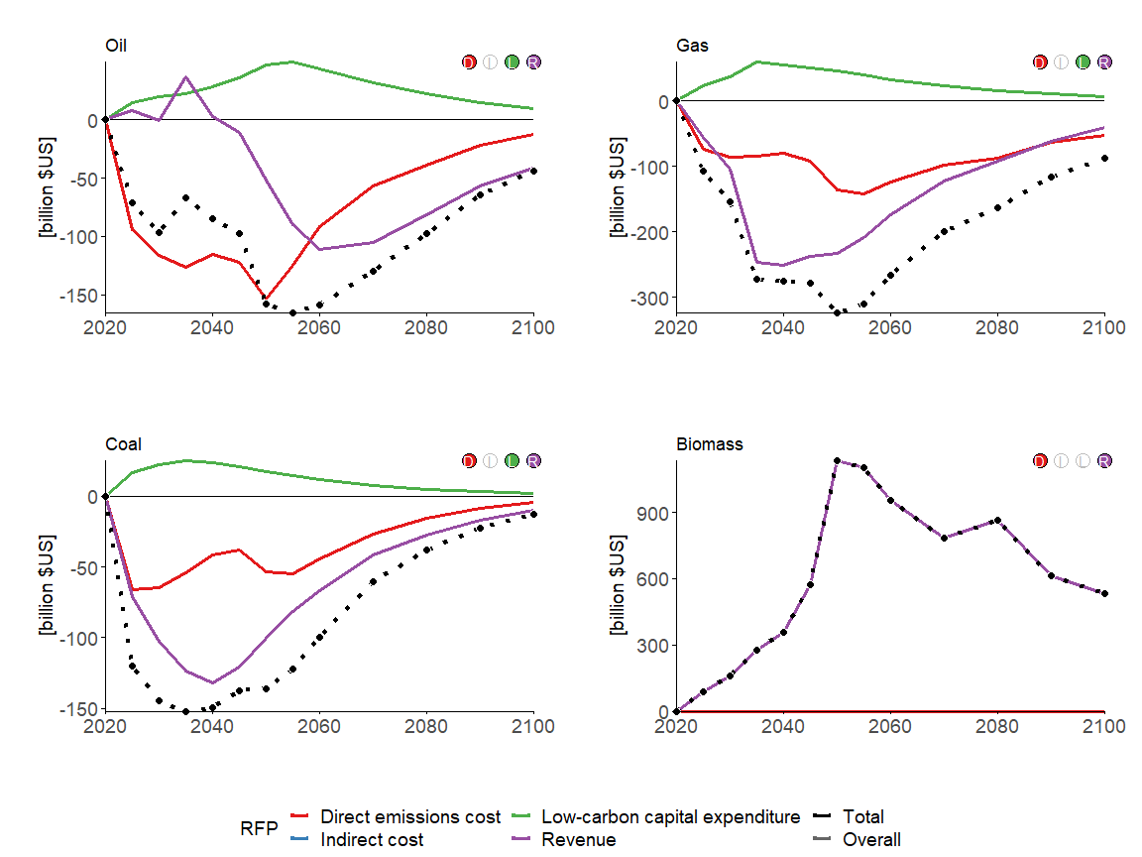

### MESSAGEix-GLOBIOM

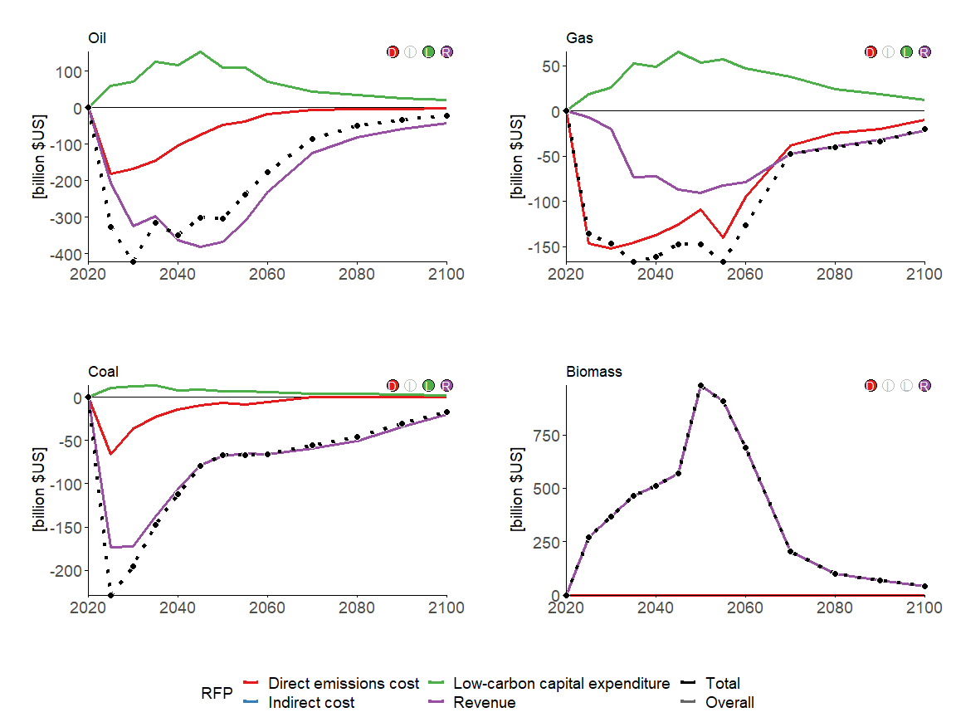

### REMIND-MAgPIE

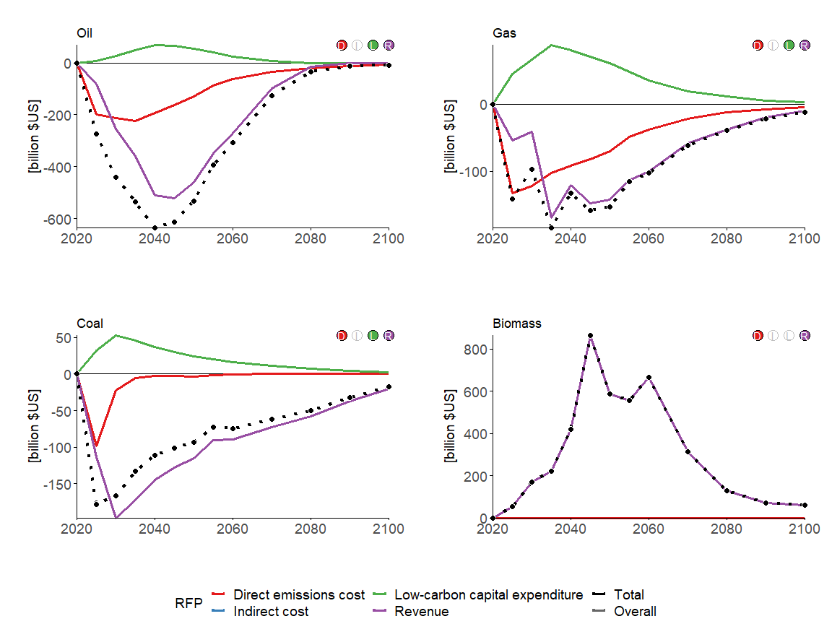

## Electric utilities

section_variables <- c("Energy Supply|Electric Utilities|Coal", "Energy Supply|Electric Utilities|Gas", "Energy Supply|Electric Utilities|Nuclear", "Energy Supply|Electric Utilities|Biomass", "Energy Supply|Electric Utilities|Non-Biomass Renewables")

### GCAM

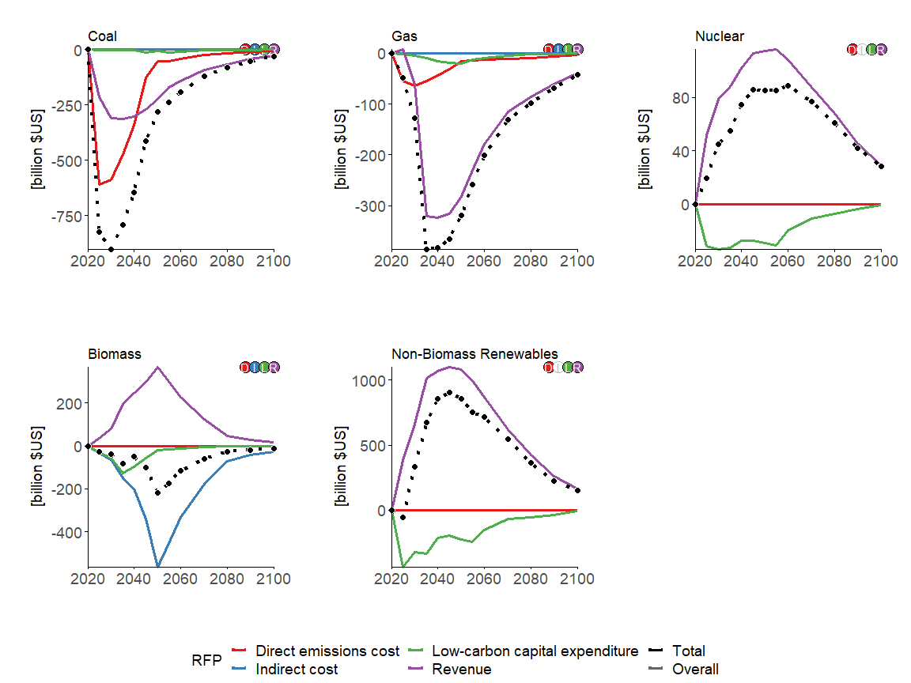

### MESSAGEix-GLOBIOM

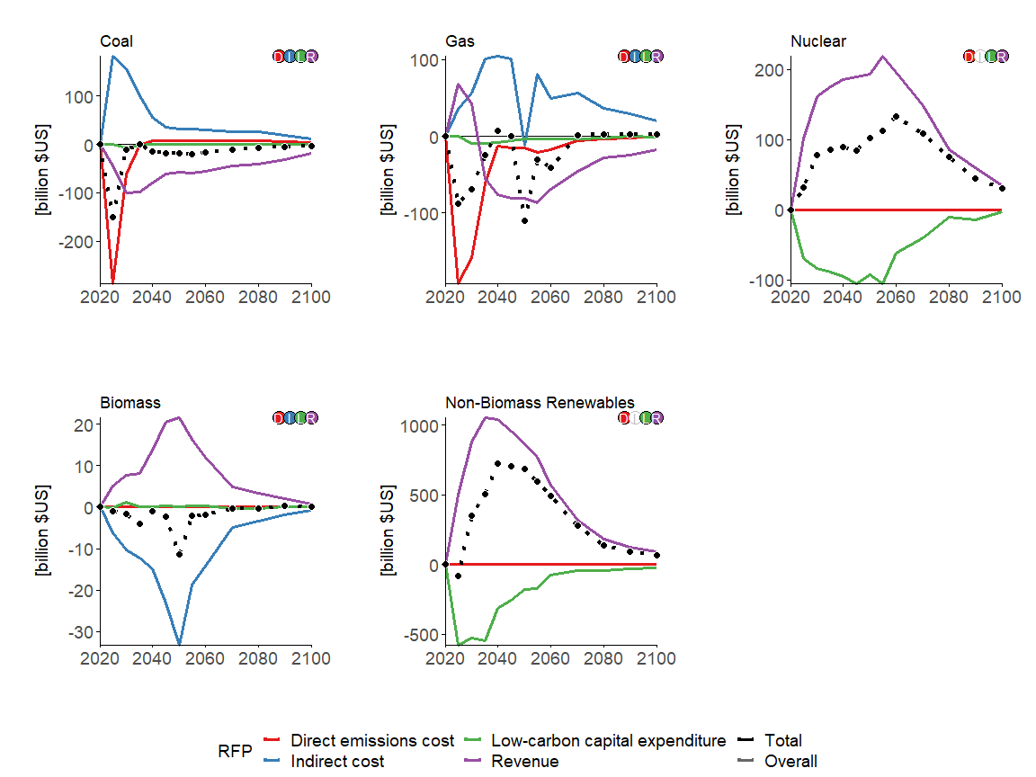

### REMIND-MAgPIE

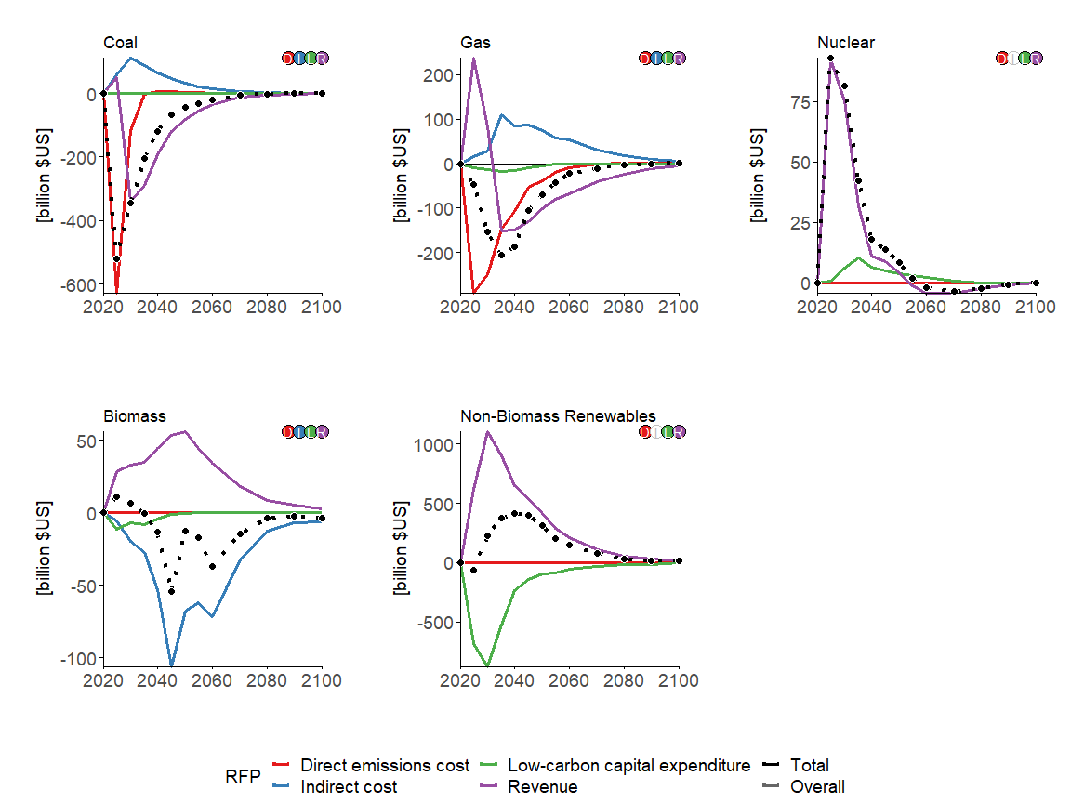

## Liquids fuels

section_variables <- c("Energy Supply|Refineries|Oil", "Energy Supply|Fischer-Tropsch Process|Biomass")

### GCAM

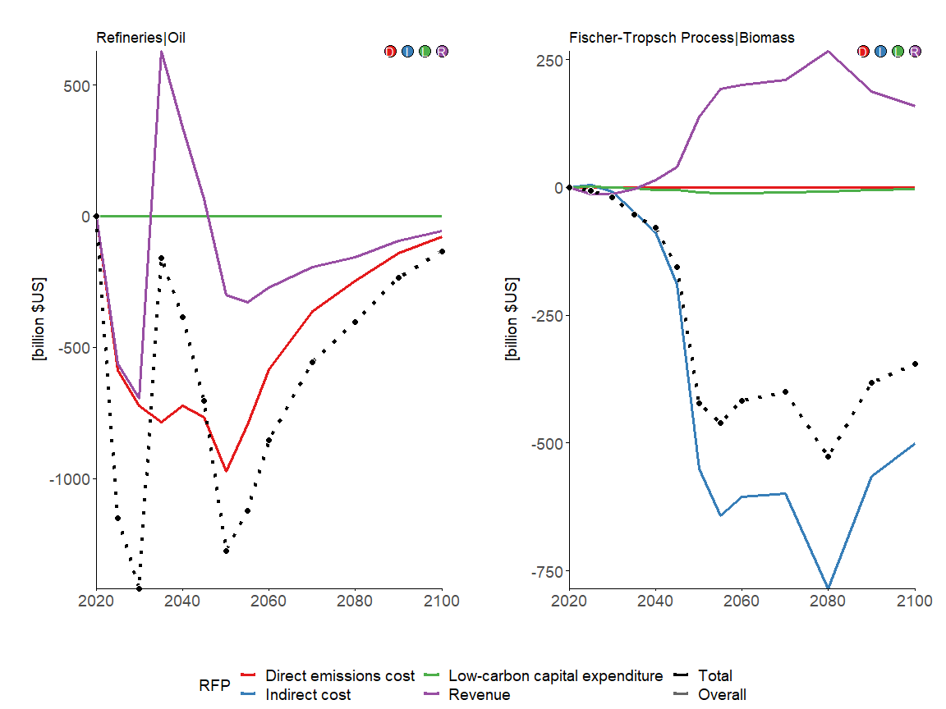

### MESSAGEix-GLOBIOM

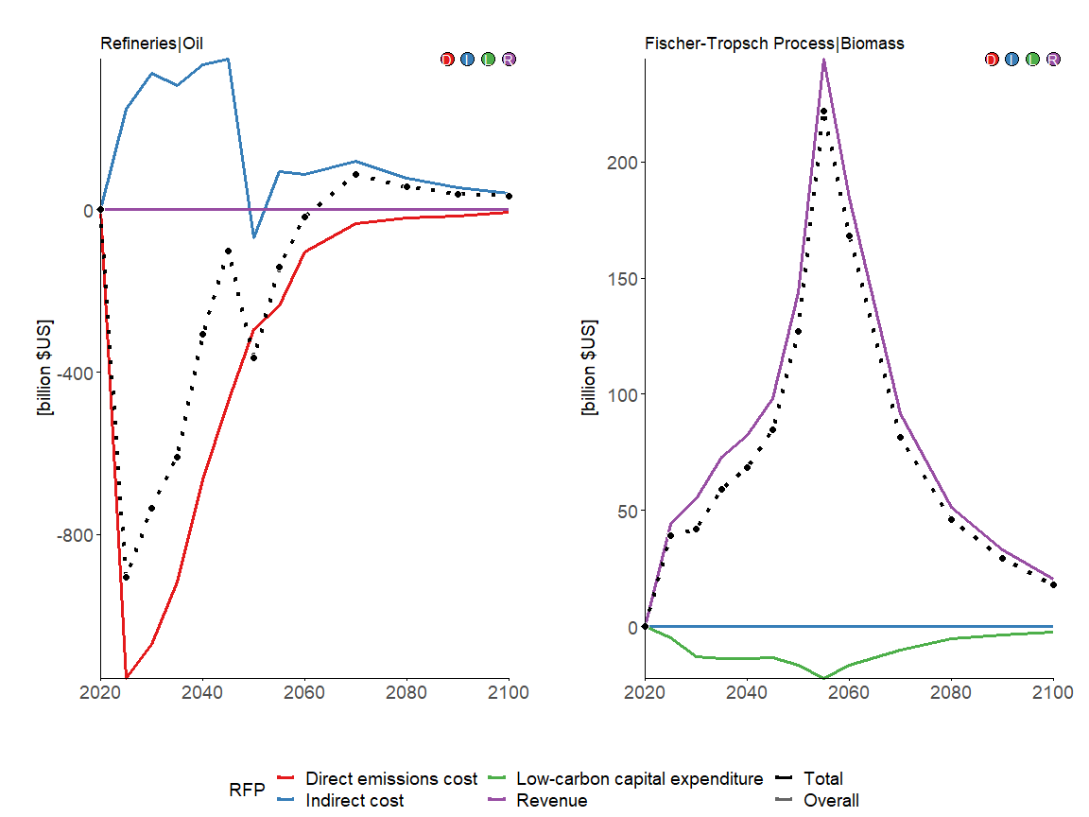

### REMIND-MAgPIE

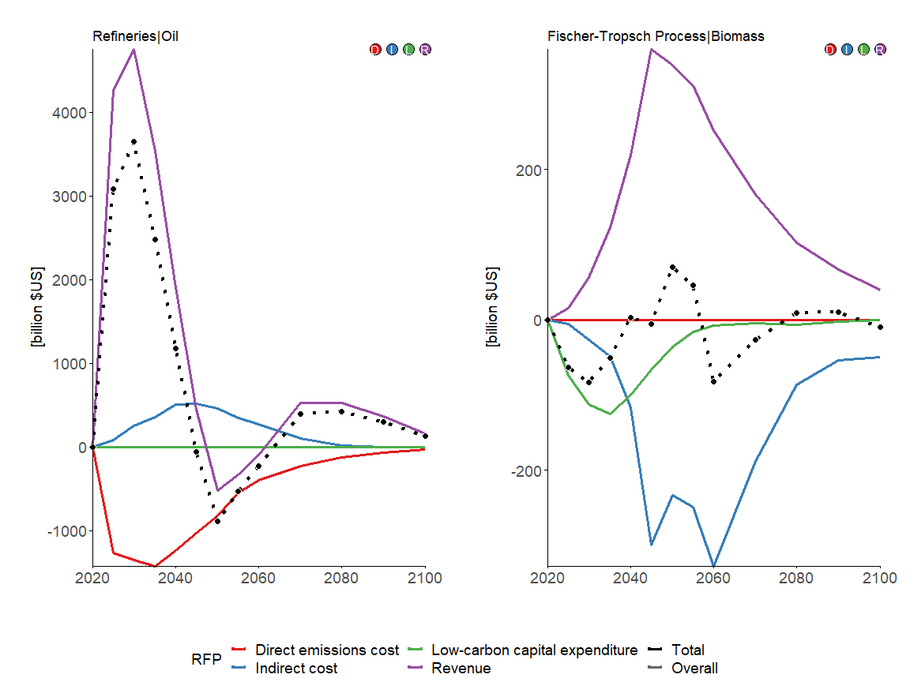

## Hydrogen plants

section_variables <- c("Energy Supply|Hydrogen Plants|Coal", "Energy Supply|Hydrogen Plants|Gas", "Energy Supply|Hydrogen Plants|Biomass", "Energy Supply|Hydrogen Plants|Electricity")

### GCAM

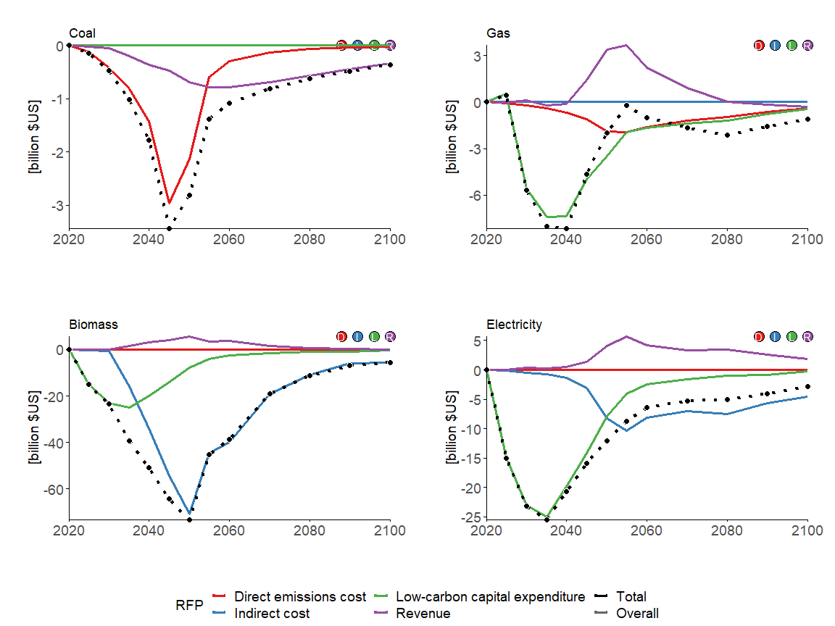

### MESSAGEix-GLOBIOM

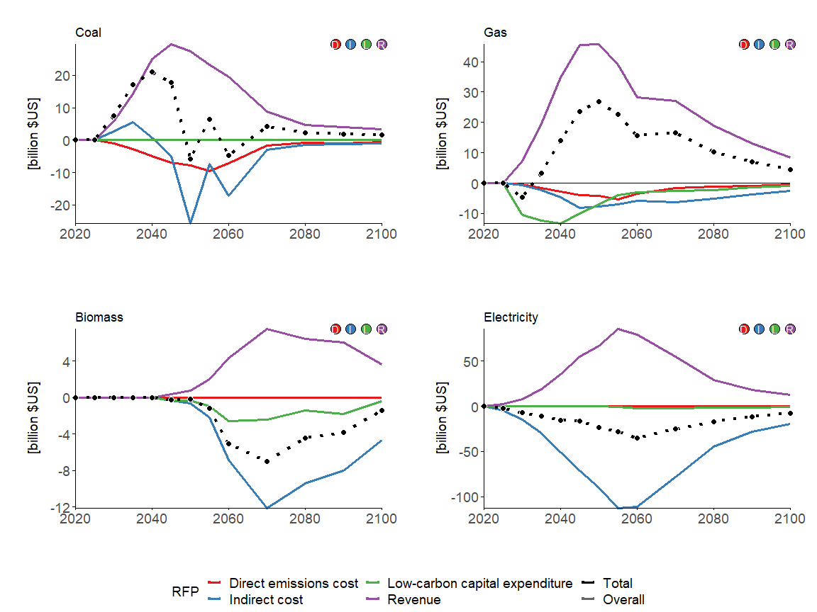

### REMIND-MAgPIE

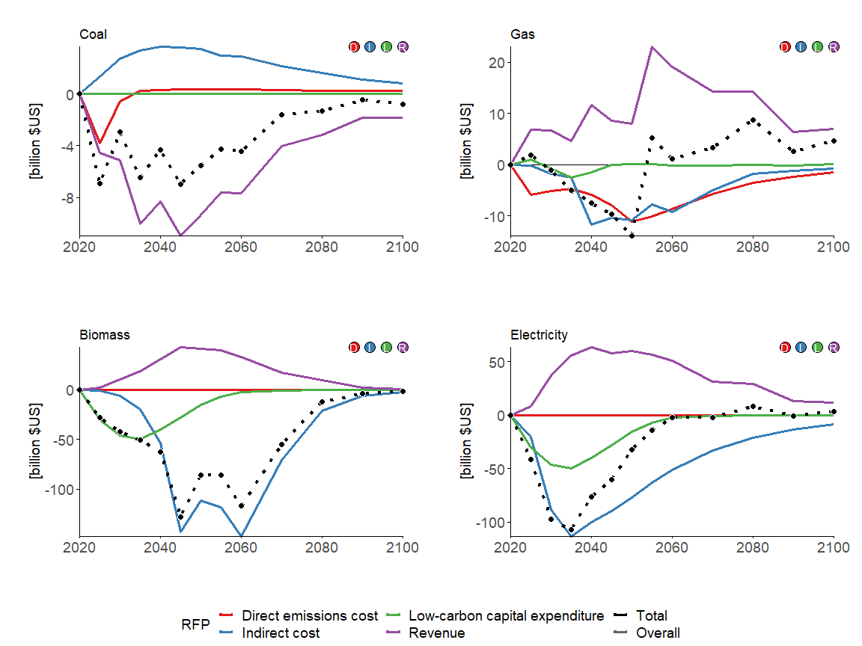

## End-use energy sectors

section_variables <- c("End-Use|Residential and Commercial", "End-Use|Industry", "End-Use|Industry|Cement", "End-Use|Industry|Chemicals", "End-Use|Industry|Steel", "End-Use|Transportation")

### GCAM

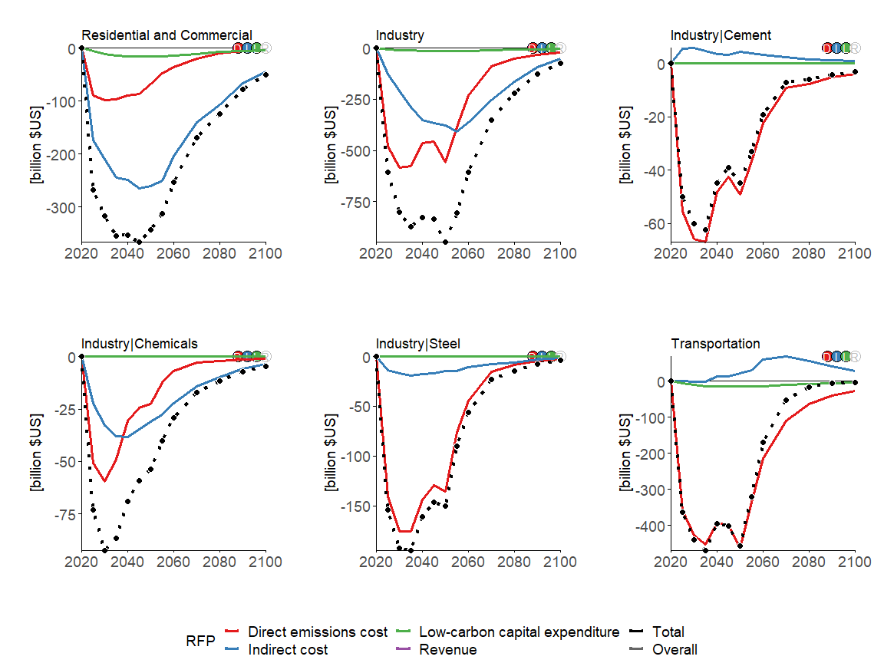

### MESSAGEix-GLOBIOM

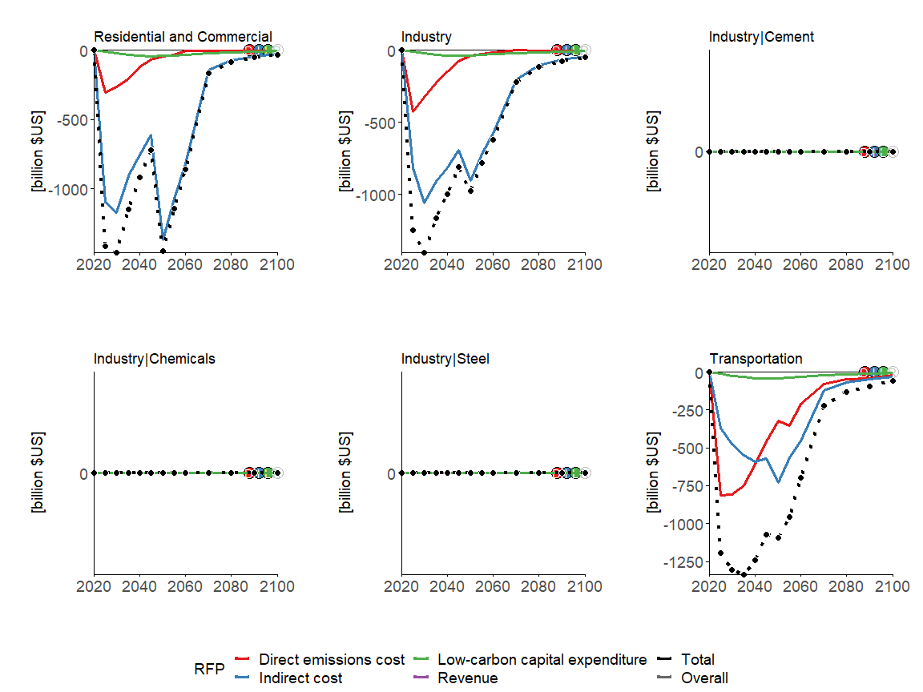

### REMIND-MAgPIE

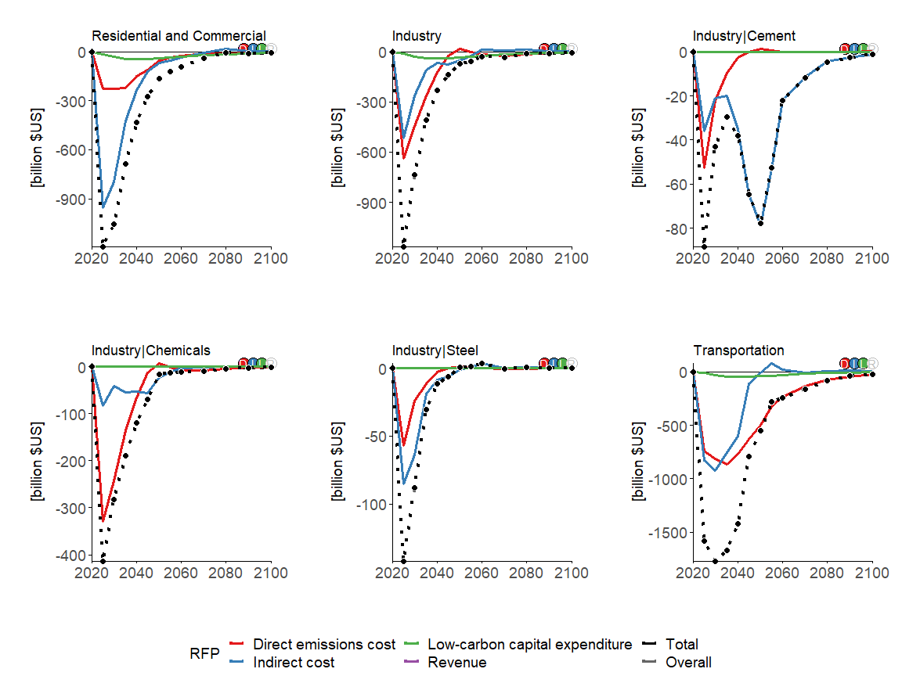

# China

v_regionall <- c("GCAM5.3_NGFS|China",   
 "MESSAGEix-GLOBIOM 1.1|R11_CP!",   
 "REMIND-MAgPIE 2.1-4.2|CHA")

## Primary energy production

section_variables <- c("Energy Supply|Production|Oil", "Energy Supply|Production|Gas", "Energy Supply|Production|Coal", "Energy Supply|Production|Biomass")

### GCAM

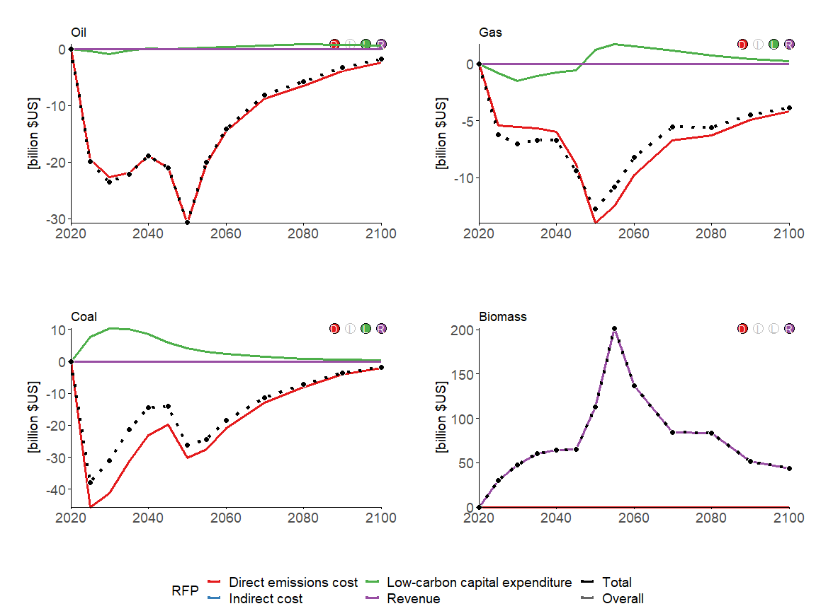

### MESSAGEix-GLOBIOM

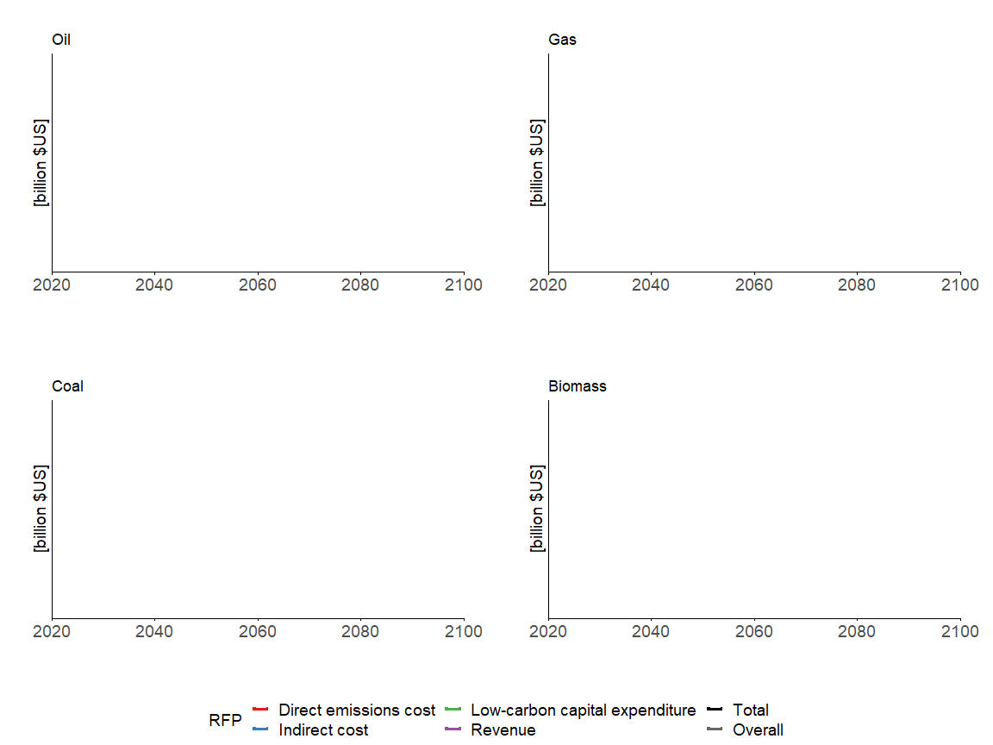

### REMIND-MAgPIE

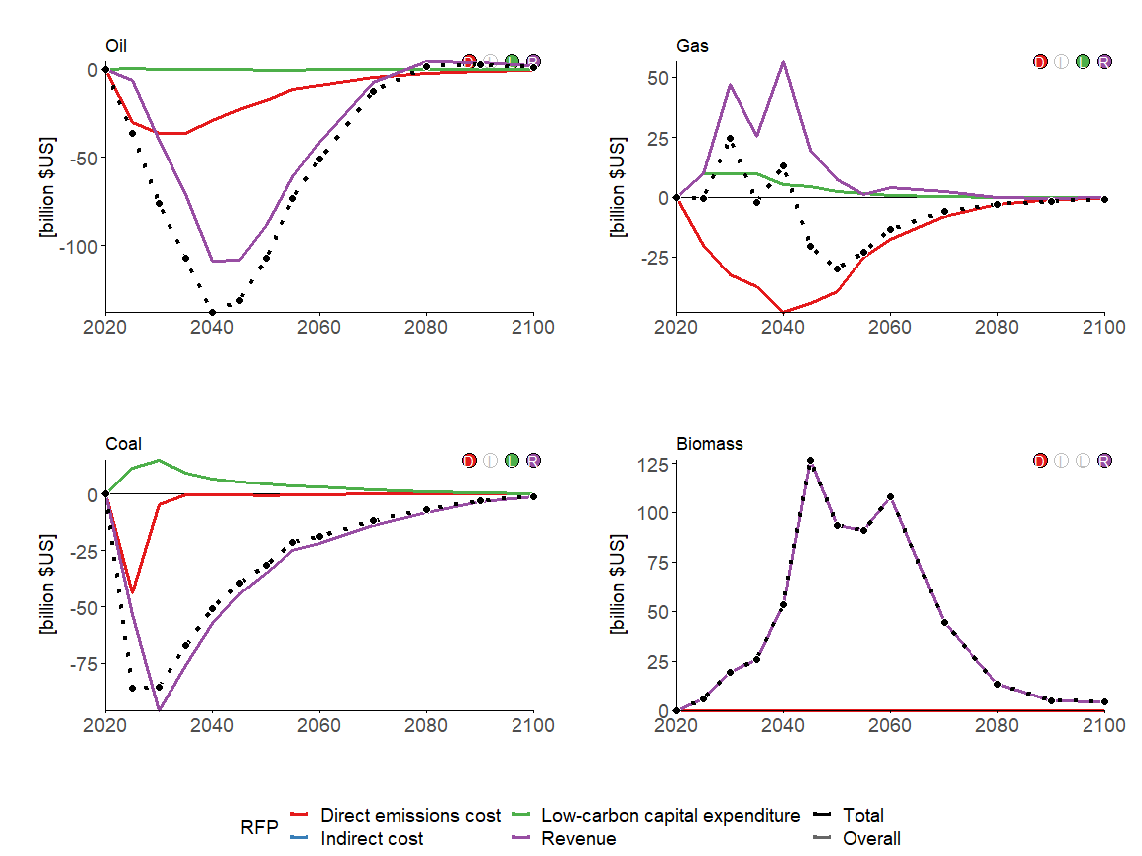

## Electric utilities

section_variables <- c("Energy Supply|Electric Utilities|Coal", "Energy Supply|Electric Utilities|Gas", "Energy Supply|Electric Utilities|Nuclear", "Energy Supply|Electric Utilities|Biomass", "Energy Supply|Electric Utilities|Non-Biomass Renewables")

### GCAM

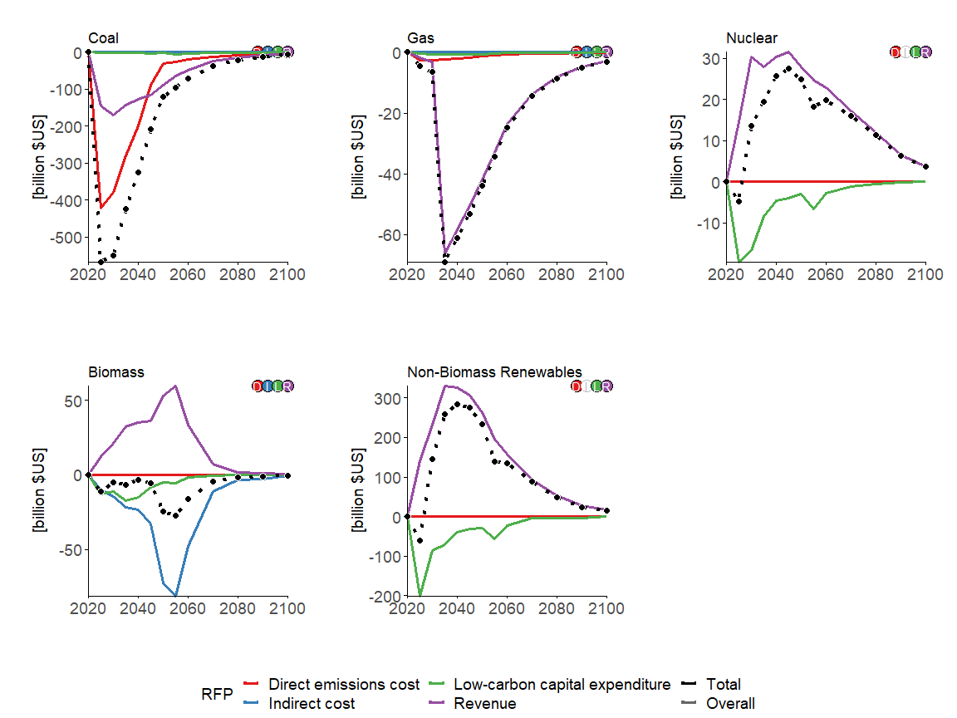

### MESSAGEix-GLOBIOM

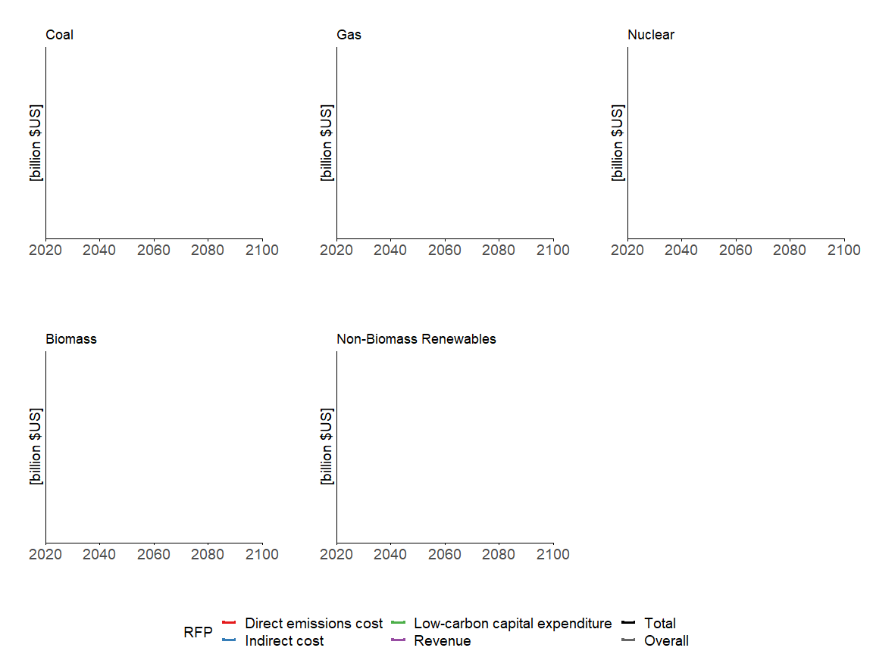

### REMIND-MAgPIE

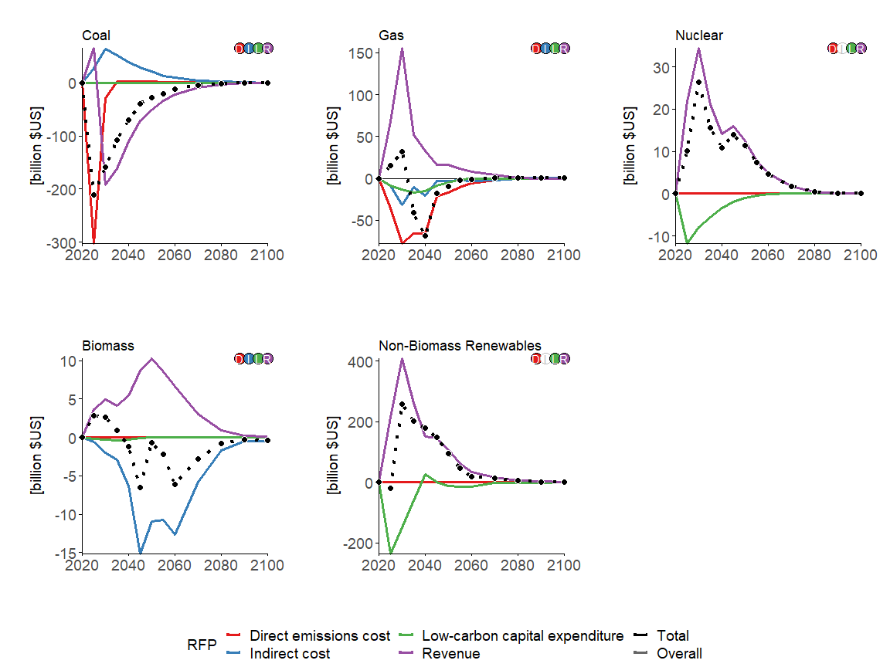

## Liquids fuels

section_variables <- c("Energy Supply|Refineries|Oil", "Energy Supply|Fischer-Tropsch Process|Biomass")

### GCAM

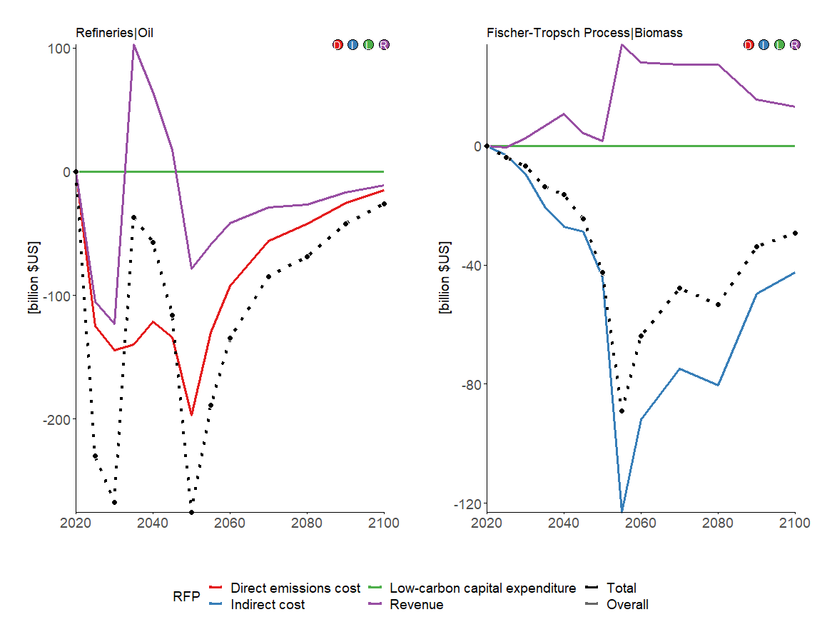

### MESSAGEix-GLOBIOM

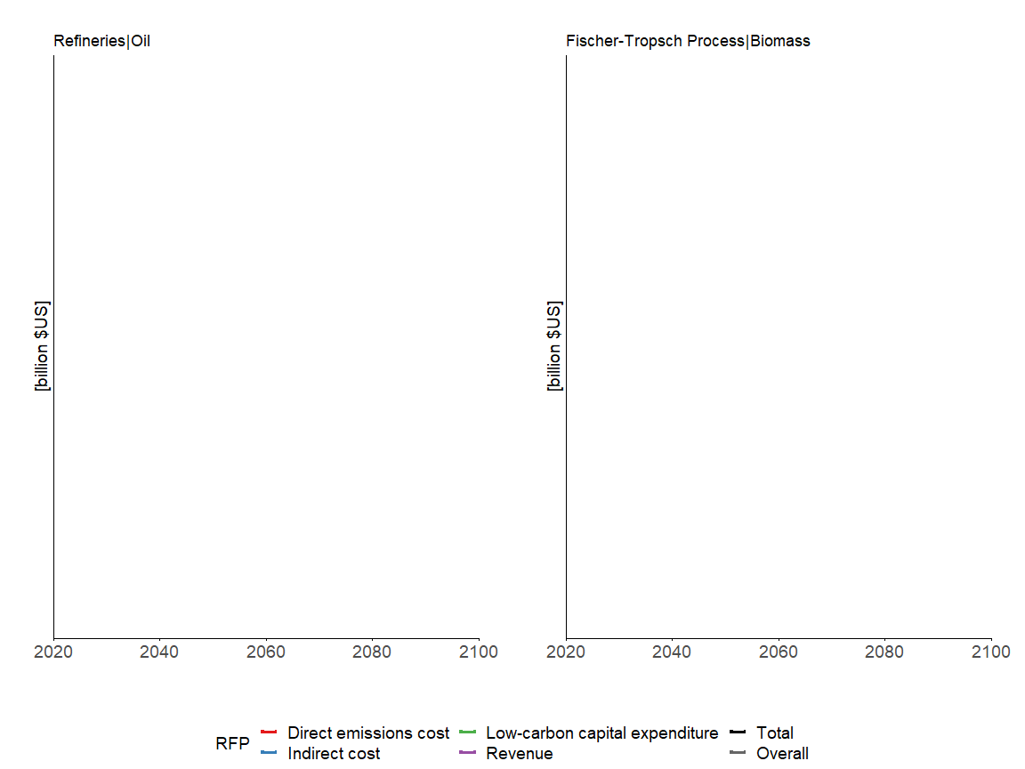

### REMIND-MAgPIE

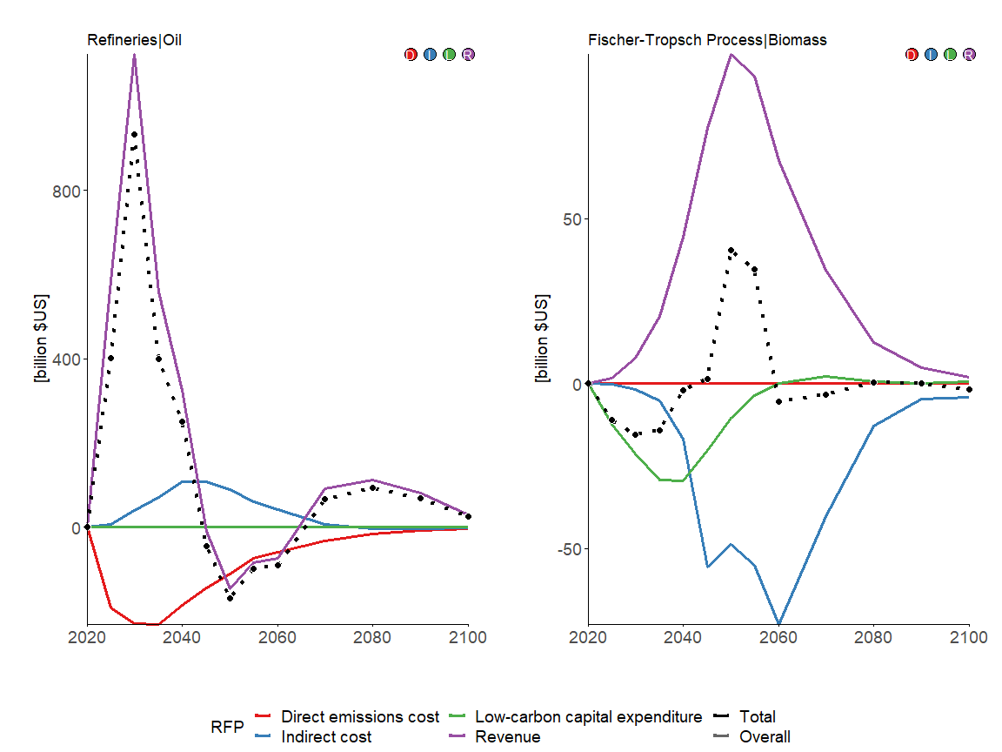

## Hydrogen plants

section_variables <- c("Energy Supply|Hydrogen Plants|Coal", "Energy Supply|Hydrogen Plants|Gas", "Energy Supply|Hydrogen Plants|Biomass", "Energy Supply|Hydrogen Plants|Electricity")

### GCAM

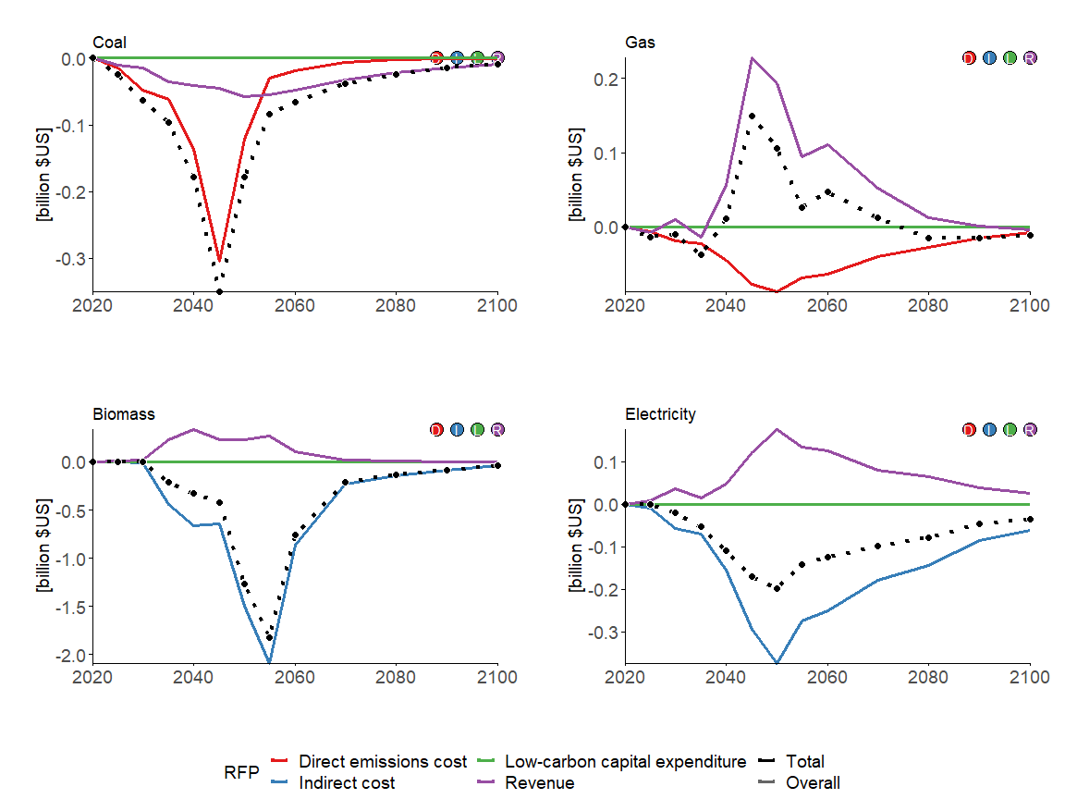

### MESSAGEix-GLOBIOM

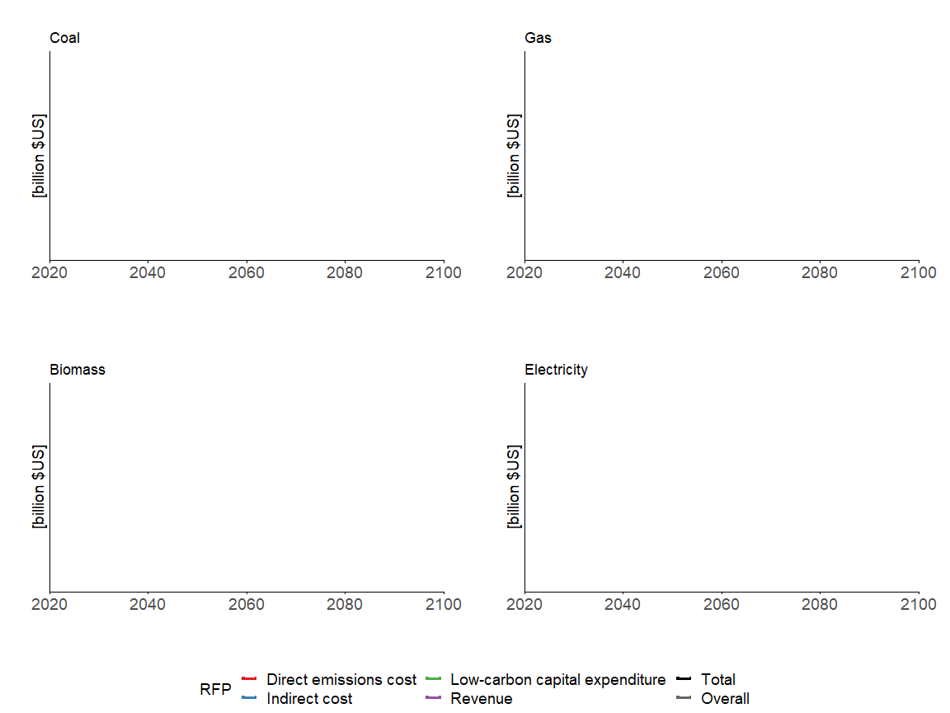

### REMIND-MAgPIE

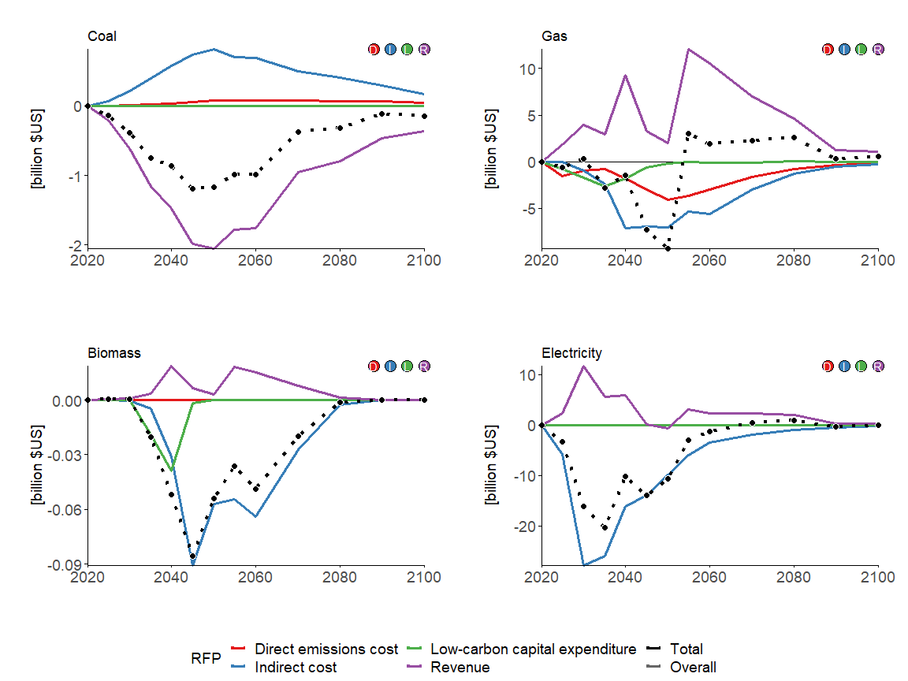

## End-use energy sectors

section_variables <- c("End-Use|Residential and Commercial", "End-Use|Industry", "End-Use|Industry|Cement", "End-Use|Industry|Chemicals", "End-Use|Industry|Steel", "End-Use|Transportation")

### GCAM

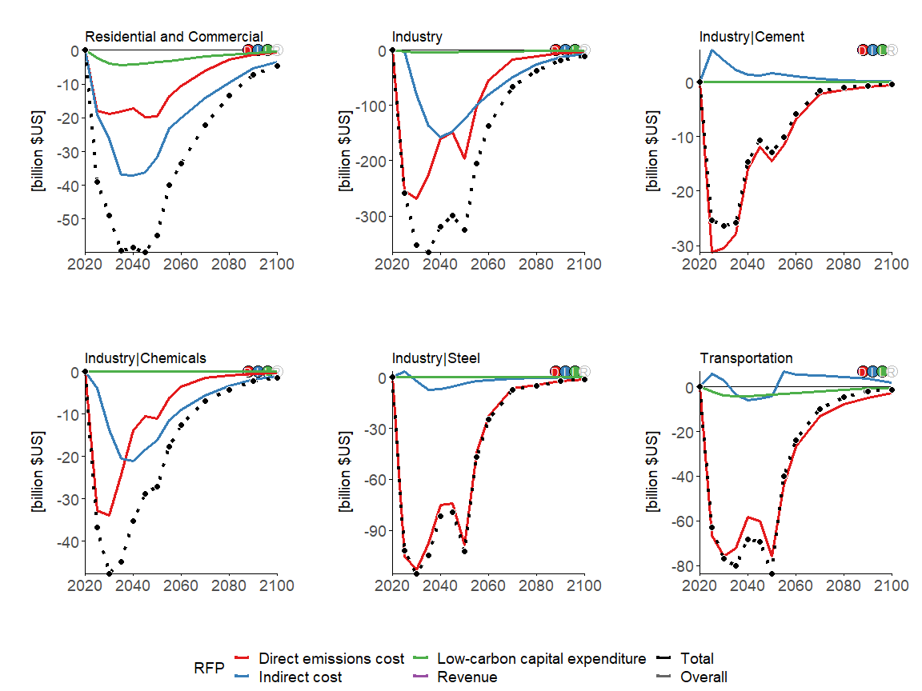

### MESSAGEix-GLOBIOM

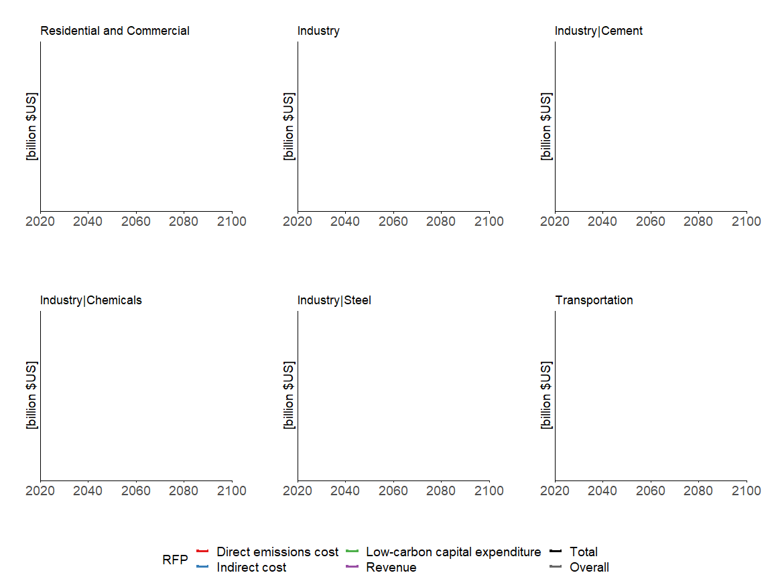

### REMIND-MAgPIE

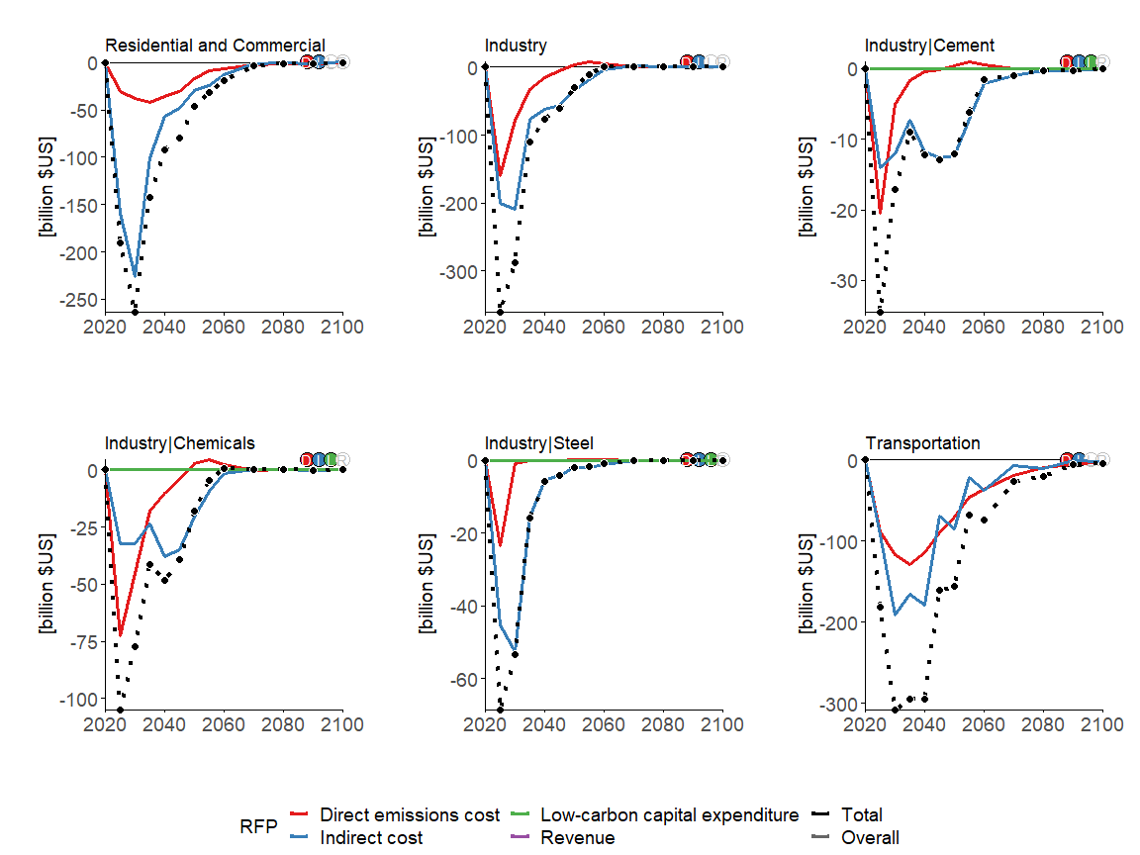

# EU

v_regionall <- c("GCAM5.3_NGFS|EU-12",   
 "MESSAGEix-GLOBIOM 1.1|R11_WEU",   
 "REMIND-MAgPIE 2.1-4.2|EUR")

## Primary energy production

section_variables <- c("Energy Supply|Production|Oil", "Energy Supply|Production|Gas", "Energy Supply|Production|Coal", "Energy Supply|Production|Biomass")

### GCAM

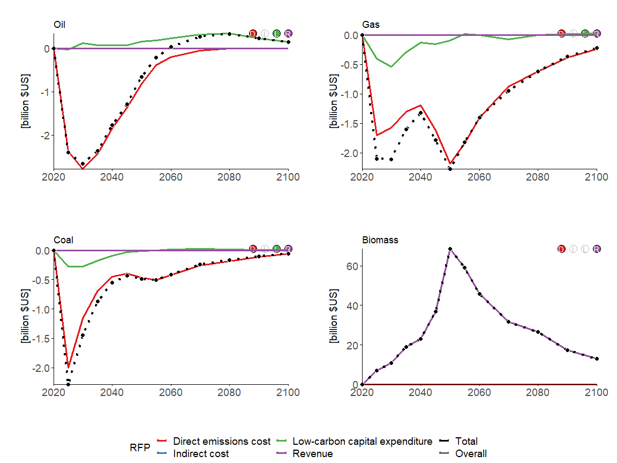

### MESSAGEix-GLOBIOM

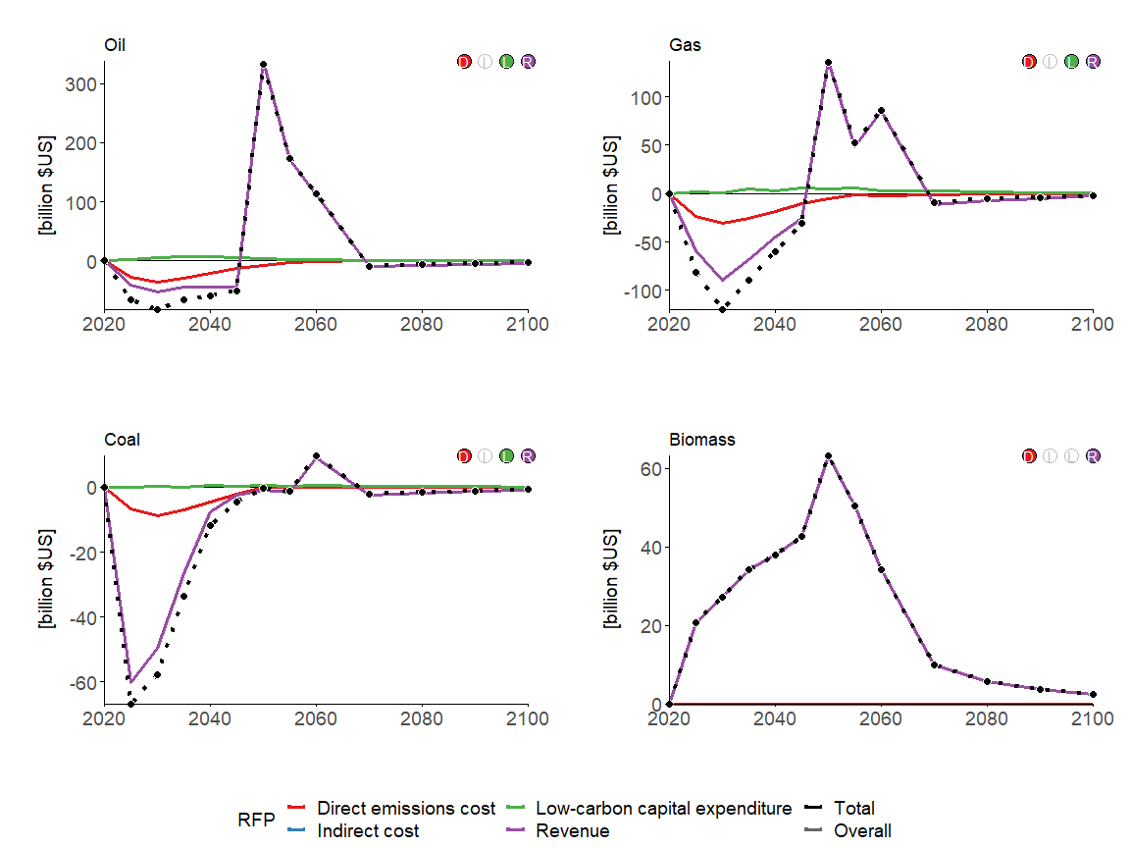

### REMIND-MAgPIE

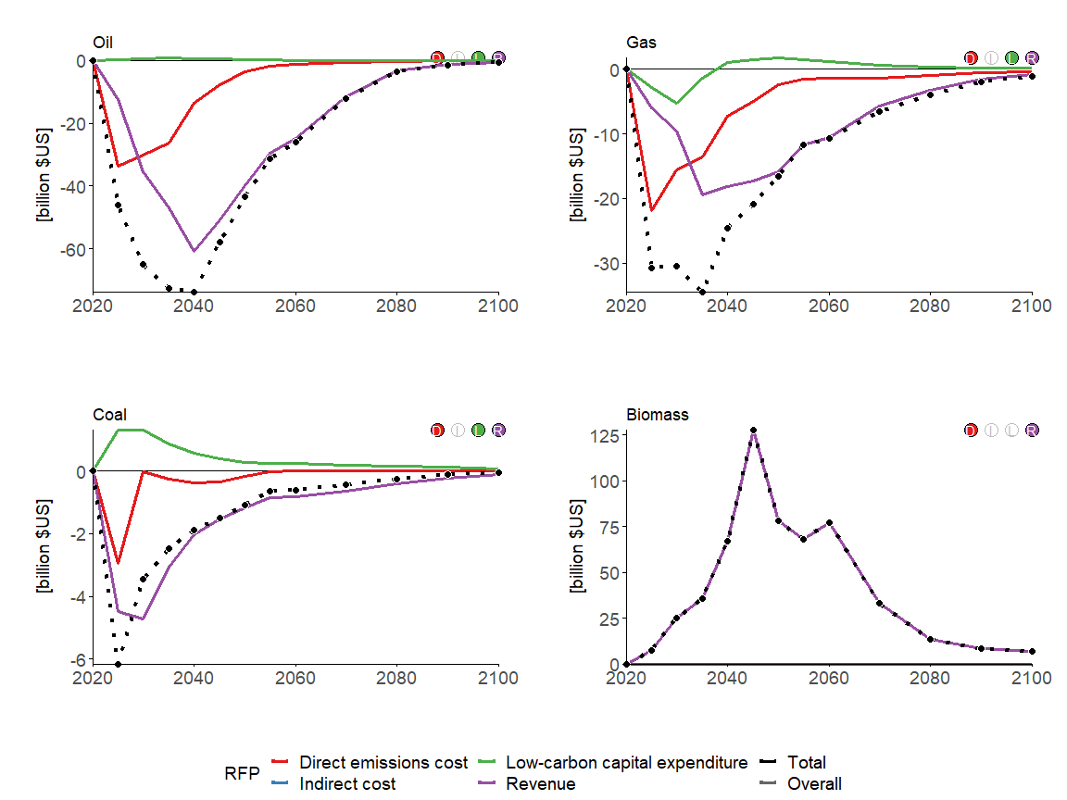

## Electric utilities

section_variables <- c("Energy Supply|Electric Utilities|Coal", "Energy Supply|Electric Utilities|Gas", "Energy Supply|Electric Utilities|Nuclear", "Energy Supply|Electric Utilities|Biomass", "Energy Supply|Electric Utilities|Non-Biomass Renewables")

### GCAM

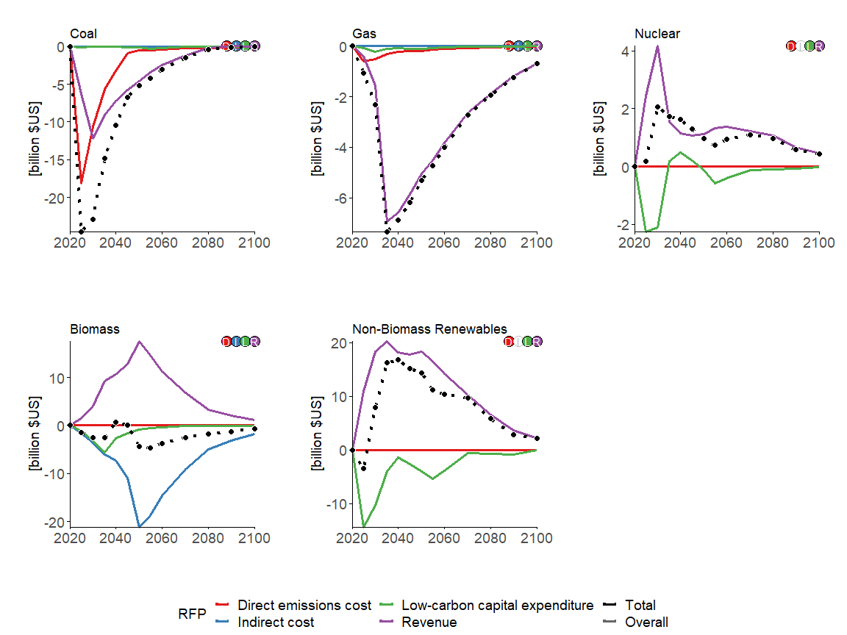

### MESSAGEix-GLOBIOM

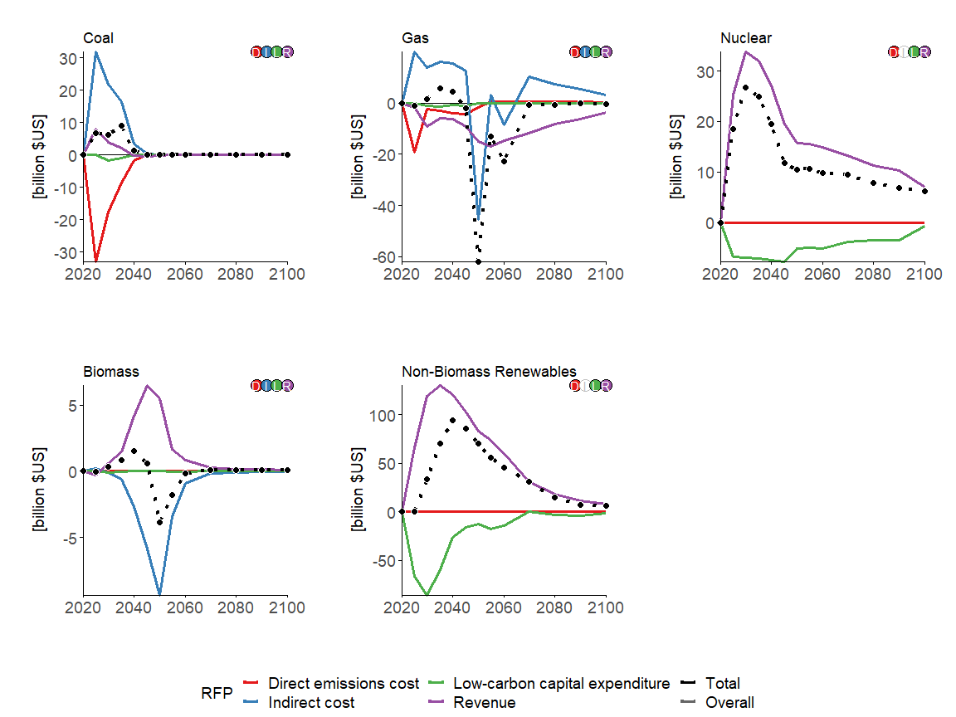

### REMIND-MAgPIE

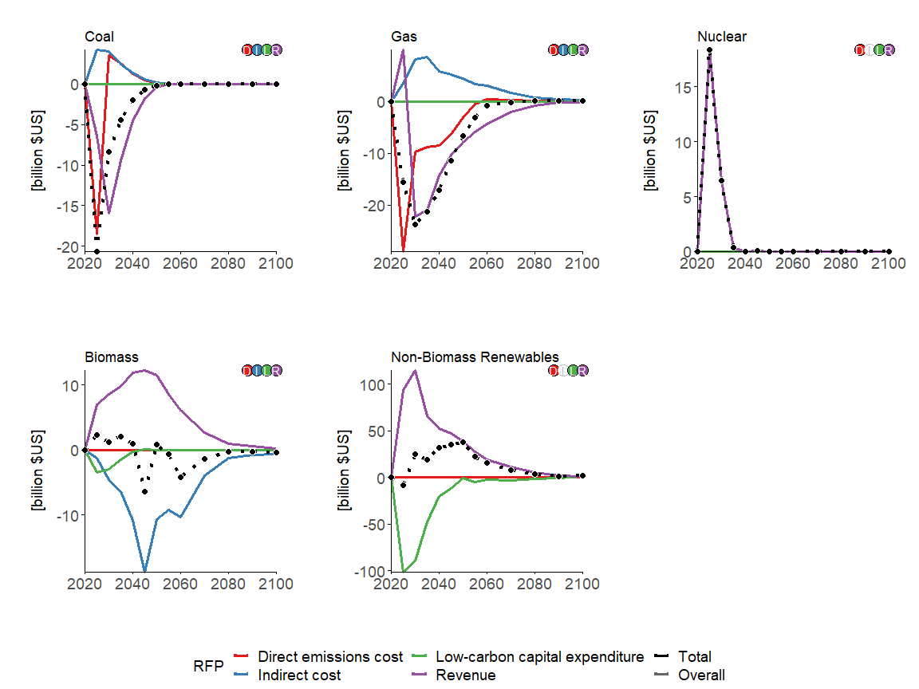

## Liquids fuels

section_variables <- c("Energy Supply|Refineries|Oil", "Energy Supply|Fischer-Tropsch Process|Biomass")

### GCAM

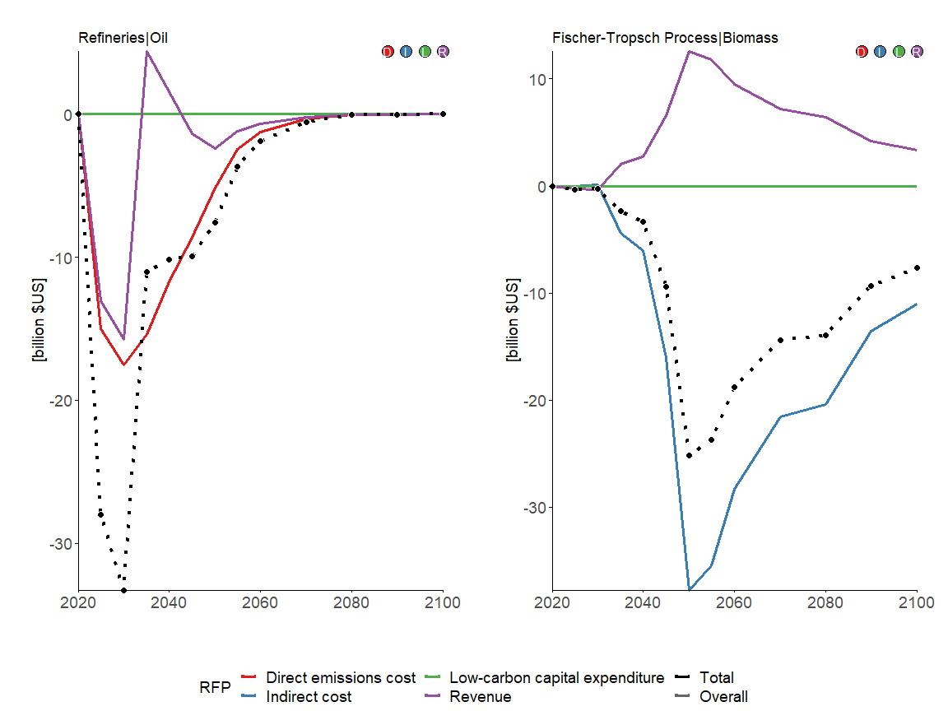

### MESSAGEix-GLOBIOM

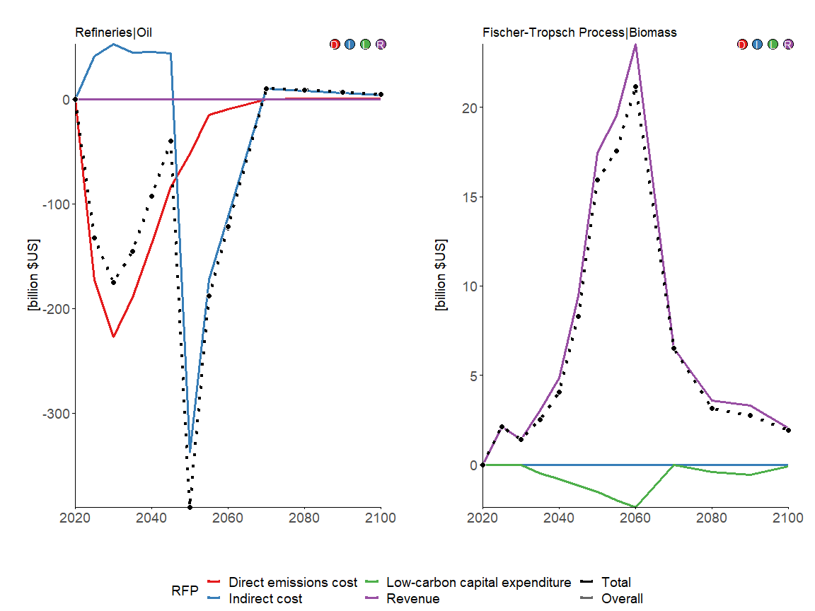

### REMIND-MAgPIE

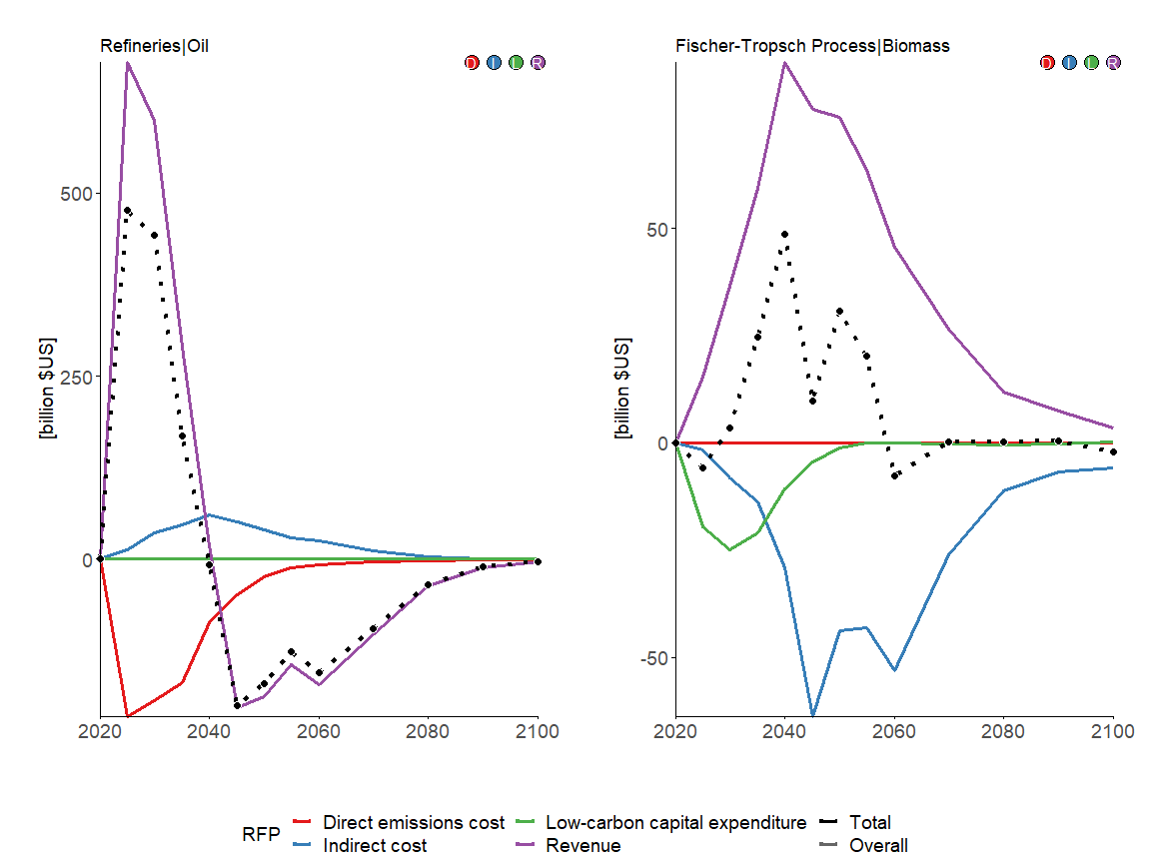

## Hydrogen plants

section_variables <- c("Energy Supply|Hydrogen Plants|Coal", "Energy Supply|Hydrogen Plants|Gas", "Energy Supply|Hydrogen Plants|Biomass", "Energy Supply|Hydrogen Plants|Electricity")

### GCAM

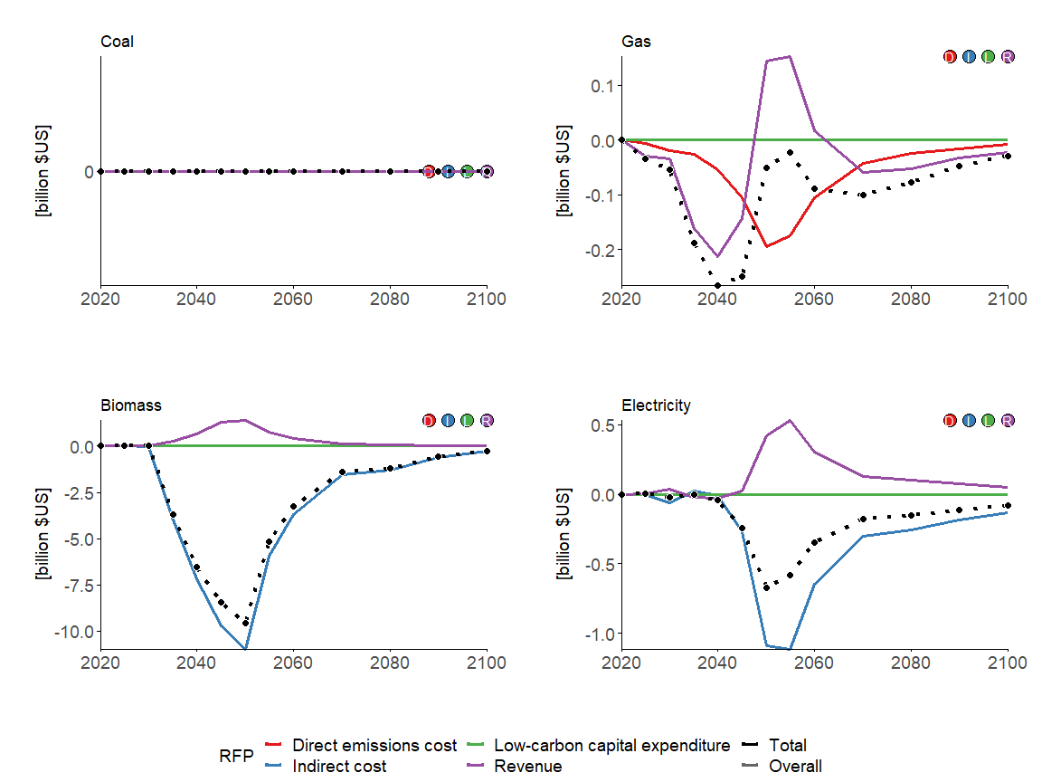

### MESSAGEix-GLOBIOM

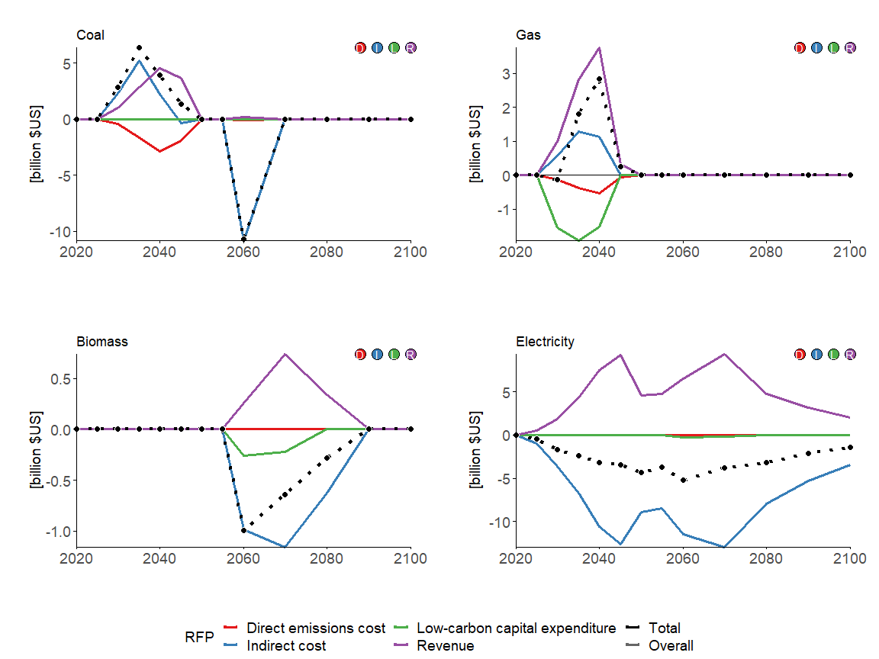

### REMIND-MAgPIE

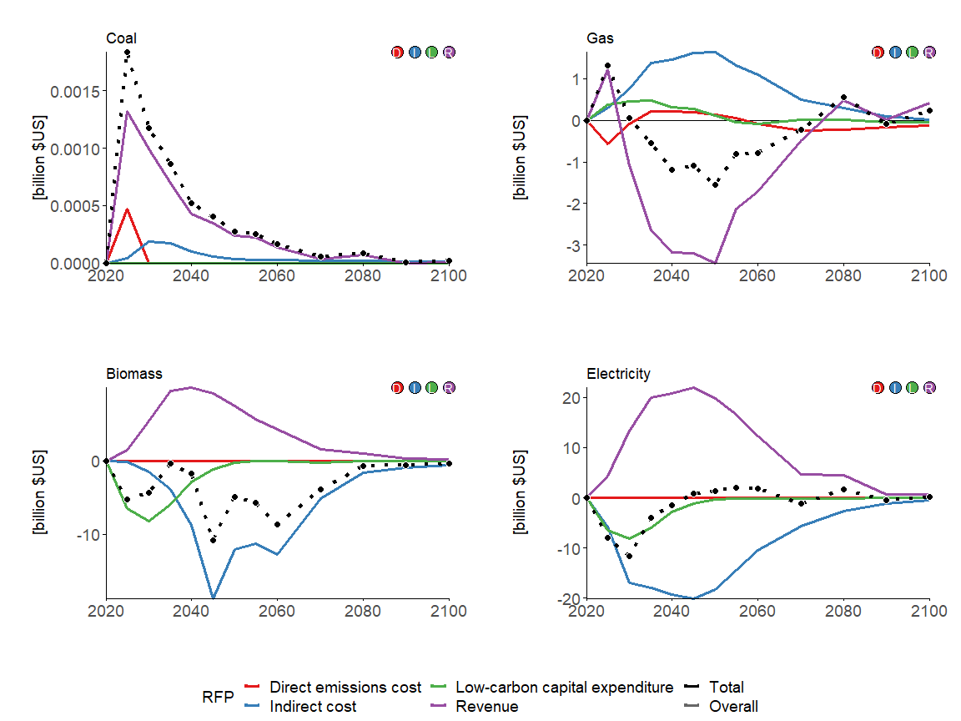

## End-use energy sectors

section_variables <- c("End-Use|Residential and Commercial", "End-Use|Industry", "End-Use|Industry|Cement", "End-Use|Industry|Chemicals", "End-Use|Industry|Steel", "End-Use|Transportation")

### GCAM

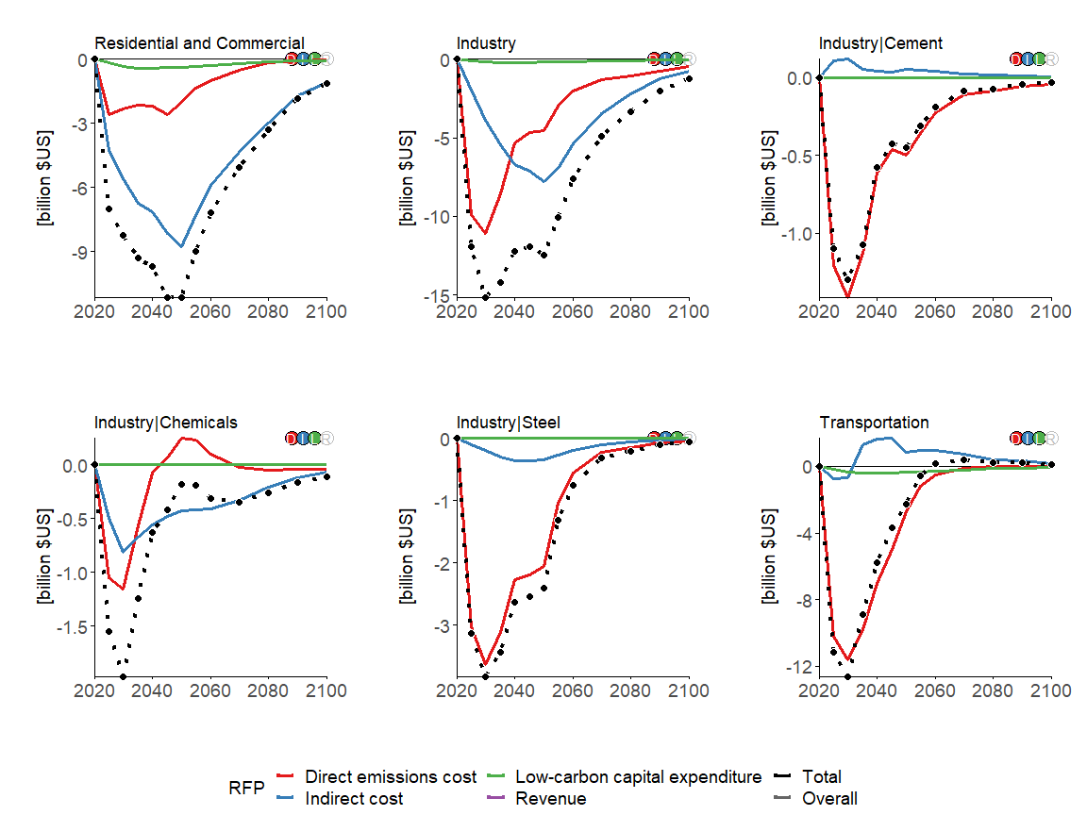

### MESSAGEix-GLOBIOM

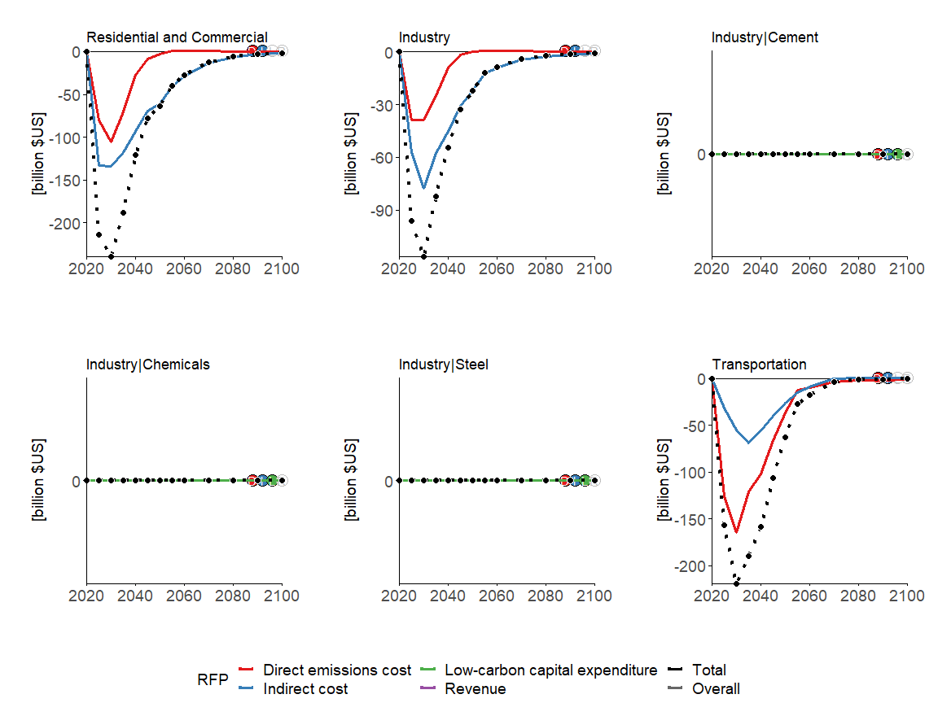

### REMIND-MAgPIE

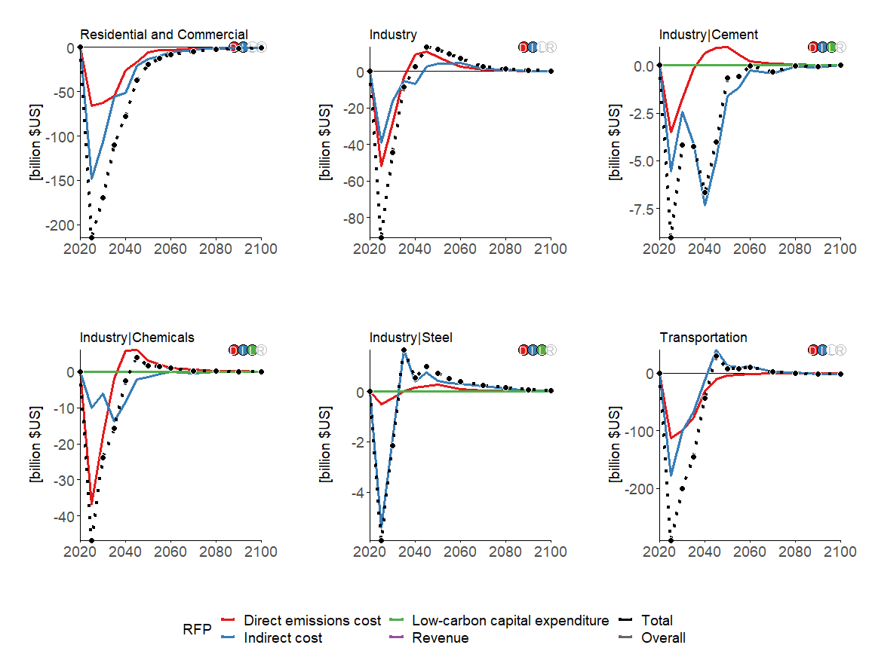

# India

v_regionall <- c("GCAM5.3_NGFS|India",   
 "MESSAGEix-GLOBIOM 1.1|R11_SAS",   
 "REMIND-MAgPIE 2.1-4.2|IND")

## Primary energy production

section_variables <- c("Energy Supply|Production|Oil", "Energy Supply|Production|Gas", "Energy Supply|Production|Coal", "Energy Supply|Production|Biomass")

### GCAM

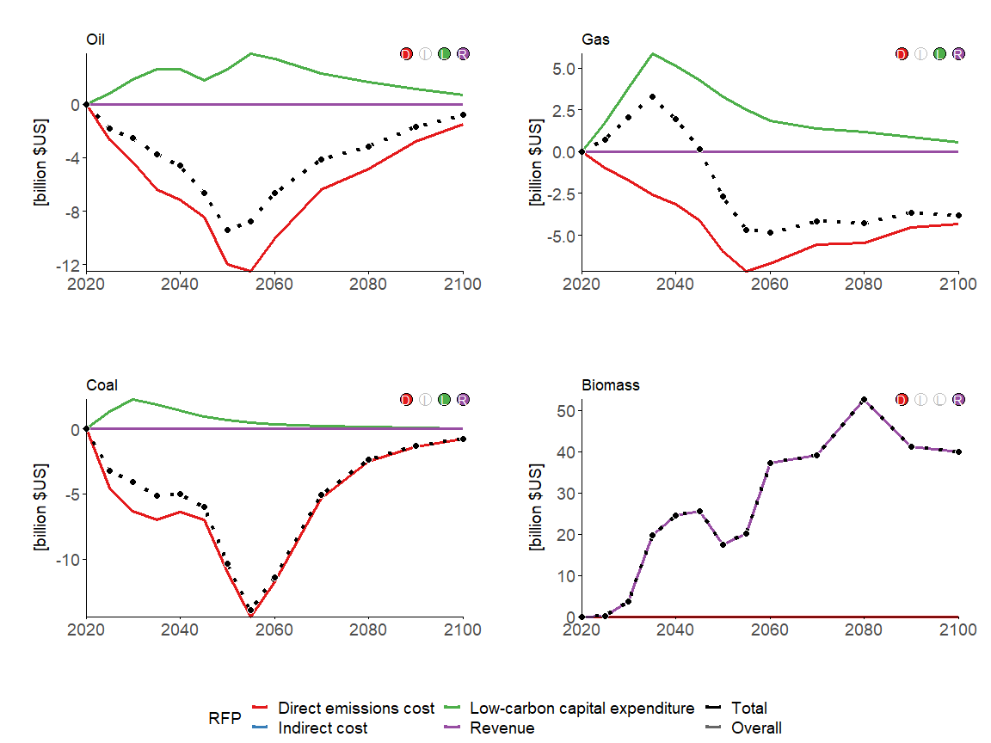

### MESSAGEix-GLOBIOM

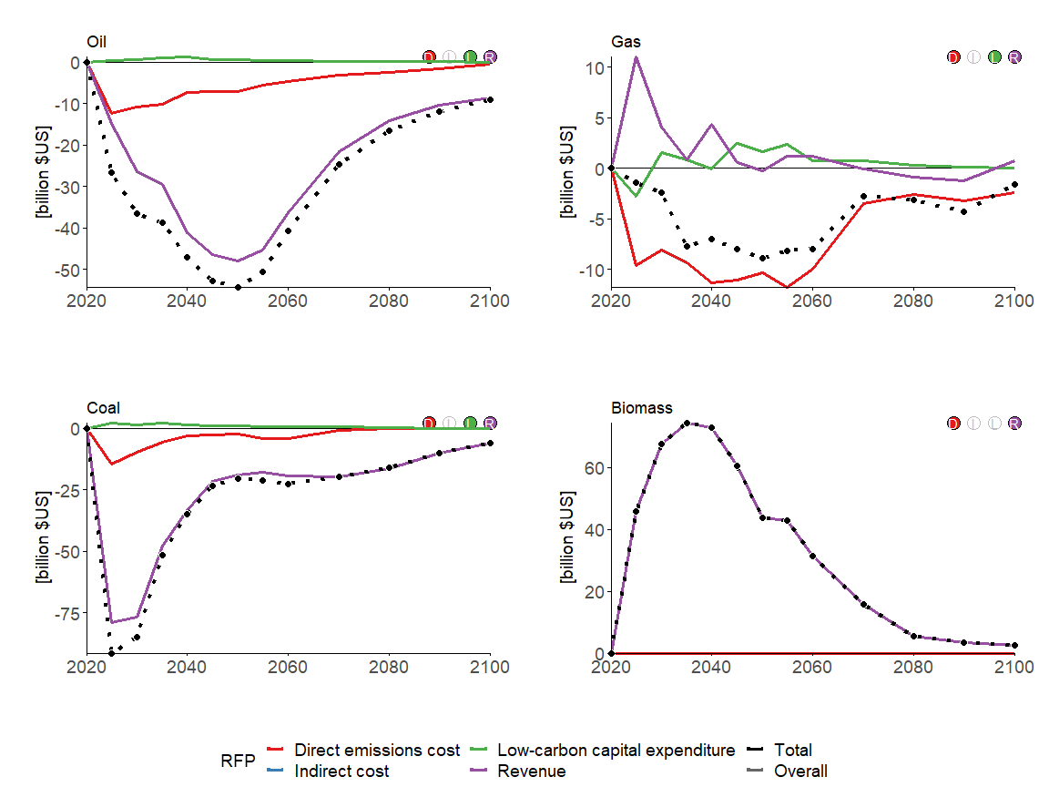

### REMIND-MAgPIE

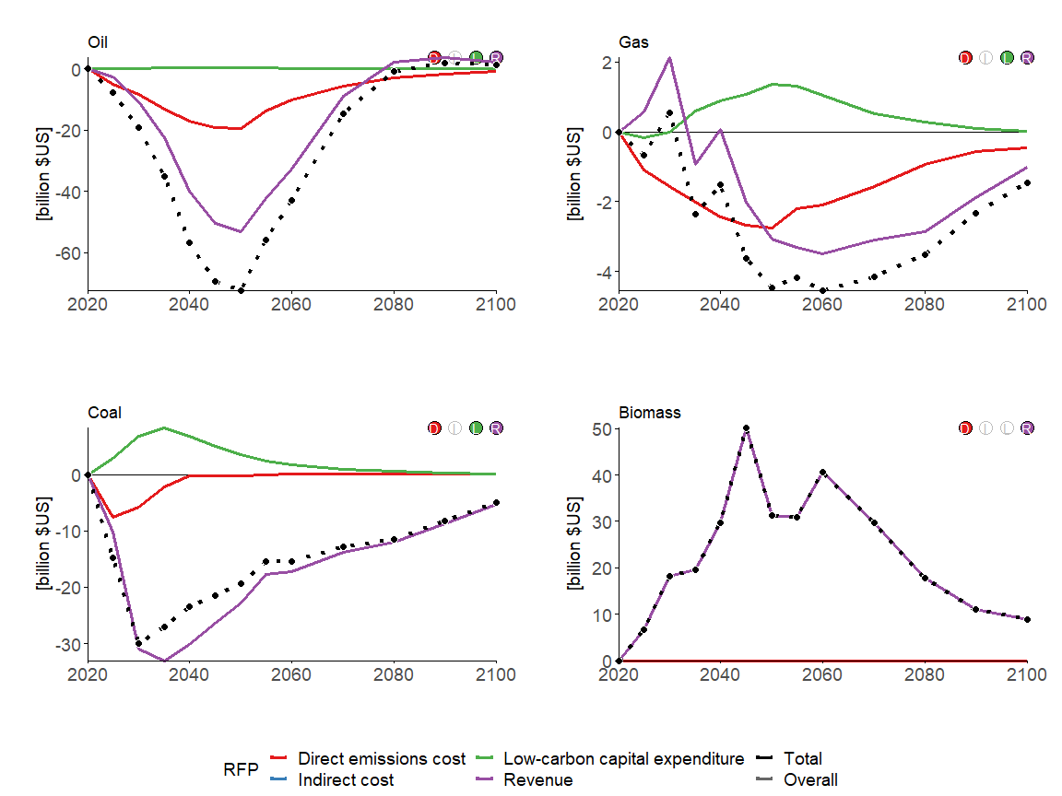

## Electric utilities

section_variables <- c("Energy Supply|Electric Utilities|Coal", "Energy Supply|Electric Utilities|Gas", "Energy Supply|Electric Utilities|Nuclear", "Energy Supply|Electric Utilities|Biomass", "Energy Supply|Electric Utilities|Non-Biomass Renewables")

### GCAM

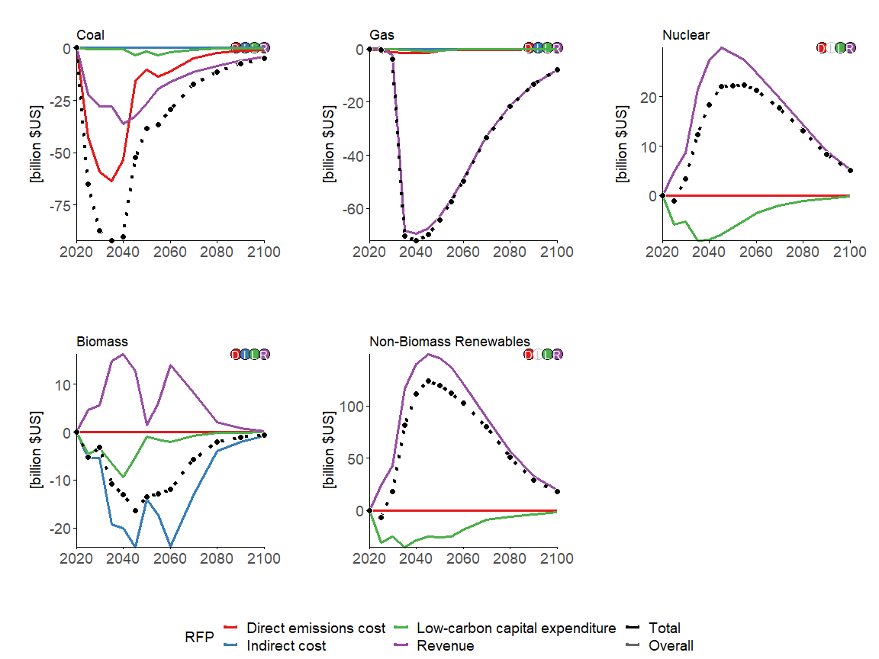

### MESSAGEix-GLOBIOM

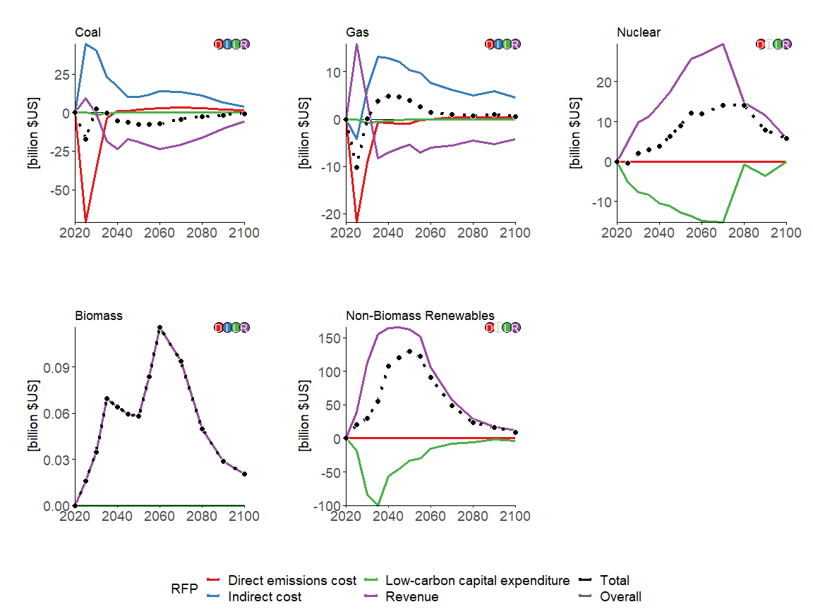

### REMIND-MAgPIE

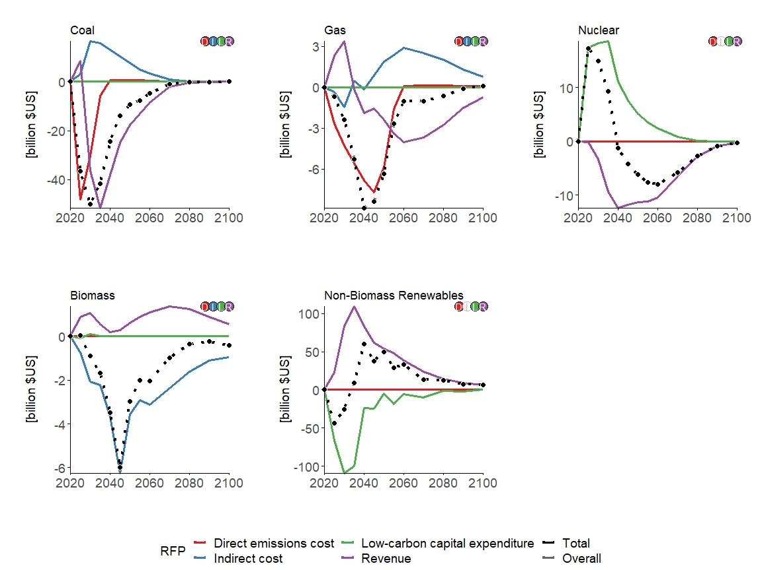

## Liquids fuels

section_variables <- c("Energy Supply|Refineries|Oil", "Energy Supply|Fischer-Tropsch Process|Biomass")

### GCAM

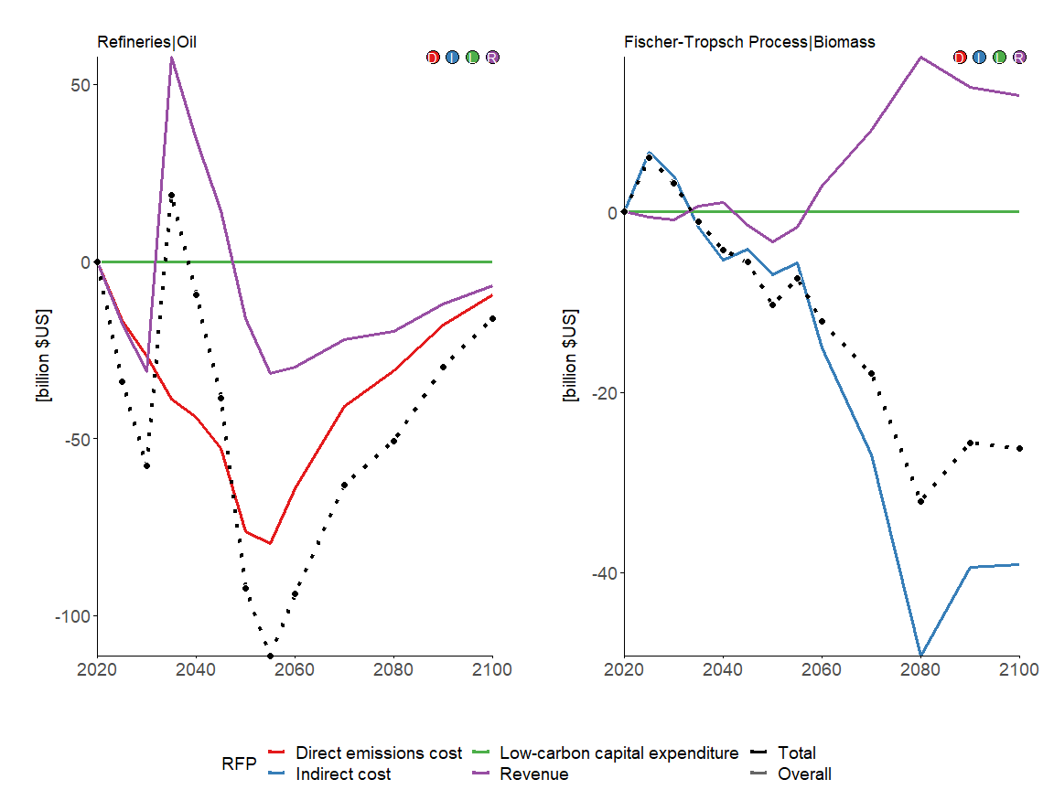

### MESSAGEix-GLOBIOM

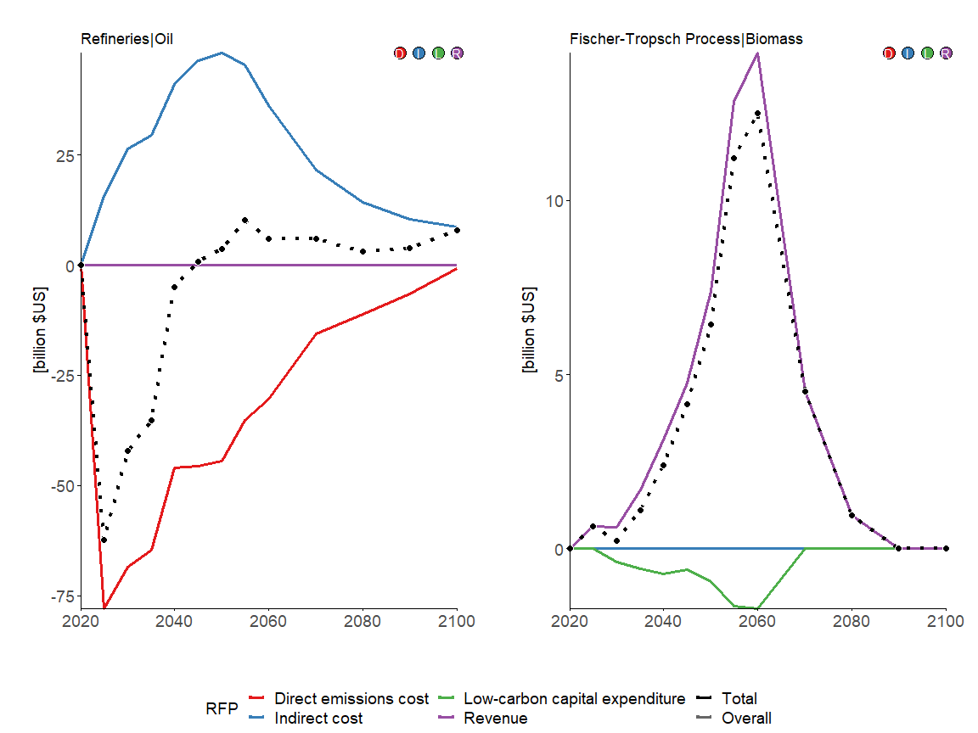

### REMIND-MAgPIE

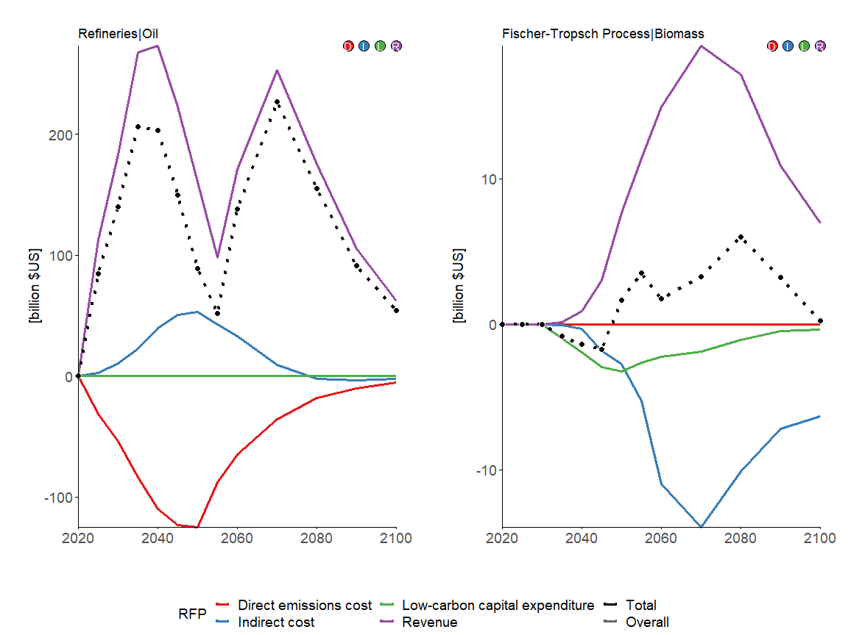

## Hydrogen plants

section_variables <- c("Energy Supply|Hydrogen Plants|Coal", "Energy Supply|Hydrogen Plants|Gas", "Energy Supply|Hydrogen Plants|Biomass", "Energy Supply|Hydrogen Plants|Electricity")

### GCAM

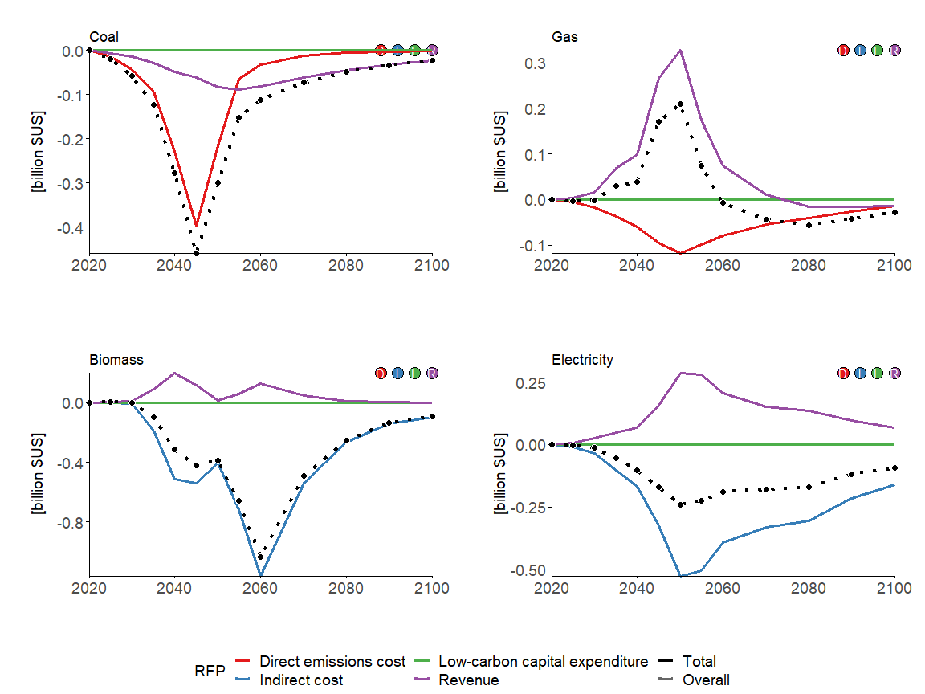

### MESSAGEix-GLOBIOM

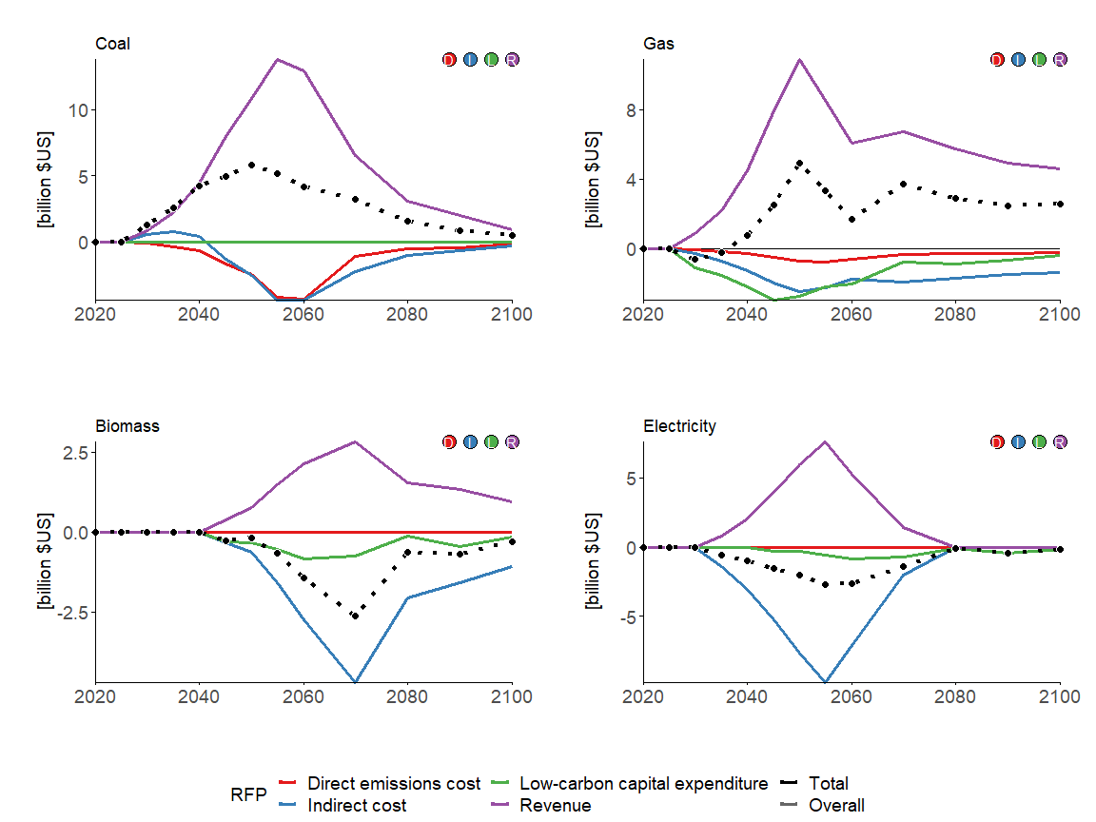

### REMIND-MAgPIE

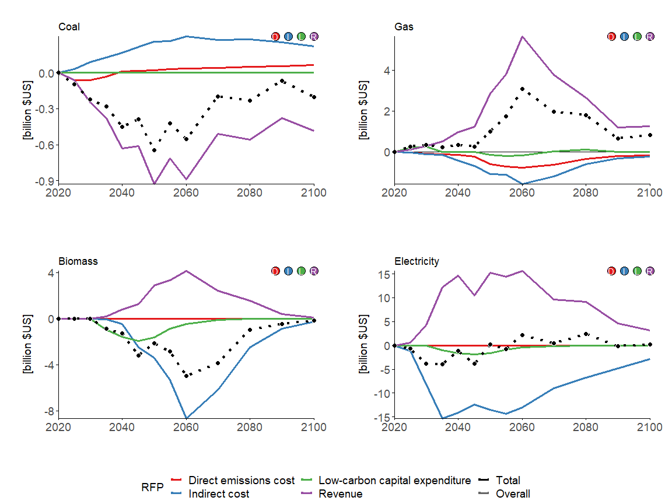

## End-use energy sectors

section_variables <- c("End-Use|Residential and Commercial", "End-Use|Industry", "End-Use|Industry|Cement", "End-Use|Industry|Chemicals", "End-Use|Industry|Steel", "End-Use|Transportation")

### GCAM

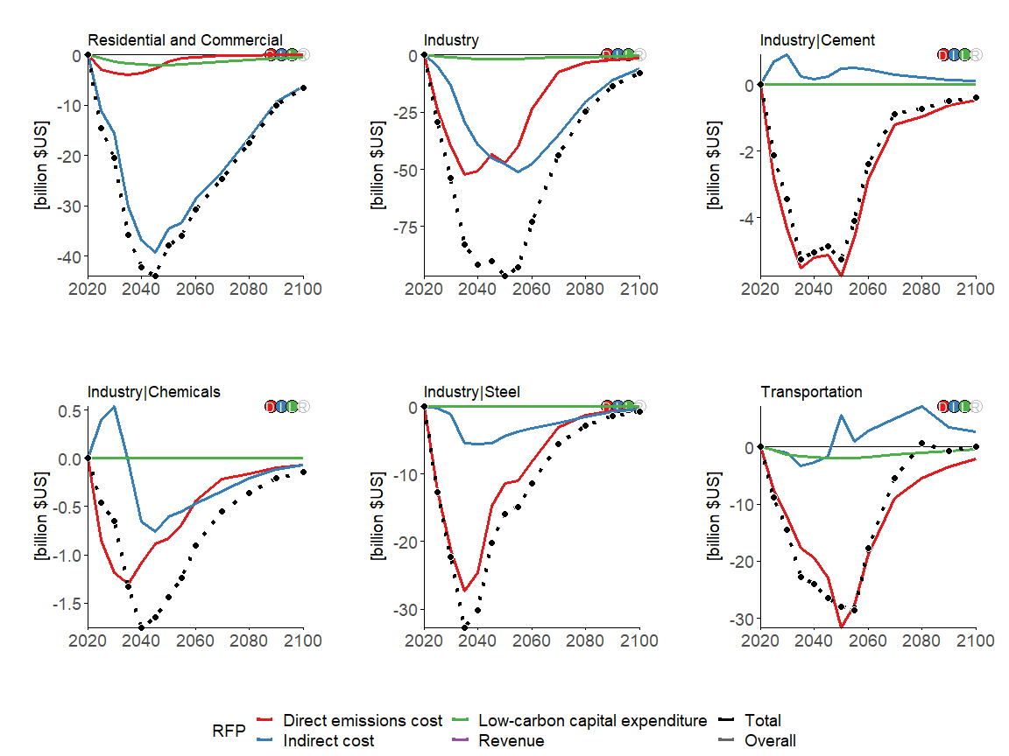

### MESSAGEix-GLOBIOM

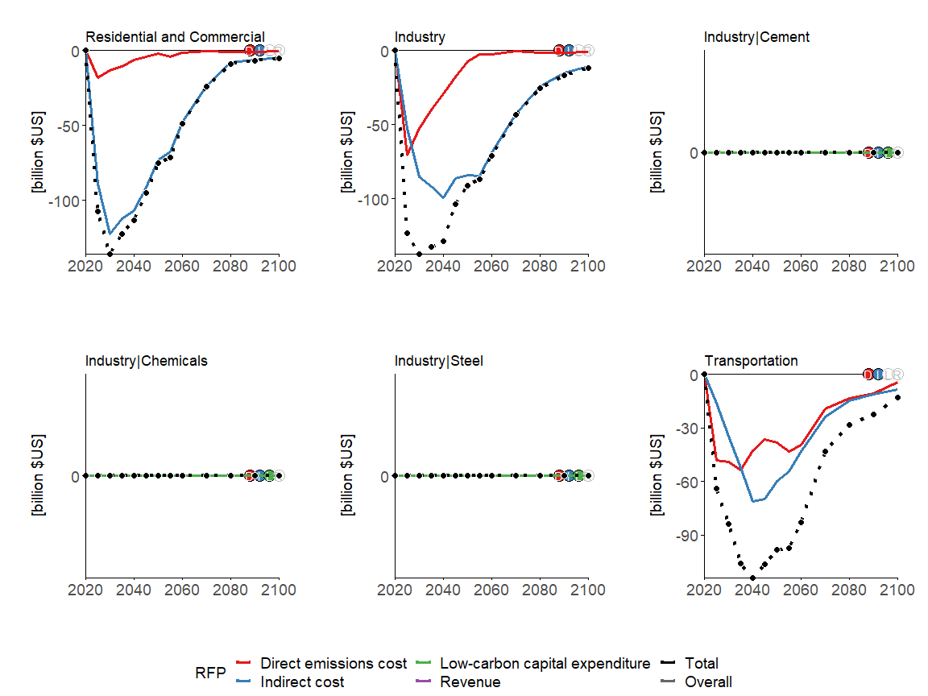

### REMIND-MAgPIE

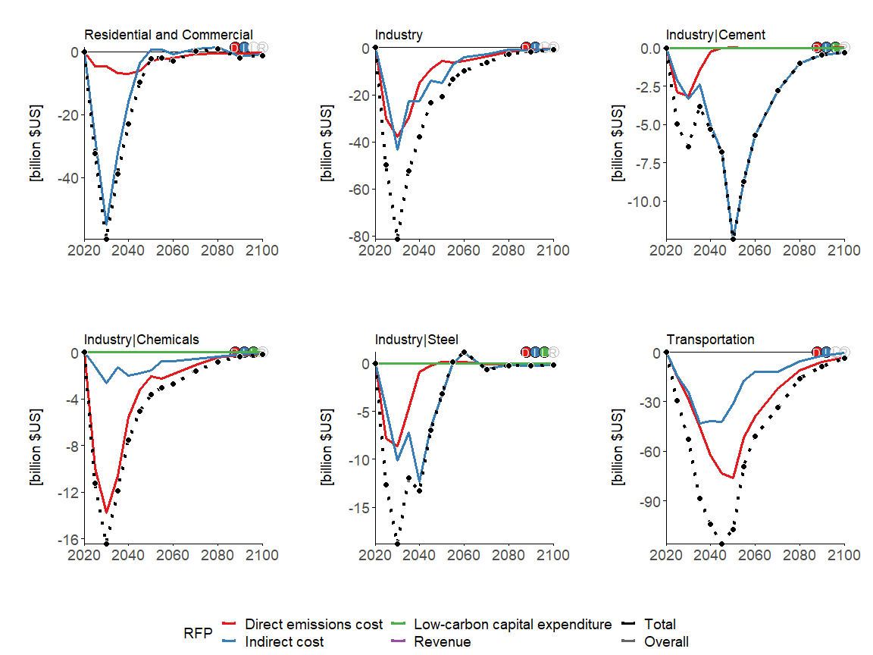

# USA

v_regionall <- c("GCAM5.3_NGFS|USA",   
 "MESSAGEix-GLOBIOM 1.1|R11_NAM",   
 "REMIND-MAgPIE 2.1-4.2|USA")

## Primary energy production

section_variables <- c("Energy Supply|Production|Oil", "Energy Supply|Production|Gas", "Energy Supply|Production|Coal", "Energy Supply|Production|Biomass")

### GCAM

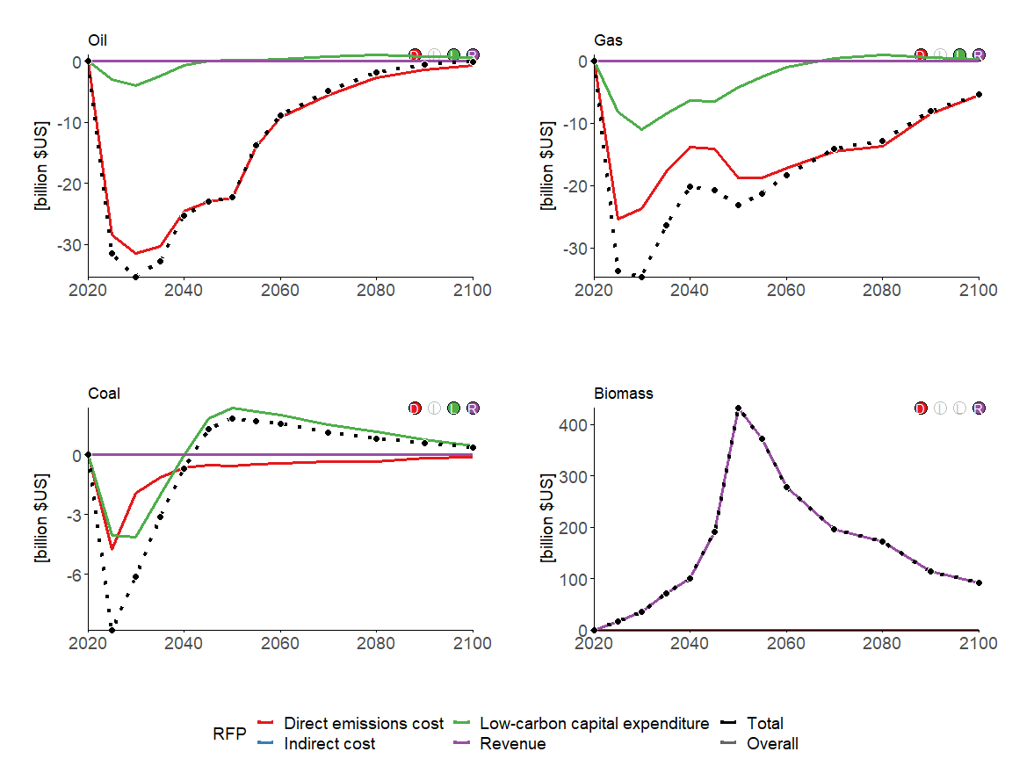

### MESSAGEix-GLOBIOM

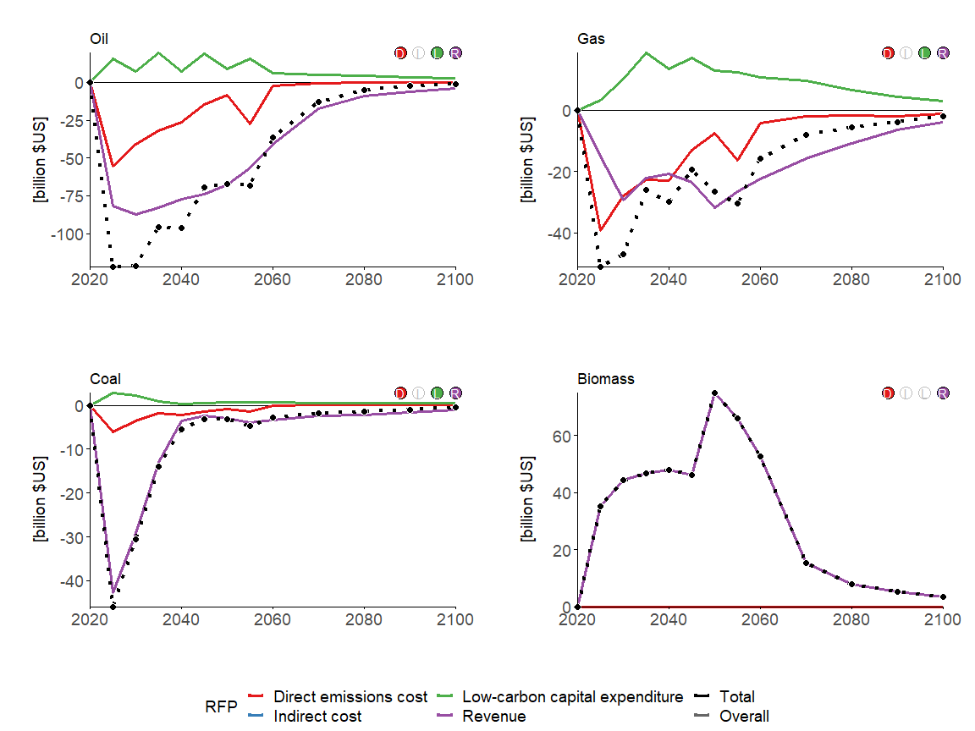

### REMIND-MAgPIE

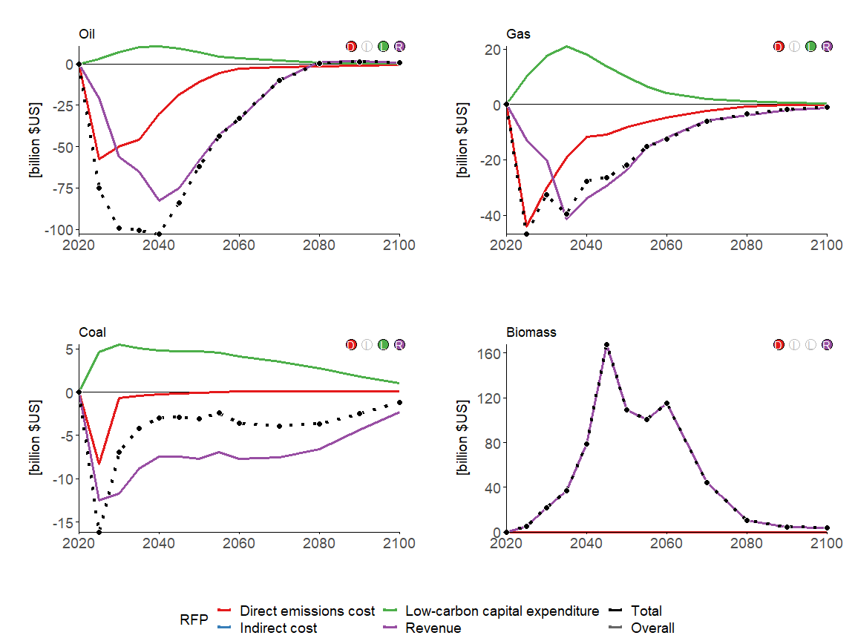

## Electric utilities

section_variables <- c("Energy Supply|Electric Utilities|Coal", "Energy Supply|Electric Utilities|Gas", "Energy Supply|Electric Utilities|Nuclear", "Energy Supply|Electric Utilities|Biomass", "Energy Supply|Electric Utilities|Non-Biomass Renewables")

### GCAM

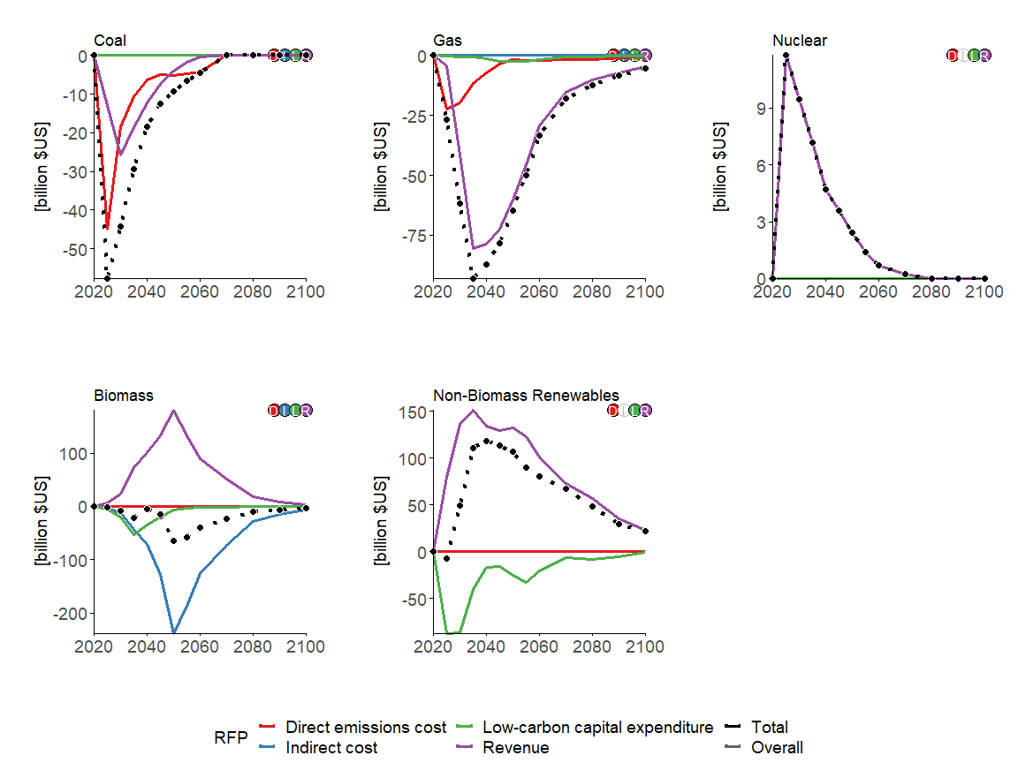

### MESSAGEix-GLOBIOM

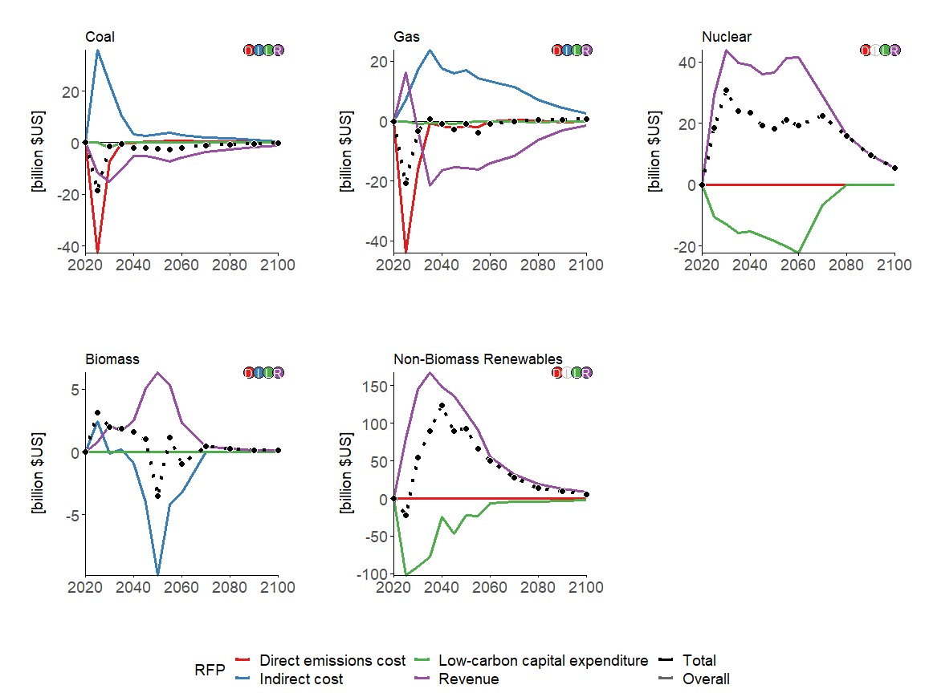

### REMIND-MAgPIE

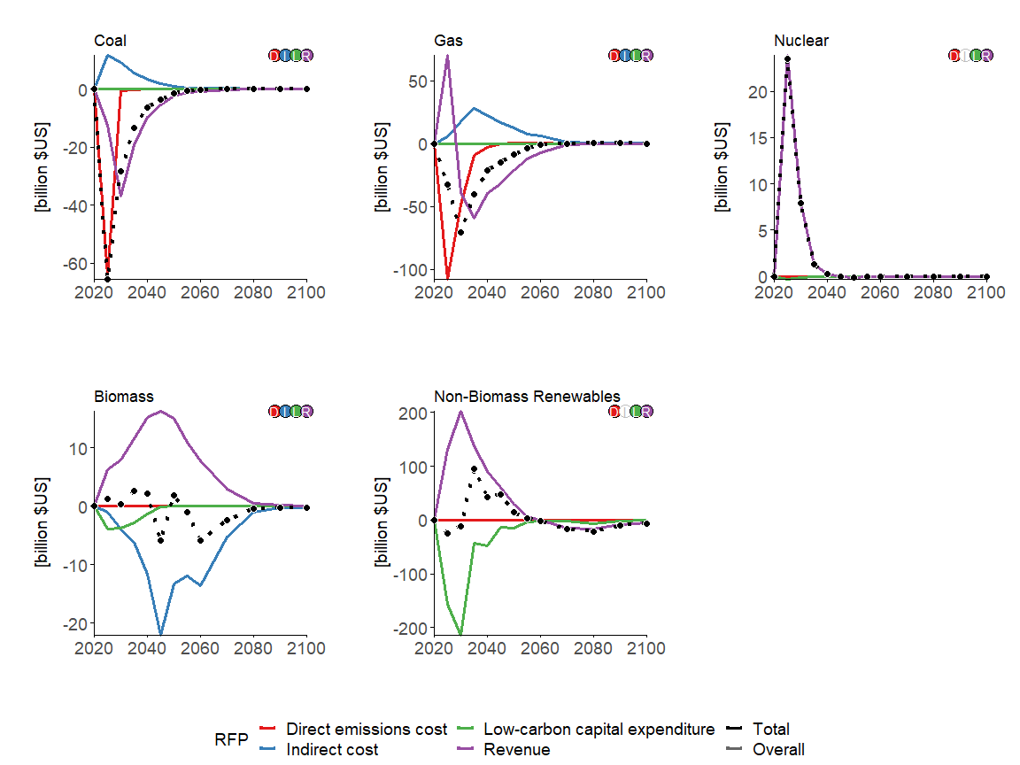

## Liquids fuels

section_variables <- c("Energy Supply|Refineries|Oil", "Energy Supply|Fischer-Tropsch Process|Biomass")

### GCAM

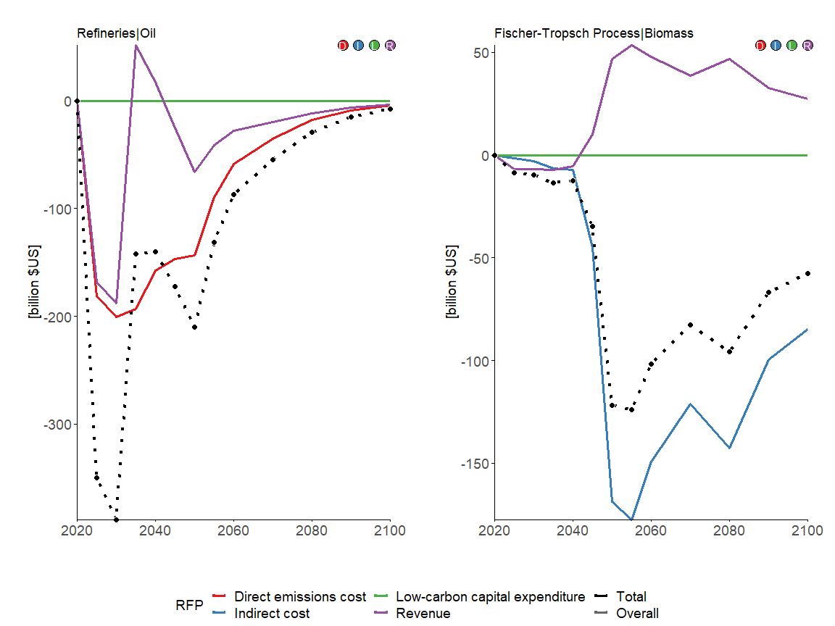

### MESSAGEix-GLOBIOM

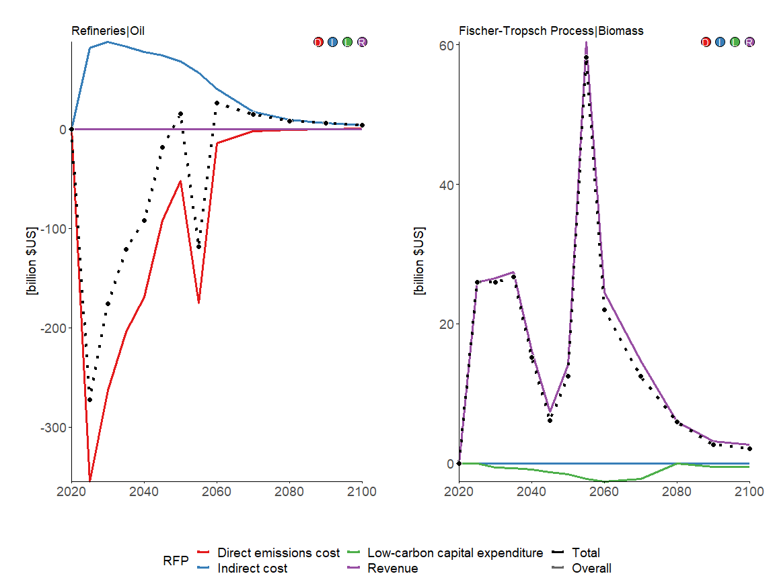

### REMIND-MAgPIE

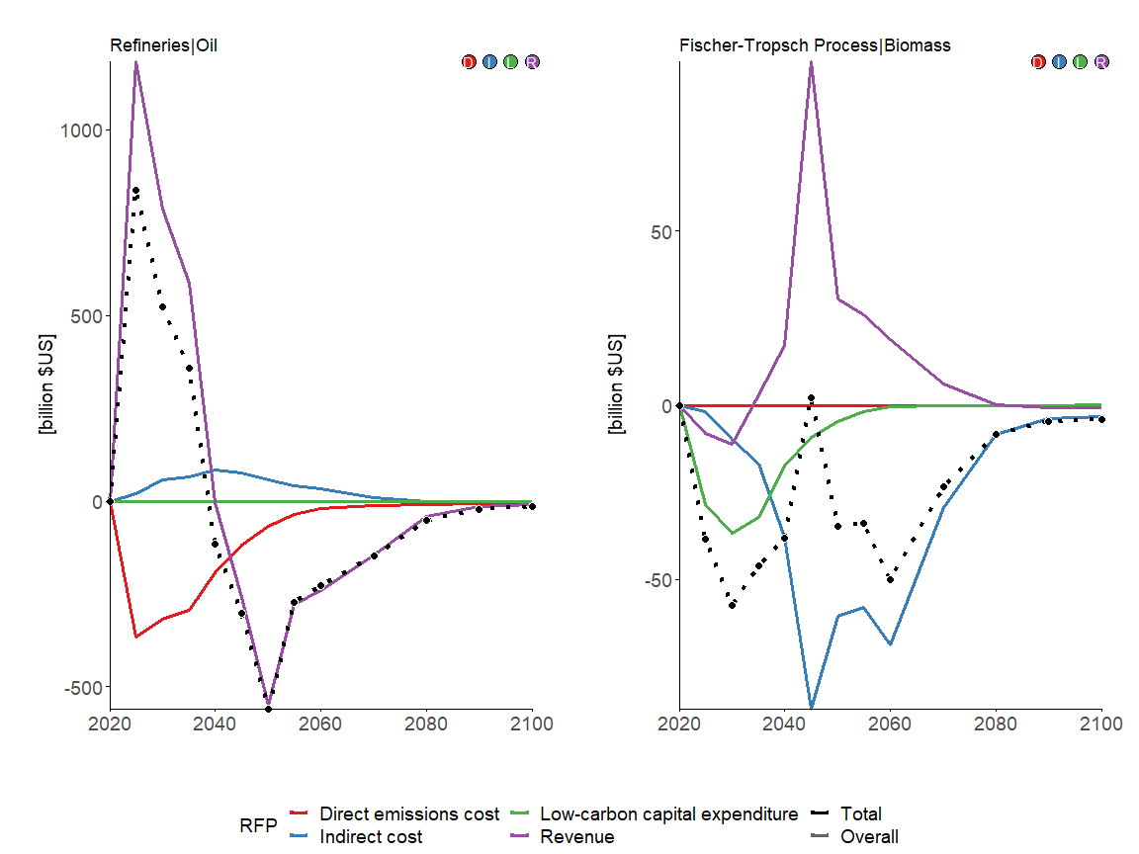

## Hydrogen plants

section_variables <- c("Energy Supply|Hydrogen Plants|Coal", "Energy Supply|Hydrogen Plants|Gas", "Energy Supply|Hydrogen Plants|Biomass", "Energy Supply|Hydrogen Plants|Electricity")

### GCAM

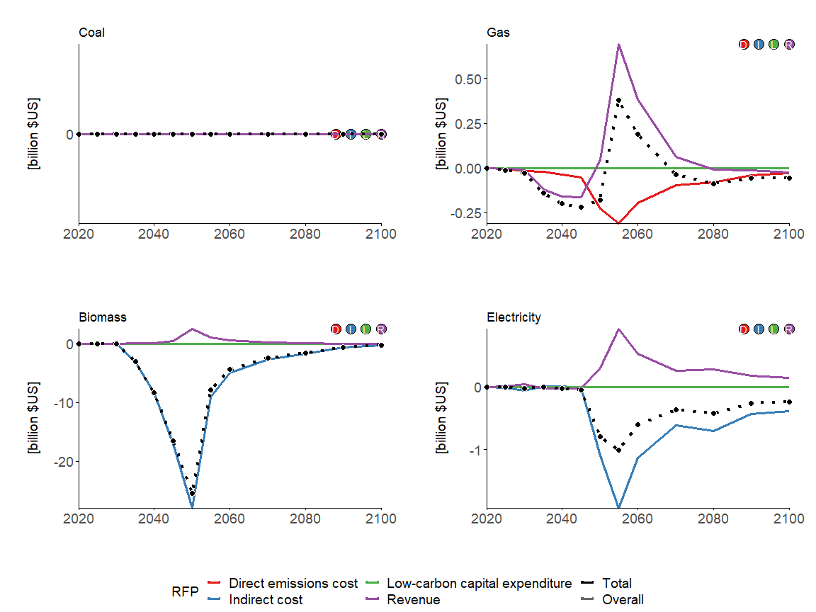

### MESSAGEix-GLOBIOM

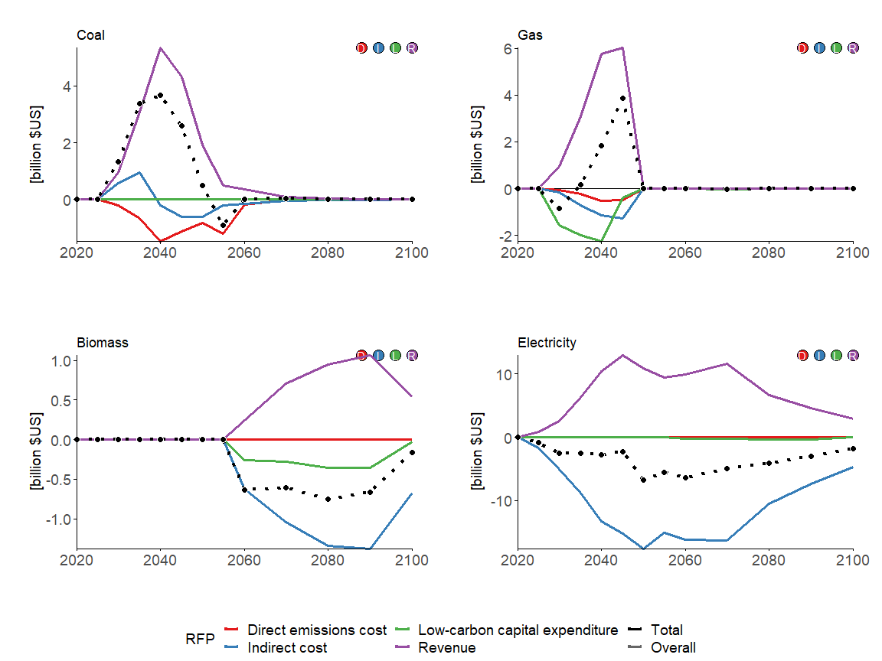

### REMIND-MAgPIE

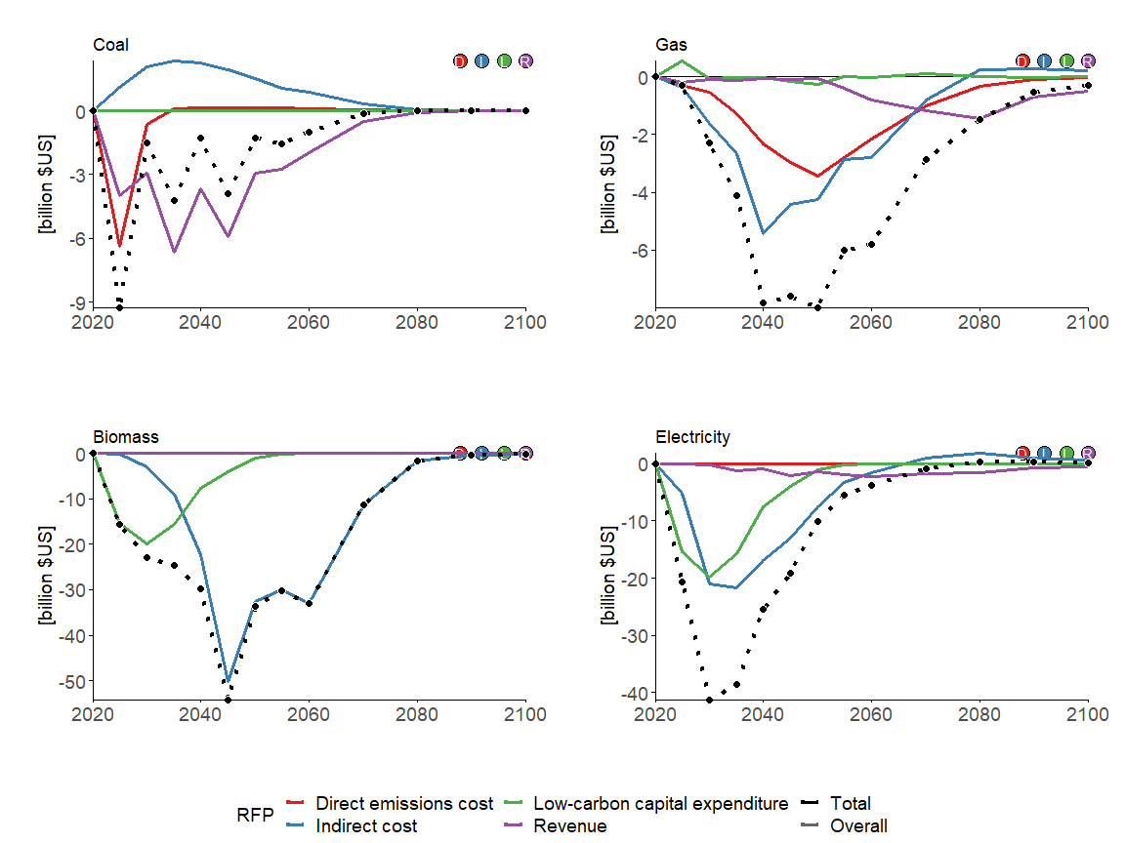

## End-use energy sectors

section_variables <- c("End-Use|Residential and Commercial", "End-Use|Industry", "End-Use|Industry|Cement", "End-Use|Industry|Chemicals", "End-Use|Industry|Steel", "End-Use|Transportation")

### GCAM

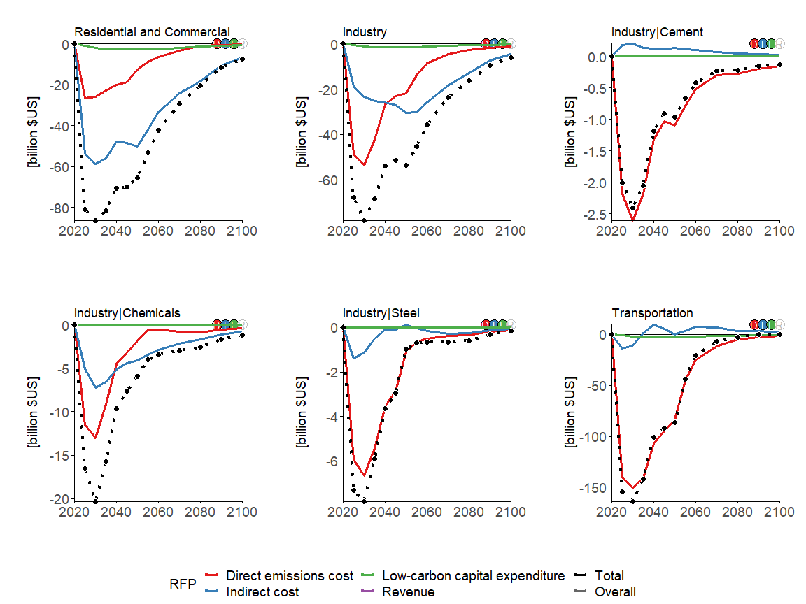

### MESSAGEix-GLOBIOM

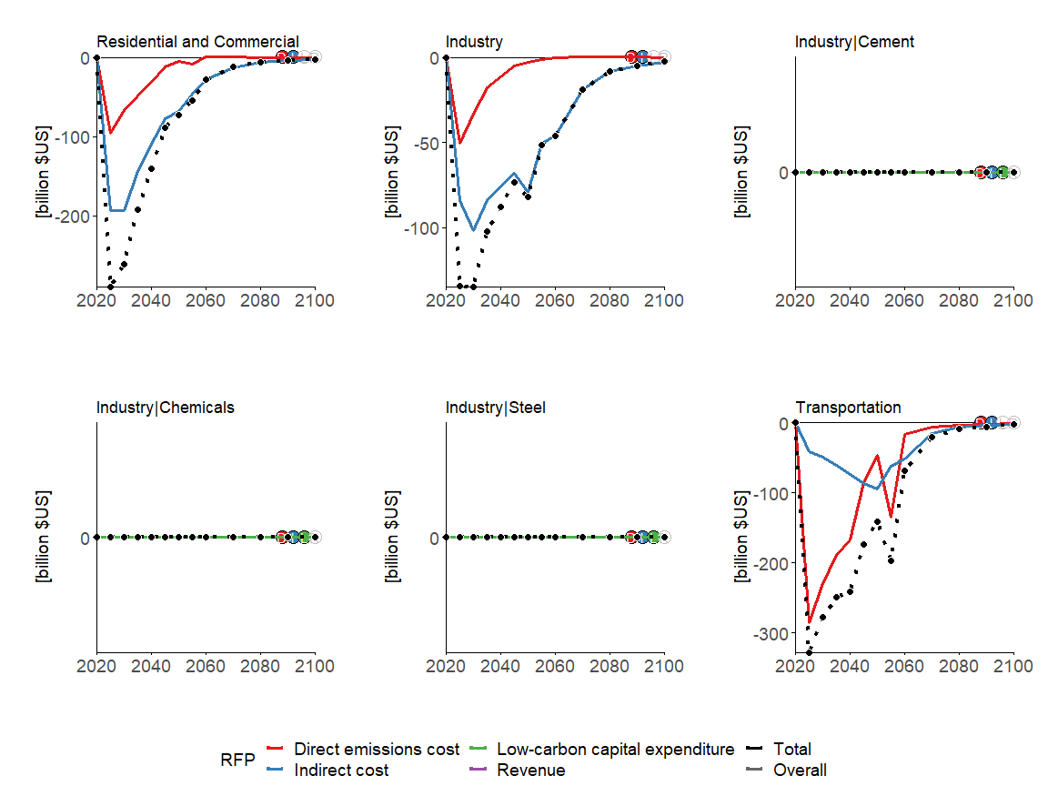

### REMIND-MAgPIE

