gitctx: Complete Step-by-Step Implementation Plan with Pitfalls, Mitigations, and Verification

This implementation plan defines the construction of gitctx, a high-fidelity indexing engine designed to provide Large Language Models (LLMs) with verifiable, structured facts from Git history. Unlike standard RAG (Retrieval-Augmented Generation) systems that index raw text, gitctx treats code history as a temporal graph of functional changes.
Project Invariants
To ensure scientific validity and operational reliability, the following invariants are enforced mechanically via CI and runtime checks:
ID | Invariant | Enforcement Mechanism
I1 | No network/LLM calls during indexing or retrieval. | unshare -n in CI; mock HTTP layer in tests.
I2 | Deterministic indexing (Repo + Config = Byte-identical state). | Double-index comparison test (Part 4.2).
I3 | Incremental index $≡$ Full index. | State equivalence test on commit ranges (Part 4.3).
I4 | Every fact carries a verifiable citation. | SQL NOT NULL constraints on commit_sha and path.
I5 | No LLM-derived text in embedding inputs. | Physical table isolation for explain_cache.
I6 | Evaluation corpus is pinned by commit SHA. | eval/corpus.lock.toml validation.
I7 | Reported numbers include baseline and uncertainty. | Mandatory template columns in cargo xtask eval.
I8 | Traversal semantics are explicit. | index_state.traversal metadata field.
1. Phase -1: Foundation and Corpus Selection
1.1 Repository Scaffolding
- Build: A Rust workspace containing gitctx-core (extraction), gitctx-index (storage), gitctx-query (retrieval), and gitctx-eval.
- Pitfalls: Dependency bloat and slow compile times for the eval harness.
- Solutions: Use a shared core crate; avoid tokio in the indexer if possible to keep it a simple CLI tool.
- Verification: cargo test passes in under $10 \text{s}$ for the base workspace.
1.2 Synthetic Fixture Generation
- Build: A tests/fixtures/mkrepo.rs utility to programmatically generate tiny Git repositories.
- Pitfalls: Real-world Git edge cases (evil merges, renames, submodules) are hard to find in small repos.
- Solutions: Explicitly generate fixtures for: (1) Linear history, (2) File rename, (3) Cross-file move, (4) Merge with conflict, (5) Squash-merge signature.
- Verification: Unit tests for lineage must pass against these fixtures with $100\%$ accuracy.
1.3 Corpus Selection and Leakage Stripping
- Build: eval/harvest.py to select 3-5 Python repos based on issue-linking density ($>150$ traceable issues).
- Pitfalls: Data Leakage where the query (issue body) contains the answer (commit hash or file name).
- Solutions: Strip Fixes #N, Closes, and PR URLs from the indexed commit messages.
- Verification: Grep the index for issue IDs; count must be zero.
2. Phase 0: Python De-risking (The Ablation Grid)
Before committing to the Rust implementation, a Python prototype validates the retrieval thesis.
2.1 The Ablation Grid
- Build: A $5×5$ matrix testing 5 document templates (D1-D5) against 5 retrievers (R1-R5).
- Templates: D1 (Raw Diff), D2 (Commit Message), D3 (Function Signature + Diff), D4 (Templated Pseudo-doc), D5 (D4 + Co-change context).
- Retrievers: BM25, MiniLM-L6, BGE-M3, RRF (BM25 + MiniLM), and a Code-aware model.
- Verification: Calculate Recall@10 and MRR (Mean Reciprocal Rank). A $Δ<0.05$ in Recall is treated as noise.
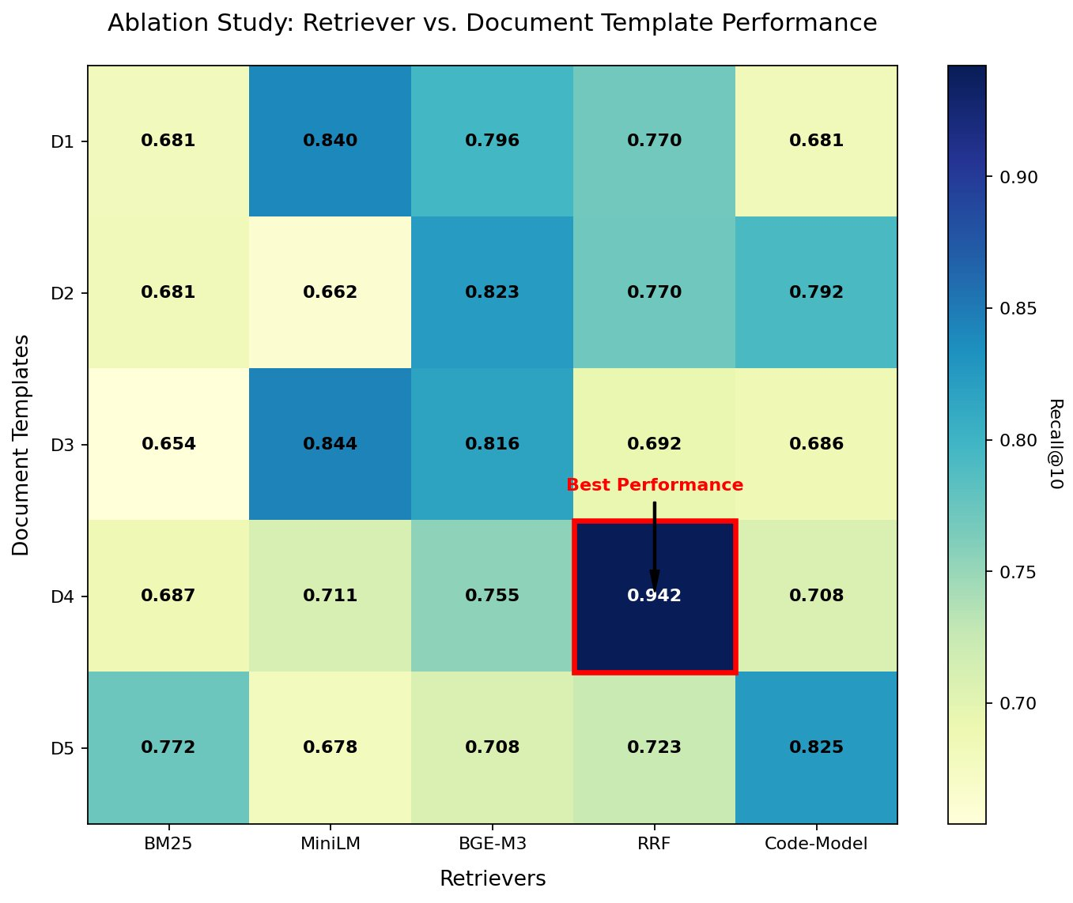
3. Phase 1: Extraction and Function Lineage
3.1 Git Traversal and Historical AST Parsing
- Build: A libgit2 walker using first-parent logic. For each commit, parse changed blobs using tree-sitter.
- Pitfalls: Syntactically broken code in historical commits.
- Solutions: Implement a “degraded chunk” fallback that treats the whole file as one chunk if parsing fails.
- Verification: Log parse_success_rate; target $>98\%$ for mature repos.
3.2 The Lineage Algorithm
- Build: An ordered matching engine to track functions across time.
- Algorithm Steps:
- Exact match (Path + Qualified Name).
- Move detection (Qualified Name + MinHash fingerprint).
- Rename detection (Path + MinHash).
- Fuzzy match (MinHash threshold $>0.7$).
- Verification: Synthetic mutation testing. Apply 10 transformations (M1-M10) to a file and verify the engine tracks the identity.
// Rust Sketch: Lineage Fingerprinting
pub struct FunctionFingerprint {
pub qualified_name: String,
pub minhash: Vec<u64>,
pub signature_hash: u64,
}
fn calculate_minhash(tokens: &[String]) -> Vec<u64> {
// Implementation of K-permuted MinHash for Jaccard similarity
// ...
}
4. Phase 2: Indexing and Data Modeling
4.1 SQLite Schema (DDL) The database is the source of truth for all temporal facts.
-- Core Schema for gitctx
CREATE TABLE index_state (
schema_version INTEGER PRIMARY KEY,
config_hash TEXT NOT NULL,
embedding_model_sha256 TEXT NOT NULL,
traversal_mode TEXT DEFAULT 'first-parent'
);
CREATE TABLE function_lineage (
lineage_id INTEGER PRIMARY KEY,
first_seen_commit TEXT NOT NULL,
last_seen_commit TEXT NOT NULL,
canonical_name TEXT NOT NULL
);
CREATE TABLE function_touches (
lineage_id INTEGER REFERENCES function_lineage(lineage_id),
commit_hash TEXT NOT NULL,
path TEXT NOT NULL,
start_line INTEGER,
end_line INTEGER,
match_confidence REAL,
PRIMARY KEY (lineage_id, commit_hash)
);
CREATE TABLE call_edges (
caller_lineage_id INTEGER,
callee_lineage_id INTEGER,
valid_from_commit TEXT,
PRIMARY KEY (caller_lineage_id, callee_lineage_id, valid_from_commit)
);
CREATE TABLE explain_cache (
fact_hash TEXT PRIMARY KEY,
llm_explanation TEXT NOT NULL
);
4.2 Vector Store and RRF Fusion
- Build: A memory-mapped $f32$ vector store for cosine similarity.
- Fusion: Combine Tantivy (BM25) scores with vector scores using Reciprocal Rank Fusion.
- Verification: Determinism test. Index the same repo twice; the tantivy segments and SQLite WAL-cleared files must be bit-identical.
5. Phase 3: Agent Surface (CLI & MCP)
5.1 MCP Tool Implementation
- Build: A Model Context Protocol server exposing tools: get_function_history, find_related_changes, query_why.
- Pitfalls: LLMs exceeding token limits with large diffs.
- Solutions: Implement a compact mode that returns only commit summaries and line ranges, and a full mode for specific deep-dives.
- Verification: MCP inspector tool validates the JSON-RPC schema.
5.2 Output Envelope Every response must include metadata to ensure the agent knows the context of the facts.
{
"gitctx_version": "0.1.0",
"config_hash": "a1b2c3d4...",
"results": [...],
"warnings": ["Parse error in commit 8f2e1: fallback to raw diff used"]
}
6. Evaluation and Risk Management
6.1 Risk Register
Risk | Likelihood | Impact | Mitigation
Lineage drift in long chains | High | Med | Use git log -L as a secondary validation signal.
Embedding model truncation | Med | High | Check truncation rate; use models with $8\text{k}+$ context if needed.
SQLite write bottleneck | Low | Med | Single-writer channel pattern with WAL mode enabled.
6.2 Performance Budgets
- Indexing Speed: $>50 \text{commits} · {\text{s}}^{−1}$ on a standard workstation.
- Query Latency: $<200 \text{ms}$ for RRF retrieval.
- Storage Overhead: $<20\%$ of the .git directory size.
6.3 Defense and README Framing The project must be framed as a fact-provider, not a reasoner.
- Non-Goal: Generating code or writing commit messages.
- Goal: Providing the exact historical context (e.g., “This function was changed 4 times in relation to Issue #402, primarily by Author X”).
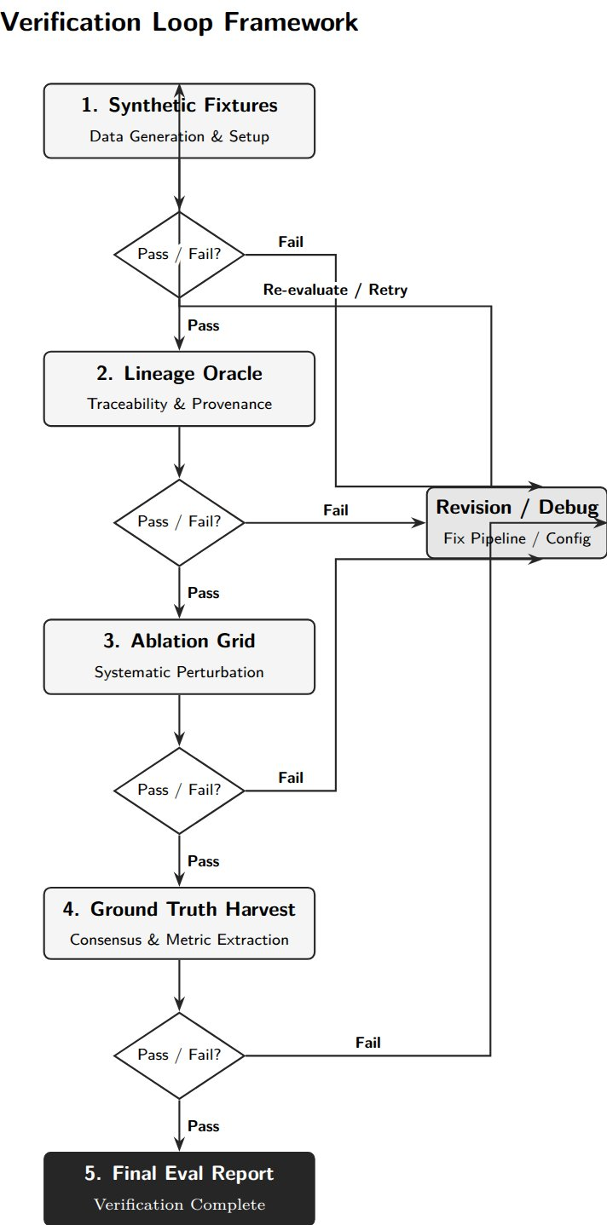
Schedule and Cut Order
- Days 1-5: Phase -1 (Scaffolding & Fixtures).
- Days 6-15: Phase 0 (Python Ablation). Gate: If RRF doesn’t beat BM25 by $15\%$, pivot to pure keyword search.
- Days 16-35: Phase 1 & 2 (Rust Core & Indexing).
- Days 36-45: Phase 3 & 4 (MCP & Final Eval). Cut Order: Drop doc-RAG first, then drop call-graph depth, then drop blame-attribution.
This plan ensures that every component of gitctx is built on a foundation of measurable accuracy, providing a reliable “memory” for AI-assisted software engineering.

