**ABV - Indian Institute Of Information Technology And Management , Gwalior**



# Class Representative Voting System

**Subject Computer Programming**

|  |  |
| --- | --- |
| ***Submitted to:*** | ***Submitted by:*** |
| ***Dr. Santosh Singh Rathore*** | ***Aditya Pandey (2020IMG-005)***  ***Donthula Akshita (2020IMG-023)***  ***Mrunal Badole (2020IMG-039)***  ***Pragya Rathore (2020IMG-049)*** |

## INTRODUCTION

The purpose of our project is to get a better and efficient way to elect a class representative by making a voting system.

## What Our Program can do ?

We implemented a vote count function. That will also show the count of other candidates , and also will show the leading candidate at any point while its running.

## Library Function used and why

**Switch case** :​ To get the choice of vote and the call the appropriate fucntion

**If & Else If**.: To get the leading candidates and Number count

**Do While Loop** : To make the voting system run until the user wants to exit and quit voting.

**Macros** :​​ To reduce to code lenght

## How the code works and it’s logic

We Divided the whole program into mainly 3 different , excluding the Main function

**Casting Vote Function :**  We defined 4 global count variable first of all ,and macros for name of the candidate , and gave user corresponding int number for the candidate , so that they can cast their vote to the respective candidate. Then using **Switch case** we increased the vote count by one for the corresponding candidate.

**Vote Count Print Function :** No nested function used here, simply printed out the current value of all the vote count variable

**Leading candidate function :** Compared each votecount variable with the rest 3 votecount and using **IF ELSE IF** , printed the candidate with the maximum vote .

**Main Function :** Gave user the option , what he wants to do , either cast his/her vote , see the result , or the current vote count . This was implemented with a **Switch Case**.

*And This switch case was repeated until the user opts to get out of the program using a* ***Do While*** *loop.*

## ER DIAGRAM

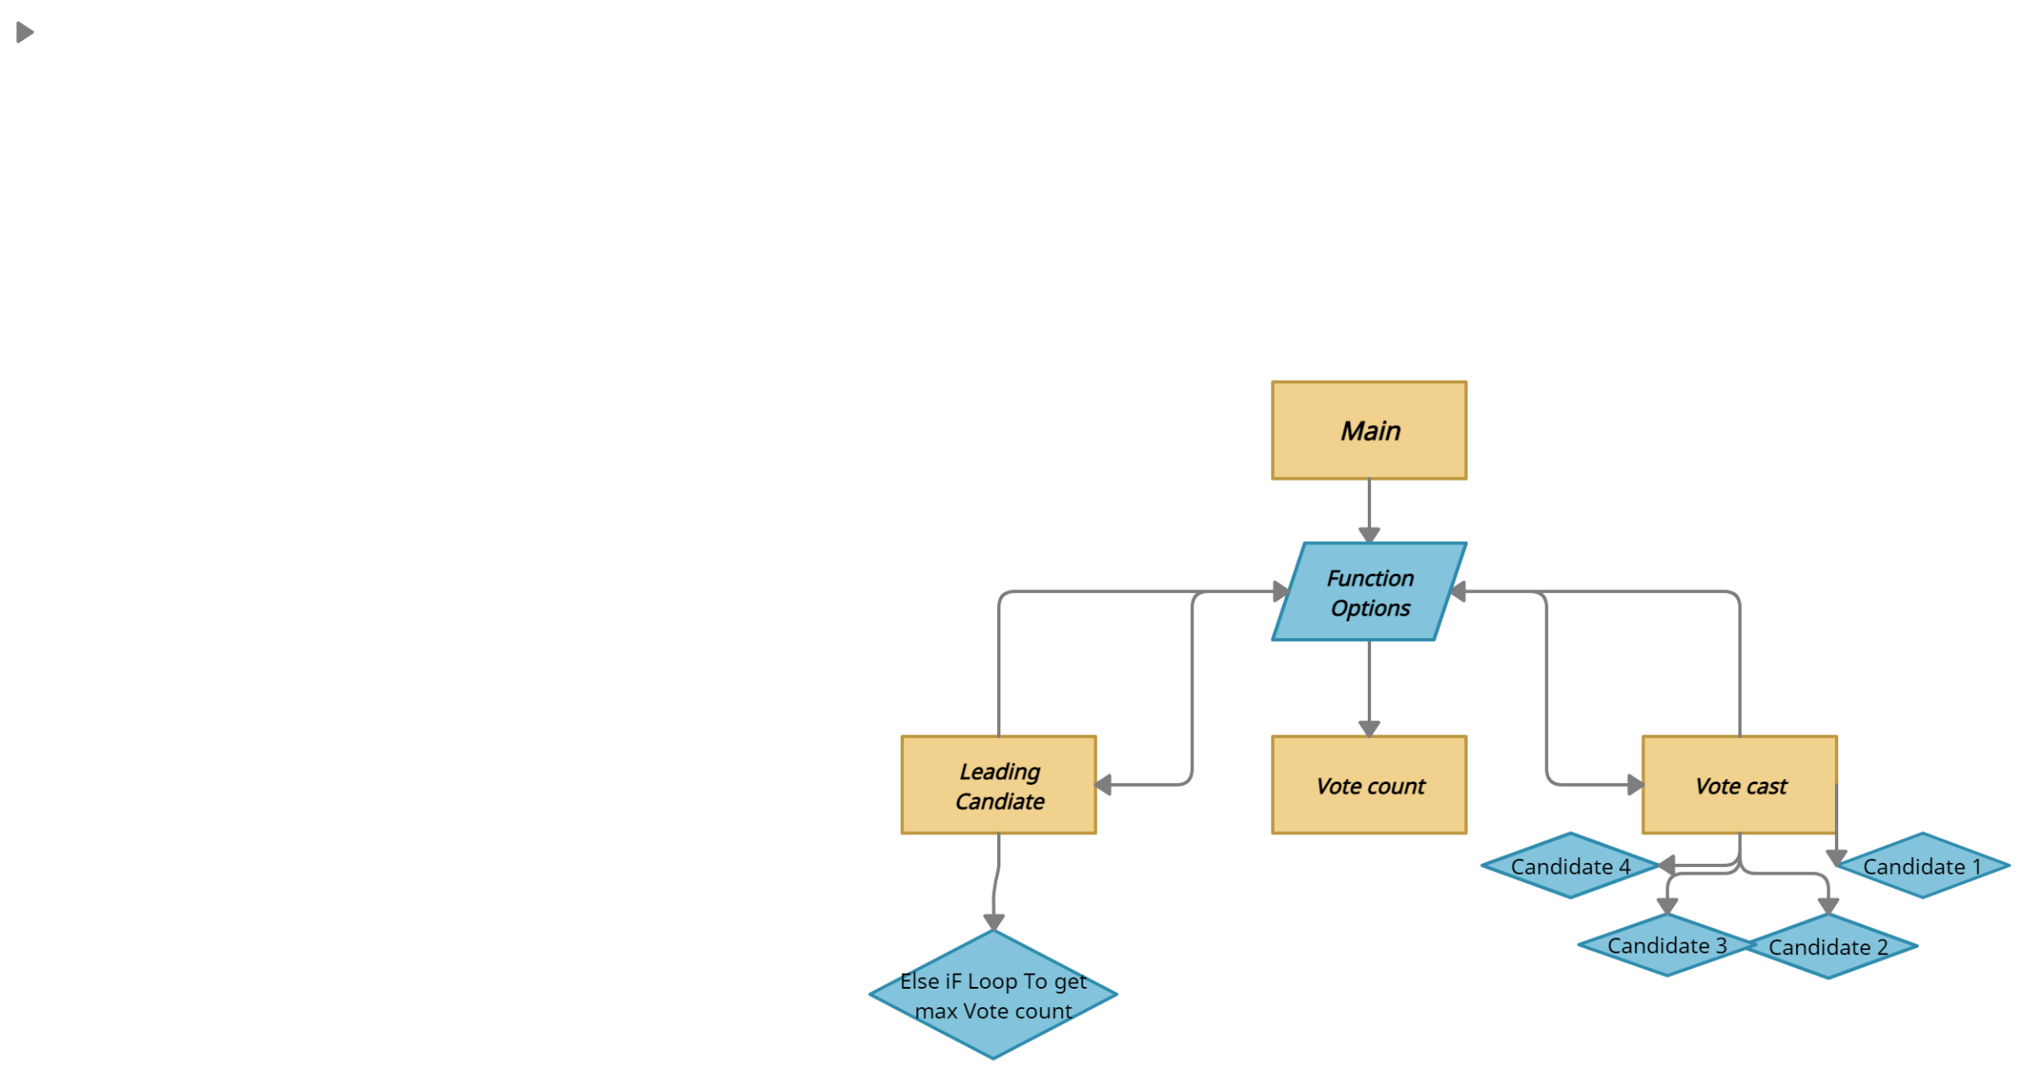

This Goes loop of returning to function option goes on until user opts to exit by pression 4(case in this function)

Our Program Does all The Counting of votes including giving the leading candidates , but we wanted to add a little more. So we brought some unexpected output at last , despite the number of votes or the leading candidate.

Which will be demonstrated in the below sample Inputs and Outputs.

## Sample Output

**1). In giving 3 votes to Adarsh Gupta and 2 votes to Mrunal Badole and Showing Total Count.**

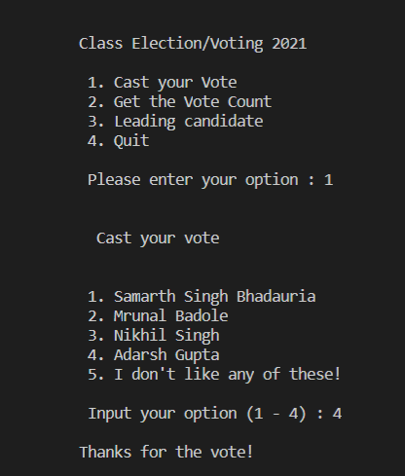 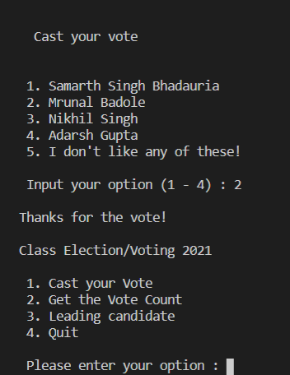

**(***Showing input only once* **)**

*Votecount Function*

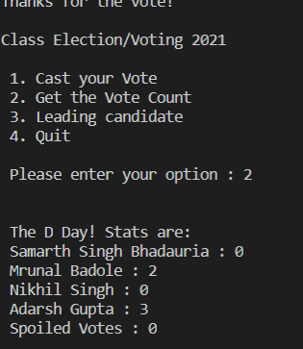

**2). For the above input show the leading candidate**

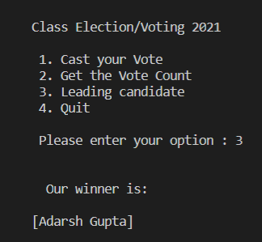

**3 ) Output when you quit the Program**

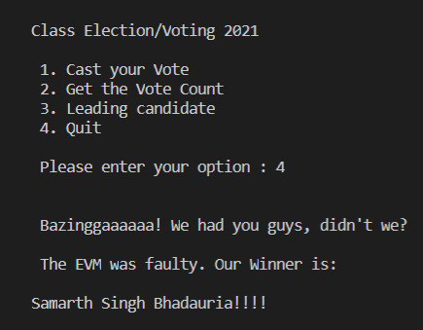

**4).Display What happens when you enter invalid choices**

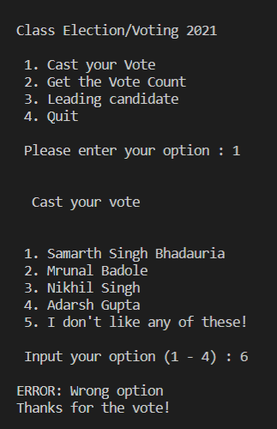 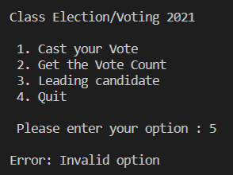

**Thank you!**