Object-Oriented Programming

**Code Instructions**

Library Management System

horizontal line



Firstly, a screen shown below pops out, by default you are logged in as a librarian.

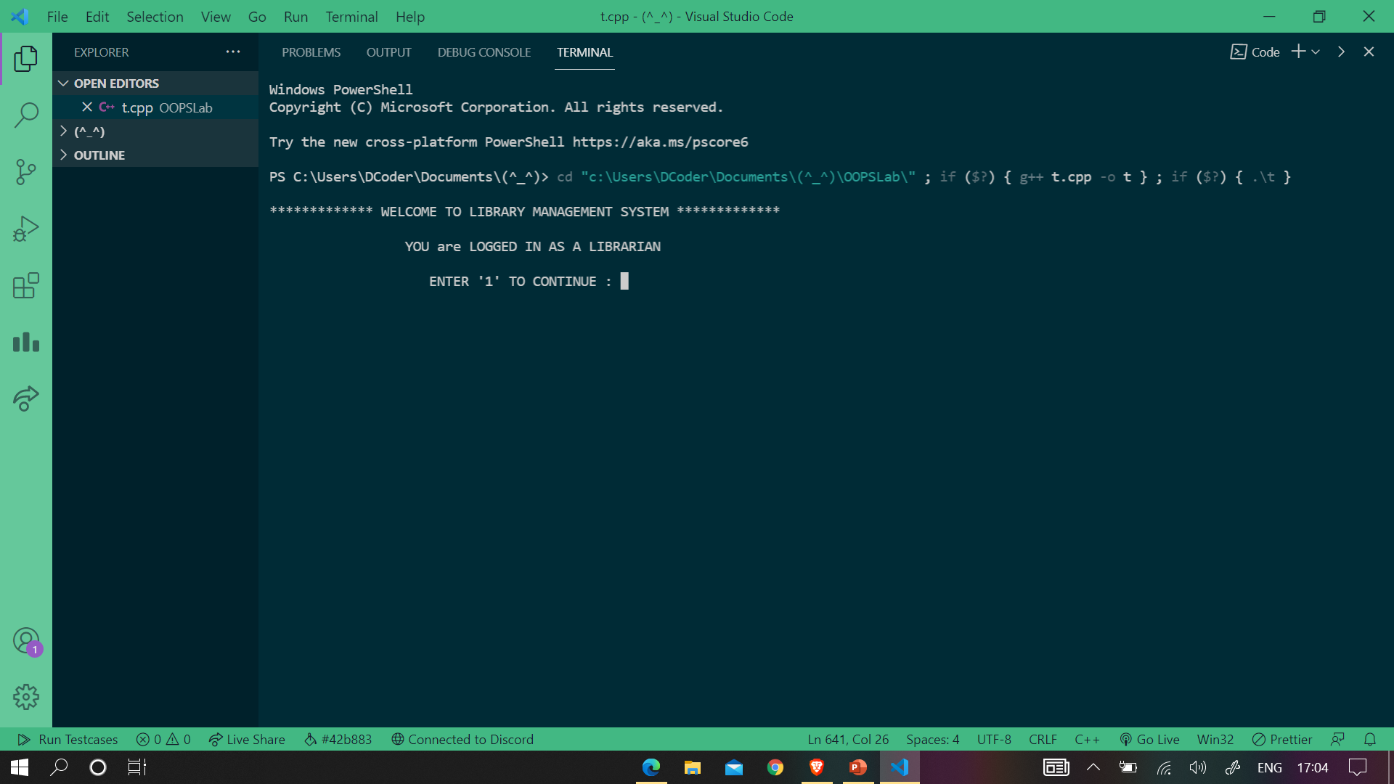

As suggested by the program, we have to enter 1 in order to proceed. As soon you enter 1, a screen (attached below) will appear.

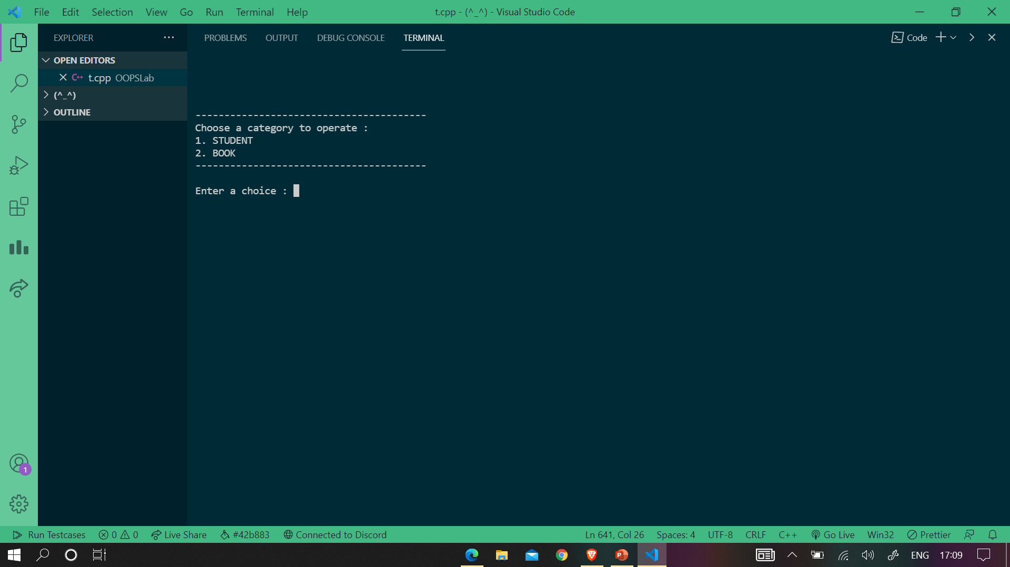

Now, here we have two options first for managing the student category and the second one for the books category. Enter the respective number (i.e., 1 for Student and 2 for Books) to manage them. Let’s suppose we choose to manage the Students category, then a new dialogue box will appear as shown below.

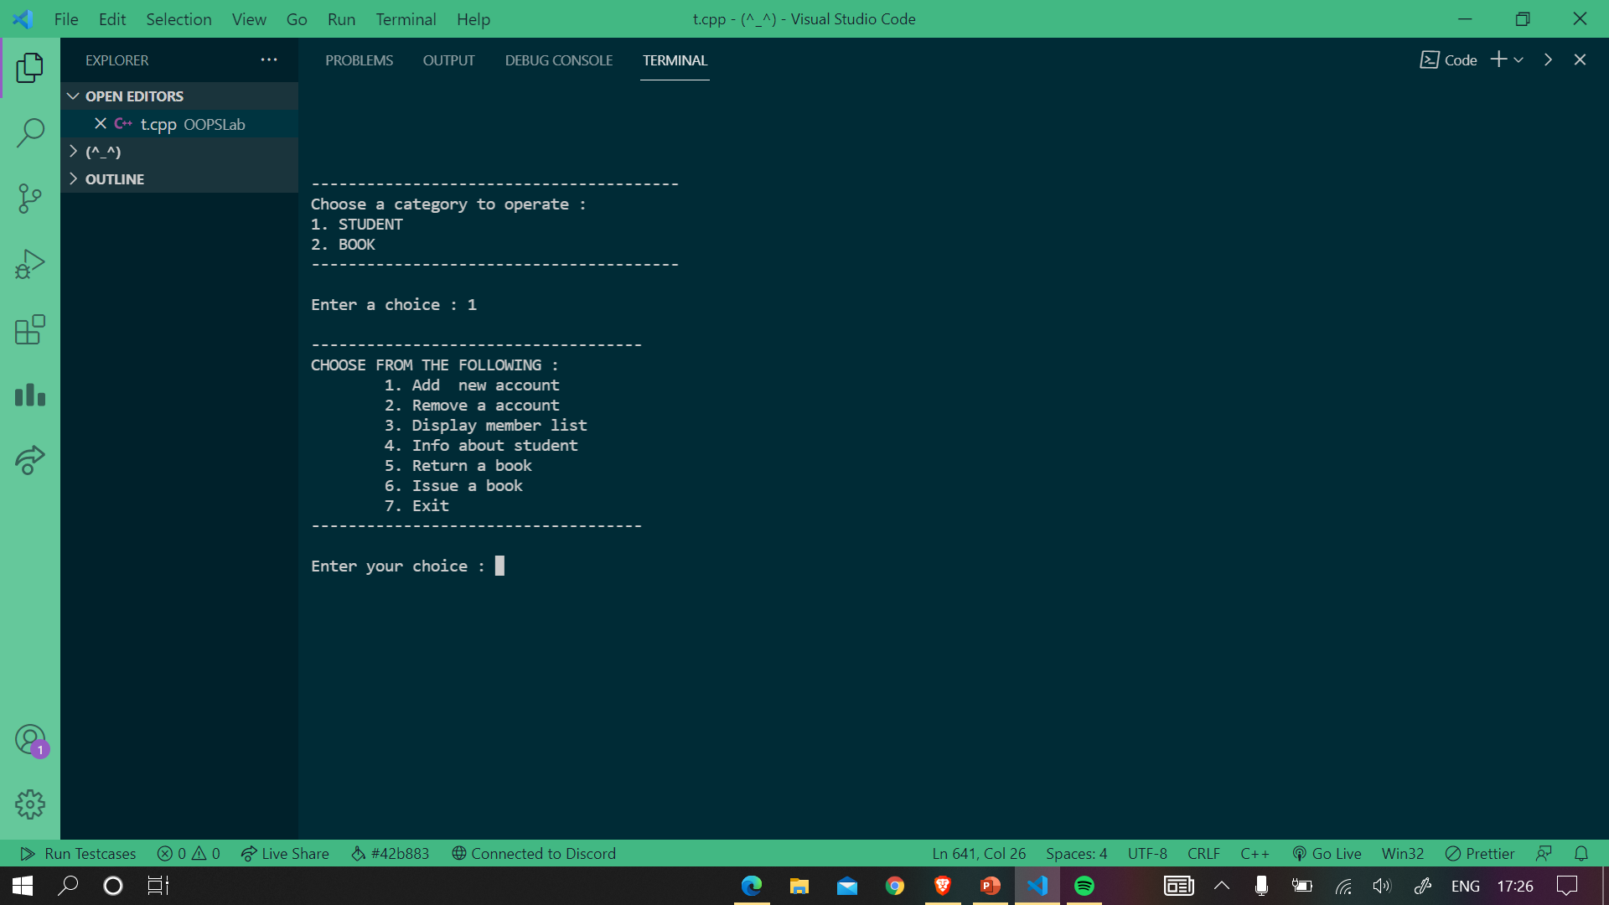

Here, we have various options. Let us explore them one by one. To use any operation enter the corresponding number.

1. **Add new account**

Firstly this function will ask the user to enter the number of students the librarian wants to register/add. Let’s register a student. Then, the program asks for the details of the student.

Enter the student’s name

**Note: You cannot give spaces in the name of the student.**

Enter the DOB of the student in the specific format **dd-mm-yyyy (with hyphens)**

A screenshot is attached below for reference.

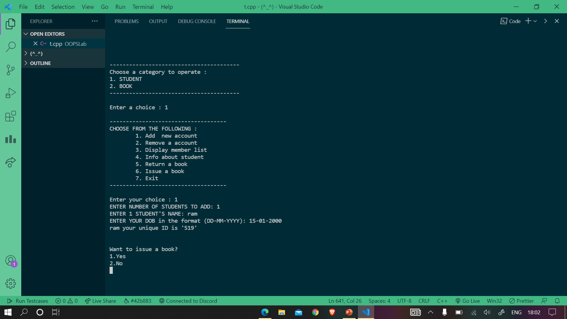

There is a prompt to issue a book. If you want to issue; enter 1, else enter 2.

Let’s issue one for demonstration

Now, enter the details of the book you want to issue

Enter the book name

**Note: You cannot enter spaces in the book name instead can use underscore.**

Enter the book id

Enter the date of issuing the book in the format **dd mm yyyy (with spaces)**

Enter the number of days for which you want to issue the book.

*Let’s make the student a prime member. So input a number greater than 10*

Enter the number of months you want the membership.

Enter the registration date in the format **dd/mm/yyyy (with slashes)**

After doing that all, you will reach on the homepage

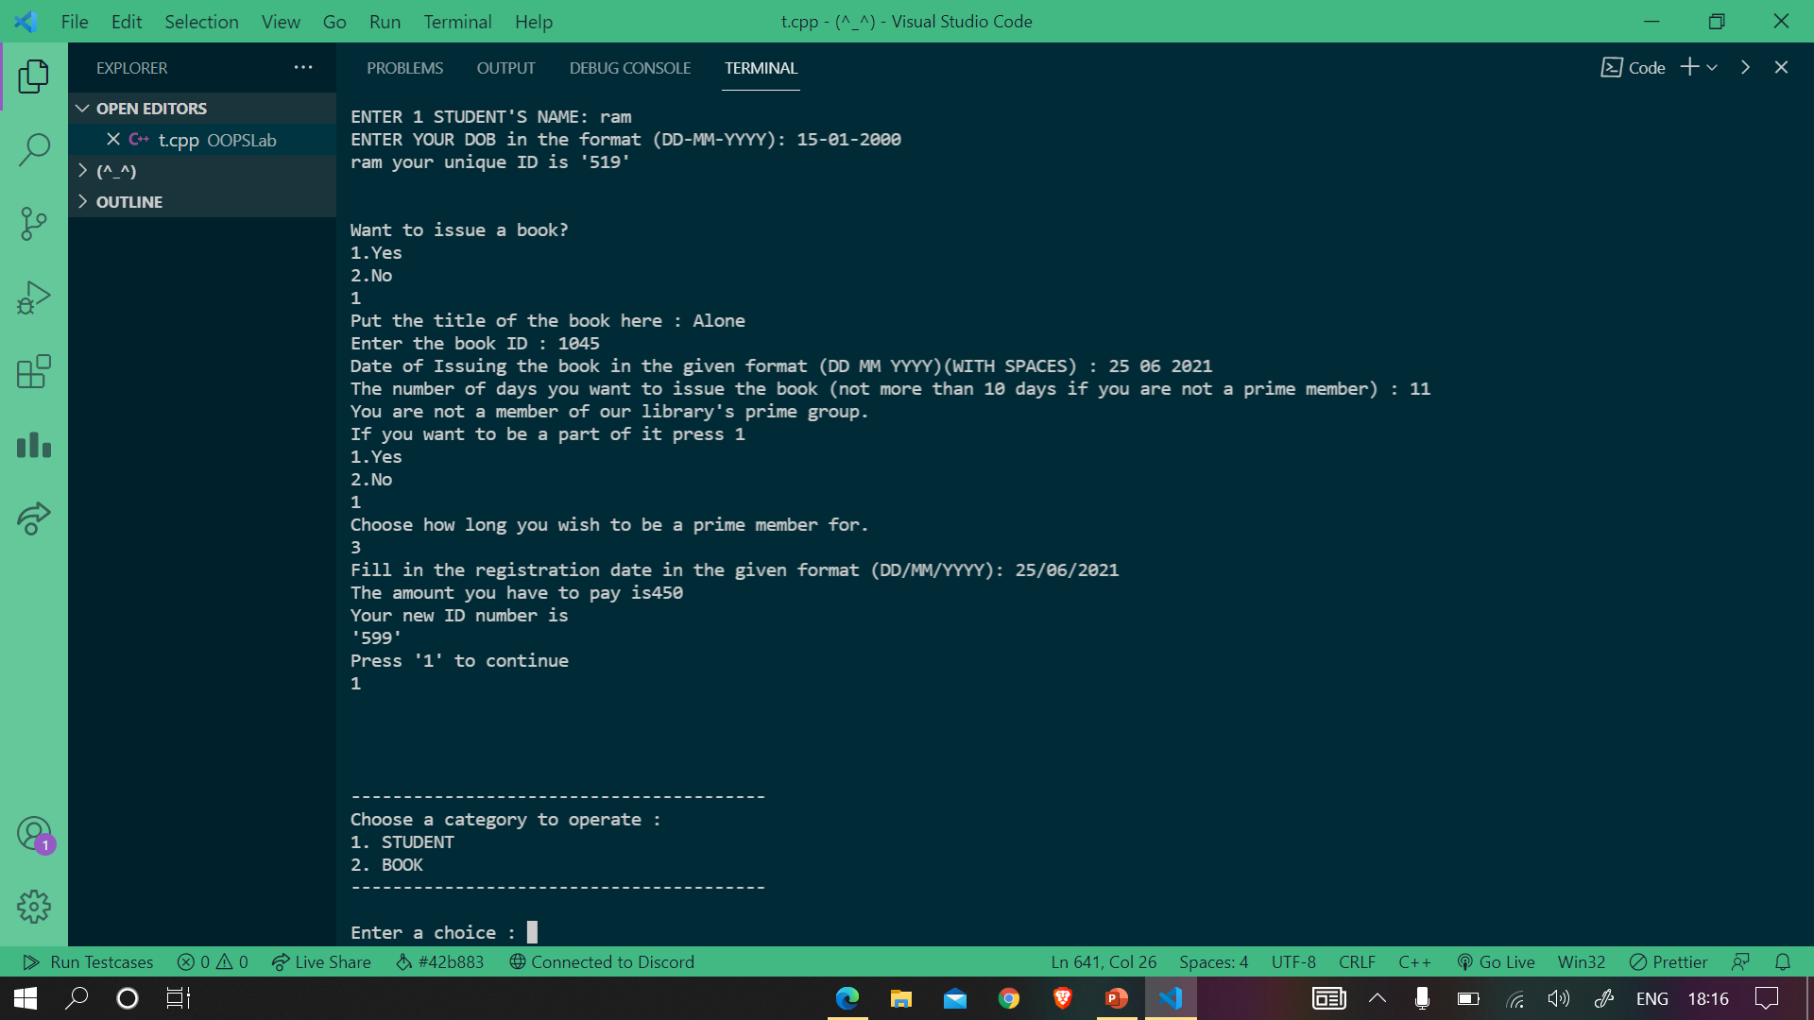

Now, let’s display the member list

1. **Display member list**

Enter the corresponding number to display the member list.

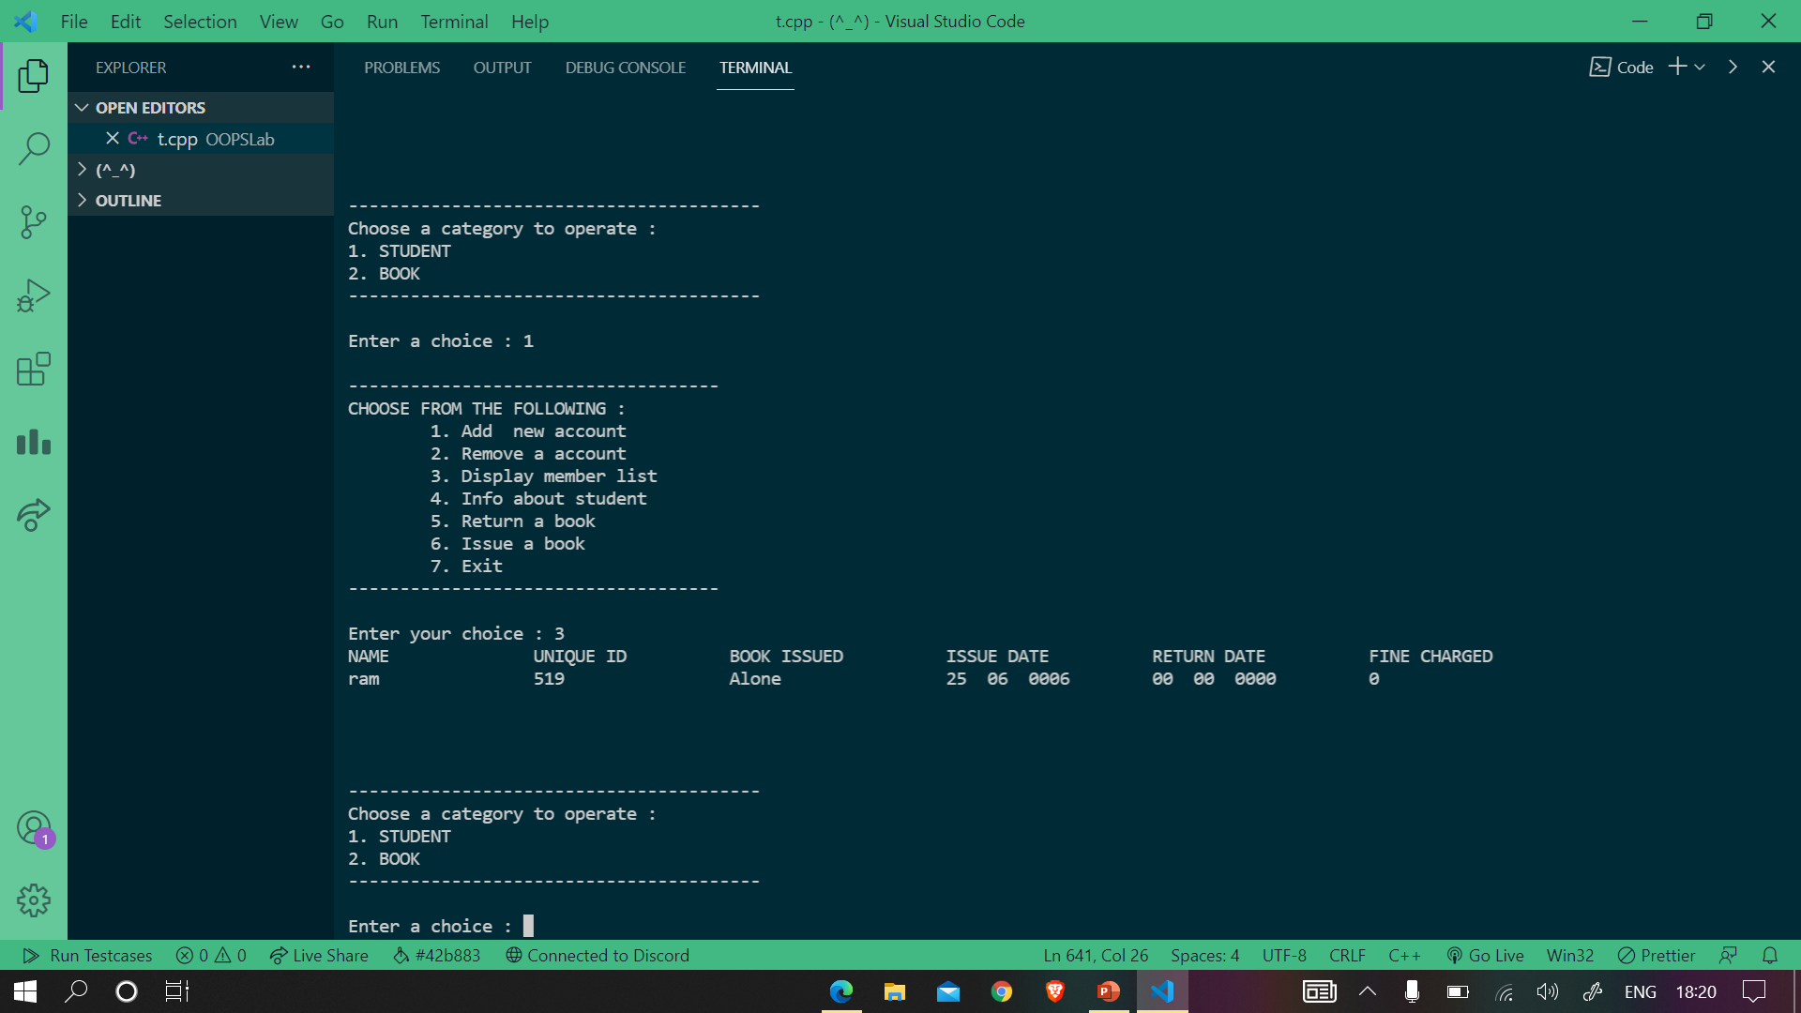

1. **Info about student**

Let’s fetch the information of the created student. It asks for the **prime id (if you are a prime member) else the id provided to you during registration**. Since we are a prime member the id for us is 599.

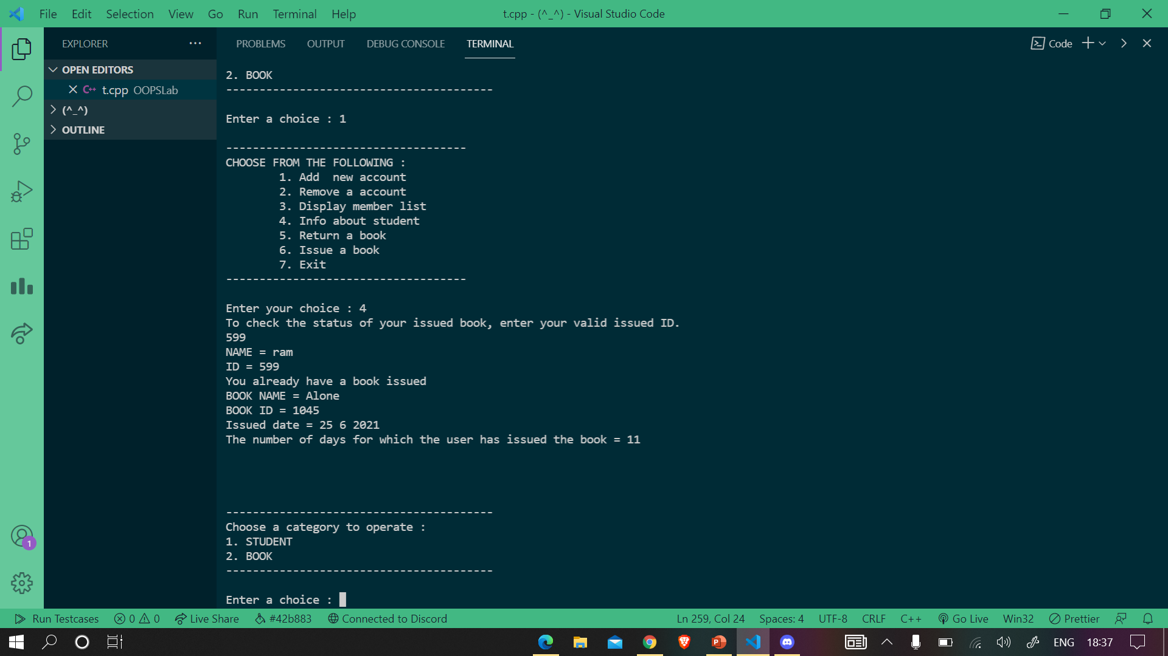

1. **Return a book**

Let’s now return the book.

It asks you the **unique id (different from the prime id)**. Enter it

Then, enter the returning date in the format **dd mm yyyy (with spaces)**

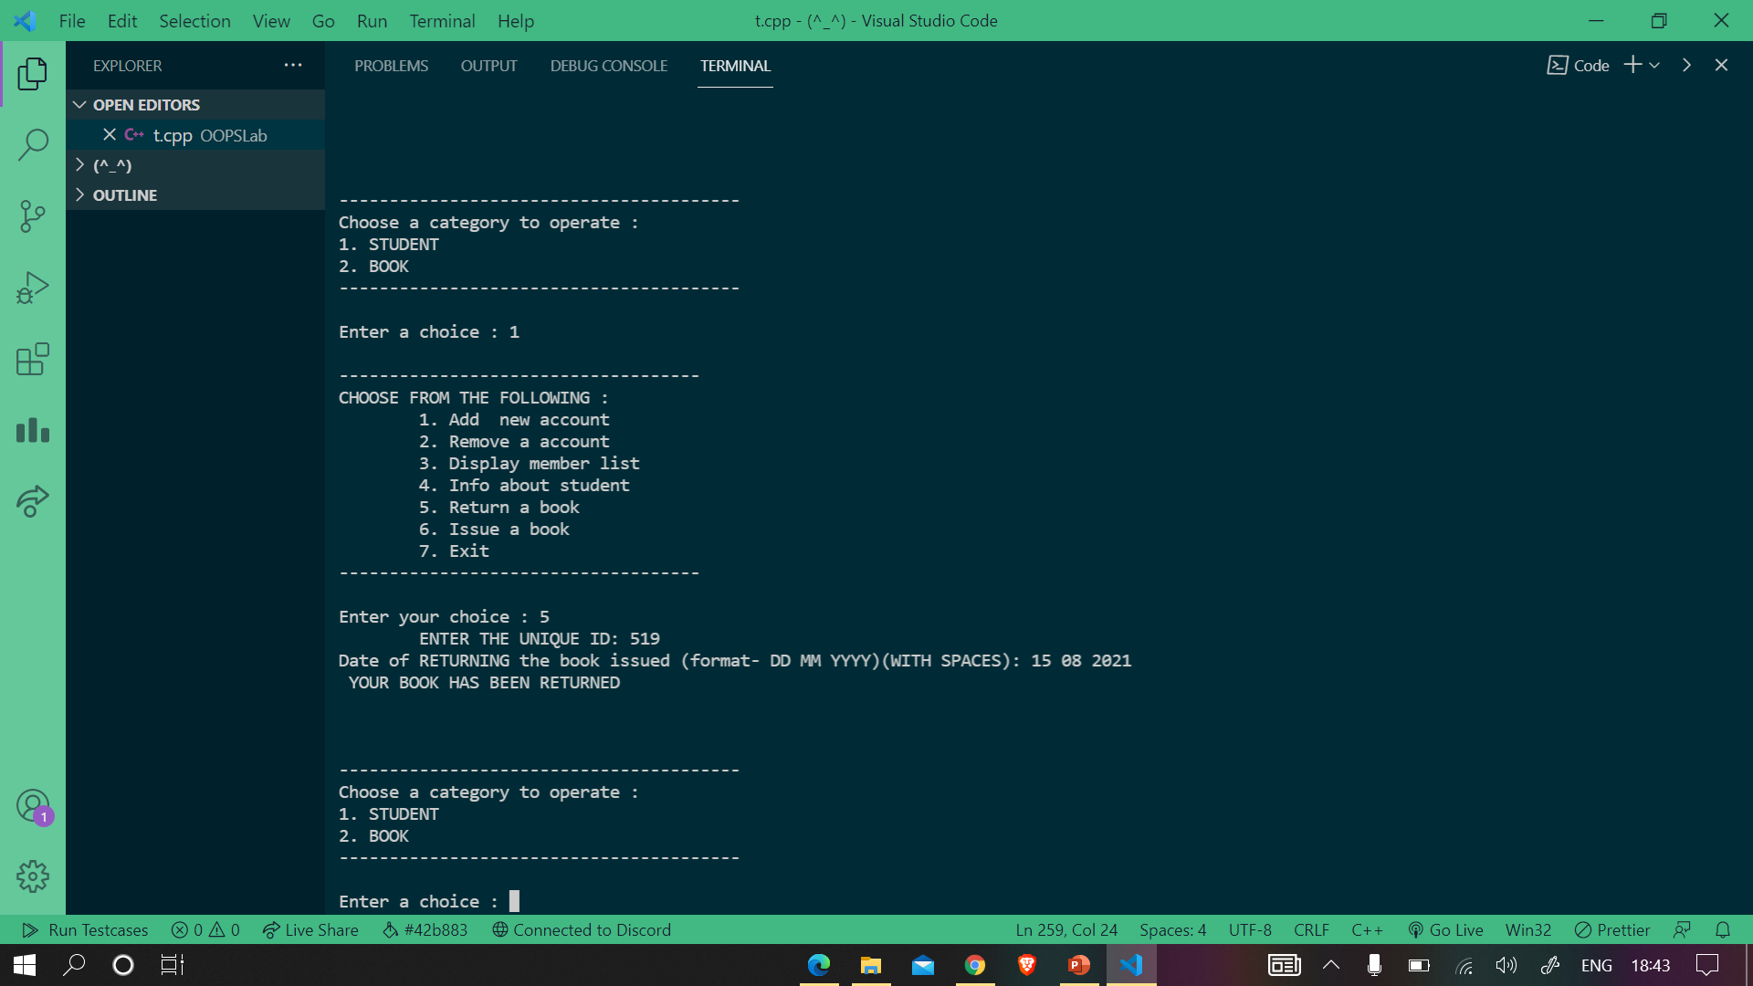

1. **Issue a book**

Now, let’s issue a different book.

It asks you the **unique id (different from the prime id)**. Enter it

Enter the book id

Then, enter the issuing date in the format **dd mm yyyy (with spaces)**

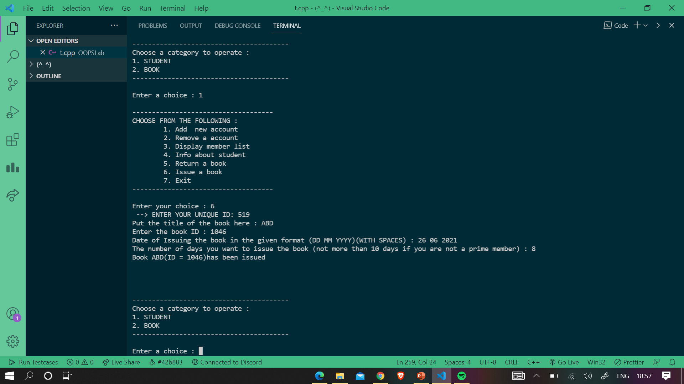

1. **Remove an account**

Let’s remove the account.

It asks you to enter the number for searching the member via his/her name or via id.

Now, let’s explore the book category.

You are provided with various option regarding books weather to

1. Add a New book
2. Remove a Book
3. Display whole Booklist

Let’s explore them.

1. **Add a new book**

Firstly, it asks you to enter the number of books you want to add.

Let’s say 2.

Then, their names and their id’s.

**Note: You cannot add spaces in the names of the book instead can use underscore.**

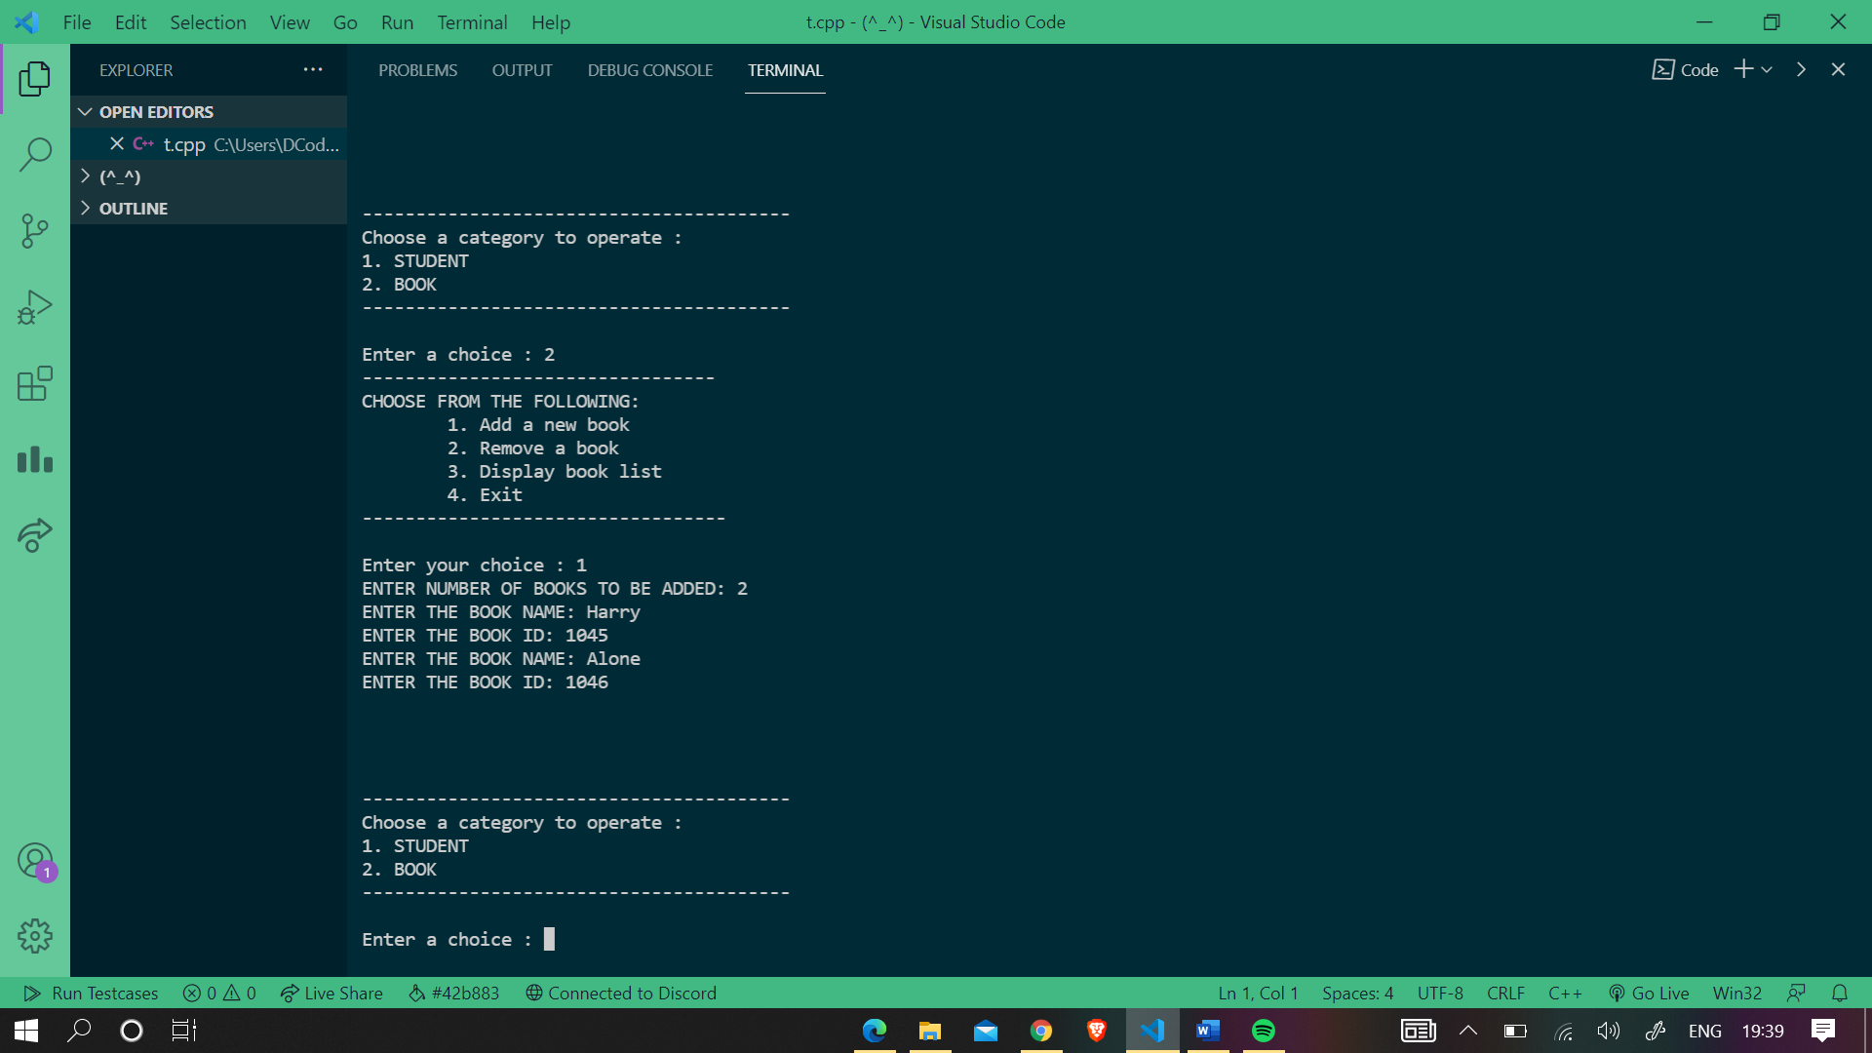

1. **Display booklist**

It just displays the book list

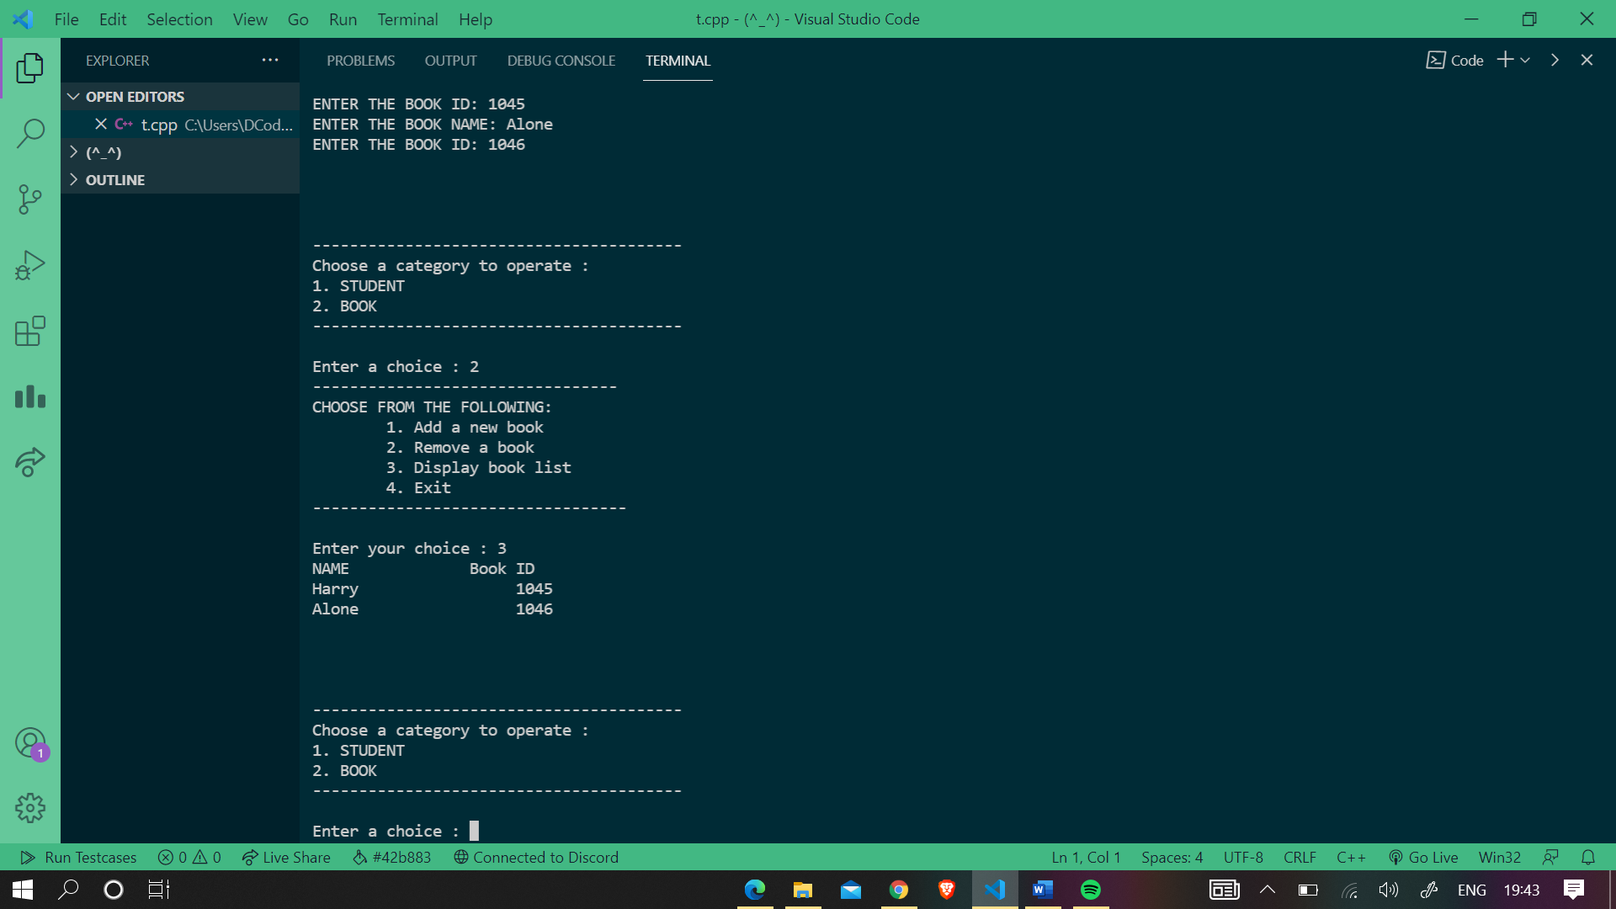

1. **Remove a book**

It asks you to either search the book via it’s name or id. Let’s search it via name.

Then, enter the name of the book.

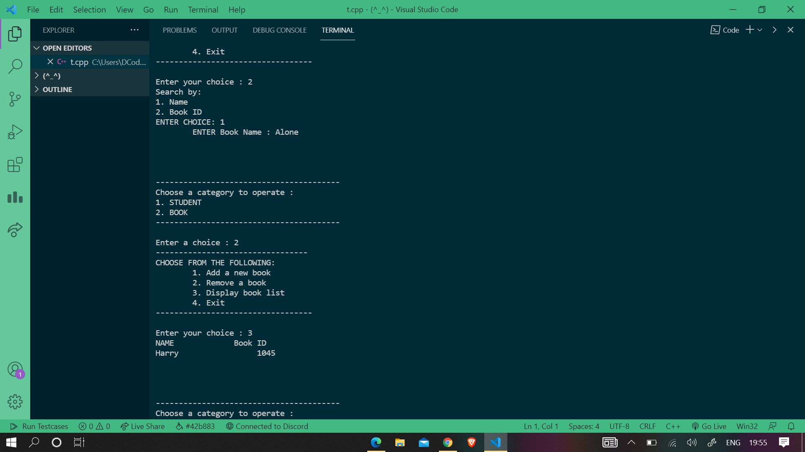

THANK YOU