**SMART STREET LIGHT SYSTEM USING ARDUINO**

By: PRATIK GUPTA (39/CSE/16027/183)

&

ABHISHEK MISHRA (39/CSE/16146/136)



*A Thesis submitted to*

**Indian Institute of Information Technology, Kalyani**

*for the partial fulfilment of the degree of*

**Bachelor of Technology**

**In**

**Computer Science and Engineering**

**April, 2019**

**Acknowledgments**

Our guide, Dr. Tamal Ghosh, has helped us throughout this project of 2 semesters from July 2018 to April 2018. As he himself has worked in this field, he has expertise and experience that helped us to understand objective of this project.

Right from the beginning he always disintegrated the project into small and singular tasks that were easy to understand and implement. Most importantly he allowed us to implement tasks with methods that we were comfortable with and he has given us enough time for implementations and at the same time he has also monitored our progress regularly.

Pratik Gupta (CSE/16027/183) Abhishek Mishra (CSE/16146/136)

Computer Science and Engineering

Indian Institute Of Information Technology Kalyani

Place: Kalyani, West Bengal

Date: 25th November, 2018

**Certificate**

This is to certify that the thesis entitled “Smart Street Light using Arduino” being submitted by Pratik Gupta and Abhishek Mishra, undergraduate students of Registration numbers - 183, 136 and Roll Numbers – 16027,16144 respectively, in the Department of Computer Science and Engineering, Indian Institute of Information Technology, Kalyani, West Bengal, 741235, India, for the award of Bachelors of Technology in Computer Science and Engineering is an original research work carried out by them under my supervision and guidance. The thesis has fulfilled all the requirements as per the regulations of Indian Institute of Information Technology, Kalyani and in my opinion, has reached the standards for submission. The work, techniques and the results presented have not been submitted to any other University or Institute for the award of any other degree or diploma.

Dr. Tamal Ghosh

Assistant Professor

Indian Institute Of Information Technology Kalyani

**Declaration**

We hereby declare that the work being presented in this thesis entitled “SMART STREET LED SYSTEM USING ARDUINO”, submitted to Indian Institute of Information Technology Kalyani in partial fulfilment for the award of the degree of Bachelor of Technology in Computer Science and Engineering during the period of July 2018 to April 2019 under the supervision of Dr. Tamal Ghosh, Indian Institute of Information Technology Kalyani, West Bengal 741235, India does not contain any classified information.

Pratik Gupta (CSE/16027/183) Abhishek Mishra (CSE/16146/136)

Computer Science and Engineering

Indian Institute of Information Technology, Kalyani

This is to certify that the above statement made by the candidates is correct to the best of my knowledge.

………………………………………………..

Dr. Tamal Ghosh

Assistant Professor

Indian Institute Of Information Technology Kalyani

Place: Kalyani, West Bengal

Date: 25th Nov,2018

**ABSTRACT**

This project aims for designing and executing the advanced development in embedded systems for energy saving of street lights. Currently we have a manual system where the street lights will be switched ON in the evening before the sunsets and they are switched OFF in the next day morning after there is sufficient light on the outside. But the actual timing for these lights to be switched ON is when there is absolute darkness. With this, the power will be wasted up to some extent. This project gives solution for electrical power wastage. Also the manual operation of the lighting system is completely eliminated. The proposed system provide a solution for energy saving.

This is achieved by sensing and approaching a vehicle using an IR transmitter and IR Receiver couple. Upon sensing the movement the sensor transmit the data to the microcontroller which furthermore the Light to switch ON.

Similarly as soon as the vehicle or an obstacle goes away the Light gets switched OFF as the sensor sense any object at the same time the status(ON/OFF) of the street light can be accessed from anywhere and anytime through internet.

This project is implemented with smart embedded system which controls the street lights based on detection of vehicles or any other obstacles on the street .Whenever the obstacle is detected on the street within the specified time the light will get automatically ON/OFF according to the obstacle detection. We can also upload the data on the Internet for people to see how it saves electricity and power.

**CONTENTS:**

1. Chapter 1 – **Introduction**……………………………………………………………..7
2. Chapter 2 – **Implementation**…………………………………………………………9
3. Chapter 3 – **Components** **used**………………………………………………………12
4. Chapter 4 – **Arduino**…………………………………………………………………17
5. Chapter 5 – **Code Implementation**………………………………………………….20
6. Chapter 6 – **Future Goals**……………………………………………………………21
7. Chapter 7 – **SSLS as a Business Model**…………………………………………….22
8. Chapter 8 – **Real World Implementations**…………………………………………24
9. References ………………………………………………………………………….25

**Chapter 1**

**Introduction**

* 1. **About Smart/Intelligent Street LED Light System:**

Currently, in the whole world, enormous electricity is consumed by the street lights, which are controlled by means of embedded brightness sensors. They are automatically turned off when it’s bright and automatically turned on when it’s dark. This is a huge waste of energy and this system needs to be changed.

There’ve been some attempts in which energy wastes of the street light are reduced. Using sensors like IR and motion to detect the object and light the street light accordingly. It only turns on for w while and when it’s dark. However, it’s usually too late to turn on the light after the light comes in front of it. The light should turn on before the person or car comes.

We propose an autonomous light distribution system in which the initial street light is always on when its dark, but with a low intensity. When it senses an object, it’ll increase its intensity to full and also light up 2 more street lights in front of it. After the object has gone by, the light changes back to its initial state, i.e. the first street light will be at a dim brightness and the rest that were on will be turned off.

**1.2 About Arduino:**

Arduino, which we will be using to implement our system is a microcontroller.

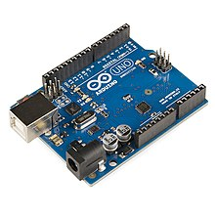

consumed by the street lights, which are controlled by

means of the embedded brightness sensors. They are

automatically turn on when it becomes dark and

automatically turn off when it becomes bright. This is the

**Arduino** is an [open-source hardware](https://en.wikipedia.org/wiki/Open-source_hardware) and [software](https://en.wikipedia.org/wiki/Open-source_software) company, project and user community that designs and manufactures [single-board microcontrollers](https://en.wikipedia.org/wiki/Single-board_microcontroller) and [microcontroller](https://en.wikipedia.org/wiki/Microcontroller) kits for building digital devices and interactive objects that can sense and control objects in the physical and digital world. Its products are licensed under the [GNU Lesser General Public License](https://en.wikipedia.org/wiki/GNU_Lesser_General_Public_License) (LGPL) or the [GNU General Public License](https://en.wikipedia.org/wiki/GNU_General_Public_License) (GPL), permitting the manufacture of Arduino boards and software distribution by anyone. Arduino boards are available commercially in preassembled form or as [do-it-yourself](https://en.wikipedia.org/wiki/Do-it-yourself) (DIY) kits.

Arduino board designs use a variety of microprocessors and controllers. The boards are equipped with sets of digital and analog [input/output](https://en.wikipedia.org/wiki/Input/output) (I/O) pins that may be interfaced to various expansion boards or [breadboards](https://en.wikipedia.org/wiki/Breadboards) (*shields*) and other circuits. The boards feature serial communications interfaces, including [Universal Serial Bus](https://en.wikipedia.org/wiki/Universal_Serial_Bus) (USB) on some models, which are also used for loading programs from personal computers. The microcontrollers are typically programmed using a dialect of features from the programming languages [C](https://en.wikipedia.org/wiki/C_(programming_language)) and [C++](https://en.wikipedia.org/wiki/C%2B%2B). In addition to using traditional compiler toolchains, the Arduino project provides an integrated development environment (IDE) based on the Processing language project.

**1.3 Advantage of SSLS:**

* Automatic street light control is used to control the street lights(Turn on and off based on the light).
* If we uses this idea and implement to it in our society it will be helpful in saving enough amount of electricity and off-course money.
* Its a solution to energy conservation is to eliminate time slot and introduce a system that could sense brightness environment and act accordingly so that seasonal change would not affect the intensity of street light.
* The existing systems consist of manual controls which need constant monitoring and maintenance. Considering the wastage of energy due to manual control many systems have been introduced. These systems are designed in such a manner that they could reduce their intensity and save as much energy as possible. Systems like these use LEDs (Light Emitting Diode) instead of HID (High Intensity Discharge) lamps due to dimming feature. This will reduce energy consumption as well as manual labor.

**CHAPTER 2**

**IMPLEMENTATION**

**2.1 Current Implementation Techniques:**

The existing solutions are based on either of the following techniques:

1. Manual switching: This is the classic and omnipresent technique. The light is switched ON and OFF by a human attendant.
2. Light dependent resistance (LDR): LDR-based lights can switch themselves ON and OFF according to the ambient light conditions. Tolerance variation in LDRs requires manual tuning of threshold levels in individual lights, typically using potentiometers. Dust deposits can also affect the sensitivity. Such factors reduce the reliability of the system.
3. Astronomical Timers: These devices choose the switch ON or switch OFF time depending on the date on the calendar. The devices are preprogramed according to the location of the installation. This scheme is inflexible, does not take care of variable light situations such as overcast, dust storm etc.

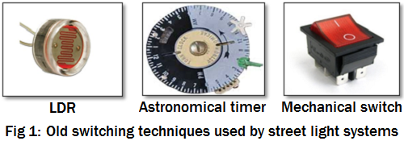

The above systems are simple, economical and easy to install. However, these are not flexible and do not lend themselves to modern power-saving strategies. They provide limited monitoring capabilities.

**2.2 Why Smart Street Lighting:**

The transformation from a classic street lighting system to a smart street lighting solution is primarily enabled by the ability of devices to connect to and communicate with each other. It means that the various components of a normal street lighting system can be interlinked via a communication network. This gives an operator the ability to individually control and monitor street lights in an entire locality. Such connected systems overcome the limitations of manual systems, and also allow one to:

1. Remotely switch ON or switch OFF street lights and control their timings.
2. Control parameters like intensity of individual street lights to attain maximum efficiency.
3. Detect and report faults from remote locations and schedule appropriate maintenance activities. Such systems can detect faults in the lamp as well as the driving circuit. These can also detect overvoltage and undervoltage situations, presence of humidity in the enclosure and operating temperature among others.
4. Identify the presence of pedestrians or vehicles to switch ON lights when they approach.
5. Measure the power consumed by the light and detect power pilferage.
6. Detect accidents or damage to the pole, by analysing the inputs from the motion sensors.
7. Monitor additional parameters like pollution level, noise and ambient light level.

The advantages that a smart street lighting system offers in terms of maintenance are often underestimated. For example, the ability to identify a faulty street light from a central location and to send a crew only to repair that particular street light offers huge savings in time and money over the current approach of having to dispatch maintenance crew to check all the street lights one by one over a period of time as a routine activity.

**2.2.1 Basic units of a smart street light system**

The following are the key components of the proposed smart street light solution:

1. Central Monitoring Station (CMS): It monitors the connected streetlights.
2. Data Concentrator Unit (DCU): One unit is installed per street. This unit communicates with the CMS over a cellular network.
3. Lamp Control Unit (LCU): An LCU is mounted on each streetlight.

**2.3 Proposed System:**

1. We are making a smart street LED system using Arduino.
2. Our idea is to get the street lights off during the daytime.
3. As it gets darker, we switch on the initial street lamp and the rest of the lamps get off only when the IR sensor of the respective lamp detects any object.
4. We’re also not switching only a single lamp, but two more street lamps in front of it with dim intensities.
5. The initial lamp is always on, the rest get off when the object passes by the lamp.
6. With the LM393 sensor, we’ve used speed as a way to calculate the number of next street lamps to be turned on.

We’ve used Arduino UNO and Arduino IDE to implement the above system.

**2.3.1 Functions Used:**

1. pinMode()
2. analogRead()
3. analogWrite()
4. digitalRead()
5. digitalWrite()
6. Serial.begin(9600)
7. Serial.println()

**CHAPTER 3**

**COMPONENTS USED**

* 1. **IR SENSOR – Infrared Sensor**

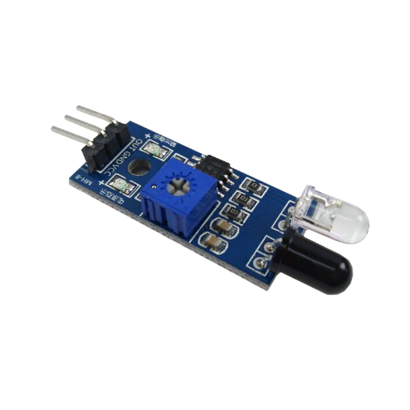

An IR sensor is a device which detects IR radiation falling on it. There are numerous types of IR sensors that are built and can be built depending on the application. Proximity sensors (Used in Touch Screen phones and Edge Avoiding Robots), contrast sensors (Used in Line Following Robots) and obstruction counters/sensors (Used for counting goods and in Burglar Alarms) are some examples, which use IR sensors.

**3.1.1 Working Mechanism:**

An IR sensor is basically a device which consists of a pair of an IR LED and a photodiode which are collectively called a photo-coupler or an opto-coupler. The IR LED emits IR radiation, reception and/or intensity of reception of which by the photodiode dictates the output of the sensor. Now, there are so many ways by which the radiation may or may not be able to reach the photodiode.

* 1. **LDR: Light Dependent Resistors**

An [LDR](https://kitronik.co.uk/components/switches-and-sensors/light-sensors.html) is a component that has a (variable) resistance that changes with the light intensity that falls upon it. This allows them to be used in light sensing circuits.

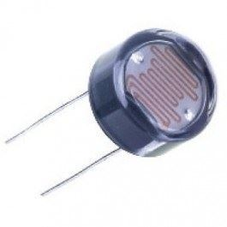

## Variation in resistance with changing light intensity:

## Typical LDR (Light Dependent Resistor) resistance vs light intensity graph

## 3.2.1 Applications of LDRs

There are many applications for Light Dependent Resistors. These include:

### **Lighting switch**

The most obvious application for an LDR is to automatically turn on a light at a certain light level. An example of this could be a street light or a garden light.

### **Camera shutter control**

LDRs can be used to control the shutter speed on a camera. The LDR would be used to measure the light intensity which then adjusts the camera shutter speed to the appropriate level.

**3.3 LED: Light Emitting Diode**

A light-emitting diode (**LED**) is a two-lead semiconductor light source. It is a p–n junction diode that emits light when activated. When a suitable current is applied to the leads, electrons are able to recombine with electron holes within the device, releasing energy in the form of photons.

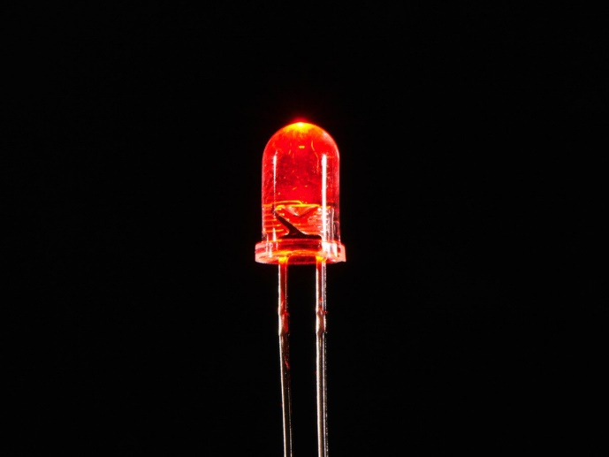

**3.4 ARDUINO UNO:**

The Arduino UNO is an open-source microcontroller board based on the [Microchip](https://en.wikipedia.org/wiki/Microchip_Technology) [ATmega328P](https://en.wikipedia.org/wiki/ATmega328P) microcontroller and developed by [Arduino.cc](https://en.wikipedia.org/wiki/Arduino).The board is equipped with sets of digital and analog input/output (I/O) pins that may be interfaced to various expansion boards (shields) and other circuits. The board has 14 Digital pins, 6 Analog pins, and programmable with the [Arduino IDE](https://en.wikipedia.org/wiki/Arduino#Software) (Integrated Development Environment) via a type B USB cable. It can be powered by a USB cable or by an external 9 volt battery, though it accepts voltages between 7 and 20 volts.

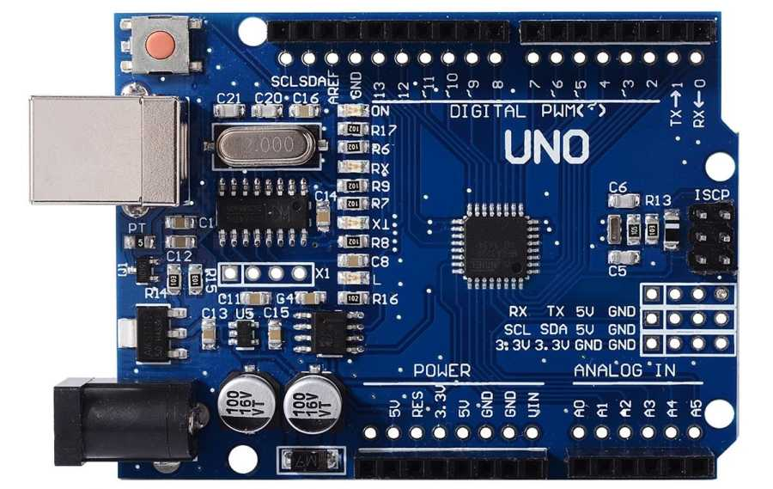

**3.4.1 Technical Specifications:**

* Microcontroller: [Microchip](https://en.wikipedia.org/wiki/Microchip_Technology) [ATmega328P](https://en.wikipedia.org/wiki/ATmega328P)
* Operating Voltage: 5 Volt
* Input Voltage: 7 to 20 Volts
* Digital I/O Pins: 14 (of which 6 provide PWM output)
* Analog Input Pins: 6
* DC Current per I/O Pin: 20 mA
* DC Current for 3.3V Pin: 50 mA
* [Flash Memory](https://en.wikipedia.org/wiki/Flash_Memory): 32 KB of which 0.5 KB used by [bootloader](https://en.wikipedia.org/wiki/Booting#BOOT-LOADER)
* [SRAM](https://en.wikipedia.org/wiki/Static_random-access_memory): 2 KB
* [EEPROM](https://en.wikipedia.org/wiki/EEPROM): 1 KB
* Clock Speed: 16 MHz
* Length: 68.6 mm
* Width: 53.4 mm
* Weight: 25 g

**3.5 BREADBOARD AND WIRES :**

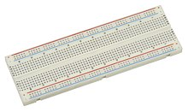A **breadboard** is a solderless device for temporary prototype with electronics and test circuit designs. Most electronic components in electronic circuits can be interconnected by inserting their leads or terminals into the holes and then making connections through wires where appropriate.

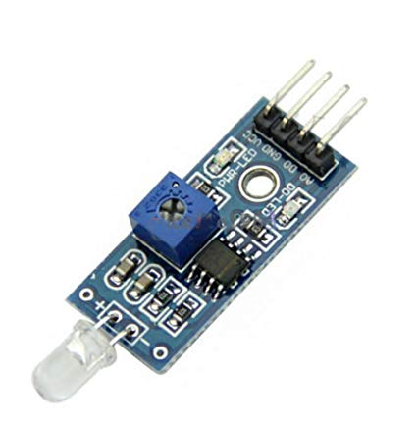**3.6 LM393 Speed Sensor:**

Widely used in motor speed detection, pulse count, the position limit, etc. The DO output interface can be directly connected to a micro-controller IO port, if there is a block detection sensor, such as the speed of the motor encoder can detect. DO modules can be connected to the relay, limit switch, and other functions, it can also with the active buzzer module, compose alarm.

Main technical characteristics:

• Dimensions: 32 x 14 x 7mm.

• The sensor reading slot has a width of 5mm.

• Two outputs, one Digital and one Analog.

• LED power indicator.

• LED indicator of the output pulses of pin D0.

**CHAPTER 4**

**ARDUINO**

*Main component of this project is Arduino. It is the heart of smart street LED light system, it coordinates and controls the whole set up of project.*

**4.1 ABOUT ARDUINO:**

* Arduino is an open-source hardware and software company, project and user community that designs and manufactures single-board microcontrollers and microcontroller kits for building digital devices and interactive objects that can sense and control objects in the physical and digital world.
* Arduino board designs use a variety of microprocessors and controllers.
* The boards are equipped with sets of digital and analog input/output (I/O) pins that may be interfaced to various expansion boards or breadboards (shields) and other circuits.
* The boards feature serial communications interfaces, including Universal Serial Bus (USB) on some models, which are also used for loading programs from personal computers.
* Most Arduino boards consist of an Atmel 8-bit AVR microcontroller (ATmega8,[24] ATmega168, ATmega328, ATmega1280, ATmega2560) with varying amounts of flash memory, pins, and features.
* We are using ATmega328.
* Arduino microcontrollers are pre-programmed with a boot loader that simplifies uploading of programs to the on-chip flash memory.
* Boards are loaded with program code via a serial connection to another computer.

**4.2 Architechture:**

Arduino’s processor basically uses the Harvard architecture where the program code and program data have separate memory. It consists of two memories- Program memory and the data memory. The code is stored in the flash program memory, whereas the data is stored in the data memory. The Atmega328 has 32 KB of flash memory for storing code (of which 0.5 KB is used for the bootloader), 2 KB of SRAM and 1 KB of EEPROM and operates with a clock speed of 16MHz.

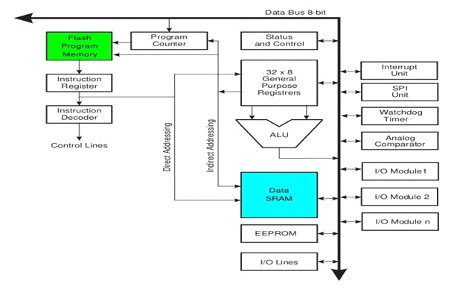

**4.3 Pin Diagram:**



Arduino Uno consists of 14 digital input/output pins (of which 6 can be used as PWM outputs), 6 analog inputs, a 16 MHz crystal oscillator, a USB connection, a power jack, an ICSP header, and a reset button.

**4.3.1 Power Jack:**

Arduino can be power either from the pc through a USB or through external source like adaptor or a battery. It can operate on an external supply of 7 to 12V. Power can be applied externally through the pin Vin or by giving voltage reference through the IORef pin.

**4.3.2 Digital Inputs:**

It consists of 14 digital inputs/output pins, each of which provide or take up 40mA current. Some of them have special functions like pins 0 and 1, which act as Rx and Tx respectively , for serial communication, pins 2 and 3-which are external interrupts, pins 3,5,6,9,11 which provides pwm output and pin 13 where LED is connected.

**4.3.3 Analog inputs:**

It has 6 analog input/output pins, each providing a resolution of 10 bits.

**CHAPTER 5**

**CODE IMPLEMENTATION**

Code of this project is available at:

***www.github.com/pikabing/Smart-Street-LED-System***

We’ve used a speed sensor, but the speed can be calculated only if that sensor is connected to a wheel.

Solution: We can connect a speed sensor to vehicles running by and send the data through a network to nearby street lamp network. The lamp will take the data, process it accordingly and calculate the number of lamps to turn on after the initial lamp.

We’ve also built an app, which will turn or off the street lamp according to their position or serial number. To connect the Arduino to our app we will need a Bluetooth module.

We’ve implemented the hardware and a beginner base has been setup for a Smart Street LED System.

We can expand this to large scale by establishing a network of Street Lamps. That is but a huge task, requires huge infrastructure and capital and is beyond our scope for now.

**CHAPTER 6**

**FUTURE GOALS**

* 1. We can use technologies like GSM to make a network and using this network, we can interconnect all the street lamps.
  2. This networked LED system can be controlled from a control room. Several PIR sensors can be used to decrement or increment the intensity of the lamps.
  3. The system architecture of the intelligent street light system will consist of IR sensors, LDR, PIC16F877A microcontroller, Relay, UART and Wi-Fi Module. A UART (Universal Asynchronous Receiver/Transmitter) is the microchip with programming that controls a computer's interface to its attached street light system.

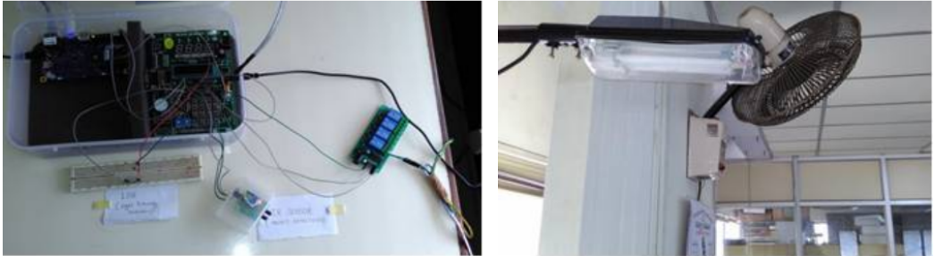

1. We can share the network data to traffic control units. The data from this network can be used in various fields.
2. As we’re using LED in place normal street lamps, we can design a mechanism as to put the LED’s at 50% of their intensity, as they are much brighter than normal street lamps.

**CHAPTER 7**

**Smart Street System As a Business Model**

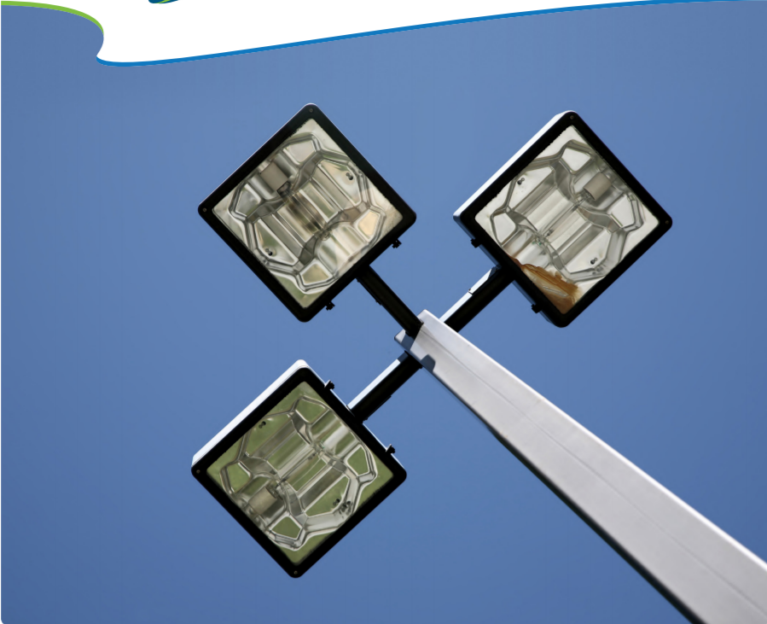

**The Business Case for Smart Street Lights:**

Street lighting is an important community service, but it can consume as much as 40 percent of a city’s energy budget. Legacy street lights are failure prone and costly to manage, which add to lighting costs.

Consequently, street lighting has emerged as a leading smart city application. By replacing existing street lights with LED-based lamps, utilities and other street light operators can cut energy and operations costs by 50 percent or more.

Networking those LEDs delivers an even faster return on investment (ROI), taking the payback period down to 6 vs. 8 years, as a result of features such as remote management and faster outage response. Understanding the operational details of networked LEDs and comparing those benefits and costs to traditional lighting lays the foundation for building a business case to upgrade street lights. The hard dollar savings in energy and operational costs make the case for replacement, and networked LEDs provide additional community value as well.

**The Advantages of Networked LEDs:**

Legacy high-pressure sodium and mercury street lamps are not energy efficient and typically operate 12 hours a day at full intensity, so their energy cost is high. These lamps also have a short life span (around 5 years), resulting in unpredictable and expensive operations. Operators must replace roughly 20 percent of these lamps each year. New energy efficient LED-based street lights have a life span of up to 20 years, enabling lower energy and operations costs.

**Energy savings**:

Typically, the largest benefit of networking LED street lights is lower energy costs, which result from the following features:

**» Low wattage:** LEDs provide significant energy savings by delivering the same or enhanced quality light at lower wattages than legacy bulbs.

**» Dimming:** Due to their high light output, LED lamps can be dimmed as much as 50 percent when first installed with minimal compromise in light output. In addition, operators can schedule lamps to dim as circumstances allow, such as at low traffic times, in unpopulated areas the middle of night, etc. The city of Brittany, France, for example, dims its street lights by 60 percent between 11 p.m. and 5 a.m. to save energy.

**» Reduced burn time:** With on/off scheduling capabilities, operators can easily modify street light operation to coincide with changing sunrise/sunset times, reducing lamp burn time. As a result of these features, networked LEDs can reduce energy use for street lighting by 60 to 74 percent. For example, Los Angeles and Oslo, Norway, which have launched smart street light projects, have seen energy savings of 63 and 62 percent, respectively.

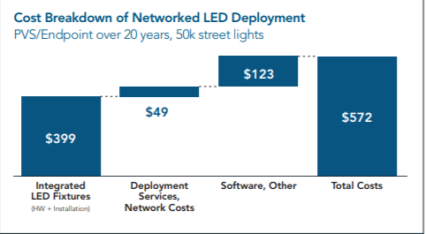**Cost:**

A typical operator will spend approximately $572 per light to deploy, operate and maintain their networked LEDs.

**CHAPTER 8**

**Real World Implementation**



**CASE STUDY**

A hub for smart city innovation, Paris has committed to reduce public lighting energy consumption by 30 percent over the next 10 years while ensuring quality lighting for residents. The approach:

» INTEGRATED SMART STREET LIGHTING AND TRAFFIC SIGNAL CONTROL – deploying a citywide canopy network connecting cabinet-based controllers for more than 200,000 street and traffic lights across the city

» IPv6-BASED MULTI-APPLICATION NETWORK – creating a platform for future services such as traffic management, environmental sensors, smart parking, electric vehicle charging, electricity metering, and water conservation

» PROJECT PILOT – quickly demonstrating improved lighting efficiencies by starting with a tightly scoped city initiative

**REFERENCES**

[1] <https://www.youtube.com/watch?v=ZGjsQpJ7Z_Y>

[2] <https://en.wikipedia.org/wiki/Arduino>

[3] <https://www.arduino.cc/reference/en/language/structure/sketch/setup/>

[4<https://www.researchgate.net/publication/323280626_Internet_Of_Things_Based_Intelligent_Street_Lighting_System_for_Smart_City>

[5] <https://www.academia.edu/24918535/IoT_based_Automatic_Street_Lightning_System>