Task 1

NavLinks: HomePage, Customer Table, Training Table and NoFound Link

Features: react-router-dom, react-bootstrap, react-table, and separated components

HomePage

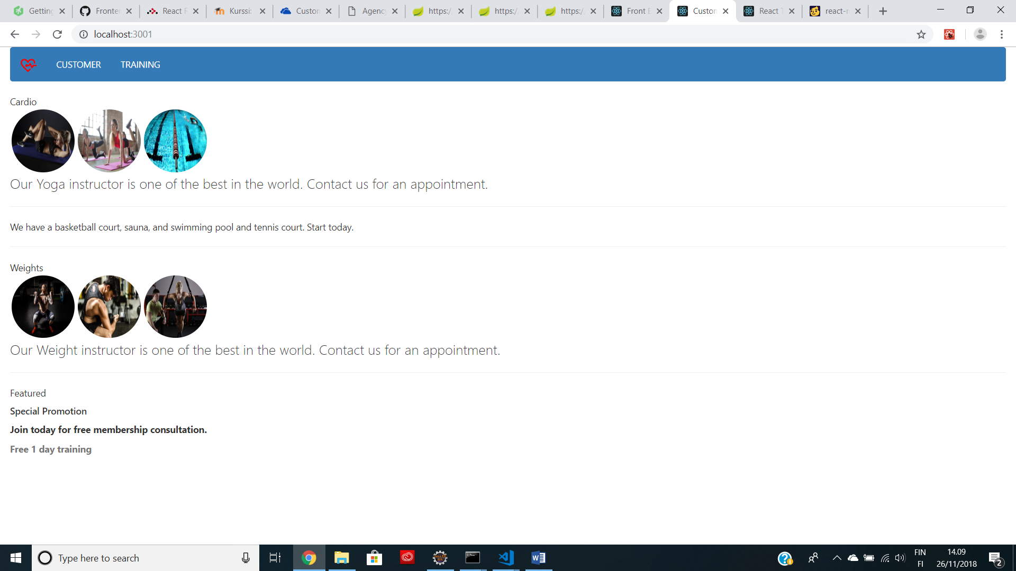

Customer Table:

defaultSorted is by lastname, asc

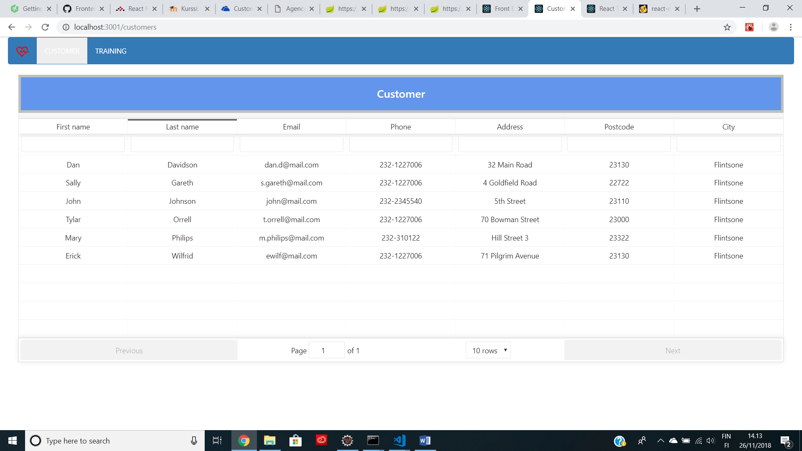

Searching by filterable

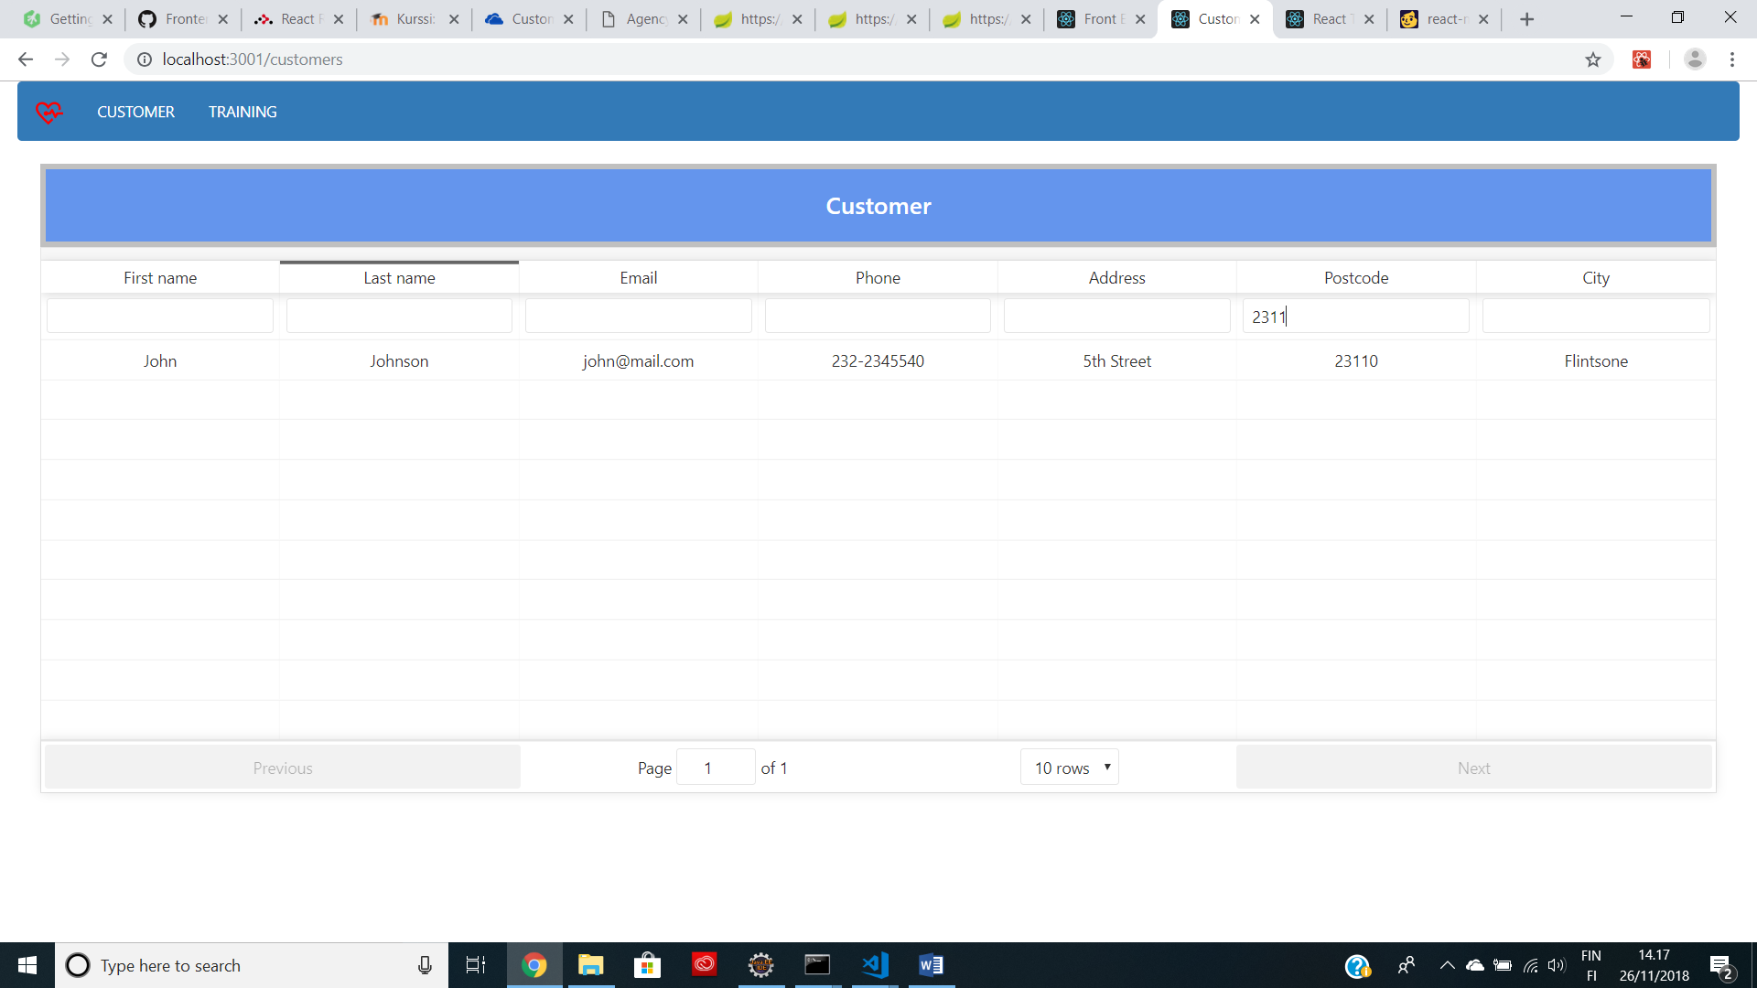

Training Table:

defaultSorted is by duration, asc

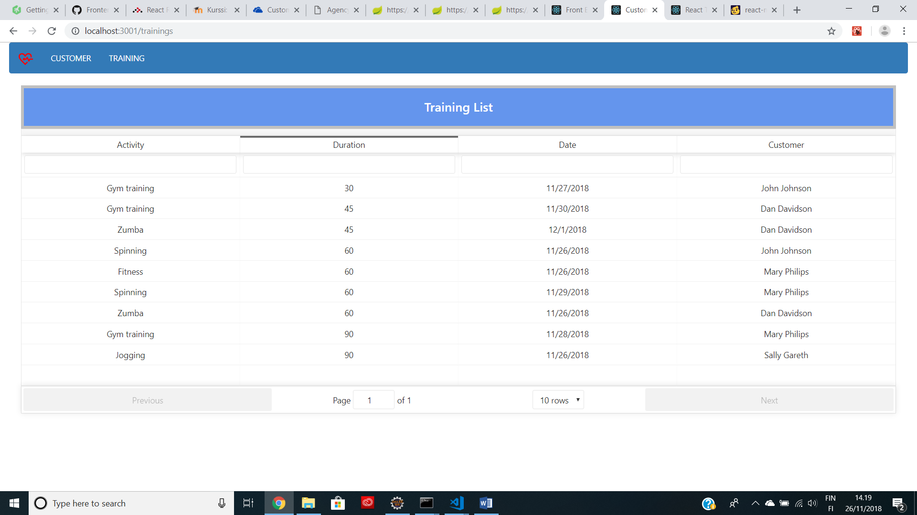Searching by filterable

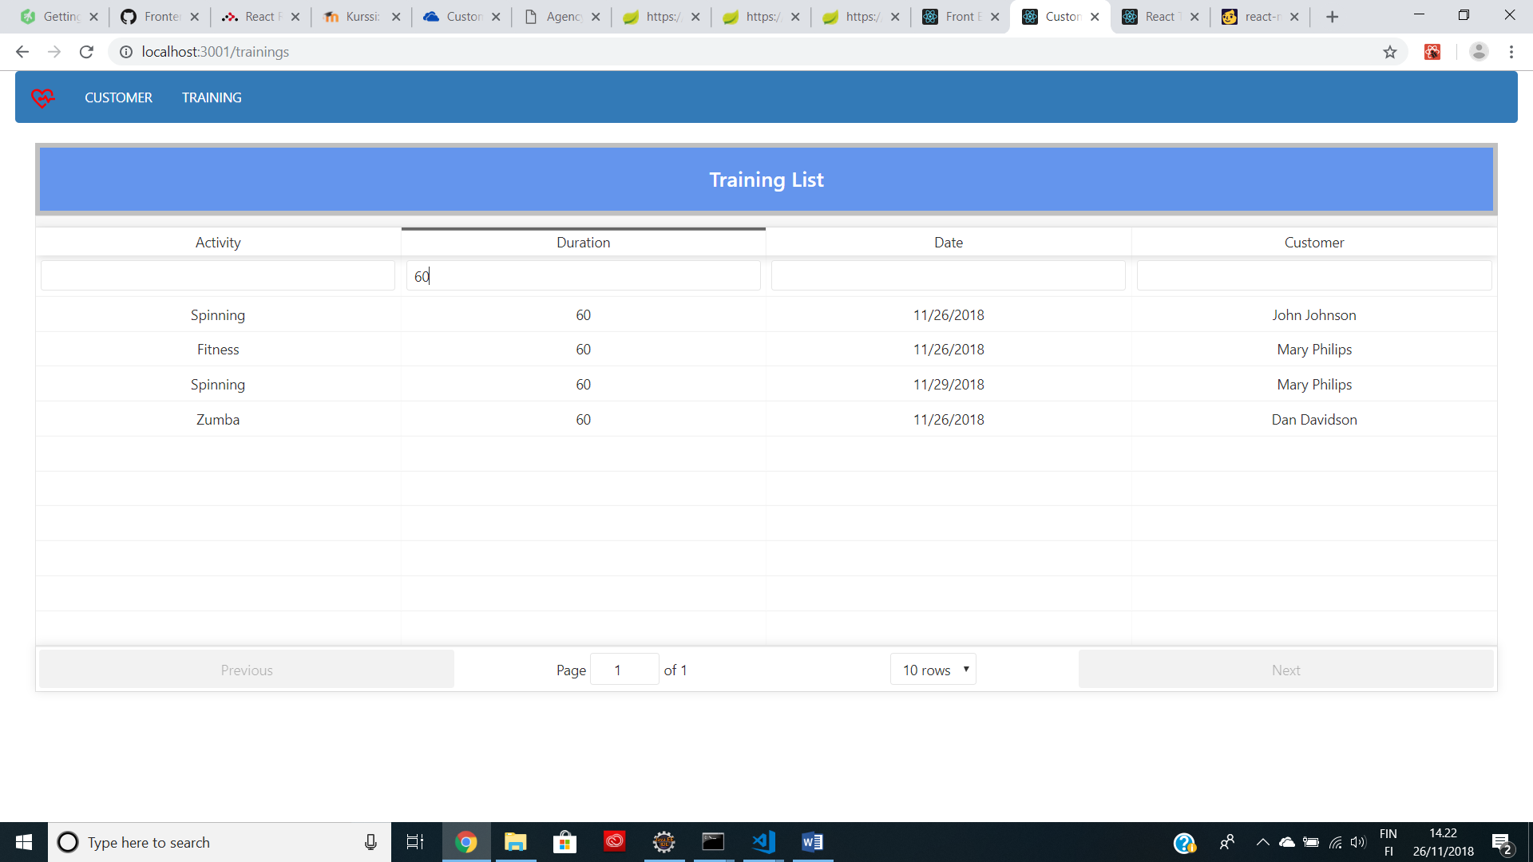

NoFound Link

