Task 2

GitHub Repo: <https://github.com/pikachu0214/Frontend-Programming/tree/master/Frontend-Backend/trainerapp-extended>

NavLinks: HomePage, Customer Table, Training Table and NoFound Link

Features: react-csv, react-skylight, react-toastify, added CRUD ADD & Delete Buttons Trainings/Customers List

HomePage

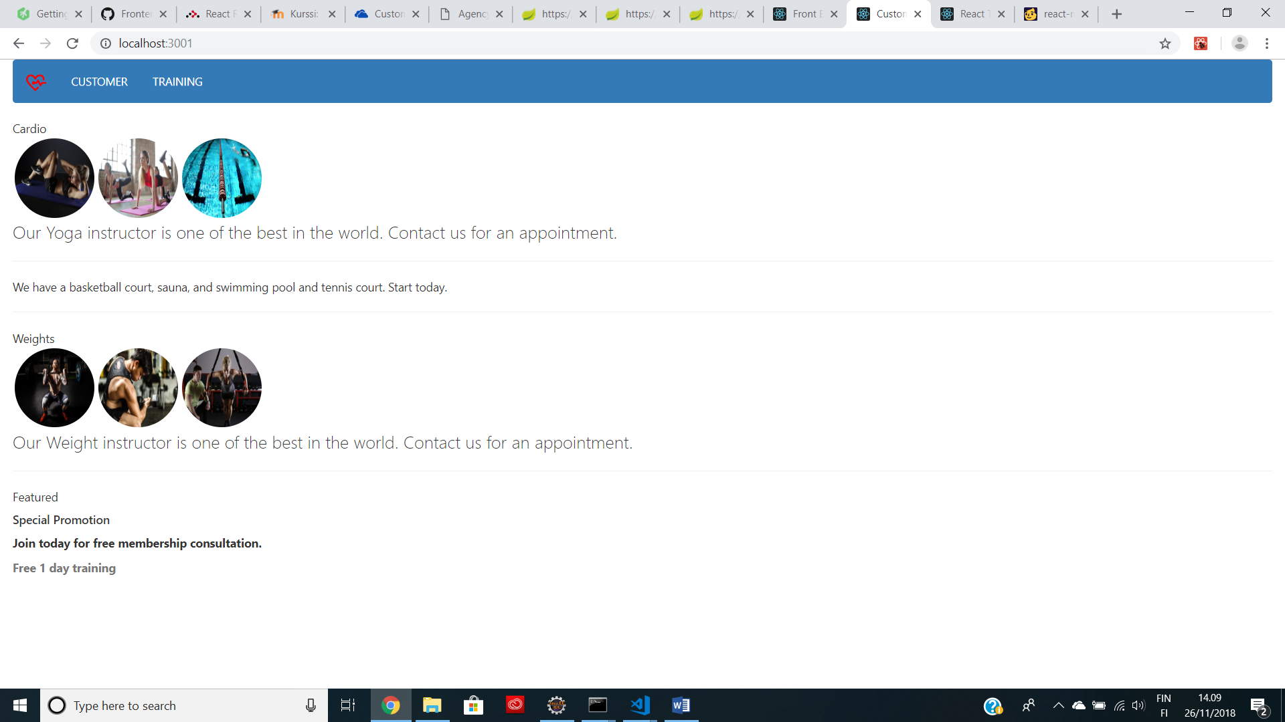

Customer Table:

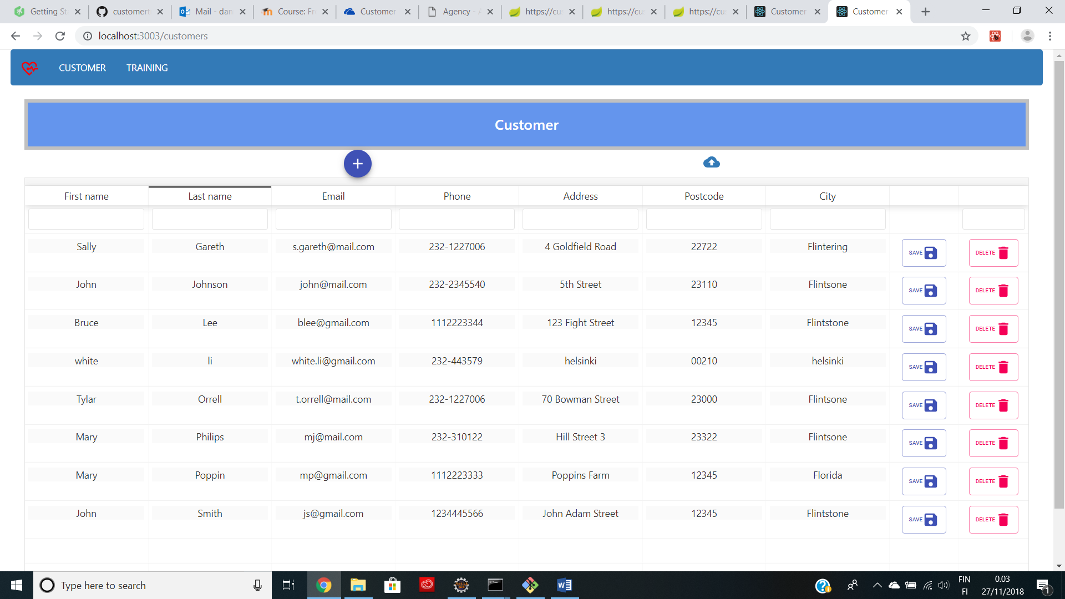

Add Customer

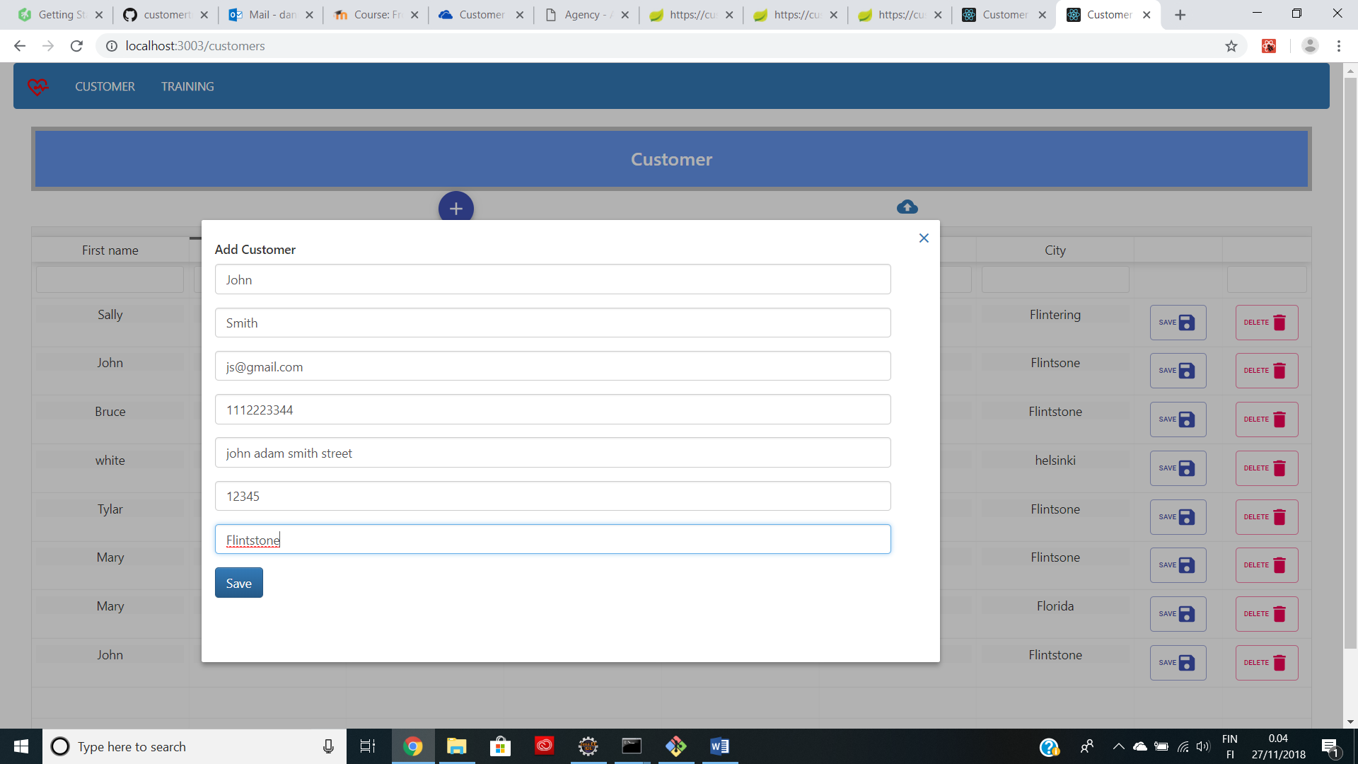

Figure 1

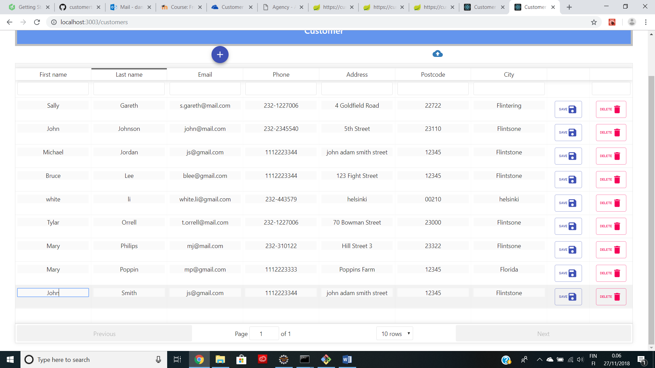

Figure 2

Delete Customer

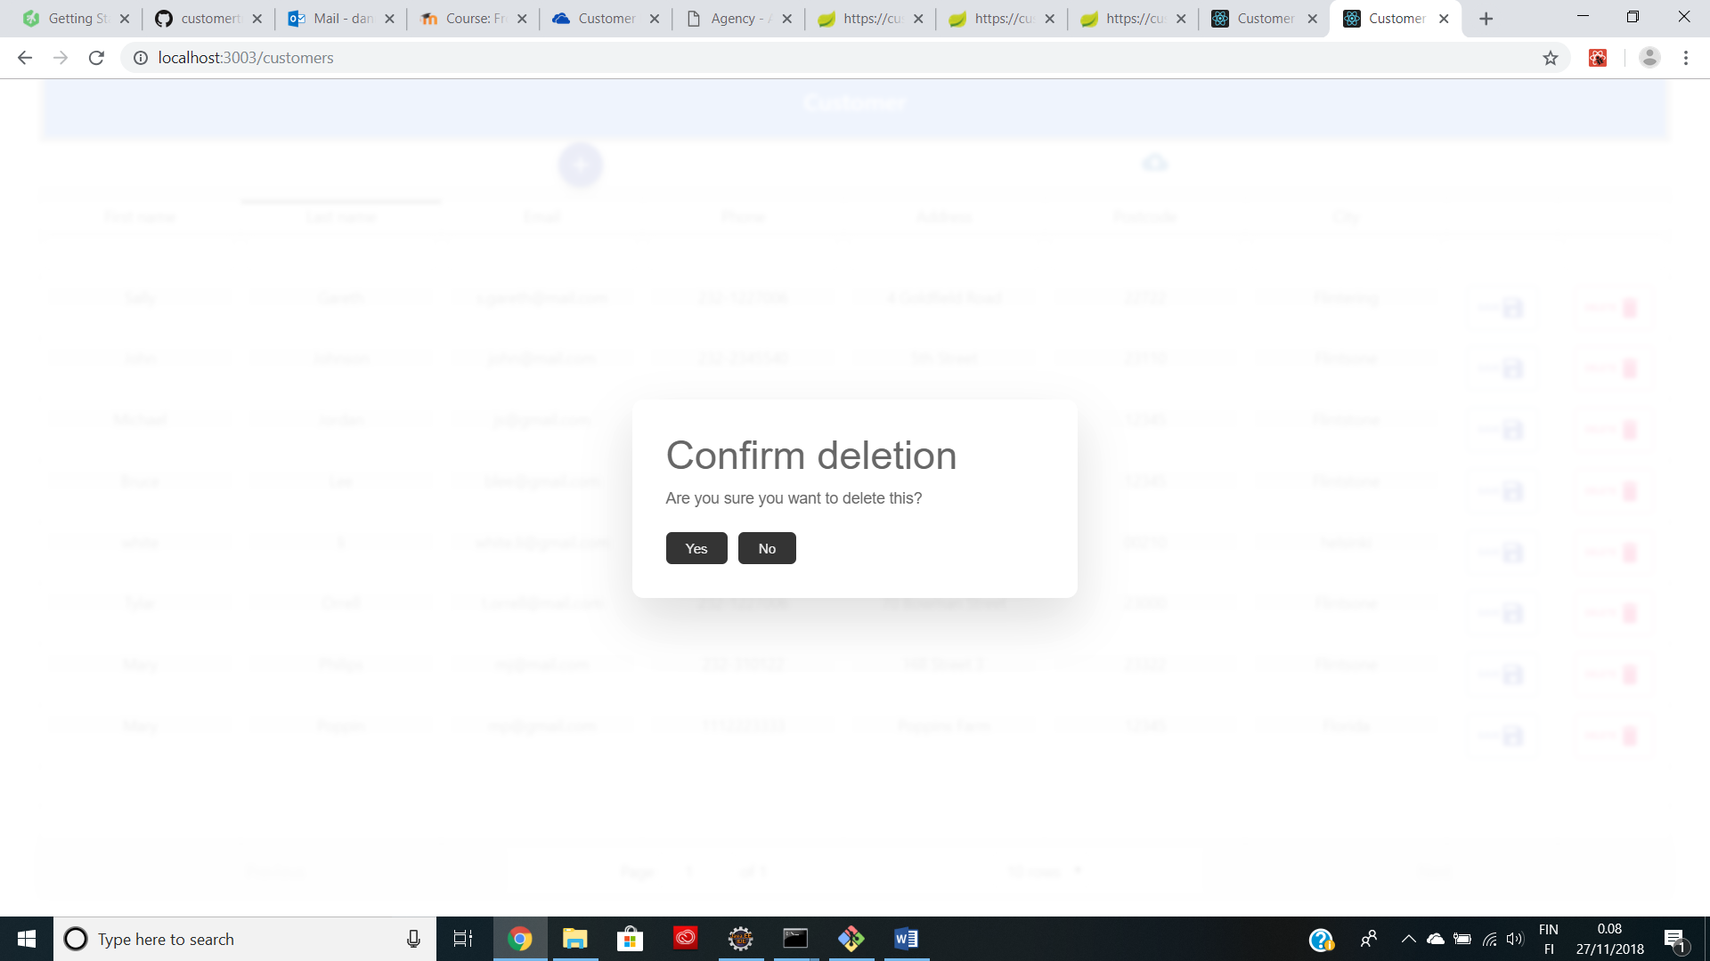

Figure 1

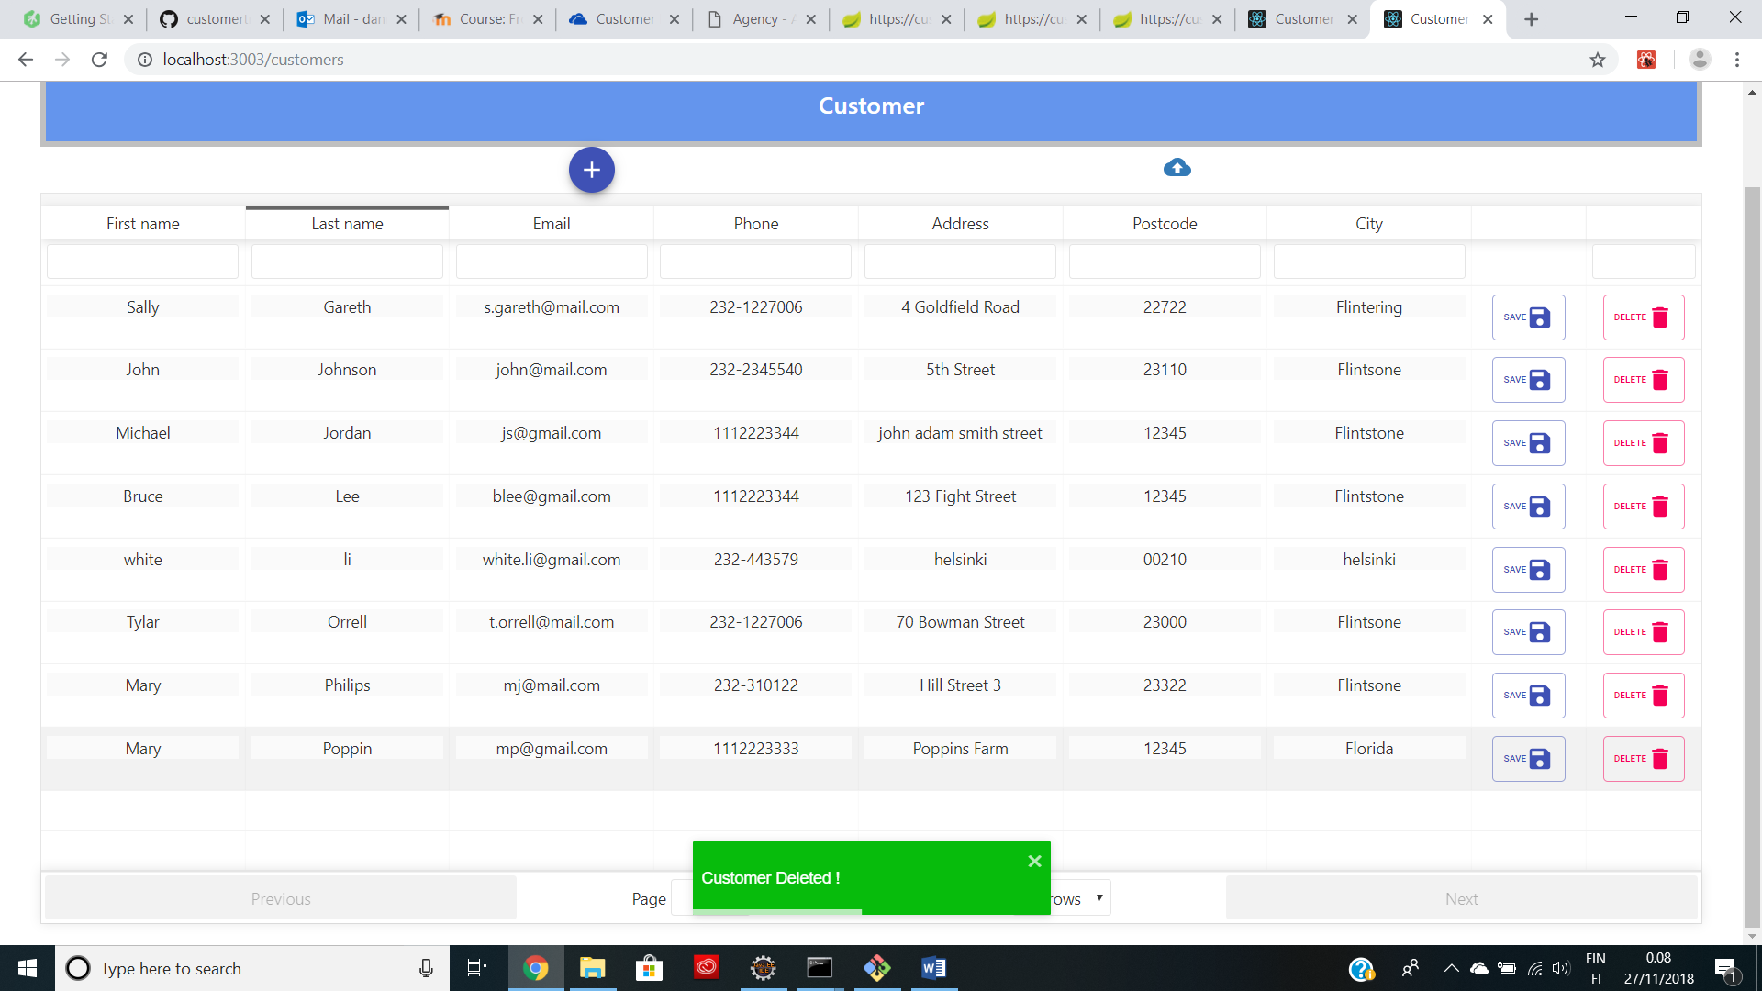

Figure 2

Customer CSV

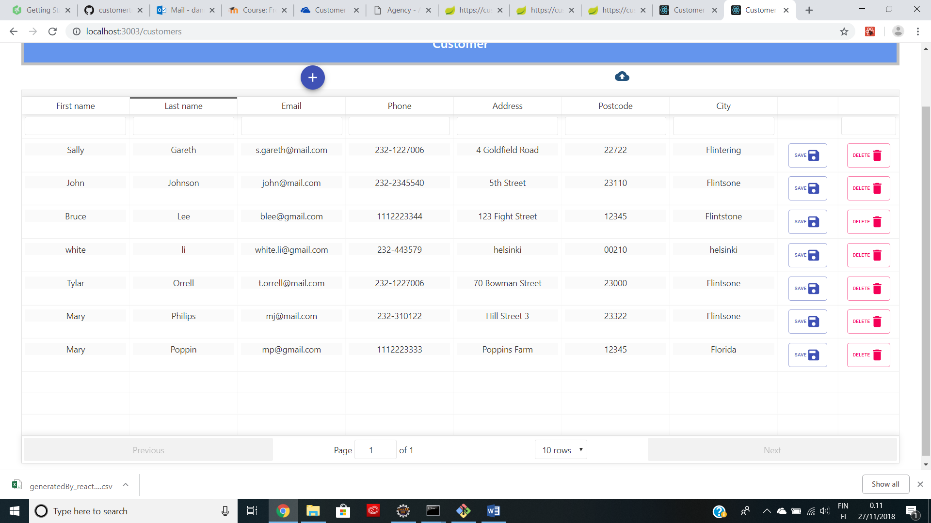

Figure 1

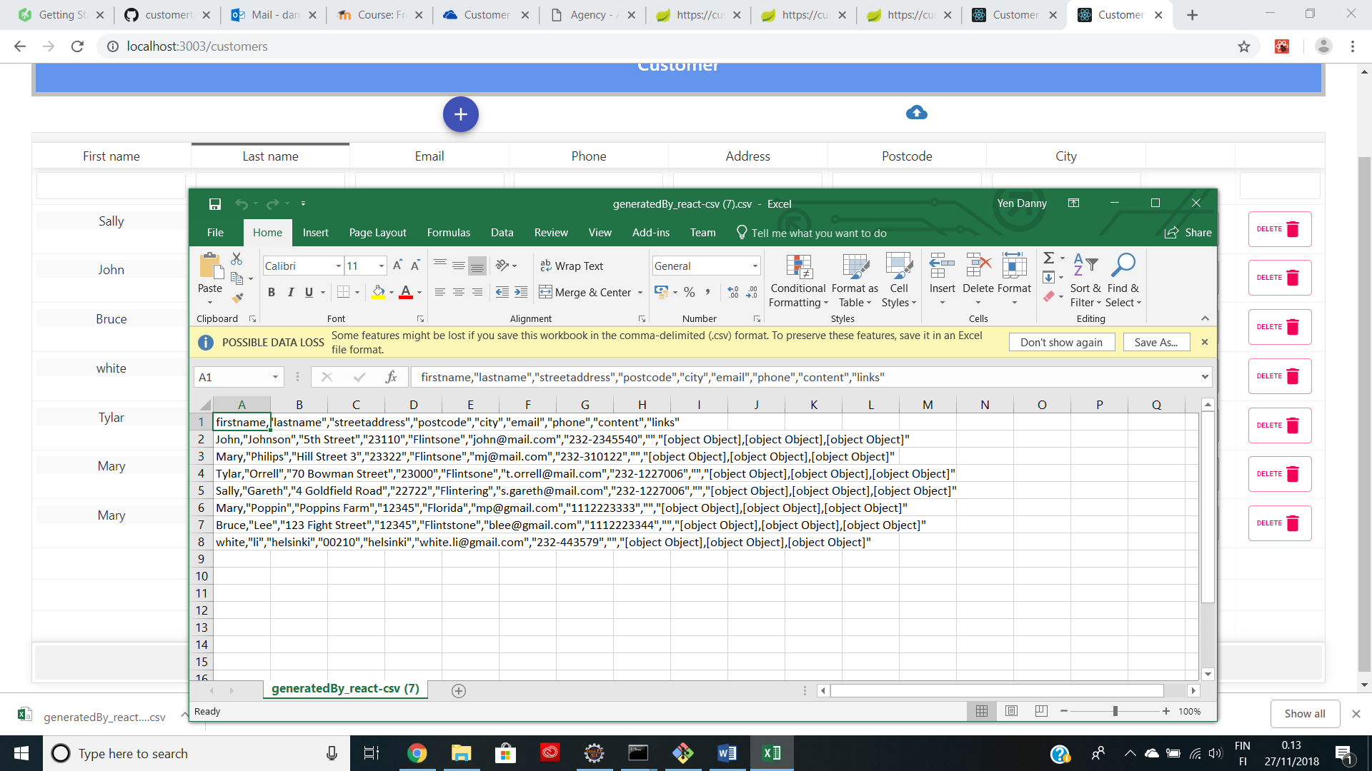

Figure 2

Customer Update and Edit

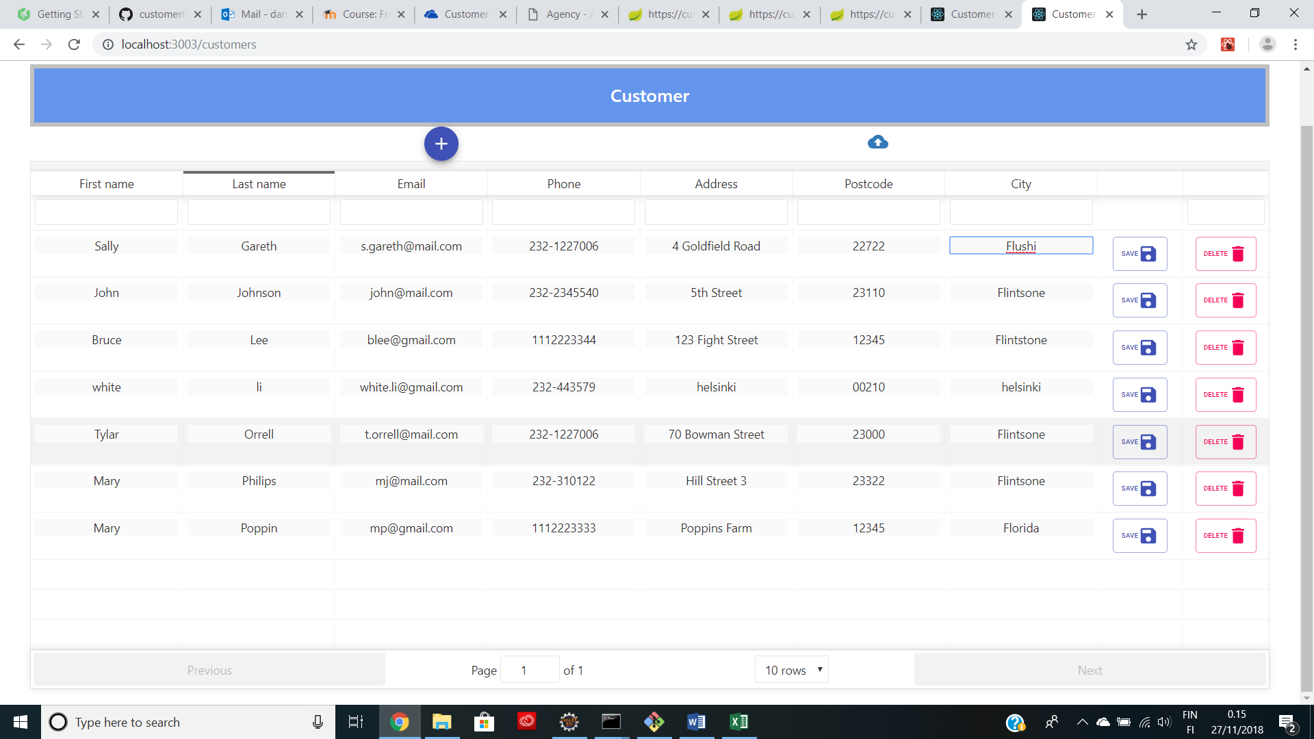

Figure 1

Training List

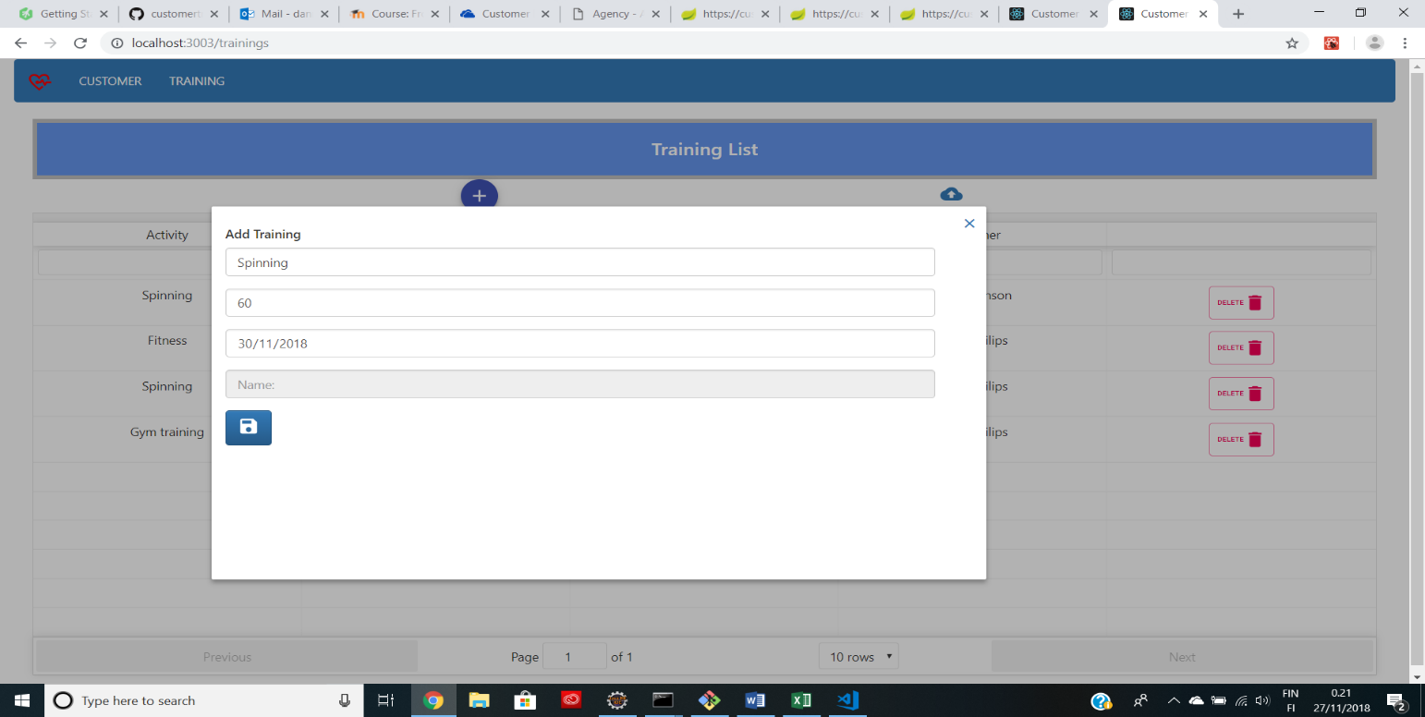Add Training

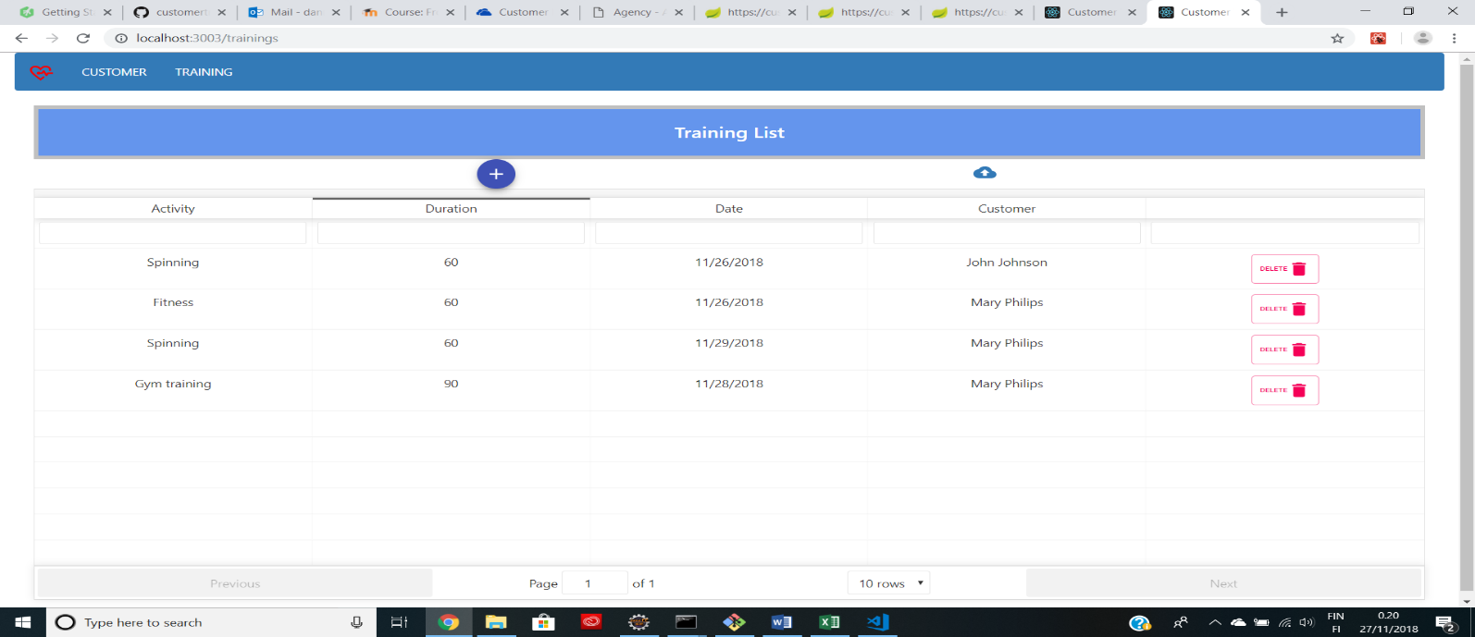Delete Training

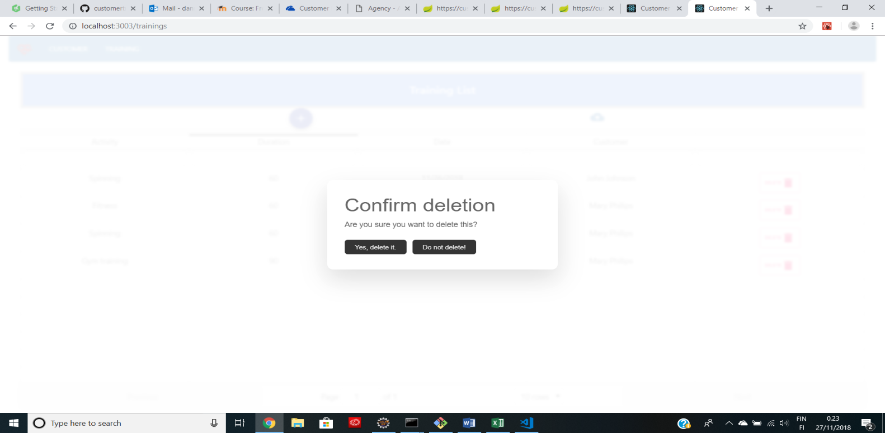

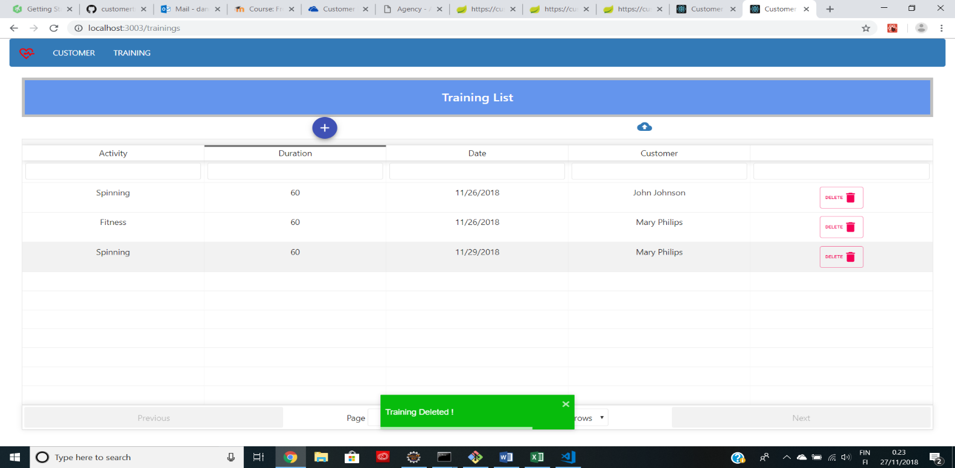

Training CSV Download

