The technologies used are PERL, JSON, SQLite, JQUERY, HTML.

Make sure to have XAMPP, as the web server to deploy the application.

JSON should also be installed in it also.

Copy the “appointment” folder to cgi-bin folder of XAMPP.

It contains the following files:

* add.pl (for adding a new appointment)
* appointment.db (the database with test data)
* search.pl (for searching appointments)

Copy the “appointment” folder to htdocs folder of XAMPP.

It contains the following files:

* index.html (the single web page)
* script.js (contains the jQuery code)
* style.css (contains styling code)

Start the XAMPP web server.

Enable localhost:8080

Access the application in a browser, <http://localhost:8080/appointment>



Adding a new appointment.

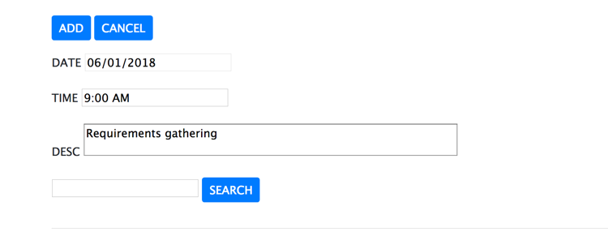

Using a date picker for the date input.

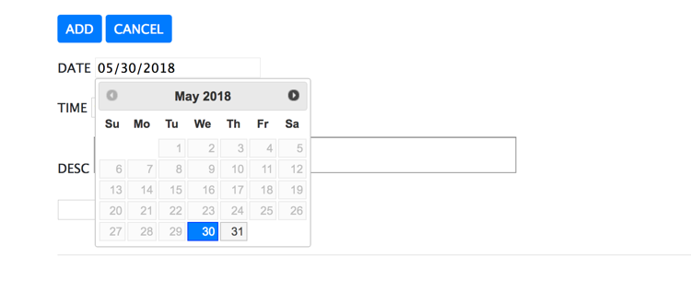

Data validation (missing “DESC” input)

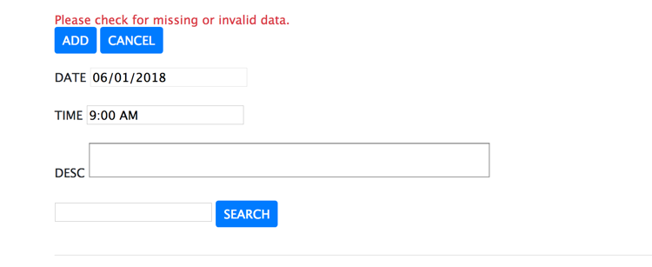

Searching for appointments with search string “meeting”.

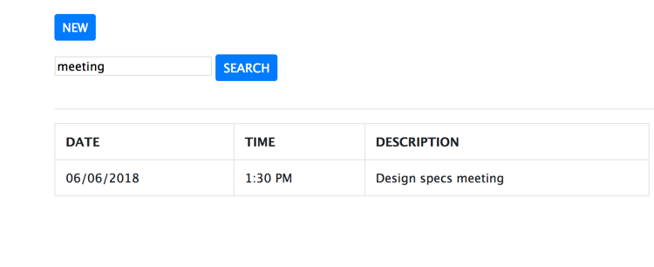

Searching for appointments without search string. All appointments are displayed.

