# HW2_problem1

* Vertex sader
* output.diffAlmost = _LightColor0.rgb *max(0, dot(normalWS, lightDir)) * atten;
* output.scale = ((1.0 + dot(normalWS, lightDir)) / 2.0);
* output.uv = TRANSFORM_TEX(input.uv, _BaseTex);
* return output;
* }
* float4 FragVertexLit(v2f input) : COLOR {
* //float3 blue = (0.0, 0.0, 1.0);
* //float3 yellow = (1.0, 1.0, 0.0);
* //float3 base =
* //float4 base = tex2D(_BaseTex, input.uv);
* float3 output = lerp(float3(1.0 , 1.0 ,0.0), float3(0.0 , 0.0 ,1.0),input.scale );
* return(float4(output,1));
* }

Output:

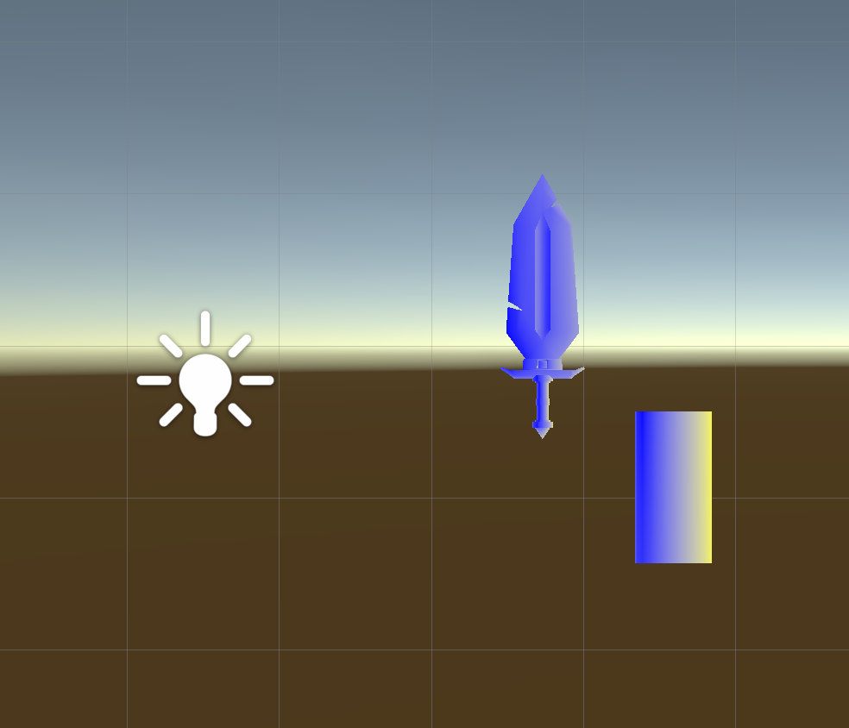

* Pixel shader

float3 diffAlmost = _LightColor0.rgb * max(0, dot(n, lightDir)) * atten;

float3 output = lerp(float3(1.0, 1.0, 0.0), float3(0.0, 0.0, 1.0), ((1.0 + dot(n, lightDir)) / 2.0));

return(float4(output,1));

Output :

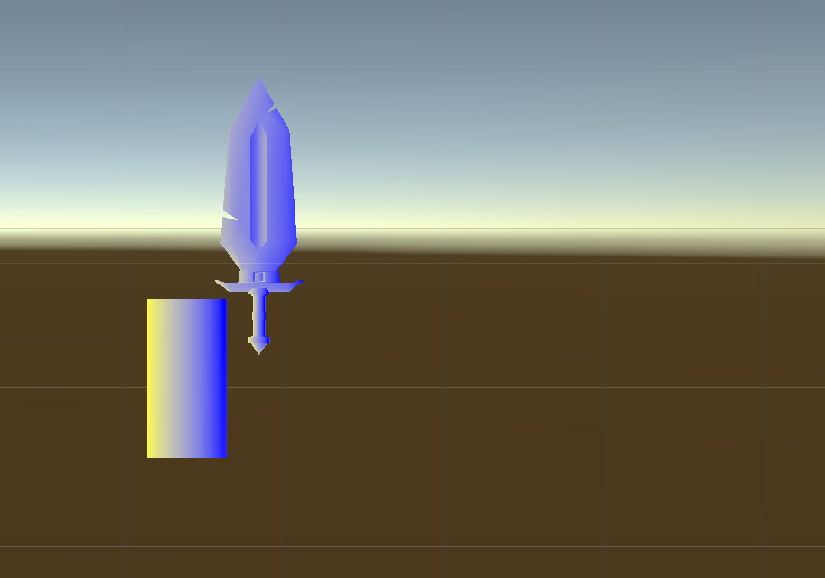

# HW2_Problem2

* I used the the pixelit shader and modified the code for it to look like wavy .

Code:

float3 diffAlmost = _LightColor0.rgb * max(0, dot(n, lightDir)) * atten;

float A = 6;

float B = 5;

float C = 16;

float D = 10;

float E = 4;

float F = 17;

input.uv.x += A * sin(B*input.uv.y) * sin(C * _Time.x);

input.uv.y += D * sin(E * input.uv.x) * sin(F * _Time.x);

float4 base = tex2D(_BaseTex, input.uv);

float3 output = diffAlmost * base.rgb;

return(float4(output,1));

}

Output:

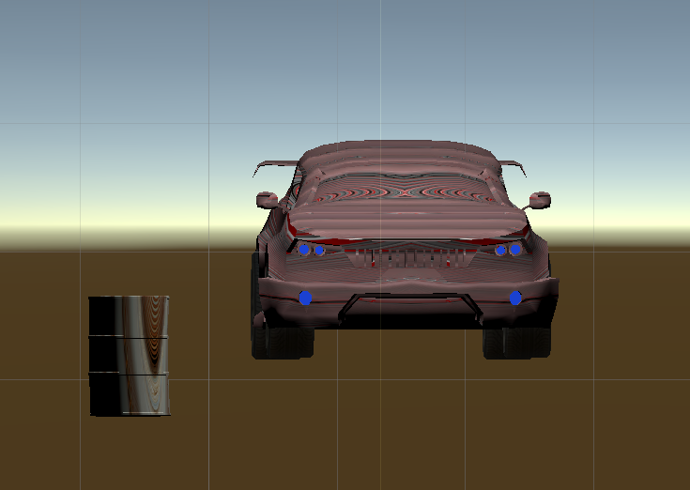

# HW2_Problem3

Code:

Properties{

_BaseTex("Base (RGB) Gloss (A)", 2D) = "white" {}

_NormalMap("Normalmap", 2D) = "bump" {}

_AttenFactor("Atten Factor", float) = 1

_Amplitude("Amplitude", float) = 1.0

_Rate("Rate", float) = 1.0

}

Then

float _AttenFactor;

float _Amplitude;

float _Rate;

then

v2f output;

input.positionOS.xyz += _Amplitude * input.normalOS * (1 + sin(_Rate*_Time.x));

float4 positionWS = mul(unity_ObjectToWorld, float4(input.positionOS.xyz, 1.0));

Output:

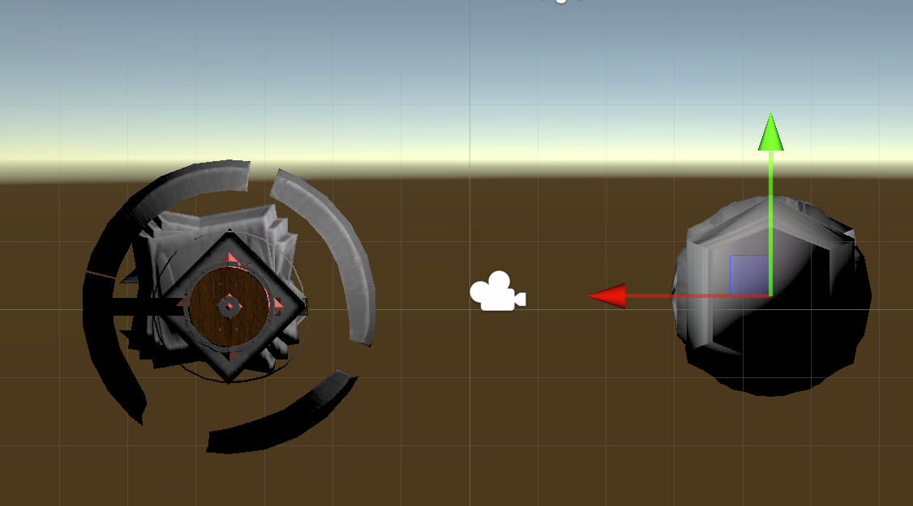

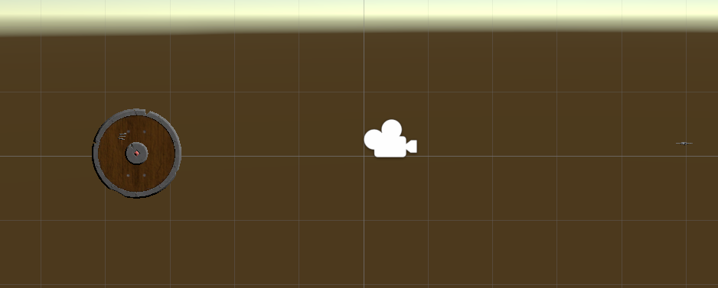

# HW2_problem4

Code:

Properties {

_BaseTex ("Base (RGB) Gloss (A)", 2D) = "white" {}

_NormalMap ("Normalmap", 2D) = "bump" {}

_NormalMap2 ("Normalmap2", 2D) = "bump" {}

_AttenFactor ("Atten Factor", float) = 1

_Rate("Rate", float) = 1.0

}

Then

sampler2D _BaseTex;

float4 _BaseTex_ST;

sampler2D _NormalMap;

float4 _NormalMap_ST;

sampler2D _NormalMap2;

float4 _NormalMap2_ST;

float _AttenFactor;

float _Rate;

then

float normX;

float normY;

float normZ;

float2 nMapXY = 2 * tex2D(_NormalMap, input.nmap_uv).ag - 1;

float2 nMap2XY = 2 * tex2D(_NormalMap2, input.nmap_uv).ag - 1;

float nMapRecreatedZ = sqrt(1 - saturate(dot(nMapXY,nMapXY)));

float nMap2RecreatedZ = sqrt(1 - saturate(dot(nMap2XY, nMap2XY)));

// we are renormalizing because the GPU's interpolator doesn't know these are unit vectors

float3 nWS = normalize(input.normalWS);

float3 tWS = normalize(input.tangentWS);

float3 btWS = normalize(input.bitangentWS);

float3 newNormal = tWS * nMapXY.x + btWS * nMapXY.y + nWS * nMapRecreatedZ;

newNormal = normalize(newNormal);

float3 newNormal2 = tWS * nMap2XY.x + btWS * nMap2XY.y + nWS * nMap2RecreatedZ;

newNormal2 = normalize(newNormal2);

normX = lerp(newNormal.x, newNormal2.x, 0.5*(1.0 + sin(_Rate*_Time.x)));

normY = lerp(newNormal.y, newNormal2.y, 0.5*(1.0 + sin(_Rate*_Time.x)));

normZ = lerp(newNormal.z, newNormal2.z, 0.5*(1.0 + sin(_Rate*_Time.x)));

float3 norm = (normX,normY,normZ);

Output:

