======================================================================

**Name : Atharva Paliwal**

**Roll No : B6 40**

**Course Name : Software Engineering Lab**

**Course Code : CSP357**

**Experiment No :**05

**Aim :**To create a Activity and State Chart Diagram to

represent thedynamic view (behavior) of the

system.

**Problem Statement :** Create a Activity and State Chartdiagram using

Star UML application for **“Smart Courier Tracking System”**.

**Date of Experiment:**21-February-2021

======================================================================

**Description of the UML Modeling View:**

There are five different views that the UML aims to visualize through different modeling diagrams. These five views are:

1. User's View
2. Structural Views
3. Behavioral Views
4. Environmental View
5. Implementation View

Activity Diagram –

Activity diagrams are graphical representations of workflows of stepwise activities and actions with support for choice, iteration and concurrency. In the UML, activity diagrams are intended to model both computational and organizational processes (i.e., workflows), as well as the data flows intersecting with the related activities. Although activity diagrams primarily show the overall flow of control, they can also include elements showing the flow of data between activities through one or more data stores.

StateChart Diagram –

Statechart diagram is one of the five UML diagrams used to model the dynamic nature of a system. They define different states of an object during its lifetime and these states are changed by events. Statechart diagrams are useful to model the reactive systems. Reactive systems can be defined as a system that responds to external or internal events.

Statechart diagram describes the flow of control from one state to another state. States are defined as a condition in which an object exists and it changes when some event is triggered. The most important purpose of Statechart diagram is to model lifetime of an object from creation to termination.

Statechart diagrams are also used for forward and reverse engineering of a system. However, the main purpose is to model the reactive system.

**\*\*\*\*\*\*\*\*\*\*\*\*\*\*\*\*\*\*\*\*\*\*\*\*\*\*\*\*\*\*\*\*\*\*\*\*\*\*\*\*\*\*\*\*\*\*\*\*\*\*\*\*\*\*\*\*\*\*\*\*\*\*\*\*\*\*\*\*\*\***

**ScreenShot of Activity Diagram**

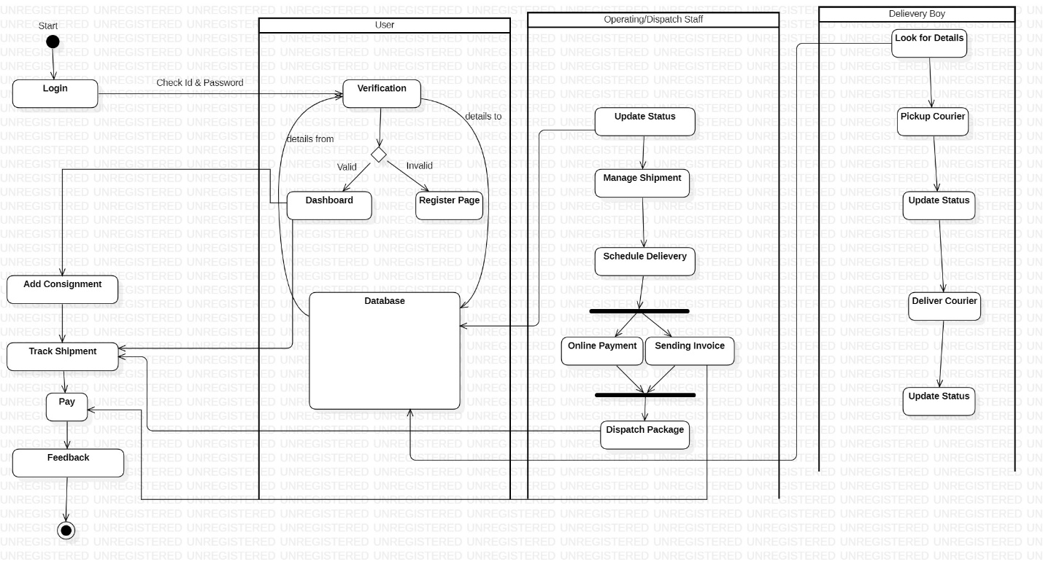

**ScreenShot of State Diagram**

