**Experiment-7**

**Author:** Atharva Paliwal

**Roll no:** B2-40

**Date:** 07 April 2021

**Aim:** To perform White-Box Testing to test the functionalities using JUnit testing tool.

**Problem Statement:**

[1] Implement a Class Quadratic representing solution involving finding roots of a quadratic equation. Create a JUnit Test Suite incorporating all possible test cases covering independent paths.

[2] Choose any class from your Class Diagram (one which involves substantial computational logic) and implement it. Now create JUnit suit to test this class appropriately.

**Description:**

White Box Testing is software testing technique in which internal structure, design and coding of software are tested to verify flow of input-output and to improve design, usability and security. In white box testing, code is visible to testers so it is also called Clear box testing, Open box testing, Transparent box testing, Code-based testing and Glass box testing.

**Code:**

**[Problem Statement 1]**

**(quadratic.java)**

import static java.lang.Math.*;

class quadratic {

private int a , b , c;

public quadratic(int x, int y, int z){

a = x;

b = y;

c = z;

}

public String findRoots(){

if (a == 0) {

System.out.println("Invalid");

return "Invalid";

}

int d = b * b - 4 * a * c;

double sqrt_val = sqrt(abs(d));

if (d > 0) {

System.out.println("Roots are real and different \n");

return((double)(-b + sqrt_val) / (2 * a) + "\n"+ (double)(-b - sqrt_val) / (2 * a));

}

else if (d == 0) {

System.out.println("Roots are real and same \n");

return(-(double)b / (2 * a) + "\n"+ -(double)b / (2 * a));

}

else {

System.out.println("Roots are complex \n");

return(-(double)b / (2 * a) + " + i"+ sqrt_val + "\n"+ -(double)b / (2 * a)+ " - i" + sqrt_val);

}

}

}

--------------------------------------------------------------------

**(quadraticTest.java)**

import org.junit.After;

import org.junit.AfterClass;

import org.junit.Before;

import org.junit.BeforeClass;

import org.junit.Test;

import static org.junit.Assert.*;

public class quadraticTest {

public quadraticTest() {

}

@BeforeClass

public static void setUpClass() {

}

@AfterClass

public static void tearDownClass() {

}

@Before

public void setUp() {

}

@After

public void tearDown() {

}

/**

* Test of findRoots method, of class quadratic.

*/

@Test

public void testCaseI(){

quadratic q = new quadratic(0,4,4);

String expected = "Invalid" ;

String actual = q.findRoots();

assertEquals(expected, actual);

}

@Test

public void testCaseII(){

quadratic q = new quadratic(1,-7,12);

String expected = "4.0" + "\n" + "3.0" ;

String actual = q.findRoots();

assertEquals(expected, actual);

}

@Test

public void testCaseIII(){

quadratic q = new quadratic(1,2,1);

String expected = "-1.0" + "\n" + "-1.0" ;

String actual = q.findRoots();

assertEquals(expected, actual);

}

@Test

public void testCaseIV(){

quadratic q = new quadratic(2,2,1);

String expected = "-0.5 + i2.0" + "\n" + "-0.5 - i2.0" ;

String actual = q.findRoots();

assertEquals(expected, actual);

}

}

---------------------------------------------------------------------

**[Problem Statement 2]**

**(Invoice.java)**

package invoice;

/**

*

* @author ACER

*/

public class Invoice {

public double generateAmount(String type,double weight,double distance){

switch(type){

case "air":

if (weight <= 8) {

return weight * 3;

}

else if ((weight >= 9) && (weight <= 16)) {

return weight * 4;

}

else if (weight >= 17){

return weight * 6;

}

break;

case "road":

if (weight <= 8) {

return weight*1.50 + distance*0.5;

}

else {

if ((weight >= 9) && (weight <= 16)) {

return 2.35 + distance*0.5;

}

else if (weight >= 17) {

return weight*3.25 + distance*0.5;

}

}

break;

case "water":

if (weight <= 8) {

return weight*0.50;

}

else {

if ((weight >= 9) && (weight <= 16)) {

return weight*1.50;

}

else if (weight >= 17) {

return weight*2.50;

}

}

break;

}

return 0;

}

}

**------------------------------------------------------------------**

**(InvoiceTest.java)**

package invoice;

import org.junit.After;

import org.junit.AfterClass;

import org.junit.Before;

import org.junit.BeforeClass;

import org.junit.Test;

import static org.junit.Assert.*;

public class InvoiceTest {

public InvoiceTest() {

}

@BeforeClass

public static void setUpClass() {

}

@AfterClass

public static void tearDownClass() {

}

@Before

public void setUp() {

}

@After

public void tearDown() {

}

@Test

public void testGenerateAmount() {

Invoice instance = new Invoice();

//AIR

double expResult = 48.0;

double result = instance.generateAmount("air", 12.0 , 0.0);

assertEquals(expResult, result, 0.0);

// ROAD

double expected = 310.5;

double actual = instance.generateAmount("road",7,600);

assertEquals(expected,actual,0.0);

// WATER

double expectedw = 62.5;

double actualw = instance.generateAmount("water",25,0);

assertEquals(expectedw,actualw,0.0);

System.out.println("Test case passed!");

}

}

--------------------------------------------------------------------

---------------------------------------------------------

OUTPUT

---------------------------------------------------------

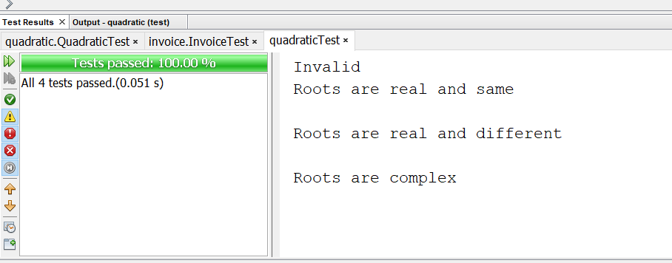

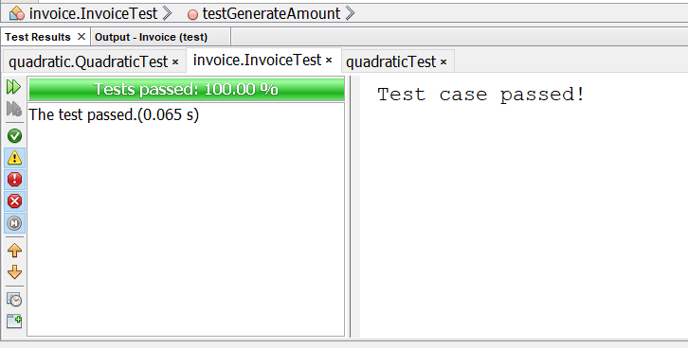

**Output:**

**[Problem Statement 1]**

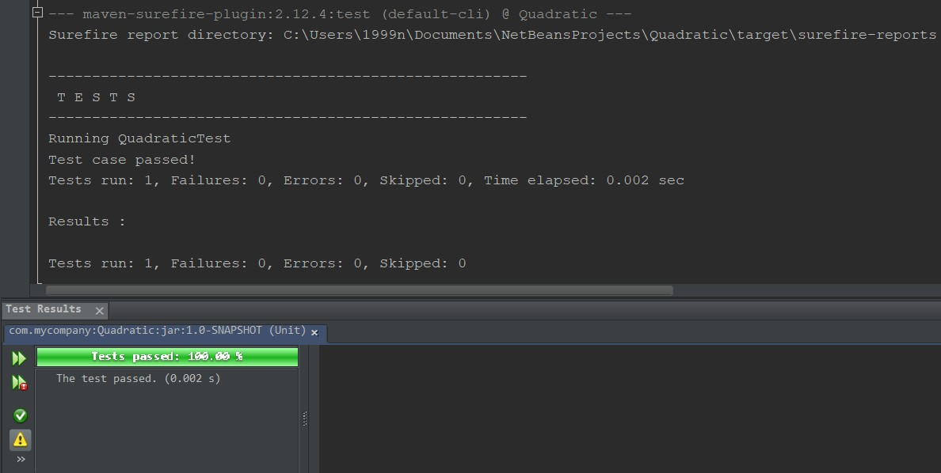

**[Problem Statement 2]**

