**Martial Arts Management System**

Aryan Nakarmi



Giriraj Rawat

FEB 29,2024

**Table of Content**

**Introduction** 4

**Home Page** 4

**About** 9

**Version Control** 12

**Conclusion** 13

**Table of Figures**

Figure 1 5

Figure 2 6

Figure 4 8

Figure 5 9

Figure 6 10

Figure 7 11

Figure 8 11

Figure 9 12

# **Introduction**

The goal of this desktop application is to provide a simple, user-friendly environment for users who are passionate about fighting, also known as martial arts. This frontend offers the user with the Home Page and the About Page. The Home page and About provide users with an interface via which they can access all available information. The desktop application is built using Python's Tkinter utilities.

# **Home Page**

Home page consists of “Add new package”, “Subscribers”, and “About” where existing user can subscribe to a martial arts package and see the information page. The user has the option” Logout” where the user can go back to the Login Page to create new account or use another account.

When a user clicks on “add new package” then the user is taken to a new page where they can subscribe to a new package. They can also choose package type and package number and when admin clicks on “Subscribers” they are taken to a page where they can edit customers’ information.

The following GUI use tkinter to enhance the home page viewing details. User gets the small GUI interface to add subscription. The background is fully cover with png image and has two frames.

## Figure

Home

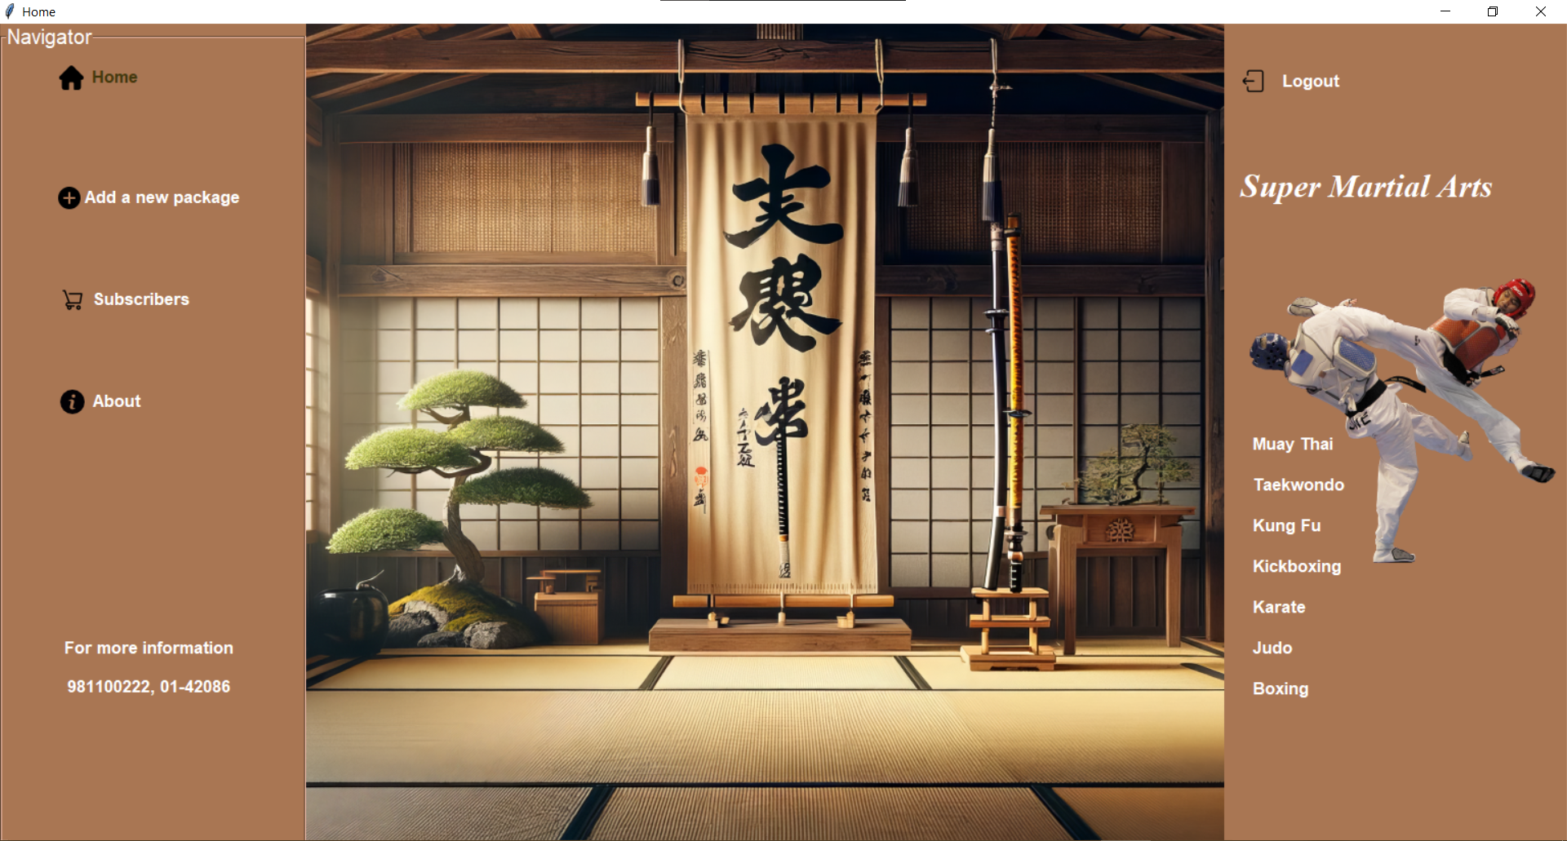

## Figure

Source code of home page

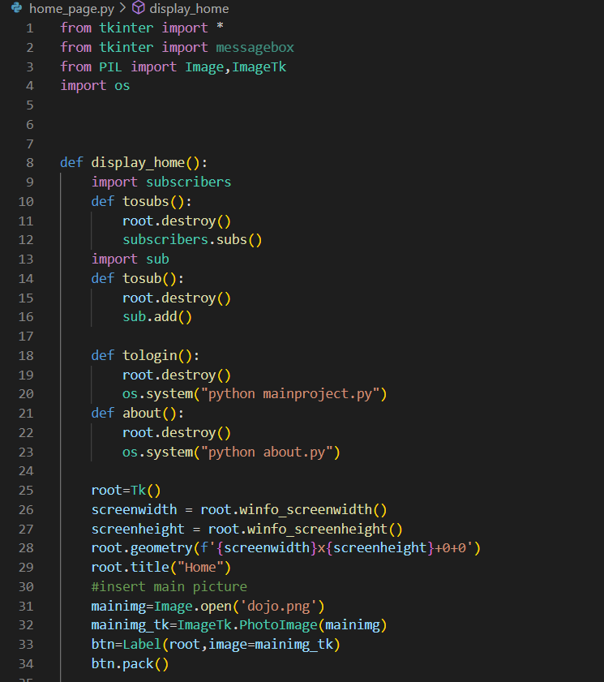

## Figure 3

Source Code Home page

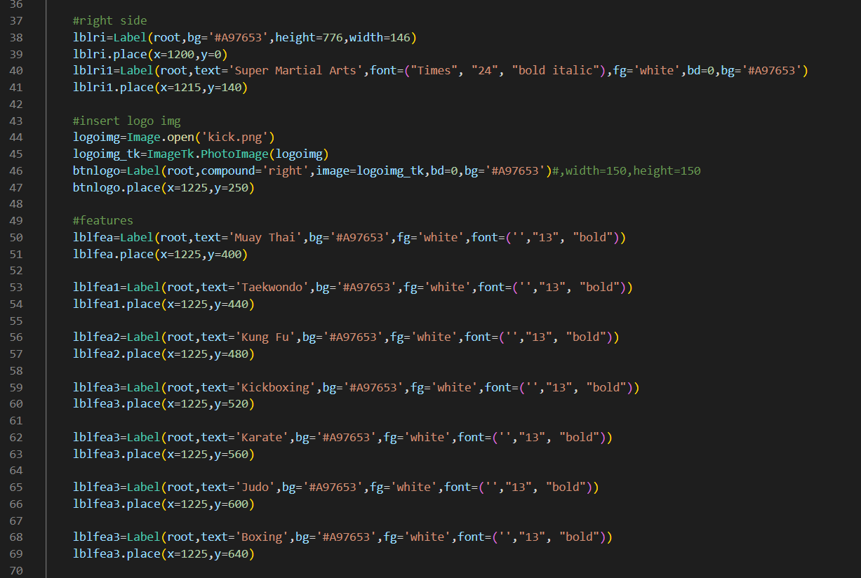

## Figure

Source Code of Home page

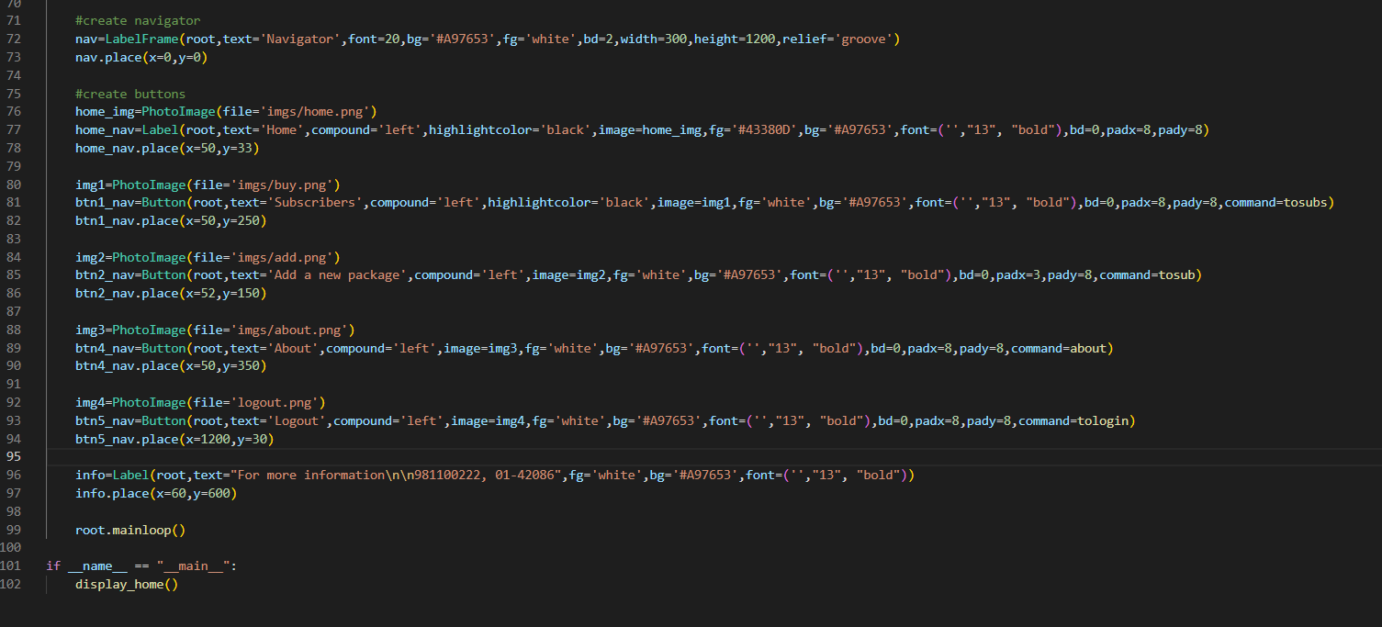

# **About**

About page helps our applicants to get through our management system. “BACK” button helps the applicant to go back to the Home Page. There are 4 pictures of Martial Arts tutors and it has their name and department. The page also contains a quote from a Japanese philosopher. The bottom of the page contains our mission and email to contact us.

## Figure

About us page

### 

## Figure

Source Code of About us page

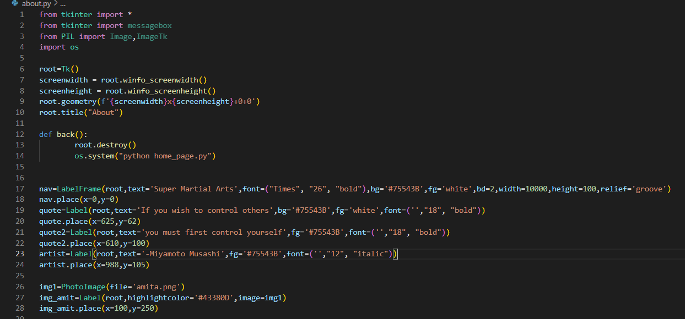

## Figure

Source code of about us

### 

## Figure

Source Code of About us

### 

# **Version Control**

**GitHub :** [**https://github.com/parathagang/martial-arts-management-system/commits/master/**](https://github.com/parathagang/martial-arts-management-system/commits/master/)

## Figure

Github commit

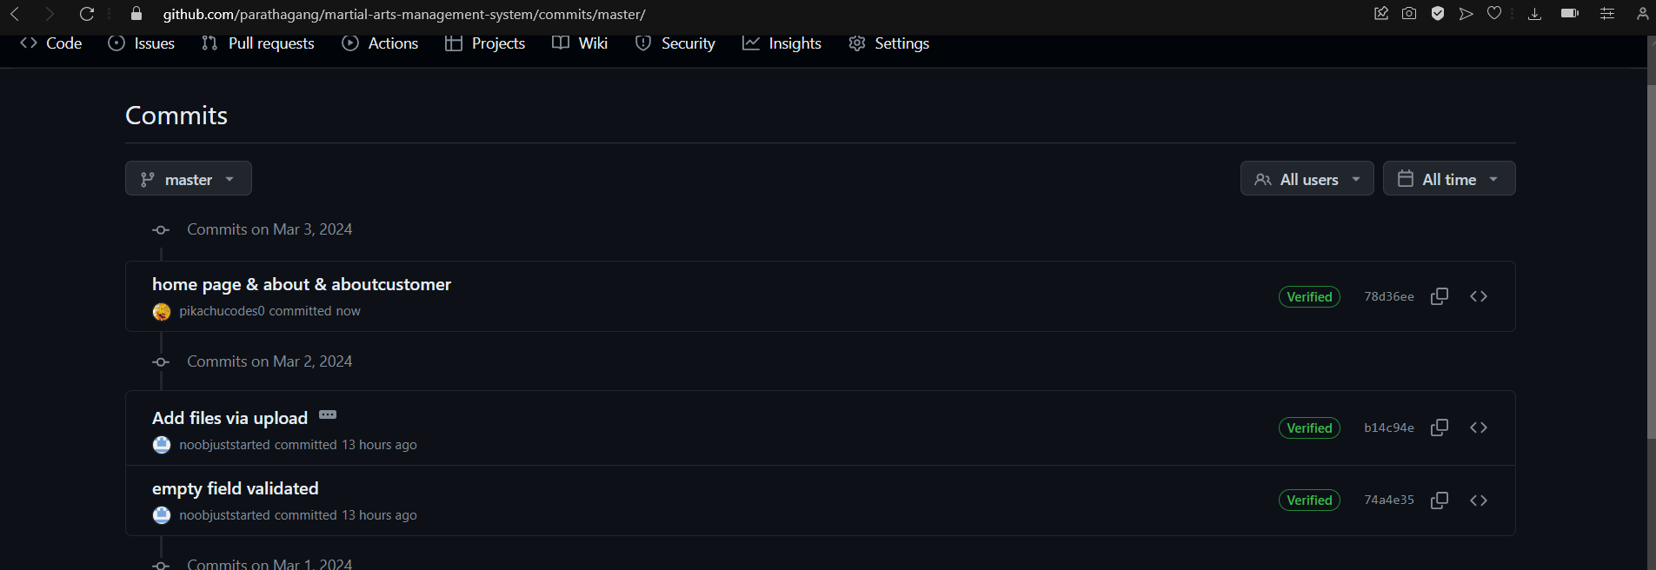

## 

# **Conclusion**

Finally, the Home and About interfaces are made available using the Tkinter GUI framework. Despite numerous challenges, I learned a lot from this project and applied all of the coding abilities I had learned in school. This was my first project in this industry, and I am delighted about the opportunity to try something new. It is impossible to make the finest work on the first try, but I tried to combine my best idea into this project. This project taught me how to operate a custom Tkinter, different labels, and entry boxes. Until this project, I felt it was difficult to use images as backdrops, but now I found it to be quite straightforward.