Assessing canopy stratification in mixed species forests through a canopy profile index

Mike Premer1,2, Ashley Carter1

1School of Forest Resources, 5755 Nutting Hall, University of Maine

2Center for Research on Sustainable Forests, University of Maine

Keywords: mixed-species, silviculture, crown stratification, stand dynamics, competition

Abstract:

We find an alternative approach of leveraging several past works to propose a method of testing for canopy stratification at the stand level.

Intro:

Ongoing interest in growing/culturing mixed species forests

Hard to know the outcomes

Silvics dependent, competition influenced

Past and common methods of quantification

A statement of need

Objectives and goals.

**Methods**

Data were curated from two long-term research trials in Maine and Washington, USA. The Commercial Thinning Research Network (CTRN) in Maine consists of 15 spruce/fir (*Picea* *rubens*/*Abies* *balsamea*) forest type study locations, originally established in 2000 in response to the spruce budworm outbreak of the 1970-80s. The CTRN covers a range of soil parent materials and site conditions, primarily post-glacial till and naturally regenerating stands with plots assigned treatments based on a randomized block design of systematic thinning regimes with one replication per site with a reference Control plot. For this analysis, only Control plots on a subset of 3 installations were used, where no density treatments had taken place. All trees on 0.08 ha plots were recorded by species and diameter at breast height (DBH – 1.37m), with total height and height to live crown measured to the nearest 0.1m on approximately 40% of all stems, chosen randomly from across the diameter distribution by species for each plot. Ages ranged from 33-59 years, and the ratio of RS to BF varied from 0.83 to 2.51 across plots (Table 1), with BF exhibiting greater individual tree size (Table 2).

The Type III network of the Stand Management Cooperative in Washington is a multifactor randomized block study that consists of variations in planting density and species mixtures. Three separate installations were planted to along the coastal/inland transition zone at various densities (247, 494, 741, 1086, 1679, and 2988 stems per hectare) with a 50/50 mix of Douglas-fir (2-0 bare root seedlings) and western hemlock (1-1 plug seedlings) in the early 1990s (Table 2). For this analysis, only the 741 plots were selected as this is the common planting density across most contemporary forestry organizations in the region (Citation). Sites cover a range of parent materials, primarily originating from unconsolidated glacial deposits, and weathered sandstone and basalt (Citation). At the time of the last measurement, the ratio of DF to WH ranged from 0.5-0.8. Total tree height and height to live crown were measured on approximately 40% of all living stems, selected randomly within each quantile per plot.

All data processing, analysis, graphics, and reporting were conducted in the R software environment, version 4.2.2 (R Core Team, 2022). To impute total height on trees without measurements the Wykoff functional equation was fit separately for all species, taking the form:

[1] HT = 4.5+exp(𝛽10+𝛽11/DBH+0.1)

Where DBH is diameter at breast height and a and b are estimated from the data. Similarly, height to crown base for trees without measurements were estimated using two different model forms from the Forest Vegetation Simulator base equations, where:

[2] If Species = BF or RS,

CR = 10 * (𝛽20 / (1 + 𝛽21 * BA) + (𝛽22 * (1 – exp(-𝛽23 * DBH))))

If Species = DF or WH,

CR = ((X - 1) * 10 + 1) / 100,

and X = 𝛽20 + 𝛽21 * HT + 𝛽22 * BA

where CR is crown ratio, BA is basal are per acre, and HT is total height. While alternative approaches exist for modeling height and CR of each dataset (e.g., Hann et al. 19XX; Li et al. XXXX), the intention was to use a common, national framework to demonstrate the methodology, yet the approach could be used with other equations. Model performance and goodness of fit were summarized with standard metrics including root mean square error (rmse), mean absolute error (mae), and mean absolute bias (mab).

When all tree records include both a total height and live crown length (observed or predicted), a composite canopy profile space is generated through a simple vector where:

[3] *Cs* = 0.01*i*,

where *i*=1,2, 3…100

where Cs is the canopy space that ranges from 0 to 1 in increments of 0.01 and serves as a framework for assessment of cumulative canopy occupancy by species. Finally, the maximum height (HTmax) and lowest height to live crown (HCBmin) for each plot are used to standardize the vertical crown distribution, where HCBmin is subtracted from all total and crown heights, and canopy points (cp) are assigned and accumulated along the Cs through the simple approach:

[4] *Cp* = Σni=1

Where Cp*i* indicates the crown points for the ith tree, Cs is the canopy space ranging from 0 to 1 as defined above, HCB and HT are the individual tree height to crown base and total height, and HTmax and HCBmin are the maximum and minimum total height (m) and height to crown base (m) on each plot, respectively. The process is iterated across tree and values expanded by the relative plot size and summed, resulting in a vector of cumulative crown points for each species (or group) along the canopy profile space (0…,1),

CiDsp =

where CiDsp is a frequency distribution of the cumulative observed crown points along the canopy space of each species in the stand. As an example, for a plot with a maximum tree height of 20 m and lowest HCB at 1 m, a single tree with a crown ranging from 5 m to 18 m and representing 25 trees per hectare would accumulate 25 points (Cp) along the *Cs* from 0.21 to 0.89. The distribution along canopy space is then compared by species or group with a beta function,

[5] ƒ (*x*;*α*,*β*) = $\frac{1}{B(,)}$ $x^{-1}{(1-x)}^{-1}$

and $B(,)$ = $\frac{ \left(\right) ()}{ (+)}$

where *α* and *β* are shape parameters (0 < *α*, *β* < 1) and *x* is a random variable, in this case, Cp, constrained between 0 and 1, in parallel with the defined Cs vector. A variation of this approach has been used in to estimate vertical leaf area at an individual tree level (Maguire and Bennett 1996; Garber 2002). Using this approach, if α > β, the species is more concentrated toward the upper portion of the canopy, and if α ≈ β the species has a more even distribution across vertical canopy space. The parameter estimates from the beta distribution are then tested across species group as factors, with installations assigned a random effect using the standard model form:

[6]  *α*, *β* = *b*30 + *bj* +𝜀*i*, *i*=1…,3

*b* ~ 𝒩 (*0*, σ2), 𝜀~ 𝒩 (*0*, σ2)

where *b*30 is the fixed effect associated with the *i*th species, *bi* is the random installation effect, and 𝜀*i* is the model residual, both assumed to follow a normal distribution. Data were analyzed separately by source (CTRN, SMC).

**Results**

Summaries from the CTRN and SMC datasets reveal general trends of larger balsam fir and Douglas-fir stems and height to live crown when compared with their red spruce and western hemlock counterparts, respectively (Table X). Final model results for total height suggested acceptable performance for this exercise, with the RMSE, and MAE less than 2 meters (Table X).

and height to live crown

Height and HCB models.

Figure – RS/BF and DF/WH height and height to live crown model outputs

Illustrate the differences in tables

Then highlight differences in betas

Mention differences in shape and scale parameters, mention the effect of tpa.

using a mixed-effects analysis of variance approach;

Species differences within each CPI were determined by fitting a beta distribution which is a continuous probability distribution used to model proportions or bounded data as displayed in the CPI (0 and 1). The Beta distribution allows for a flexible representation of species-specific crown space occupation patters, helping to determine whether different species exhibit significantly distinct vertical crown distributions. Statistical testing of differences among species Beta distributions across treatments conducted using the glht() function from the multcomp package in R (Hothorn et al., 2025). The glht() function in R, allows for multiple comparisons of model parameters, and it supports various adjustment methods for p-values, including the Tukey HSD (Honest Significant Difference) with Bonferroni adjustments.

To model the occurrence and severity (count) of stem sinuosity,

several distribution families were tested, including

Statistics

Fit height

Fit HLC

Calculate max Height per plot

Calculate min HLC per plot

Generate a vector from 0-1, representing the proportion of vertical canopy profile space, where 1 is the Max Height per plot, and 0 is the ground

Prop = vector(0,1,0.1), or ~v(0,1,0.1)

Prop.points = ifelse(prop>=bot.prop AND prop<=top.prop,1,0)

Discussion

How could/would this be useful.

PCT and thinning – why else does Oliver justify why stratification is useful?

Single story or two/three story? You could do it by height/age class, or by species/cohort

Anotther structural metric

How is it different?

Garber was at the individual tree.

It is very similar to what was proposed by

[2] CRSMC =

[5] Beta distribution of spx, alpha, beta

The approach requires plot or stand replicates, could be done with inventory data, or where study replicates are available (See Carter et al. 2025), such as within site (pseudo)replicates.

Implicitly captures the effect of tree size, as larger trees would have a greater crown ratio, which would be reflected by a deeper crown in the canopy profile.

References:

Oliver and Larson – Forest stand dynamics.

Wierman and Oliver – Douglas fir and western hemlock

S.M. Garber. 2002. Crown structure, stand dynamics, and production ecology of two species mixtures in the central Oregon Cascades. MSc. thesis. Oregon State University. 253 p.

Pretzsch?

Waleters

Williams, L.J., Paquette, A., Cavender-Bares, J., Messier, C., and P.B. Reich. 2017. Spatial complementarity in tree crowns explains overyielding in species mixtures. Nat. Eco & Evo. 1(63): 7 p.

Eifferent from work of Waleters and Garber because those are individual tree base.

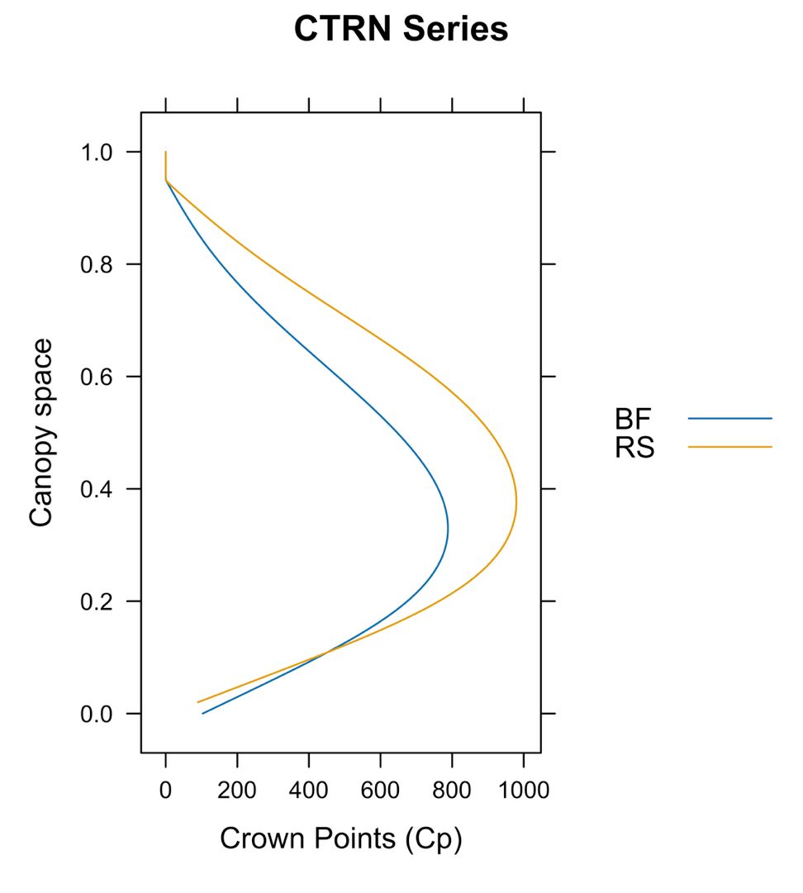

**Figure X** – Crown points (cumulative vertical canopy area occupied by trees per hectare - x axis) across the canopy profile space (0=lowest live crown, 1=top of tallest tree-y axis), where the blue line corresponds to balsam fir and the maize line indicates red spruce in the CTRN Network Series in Maine, USA.

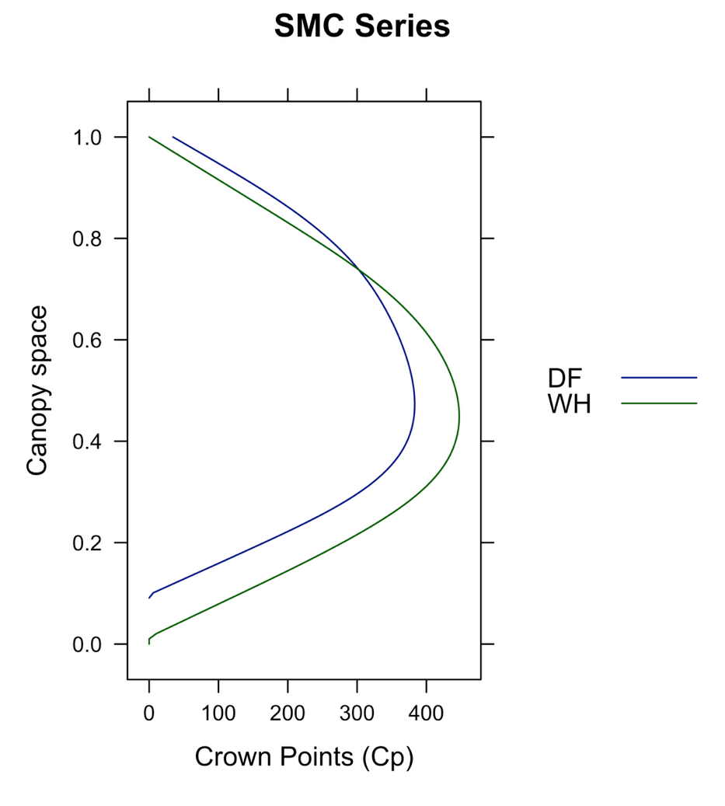

**Figure X** – Crown points (cumulative vertical canopy space occupied by the total trees per hectare by species- x axis) across the canopy profile space (0=lowest live crown, 1=top of tallest tree-y axis), where the blue line corresponds to Douglas-fir and the dark green line indicates Western hemlock in the SMC Type III Network Series in Washington, USA.