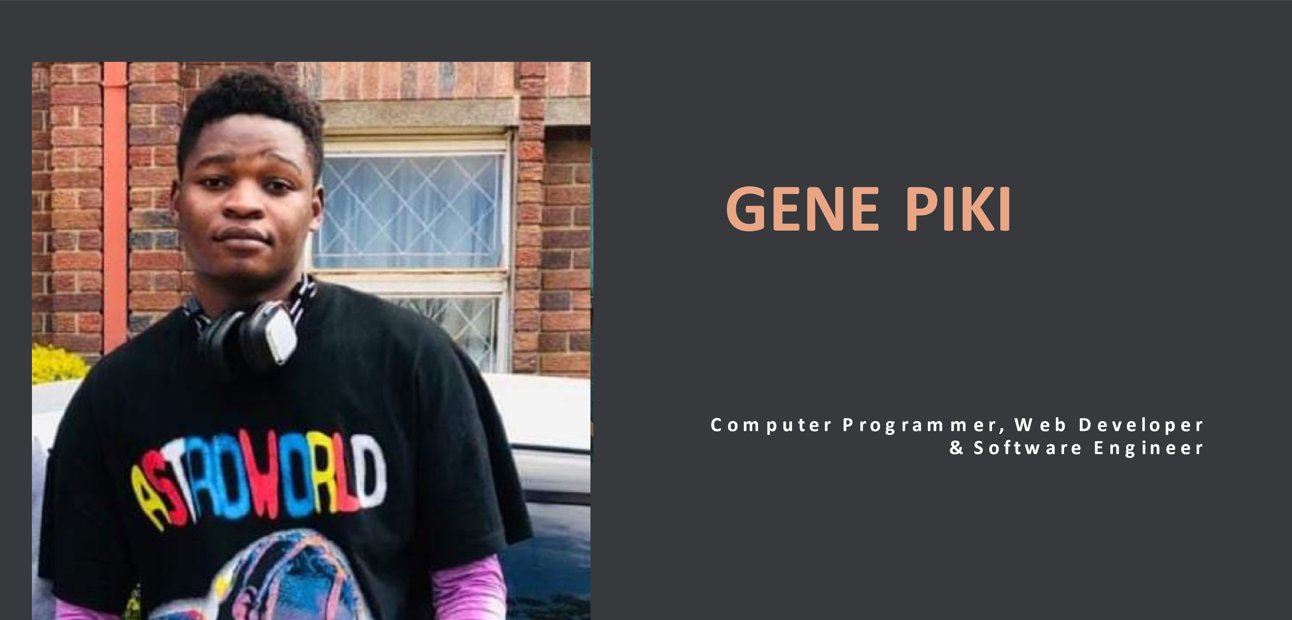



ALL ABOUT GENE



Hi I have been working as a software developer since 2015 and I started learning



Java as my primary language. I have more 7 years experience as a freelancer



developer and I

’

m fluent in :



PHP



NodeJS



JavaScript

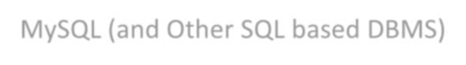

MySQL (and Other SQL based DBMS)



JQuery



React.JS



Web Development (HTML, CSS)



Wordpress



Laravel



Magento



I

’

m

a full stack developer that is l handle, backend and frontend at the same time

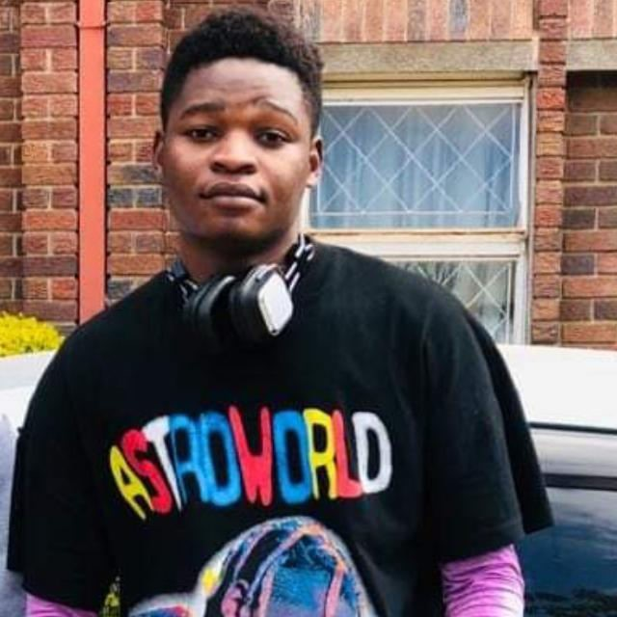

Archivements**EER OBJECTIVES**

Looking to utilize broad knowledge of programming, software engineering lifecycle, and data management to perform programming and software development using various programming languages and related tools and frameworks to solve clients’ business problems as a

Programmer. Offering critical thinking and strong interpersonal skills, plus more than 4 years of freelance programmer experience. \

WORK EXPERIENCE

1.Future + 01/2020 – 09/2022

Position: Senior Mobile Developer

* Developed and customized Flutter packages
* Developed hybrid applications (Android & IOS)
* Defined strategy for the application development
* Created the UI/UX Design
* Testing
* Application development
* Application Deployment & Support

Key Achievements

* Developed a dealer management mobile application for CoreLogic using Flutter & Flutter-Bloc for State management followed strict TDD principles, used sonar cube for monitoring code test coverage, collaborated with more than 30developers on a single projects
* Developed Future + App Using Flutter, this application works as a students help care centre to report all based violence • Developed Future + App Using Flutter, this application works as management partner for UNESCO.

2.Design Avenue 2020 – Date (Part-time)

Position: Project Lead Developer

* Elaborated business development plans.
* Recruited team members.
* Supervised a team of 4.
* Budgeted for equipment and operations costs.
* Built and maintained contacts with current and prospective business partners.
* Implemented processes to support growth through market definition.

* Managed technology development processes and operations.
* Designed and developed software architecture for business applications.
* Designed UI and UX.
* Oversaw deployment and change management.
* Prepared software development documentation.
* Developed company website.



* In charge of brand identity - name and logos. Designed and Developed picture ads.
* Provided network administration and support

Key Achievements

Booze Liquor Ecommerce App (Android & IOS) & WebSite (Project)

* Built an eCommerce market with the ability to handle deliveries, express checkout, and payment methods integration
* Utilized Laravel 7 for backend, Vue.js for frontend, and capacitor for compiling hybrid mobile applications for both android and

IOS https://booze.co.zw

Ministry Primary and Secondary Education Zimbabwe (MOPSE) (WebApp)(Project)

* Built a public directory of open educational resources (OER) for primary and secondary school teachers. This Project was sponsored by UNESCO for Teachers to contribute to the directory by submitting and sharing relevant OERs.
* Followed TDD Principles, implemented the backend using Node/Express.js and front end using HandleBars

TBD investments Android App (Project)

Built a mobile application that makes it possible for users to access, rounds, stands investments, and all the other activities that are done in TBD trust.

3.University of Zimbabwe 2018 – 2020

Position: Innovation Engineer

* Manufacturing management information system development
* Defining strategy for the system development process
* Presenting innovative project ideas
* Leading Hackerthorns
* Developing web applications (SPA, MPA, PWA, eCommerce etc.)
* Developing hybrid applications (Android & IOS)
* Defining strategy for the application development
* Creating the UI/UX Design
* Testing
* Application development
* Application Deployment & Support

4) GenePiki 2023 – Date (My Project App)

Position: Project Lead Developer

* Elaborated business development plans.
* Recruited team members.
* Supervised a team of 2.
* Budgeted for equipment and operations costs.
* Built and maintained contacts with current and prospective business partners.
* Implemented processes to support growth through market definition.

* Managed technology development processes and operations.
* Designed and developed software architecture for business applications.
* Designed UI and UX.
* Oversaw deployment and change management.
* Chat Application with user experience to save chats and export.
* Use Socket.io and Node JS for Realtime video calls and messages

5) RISKS AI APP 2023 – Date (My Project App)   
App Features AI powered System Auto generated company risks Super Admin Can Manage AI Prompts Multi domain & sub domain supportSeparate database for domainSAAS Based Admin PanelUser create domain request from frontendStripe Payment Gateway & AdminEarning report for both Super admin & AdminDynamic FrontendUser RegistrationUser LoginRemember me tokenUser ManagementRoles and PermissionsProfile Picture Upload with Crop featureChat SupportRTL SupportDark mode SupportTwo Factor AuthenticationCSRF Protection for all formsResponsive Dashboard DesignDesign Optimized for MobileBlade Format with Master LayoutBuilt with Laravel 9, vite, Vue JSSupport Module

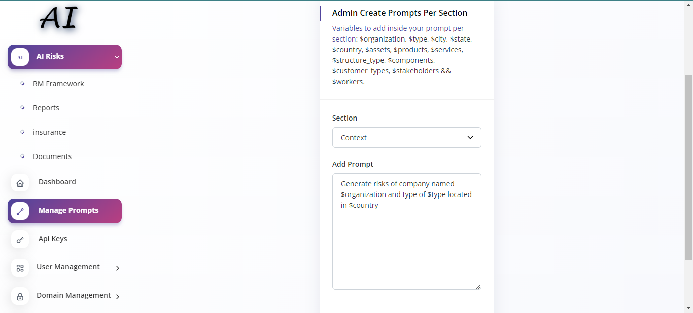

Coupons Support

**RESEARCH**

UNESCO, ROSA Harare, Zimbabwe

The research was initiated as a concept for the Zimbabwe Youth Mobile Training for Mobile Applications Development 2019. The research proposed the development of a career guidance expert system. After completing the training, I decided to continue with the research and development.

QUALIFICATIONS

* Banchelors Degree in Computer Science (Current)
* Youth Mobile Training for Mobile Applications Development 2018 - 2019

**UN**Zimbabwe CADEMIC QUALIFICATIONS

5 Ordinary Level Passes: Including English and Mathematics

HOBBIES

* Researching
* Coding
* Swimming
* Gaming
* Making ideas become reality

REFEREES

Available on Request





CONTACT ME

**Mailing Address**



no.61 Melfort Goromonzi, Harare, Zimbabwe



Email Address pikigene01@gmail.com



Phone Number

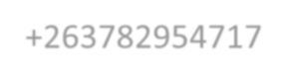

+263782954717

