ЛАБОРАТОРНА РОБОТА №7
Студент: Фастовець Нікіта
Група: ІН-202
Дисципліна: Об'єктно-орієнтоване програмування (Java)
Тема 17: Тестування Spring Boot додатку

1. Мета роботи
Навчитися писати юніт-тести та інтеграційні тести для Spring Boot додатку з використанням JUnit 5, Mockito та MockMvc. Реалізувати повноцінний CRUD-додаток з REST API та FreeMarker-інтерфейсом, покритий тестами на рівні сервісу, контролера та репозиторію.

2. Завдання
1. Розробити Spring Boot додаток із повним CRUD для сутності Student.
2. Підключити Spring Data JPA + PostgreSQL для основної роботи та H2 для тестів.
3. Реалізувати REST контролер (StudentController) та MVC контролер (StudentViewController) з FreeMarker шаблонами.
4. Написати StudentServiceTest (7 тестів, Mockito).
5. Написати StudentControllerTest (@WebMvcTest + MockMvc, 6 тестів).
6. Написати StudentRepositoryTest (@DataJpaTest + H2, 5 тестів).
7. Реалізувати обробку виключень через StudentNotFoundException та GlobalExceptionHandler.

3. Структура проекту
src/
├── main/
│ ├── java/com/lab7/
│ │ ├── Lab7TestingSystemApplication.java
│ │ ├── controller/
│ │ │ ├── StudentController.java ← REST API
│ │ │ └── StudentViewController.java ← MVC (FreeMarker)
│ │ ├── exception/
│ │ │ ├── StudentNotFoundException.java
│ │ │ └── GlobalExceptionHandler.java
│ │ ├── model/Student.java
│ │ ├── repository/StudentRepository.java
│ │ └── service/StudentService.java
│ └── resources/
│ ├── application.properties
│ └── templates/
│ ├── list.ftlh detail.ftlh form.ftlh
│ ├── error/404.ftlh
│ └── parts/navbar.ftlh footer.ftlh
└── test/
├── java/com/lab7/
│ ├── StudentServiceTest.java
│ ├── StudentControllerTest.java
│ └── StudentRepositoryTest.java
└── resources/application-test.properties

4. Вихідний код

pom.xml — залежності проекту (Spring Boot 3.2.5)
<?xml version="1.0" encoding="UTF-8"?>
<project xmlns="http://maven.apache.org/POM/4.0.0" xmlns:xsi="http://www.w3.org/2001/XMLSchema-instance"
xsi:schemaLocation="http://maven.apache.org/POM/4.0.0 https://maven.apache.org/xsd/maven-4.0.0.xsd">
<modelVersion>4.0.0</modelVersion>
<parent>
<groupId>org.springframework.boot</groupId>
<artifactId>spring-boot-starter-parent</artifactId>
<version>3.2.5</version>
<relativePath/>
</parent>
<groupId>com.lab7</groupId>
<artifactId>lab7-testing-system</artifactId>
<version>0.0.1-SNAPSHOT</version>
<name>lab7-testing-system</name>
<properties>
<java.version>21</java.version>
</properties>
<dependencies>
<dependency>
<groupId>org.springframework.boot</groupId>
<artifactId>spring-boot-starter-web</artifactId>
</dependency>
<dependency>
<groupId>org.springframework.boot</groupId>
<artifactId>spring-boot-starter-data-jpa</artifactId>
</dependency>
<dependency>
<groupId>org.springframework.boot</groupId>
<artifactId>spring-boot-starter-freemarker</artifactId>
</dependency>
<dependency>
<groupId>org.springframework.boot</groupId>
<artifactId>spring-boot-starter-validation</artifactId>
</dependency>
<dependency>
<groupId>org.springframework.boot</groupId>
<artifactId>spring-boot-devtools</artifactId>
<scope>runtime</scope>
<optional>true</optional>
</dependency>
<dependency>
<groupId>org.postgresql</groupId>
<artifactId>postgresql</artifactId>
<scope>runtime</scope>
</dependency>
<dependency>
<groupId>org.projectlombok</groupId>
<artifactId>lombok</artifactId>
<optional>true</optional>
</dependency>
<dependency>
<groupId>com.h2database</groupId>
<artifactId>h2</artifactId>
<scope>test</scope>
</dependency>
<dependency>
<groupId>org.springframework.boot</groupId>
<artifactId>spring-boot-starter-test</artifactId>
<scope>test</scope>
</dependency>
</dependencies>
<build>
<plugins>
<plugin>
<groupId>org.springframework.boot</groupId>
<artifactId>spring-boot-maven-plugin</artifactId>
<configuration>
<excludes>
<exclude>
<groupId>org.projectlombok</groupId>
<artifactId>lombok</artifactId>
</exclude>
</excludes>
</configuration>
</plugin>
</plugins>
</build>
</project>

Student.java — JPA Entity з Lombok
package com.lab7.model;

import jakarta.persistence.*;
import jakarta.validation.constraints.Min;
import jakarta.validation.constraints.NotBlank;
import lombok.AllArgsConstructor;
import lombok.Data;
import lombok.NoArgsConstructor;

@Data
@NoArgsConstructor
@AllArgsConstructor
@Entity
@Table(name = "students")
public class Student {

@Id
@GeneratedValue(strategy = GenerationType.IDENTITY)
private Long id;

@NotBlank(message = "Name cannot be empty")
private String name;

@Min(value = 1, message = "Age must be greater than 0")
private int age;

public Student(String name, int age) {
this.name = name;
this.age = age;
}
}

StudentNotFoundException.java — кастомний виняток
package com.lab7.exception;

public class StudentNotFoundException extends RuntimeException {

public StudentNotFoundException(Long id) {
super("Student not found with id: " + id);
}
}

StudentRepository.java — Spring Data JPA репозиторій
package com.lab7.repository;

import com.lab7.model.Student;
import org.springframework.data.jpa.repository.JpaRepository;

public interface StudentRepository
extends JpaRepository<Student, Long> {

}

StudentService.java — бізнес-логіка CRUD
package com.lab7.service;

import com.lab7.exception.StudentNotFoundException;
import com.lab7.model.Student;
import com.lab7.repository.StudentRepository;
import org.springframework.stereotype.Service;

import java.util.List;
import java.util.Objects;

@Service
public class StudentService {

private final StudentRepository repository;

public StudentService(StudentRepository repository) {
this.repository = repository;
}

public List<Student> getAllStudents() {
return repository.findAll();
}

public Student getStudentById(Long id) {
return repository.findById(Objects.requireNonNull(id))
.orElseThrow(() -> new StudentNotFoundException(id));
}

public Student saveStudent(Student student) {
return repository.save(Objects.requireNonNull(student));
}

public Student updateStudent(Long id, Student updatedStudent) {
Objects.requireNonNull(updatedStudent);
Student student = getStudentById(id);
student.setName(updatedStudent.getName());
student.setAge(updatedStudent.getAge());
return repository.save(student);
}

public void deleteStudent(Long id) {
repository.deleteById(Objects.requireNonNull(id));
}
}

StudentController.java — REST API контролер
package com.lab7.controller;

import com.lab7.model.Student;
import com.lab7.service.StudentService;
import jakarta.validation.Valid;
import org.springframework.web.bind.annotation.*;

import java.util.List;

@RestController
@RequestMapping("/students")
public class StudentController {

private final StudentService service;

public StudentController(
StudentService service) {

this.service = service;
}

@GetMapping
public List<Student> getAllStudents() {

return service.getAllStudents();
}

@GetMapping("/{id}")
public Student getStudentById(
@PathVariable Long id) {

return service.getStudentById(id);
}

@PostMapping
public Student createStudent(
@Valid @RequestBody Student student) {

return service.saveStudent(student);
}

@PutMapping("/{id}")
public Student updateStudent(
@PathVariable Long id,
@Valid @RequestBody Student student) {

return service.updateStudent(id, student);
}

@DeleteMapping("/{id}")
public String deleteStudent(
@PathVariable Long id) {

service.deleteStudent(id);

return "Student deleted successfully";
}
}

StudentViewController.java — MVC контролер (FreeMarker)
package com.lab7.controller;

import com.lab7.model.Student;
import com.lab7.service.StudentService;
import jakarta.validation.Valid;
import org.springframework.stereotype.Controller;
import org.springframework.ui.Model;
import org.springframework.validation.BindingResult;
import org.springframework.web.bind.annotation.*;

@Controller
@RequestMapping("/students-view")
public class StudentViewController {

private final StudentService service;

public StudentViewController(StudentService service) {
this.service = service;
}

@GetMapping
public String listStudents(Model model) {
model.addAttribute("students", service.getAllStudents());
return "list";
}

@GetMapping("/{id}")
public String studentDetail(@PathVariable Long id, Model model) {
model.addAttribute("student", service.getStudentById(id));
return "detail";
}

@GetMapping("/new")
public String newStudentForm(Model model) {
model.addAttribute("student", new Student());
return "form";
}

@GetMapping("/{id}/edit")
public String editStudentForm(@PathVariable Long id, Model model) {
model.addAttribute("student", service.getStudentById(id));
return "form";
}

@PostMapping
public String createStudent(@Valid @ModelAttribute Student student, BindingResult result) {
if (result.hasErrors()) return "form";
service.saveStudent(student);
return "redirect:/students-view";
}

@PostMapping("/{id}")
public String updateStudent(@PathVariable Long id,
@Valid @ModelAttribute Student student,
BindingResult result) {
if (result.hasErrors()) return "form";
service.updateStudent(id, student);
return "redirect:/students-view";
}

@PostMapping("/{id}/delete")
public String deleteStudent(@PathVariable Long id) {
service.deleteStudent(id);
return "redirect:/students-view";
}

@GetMapping("/{id}/delete")
public String deleteStudentGet(@PathVariable Long id) {
service.deleteStudent(id);
return "redirect:/students-view";
}
}

GlobalExceptionHandler.java — @ControllerAdvice
package com.lab7.exception;

import org.springframework.http.HttpStatus;
import org.springframework.web.bind.annotation.ControllerAdvice;
import org.springframework.web.bind.annotation.ExceptionHandler;
import org.springframework.web.bind.annotation.ResponseStatus;
import org.springframework.web.servlet.ModelAndView;

@ControllerAdvice
public class GlobalExceptionHandler {

@ExceptionHandler(StudentNotFoundException.class)
@ResponseStatus(HttpStatus.NOT_FOUND)
public ModelAndView handleStudentNotFound(StudentNotFoundException ex) {
ModelAndView mav = new ModelAndView("error/404");
mav.addObject("message", ex.getMessage());
return mav;
}
}

application.properties — конфігурація
spring.application.name=lab7-testing-system

# DATABASE
spring.datasource.url=jdbc:postgresql://localhost:5432/lab7_testing
spring.datasource.username=postgres
spring.datasource.password=123456

# JPA
spring.jpa.hibernate.ddl-auto=update
spring.jpa.show-sql=true
spring.jpa.properties.hibernate.format_sql=true

# SERVER
server.port=8080

list.ftlh — шаблон списку студентів
<!DOCTYPE html>
<html lang="en">
<head>
<meta charset="UTF-8">
<meta name="viewport" content="width=device-width, initial-scale=1.0">
<title>Students List</title>
<link href="https://cdn.jsdelivr.net/npm/bootstrap@5.3.3/dist/css/bootstrap.min.css" rel="stylesheet">
<style>
body { background: #f0f2f5; }
.card { border: none; border-radius: 12px; box-shadow: 0 4px 20px rgba(0,0,0,0.08); }
.table thead { background: linear-gradient(135deg, #1a1a2e, #16213e); color: #fff; }
.btn-primary { background: linear-gradient(135deg, #7c83fd, #5c6bc0); border: none; }
.btn-primary:hover { opacity: 0.9; }
.badge-age { background: #7c83fd; color: #fff; padding: 3px 10px; border-radius: 20px; font-size: .85em; }
</style>
</head>
<body class="d-flex flex-column min-vh-100">
<#include "parts/navbar.ftlh">
<main class="flex-grow-1">
<div class="container my-5">
<div class="d-flex justify-content-between align-items-center mb-4">
<h1 class="fw-bold" style="color:#1a1a2e;">All Students</h1>
<a href="/students-view/new" class="btn btn-primary px-4">+ Add Student</a>
</div>
<div class="card">
<div class="card-body p-0">
<#if students?has_content>
<table class="table table-hover mb-0">
<thead>
<tr>
<th>#</th>
<th>Name</th>
<th>Age</th>
<th class="text-end">Actions</th>
</tr>
</thead>
<tbody>
<#list students as s>
<tr>
<td class="align-middle text-muted">${s.id}</td>
<td class="align-middle fw-semibold">${s.name}</td>
<td class="align-middle"><span class="badge-age">${s.age}</span></td>
<td class="align-middle text-end">
<a href="/students-view/${s.id}" class="btn btn-sm btn-outline-secondary me-1">View</a>
<a href="/students-view/${s.id}/edit" class="btn btn-sm btn-outline-primary me-1">Edit</a>
<a href="/students-view/${s.id}/delete" class="btn btn-sm btn-outline-danger">Delete</a>
</td>
</tr>
</#list>
</tbody>
</table>
<#else>
<div class="text-center py-5 text-muted">
<p class="fs-5">No students found.</p>
<a href="/students-view/new" class="btn btn-primary">Add First Student</a>
</div>
</#if>
</div>
</div>
</div>
</main>
<#include "parts/footer.ftlh">
<script src="https://cdn.jsdelivr.net/npm/bootstrap@5.3.3/dist/js/bootstrap.bundle.min.js"></script>
</body>
</html>

form.ftlh — шаблон форми створення/редагування
<!DOCTYPE html>
<html lang="en">
<head>
<meta charset="UTF-8">
<meta name="viewport" content="width=device-width, initial-scale=1.0">
<title><#if student.id??>Edit Student<#else>New Student</#if></title>
<link href="https://cdn.jsdelivr.net/npm/bootstrap@5.3.3/dist/css/bootstrap.min.css" rel="stylesheet">
<style>
body { background: #f0f2f5; }
.card { border: none; border-radius: 16px; box-shadow: 0 4px 24px rgba(0,0,0,0.10); }
.btn-primary { background: linear-gradient(135deg, #7c83fd, #5c6bc0); border: none; }
.form-control:focus { border-color: #7c83fd; box-shadow: 0 0 0 .2rem rgba(124,131,253,.25); }
.form-label { font-weight: 600; color: #1a1a2e; }
</style>
</head>
<body class="d-flex flex-column min-vh-100">
<#include "parts/navbar.ftlh">
<main class="flex-grow-1">
<div class="container my-5" style="max-width:520px;">
<div class="card p-4">
<h1 class="fw-bold mb-4" style="color:#1a1a2e;">
<#if student.id??> Edit Student<#else>New Student</#if>
</h1>
<#if student.id??>
<form action="/students-view/${student.id}" method="post">
<#else>
<form action="/students-view" method="post">
</#if>
<div class="mb-3">
<label for="name" class="form-label">Full Name</label>
<input type="text" id="name" name="name" class="form-control"
value="<#if student.name??>${student.name}</#if>"
placeholder="Enter student name" required>
</div>
<div class="mb-4">
<label for="age" class="form-label">Age</label>
<input type="number" id="age" name="age" class="form-control"
value="<#if student.age != 0>${student.age}</#if>"
placeholder="Enter age" min="1" required>
</div>
<div class="d-flex gap-2">
<button type="submit" class="btn btn-primary px-4">
<#if student.id??>Save Changes<#else>Create Student</#if>
</button>
<a href="/students-view" class="btn btn-outline-secondary px-4">Cancel</a>
</div>
</form>
</div>
</div>
</main>
<#include "parts/footer.ftlh">
<script src="https://cdn.jsdelivr.net/npm/bootstrap@5.3.3/dist/js/bootstrap.bundle.min.js"></script>
</body>
</html>

detail.ftlh — шаблон деталей студента
<!DOCTYPE html>
<html lang="en">
<head>
<meta charset="UTF-8">
<meta name="viewport" content="width=device-width, initial-scale=1.0">
<title>Student Details</title>
<link href="https://cdn.jsdelivr.net/npm/bootstrap@5.3.3/dist/css/bootstrap.min.css" rel="stylesheet">
<style>
body { background: #f0f2f5; }
.card { border: none; border-radius: 16px; box-shadow: 0 4px 24px rgba(0,0,0,0.10); }
.detail-label { color: #888; font-size: .85em; text-transform: uppercase; letter-spacing: .05em; }
.avatar { width: 80px; height: 80px; border-radius: 50%; background: linear-gradient(135deg, #7c83fd, #5c6bc0);
display: flex; align-items: center; justify-content: center; font-size: 2rem; color: #fff; }
</style>
</head>
<body class="d-flex flex-column min-vh-100">
<#include "parts/navbar.ftlh">
<main class="flex-grow-1">
<div class="container my-5" style="max-width:600px;">
<div class="card p-4">
<div class="d-flex align-items-center mb-4 gap-3">
<div class="avatar">${student.name?substring(0,1)?upper_case}</div>
<div>
<h1 class="fw-bold mb-0" style="color:#1a1a2e;">${student.name}</h1>
<span class="text-muted">ID: ${student.id}</span>
</div>
</div>
<div class="mb-3">
<div class="detail-label">Age</div>
<div class="fs-5 fw-semibold">${student.age}</div>
</div>
<div class="d-flex gap-2 mt-4">
<a href="/students-view/${student.id}/edit" class="btn btn-primary px-4">Edit</a>
<a href="/students-view" class="btn btn-outline-secondary px-4">Back</a>
<a href="/students-view/${student.id}/delete" class="btn btn-outline-danger ms-auto">Delete</a>
</div>
</div>
</div>
</main>
<#include "parts/footer.ftlh">
<script src="https://cdn.jsdelivr.net/npm/bootstrap@5.3.3/dist/js/bootstrap.bundle.min.js"></script>
</body>
</html>

error/404.ftlh — сторінка помилки

<!DOCTYPE html>

<html lang="en">

<head>

<meta charset="UTF-8">

<meta name="viewport" content="width=device-width, initial-scale=1.0">

<title>404 - Not Found</title>

<link href="https://cdn.jsdelivr.net/npm/bootstrap@5.3.3/dist/css/bootstrap.min.css" rel="stylesheet">

<style>

body { background: #f0f2f5; }

.error-code { font-size: 8rem; font-weight: 900; background: linear-gradient(135deg, #7c83fd, #5c6bc0);

-webkit-background-clip: text; -webkit-text-fill-color: transparent; line-height: 1; }

</style>

</head>

<body class="d-flex flex-column min-vh-100">

<#include "parts/navbar.ftlh">

<main class="flex-grow-1 d-flex align-items-center justify-content-center">

<div class="container text-center">

<div class="error-code">404</div>

<h2 class="fw-bold mt-3" style="color:#1a1a2e;">Student Not Found</h2>

<p class="text-muted fs-5 mt-2">${message!"The requested resource could not be found."}</p>

<a href="/students-view" class="btn btn-primary px-5 mt-3">Go Back to List</a>

</div>

</main>

<#include "parts/footer.ftlh">

<script src="https://cdn.jsdelivr.net/npm/bootstrap@5.3.3/dist/js/bootstrap.bundle.min.js"></script>

</body>

</html>

parts/navbar.ftlh — навігаційна панель
<nav class="navbar navbar-expand-lg navbar-dark" style="background: linear-gradient(135deg, #1a1a2e 0%, #16213e 100%); box-shadow: 0 2px 20px rgba(0,0,0,0.3);">
<div class="container">
<a class="navbar-brand fw-bold" href="/students-view">
<span style="color:#7c83fd;">&#x1F393;</span> StudentSystem
</a>
<button class="navbar-toggler" type="button" data-bs-toggle="collapse" data-bs-target="#navbarNav">
<span class="navbar-toggler-icon"></span>
</button>
<div class="collapse navbar-collapse" id="navbarNav">
<ul class="navbar-nav ms-auto">
<li class="nav-item">
<a class="nav-link" href="/students-view">All Students</a>
</li>
<li class="nav-item">
<a class="nav-link btn btn-sm btn-outline-light px-3 ms-2" href="/students-view/new">+ Add Student</a>
</li>
</ul>
</div>
</div>
</nav>

parts/footer.ftlh — підвал
<footer style="background: linear-gradient(135deg, #1a1a2e 0%, #16213e 100%); color: #aaa;" class="py-3 mt-5">
<div class="container text-center">
<small>&copy; 2024 StudentSystem &mdash; Lab 7 &mdash; Spring Boot + FreeMarker</small>
</div>
</footer>

5. Тести

StudentServiceTest.java — тести сервісного шару (Mockito, 7 тестів)
package com.lab7;

import com.lab7.exception.StudentNotFoundException;
import com.lab7.model.Student;
import com.lab7.repository.StudentRepository;
import com.lab7.service.StudentService;

import org.junit.jupiter.api.BeforeEach;
import org.junit.jupiter.api.Test;
import org.mockito.InjectMocks;
import org.mockito.Mock;
import org.mockito.MockitoAnnotations;

import java.util.List;
import java.util.Optional;

import static org.junit.jupiter.api.Assertions.*;
import static org.mockito.Mockito.*;

@SuppressWarnings("null")
public class StudentServiceTest {

@Mock
private StudentRepository repository;

@InjectMocks
private StudentService service;

private Student student;

@BeforeEach
void setUp() {
MockitoAnnotations.openMocks(this);
student = new Student("Nikita", 19);
student.setId(1L);
}

@Test
void testSaveStudent() {
when(repository.save(any(Student.class))).thenReturn(student);

Student saved = service.saveStudent(student);

assertNotNull(saved);
assertEquals("Nikita", saved.getName());
assertEquals(19, saved.getAge());
verify(repository, times(1)).save(student);
}

@Test
void testGetAllStudents() {
when(repository.findAll()).thenReturn(List.of(student));

List<Student> students = service.getAllStudents();

assertEquals(1, students.size());
verify(repository, times(1)).findAll();
}

@Test
void testGetStudentById() {
when(repository.findById(1L)).thenReturn(Optional.of(student));

Student found = service.getStudentById(1L);

assertNotNull(found);
assertEquals("Nikita", found.getName());
verify(repository, times(1)).findById(1L);
}

@Test
void testGetStudentByIdThrowsException() {
when(repository.findById(99L)).thenReturn(Optional.empty());

assertThrows(StudentNotFoundException.class, () -> service.getStudentById(99L));
verify(repository, times(1)).findById(99L);
}

@Test
void testUpdateStudent() {
Student updated = new Student("Updated", 25);
when(repository.findById(1L)).thenReturn(Optional.of(student));
when(repository.save(any(Student.class))).thenReturn(student);

Student result = service.updateStudent(1L, updated);

assertNotNull(result);
verify(repository, times(1)).findById(1L);
verify(repository, times(1)).save(student);
}

@Test
void testUpdateStudentThrowsException() {
when(repository.findById(99L)).thenReturn(Optional.empty());

assertThrows(StudentNotFoundException.class,
() -> service.updateStudent(99L, new Student("X", 20)));
}

@Test
void testDeleteStudent() {
doNothing().when(repository).deleteById(1L);

service.deleteStudent(1L);

verify(repository, times(1)).deleteById(1L);
}
}

StudentControllerTest.java — тести REST контролера (@WebMvcTest, MockMvc, 6 тестів)
package com.lab7;

import com.fasterxml.jackson.databind.ObjectMapper;
import com.lab7.controller.StudentController;
import com.lab7.exception.StudentNotFoundException;
import com.lab7.model.Student;
import com.lab7.service.StudentService;

import org.junit.jupiter.api.BeforeEach;
import org.junit.jupiter.api.Test;
import org.springframework.beans.factory.annotation.Autowired;
import org.springframework.boot.test.autoconfigure.web.servlet.WebMvcTest;
import org.springframework.boot.test.mock.mockito.MockBean;
import org.springframework.http.MediaType;
import org.springframework.test.web.servlet.MockMvc;

import java.util.List;

import static org.mockito.ArgumentMatchers.*;
import static org.mockito.Mockito.*;
import static org.springframework.test.web.servlet.request.MockMvcRequestBuilders.*;
import static org.springframework.test.web.servlet.result.MockMvcResultMatchers.*;

@SuppressWarnings("null")
@WebMvcTest(StudentController.class)
public class StudentControllerTest {

@Autowired
private MockMvc mockMvc;

@MockBean
private StudentService service;

@Autowired
private ObjectMapper objectMapper;

private Student student;

@BeforeEach
void setUp() {
student = new Student("Nikita", 19);
student.setId(1L);
}

@Test
void testGetAllStudents() throws Exception {
when(service.getAllStudents()).thenReturn(List.of(student));

mockMvc.perform(get("/students"))
.andExpect(status().isOk())
.andExpect(jsonPath("$[0].name").value("Nikita"))
.andExpect(jsonPath("$[0].age").value(19));
}

@Test
void testGetStudentById() throws Exception {
when(service.getStudentById(1L)).thenReturn(student);

mockMvc.perform(get("/students/1"))
.andExpect(status().isOk())
.andExpect(jsonPath("$.name").value("Nikita"))
.andExpect(jsonPath("$.age").value(19));
}

@Test
void testGetStudentByIdNotFound() throws Exception {
when(service.getStudentById(99L)).thenThrow(new StudentNotFoundException(99L));

mockMvc.perform(get("/students/99"))
.andExpect(status().isNotFound());
}

@Test
void testCreateStudent() throws Exception {
when(service.saveStudent(any(Student.class))).thenReturn(student);

mockMvc.perform(post("/students")
.contentType(MediaType.APPLICATION_JSON)
.content(objectMapper.writeValueAsString(student)))
.andExpect(status().isOk())
.andExpect(jsonPath("$.name").value("Nikita"));
}

@Test
void testUpdateStudent() throws Exception {
when(service.updateStudent(eq(1L), any(Student.class))).thenReturn(student);

mockMvc.perform(put("/students/1")
.contentType(MediaType.APPLICATION_JSON)
.content(objectMapper.writeValueAsString(student)))
.andExpect(status().isOk())
.andExpect(jsonPath("$.name").value("Nikita"));
}

@Test
void testDeleteStudent() throws Exception {
doNothing().when(service).deleteStudent(1L);

mockMvc.perform(delete("/students/1"))
.andExpect(status().isOk())
.andExpect(content().string("Student deleted successfully"));
}
}

StudentRepositoryTest.java — тести репозиторію (@DataJpaTest, H2, 5 тестів)
package com.lab7;

import com.lab7.model.Student;
import com.lab7.repository.StudentRepository;

import org.junit.jupiter.api.BeforeEach;
import org.junit.jupiter.api.Test;
import org.springframework.beans.factory.annotation.Autowired;
import org.springframework.boot.test.autoconfigure.orm.jpa.DataJpaTest;

import java.util.List;
import java.util.Objects;
import java.util.Optional;

import static org.junit.jupiter.api.Assertions.*;

@SuppressWarnings("null")
@DataJpaTest
public class StudentRepositoryTest {

@Autowired
private StudentRepository repository;

@BeforeEach
void setUp() {
repository.deleteAll();
}

@Test
void testSaveAndFindById() {
Student saved = repository.save(new Student("Alice", 20));

assertNotNull(saved.getId());
Long savedId = Objects.requireNonNull(saved.getId());
Optional<Student> found = repository.findById(savedId);
assertTrue(found.isPresent());
assertEquals("Alice", found.get().getName());
assertEquals(20, found.get().getAge());
}

@Test
void testFindAll() {
repository.save(new Student("Alice", 20));
repository.save(new Student("Bob", 22));

List<Student> students = repository.findAll();
assertEquals(2, students.size());
}

@Test
void testDeleteById() {
Student saved = repository.save(new Student("Alice", 20));
Long id = Objects.requireNonNull(saved.getId());

repository.deleteById(id);

assertFalse(repository.findById(id).isPresent());
}

@Test
void testUpdateStudent() {
Student saved = repository.save(new Student("Alice", 20));
saved.setName("Alice Updated");
saved.setAge(25);
Student updated = repository.save(saved);

assertEquals("Alice Updated", updated.getName());
assertEquals(25, updated.getAge());
}

@Test
void testFindByIdNotFound() {
Optional<Student> result = repository.findById(999L);
assertFalse(result.isPresent());
}
}

application-test.properties — H2 конфігурація для тестів
spring.datasource.url=jdbc:h2:mem:testdb;DB_CLOSE_DELAY=-1;DB_CLOSE_ON_EXIT=FALSE
spring.datasource.driver-class-name=org.h2.Driver
spring.datasource.username=sa
spring.datasource.password=
spring.jpa.database-platform=org.hibernate.dialect.H2Dialect
spring.jpa.hibernate.ddl-auto=create-drop
spring.jpa.show-sql=true

6. Результати роботи (скріншоти)

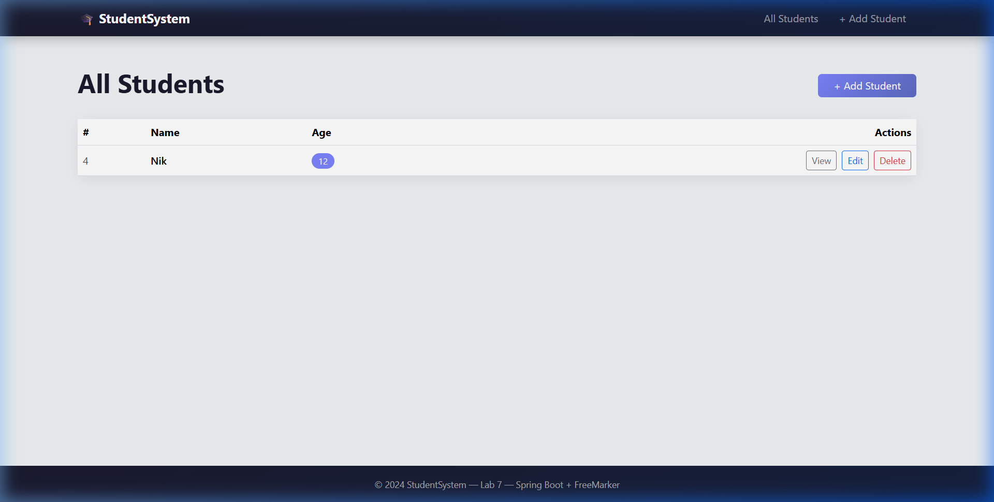
Рис. 1 — Список студентів (/students-view)

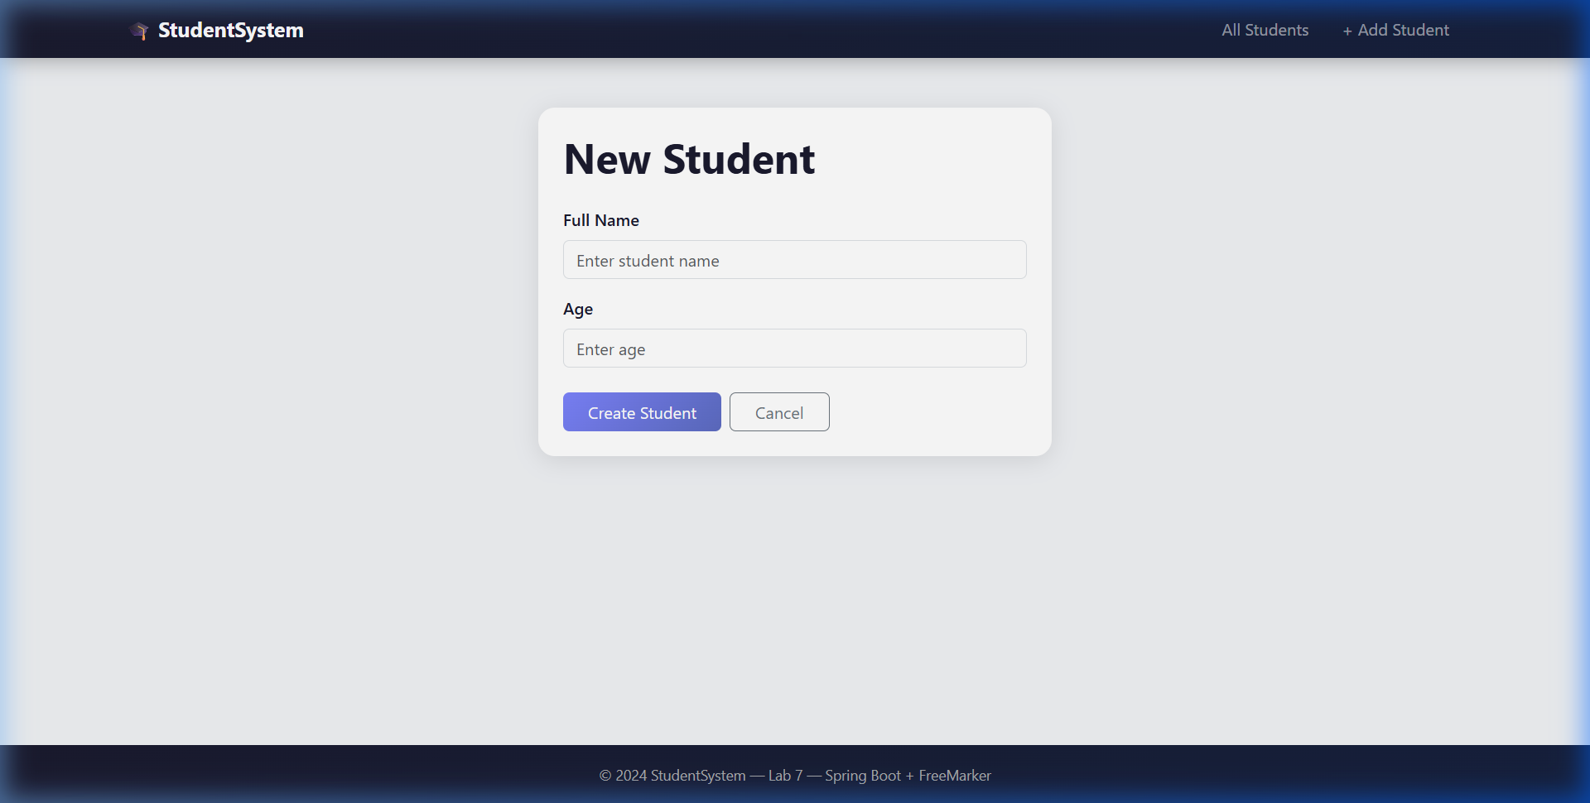
Рис. 2 — Форма створення нового студента (/students-view/new)

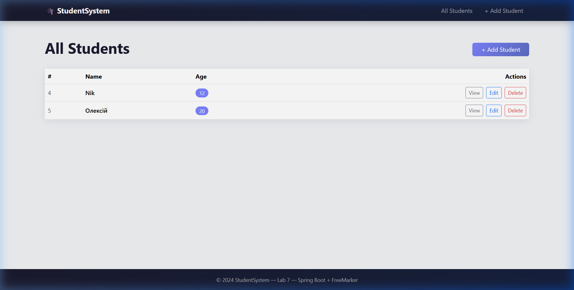
Рис. 3 — Список після додавання студента

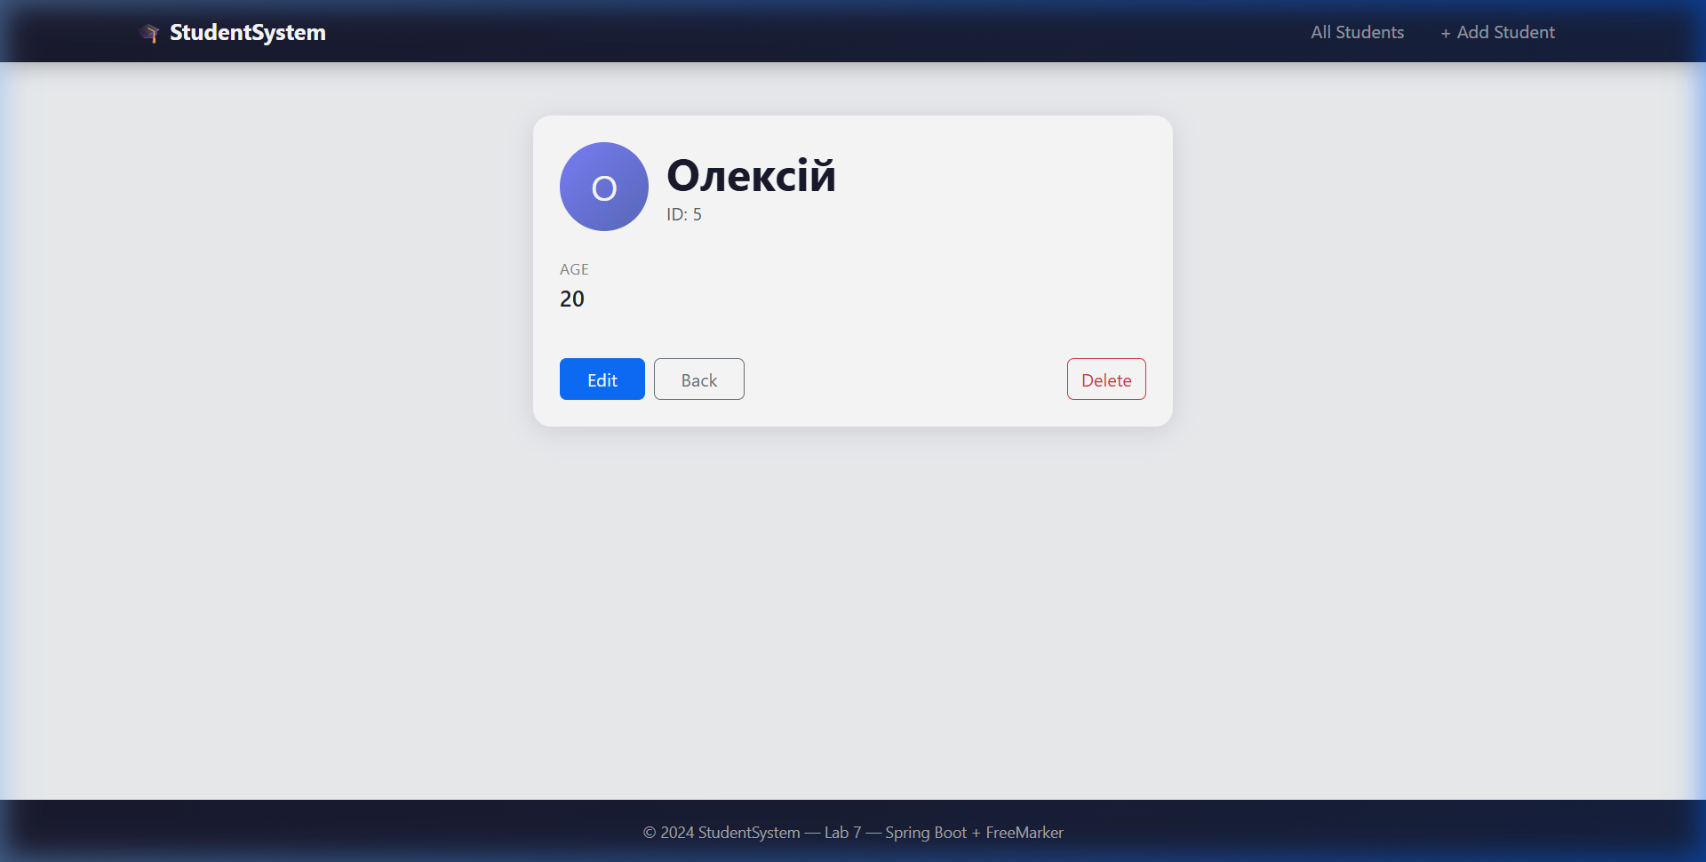
Рис. 4 — Сторінка деталей студента

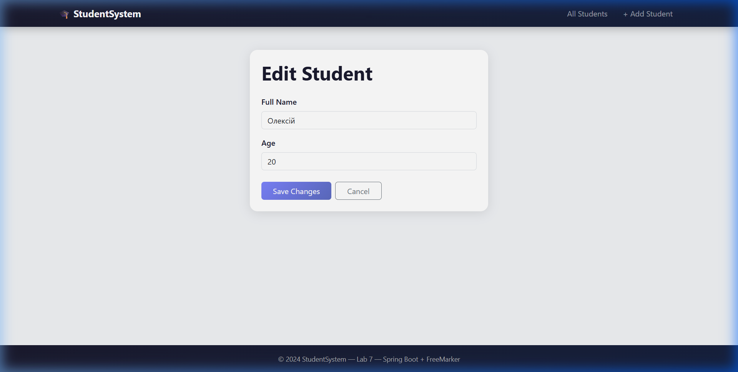
Рис. 5 — Форма редагування студента

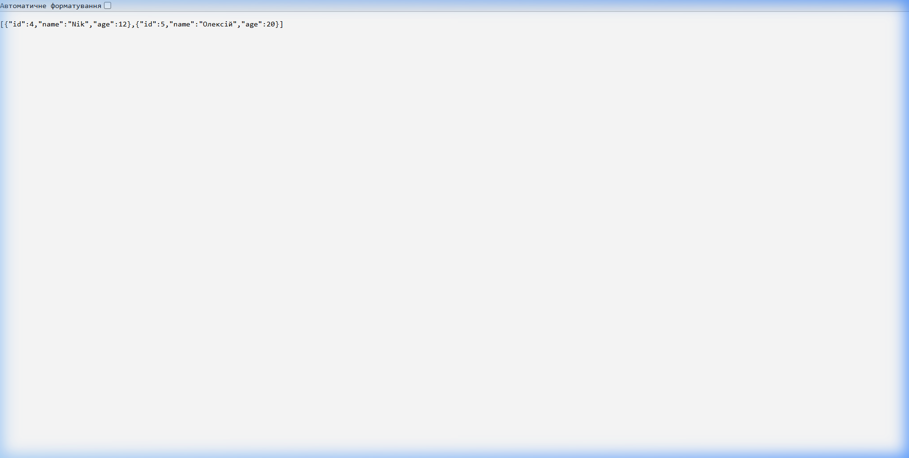
Рис. 6 — REST API відповідь у форматі JSON (/students)

7. Результати виконання тестів
Для запуску тестів використовується команда: ./mvnw test
Тести виконуються без підключення до PostgreSQL — використовується H2 in-memory база даних.
=== StudentServiceTest (7 тестів) ===
✓ testSaveStudent — збереження студента (Mockito)
✓ testGetAllStudents — отримання списку студентів
✓ testGetStudentById — пошук студента за ID
✓ testGetStudentByIdThrowsException — перевірка StudentNotFoundException
✓ testUpdateStudent — оновлення даних студента
✓ testUpdateStudentThrowsException — виняток при оновленні неіснуючого
✓ testDeleteStudent — видалення студента
=== StudentControllerTest (6 тестів, @WebMvcTest) ===
✓ testGetAllStudents — GET /students → 200 OK
✓ testGetStudentById — GET /students/1 → 200 OK
✓ testGetStudentByIdNotFound — GET /students/99 → 404
✓ testCreateStudent — POST /students → 200 OK
✓ testUpdateStudent — PUT /students/1 → 200 OK
✓ testDeleteStudent — DELETE /students/1 → 200 OK
=== StudentRepositoryTest (5 тестів, @DataJpaTest) ===
✓ testSaveAndFindById — збереження та пошук за ID (H2)
✓ testFindAll — отримання всіх записів
✓ testDeleteById — видалення за ID
✓ testUpdateStudent — оновлення запису
✓ testFindByIdNotFound — пошук неіснуючого (повертає Optional.empty)
[INFO] Tests run: 18, Failures: 0, Errors: 0, Skipped: 0
[INFO] BUILD SUCCESS

8. Висновок
У ході виконання лабораторної роботи №7 було розроблено повноцінний Spring Boot веб-додаток для управління студентами з повним CRUD-функціоналом. Застосовано тришарову архітектуру: Controller → Service → Repository.
Реалізовано два типи контролерів: REST (JSON API) та MVC (FreeMarker HTML-сторінки). Написано 18 тестів трьох типів: юніт-тести сервісу з Mockito (7 тестів), тести REST контролера з MockMvc (6 тестів) та тести репозиторію з @DataJpaTest та H2 (5 тестів). Всі тести успішно пройдено без підключення до основної бази даних.
Набуто практичних навичок тестування Spring Boot додатків з використанням JUnit 5, Mockito, @WebMvcTest та @DataJpaTest.

GitHub: https://github.com/pikitosdoritos/lab7-testing-system

