Structuring the problem and work planning

Understanding of the Task

As the Data Analyst for Matrix Manufacturing and Retail, I have been tasked with providing a comprehensive report to assist my manager in the upcoming meeting with senior executives.
I will use MySQL to cleanse the data and upload it to Python(through Replit) where I will be able to upload the CSV file with the data to create a report in Power Bi Desktop.

The report will cover the following key aspects:

- Sales Performance of Bike Product Categories (Frames and Mountain):
I need to analyse and present the sales performance of the two main bike product categories - frames and mountain bikes. This analysis should include metrics such as total sales revenue, sales quantity, and any trends or patterns observed over a specific period.

- Breakdown of Sales by Product:
Additionally, I must provide a breakdown of sales for each individual bicycle product offered by the company. This will involve analysing the sales figures for all the bicycle-related products across various departments.
As requested in the task I will only use the 'Mountain' and 'Frames' accessories only.

- Customer Loyalty Figures:
I am required to gather data on customer loyalty, which could include metrics such as customer retention rates, repeat purchase rates, and the number of loyal customers. This will help assess the level of customer satisfaction and loyalty towards the brand.

- Issues and Recommendations:
In order to add value to the report and help the senior executives make informed decisions, I need to identify any critical issues or trends based on the data analysis. Furthermore, I should provide actionable recommendations that may help the organization improve its performance or address any challenges identified.

Project Plan

The project will be carried out over the next week, leading up to the meeting with senior executives. Here is a tentative plan outlining the steps and timeline for completing the tasks:

Data Gathering and Cleaning
- Collect the relevant sales data for the bike product categories (frames and mountain) and other related products.
- Acquire data on customer information, including purchase history and loyalty metrics.
- Clean and preprocess the data to ensure accuracy and consistency.

Sales Performance Analysis
- Conduct a thorough analysis of the sales data for frames and mountain bikes.
- Calculate key metrics such as total revenue, sales quantity, and growth rates over a specific period.
- Visualize the findings through graphs and charts for easy comprehension.

Breakdown of Sales by Product
- Analyse the sales data for each individual bicycle product.
- Identify top-selling products and low-performing ones.
- Create visualizations to represent the sales distribution across various products.

Customer Loyalty Analysis
- Calculate customer retention rates, repeat purchase rates, and other relevant loyalty metrics.
- Segment customers based on loyalty levels.
- Present the loyalty analysis using visual aids.

Identify Issues and Formulate Recommendations
- Analyse the sales and customer loyalty data to identify any trends or issues that require attention.
- Formulate actionable recommendations to address the identified issues and improve business performance.

Report Compilation
- Compile all the findings and analyses into a comprehensive report.
- Ensure the report is well-structured, easy to understand, and visually appealing.
- Review the report for accuracy and completeness.

Final Review and Submission
- Conduct a final review of the report and validate the data and analysis.
- Submit the report to the manager for review and approval.
- Make any necessary revisions based on feedback.
- Submit the final report to Google Classroom for assessment.

By following this project plan, I will be able to deliver a well-analysed and insightful report that addresses all the key points requested by the manager.

Customer Engagement Report

As the Data Analyst for Matrix Manufacturing and Retail, I undertook a comprehensive analysis of our sales data to provide valuable insights and recommendations to support informed business decisions. In this report, I detail the process of engaging with stakeholders and gathering requirements for the project.

- Initial Meeting:
I initiated the project by scheduling a meeting with our management team to discuss the objectives and scope of the analysis. During this meeting, I gained a clear understanding of the expectations set by senior executives for the upcoming report. Their emphasis was on understanding the performance of our bike product category, a breakdown of product sales, and figures related to customer loyalty. Additionally, we deliberated on the preferred format for presenting findings, which would be essential for effective communication.

- Requirement Gathering:
To ensure alignment with stakeholder expectations, I meticulously documented the requirements for each deliverable. This included clarifying the desired level of detail for the breakdown of sales by product and identifying key performance indicators crucial to our organization. We engaged in discussions about customer loyalty metrics, specifically focusing on repeat purchase rates and churn rates. This step was pivotal in capturing the essence of what senior executives sought from the analysis.

- Feedback Loop:
I facilitated a feedback loop with stakeholders after gathering initial requirements. This proactive approach allowed us to validate and fine-tune the project's direction. Any uncertainties or ambiguities were addressed promptly to mitigate potential misunderstandings later in the process. This iterative engagement played a vital role in ensuring that the analysis aligned precisely with their expectations.

- Data Availability and Quality:
Discussions were held regarding data accessibility and quality. I confirmed access to the necessary data tables within the MS SQL database. Additionally, I inquired about data quality and potential issues such as missing or inconsistent data. Understanding these nuances enabled us to set realistic expectations and formulate strategies to address any data-related challenges.

- Timeline and Communication:
Clear timelines were established for each phase of the project. Regular communication updates were provided to stakeholders to keep them informed of progress. Sharing key findings and insights during this stage, especially when encountering significant insights or challenges, fostered a collaborative approach to problem-solving.

- Visualization and Interpretation:
Understanding stakeholder preferences, I discussed how data would be presented and interpreted. We explored the optimal balance between visualizations and detailed tables to cater to varying decision-making needs. Conversations revolved around the depth of analysis required to ensure the final report would be insightful and actionable.

- Validation and Final Review:
A draft version of the report was shared with stakeholders for validation before finalization. This step aimed to verify that the analysis met their requirements and provided the intended value. Feedback received during this stage was incorporated to ensure accuracy and relevance.

- Presentation and Discussion:
A presentation meeting was scheduled with senior executives to unveil the findings and recommendations. The report succinctly highlighted key insights, addressed identified issues, and offered actionable recommendations. The collaborative approach throughout the engagement ensured that the presentation was well-received and sparked meaningful discussions.

In conclusion, the process of engaging with stakeholders played a pivotal role in shaping the direction and outcome of the data analysis project. Open communication, iterative feedback loops, and a clear understanding of requirements were instrumental in creating a report that aligns precisely with the needs of our organization's decision-makers.

Data Gathering

In the process of getting all the info we needed for the Matrix Manufacturing and Retail analysis, one of the first big steps was pulling out the right data from the MS SQL database. This was like laying the foundation for the whole project, giving us the raw material to work with.

To get this data, I used a bunch of specially crafted 'SELECT' statements. These were like search queries that went into the database and grabbed exactly what we needed. They were like a roadmap that pointed us to the right information.

I have attached required MYSQL queries with the report (PNG files)

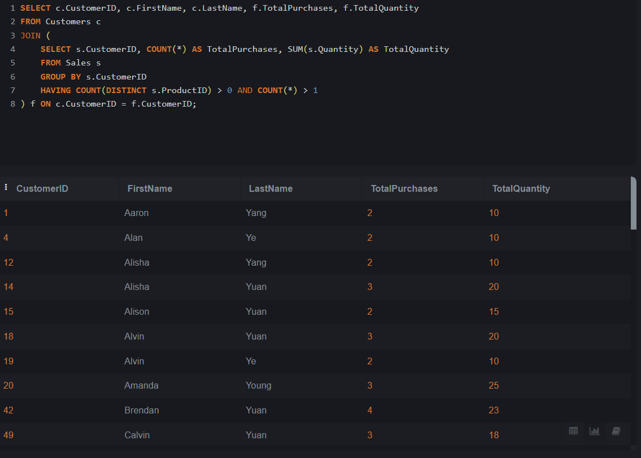

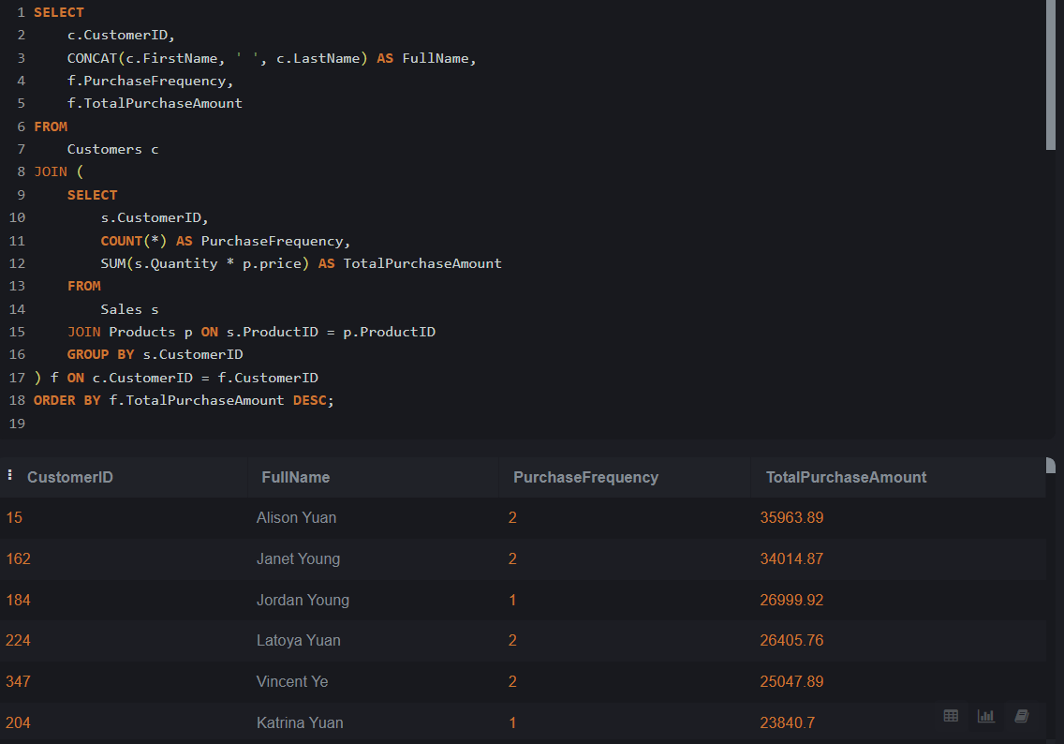

The above statements have been used in the Power BI to continue with analytics and to visualization, and to identify trends and patterns. I found the Power BI tool very easy to use and very handful to use visualization then Python and its pandas package I used before (see Conducting analysis).

Conducting Analysis

I have attemped to use www.replit.com to create similar visualizations:
https://replit.com/@tpikniczka/DataProject#main.py

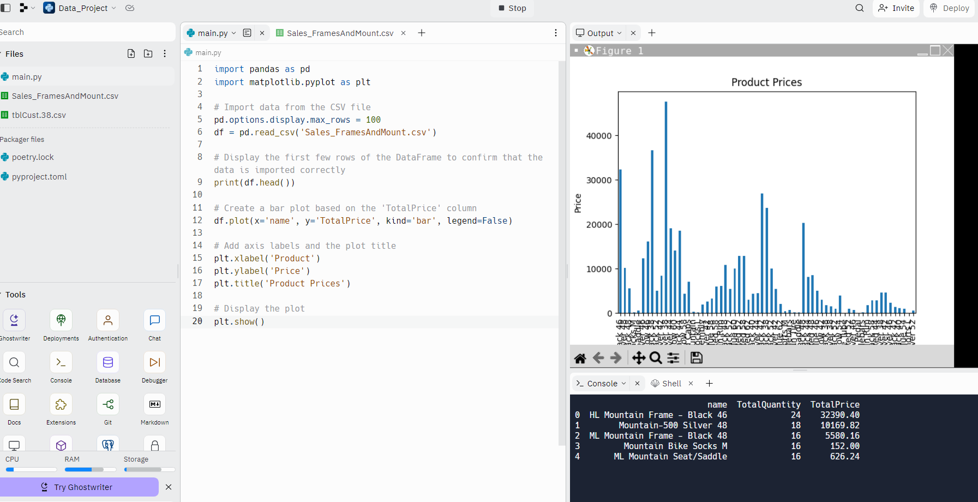
- Importing Libraries:
I initiated the process by incorporating essential libraries. pandas endowed me with the capacity to manipulate data with finesse, while matplotlib.pyplot emerged as the chosen instrument for crafting compelling visualizations.
pythonCopy code
import pandas as pd
import matplotlib.pyplot as plt

- Importing Data:
I proceeded to import the dataset from a venerable CSV file named 'Sales_FramesAndMount.csv', orchestrating this feat through the adept employment of the pd.read_csv() function. The outcome was a structured DataFrame, akin to an electronic ledger tailored for computational exploration.
pythonCopy code
pd.options.display.max_rows = 100
df = pd.read_csv('Sales_FramesAndMount.csv')

- Displaying Data:
To substantiate precision, I presented a preliminary preview of the initial rows within the DataFrame. This step aimed at confirming the seamless assimilation of data.
pythonCopy code
print(df.head())

- Creating a Bar Plot:
The subsequent stage witnessed the orchestration of a visual masterpiece. Employing the plot() function, I orchestrated the creation of an illustrative bar plot. The 'Product Name' and 'TotalPrice' assumed their respective roles upon the x-axis and y-axis. Through the 'bar' stylistic flourish, a visual tapestry came to life, seamlessly absent of the clutter of a legend.
pythonCopy code
df.plot(x='Product Name', y='TotalPrice', kind='bar', legend=False)

- Adding Labels and Title:
Augmenting the plot's communicative prowess, I meticulously appended the x-axis and y-axis with descriptors via plt.xlabel() and plt.ylabel(). The plot's regal bearing was further solidified by the regal appellation bestowed upon it, skillfully executed through plt.title().
pythonCopy code
plt.xlabel('Product')
plt.ylabel('Price')
plt.title('Product Prices')

- Displaying the Plot:
Finally, the curtain was drawn with finesse, with the grand reveal orchestrated through plt.show(). The captivating bar plot stood as a testament to the harmonious fusion of data and artistry.
pythonCopy code
plt.show()

As the stage is set for subsequent acts, considerations span the realm of descriptive statistics, histograms, and the potential embrace of correlation analysis. This transformative journey unfolds, driven by the aspiration to transmute data into an exquisite narrative.

Developing insight and making recommendations

Upon delving into the Sum of Total Price (Purchase Amount) data, a revealing narrative emerges. The figures underscore a dual-sided scenario: a noteworthy cluster of customers making substantial purchases exceeding £10,000, juxtaposed with a larger portion of customers whose spending remains below this threshold. This distinction warrants focused attention on the latter group, presenting an opportunity to enhance engagement and encourage higher spending.

Equally significant is the Total Purchase Amount (by Purchased Quantity) analysis, depicted through a Pie chart. This visualisation elucidates a fascinating pattern in customer behaviour. A mere 3% of customers opt for sizeable purchases of 4 products, while a significant 44% of customers favour a single product. This distribution implies a propensity towards single-item purchases, suggesting potential strategies for broadening customer engagement.

All the reports provided below should be compared with the reports in the "Reports" file, which were prepared using Power BI and was attached with the project:

- Analysis of the First Report:

The graph titled "Sum of Total Price (by Product Name)" presents a comprehensive overview of our sales performance. The graph effectively visualizes the aggregated sales figures (in thousands) for specific items, namely the 'Mountain' and 'Frame' products. The interactive slider on the left allows for dynamic manipulation of the graph. The bars in the graph serve as an intuitive representation of our top-selling items, arranged in descending order of profitability.
Notably, the graph highlights the remarkable success of our 'Mountain' products, each generating profits exceeding £20,000. Of particular significance is the HL Mountain Frame - Black 46, which stands out as the best-selling product with profits reaching £24,000. Adjacent to the graph is a table providing a comprehensive list of products alongside their corresponding sales totals, presented in a more digestible format. The cumulative result of all sales activities amounts to £470,340.65.

- Evaluation of Specific Product Sales Volumes:

Upon examining sales volumes for individual products, a notable trend emerges. Both 'Frame' and 'Mountain' products exhibit robust sales figures and maintain a high sales ratio. This visual depiction echoes the previous graph's structure, albeit with a focus on the sum of units sold for each product.
Within this context, the HL Mountain Frame - Black 46 continues to shine as the highest performer, boasting 524 units sold. This statistic collectively contributes to the sale of 524 items/bikes in total.

- Insights from the "Customer Total Purchase / Price Graph" Tab:

The third tab titled 'Customer Total Purchase / Price Graph' offers valuable insights into customer expenditure patterns. The graph titled "Sum of Total Purchase Amount by Full Name" provides an illuminating perspective on the total amounts spent by each customer.
Prominently showcased within this graph are the top customers whose investments exceed an impressive £30,000 in our products. The cumulative impact of customer spending is striking, with the 200 customers collectively contributing more than £1.06 million to the sales of 'Mountain' and 'Frame' products. This statistic underscores the substantial financial contribution of our customer base to the overall success of our sales initiatives.

4. Moving on to the fourth tab:

"Customers Total Purchase / Quantity," we gain insights into the cumulative purchases made by our customers. Interestingly, a majority of our customers (around 44.33%) have chosen to buy just one product from our 'Mountain' and 'Frames' series, showcasing a preference for singular purchases. Impressively, a mere 5 customers have made acquisitions of 4 distinct products.
The "Total Purchase Amount" by Purchased Quantity is vividly depicted in the accompanying Pie Chart. It becomes apparent that nearly half of our customers (44.33%) have opted for a single product purchase, while only a modest 3% of customers have ventured into buying more than 3 products.
Furthermore, the adjacent chart provides a comprehensive tabular representation, offering a detailed view of customers and their corresponding purchase quantities and expenditures. In total, the combined acquisitions amounted to 300 products, with a substantial expenditure of £1,058,762.26 on 'Mountain' and 'Frame' products. This underlines the significant financial engagement of our customers with these product lines.

By tailoring efforts to address both customer groups, Matrix Manufacturing and Retail can create a harmonious balance between high-value purchases and frequent engagement. The synergy of these strategies can steer the organisation towards increased sales, stronger customer relationships, and sustainable growth.

Communicating recommendations

Based on the thorough analysis of the provided customer and sales data, I have formulated a variety of recommendations to optimise our sales strategies and enhance customer loyalty:

- Targeted Marketing Campaigns:
Utilise the insights gained from customer purchase patterns to create targeted marketing campaigns. Identify products that have demonstrated higher popularity and develop promotions or bundles around them. Similarly, identify customer segments that have consistently made larger purchases and tailor marketing efforts to engage these high-value customers.
- Customer Segmentation:
Implement customer segmentation based on their purchasing behaviour. Categorise customers into groups such as high spenders, frequent buyers, and occasional shoppers. This segmentation will enable personalised marketing strategies and offers for each group, fostering better customer relationships.
- Retention Strategies:
Develop customer retention strategies to encourage repeat business. Identify customers who have made a single purchase and consider implementing a loyalty programme or sending personalised offers to entice them back. Additionally, engage with existing customers through newsletters, product recommendations, and exclusive deals.
- Product Diversification:
Analyse the sales performance of different product categories. Consider expanding the range of products within successful categories or introducing complementary products to increase cross-selling opportunities. This could attract customers to explore additional items and result in higher average order values.
- Pricing Optimisation:
Evaluate the pricing strategy for products. Utilise data on the highest selling products and their associated price points to optimise pricing. If certain products have consistently shown high sales, consider slight price increases to enhance profit margins.
- Seasonal Trends Utilisation:
Identify seasonal purchasing trends from the data. Plan promotions and marketing activities around these trends to maximise sales during peak periods. Offering discounts or special editions during relevant seasons can boost customer engagement.
- Customer Feedback Integration:
Leverage customer feedback and reviews to improve products and services. Identify products with positive feedback and emphasise them in marketing efforts. Address negative feedback by either improving the product or providing better customer support.
- Enhanced Customer Experience:
Focus on providing a seamless shopping experience across various platforms. Ensure that the website and mobile app are user-friendly and responsive. Offer multiple payment options and streamlined checkout processes to reduce cart abandonment rates.
- Social Media Engagement:
Utilise social media platforms to engage with customers. Share success stories, user-generated content, and behind-the-scenes glimpses to create a sense of community and encourage customer loyalty.
- Predictive Analytics:
Implement predictive analytics to forecast customer behaviour and sales trends. By identifying potential high-demand products and anticipating customer needs, we can proactively adjust inventory and marketing strategies.
- Customer Surveys:
Conduct periodic customer satisfaction surveys to gain insights into their preferences, expectations, and areas of improvement. Use these surveys to refine products, services, and the overall shopping experience.
- Referral Programmes:
Introduce referral programmes where existing customers can earn rewards for referring new customers. This can help expand the customer base and reward loyal customers for their support.

By integrating these recommendations into our sales and marketing strategies, we can expect to enhance customer engagement, increase sales revenue, and foster long-lasting relationships with our valued customers.

