**Author: Dionysios Tachtsidis**

**Title: Vending machine**

**Functional description**

This program allows a user to buy an item from this virtual vending machine.

The program uses a file to store the Item data (Name, price, Inventory Amount).

The program allows the user to enter a double amount of money, and then choose the item they wish to purchase.

The program uses the console to interact with the user.

(SAME AS THE PREVIOUS VERSION)

**CHANGES**

**MAIN**

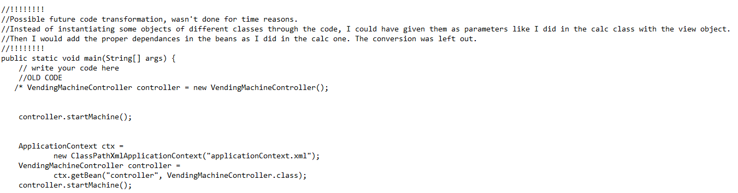

The main method has been converted to one that uses SpringDI.

There are xml files that handle the injection, throughout the code, as demonstrated in the code along.