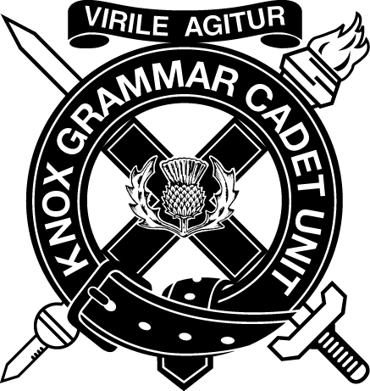­ AUSTRALIAN ARMY CADETS

KNOX GRAMMAR SCHOOL ARMY CADET UNIT

[**http://tinyurl.com/kgsacu**](http://tinyurl.com/kgsacu)

## Routine Orders

**Friday 30th November 2018**

# RO 019/18-19

1. Cadets IS ON for all members of the Unit.
2. Dress of the Day;

|  |  |
| --- | --- |
| **Recruit COYs** | **Dress Order 2A: DPCU Summer Ceremonial:** Balmoral; DPCU Coat: sleeves up, tucked in, ironed free of creases; Black Web Belt with Brass: polished, keepers and buckles touching; Black Boots: polished. |
| **Senior COYs** | **Dress Order 3A: DPCU Summer Barracks:** Balmoral; DPCU Coat: sleeves down, untucked, ironed free of creases; Black Web Belt with Brass: polished, keepers and buckles touching; Green Boots: Black Boots if unavailable. |

1. Gate inspections will be carried out by the RSM and WO’s.

# RO 020/18-19

1. ALL COYs will participate in the COY Admin and Dismissal Parades.
2. Rolls will be taken.
3. Form up as per the diagram.
4. POI 1: 1540-1625
5. POI 2: 1625-1710
6. ALL COYs will participate in training as per the TP after the COY Admin Parade.

# RO 021/18-19

| **COY** | **POI** | **Tier** | **Training** | **Location** |
| --- | --- | --- | --- | --- |
| **A** | 1 | 1 | St Ives Ex | St Ives |
| 2 |
| 2 | 1 | St Ives Ex | St Ives |
| 2 |
| **B** | 1 |  | C2MIL12 - Turns and inclines on the march in quick time | Knox 1 |
| 2 |  | C2MIL29 – Methods of movement | Boarders Lawn |
| **C** | 1 |  | C2MIL12 - Turns and inclines on the march in quick time | Knox 1 |
| 2 |  | C2MIL29 - Methods of movement | Memorial Lawn |
| **D** | 1 |  | C2MIL12 - Turns and inclines on the march in quick time | Knox 1 |
| 2 |  | C2MIL29 - Methods of movement | Chapel Lawn |
| **E** | 1 |  | C2MIL29 - Demonstrates individual movement by night | Boarders Lawn |
| 2 |  | C2MIL12 - Methods of movement | Knox 1 |
| **F** | 1 |  | C2MIL29 - Demonstrates individual movement by night | Memorial Lawn |
| 2 |  | C2MIL12 - Methods of movement | Knox 1 |

|  |  |  |  |  |  |
| --- | --- | --- | --- | --- | --- |
| **COY** | **POI** | **Pl** | **Tier** | **Training** | **Location** |
| **HQ** | 1 | ADMIN PL | 1 | Drill Revision | Knox 1 |
| 2 |
| 2 | 1 | Filing | Allocated Classroom |
| 2 |
| 1 | OPS PL | Lesson: Fieldcraft | | Chapel Lawn |
| 2 | Theory Lesson: Navigating at Night | | Chapel Lawn |
| 1 | QM PL | 1 | Q-Store Activity | Boulevard |
| 2 |
| 2 | 1 | AFX introduction and Term 4 debrief (QM) | Boulevard |
| 2 |

|  |  |  |  |  |  |
| --- | --- | --- | --- | --- | --- |
| **COY** | **POI** | **Pl** | **Tier** | **Training** | **Location** |
| **SPT** | 1 | ENG PL | 1 | 6.1.7 | KCC Auditorium |
| 2 | Field Skills | PG |
| 2 | 1 | 6.1.8 | KCC Auditorium |
| 2 | Field Skills | PG |
| 1 | MED PL | 1 | 12.2.9 / 12.2.3 | Chapel Lawn |
| 2 | RATEL Procedures | Chapel Lawn |
| 2 | 1 | Practical Assessment | Chapel Lawn |
| 2 |
| 1 | PNR PL | 1 | 6.1.7 | KCC Auditorium |
| 2 | Lashing | PG |
| 2 | 1 | 6.1.8 | KCC Auditorium |
| 2 |
| 1 | SIGS PL | 1 | 11.1.1/11.2.1 - 11.2.8 | Classroom |
| 2 |
| 2 | 1 | Exercise Notebook | Grandstand |
| 2 |