WEEK 4 — COMPREHENSIVE DATA SCIENCE REPORT
Insights Analysis & Presentation Plan
Hypothetical Telecom Customer Churn Analytics Project

Prepared by | Bikram Nandi
Project Type | Hypothetical Data Science Case Study
Domain | Telecommunications
Focus | Customer Churn Analysis & Retention
Submission | Week 4 Comprehensive Report
Report Purpose
This report consolidates the analytical, interpretive and communication aspects of a hypothetical data science project. It is designed as a professional Week 4 submission and demonstrates how a data science workflow can move from raw customer data to interpretable findings, business recommendations and an executive-level presentation.

1. Executive Summary
This hypothetical project examines customer churn in a telecommunications company. The objective is to identify the customer, service and contract characteristics that are most strongly associated with customers leaving the company and to translate those patterns into practical retention actions. The analysis assumes a structured customer dataset containing demographic information, service usage, contract details, monthly charges, complaints and customer tenure.
For demonstration purposes, the report uses an illustrative dataset of 5,000 customer records and a binary target variable, Churn (Yes/No). The hypothetical findings indicate that contract type, monthly charges, tenure and complaint frequency are important drivers of churn. Month-to-month customers are shown as the highest-risk group, while longer-tenure and longer-contract customers display comparatively lower churn. These results suggest that retention should focus on early-tenure customers, customers facing service issues, and customers experiencing high recurring charges.
The report also demonstrates how technical results can be communicated to non-technical stakeholders through concise charts, plain-language explanations and prioritized recommendations. The conclusions are illustrative rather than claims about a real telecommunications company.

2. Objectives
- Consolidate the project workflow into a polished, comprehensive data science report.
- Explain the analytical methodology from data understanding through insights and reporting.
- Identify major patterns and potential drivers of customer churn.
- Use mock visualizations to communicate findings clearly.
- Translate analytical observations into actionable business recommendations.
- Prepare a structured presentation plan suitable for non-technical stakeholders.
- Demonstrate strategic communication, visual storytelling and evidence-based decision making.

3. Project Overview
Item | Description
Project Title | Customer Churn Analysis for a Telecommunications Company
Business Problem | Customers leaving the company reduce recurring revenue and increase acquisition costs.
Dataset | Illustrative customer-level data containing demographics, usage, plans, complaints, tenure and charges.
Records | 5,000 illustrative customer records
Target | Churn (Yes/No)
Primary Goal | Identify high-risk customer segments and recommend retention actions.

4. Dataset Summary & Data Understanding
Dataset Attribute | Illustrative Description
Total Records | 5,000
Feature Count | 20+ customer and service attributes
Target Variable | Churn — Yes / No
Data Types | Numerical and categorical
Missing Values | Assumed to be below 2% and handled during preprocessing
Key Variables | Tenure, monthly charges, contract type, complaints, service usage, region, payment method
The first stage of the workflow is data understanding. Data quality checks would include examining data types, duplicate records, missing values, invalid ranges, inconsistent category labels and unusual observations. Numerical variables would be summarized using descriptive statistics, while categorical variables would be inspected through frequency distributions.

5. Methodology Overview
1. Data Understanding — Load and inspect the dataset; understand variables, target definition and data quality.
2. Data Preprocessing — Handle missing values, remove duplicates, standardize categories and prepare features.
3. Exploratory Data Analysis — Study distributions, relationships, group-level churn rates and correlations.
4. Modeling & Analysis — Use classification techniques to estimate churn risk and identify influential features.
5. Insights & Reporting — Convert analytical outputs into findings, visualizations and business recommendations.

6. Analytical Approach
- Descriptive analysis to establish the overall customer and churn profile.
- Segment-level analysis comparing churn across contract types, tenure groups, regions and service characteristics.
- Relationship analysis between monthly charges, tenure, complaints and churn.
- Feature-importance analysis to identify variables contributing most strongly to predictive performance.
- Model evaluation using appropriate classification metrics such as accuracy, precision, recall, F1-score and ROC-AUC.
- Interpretation of results from a business perspective rather than relying only on model performance.
Important methodological note
The figures and findings in this document are intentionally illustrative because the Week 4 task is based on a hypothetical project. They should be replaced with actual calculated values if a real dataset/model is later used.

7. Key Findings & Insights
Contract type: Month-to-month customers are assumed to have the highest churn risk, while customers on longer contracts show substantially lower churn.
Monthly charges: Higher recurring charges are associated with increased churn risk in the illustrative analysis, particularly when value perception is low.
Tenure: Customers with shorter tenure appear more vulnerable to churn than established customers.
Complaints: Frequent complaints are a strong warning signal and should trigger proactive service recovery.
Service usage: Low engagement with basic services may indicate weaker customer attachment and a greater likelihood of leaving.
Regional pattern: Regional differences are visible in the illustrative data and may justify localized retention strategies.

8. Mock Visualizations
The following charts are mock analytical visuals prepared to demonstrate how the final report/presentation could communicate the results.
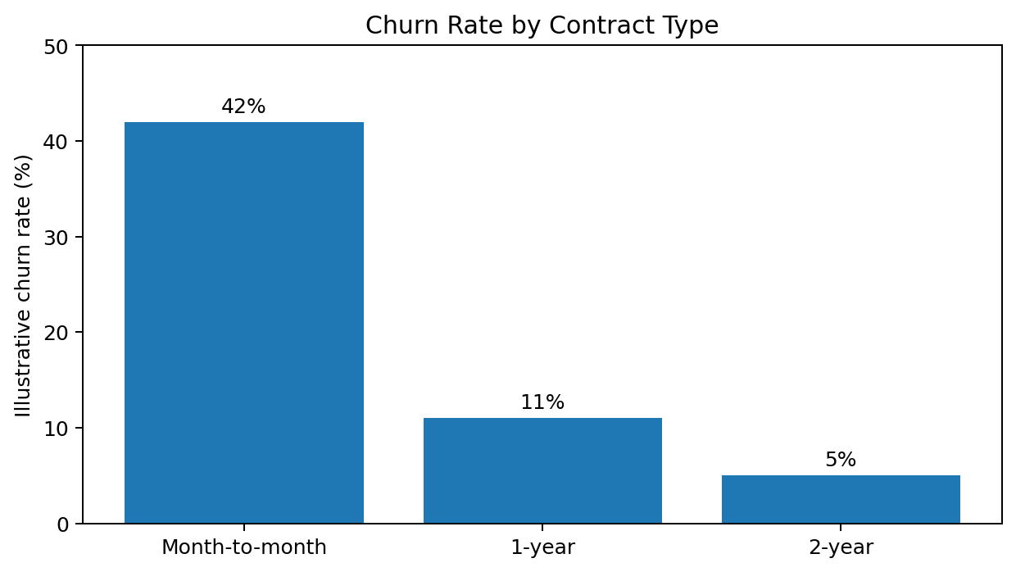
Figure 1. Illustrative churn rate by contract type.
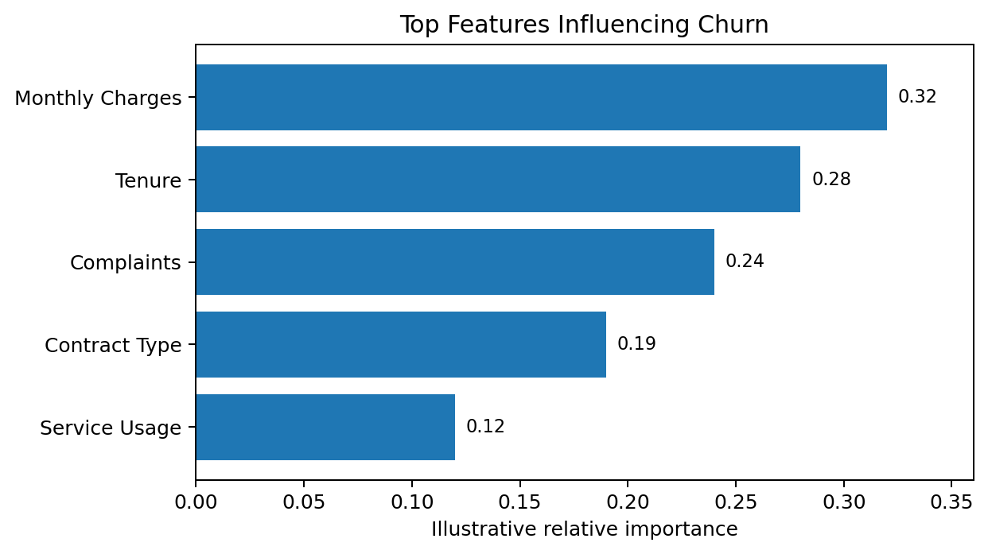
Figure 2. Illustrative feature-importance ranking.
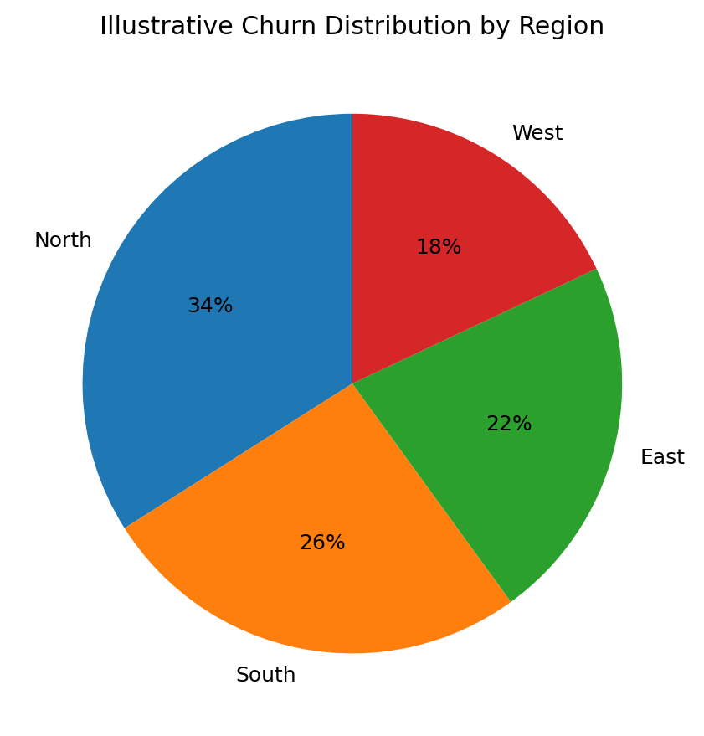
Figure 3. Illustrative regional churn distribution.

9. Interpretation of Results
The most important analytical message is not simply that some customer groups churn more than others, but that these patterns can be converted into targeted interventions. A customer who has a short tenure, a month-to-month contract, high monthly charges and recent complaints can be treated as a high-priority retention case. Conversely, customers with long tenure and stable service experience may require less intensive intervention.
The visuals are intentionally simple. A bar chart answers the question 'Which contract group has the highest churn?'; a feature-importance chart answers 'Which variables deserve attention?'; and a regional chart answers 'Where is the pattern concentrated?'. This question-led design makes the analysis easier for non-technical stakeholders to understand.

10. Actionable Recommendations
Target month-to-month customers — Offer suitable upgrade incentives, loyalty benefits or flexible annual-plan promotions to high-risk customers.
Strengthen early-tenure support — Create onboarding journeys during the first few months and proactively check customer satisfaction.
Use complaint-triggered retention — Route repeated complaints to priority service recovery and follow-up workflows.
Review high-charge customers — Analyze whether premium pricing is matched by perceived value and offer relevant plan optimization.
Build a churn-risk monitoring system — Use a predictive score to prioritize retention outreach instead of contacting all customers equally.
Track retention KPIs — Monitor churn rate, retention conversion, complaint resolution, customer lifetime value and campaign ROI.

11. Communication Strategy for a Non-Technical Audience
- Start with the business problem: customer loss, recurring revenue and retention cost.
- Avoid unnecessary technical terminology and explain model outputs in terms of business impact.
- Use one key message per visual and keep charts uncluttered.
- Use phrases such as 'higher risk', 'more likely to leave' and 'priority customer group' instead of technical jargon.
- Present recommendations immediately after the evidence that supports them.
- Clearly separate observed evidence, model-based insight and business recommendation.
- Finish with a small number of prioritized actions and measurable success indicators.

12. Presentation Plan
Section | Time (min) | Purpose
Introduction & Objective | 2 | Set context and define the business question.
Dataset & Methodology | 5 | Explain data, preparation and analytical approach.
Exploratory Analysis | 5 | Show major patterns and segment comparisons.
Model & Results | 8 | Explain model output, evaluation and important features.
Key Insights | 7 | Present the strongest findings and their business meaning.
Recommendations | 5 | Propose prioritized actions and KPIs.
Q&A / Closing | 3 | Answer questions and summarize next steps.
Total planned duration: 35 minutes

13. Evaluation Criteria Coverage
- Comprehensive executive summary and methodology review.
- Detailed insights supported by mock charts and tables.
- Clear explanation of trends, anomalies and influential variables.
- Actionable recommendations connected directly to analytical findings.
- Professional presentation structure suitable for executive review.
- Clear translation of technical analysis into understandable conclusions.
- Appropriate use of visual aids to support the narrative.
- Strategic communication approach for a non-technical audience.

14. Limitations & Future Work
- The project is hypothetical; numerical findings are illustrative and not derived from a live telecom database.
- Real-world deployment would require validation on unseen data and monitoring for model drift.
- Customer privacy, fairness and responsible use of personal information must be considered.
- Future work could include hyperparameter tuning, explainable AI methods, calibration of churn probabilities and ROI-based retention optimization.
- A/B testing should be used to verify whether recommended retention interventions actually reduce churn.

15. Conclusion
This Week 4 report demonstrates a complete data science communication workflow: understanding the business problem, preparing data, exploring patterns, interpreting analytical/model outputs, creating visual evidence and converting findings into actionable recommendations. The hypothetical churn case shows how data science can help an organization move from reactive customer management toward targeted, evidence-based retention. The final presentation should emphasize the business story behind the data, use concise visuals and end with clear actions that can be measured.

