WEEK 1 TASK REPORT
Data Science Project Planning and Strategy Design
Virtual Data Science Explorer Intern | Yuva Intern
Submitted by: Bikram Nandi

1. Executive Summary
This report presents a complete planning and strategy framework for a hypothetical data science project: a Retail Sales Demand Forecasting and Inventory Planning System. The project is designed to use Python to convert historical retail transaction and product information into demand forecasts that can support inventory decisions. No real dataset is required for this Week 1 task; the emphasis is on project architecture, methodology, tools, timeline, expected outcomes, risks, and evaluation strategy.
The proposed workflow follows a practical data science lifecycle: define the business problem, identify data sources, plan data cleaning, perform exploratory analysis, engineer features, build forecasting models, evaluate them using appropriate metrics, and translate results into actionable inventory insights. The plan also includes data-quality checks, time-aware validation, documentation, and a monitoring strategy so that the project can later be converted into an implementable Python solution.

2. Introduction and Background
Retail businesses need to maintain enough stock to satisfy customers without holding excess inventory. Demand varies with seasonality, holidays, promotions, price changes, product category, and historical sales patterns. A data science approach can identify these patterns and estimate future demand for individual products or product groups.
The hypothetical project therefore focuses on forecasting future daily or weekly product demand. The planned system will accept historical sales records and relevant explanatory variables, process the information through a reproducible Python pipeline, compare suitable forecasting models, and produce forecasts with interpretable performance measures.

3. Problem Statement and Motivation
Problem statement: Given historical retail sales and related business information, design a Python-based data science workflow capable of estimating future product demand and providing inventory-planning insights.
Motivation: Poor demand estimates can lead to stock-outs, excess inventory, inefficient working capital, and avoidable operational costs. A structured forecasting workflow can help decision-makers identify demand patterns and make more consistent replenishment decisions. The project is hypothetical, so all proposed results are to be validated only after a suitable dataset becomes available.

4. Project Objectives
- Define a clear business and data science problem for retail demand forecasting.
- Identify the data fields and sources required for a future implementation.
- Design a reproducible data cleaning and preprocessing pipeline in Python.
- Plan exploratory data analysis to identify trend, seasonality, outliers, and relationships.
- Develop a feature-engineering strategy using calendar, lag, rolling, and promotional variables.
- Compare suitable baseline and forecasting models using time-aware validation.
- Define evaluation metrics such as MAE, RMSE, and MAPE where appropriate.
- Translate model outputs into inventory-planning insights and a practical reporting format.
- Document risks, assumptions, limitations, and a monitoring strategy.

5. Project Scope
In Scope | Out of Scope | Assumptions
Historical sales analysis | Real-time POS integration | Historical data will be available
Data cleaning and validation | Automatic purchase execution | Sales records contain product/date information
EDA and feature engineering | Full ERP implementation | Relevant business variables can be obtained
Forecasting model design | Guaranteed business savings | Forecast accuracy depends on data quality
Model evaluation and reporting | Production deployment in Week 1 | Deployment is a future phase

6. Methodology and Strategy

6.1 Data Collection Plan
Potential inputs include date/time, product ID, category, store/location, units sold, selling price, discount/promotion indicator, holiday indicator, and stock information if available. Data sources may include CSV/Excel exports, a SQL database, or an approved public dataset. Data provenance and field definitions will be documented before analysis.

6.2 Data Quality and Cleaning
Check schema, data types, missing values, duplicates, impossible values, inconsistent product identifiers, negative or abnormal quantities, and date gaps. Missing values will be handled according to business meaning rather than by blindly applying one method. Outliers will be investigated before removal.

6.3 Exploratory Data Analysis
Analyze sales distributions, time trends, weekly/monthly seasonality, category-level demand, promotion effects, missingness, and correlations where meaningful. Visualizations will include line plots, bar charts, box plots, histograms, and heatmaps where appropriate.

6.4 Feature Engineering
Create calendar features such as day-of-week, month, quarter, weekend, and holiday flags. For forecasting models, plan lag features such as previous-day/previous-week demand and rolling statistics such as 7-day or 28-day moving averages, while preventing future-data leakage.

6.5 Model Strategy
Begin with a simple baseline such as last-period demand or moving-average forecasting. Candidate models may include linear regression with engineered features, Random Forest/Gradient Boosting regression, and time-series models such as SARIMA or Prophet where suitable. Model choice will depend on data characteristics and validation results.

6.6 Evaluation Strategy
Use chronological train-validation-test splits rather than random splitting. Primary metrics will be MAE and RMSE; MAPE will be considered when actual demand values are not zero or near zero. Compare each model against the baseline and record assumptions and limitations.

6.7 Interpretation and Business Output
The final output should contain forecasted demand, error metrics, demand trends, and product/category-level insights. Results should be presented in a simple report or dashboard so that a non-technical user can understand the implications.

7. Planned Data Science Architecture
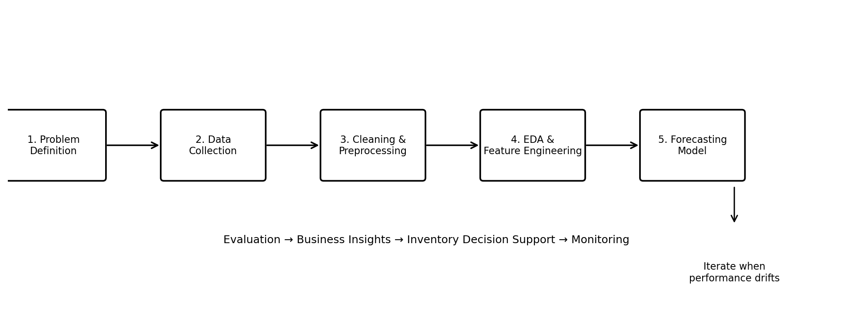
Figure 1. Proposed end-to-end data science workflow.
The architecture is intentionally modular. Each stage can be tested independently, which improves reproducibility and makes future maintenance easier. The validation stage feeds back into feature and model selection, while monitoring allows the workflow to be revisited when demand patterns change.

8. Python Libraries and Tools
Tool / Library | Purpose | Planned Use
Python | Core programming language | Entire analysis pipeline
Pandas | Tabular data processing | Loading, cleaning, transformation
NumPy | Numerical computation | Arrays and mathematical operations
Matplotlib | Visualization | Trends, distributions, comparisons
Seaborn | Statistical visualization | EDA plots and heatmaps
Scikit-learn | ML algorithms and metrics | Baselines, regression, evaluation
Statsmodels | Statistical/time-series modeling | SARIMA and diagnostics if suitable
Jupyter Notebook | Interactive development | EDA, experiments, documentation
Git/GitHub | Version control | Code and report versioning

9. Work Timeline — 32 Hours
The task requirement calls for approximately 30–35 hours. The following plan allocates 32 hours across the project-planning activities.
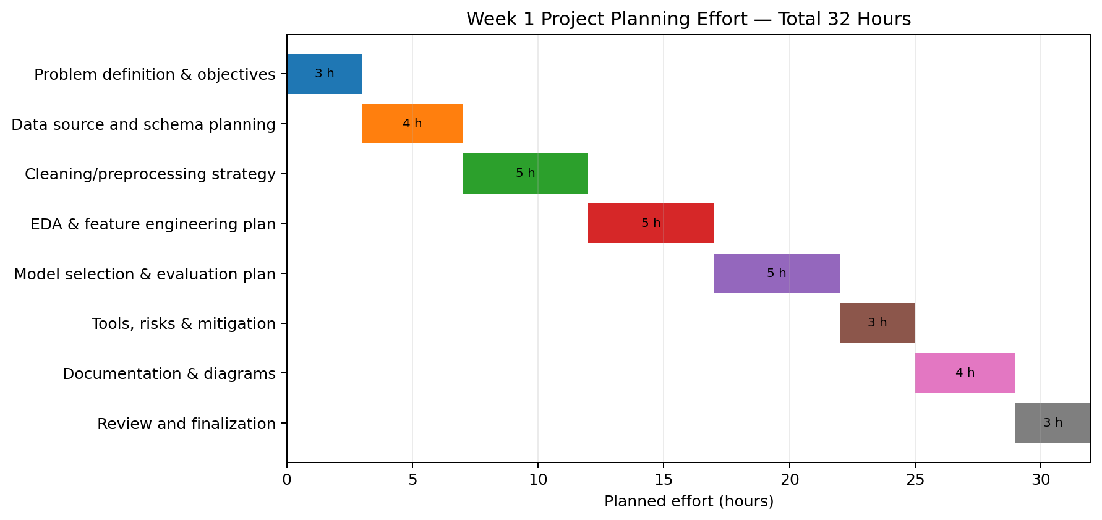
Figure 2. Planned effort distribution (32 hours total).
Activity | Hours | Deliverable
Problem definition & objectives | 3 | Problem statement and measurable objectives
Data source and schema planning | 4 | Data dictionary and source plan
Cleaning/preprocessing strategy | 5 | Quality checks and preprocessing rules
EDA & feature engineering plan | 5 | EDA checklist and feature plan
Model selection & evaluation plan | 5 | Model candidates and validation strategy
Tools, risks & mitigation | 3 | Technology stack and risk register
Documentation & diagrams | 4 | Architecture and timeline diagrams
Review and finalization | 3 | Final report quality check

10. Expected Outcomes
- A clearly defined retail demand forecasting problem and implementation roadmap.
- A documented data schema and data-quality checklist.
- A reproducible Python workflow design from data ingestion to model evaluation.
- A justified feature-engineering and model-selection strategy.
- A time-aware evaluation framework with clearly defined metrics.
- Business-oriented outputs that can support inventory planning.
- A foundation that can later be implemented using a real dataset.

11. Anticipated Challenges and Mitigation
Challenge | Potential Effect | Mitigation
Missing or inconsistent records | Biased or unstable forecasts | Profile data quality and document rules for handling missingness.
Seasonality or promotions | Model may miss demand spikes | Add calendar/promotion features and evaluate seasonal patterns.
Data leakage | Unrealistically high validation score | Use chronological splits and ensure features use only past information.
Sparse products | High forecast error | Group similar products or use appropriate fallback baselines.
Concept drift | Performance declines over time | Monitor error and retrain when justified by new data.
Zero/near-zero demand | MAPE becomes misleading | Use MAE/RMSE and consider alternative percentage metrics carefully.

12. Evaluation Criteria for the Proposed Project
- Completeness of the project plan and clarity of the business problem.
- Demonstrated understanding of the data science lifecycle.
- Logical organization of methodology and justified strategy.
- Appropriate identification of Python libraries and tools.
- Realistic 30–35 hour effort allocation.
- Clear architecture and timeline diagrams.
- Identification of expected outcomes, assumptions, and risks.
- Professional presentation and reproducibility of the planned workflow.

13. Conclusion
This Week 1 plan establishes a practical foundation for a hypothetical retail demand forecasting project. It connects a real-world business problem with a structured Python data science workflow and explicitly addresses data collection, preparation, exploration, feature engineering, model selection, evaluation, reporting, and monitoring. Because no dataset is supplied at this stage, the report avoids claiming actual model performance or business impact. The next phase can use an approved dataset to implement the planned pipeline, validate assumptions, and refine the methodology based on observed data.

14. Submission Note
This document is prepared as the Week 1 planning report. The GitHub project URL should be added in the internship portal after creating/uploading the corresponding project repository. Do not submit a fabricated GitHub URL.

