Last week, I had the pleasure of assisting to a small conference which was about student housing. Five companies came and presented their ideas on how to rework current student housing to increase their quality of life.
First off, let's remind everyone what regular student housing is like. In most cases, you get twelve square meters, living in a huge complex called the CROUS. That's not a lot. Most student refer to them as corridors, and that's not far from the truth.

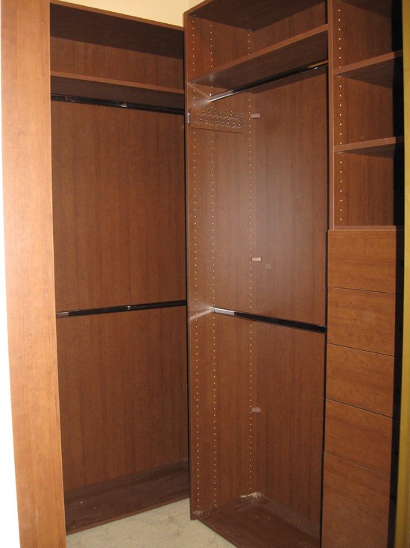

Slightly accurate representation
of student housing

You don't have a lot of breathing room in there. If you're really unlucky (or were late to the registration), you get old, non renovated housing. Nine square meters in buildings that were built back when Germany was still two separate countries. Of course, it's all not bad. The rent is extremely cheap, you get rights to the CAF which once again halves your rent, The room already has furniture, you get a fridge, a common kitchen for the entire floor which gets cleaned often.

Those companies proposed a variety of projects, ranging from adapting current rooms to changing the entire layout and size of the room, making most rooms suited for sharing it with another person.
Stu'Design decided to adapt the current room to make it more pleasant for people living there. Their project is mostly centered on adding smart features to the room. Speaker are integrated to the wall, the store is a smart one. Everything is linked to your smartphone, waking you up smoothly or allowing you to control your room easily.
Home Green Home is all about clean technologies. Turning off heating when needed, efficient insulation, and a lot of small spaces to create a vast room. It would require rebuilding the entire room though.
EcoLux decided to go full modular, where your room adapts itself throughout the day to your needs.
All those projects are definitely interesting and will certainly improve the quality of life.

